1. Recommender systems are a hot topic in data science companies. Recommender systems aim to predict the rating that a user will give for an item (e.g., a restaurant, a movie, a product, a Point of Interest). Surprise (http://surpriselib.com) is a Python package for developing recommender systems. To install Surprise, the easiest way is to use pip. Open your console: $ pip install numpy

$ pip install scikit-surprise

1. Download an experimental dataset “restaurant_ratings.txt” from the Canvas: Files/Data/ restaurant_ratings.txt

1. Load data from “restaurant_ratings.txt” with line format: 'user item rating timestamp'. The introduction of the Surprise data module can be found via http://surprise.readthedocs.io/en/v1.0.2/dataset.html. The sample python codes are as follows:

*from surprise import Dataset from surprise import Reader import os*

*#load data from a file*

*file_path = os.path.expanduser('restaurant_ratings.txt') reader = Reader(line_format='user item rating timestamp', sep='\t') data = Dataset.load_from_file(file_path, reader=reader)*

1. MAE and RMSE are two famous metrics for evaluating the performances of a recommender system. The definition of MAE can be found via:

https://en.wikipedia.org/wiki/Mean_absolute_error. The definition of RMSE can be found via: https://en.wikipedia.org/wiki/Root-mean-square_deviation.

1. Split the data for 3-folds cross-validation, and compute the MAE and RMSE of the SVD (Singular Value Decomposition) algorithm. The introduction of SVD algorithm can be found via http://surprise.readthedocs.io/en/v1.0.2/matrix_factorization.html.

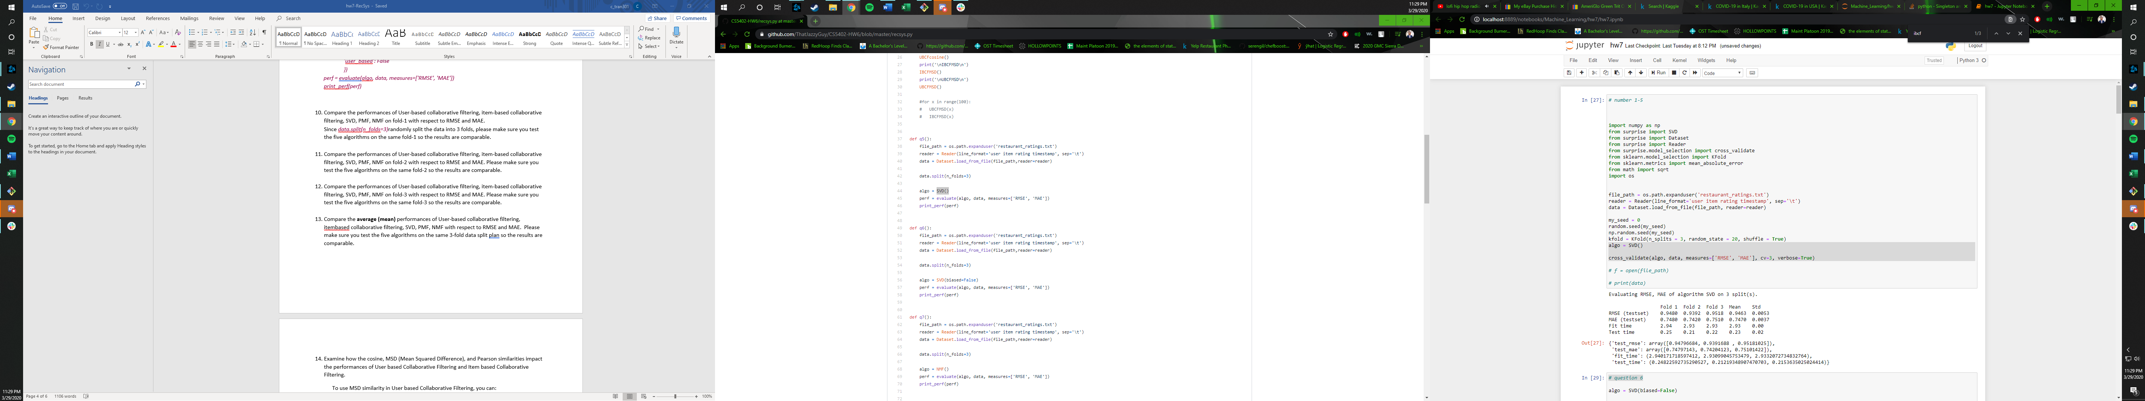

1. Split the data for 3-folds cross-validation, and compute the MAE and RMSE of the PMF (Probabilistic Matrix Factorization) algorithm. The introduction of PMF algorithm can be found via http://surprise.readthedocs.io/en/v1.0.2/matrix_factorization.html.

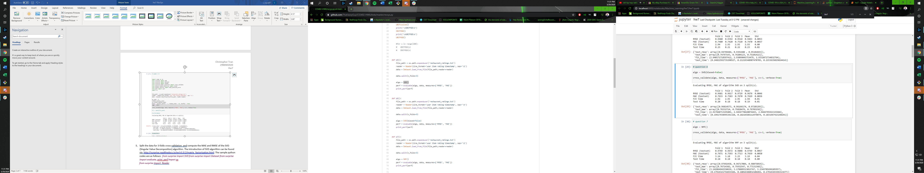

1. 7. Split the data for 3-folds cross-validation, and compute the MAE and RMSE of the NMF (Non-negative Matrix Factorization) algorithm. The introduction of NMF algorithm can be found via http://surprise.readthedocs.io/en/v1.0.2/matrix_factorization.html. 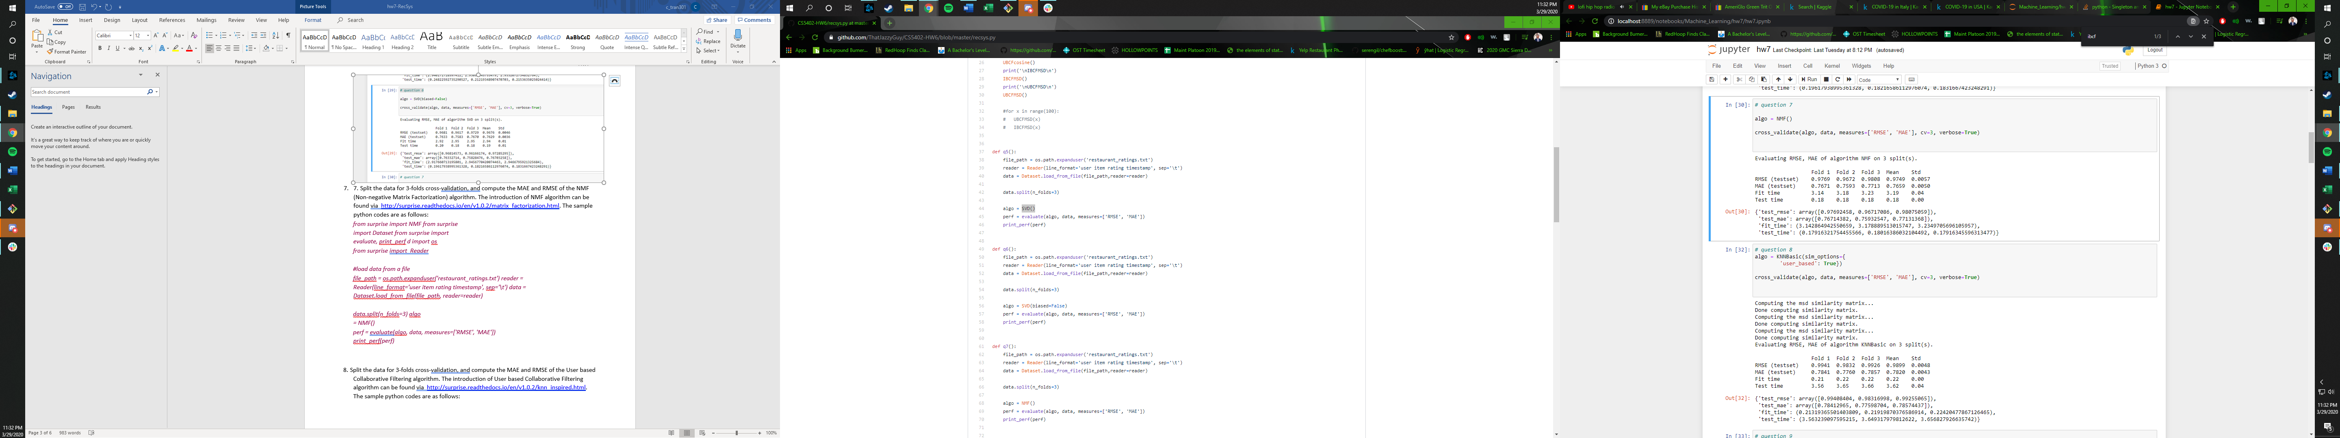
2. Split the data for 3-folds cross-validation, and compute the MAE and RMSE of the User based Collaborative Filtering algorithm. The introduction of User based Collaborative Filtering algorithm can be found via http://surprise.readthedocs.io/en/v1.0.2/knn_inspired.html.

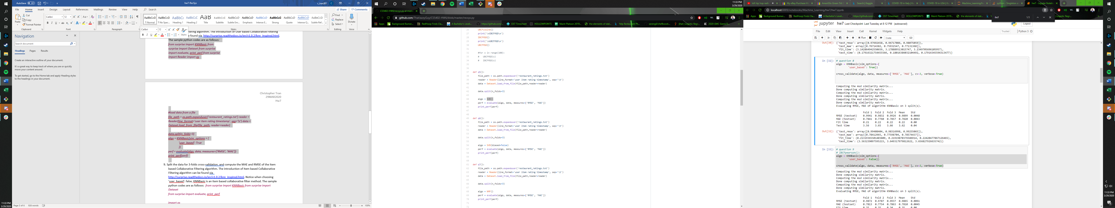

9. Split the data for 3-folds cross-validation, and compute the MAE and RMSE of the Item based Collaborative Filtering algorithm. The introduction of Item based Collaborative Filtering algorithm can be found via http://surprise.readthedocs.io/en/v1.0.2/knn_inspired.html. 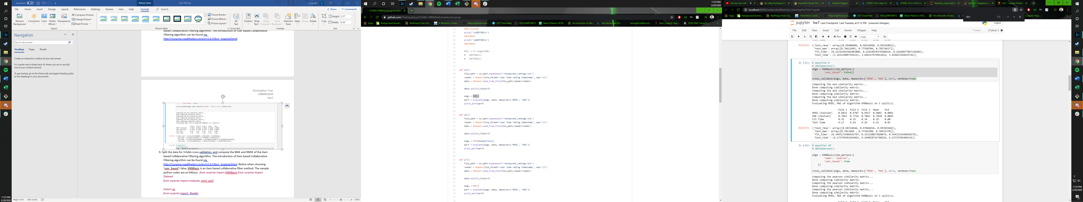

Questions 10-15 can be found at the following link due to length of code and output: