Christopher Tran

STA5206 Midterm

10/29/19

Perform statistical analyses and provide brief answers to each of the following questions. Determine statistical methods to be used. Present values of observed test statistic, corresponding p-values to draw statistical conclusions. All tests are conducted at α level 0.05. Only present tailored SAS output that are directly relevant to your answer. Do not provide irrelevant SAS output.

1. Test for a one-way contingency table to confirm the race percentages with race codes=1, 2, 3 are 0.45, 0.20 and 0.35, respectively. Compute p-value and draw statistical conclusion.
   1. Before running the test, we must assume H0 is that the race codes are wrong and H1 is that the percentages are correct. Once we run the calculation, we find that the X^2= 4.84 and the degrees of freedom is 2, our p-value would be the 0.0891. Because α level is 0.05, we cannot reject H1, therefore the percentages are likely correct. 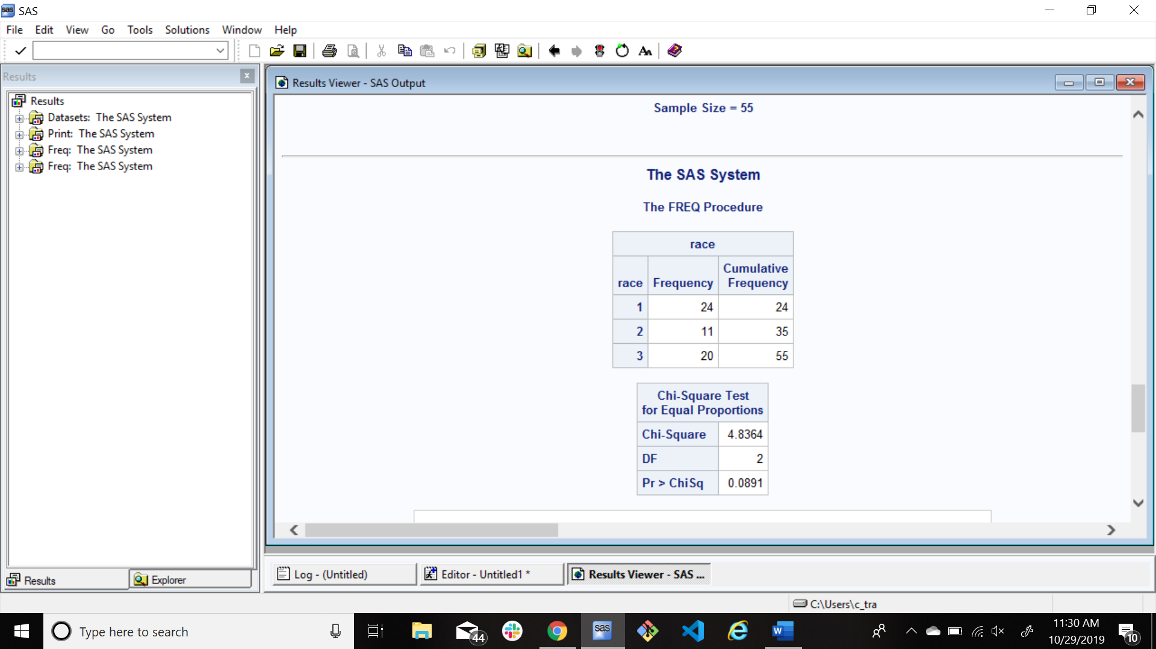
2. Test for H0: p1 = p2 vs H1: p1 ̸= p2, where p1 and p2 are proportions of female and male students. Draw statistical conclusion.
   1. After running tests, the results showed that X^2 = 1.47 with a degree of freedom of 1 and a p-value of 0.2249. Since the α level is 0.05, we can reject H0 meaning the proportion of female and male students are not equal. 
3. Use the chi-square goodness-of-fit method without continuity correction to determine whether the student reading scores are from the normal distribution N(47.8, 8.8 2 ). Divide data into 5 disjoint categories: ≤ 40 , > 40 and ≤ 46 , > 46 and ≤ 48 , > 48 and ≤ 52 , and > 52 . Report the degree of freedom and the observed value of chi-square test statistic, p-value and draw statistical conclusion based on your findings.
   1. With the observed chi-square of 15.0191, the degree of freedom of 4 and the p-value of 0.01 which is less than 0.05, we can determine that the normal distribution of N(47.8, 8.8 2 ) is not a good fit for the data.
   2. 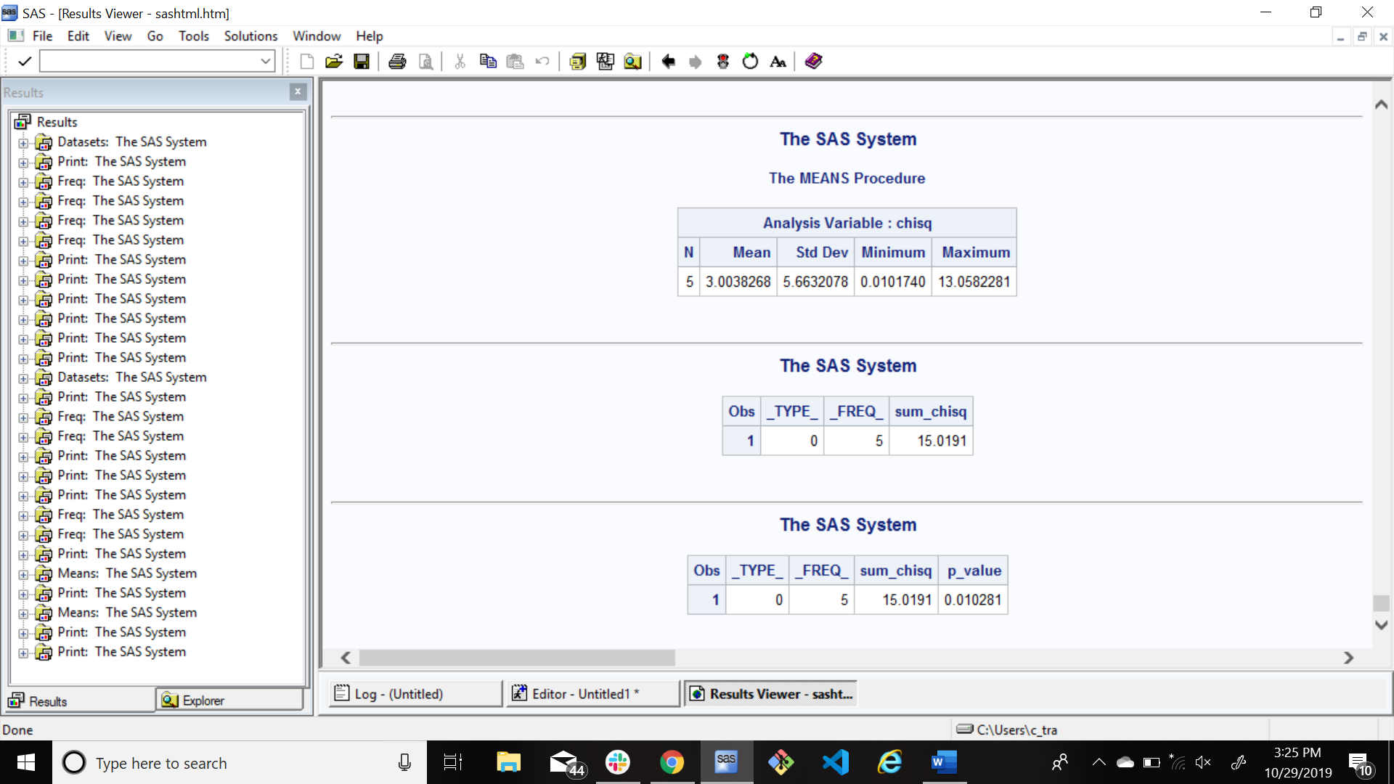
4. Determine an appropriate statistical method to compare mean test scores between male and female students for each of 5 courses, respectively. Describe the null and alternative hypotheses. Calculate 5 p-values and perform 2-sided tests to draw 5 conclusions.
   1. When comparing the male scores to the female scores, the null hypothesis can always be that the scores will always be equal (m1=f1 if m1 is the male score and f1 is the female score) and the alternative hypothesis can be that they are not equal. Finding the mean of each score, you’ll find that in most cases that we would have to reject the null hypothesis.
5. Select an appropriate statistical method to test for the equality between mathematics and science scores, and the equality between writing and social science scores, but only for all female students. Report the values of the observed test statistic for each of the two comparisons. Compute the two p-values for your tests and drawn two statistical conclusions.