Utano Market Survey Report

UlwaziHub

## Introduction

This report presents the latest findings from the Utano Market Survey, conducted by UlwaziHUB Consulting Services in South Africa. The survey, which targeted a diverse population, was administered online between May 30 and June 5. A total of 391 responses were recorded. However 384 have been considered as valid records while 3 are responses from participants that did not give consent to the survey. The remaining 3 have been considered as missing values. Thus, the achieved response rate is 99.7%. The respondents providing valuable insights into current market trends, healthcare access, and service preferences. The data collected serves as a critical foundation for understanding the needs and expectations of communities, and will inform the design and delivery of more inclusive and responsive health-related services.

## Methods

The Utano Market Survey employed a cross-sectional study design and was conducted entirely online using a structured digital questionnaire. The survey instrument was developed in English and translated into additional local languages to improve accessibility and comprehension. A combination of purposive and snowball sampling techniques was used to recruit participants through social media platforms, community networks, and digital outreach by local partners.

The questionnaire included both closed- and open-ended questions covering themes such as demographics, health-seeking behavior, service delivery preferences, and perceived barriers to healthcare. Data collection was anonymous, and participants provided informed consent electronically before beginning the survey. All data were securely stored and analyzed using statistical software to produce descriptive and inferential insights, including cross-tabulations and chi-square tests for associations between key variables such as gender and nationality.

## Results

## Section A: Demographic Characteristic of the Respondents

This section presents the demographics and distribution of the results

The sampled respondents were from 16 nationalities with 193 (50.1 %) of them being females and the remaining 185 (48.1 %) being males. Table @@@@ shows a breakdown of the nationalities that responded by gender.

Table 1: Distribution of Males and Females by Country

| Nationality | Female (n %) | Male (n %) |
| --- | --- | --- |
| Zimbabwe | 95 (60%) | 63 (40%) |
| Mozambique | 26 (30%) | 60 (70%) |
| Lesotho | 25 (52%) | 23 (48%) |
| South africa | 24 (55%) | 20 (45%) |
| Malawi | 12 (55%) | 10 (45%) |
| Kenya | 2 (40%) | 3 (60%) |
| Nigeria | 0 (0%) | 2 (100%) |
| Botswana | 0 (0%) | 1 (100%) |
| Eswatini | 0 (0%) | 1 (100%) |
| Gambia | 0 (0%) | 1 (100%) |
| Other | 0 (0%) | 1 (100%) |
| Angola | 1 (100%) | 0 (0%) |
| Congo kinshasa | 2 (100%) | 0 (0%) |
| Ghana | 1 (100%) | 0 (0%) |
| Namibia | 4 (100%) | 0 (0%) |
| Tanzania | 1 (100%) | 0 (0%) |
|  | 1 (100%) | 0 (0%) |
| Total | 194 (51%) | 185 (49%) |

A chi-square test of independence was conducted to examine the relationship between gender and nationality among participants. The analysis revealed a statistically significant association between gender and nationality,p = 0.002. This suggests that the distribution of gender differs significantly across nationalities in the dataset. The observed differences were supported by the cross-tabulated counts and row-wise percentages, with variations noted particularly in the proportions of males and females within each nationality group.

The overall average age for the survey respondents was 35.1 years. The females’ average age was 35.4 years and the males’ average age was 34.6 years. Majority of the survey participants that currently lived in South Africa as shown in Table @@@ were based in Pretoria followed by Johannesburg and then Capetown which seems to be in line with the order of launching the business model in question with Pretoria being the city where the health service product will be launched first and followed by the rest of Gauteng. Looking at the participants’ current location by nationality indicated that the largest proportions of each of the focus nationalities (Zimbabwe, Mozambique, Lesotho, Malawi) currently reside in Pretoria.

| Current location where respondent lives | Frequency | Percent |
| --- | --- | --- |
| City of Tshwane Metropolitan Municipality | 191 | 63% |
| City of Johannesburg Metropolitan Municipality | 42 | 14% |
| Capetown | 22 | 7% |
| Chris Hani District | 12 | 4% |
| City of Ekurhuleni Metropolitan Municipality | 8 | 3% |
| Sedibeng District | 4 | 1% |
| eThekwini Metropolitan Municipality | 4 | 1% |
| West Rand District | 3 | 1% |
| Central Karoo District | 2 | 1% |
| City of Cape Town Metropolitan Municipality | 2 | 1% |
| Ehlanzeni District | 2 | 1% |
| Mopani District | 2 | 1% |
| OR Tambo District | 2 | 1% |
| Bojanala Platinum District | 1 | 0% |
| Buffalo City Metropolitan Municipality | 1 | 0% |
| Garden Route District | 1 | 0% |
| Gert Sibande District | 1 | 0% |
| Lejweleputswa District | 1 | 0% |
| Nkangala District | 1 | 0% |
| uMzinyathi District | 1 | 0% |

Fifty percent of the non-South African nationalities respondents have been in South Africa for over five years while the second largest proportion of 37.5% have been in lived in South Africa for 1 - 5 yrs followed by those who have lived for 6 months - 12 months at 9.1% and then those that have been in South Africa for less than six months making up the remaining 3.4%. When the length of stay in South Africa was disaggregated by gender there did not seem to be a significant difference in the proportions by length of stay. However, disaggregating the length of stay by nationality, more Zimbabweans and Basotho tended to have been in South Africa for over 5 years (61.2% and 50% respectively) while a larger percentage of Malawians and Mozambicans indicated having lived in South Africa for 1 - 5 years.

| Education | Formal | Informal | Ownbusiness | Unemployed |
| --- | --- | --- | --- | --- |
| None | 10% | 52% | 23% | 16% |
| Primary | 16% | 47% | 20% | 17% |
| Secondary | 9% | 54% | 14% | 22% |
| Tertiary | 66% | 0% | 17% | 17% |
| Vocational | 6% | 62% | 12% | 19% |
| Total | 30% | 35% | 17% | 19% |

Overall, the majority of respondents have attained either tertiary (33.9%) or secondary (33.2%) education, reflecting a generally high level of educational attainment within the target population. However, a notable proportion—8.2%—reported having no formal education, highlighting the need for tailored communication strategies that accommodate varying literacy and comprehension levels within the market. As presented in Table @@@, 30% respondents reported being formally employed, while 17% indicated they operated their own business—together reflecting substantial engagement in formal income-generating activities. In contrast, 35% were employed in the informal sector, and 19% of the sampled population were recorded as unemployed. These findings suggest that market segmentation strategies should consider the varying levels of financial stability and purchasing power across these groups, with tailored approaches for formally employed and business-owning segments, while accounting for the unique needs and constraints of the informally employed and unemployed populations. An analysis of occupational status by nationality reveals that the majority of Basotho respondents were unemployed (36%). On the other hand, the highest proportions of Malawian (76%), Mozambican (37%), and Zimbabwean (39%) respondents were engaged in informal employment. For respondents classified under ‘Other’ nationalities, the largest share was found to be formally employed.

## SECTION B: Healthcare Needs & Usage.

Measuring healthcare importance and usage.

To assess the importance placed on healthcare and its utilization, the target population was asked to respond to the following three statements:

* Access to quality healthcare is essential for me to live a productive and fulfilling life.
* I will do whatever it takes to ensure access to healthcare for myself and my family.
* I go for health check-ups even when I am not feeling unwell.

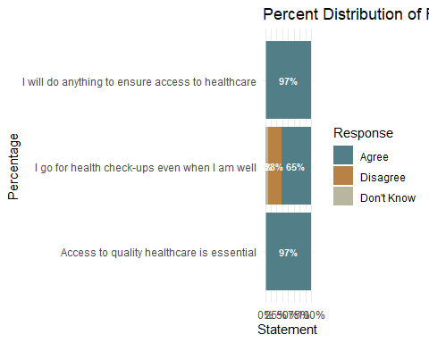

The respondents’ overwhelming agreement with “access to quality health is essential” and “I will do anything to ensure access to healthcare” shows the high value on access to quality healthcare. Such strong sentiments suggest that the targetted population placess strong importance on healthcare that is of quality, and is also accessible and will be willing to engage with service that offers such qualities. “I go for health check-ups even when I am well”, which assesses health-seeking and preventative health behavior, received 65 % agreement, 28 % disagreement, and 7 % uncertainty, reflecting a more mixed view compared to the consistently high agreement observed in the other two statements. This disparity may point to limitations in preventative health practices, potentially driven by affordability or access barriers. It suggests that a significant portion of the population may only seek healthcare when they are already ill, rather than engaging in routine preventive care.

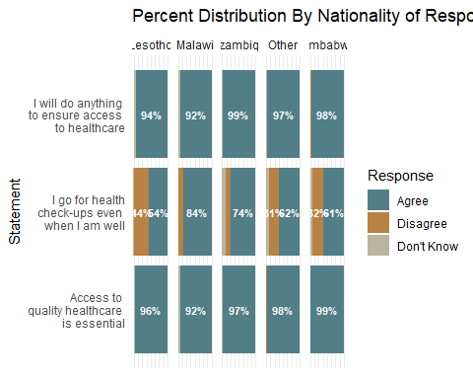

An analysis of responses to the healthcare statements by nationality reflects a consistent emphasis across most groups on the importance of accessing quality healthcare and ensuring healthcare access. As presented in Table @@@, Basotho, Zimbabwean, and ‘Other’ nationalities are notably less likely to seek routine health check-ups compared to their Malawian and Mozambican counterparts.

## SECTION C: Willingness to sign up for the product.

### Language Preference and Choice of Healthcare Provider

When asked whether language influences their decision when choosing a healthcare provider, the majority of respondents affirmed its importance. Specifically, 88% of females and 89% of males agreed that language plays a role in their decision-making, resulting in an overall agreement of 88%. This suggests that language is a key consideration for both females and males when selecting a healthcare provider, emphasizing the critical importance of language-concordant care in health service delivery (Table below)

| Language | Female | Male | Total |
| --- | --- | --- | --- |
| Agree | 163 (88%) | 160 (89%) | 323 (88%) |
| Disagree | 17 (9%) | 13 (7%) | 30 (8%) |
| Dont know | 6 (3%) | 7 (4%) | 13 (4%) |
| Total | 186 (100%) | 180 (100%) | 366 (100%) |

### Gender Preference and Choice of Healthcare Provider

When asked whether they choose a healthcare provider based on gender, 61% of females and 64% of males agreed with the statement, suggesting that gender plays a role in provider selection for a significant portion of both groups. Overall, 62% of respondents agreed.

| Gender | Female | Male | Total |
| --- | --- | --- | --- |
| Agree | 114 (61%) | 114 (64%) | 228 (62%) |
| Disagree | 68 (36%) | 58 (33%) | 126 (35%) |
| Dont know | 6 (3%) | 5 (3%) | 11 (3%) |
| Total | 188 (100%) | 177 (100%) | 365 (100%) |

### Choosing a healthcare provider based on Availablity of Key population Services

When considering the availability of key population services as a factor in choosing a healthcare provider, a majority of respondents across both genders agreed that it influences their choice. Specifically, 67% of females and 78% of males agreed, resulting in an overall agreement of 73%. This indicates a strong preference for providers that offer services tailored to key populations.

| Key population | Female | Male | Total |
| --- | --- | --- | --- |
| Agree | 125 (67%) | 140 (78%) | 265 (73%) |
| Disagree | 32 (17%) | 21 (12%) | 53 (15%) |
| Dont know | 29 (16%) | 18 (10%) | 47 (13%) |
| Total | 186 (100%) | 179 (100%) | 365 (100%) |

### Years of Clinical Experience and Choice of Healthcare Provider

The majority of respondents indicated that years of clinical experience play a significant role in their choice of healthcare provider. 79% of females and 85% of males agreed with this statement, contributing to an overall agreement rate of 82%. This reflects a strong and consistent preference across both genders for experienced healthcare professionals.

| Years of experience | Female | Male | Total |
| --- | --- | --- | --- |
| Agree | 146 (79%) | 153 (85%) | 299 (82%) |
| Disagree | 31 (17%) | 20 (11%) | 51 (14%) |
| Dont know | 7 (4%) | 6 (3%) | 13 (4%) |
| Total | 184 (100%) | 179 (100%) | 363 (100%) |

## Selecting health services products

Understanding how different genders engage with various service types can provide valuable insights into consumer preferences and accessibility. This analysis explores the distribution of male and female preferences across different service types.The chart highlights a clear gender difference in service preferences. Females predominantly chose Gold, Platinum, and Silver services, with Gold being the most favored. In contrast, males showed a stronger preference for Lithium services, demonstrating a noticeable skew toward this option. This pattern suggests potential gender-driven trends that could inform service customization and marketing strategies

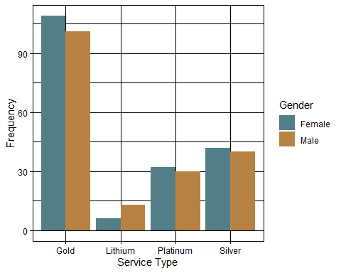

Understanding how different Nationality engage with various service types can provide valuable insights into consumer preferences and accessibility.The chart below highlights how employment status influence service preferences. Those in the informal sector predominantly chose Gold while those in the formal sector,show stronger preference in Lithium, Platinum and Silver services.

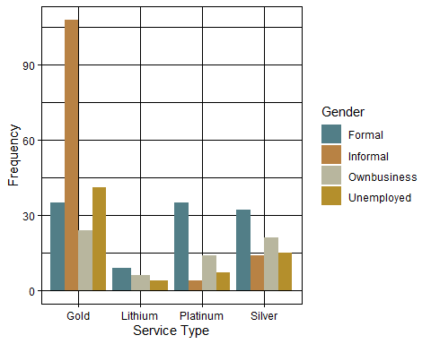

## Preferred Payment Options

When asked about their preferred payment method for healthcare services, cash emerged as the most commonly selected option, with 40% of respondents indicating this preference. This was followed by card payments, selected by 26%, and insurance, chosen by 21% of respondents. Prepaid options were the least preferred, with only 12% of participants opting for this method.

| Payment Option | Frequency | Percentage |
| --- | --- | --- |
| Card | 99 | 26% |
| Cash | 152 | 40% |
| Insurance | 81 | 21% |
| Prepaid | 46 | 12% |
| Total | 378 | 100% |

When asked about their preferred subscription method for healthcare services, the majority of respondents (46%) indicated a preference for monthly subscriptions, suggesting a favorability toward shorter, more flexible payment cycles. This was followed by one-time subscriptions at 20%, and annual subscriptions at 16%.Less commonly selected were quarterly and biannual subscriptions, accounting for 12% and 6% of responses, respectively.

| Subscription Option | Frequency | Percentage |
| --- | --- | --- |
| Annual | 60 | 16% |
| Biannual | 22 | 6% |
| Monthly | 172 | 46% |
| Once | 76 | 20% |
| Quarterly | 46 | 12% |
| Total | 376 | 100% |

When asked about their preferred method of subscribing to a healthcare service, 44% of respondents favored an assisted subscription, indicating a preference for guided or in-person support. Online subscriptions were selected by 35%, demonstrating a growing acceptance of digital platforms for managing healthcare enrollment. Meanwhile, 21% preferred to subscribe through their employer.

| Subscription Method | Frequency | Percentage |
| --- | --- | --- |
| Assisted | 167 | 44% |
| Employer | 80 | 21% |
| Online | 132 | 35% |
| Total | 379 | 100% |

| Employer | Frequency | Percentage |
| --- | --- | --- |
| I am not an employer | 184 | 49% |
| No | 24 | 6% |
| Yes | 169 | 45% |
| Total | 377 | 100% |

| Employer | Assisted | Employer | Online | Total |
| --- | --- | --- | --- | --- |
| I am not an employer | 73 (40%) | 48 (26%) | 62 (34%) | 183 (100%) |
| No | 14 (58%) | 4 (17%) | 6 (25%) | 24 (100%) |
| Yes | 77 (46%) | 27 (16%) | 62 (37%) | 166 (100%) |
| Total | 164 (44%) | 79 (21%) | 130 (35%) | 373 (100%) |

Among respondents who indicated they are currently employers, a significant majority—95% (153 individuals)—reported that they would be willing to obtain insurance coverage for their employees if offered a plan that costs less than their current payment. Only 5% (8 individuals) expressed reluctance to make such a change.Furthermore,Among 167 employers surveyed, the majority—56% (93)—indicated they would choose the Gold package for their employees, reflecting a strong preference for premium coverage. This was followed by Silver (24%), Platinum (16%), and Lithium (5%).

| Employer | Annual | Biannual | Monthly | Once | Quarterly | Total |
| --- | --- | --- | --- | --- | --- | --- |
| Yes | 18 (11%) | 9 (5%) | 95 (57%) | 28 (17%) | 16 (10%) | 166 (100%) |

| Employer | Gold | Lithium | Platinum | Silver | Total |
| --- | --- | --- | --- | --- | --- |
| Yes | 93 (56%) | 8 (5%) | 26 (16%) | 40 (24%) | 167 (100%) |

Among respondents who indicated they are currently employers, a significant majority—95% (153 individuals)—reported that they would be willing to obtain insurance coverage for their employees if offered a plan that costs less than their current payment. Only 5% (8 individuals) expressed reluctance to make such a change.

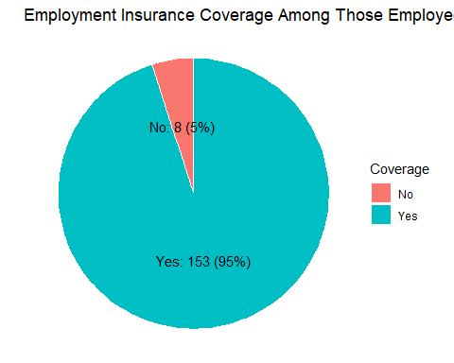

A total of 376 subscriptions were recorded. Most were in the 100+ ZAR (129; 34%) and 50–59 ZAR (75; 20%) ranges, followed by 10–19 ZAR (65; 17%), 30–39 ZAR (45; 12%), 20–29 ZAR (41; 11%), and 40–49 ZAR (21; 6%). Within the 100+ ZAR range, online accounted for 57 (44%), assisted 49 (30%), and employer 23 (29%). In the 50–59 ZAR band, assisted made up 34 (21%), employer 17 (21%), and online 24 (18%). Lower price tiers were dominated by assisted subscriptions, especially in the 10–19 ZAR category with 38 (23%). Online subscriptions increased progressively with price, peaking in the highest bracket.

| Subscription Method | 10-19 ZAR | 20-29 ZAR | 30-39 ZAR | 40-49 ZAR | 50-59 ZAR | 100+ ZAR |
| --- | --- | --- | --- | --- | --- | --- |
| Assisted | 38 (3800%) | 18 (1800%) | 18 (1800%) | 8 (800%) | 34 (3400%) | 49 (4900%) |
| Employer | 17 (1700%) | 11 (1100%) | 10 (1000%) | 2 (200%) | 17 (1700%) | 23 (2300%) |
| Online | 10 (1000%) | 12 (1200%) | 17 (1700%) | 11 (1100%) | 24 (2400%) | 57 (5700%) |
| Total | 65 (6500%) | 41 (4100%) | 45 (4500%) | 21 (2100%) | 75 (7500%) | 129 (12900%) |

## SECTION D: Engagement and Referral

Respondents were asked whether they would share information about the new healthcare service with their friends and family. An overwhelming 97% indicated they would, highlighting a strong potential for word-of-mouth dissemination.

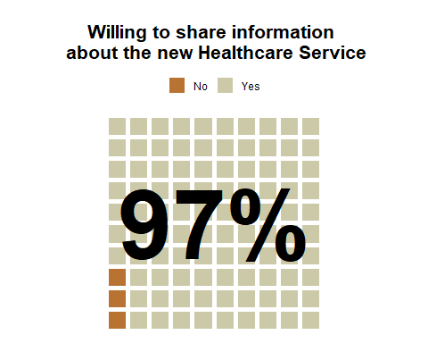

Approximately three in five individuals expressed willingness to serve as community agents and earn an incentive by referring clients to the new healthcare service. This indicates a strong opportunity to leverage grassroots engagement as a powerful marketing and outreach channel.

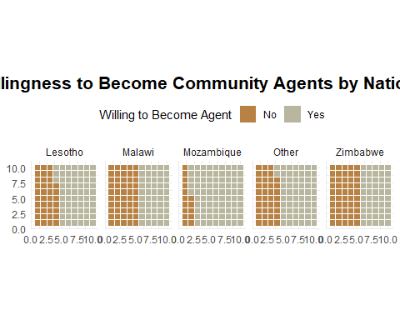

Notably, analysis of respondents’ willingness to become community agents for an incentive shows interesting relationship between perceived package prestige and engagement interest. A higher proportion of individuals enrolled in the mid-tier Gold (Yes - 62%) and Silver (Yes - 73%) health service packages expressed willingness to serve as community agents compared to those who selected the more premium Platinum (Yes - 48%) and top-tier Lithium (Yes - 56%) packages. This suggests that individuals opting for less expensive packages may view the community agent role as an opportunity to derive added value. In contrast, those in higher-tier plans may have less motivation to engage at a grassroots level.

The average commission rate across the total respondent population was R1,596.16 per person referred. However, this average masks substantial variation across nationality and gender subgroups. The reported commission values ranged from a minimum of R2 to a maximum of R150,000, indicating a highly skewed distribution.

When disaggregated by nationality, respondents from Lesotho reported the highest average commission at R6,120—nearly four times the overall average—suggesting a stronger perceived value or expectation for referral incentives. Zimbabwe followed with a mean of R1,391, closely aligning with the overall average. Respondents classified under ‘Other nationalities’ had a mean of R878, while Malawians and Mozambicans reported significantly lower average commissions at R153 and R137, respectively. This widespread view may reflect differences in economic expectations, market exposure, or perceived effort-to-reward ratios across national groups.

Gender-based analysis revealed that women, on average, expected significantly higher commissions (R3,030) than their male and “other gender”counterparts, whose average responses ranged from R460 to R800. This disparity may reflect differing motivations or opportunity costs associated with participation in referral-based models.

Nearly half of the respondents (49%) indicated that no formal endorsement is needed, suggesting a high level of direct trust in the service itself. About 34% of respondents expressed a preference for endorsement by their own government, indicating that messaging that resonates with national identity and local credibility may be effective for this group. Conversely, endorsements from private companies (18%) and the South African government (19%) received the least support.

