Info 3097 Project 1 Proposal

Craig Treulieb, Tyler Garrow

9/19/2014

Target Platform: Android 4.1

Hardware Target: Asus Nexus 7 2012 model

Project summary:

Our app is called the LTC Next Bus app. Its goal is to have the user enter the stop number where they’re at and it will tell them the next busses to that stop. Similar apps exist, but they don’t really work the way I’d like them to. Sometimes I will be at a stop and given my destination one of several bus routes will work for me. (Eg, on Oxford headed towards Fanshawe. The 4 or the 17 will get me there). With other apps I’d have to manually check every route, which is annoying. With our app, it will just bring up a list of the next few busses that are coming to that stop. Users will be able to save a list of “favourite” stops, so they don’t even have to memorize the stop numbers.

Functional requirements will be

Users enter a bus stop ID and are returned a list of the next busses to come to that stop.

Users can save a list of favourite stops for easy access to frequently visited stops and they will have the opportunity apply their own custom names for favourited stop.

Hardware requirements would simply be an android phone or tablet running Android 4.1 or higher with an internet connection.

Screenshots:

Main app page. Users will enter a stop ID and be presented with the next 10 busses to that stop in a listview. The user can also add the stop to their favourites list, when adding to favourites the option to apply a custom name to the stop will be provided.

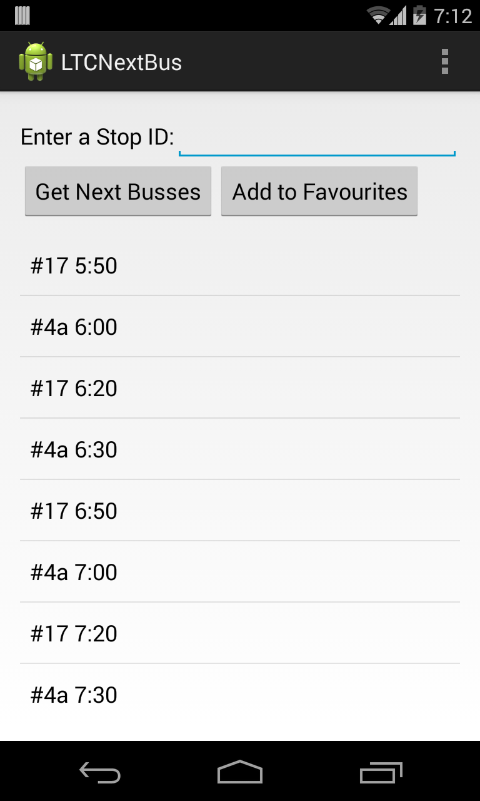

Favourites page. Users will be presented with their favourite stops in a spinnee. Selecting the stop will give them the option to either view times, delete the favourite, or edit the label for the favourites entry.

