CSE522: REAL TIME EMBEDDED SYSTEMS
ASSIGNMENT-2
(SUSHANT TRIVEDI, ASU ID: 1213366971)

TASKS PER TASKSET: 10

CASE-1: DEADLINE RANGE: [C, T]

CASE-2: DEADLINE RANGE: [C+(T-C)/2, T]

TASKS PER TASKSET: 25

CASE-1: DEADLINE RANGE: [C, T]

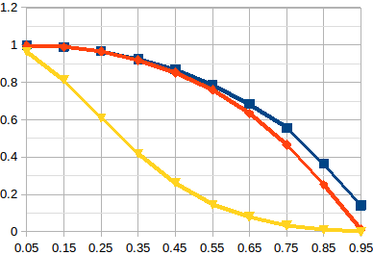

CASE-2: DEADLINE RANGE: [C+(T-C)/2, T]

