Crop Analysis Report

Farmer's Name: Juan Dela Cruz
Report Type: Lettuce Comparison Report
Date Generated: 2025-08-29

Location: Nueva Ecija, Philippines

Uploaded Images for Comparison:
Image 1 Image 2

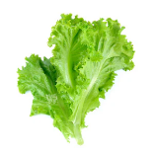
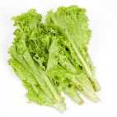

Comparison Results:
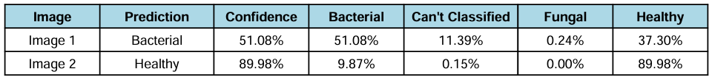

Crop Details:
Detail | Value
Crop Variety | Lettuce
Date Planted | August 01, 2025
Date Observed | August 28, 2025

Lettuce Information:
Katangian | Detalye
Pangalan ng Halaman | Lettuce
Uri | Leafy Green Vegetable
Pangunahing Sakit | Bacterial, Fungal
Benepisyo | Mataas sa fiber, vitamins A, C, at K
Ideal na Klima | Malamig at katamtamang araw
Harvest Period | 30–60 days depende sa variety

Recommendations:

Image 2 (Healthy):
- Panatilihin ang tamang irrigation schedule.
- Siguraduhin na sapat ang araw at sustansya mula sa lupa.
- Regular na obserbahan upang maagapan ang posibleng sakit.
- Maari nang ipagbenta o gamitin para sa konsumo.

Image 1 (Bacterial):
- Alisin agad ang may impeksyon.
- Iwasan ang sobrang tubig; siguraduhin drainage.
- Gumamit ng ligtas na fungicide/bactericide.

