CROP ANALYSIS REPORT

Farmer Information
Farmer’s Name | ________________________
Location | ________________________
Crop Variety | ________________________
Date Planted | ________________________
Date Observed | ________________________

Crop Image: Analysis Details:
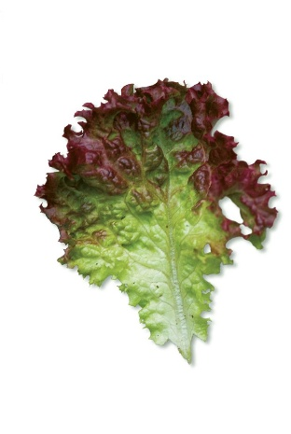
Prediction: Fungal Type
Confidence: 77.65%
Model: V2 (v1.0.0)
Scan Mode: Single Image
Analyzed: 8/29/2025, 8:32:07 PM

Crop Condition Summary
Overall Health | ________________________
Symptoms Observed | ________________________
Possible Cause | ________________________
Growth Stage | ________________________

Environmental Data
Temperature | ________________________
Humidity | ________________________
Rainfall/Watering Condition | ________________________
Soil Condition | ________________________

RECOMMENDATIONS:
• Panatilihin ang tamang iskedyul ng pagtutubig.
• Pagandahin ang sirkulasyon ng hangin sa paligid ng mga pananim.
• Maglagay ng organikong foliar spray kada 2 linggo.
• Regular na mag-monitor para sa mga peste o maagang palatandaan ng sakit.

