EXPT NO:2 | Implementation of data visualization techniques
DATE: 06.01.2026 | Implementation of data visualization techniques

PRE-LAB QUESTIONS (PROVIDE BRIEF ANSWERS TO THE FOLLOWING QUESTIONS)
- Why is exploratory data analysis critical before model building?
Answer: EDA enables analysts to grasp the dataset's layout, spot null entries, and find irregularities. This avoids "Garbage In, Garbage Out" scenarios and guarantees the data is fitting for the selected machine learning models.
- How do distributions influence algorithm selection in ML?
Answer: Numerous models, including Linear Regression and Gaussian Naive Bayes, rely on data having a normal (bell curve) shape. When data is asymmetrical, we need to apply transformations or choose non-parametric methods like Decision Trees that manage skewness effectively.
- What insights can outliers provide in business data?
Answer: Anomalies frequently indicate major business occurrences. In online retail, extremely high values may point to top-tier clients ("whales") to keep, whereas low or repeating outliers might suggest fraud or technical glitches.
- Why are visual summaries preferred over raw tables?
Answer: Graphics capitalize on the brain's capacity to recognize patterns much quicker than reading text. They instantly uncover trends, groupings, and relationships that are undetectable in a massive spreadsheet filled with rows of data.
- How does visualization improve business intelligence?
Answer: Visualization converts complicated data into easy-to-read dashboards. This enables non-technical users to track Key Performance Indicators (KPIs) live, speeding up data-driven choices without requiring manual database queries.

IN-LAB EXERCISE:
OBJECTIVE:

To explore data distribution and variability using advanced visualization techniques.
SCENARIO:
A startup analyzes e-commerce transaction data to understand customer spending behavior and detect abnormal purchase patterns.

IN-LAB TASKS (Using R Language)
- Plot histogram of transaction amounts
- Use boxplot to detect outliers
- Create heatmap of monthly sales intensity

CODE:
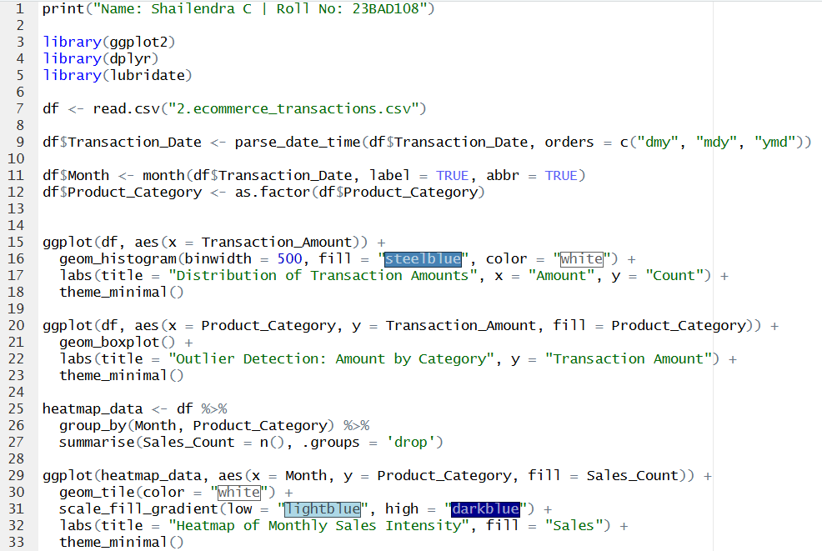

OUTPUT:
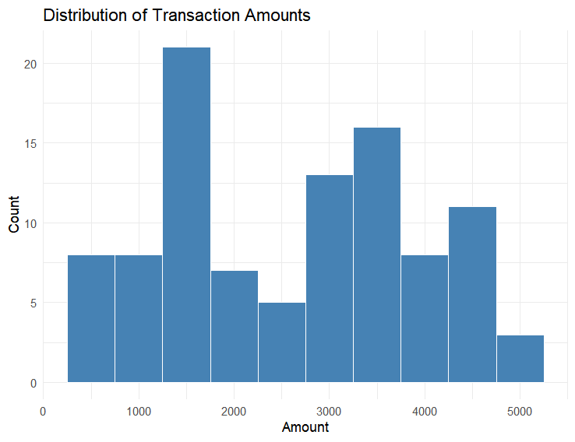
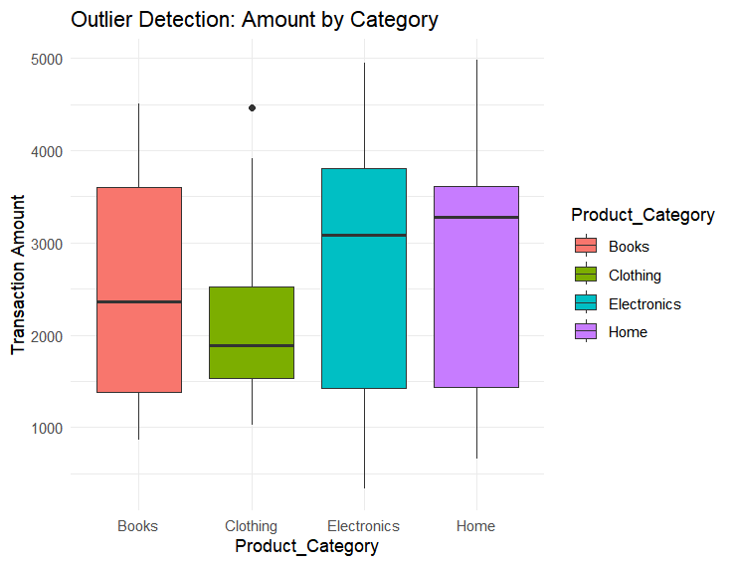
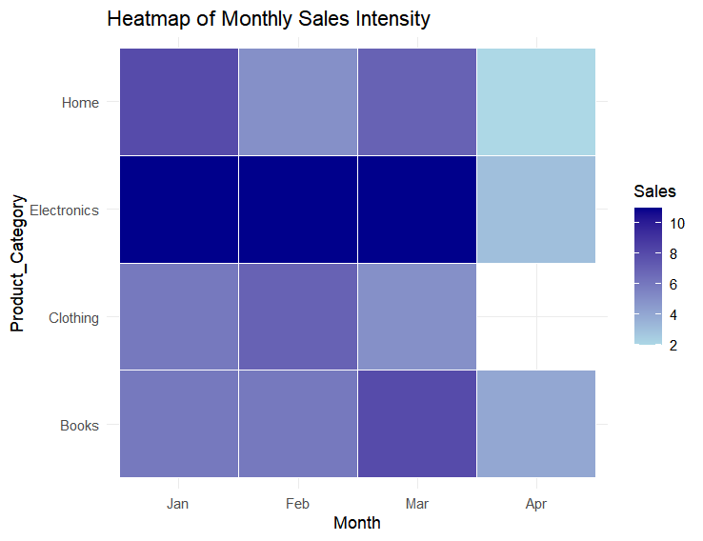
POST-LAB QUESTIONS (PROVIDE BRIEF ANSWERS TO THE FOLLOWING QUESTIONS)
- What does right-skewed distribution indicate about customer behavior?
Answer: It suggests that most shoppers make minor, inexpensive transactions, whereas a tiny fraction of clients complete expensive ones. In retail, this phenomenon is referred to as the "Long Tail" effect.
- How can detected outliers impact business decisions?
Answer: Outliers highlight anomalies. For instance, the Boxplot revealed an exceptionally high value in the Clothing section. Commercially, this might indicate a high-spending VIP (a "whale") suitable for rewards, or possibly a recording mistake needing verification.
- Which visualization best supports anomaly detection?
Answer: The Boxplot is optimal for this task as it statistically establishes the "standard" boundaries (whiskers) and clearly separates irregularities as distinct points (similar to the one observed in the Clothing group).
- How does EDA improve AI model accuracy?
Answer: EDA spots skewness and irregularities beforehand. This enables analysts to scrub the dataset (e.g., deleting severe outliers) or use adjustments (such as log-transforming) to prevent the AI from being skewed by interference.
- How can visualization guide feature engineering?
Answer: Graphics uncover concealed trends. For example, the Heatmap displays strong sales volume for "Electronics" during the initial quarter. This hints at building a variable such as Is_Peak_Season to assist the AI in forecasting upcoming demand surges more precisely.

ASSESSMENT
Description | Max Marks | Marks Awarded
Pre Lab Exercise | 5
In Lab Exercise | 10
Post Lab Exercise | 5
Viva | 10
Total | 30
Faculty Signature

