EXPT NO:3 | Designing Multivariate Patterns
DATE: 12.01.2026 | Designing Multivariate Patterns

PRE-LAB QUESTIONS (PROVIDE BRIEF ANSWERS TO THE FOLLOWING QUESTIONS)

- Why is multivariate analysis essential in real-world AI problems?
Real-world systems are complex and rarely depend on a single variable. Multivariate analysis allows AI to understand the simultaneous interactions and hidden patterns between multiple variables (like how age, weight, and blood pressure together influence disease risk) rather than looking at them in isolation.

- What challenges arise when visualizing high-dimensional data?
Visualizing data with more than three dimensions is difficult because human perception is limited to 3D space. Challenges include visual clutter (overplotting), cognitive overload for the viewer, and the "curse of dimensionality," where traditional visualization techniques fail to represent complex relationships accurately on a 2D screen.

- How does correlation analysis support feature selection?
Correlation analysis helps identify variables that are highly related to the target output (good predictors) and variables that are highly correlated with each other (redundant features). Removing redundant features simplifies the AI model, improves performance, and reduces computational costs.

- What are ethical concerns in healthcare data visualization?
Key concerns include patient privacy (ensuring data is fully anonymized so individuals cannot be identified), bias representation (accidentally highlighting or obscuring demographic disparities in care), and misinterpretation (where a poorly designed chart could lead a medical professional to make an incorrect diagnostic decision).

- Give examples of multivariate data in AI systems.
- Healthcare: Electronic Health Records containing a patient's age, BMI, blood pressure, lab results, and genetic markers.
- Finance: Credit card fraud detection datasets containing transaction amount, location, time of day, and merchant type.
- Autonomous Vehicles: Sensor data combining LIDAR (distance), radar (speed), and camera feeds (object recognition) simultaneously.

IN-LAB EXERCISE:

OBJECTIVE:
To discover relationships among multiple variables using multivariate visualization.

SCENARIO:
A hospital analytics team studies patient health records to identify relationships between age, BMI, glucose levels, and blood pressure for early disease prediction.

IN-LAB TASKS (Using R Language)
- Generate scatter plot matrix
- Apply color encoding for age groups
- Identify correlated health indicators

CODE:

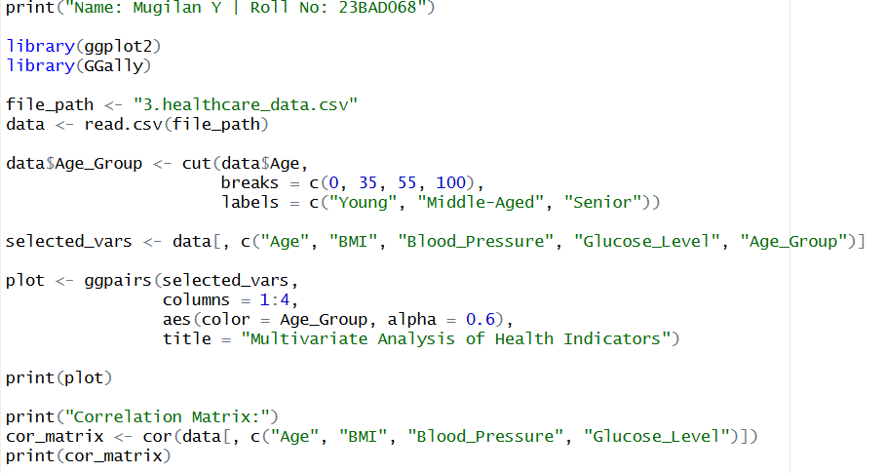

Output:

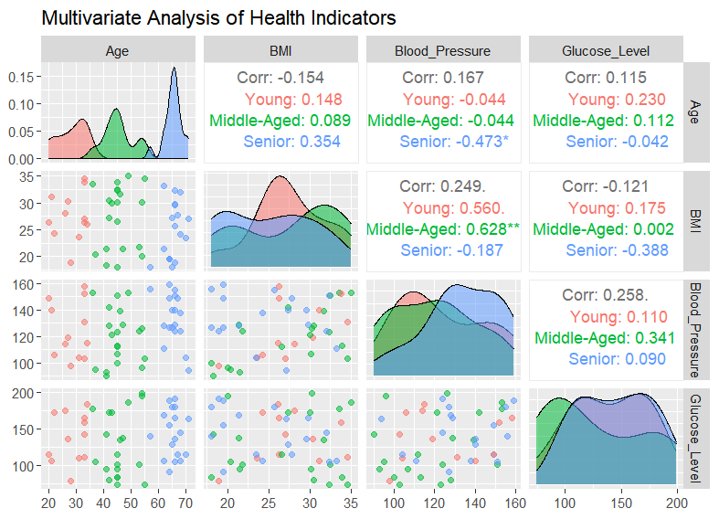
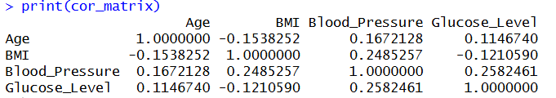
POST-LAB QUESTIONS (PROVIDE BRIEF ANSWERS TO THE FOLLOWING QUESTIONS)

- Which health parameters show strong correlation?
Based on your dataset's correlation matrix, there are no strong correlations (which would typically be values close to 1.0 or -1.0). However, the strongest positive relationships found are between Blood Pressure and Glucose Level (r = 0.258) and between BMI and Blood Pressure (r = 0.248). This indicates a weak-to-moderate positive relationship where as one increases, the other tends to increase slightly.

- Why correlation does not imply causation in medical data?
Just because Blood Pressure and Glucose Level move together (r = 0.258) does not mean high glucose causes high blood pressure. They might both be caused by a third, hidden factor (a "confounding variable") like diet, stress, or underlying metabolic syndrome.

- How can these patterns assist predictive healthcare AI?
Since individual correlations in this dataset are relatively weak, an AI system is highly beneficial here. AI can look at the cumulative effect of these weak correlations (e.g., slightly elevated BMI + slightly elevated BP) to predict disease risk more accurately than looking at any single variable alone.

- What visualization limitations exist for high-dimensional data?
The main limitation is "visual clutter" and the limits of human perception. While a scatter plot matrix effectively shows pairs of variables, it cannot easily show the simultaneous interaction of 4+ variables without becoming too chaotic and difficult to interpret on a 2D screen.

- How can dimensionality reduction improve visualization?
Techniques like Principal Component Analysis (PCA) mathematically compress highly related variables into a single new variable (a "principal component"). For example, it could combine the correlated BMI and Blood Pressure data into a single "Cardiovascular Strain" axis, making it much easier to plot and identify distinct clusters of patients.

ASSESSMENT
Description | Max Marks | Marks Awarded
Pre Lab Exercise | 5
In Lab Exercise | 10
Post Lab Exercise | 5
Viva | 10
Total | 30
Faculty Signature

