Windows Vista
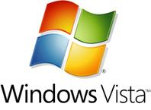
Windows Vista is an operating system by Microsoft for use on personal computers, including home and business desktops, laptops, tablet PCs and media center PCs.
Pivot Table
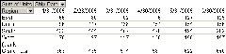
In data processing, a pivot table is a data summarization tool found in data visualization programs such as spreadsheets or business intelligence software.
The Blue Screen of Death
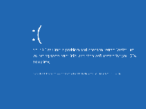
also known as a blue, screen Blue Screen of Doom, or BSoD. is an error screen displayed on a Windows computer system after a fatal system error, also known as a system crash: when the operating system reaches a condition where it can no longer operate safely.
- end -

