Cobol
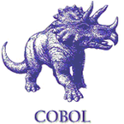
Is a compiled English-like computer programming language designed for business use. It is imperative, procedural and, since 2002, object-oriented.
Python
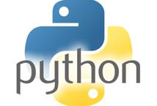
Python is a widely used general-purpose, high-level programming language, supports multiple programming paradigms, including object-oriented, imperative and functional programming or procedural styles.
Java
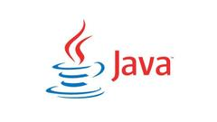
Java is a general-purpose computer programming language that is concurrent, class-based, object-oriented, and specifically designed to have as few implementation dependencies as possible.
JavaScript
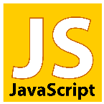
JavaScript is a high level, dynamic, untyped, and interpreted programming language. It has been standardized in the ECMAScript language specification. Alongside HTML and CSS, it is one of the three essential technologies of World Wide Web content production.
Pascal
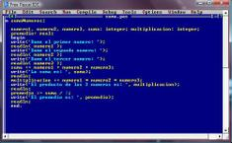
Pascal is a historically influential imperative and procedural programming language, designed in 1968–1969 and published in 1970 by Niklaus Wirth as a small and efficient language intended to encourage good programming practices using structured programming and data structuring.
Php

Is a server-side scripting language designed for web development but also used as a general-purpose programming language.
POO
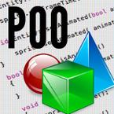
It is an imperative programming language, is generally used in artificial intelligence and can become twice as fast as java.
C9
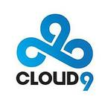
Is an American sports organization.
AngularJS

Is an open-source web application framework maintained by Google and by a community of individual developers and corporations to address many of the challenges encountered in developing single-page applications.
Jquery

Is a cross-platform JavaScript library designed to simplify the client-side scripting of HTML.
NetBeans

Is a software development platform written in Java.
Eclipse

Is a general-purpose, imperative computer programming language, supporting structured programming, lexical variable scope and recursion, while a static type system prevents many unintended operations.
C++
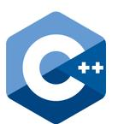
Is a general-purpose programming language.
Django

Is a high-level Python Web framework that encourages rapid development and clean, pragmatic design. Built by experienced developers, it takes care of much of the hassle of Web development, so you can focus on writing your app without needing to reinvent the wheel. It’s free and open source.
- end -

