Router
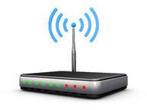
is a networking device that forwards data packets between computer networks. Routers perform the "traffic directing" functions on the Internet.
Switch
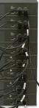
A network switch (also called switching hub, bridging hub, officially MAC bridge[1]) is a computer networking device that connects devices together on a computer network, by using packet switching to receive, process and forward data to the destination device.
IP
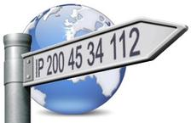
An Internet Protocol address (IP address) is a numerical label assigned to each device participating in a computer network that uses the Internet Protocol for communication. An IP address serves two principal functions: host or network interface identification and location addressing. Its role has been characterized as follows: "A name indicates what we seek. An address indicates where it is. A route indicates how to get there.
WIFI

Is a local area wireless computer networking technology that allows electronic devices to network, mainly using the 2.4 gigahertz and 5 gigahertz
MAC
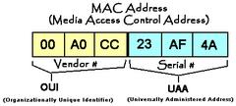
A media access control address (MAC address) is a unique identifier assigned to network interfaces for communications on the physical network segment. MAC addresses are used as a network address for most IEEE 802 network technologies, including Ethernet and WiFi.
Ethernet
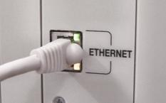
Is a family of computer networking technologies for local area networks (LANs) and metropolitan area networks (MANs). It was commercially introduced in 1980 and first standardized in 1983 as IEEE 802.3, and has since been refined to support higher bit rates and longer link distances.
Rack
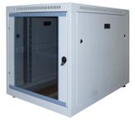
A 19-inch rack is a standardized frame or enclosure for mounting multiple equipment modules. Each module has a front panel that is 19 inches (482.6 mm) wide, including edges or ears that protrude on each side which allow the module to be fastened to the rack frame with screws.
RJ45
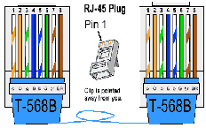
The RJ45 connector is standardized as the IEC 60603-7 8P8C modular connector with eight conductors. A Registered Jack (RJ) is a standardized telecommunication network interface for connecting voice and data equipment to a service provided by a local exchange carrier or long distance carrier. It is the standarised connector for computer networking specifications (RJ45), such as Ethernet.
IPV6
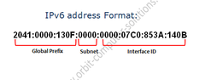
Is the most recent version of the Internet Protocol (IP), the communications protocol that provides an identification and location system for computers on networks and routes traffic across the Internet.
SSID
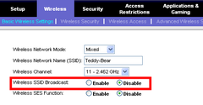
Is a set consisting of all the devices associated with a consumer or enterprise IEEE 802.11 wireless local area network (WLAN). The service set can be local, independent, extended or mesh.
TCP/IP
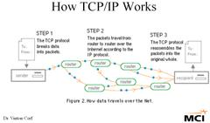
Service sets have an associated identifier, the Service Set Identifier (SSID), which consists of 32 octets that frequently contains a human readable identifier of the network.
Gateway

Gateways, also called protocol converters, can operate at any network layer. The activities of a gateway are more complex than that of the router or switch as it communicates using more than one protocol.
PING
Ping is a computer network administration software utility used to test the reachability of a host on an Internet Protocol (IP) network and to measure the round-trip time for messages sent from the originating host to a destination computer and back.
CISCO
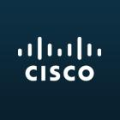
Cisco Systems, Inc. is an American multinational technology company headquartered in San Jose, California, that designs, manufactures, and sells networking equipment.[4] The stock was added to the Dow Jones Industrial Average on June 8, 2009, and is also included in the S&P 500 Index, the Russell 1000 Index, NASDAQ-100 Index and the Russell 1000 Growth Stock Index.
Acces Point
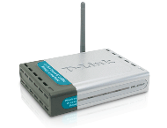
a wireless access point (AP) is a device that allows wireless devices to connect to a wired network using Wi-Fi, or related standards.
Firewall

In computing, a firewall is a network security system that monitors and controls the incoming and outgoing network traffic based on predetermined security rules.
Patch Panel
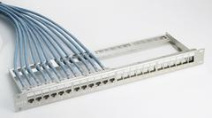
A patch panel, patch bay, patch field or jack field is a device or unit featuring a number of jacks, usually of the same or similar type, for the use of connecting and routing circuits for monitoring, interconnecting, and testing circuits in a convenient, flexible manner.
DNS
The Domain Name System (DNS) is a hierarchical distributed naming system for computers, services, or any resource connected to the Internet or a private network. It associates various information with domain names assigned to each of the participating entities. Most prominently, it translates domain names, which can be easily memorized by humans, to the numerical IP addresses needed for the purpose of computer services and devices worldwide.
IMAP
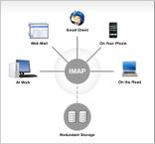
Is an Internet standard protocol used by e-mail clients to retrieve e-mail messages from a mail server over a TCP/IP connection
RIP
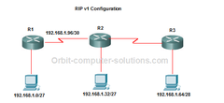
Enhanced Interior Gateway Routing Protocol (EIGRP) is an advanced distance-vector routing protocol that is used on a computer network to help automate routing decisions and configuration.
Subnetting
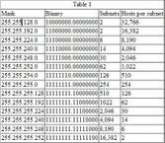
Is a logical, visible subdivision of an IP network. The practice of dividing a network into two or more networks is called subnetting.
Proxy
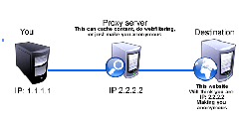
In computer networks, a proxy server is a server (a computer system or an application) that acts as an intermediary for requests from clients seeking resources from other servers.
Mask
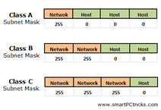
It's the bitmask that when applied by a bitwise AND operation to any IP address in the network, yields the routing prefix. Subnet masks are also expressed in dot-decimal notation like an address. For example, 255.255.255.0 is the network mask for the 192.168.1.0/24 prefix.
LDAP
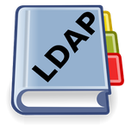
Is an open, vendor-neutral, industry standard application protocol for accessing and maintaining distributed directory information services over an Internet Protocol (IP) network.
Domain

A domain name is an identification string that defines a realm of administrative autonomy, authority or control within the Internet.
Latency
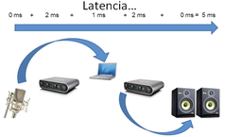
Latency is a time interval between the stimulation and response, or, from a more general point of view, as a time delay between the cause and the effect of some physical change in the system being observed.[1] Latency is physically a consequence of the limited velocity with which any physical interaction can propagate. This velocity is always lower than or equal to the speed of light.
TRACERT
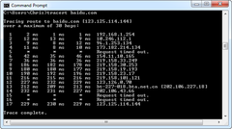
TRACERT determines the route taken to a destination by sending the first echo packet with a TTL of 1 and incrementing by 1 on each transmission until the target responds.
Optical Fiber

An optical fiber (or optical fibre) is a flexible, transparent fiber made by drawing glass (silica) or plastic to a diameter slightly thicker than that of a human hair.
FTP
The File Transfer Protocol (FTP) is a standard network protocol used to transfer computer files from one host to another host over a TCP-based network, such as the Internet.
Network Administrator
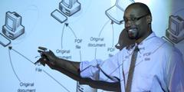
The role of the network administrator can vary significantly depending on an organizations size, location and socio-economic considerations. Some organizations work on a user-to-technical support ratio, whilst others implement many. other strategies.
Wireshark
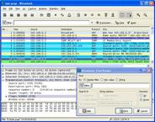
Wireshark is a free and open-source packet analyzer. It is used for network troubleshooting, analysis, software and communications protocol development, and education. Originally named Ethereal, the project was renamed Wireshark in May 2006 due to trademark issues.
Ports
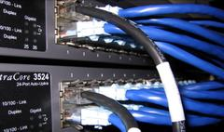
In computer hardware, a port serves as an interface between the computer and other computers or peripheral devices. In computer terms, a port generally refers to the female part of connection.
Sniffer
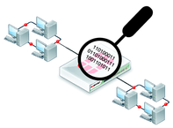
Is a program that monitors and analyzes network traffic, detecting bottlenecks and problems. Using this information, a network manager can keep traffic flowing efficiently.
- end -

