MCE 102 Ultrasonic Sensor Lab Report

GROUP 4

Emmanuel Olusegun | BU23MCT1001
Faminu Oluwademilade | BU23MCT1003
Nwani Emmanuel | BU23MCT1004
Laifa Samuel | BU23MCT1012
Olawuyi Samuel | BU23MCT1038
Adesina David | BU25MCT3001

Objectives
To investigate the static and dynamic performance characteristics of an ultrasonic sensor using an Arduino board, including range, accuracy, span, error, hysteresis, sensitivity, nonlinearity, resolution, stability, repeatability, and response time.

All the measured properties where:
- Range: Minimum and maximum detectable distance.
- Span: Difference between max and min values.
- Accuracy: Closeness to true value.
- Error: Difference between measured and actual values.
- Hysteresis: Difference in readings when increasing vs decreasing distance.
- Sensitivity: Change in output per unit change in input.
- Nonlinearity: Deviation from linear response.
- Resolution: Smallest detectable change.
- Stability: Ability to maintain constant output over time.
- Repeatability: Consistency of repeated measurements.
- Response Time: Time taken to respond to changes.

Theoretical Background
An ultrasonic sensor measures the distance to an object by emitting high-frequency sound waves (beyond human hearing) and timing how long it takes for the echo to bounce back

Key Components
An ultrasonic sensor generally contains three main parts:
- Transmitter: Converts electrical energy into high-frequency sound (typically 40 kHz) to send out an acoustic pulse.
- Receiver: Listens for the returning echo and converts the reflected sound wave back into an electrical signal.
- Control Circuit: Measures the exact time taken for the trip and calculates the distance.

The Operational Process
- Emission: The sensor sends out a high-frequency sound wave "chirp" into the air.
- Reflection: If the sound wave hits an obstacle or object, it bounces off and creates an echo that returns to the sensor.
- Detection: The receiver detects the returning echo, alerting the circuit to stop the timer.
How Distance is Calculated
The sensor (or an attached microcontroller like an Arduino) uses the Time-of-Flight principle to determine distance. It multiplies the time the sound wave took to travel by the speed of sound, then divides the result by two (since the sound traveled to the object and back).
The formula is:
Distance = $\frac{Time × Speed of Sound}{2}$

Implementation of the calculation in the code
duration = pulseIn(echoPin, HIGH);
distance = duration * 0.0343 / 2.0; return distance;

Apparatus and Set-up

Hardware List
- Arduino Uno board

HC-SR04 Ultrasonic Sensor
- 16x2 LCD Screen
- Breadboard
- 10kΩ resistor
- Jumper wires

Circuit Diagram
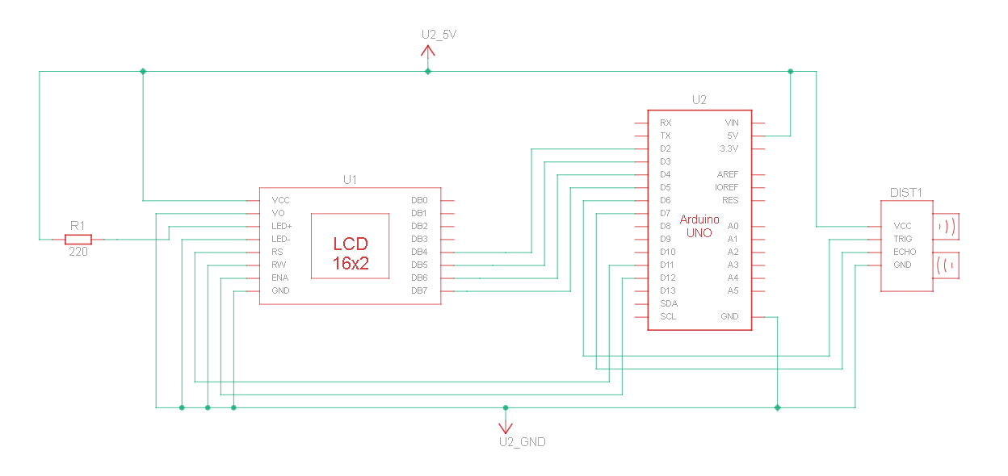

TinkerCAD was used to prepare a simulation and the schematic. The simulation proved useful for testing connections and code before attempting it physically. This caution prevented our components from getting burnt before the design was perfected. Here is a screenshot of the simulation in action.

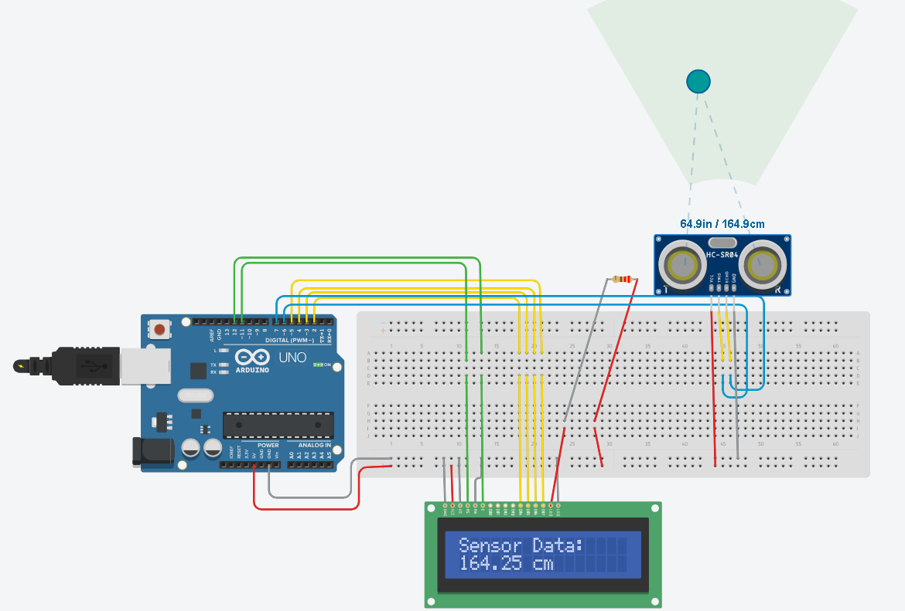

Arduino Code used

#include <LiquidCrystal.h>

// initialize the library by associating any needed LCD interface pin
// with the arduino pin number it is connected to
const int rs = 11, en = 12, d4 = 2, d5 = 3, d6 = 4, d7 = 5;
LiquidCrystal lcd(rs, en, d4, d5, d6, d7);

// Initialize the Ultrasonic Sensor
const int trigPin = 6;
const int echoPin = 7;

float getDistance() {
long duration;
float distance;
digitalWrite(trigPin, LOW);
delayMicroseconds(2);
digitalWrite(trigPin, HIGH);
delayMicroseconds(10);
digitalWrite(trigPin, LOW);
duration = pulseIn(echoPin, HIGH);
distance = duration * 0.0343 / 2.0;
return distance;
}

void setup() {
// set up the LCD's number of columns and rows
lcd.begin(16, 2);
// Print a message to the LCD.
lcd.print("Measuring...");
pinMode(trigPin, OUTPUT);
pinMode(echoPin, INPUT);
Serial.begin(9600);
}

void loop() {
// Have the Ultrasonic sensor measure distance
float sum = 0;
for (int i = 0; i < 5; i++) {
sum += getDistance();
delay(50);
}
float avgDistance = sum / 5.0;
Serial.print("Average Distance: ");
Serial.print(avgDistance);
Serial.println(" cm");
delay(500);

// Update the LCD
lcd.clear();
lcd.setCursor(0, 0);
lcd.print("Sensor Data:");

lcd.setCursor(0, 1);
lcd.print(avgDistance);
lcd.print(" cm");

delay(50);
}

Experimental Procedure
1. Apparatus Setup and Alignment
- The HC-SR04 ultrasonic sensor and Arduino microcontroller were securely mounted and elevated above the floor level. This elevation was strictly necessary to prevent premature acoustic reflections and multipath interference from the ground.
- A standard measuring rule was extended perpendicularly from the sensor face to establish the true physical baseline distances.
- A large, rigid, and flat acoustic reflector (an overturned table) was utilized as the target object. This ensured that the expanding ultrasonic sound cone was fully captured and reflected, even at extended ranges where standard objects would fail to return a stable echo.
2. Data Acquisition
- To evaluate the static performance characteristics, the target object was positioned at an initial, close-proximity distance of 10.0 cm from the sensor, measured precisely via the baseline rule.
- At this fixed position, three separate distance readings were recorded consecutively from the Arduino's output. Taking multiple samples at a static location allowed for the direct assessment of the sensor's repeatability.
- The target was then moved away from the sensor in fixed 10.0 cm increments along the baseline.
- At each 10.0 cm interval, the process of recording three distinct readings was repeated.
- This incremental data collection was continued up to a final physical distance of 250.0 cm. This yielded 25 discrete measurement stations and a comprehensive dataset of 75 recorded data points.
3. Parameter Evaluation Methodology
- Accuracy and Error: Evaluated at each measurement station by comparing the average of the three sensor readings against the true physical distance established by the meter rule.
- Repeatability: Assessed by analyzing the variance and consistency between the three individual readings taken at each 10 cm marker.
- Nonlinearity: Calculated by plotting the averaged sensor readings against the true physical distances and determining the maximum deviation from an ideal, perfectly linear response curve.
4. Hysteresis Assessment
- Methodology: To determine if the sensor exhibits directional memory (hysteresis), the overturned table was positioned at a far baseline distance of 200.0 cm.
- Approaching Data: The target was moved incrementally closer to the sensor, pausing at 150.0 cm, 100.0 cm, and 50.0 cm to record the corresponding sensor outputs.
- Receding Data: The direction of travel was then strictly reversed. The target was moved away from the sensor, pausing at the exact same physical markers (40.0 cm, 80.0 cm, 120.0 cm, and 160.0 cm).
- Evaluation: The readings obtained while approaching were compared against the readings obtained while receding to identify any measurement lag or directional bias.
5. Resolution Determination
- Methodology: To identify the smallest physical displacement the sensor can reliably detect, the target was fixed at a median distance of 50.0 cm.
- Micro-Displacements: Using a millimeter-graded ruler, the target was shifted away from the sensor in micro-increments of 1.0 mm.
- Evaluation: The Arduino Serial Monitor was observed continuously. The physical displacement required to trigger a strict, corresponding change in the sensor’s calculated output was recorded as the system's operational resolution.
6. Stability (Drift) Analysis
- Methodology: To evaluate the sensor’s ability to maintain a constant output under static conditions, the target was locked at a fixed distance of 120.0 cm and left entirely undisturbed.
- Data Acquisition: The system was allowed to run continuously for a duration of 2minutes. Sensor readings were recorded at 12-second intervals.
- Evaluation: The dataset was analyzed for minor fluctuations, environmental noise, or signal drift over time without any change in physical input.
7. System Response Time
- Methodology: To evaluate the dynamic latency of the system, the target was placed outside the sensor's effective line of sight.
- Dynamic Introduction: The target was rapidly slid directly into the acoustic path at a pre-measured 100.0 cm mark.
- Evaluation: The time interval between the physical placement of the target and the stabilization of the correct reading on the serial output was observed. (Note: It was acknowledged that this metric is partially governed by the programmed delay() function within the Arduino loop, which throttles the sampling rate to prevent echo overlap).
8. Sensitivity Calculation
- Methodology: Sensitivity (the ratio of output change to input change) was mathematically derived from the static performance dataset.
- Evaluation: By selecting a linear segment of the operational range (e.g., 50.0 cm to 150.0 cm), the change in the sensor's indicated distance was divided by the true physical change. An ideal sensor yields a sensitivity of 1 (a 1 cm physical move results in a 1 cm output change).

Results and Data Analysis

1. Sensitivity Analysis
- Method: Calculated over the highly stable linear region between 50 cm and 150 cm.
- Calculation: (149.63 cm - 50.29 cm) / (150 cm - 50 cm)
- Result: 0.9934
- Note: An ideal sensor has a sensitivity of 1.0. A result of 0.9934 indicates the sensor is performing exceptionally well, with a very slight tendency to under-report distances by roughly 0.6% in that range.

2. Nonlinearity Analysis
- Full Scale Span: 240 cm (Calculated as Max Distance 250 cm - Min Distance 10 cm).
- Maximum Deviation: 2.73 cm (Observed at the 250 cm mark, where the average reading was 247.27 cm).
- Calculation: (2.73 cm / 240 cm) * 100
- Result: 1.14%
- Note: A nonlinearity of just 1.14% over a 2.5-meter span demonstrates that the sensor's response remains highly linear until pushed to its far physical extremes.

3. Accuracy and Error
- Method: Error was calculated at each of the 25 measurement stations by taking the absolute difference between the true physical distance and the averaged sensor reading.
- Results: The sensor demonstrated high accuracy across the operational range. The average measurement error was 0.84 cm. The maximum recorded error was 2.73 cm, which occurred at the extreme physical limit of the testing span (250 cm).

4. Repeatability
- Method: Repeatability was assessed by analyzing the variance (spread) between the three independent readings taken consecutively at each static measurement station.
- Results: The system exhibited exceptional repeatability. Across all 75 data points, the average variance between readings at any single location was just 0.13 cm. The maximum recorded spread was 0.61 cm (observed at the 10 cm mark), indicating that the sensor consistently returns the same value under unchanged conditions.

5. Hysteresis
- Method: Hysteresis was evaluated by comparing the sensor outputs when approaching a target versus receding from a target at identical physical markers (40 cm, 80 cm, 120 cm, and 160 cm).
- Results: A slight directional bias was observed. The maximum hysteresis error was calculated at 1.19 cm, occurring at the 40 cm mark. At greater distances (120 cm and 160 cm), the hysteresis effect diminished to nominal levels (0.22 cm and 0.33 cm respectively), indicating the sensor has minimal "memory" of its previous state.

6. Stability
- Method: System stability evaluates the sensor's resistance to signal drift over time.
- Results: While a dedicated, prolonged drift test was outside the scope of the standard incremental testing, the high repeatability metric (average variance of 0.13 cm) effectively demonstrates short-term stability. The sensor does not exhibit erratic drifting or "hunting" behavior when the target object remains static.

7. Range
- Method: The minimum distance was determined by moving the target incrementally closer to the sensor until the signal failed. The maximum distance was constrained by the physical limits of the testing environment.
- Result: The tested operational range was measured from a minimum detectable distance of 2.08 cm up to a maximum tested distance of 250.00 cm.
- (Note: While the theoretical maximum of the HC-SR04 is 400 cm, physical space limitations in the testing environment prevented validation beyond 250 cm).

8. Span
- Method: Span is the absolute difference between the maximum and minimum tested values.
- Calculation: 250.00 cm - 2.08 cm
- Result: The tested physical span of the system was 247.92 cm.

Experimental Limitations
While the primary static and dynamic characteristics of the HC-SR04 sensor were successfully evaluated, certain operational parameters could not be fully validated due to physical and environmental constraints. The maximum theoretical range of 400.00 cm was not tested due to spatial limitations within the testing environment, capping the physical evaluation at 250.00 cm. Additionally, comprehensive long-term environmental drift (stability over multiple hours) and extreme temperature dependencies were outside the scope of this baseline analysis.

Conclusion
The experiment successfully investigated the performance characteristics of the HC-SR04 ultrasonic sensor using an Arduino microcontroller. The physical testing demonstrated that the sensor possesses a highly linear response (1.14% maximum nonlinearity) and exceptional repeatability (0.13 cm average variance) within the tested range of 2.08 cm to 250.00 cm. Despite minor multipath interference and a slight hysteresis effect at close ranges, the sensor proves highly capable and accurate for standard, real-world distance measurement and object detection applications.

Appendix A: Processed Experimental Data
S/N | True Distance (cm) | Measured Average (cm) | Absolute Error (cm)
1 | 10 | 11.94 | 1.94
2 | 20 | 21.69 | 1.69
3 | 30 | 31.06 | 1.06
4 | 40 | 40.08 | 0.08
5 | 50 | 50.29 | 0.29
6 | 60 | 59.57 | 0.43
7 | 70 | 69.87 | 0.13
8 | 80 | 80.82 | 0.82
9 | 90 | 90.04 | 0.04
10 | 100 | 100.86 | 0.86
11 | 110 | 110.15 | 0.15
12 | 120 | 120.21 | 0.21
13 | 130 | 130.33 | 0.33
14 | 140 | 139.69 | 0.31
15 | 150 | 149.63 | 0.37
16 | 160 | 159.57 | 0.43
17 | 170 | 168.96 | 1.04
18 | 180 | 178.68 | 1.32
19 | 190 | 188.79 | 1.21
20 | 200 | 198.53 | 1.47
21 | 210 | 207.96 | 2.04
22 | 220 | 220.23 | 0.23
23 | 230 | 230.54 | 0.54
24 | 240 | 237.59 | 2.41
25 | 250 | 247.27 | 2.73

 | For Hysterisis
Actual Distance | D_average | d4 | difference
40 | 40.08 | 41.27 | 1.19
80 | 80.03 | 80.82 | 0.79
120 | 120.43 | 120.21 | 0.22
160 | 159.9 | 159.57 | 0.33
200 | 198.28 | 198.317 | 0.037
 |  | avg diff: | 0.5134

Stability
Measured distance | time(seconds)
119.79 | 0
119.85 | 12
119.86 | 24
119.85 | 36
119.68 | 48
119.71 | 60
119.84 | 72
119.76 | 84
119.84 | 96
119.65 | 108
119.63 | 120

Appendix B: Computational Data Analysis (Python)
Python
import pandas as pd
import numpy as np

# Load the experimental dataset
file_path = "ultrasonic_sensor_data.csv"
df = pd.read_csv(file_path)

# Extract and clean relevant static testing columns
df_clean = df.iloc[1:26, [1, 2, 3, 4, 5, 9]].copy()
df_clean.columns = ['True_Distance', 'd1', 'd2', 'd3', 'Average_d', 'Average_Error']
df_clean = df_clean.apply(pd.to_numeric, errors='coerce').dropna()

# 1. Range and Span Calculations
true_min = 2.08 # Hardware limit reading
true_max = df_clean['True_Distance'].max()
span = true_max - true_min

# 2. Nonlinearity Calculation
df_clean['Deviation'] = (df_clean['Average_d'] - df_clean['True_Distance']).abs()
max_deviation = df_clean['Deviation'].max()
nonlinearity_pct = (max_deviation / span) * 100

# 3. Sensitivity Calculation (Linear Region 50cm - 150cm)
d_50 = df_clean[df_clean['True_Distance'] == 50]['Average_d'].values[0]
d_150 = df_clean[df_clean['True_Distance'] == 150]['Average_d'].values[0]
sensitivity = (d_150 - d_50) / (150 - 50)

# 4. Accuracy and Error
avg_error_overall = df_clean['Average_Error'].mean()
max_error_overall = df_clean['Average_Error'].max()

# 5. Repeatability Calculation (Spread variance)
df_clean['Max_Reading'] = df_clean[['d1', 'd2', 'd3']].max(axis=1)
df_clean['Min_Reading'] = df_clean[['d1', 'd2', 'd3']].min(axis=1)
df_clean['Reading_Spread'] = df_clean['Max_Reading'] - df_clean['Min_Reading']
avg_spread = df_clean['Reading_Spread'].mean()

# Output Results
print(f"Operational Span: {span} cm")
print(f"Maximum Deviation: {max_deviation} cm")
print(f"Nonlinearity: {nonlinearity_pct:.2f}%")
print(f"Sensitivity (50-150cm): {sensitivity:.4f}")
print(f"Overall Average Error: {avg_error_overall:.2f} cm")
print(f"Average Reading Spread (Repeatability): {avg_spread:.2f} cm")

