B.TECH. (CSE) – V SEMESTER
UE24CS341A – SOFTWARE ENGINEERING
SOFTWARE ARCHITECTURE
FILE COMPRESSION TOOL
Team No.: 22 | Team Name: Ctrl Freaks | Project ID: 76
SUBMITTED BY
Jai Jaswanth Tummala – PES2UG24AM068
Architha Sidharth Panicker – PES2UG24AM024
Krati Patil – PES2UG24AM077
Chandana Rajeswari P – PES2UG24AM043

PES University – Department of Computer Science & Engineering
Version 1.0 | 02 October 2026
Repository: github.com/ctrl-freaks-SE/file-compresion-tool-id-76

1. Introduction

1.1 Purpose
This document describes the software architecture of the File Compression Tool (Project 76): its structure, the responsibilities of each component, how components interact at run time, the file and database formats, and the decisions behind them. It is the basis for the detailed design, implementation, test planning and the architecture references (ARCH-5.x) in the SRS traceability matrix. This is the planned design (v1.0); implementation progress of each component is tracked in 22_Jira Backlog.

1.2 Scope and Audience
The architecture covers the local desktop application defined in SRS v1.0: features F1–F9, the REQ-001 to REQ-036 requirements and the quality attributes in SRS Section 6. It is written for the four team members, the evaluator and future maintainers.

1.3 References
- SRS v1.0, Project Proposal and Field Layouts workbook (repository ctrl-freaks-SE/file-compresion-tool-id-76).
- 22_Project Test Plan – test cases and system tests that verify this architecture.
- 22_Jira Backlog – work items (CFT-n) that implement it.

1.4 ARCH Reference Scheme
Architecture references follow the SRS: ARCH-5.n corresponds to SRS section 5.n (feature F-n). ARCH-5.9 is added for the Desktop Interface (F9), which has no REQ IDs of its own, and ARCH-NFR covers cross-cutting quality attributes. Section 11 maps every ARCH reference to components and requirements.

2. Architectural Drivers

2.1 Key Requirements
- Correctness first: valid archives must restore byte-for-byte (REQ-013), and a corrupted archive must never be reported as valid (REQ-019).
- Common algorithm interface: Huffman, RLE and LZW are interchangeable and a new one can be added without major GUI changes (SRS 2.5, 6.4).
- Responsive GUI: long operations must not block the Tkinter event loop and large inputs use chunked I/O (SRS 2.5, 6.1).
- Safe by default: originals are never overwritten, existing destinations need confirmation, failures never show false success, archive extraction cannot escape the destination (SRS 6.2, 6.3).
- Testable core: algorithms and services run without launching the GUI (SRS 6.4).

2.2 Constraints
- Python 3.12+, Tkinter/ttk, embedded SQLite; prefer the standard library (SRS 7).
- Windows, Linux and macOS; no network use; lossless algorithms only.
- Four-person team with feature ownership by member (proposal Section 5).

2.3 Quality Attribute Tactics
Attribute | Architectural tactic | Where realised
Correctness | Whole-stream SHA-256 stored in header and re-verified on restore; round-trip and property tests. | Checksum, ArchiveWriter/Reader, IntegrityService
Reliability | Header magic/version/CRC32, declared-size cross-checks; temp file + atomic replace; typed error hierarchy mapped to statuses. | ArchiveReader, FileSystemAdapter, errors.py
Maintainability / Extensibility | CompressionAlgorithm interface + AlgorithmRegistry; views build their algorithm lists from the registry. | core/algorithms, CompressView, CompareView
Testability | Layering with no GUI imports below ui/; injected clock, filesystem and repository. | services/, core/
Performance | Worker thread; chunked streaming I/O; progress callbacks per chunk; Huffman two-pass design avoids loading files in memory. | TaskRunner, FileSystemAdapter, codecs
Security | PathValidator for inputs and extraction targets; no shell calls; parameterised SQL; no file content stored in history or logs. | PathValidator, SQLiteHistoryRepository
Usability | One service result object feeds all result panels; consistent, actionable error messages from a single catalogue. | OpResult, ui/messages

3. Architecture Overview
The system is a four-layer, single-process desktop application. Views only call application services; services orchestrate pure core logic; the infrastructure layer isolates the file system and SQLite behind small adapters. Dependencies point downwards only, and the core layer has no GUI or database imports, so it can be tested on its own.
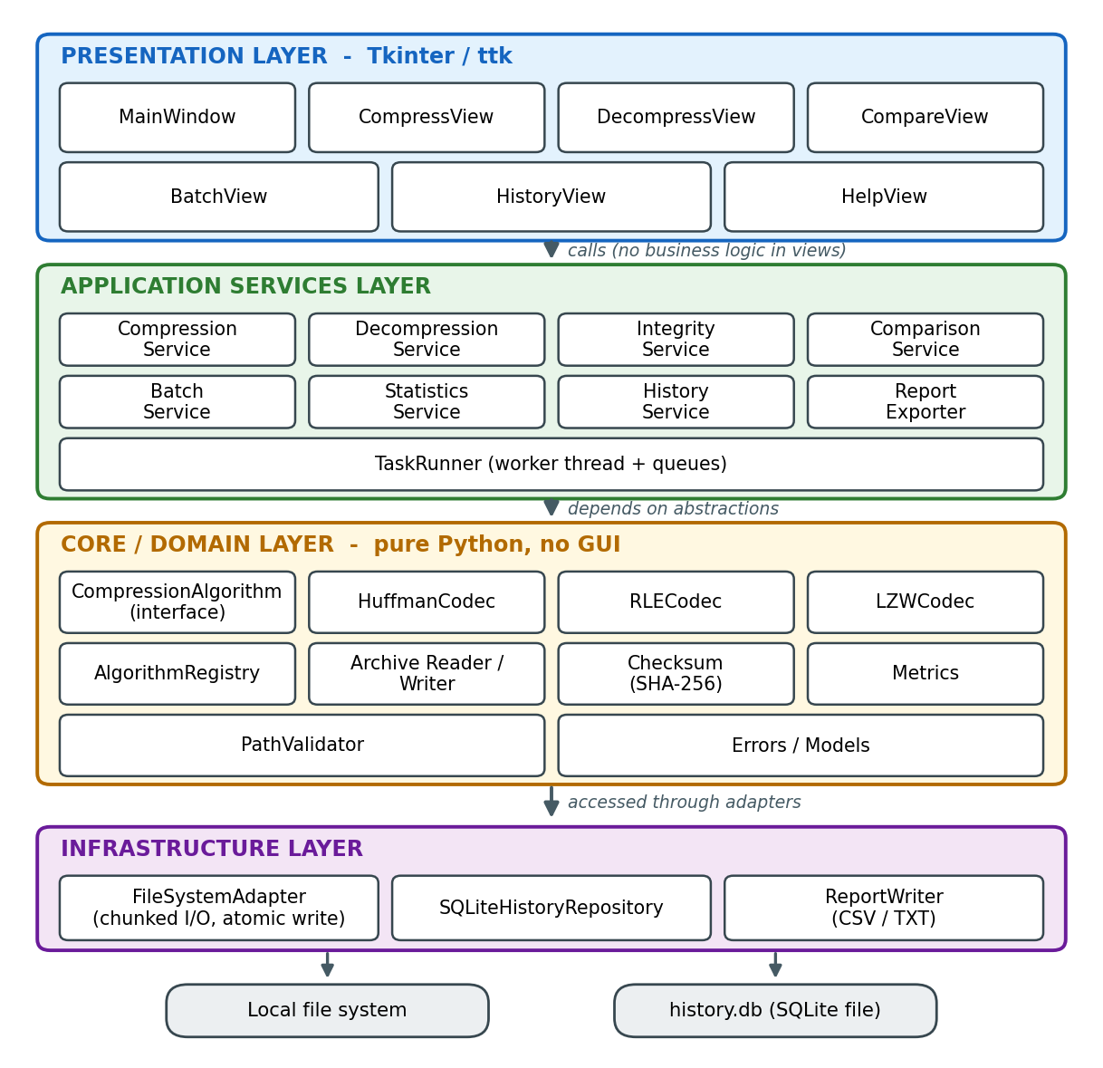
Figure 1 – Layered architecture (ARCH-5.1 to 5.9)

Layer responsibilities
Layer | Responsibility
Presentation | Tkinter/ttk views: file/folder pickers, algorithm selector, progress bar, results panel, dialogs. Validates form completeness only; never touches files or the database.
Application services | One service per feature. Orchestrates a use case, runs inside the TaskRunner worker thread, returns an OpResult (or summary object), and records history.
Core / domain | Algorithms, archive container format, checksum, metrics, path rules and error types. Pure functions and classes working on streams.
Infrastructure | FileSystemAdapter (chunked reads/writes, temp files, atomic replace), SQLiteHistoryRepository, ReportWriter (CSV/TXT).

4. Logical View

4.1 Components, Responsibilities and Owners
Component | Responsibility | Requirements | Owner
PathValidator | Check existence/readability/type of inputs; reject special files and broken symlinks; safe-join extraction paths; reject traversal. | REQ-001, 002; NFR 6.3 | Jai
CompressionAlgorithm + Registry | Common interface and lookup of Huffman, RLE, LZW; unknown names rejected. | REQ-003, 020 | Jai
HuffmanCodec | Frequencies, canonical prefix codes, code-length metadata, bit packing, empty/single-symbol handling. | REQ-006 – 010 | Jai
RLECodec / LZWCodec | Second and third algorithms so that comparison is meaningful. | REQ-020, 022 | Krati / Chandana
ArchiveWriter / ArchiveReader | Container stream for files and folders; 64-byte header with sizes, SHA-256, CRC32; parsing and header validation. | REQ-008, 012, 018 | Architha
Checksum | Streaming SHA-256 and header CRC32. | REQ-016, 017 | Architha
CompressionService | Validate → build container → metadata pass → encode → patch header → atomic rename → metrics → history. | REQ-001 – 005 | Jai
DecompressionService | Check header → decode to temp → verify → confirm overwrite → atomic move; deletes temp on failure. | REQ-011 – 015 | Architha
IntegrityService | Validate archive without extracting; returns VALID/INVALID with reason. | REQ-016 – 019 | Architha
Metrics | Ratio = compressed / original; space saved %; N/A for zero-size input. | REQ-025, 026 | Krati
ComparisonService | Run ≥ 2 algorithms on identical input, measure with one timing procedure, isolate failures. | REQ-020 – 023 | Krati
StatisticsService / ReportExporter | Readable summaries; CSV/TXT export with the fields in the Field Layouts workbook. | REQ-024, 027 | Krati
BatchService | Expand selection, process items sequentially, record each result, never abort on one failure, return summary. | REQ-028 – 032 | Chandana
HistoryService / SQLiteHistoryRepository | Create schema if missing; insert and query records; clip field lengths; parameterised SQL. | REQ-033 – 036 | Chandana
TaskRunner | Worker thread, task and event queues, progress and cancel support. | NFR 6.1 | Krati
Views (ui/) | Main window with Compress, Decompress, Compare, Batch, History, Help. | SRS 3.1 (ARCH-5.9) | All

4.2 Core Class Model
Algorithms implement one interface. The writer asks an algorithm for its metadata first (build_metadata, a full pass over the input for Huffman and empty for RLE/LZW), stores it, then lets the algorithm stream the payload with compress. Decoding passes the stored metadata and the declared original size back to decompress.
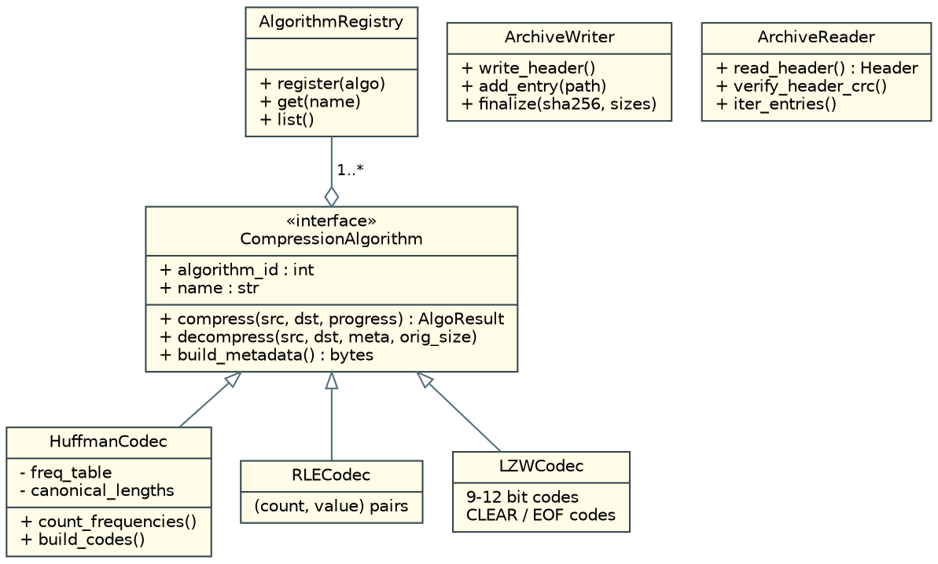
Figure 2 – Algorithm interface and archive classes

4.3 Service Model
Services depend on core abstractions and on HistoryService; BatchService and ComparisonService reuse the single-item services so behaviour is identical in every entry point. Dashed relationships in the application layer write history after every operation, including failures.
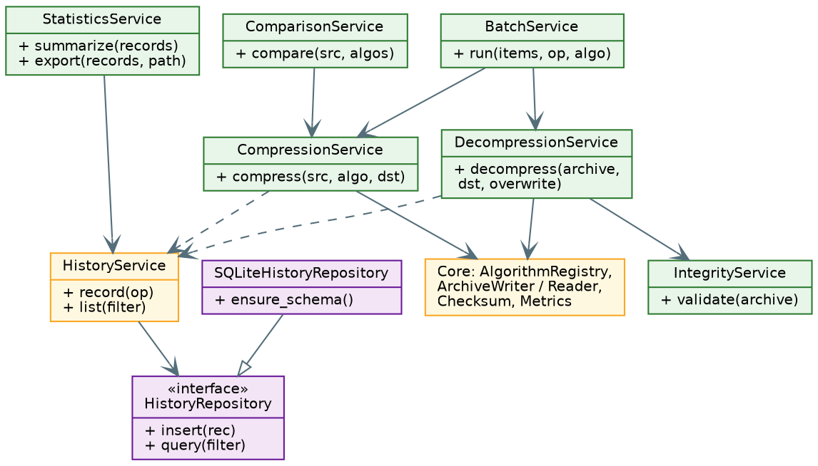
Figure 3 – Application services and their collaborators

Service result object
Every service returns an OpResult whose fields mirror the history table, so one object feeds the results panel, the statistics view, the report exporter and the repository:
operation_type, source_name, source_path, algorithm, original_size, compressed_size, compression_ratio, space_saved_percent, elapsed_ms, checksum, status (SUCCESS | FAILED | INVALID), timestamp, error_message, plus destination (not stored).

5. Process View

5.1 Compress and Decompress Flows
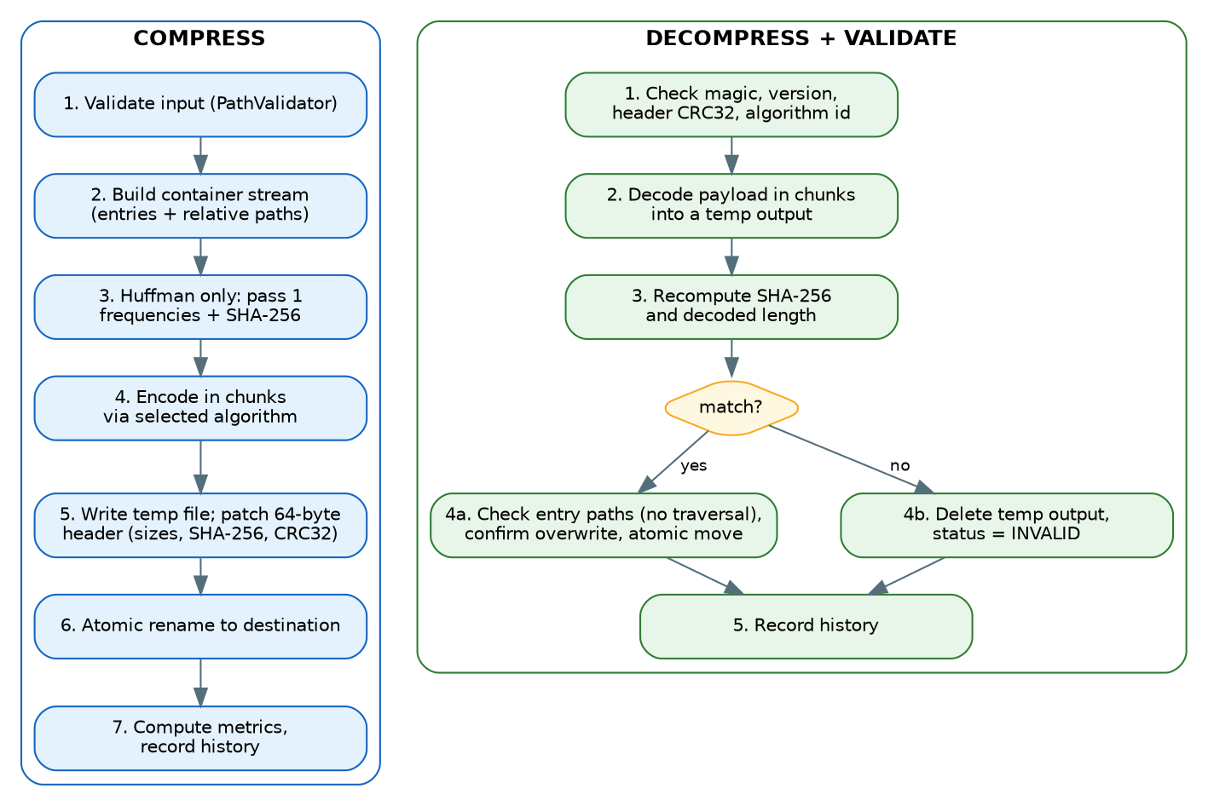
Figure 4 – Compression and decompression/validation flows
- Container stream. Files and folders are first presented as one logical stream of entries (Section 6.1), so a single code path serves REQ-001 for both.
- Two-pass Huffman. Pass 1 counts frequencies and computes SHA-256 while reading; pass 2 encodes. RLE and LZW use one pass and compute SHA-256 as they read.
- Temp file and header patch. The writer reserves 64 header bytes, writes metadata and payload to a temporary file in the destination folder, then patches sizes, SHA-256 and CRC32 into the header and renames atomically. The original is only read (REQ-004).
- Never false success. Decompression writes to a temporary output; only a matching SHA-256 and decoded length promote it to the final name. Otherwise the temp output is deleted and the status is INVALID (REQ-017, 019).
- Overwrite policy. If the destination exists the service returns DestinationExistsError; the view asks the user and calls again with overwrite=True (REQ-014). Batch never overwrites silently.

5.2 Algorithm Comparison
The comparison service opens the same source for each selected algorithm in turn (sequentially, never in parallel). Each run writes to a counting null sink instead of disk and is timed with time.perf_counter, so disk speed does not distort results and the procedure is identical for every algorithm (REQ-021, SRS 6.1). An exception in one algorithm is captured as a FAILED row and the remaining algorithms still run (REQ-023).

5.3 Batch Processing
BatchService expands the selection (files, or a folder tree) into a list, then processes items one after another in the worker thread. Each item is wrapped in try/except; success or failure is stored as an OpResult, written to history and sent to the UI as an event. At the end a summary (processed = successful + failed) is returned (REQ-028 to REQ-032).

5.4 Concurrency Model
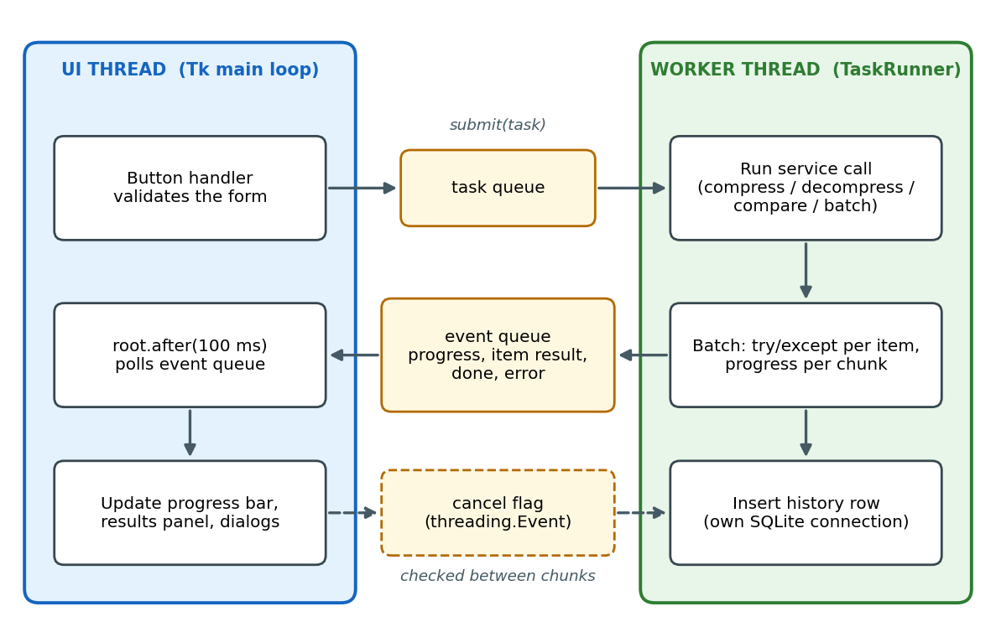
Figure 5 – UI thread and worker thread communication
- The Tk main loop is the only thread that touches widgets. It submits tasks to a queue and polls an event queue every 100 ms with root.after.
- One worker thread runs one task at a time (a second request is queued or the buttons are disabled). Progress, per-item results, completion and errors are posted as events.
- Cancellation uses a threading.Event checked between chunks; a cancelled operation deletes its temp file and is reported as cancelled, not as success.
- SQLite connections are opened per call (cheap for a local file), so no connection is shared across threads.
- Contingency: if pure-Python codecs starve the UI thread (TC-066 fails), the worker is switched to a multiprocessing process with the same queue interface, without changing services or views.

6. Data View

6.1 Archive Format (.cft, version 1)
A tool-generated archive is a 64-byte header, followed by algorithm metadata, followed by the payload. The header carries everything needed for REQ-008, REQ-012, REQ-016 and REQ-018. All integers are little-endian.
Offset | Size | Field | Description
0 | 4 | magic | ASCII CFTA. Anything else is rejected as "not a File Compression Tool archive".
4 | 1 | format_version | 1. Unknown versions are rejected with a clear message.
5 | 1 | algorithm_id | 1 = Huffman, 2 = RLE, 3 = LZW. Unknown ids are rejected.
6 | 1 | flags | Reserved, 0.
7 | 1 | reserved | Reserved, 0.
8 | 8 | original_size | Length in bytes of the uncompressed container stream.
16 | 8 | payload_size | Length in bytes of the compressed payload.
24 | 32 | sha256 | SHA-256 of the uncompressed container stream (shown as 64 hex characters in history and reports).
56 | 4 | metadata_length | Length of the algorithm metadata block.
60 | 4 | header_crc32 | CRC32 of header bytes 0–59; checked before any decoding.
File size must equal 64 + metadata_length + payload_size; any other size is an inconsistent archive (REQ-018).

Container stream (what is compressed)
entry_count (u32), then per entry: type (u8: 0 file, 1 folder), path_len (u16), path (UTF-8, relative, / separators, starting with the selected item’s name), size (u64, 0 for folders) and the file bytes. Single files and folders use the same format, so decompression always restores the original name. Extraction validates every path with PathValidator.safe_join before writing (SRS 6.3).

Per-algorithm payload
Algorithm | Metadata | Payload
Huffman | 256 bytes: canonical code length per byte value (0 = unused). | Bit-packed canonical codes. Empty input: all-zero metadata and empty payload. Single distinct symbol: that symbol gets a 1-bit code 0; the decoder stops at original_size and ignores padding bits (REQ-010).
RLE | None. | Pairs of (count 1–255, value). Binary safe; worst case doubles the size.
LZW | None. | Variable-width codes (9–12 bits). Code 256 = CLEAR, 257 = end of data; the dictionary resets when full.

6.2 History Database (SQLite)
One table implements the Field Layouts workbook. The repository creates it on first run (REQ-036) and uses parameterised statements only. SQLite does not enforce the declared lengths, so the repository clips values to the specified maximum lengths.
CREATE TABLE IF NOT EXISTS operation_history (
operation_id INTEGER PRIMARY KEY AUTOINCREMENT,
operation_type TEXT NOT NULL CHECK (operation_type IN ('Compress','Decompress','Compare','Batch')),
source_name TEXT NOT NULL, -- max 255
source_path TEXT, -- max 1024
algorithm TEXT, -- max 50
original_size INTEGER, compressed_size INTEGER,
compression_ratio REAL, space_saved_percent REAL,
elapsed_ms INTEGER,
checksum TEXT, -- hex digest, max 128
status TEXT NOT NULL CHECK (status IN ('SUCCESS','FAILED','INVALID')),
timestamp TEXT NOT NULL, -- ISO-8601 UTC, 32 chars
error_message TEXT -- max 500
); CREATE INDEX IF NOT EXISTS idx_history_time ON operation_history(timestamp DESC);
Proposed extension (needs an SRS change request): a nullable batch_ref INTEGER column holding the operation_id of the Batch summary row would link per-item rows to their batch for REQ-030. Without it, items are only associated with a batch by time order. File contents are never stored in the database (SRS 6.3).

6.3 Reports
ReportExporter writes CSV or plain text. The Compression Operation Report contains operation ID, type, source name, algorithm, original size, compressed size, ratio, space saved, elapsed time, status and timestamp. The Algorithm Comparison Report contains source name, algorithm, original size, compressed size, ratio, space saved, elapsed time and status (Field Layouts workbook, sheet "Report Requirements").

6.4 Metrics Definitions
- Compression ratio = compressed size / original size (SRS 6.5). Values above 1 mean expansion.
- Space saved % = (original − compressed) / original × 100; negative on expansion.
- For a 0-byte original both values are shown as N/A (no division by zero).

7. Cross-Cutting Concerns

7.1 Error Handling
All expected failures are subclasses of CftError. Services catch them (and unexpected exceptions as a last resort), build an OpResult, write it to history and return it; the GUI never shows a stack trace.
Exception | Raised when | Status | Requirements
InputError | Missing, unreadable or unsupported source. | FAILED | REQ-002
UnsupportedAlgorithmError | Algorithm name/id not registered. | FAILED | REQ-003, 012
DestinationExistsError | Target exists and overwrite not confirmed. | FAILED | REQ-014
StorageError | Disk full, permission denied or other I/O failure; temp output removed. | FAILED | SRS 6.2
ArchiveFormatError | Bad magic, version, header CRC, truncation or inconsistent sizes. | INVALID | REQ-012, 018
IntegrityError | SHA-256 or decoded length mismatch. | INVALID | REQ-017, 019
HistoryError | Database cannot be opened or written; operation continues, user warned once. | (not recorded) | REQ-036

7.2 Security
- File names and paths are data: no shell invocation, no eval, file content is never interpreted.
- Extraction targets are resolved with safe_join: absolute paths, drive letters, .. segments, NUL bytes and backslash tricks are rejected; the final path must stay inside the destination root.
- Symbolic links are not followed during compression (reported as unsupported) and are never created during extraction.
- History, reports and logs store sizes, names and metadata only.

7.3 Configuration, Logging and Scope Limits
- The history database and log files live in the per-user application data folder (%APPDATA%, ~/Library/Application Support, or $XDG_DATA_HOME), resolved with the standard library.
- Logging uses the logging module with a rotating file; messages contain operation type, status and error class, never file contents.
- Version 1 restores file bytes and folder structure only; timestamps, permissions and extended attributes are not preserved.

7.4 Adding a New Algorithm
- Create core/algorithms/<name>.py implementing CompressionAlgorithm with a unique algorithm_id and name.
- Register it in AlgorithmRegistry.
- Run the parametrised round-trip and corruption tests; they pick up every registered algorithm automatically.
- No view or service code changes: selectors and comparison lists are built from the registry (TC-071).

8. Development View

8.1 Repository and Package Structure
file-compression-tool/
pyproject.toml # Ruff, pytest, coverage settings
src/cft/
app.py # entry point
ui/ # main_window, compress_view, decompress_view,
# compare_view, batch_view, history_view, help_view, messages
services/ # compression, decompression, integrity, comparison,
# batch, statistics, history, report_exporter, task_runner
core/ # errors, models, paths, checksum, metrics, container,
algorithms/ # base, registry, huffman, rle, lzw
infra/ # fs (chunked I/O, atomic write), history_repo, config
tests/{unit,integration,system,data}/
docs/ # SRS, test plan, architecture, backlog
.github/workflows/ci.yml

8.2 Dependency Rules
- ui → services → core; services and core use infra only through adapters passed in or imported at the composition root (app.py).
- core imports nothing from ui, services, infra, tkinter or sqlite3. An import-linter or simple test enforces this in CI.
- The composition root wires concrete adapters (FileSystemAdapter, SQLiteHistoryRepository, real clock); tests wire fakes.

8.3 Workflow and CI
- Branches named feature/CFT-<n>-<slug>; pull requests require one review from the paired member and a green CI run.
- CI (GitHub Actions): Ruff lint → unit and integration tests on Windows/Linux/macOS × Python 3.12/3.13 → coverage gate → nightly large-file tests. Jenkins-compatible because every step is a plain command.

9. Deployment View
The product is one Python process on the user’s machine with two threads (UI and worker). There is no server, network or installer in the initial release; it runs from source with Python 3.12+ and Tkinter available.
Element | Detail
Process | python -m cft.app: Tk main loop + TaskRunner worker thread.
Files read/written | User-selected sources and destinations; .cft archives; temporary .cft-tmp-* files in the destination folder (removed on failure or after atomic rename).
Local data | history.db (SQLite) and rotating log in the per-user data folder.
Platforms | Windows 10/11, Linux and macOS with Tkinter.

10. Design Decisions
ID | Decision | Alternatives | Rationale and trade-off
AD-01 | Four-layer architecture; no logic in views. | Logic inside Tk callbacks. | Makes core and services testable without a GUI and keeps feature ownership clean. Cost: a few more modules.
AD-02 | Tkinter/ttk for the GUI. | PyQt, web front end. | Standard library, no extra dependency, matches the proposal. Cost: plain look; headless GUI testing only on Linux.
AD-03 | Own .cft container format. | ZIP or TAR. | Needs algorithm id, SHA-256, header CRC and exact-size checks that REQ-008/016/018 demand and keeps Huffman/RLE/LZW inside our code. Cost: no interoperability with other tools.
AD-04 | Canonical Huffman with 256-byte code-length table. | Store tree or frequencies. | Deterministic, simple to validate, independent of tie-breaking. Cost: 256-byte overhead makes files of a few hundred bytes expand (UI shows a notice).
AD-05 | Two-pass Huffman over a re-readable source. | Per-block Huffman in one pass. | Better ratio with one global table and still bounded memory. Cost: input is read twice.
AD-06 | SHA-256 of the whole container stream plus header CRC32. | CRC32 only; MD5. | Strong detection of any corruption; CRC32 gives a cheap early header check. hashlib and zlib are in the standard library.
AD-07 | Temp file in destination folder, then atomic os.replace. | Write directly to final name. | No partial or corrupt output visible after a failure (SRS 6.2). Cost: needs free space for the temp file.
AD-08 | Worker thread with queues and after() polling. | multiprocessing; asyncio. | Simplest model that keeps Tk responsive; multiprocessing kept as contingency (Section 5.4).
AD-09 | Algorithm registry and common interface. | If/else on algorithm names. | Satisfies extensibility and lets tests and views enumerate algorithms automatically.
AD-10 | SQLite via sqlite3, parameterised SQL, connection per call. | ORM; long-lived shared connection. | No dependency, avoids thread-affinity errors and SQL injection. Cost: negligible per-call overhead.
AD-11 | Ratio = compressed / original; N/A for 0 bytes. | Original / compressed. | Follows SRS 6.5 exactly; guards division by zero.

11. Traceability: ARCH References to Requirements
ARCH ref | Feature | Primary components | Requirements | Owner
ARCH-5.1 | F1 File Compression | PathValidator, CompressionService, ArchiveWriter, AlgorithmRegistry, Metrics | REQ-001 – 005 | Jai
ARCH-5.2 | F2 Huffman Engine | HuffmanCodec, container metadata | REQ-006 – 010 | Jai
ARCH-5.3 | F3 File Decompression | DecompressionService, ArchiveReader, FileSystemAdapter | REQ-011 – 015 | Architha
ARCH-5.4 | F4 Integrity Validation | Checksum, header CRC, IntegrityService | REQ-016 – 019 | Architha
ARCH-5.5 | F5 Algorithm Comparison | ComparisonService, timing harness, RLECodec, LZWCodec | REQ-020 – 023 | Krati
ARCH-5.6 | F6 Statistics and Reporting | Metrics, StatisticsService, ReportExporter | REQ-024 – 027 | Krati
ARCH-5.7 | F7 Batch Processing | BatchService, TaskRunner | REQ-028 – 032 | Chandana
ARCH-5.8 | F8 Operation History | HistoryService, SQLiteHistoryRepository | REQ-033 – 036 | Chandana
ARCH-5.9 | F9 Desktop Interface | ui/ views, TaskRunner events, messages catalogue | SRS 3.1 | All
ARCH-NFR | Quality attributes | Section 2.3 tactics; errors.py; PathValidator; FileSystemAdapter | SRS 6.1 – 6.4 | All

12. Risks and Open Issues
Risk / open issue | Handling
Pure-Python codecs may be slow on large files. | Chunked streaming, progress, worker thread; performance baselines in Sprint 4; multiprocessing contingency; Huffman bit packing optimised with lookup tables if needed.
Huffman table overhead expands very small files. | Accepted for v1 (AD-04); UI shows an expansion notice; a sparse table is a possible later format version.
Per-item batch records cannot be linked to their batch with the current field layout. | Raise an SRS change request for the optional batch_ref column (Section 6.2).
SRS gaps (unsupported-input definition, zero-size metrics, batch overwrite policy). | Assumptions listed in 22_Project Test Plan, Section 14; confirm with the evaluator.
Timestamps and permissions are not preserved on restore. | Out of scope for v1 (SRS only requires content equality); documented in the Help screen.
SQLite does not enforce column lengths. | Repository clips values; unit test TC-057 verifies it.
SRS 3.1 lists no Batch entry on the main screen, although F7 requires batch processing. | Batch view added to the main window (ARCH-5.9); confirm with the evaluator or add it to SRS 3.1.

