**ALGORITHMS AND DATA STRUCTURES**

Laboratory work 1.2

STUDY OF “HASH TABLE” DATA STRUCTURE

*Prepared by:*

*student of 221(B)A,*

*Student: Quadri Okhifo Jemimah*

*Accepted by:*

*Vasilieva M.D.*

**The objective**: to study “hash-table” data structure, hash methods and ways of collision resolutions; to gain practical skills for using a hash-table.

**The first-level task**

Do the following:

- define an element of a hash-table that represents a geometrical figure according to the variant (appendix 2, table 2.1, col. 2);

- define a hash-table with an open addressing that uses a hash method (appendix 2, table 2.1, col. 3) for a given key (appendix 2, table 2.1, col. 4);

- create an instance of a hash-table with a given size;

- insert elements into the created hash-table avoiding collisions;

- output the hash-table.

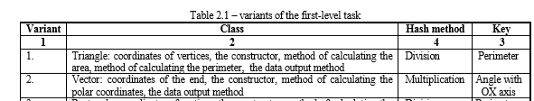

**Code listing:**

**The second-level task**

Do the following:

* change definition of the hash-table from the first-level task so that collision would be resolved by given method of collision resolution (appendix 2, table 2.2) when it occurs;
* create an instance of a hash-table with given size;
* insert elements to the hash-table so that collisions appear;
* output the hash-table.



**Code listing:**

**The third-level task**

Do the following:

* change definition of a hash-table from the second-level task so that elements can be deleted from a hash-table by given criteria (appendix 2, table 2.3);
* create an instance of a hash-table with a given size;
* insert elements into the hash-table so that collisions appear; output the content of the hash-table;
* remove elements from the hash-table by given criteria and output a content of the hash-table.

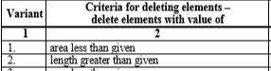

**Code listing:**

**MAIN:**

**OUTPUT:**

**Questions**

1. What is called a hash table? What criteria are hash-tables classified by?

2. What is hashing intended for? What hash methods are known?

3. When do collisions happen in hash tables? What are methods of collision resolution?

4. How is hash-table with open addressing implemented using linear probing?

5. How is hash-table with open addressing implemented using double probing?

6. How is hash-table with open addressing implemented using quadratic probing?

7. How is hash-table with separate chaining implemented?