**Ministry of education and science of Ukraine  
National Aviation University**

**Faculty of Cybersecurity, Computer and Software Engineering**

**Algorithm and Data Structure  
Module Test Work 2**

**Variant 17**

**Prepared by  
Student of ПІ-221Б(а)**

**Year: 2  
Quadri Jemimah**

**Accepted by  
Maria Vasilieva**

**Date: 6/5/20**

**Kyiv 2020**

**Tasks**

1. **What is Combinatorics? What are general Principles of combinatorics?**
2. **How is the integral calculated by the method of Parabola (Simpson)? How can this method be graphically explained?**
3. **Write a program in Java, which uses Regular expressions to search for integer values in any text file.**

**Answers.**

1. **Combinatorics is a branch of mathematics that deals with the study of a finite set of objects in ways that they can be arranged or combined, the study of sequences and series also mathematically can be explained as counting objects or groups of objects.**

**General principles of combinatorics: - Pigeonhole Principle (The pigeonhole principle states that if *a* items are each put into one of *b* boxes, where *a* > *b*, then one of the boxes contains more than one item**.**)**

* **Inclusion- exclusion principle;**
* **Bijective proof (Bijective proofs prove that two sets have the same number of elements by finding a bijective function (one-to-one correspondence) from one set to the other.)**
* **Rule of sum (the sum of the sizes of two**[**disjoint**](https://en.wikipedia.org/wiki/Disjoint_sets)**sets is equal to the size of their union**.)
* **Rule of products (if there are *a* ways to do something and *b* ways to do another thing, then there are *a* · *b* ways to do both things.)**
* **Rule of division (States that there are n/d ways to do a task if it can be done using a procedure that can be carried out in n ways, and for every way w, exactly d of the n ways corresponds to way w.)**

1. **To obtain an approximation of the definite integral  using Simpson’s rule, we partition the interval into an even number of n of subintervals, with each width. If the function f(x) is continuous on [a,b] **

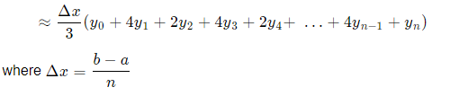

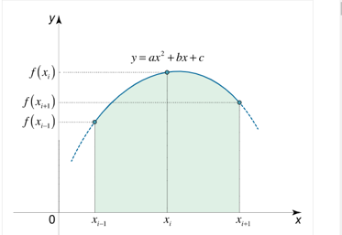

1. package com.company;  
   import java.io.*;  
   import java.lang.reflect.Array;  
   import java.util.ArrayList;  
   import java.util.Scanner;  
   import java.util.regex.Matcher;  
   import java.util.regex.Pattern;  
     
   public class Main {  
    public static ArrayList<String> ReadFile(String file) {  
    ArrayList<String> array = new ArrayList<String>();  
    try(FileInputStream fis = new FileInputStream(file);  
    InputStreamReader isreader = new InputStreamReader(fis);  
    BufferedReader bread = new BufferedReader(isreader)){  
    String line = bread.readLine();  
    while (line != null){  
    array.add(line);  
    line = bread.readLine();  
    }  
    }  
    catch (IOException e){  
    System.*out*.println(e.getMessage());  
    }  
    return array;  
    }  
    public static void main(String[] args) {  
    System.*out*.println("Enter name of file");  
    Scanner s = new Scanner(System.*in*);  
    ArrayList<String> file = *ReadFile*(s.nextLine());  
    try {  
    Pattern pattern = Pattern.*compile*("^(\\+|-)?[0-9]+$");  
    Matcher m;  
    for (int i = 0; i < file.size(); i++) {  
    m = pattern.matcher(file.get(i));  
    if (m.find()) {  
    System.*out*.println("Integers exist in this line");  
    } else {  
    System.*out*.println("no integers in this line");  
    }  
    }  
    }  
    catch (Exception ex) {  
    ex.printStackTrace();  
    }  
    }  
   }

