MYBOOT
An Intelligent, Transactional UEFI Boot-Environment Manager Written in Rust
Design, Discovery and Boot-Management Blueprint
System Project Report
Chapters One and Two
Prepared by Shaka
Independent Systems Engineering Project
Version 1.2 · August 2026

Declaration
This report documents an independent systems engineering project. It is my own work; where the ideas, writing or published implementations of others have been drawn upon, they have been acknowledged in the text and listed in the References. The system described here — its boot-management model, discovery engine, boot providers, transactional boot lifecycle and user interface — was designed by me, and the surveyed open-source projects are cited where their designs informed the work.
Author: Shaka
Signature: ................................. Date: .................................

Abstract
On a modern personal computer the transition from a cold power-on to a usable graphical desktop is governed by a short but critical chain of software: platform firmware conforming to the Unified Extensible Firmware Interface (UEFI), a boot manager that selects an operating system, an operating-system boot loader that loads a kernel, and finally the kernel and user space that render the desktop. The boot-manager stage is served on most machines by tools that are technically mature at the narrow task of loading an operating system, but that remain comparatively immature as intelligent, self-describing, transactional and recoverable boot-management platforms.
A careful comparison of the existing ecosystem — GRUB, systemd-boot, rEFInd, Limine, Clover and the Windows Boot Manager, together with the rust-osdev bootloader and the NixOS generation model — shows that automatic discovery, graphical presentation, theming and multi-protocol kernel loading are already solved problems. What is not solved is the layer above them: a coherent model that understands what is healthiest to boot and why, that treats a boot attempt as a transaction which can be confirmed, committed or rolled back, that federates the fragmented configuration and boot-order state spread across UEFI variables and each operating system's own store, and that offers unified diagnostics and cross-operating-system recovery when a machine will not start.
This project therefore proposes MyBoot: an intelligent, transactional UEFI boot-environment manager written primarily in Rust, with a minimal assembly boundary, that discovers installed systems, organises them into a semantic Boot Graph rather than a flat list, verifies their health, presents them through a graphical interface rendered on the firmware framebuffer, launches each through its native boot mechanism, and confirms the outcome so that a failed boot can be detected and rolled back. The memory safety of Rust is a deliberate response to a class of pre-boot vulnerabilities exemplified by the GRUB BootHole flaw; the graphical interface and the choice of language are treated as implementation technology, not as the innovation. The project further commits to formal methods for its most safety-critical parts — specifying the boot transaction in a model checker and verifying the boot-critical parsers at the level of the Rust code — and to three coordinated interfaces over one engine: a graphical boot menu, a pre-boot recovery shell and a host-side management command-line tool. This document presents the first two chapters. Chapter One establishes the background, problem, objectives, scope and methodology. Chapter Two reviews the firmware and boot landscape, critically surveys seven representative open-source projects, examines the operating-system boot protocols the manager must accommodate, isolates the gaps in the existing ecosystem, and sets out the boot-management model that guides the design chapters. Throughout, the position is stated honestly: these are gaps of integration and coherence, not claims that no individual feature has ever been implemented anywhere.

Table of Contents

Note: the table of contents is a field. In Microsoft Word, right-click it and choose “Update Field” (or press F9) to populate page numbers after any edit.

List of Abbreviations
Abbreviation | Meaning
ACPI | Advanced Configuration and Power Interface
BCD | Boot Configuration Data (Windows boot store)
BDS | Boot Device Selection (a UEFI boot phase)
BIOS | Basic Input/Output System (legacy firmware)
BLS | Boot Loader Specification
BMC | Bounded Model Checking
CVE | Common Vulnerabilities and Exposures
EFI | Extensible Firmware Interface
ESP | EFI System Partition (a FAT-formatted partition)
GOP | Graphics Output Protocol
GPT | GUID Partition Table
HID | Human Interface Device
LTL | Linear Temporal Logic
MBR | Master Boot Record
NVRAM | Non-Volatile Random-Access Memory (firmware variable store)
OVMF | Open Virtual Machine Firmware (UEFI firmware for QEMU)
PE/COFF | Portable Executable / Common Object File Format
QEMU | Quick Emulator (machine emulator and virtualiser)
RDBMS | Relational Database Management System
SMT | Satisfiability Modulo Theories
TLA+ | Temporal Logic of Actions (a specification language)
TPM | Trusted Platform Module
UEFI | Unified Extensible Firmware Interface
UKI | Unified Kernel Image
WinRE | Windows Recovery Environment
XBOOTLDR | Extended Boot Loader partition

Chapter One: Introduction

1.1 Background of the Study
When a computer is powered on, the processor does not know which operating system is installed or how to run it. It begins execution from a fixed reset address in the platform firmware, which performs power-on self-test, initialises memory and buses, and eventually hands control to software stored on disk. On the overwhelming majority of computers manufactured since 2011, that firmware conforms to the Unified Extensible Firmware Interface (UEFI), which replaced the legacy Basic Input/Output System (BIOS). Unlike legacy BIOS, which read a single 512-byte sector from the start of a disk and executed it, UEFI can read partitioned disks using the GUID Partition Table (GPT) and load and execute standard Portable Executable binaries from a dedicated FAT-formatted partition called the EFI System Partition (ESP).
This architectural change is the foundation on which this project rests. Because UEFI launches ordinary executable files from an ordinary filesystem, replacing or supplementing the program that chooses and launches an operating system no longer requires writing raw sector code in assembly. It becomes a matter of producing a well-formed UEFI application and registering it with the firmware. The program that presents the user with a menu of operating systems and launches the chosen one is properly called a boot manager, and is distinct from a boot loader, which loads an operating-system kernel and transfers control to it. Some widely used tools, such as GNU GRUB, perform both roles, which has blurred the distinction in common usage.
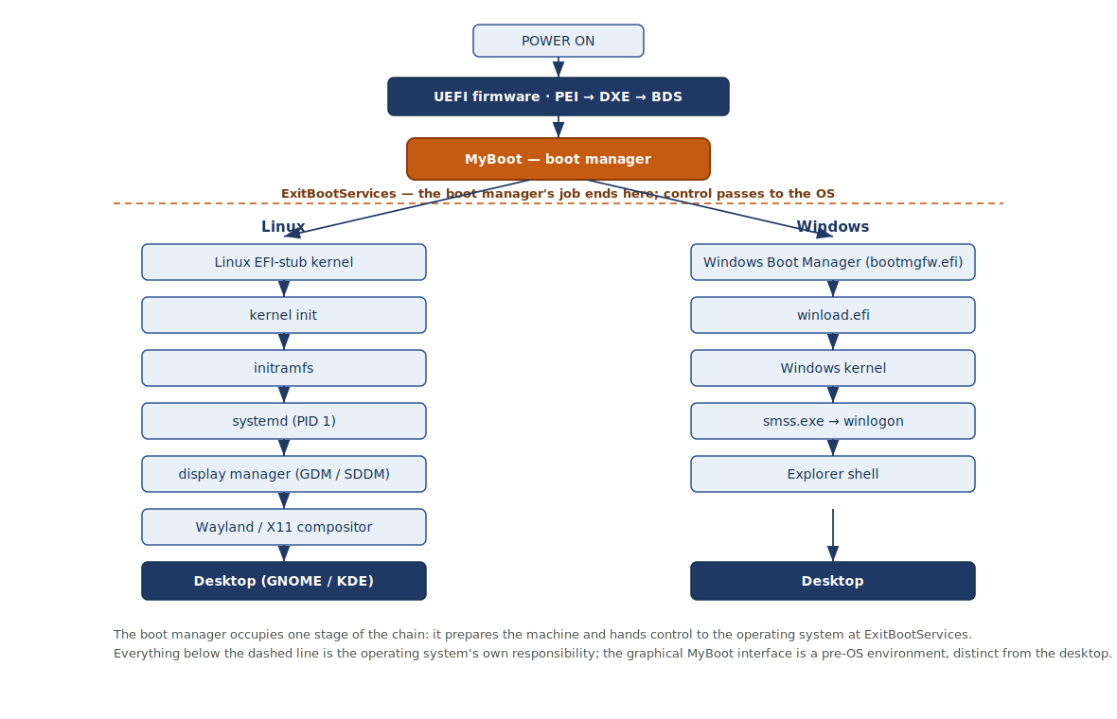
Figure 1.1: The boot chain from power-on to desktop, for Linux and Windows. The boot manager occupies one stage; at ExitBootServices it hands control to the operating system, whose own components then reach the desktop.
The central observation motivating this project is that the boot-manager stage, considered as a category of software, is technically mature at its narrow task and comparatively immature as a discipline. The existing tools reliably answer the question “what can I boot?”. GRUB boots almost anything and carries its own filesystem drivers and scripting engine; rEFInd automatically discovers installed loaders, kernels and recovery tools and presents them graphically; Clover offers a themed graphical interface with icons, animations and pointer support; systemd-boot boots UEFI systems simply and quickly; and Limine loads kernels through several boot protocols. Automatic discovery, graphical presentation and multi-protocol loading are therefore not open problems. What these tools do far less is answer the harder questions: what is the healthiest option to boot and why, what should happen when a chosen option fails, and how should the fragmented boot configuration spread across the firmware and each operating system be kept coherent and repairable. The frontier, in other words, is not boot selection but boot management.
A particular complication both illustrates the opportunity and sets a design constraint. NixOS, a Linux distribution built on a declarative and reproducible configuration model, does not overwrite the system when it is reconfigured. Each rebuild produces a complete, immutable system profile — a generation — and previous generations remain bootable so that a faulty change can be undone simply by selecting an older entry at boot time. A machine reconfigured many times therefore presents not a handful of operating systems but potentially dozens of bootable configurations of a single one, sometimes each with its own specialised variants. This is precisely the kind of versioned, rollback-oriented boot environment that a management-focused boot manager should model natively, rather than flatten into an undifferentiated list.
A further consideration is safety. Because a boot manager executes before any operating system and with elevated privilege on bare metal, defects in it are both easy to introduce and severe in consequence. The BootHole vulnerability disclosed in 2020, a buffer overflow in GRUB's parsing of its own configuration file that permitted the bypass of UEFI Secure Boot on a very large number of machines, is a concrete illustration: a string-handling error in a boot component written in a memory-unsafe language undermined the security of the entire boot chain. This is the background against which the choice of a memory-safe implementation language, and the emphasis on transactional recovery rather than silent failure, are made.

1.2 Problem Statement
The existing boot-manager ecosystem answers what can be booted but provides little intelligence about what should be booted, why, and what must happen when a boot fails. Its configuration and boot-order state is fragmented across UEFI firmware variables, the Windows Boot Configuration Data store, and the several configuration formats of the various Linux boot managers, with no coherent federating model; and because installers and updates routinely re-assert their own boot entries, the effective boot configuration drifts without the user's knowledge. When many operating systems, kernels, generations and recovery environments are present, they are shown as a flat list that is difficult to navigate. A boot attempt is not treated as a transaction that can be confirmed and, on failure, rolled back, so a defective selection can leave a machine unbootable with no automatic remedy and only an opaque error to guide the user. Diagnostics and recovery are fragmented across operating-system-specific tools rather than presented through one coherent interface. Finally, the graphical, self-discovering tool that best matches the desired user experience is written in a memory-unsafe language whose class of pre-boot parsing defects has already been shown to compromise the boot chain. This project addresses the absence of an intelligent, transactional, memory-safe boot-environment manager for x86-64 UEFI systems that discovers and semantically models an arbitrary number of heterogeneous boot targets, verifies their health, launches them through their native mechanisms, confirms the outcome and recovers from failure, and federates the fragmented boot configuration into one coherent and repairable model — and it addresses the corresponding absence of a consolidated, correctness-oriented methodology for building and testing such software safely.

1.3 Project Objectives

1.3.1 General Objective
To design and document an intelligent, transactional UEFI boot-environment manager, written primarily in Rust with a minimal assembly boundary, that automatically discovers the operating systems and boot environments installed on an x86-64 computer, organises them into a semantic Boot Graph, verifies their health, launches each through its native boot mechanism, confirms the outcome, and recovers from failure.

1.3.2 Specific Objectives
- To analyse the UEFI boot process and the native boot mechanisms of Linux, Windows and generation-based Linux distributions, and to derive from them the requirements a management-focused boot manager must satisfy.
- To design a discovery subsystem that enumerates disks, partitions, the EFI System Partition, firmware boot variables and Boot Loader Specification entries, and reduces them to a uniform, operating-system-agnostic model of bootable targets.
- To design a semantic Boot Graph that groups those targets hierarchically by operating system, generation, kernel, specialisation and recovery environment, and that scales gracefully to an arbitrary number of entries.
- To design an operating-system adapter architecture in which each supported system contributes discovery, identification, validation, health reporting and launch behaviour behind a common interface, so that the manager is extensible to new systems.
- To design a transactional boot lifecycle in which a boot attempt is validated, staged, launched, confirmed on success and rolled back on failure, together with the cooperative success-confirmation mechanism this requires.
- To design a declarative boot-configuration model, with atomic staged changes and reconciliation against the actual firmware state, that federates rather than replaces the native configuration stores and can repair boot-order drift.
- To provide three coordinated interfaces over one engine — a graphical boot menu rendered on the firmware framebuffer with keyboard and pointer input, a pre-boot recovery and inspection shell, and a host-side management command-line tool for installation, signing and configuration — together with structured pre-boot diagnostics, exportable boot logs and a cross-operating-system recovery facility.
- To define an adequate, efficient and safe testing strategy based on emulated firmware, off-target unit testing, source-level debugging and deliberate failure injection, and to critically survey representative open-source projects to ground the design.
- To formally specify the safety and liveness properties of the boot transaction in a model checker, to verify the boot-critical parsers at the level of the Rust code, and to treat these as complements to, not replacements for, the testing strategy.

1.4 Research Questions
- What sequence of events connects a cold power-on to a rendered operating-system desktop, and at which precise point does responsibility pass from the boot manager to the operating system?
- How can a single boot manager discover, semantically model and launch an arbitrary number of heterogeneous operating systems, generations and recovery environments without embedding knowledge of each system's private internals?
- Can a UEFI boot manager provide a transactional, declarative, operating-system-agnostic boot-environment model — with automatic discovery, health verification, failure detection, rollback and recovery — built above the firmware's existing boot-selection primitives rather than replacing each operating system's native configuration?
- Since control passes irrevocably to the operating system at handoff, by what cooperative mechanism can the manager learn whether a boot ultimately succeeded, so that failure can be detected and rolled back?
- Which safety and liveness properties of the boot transaction can be formally specified and machine-checked, and which boot-critical components can be verified at the level of the implementation code rather than only tested?
- What persistence and configuration mechanisms are appropriate to a program that executes before any operating system, and is a conventional relational database among them?
- How can such a manager be developed and tested so that defects are contained safely rather than leaving the host machine unbootable?

1.5 Justification and Significance of the Study
A boot manager occupies a uniquely privileged position: it is the first substantial, user-facing software a machine runs, and on a multi-boot system it determines whether living with several operating systems is coherent or chaotic. Elevating this stage from selection to management therefore has a disproportionate effect on reliability and on the everyday experience of developers, researchers and enthusiasts who run more than one system. A transactional model with confirmation and rollback directly attacks the most damaging failure mode of multi-boot machines, the machine that will not start after a change, and a federating configuration model directly attacks the silent boot-order drift caused by successive installers re-asserting their own entries.
Writing the manager in Rust is significant because memory-safety defects at the firmware level are both easy to introduce and severe in consequence, as the BootHole class of vulnerabilities demonstrated; a language that eliminates broad classes of such defects at compile time is well matched to software that must not compromise the environment it prepares. The treatment of generation-based systems is significant because the declarative, immutable configuration model is growing in influence and interacts awkwardly with conventional flat boot menus. Finally, the consolidated development-and-testing methodology has educational value, since constructing such a manager exercises processor architecture, firmware interfaces, executable and partition formats, filesystems, graphics, memory management and cryptographic verification in one coherent project. It should be stated plainly that the contribution claimed here is integration and coherence: several of the individual capabilities exist in isolated, operating-system-specific or tool-specific forms in the current ecosystem, and the aim is to unify them into one cross-operating-system architecture with a strong transactional and recovery model, built above the primitives the UEFI specification already provides.

1.6 Scope of the Project
The project targets x86-64 personal computers with UEFI firmware. Within that platform it treats Linux and Windows as first-class boot targets and gives explicit design attention to NixOS generations and specialisations. It models an arbitrary number of installed boot environments rather than a fixed maximum. The launching strategy is founded on chainloading native boot components, supplemented by direct Linux kernel loading as an advanced capability. Above launching, the project's core deliverables are the semantic Boot Graph, the operating-system adapter architecture, the transactional boot lifecycle with confirmation and rollback for Linux and NixOS, health verification of boot targets, the declarative configuration model with reconciliation and boot-order repair, structured diagnostics and exportable logs, cross-operating-system recovery orchestration, three coordinated interfaces (a graphical boot menu, a pre-boot recovery shell and a host-side management command-line tool), and the formal specification and model-checking of the boot-transaction's safety and liveness properties together with code-level verification of the boot-critical parsers.
Certain ambitious capabilities are deliberately positioned as future work rather than core deliverables, so that the core remains credible and achievable: runtime parsing of Btrfs, ZFS or Bcachefs snapshots for direct snapshot booting; on-the-fly ACPI table patching; a comprehensive USB and I2C touch-input stack; atomic self-update and self-rollback of the manager's own binary; full functional verification of the entire codebase in the manner of CompCert or seL4, which is a person-years undertaking; and any machine-learning-assisted analysis. The following are outside the project entirely. Legacy BIOS booting is not a target, since the platform is UEFI. Booting macOS directly is not treated as a supported capability, because Apple's boot chain expects behaviours general-purpose UEFI managers do not provide, and Apple-Silicon machines use an entirely different, non-UEFI boot architecture; where macOS is discussed it is limited to chainloading a purpose-built environment the user has already installed. The project does not implement operating-system kernels, desktop environments or firmware; it prepares the machine, launches existing systems and manages the outcome.

1.7 Constraints, Assumptions and Delimitations

1.7.1 Constraints
- Pre-operating-system environment. The manager runs before any operating system exists and, after the firmware boot services are exited, without firmware assistance; it cannot rely on an operating-system runtime, a conventional filesystem stack beyond what it implements or invokes, or a hosted database engine.
- Irrevocable handoff. Once control is transferred to an operating system the manager no longer runs, so confirming that a boot ultimately succeeded requires cooperation from the booted system rather than direct observation.
- Firmware variability. UEFI implementations differ in quality and behaviour between vendors, so the design must tolerate non-conforming firmware and degrade gracefully.
- Safety-critical failure surface. A defect can render a machine unbootable, which constrains development to emulated and removable-media testing before any installation to a primary machine.
- Secure Boot. On machines with Secure Boot enabled, the firmware will refuse to launch an unsigned or untrusted image, which constrains both development and deployment.

1.7.2 Assumptions
- UEFI firmware. The host is assumed to provide UEFI firmware with a Graphics Output Protocol and a readable EFI System Partition.
- GPT-partitioned storage. Storage is assumed to be partitioned with a GUID Partition Table containing a standard EFI System Partition.
- Cooperative native boot components. Installed operating systems are assumed to provide their own EFI boot components, which the manager launches rather than replaces, and to be able to record a success marker for the transactional model.

1.7.3 Delimitations
- Architecture. The work is delimited to x86-64; ARM64 UEFI is noted as future work rather than delivered.
- Direct macOS boot. Directly booting macOS is deliberately excluded for the reasons given under scope.
- First-stage deliverable. This document delivers the introductory and review chapters; the design, implementation and testing chapters follow separately.

1.8 Development Methodology and Documentation Sequence
The project follows an incremental, prototype-driven methodology in which every stage produces a demonstrable artefact that boots in an emulator. Development begins with a minimal UEFI application that prints diagnostic output, and proceeds through framebuffer graphics, filesystem and partition reading, discovery of boot targets and construction of the Boot Graph, chainloading of Windows and Linux, the transactional boot lifecycle and its success-confirmation marker, generation-aware NixOS handling, the declarative configuration model with reconciliation, diagnostics and recovery, Secure Boot, and, only last, aesthetic refinement of the interface. This ordering enforces a strict priority — boot correctly, then discover and model correctly, then fail safely and recover, then secure, then optimise, and only then beautify — because a visually polished manager that occasionally leaves a machine unbootable is worse than a plain one that never does. The policy that selects a default boot target is required throughout to be deterministic and explainable rather than opaque, so that its recommendations can always be justified to the user. In parallel with this staged construction, the safety and liveness properties of the boot transaction are specified and model-checked, and the boot-critical parsers are verified at the code level, so that verification proceeds alongside rather than after implementation.
The documentation follows the sequence conventional to a systems engineering report: an introduction that frames the problem, a literature review that surveys the landscape and isolates the gaps, a system analysis and design chapter, an implementation chapter, a testing-and-results chapter, and a chapter of conclusions and recommendations. The present document contains the first two chapters.

1.9 Organisation of the Report
Chapter One has introduced the project, stated the problem, objectives, research questions, justification, scope and methodology, and has argued that the frontier lies in boot management rather than boot selection. Chapter Two reviews the firmware and boot landscape, distinguishes the boot manager from the boot loader, critically surveys seven representative open-source projects, examines the operating-system boot protocols the manager must accommodate, isolates the gaps in the existing ecosystem, and sets out the boot-management model — the Boot Graph, the transactional lifecycle, the adapter architecture, the declarative configuration model, the policy engine, observability and recovery — that guides the design. Chapter Three will present requirements, analysis and the detailed design of these subsystems, including the configuration and state model and the reasoned exclusion of a relational database. Chapter Four will describe the implementation, Chapter Five the testing strategy and results, and Chapter Six the conclusions, limitations and recommendations for future work.

Chapter Two: Literature Review

2.1 Introduction
This chapter establishes the technical and comparative foundation for the project and locates its contribution. It begins by contrasting the two firmware environments a boot manager may encounter and explaining why the project targets UEFI exclusively. It then draws the distinction between a boot manager and a boot loader, which structures the entire design. The core of the chapter is a critical survey of seven representative open-source projects, examined not only for how well they select and load operating systems but for how far they go toward managing them. The chapter then examines the native boot protocols of the operating systems the manager must accommodate, isolates the gaps in the existing ecosystem in detail, and presents the boot-management model — centred on a semantic Boot Graph and a transactional boot lifecycle — that guides the design chapters. Throughout, gaps are described honestly as opportunities for integration and coherence rather than as claims of absolute novelty.

2.2 Firmware Environments: Legacy BIOS versus UEFI
Legacy BIOS firmware boots a computer by reading the first 512-byte sector of the boot disk, the Master Boot Record, into a fixed memory address and executing it in a constrained sixteen-bit processor mode. Because so little code fits in a single sector, traditional BIOS bootloaders are multi-stage: the first stage loads a second stage, which switches the processor into a wider mode and loads the kernel. This arrangement is powerful but low-level and fragile, and it requires substantial assembly programming merely to reach a state in which higher-level code can run.
UEFI firmware operates differently. It executes in a full thirty-two or sixty-four bit mode with a flat memory map, reads GPT-partitioned disks, and loads and executes standard Portable Executable binaries from the FAT-formatted EFI System Partition. Crucially, it exposes a large set of services and protocols — for block and file access, for graphics through the Graphics Output Protocol, for memory management and for firmware variables such as the boot-order and boot-selection variables — so that a boot application can perform sophisticated work without writing hardware drivers from scratch. These firmware variables are themselves a boot-policy mechanism, and are the primitives above which the project's management model is built. The default fallback path a UEFI machine will execute in the absence of an explicit firmware entry is a well-known file on the ESP, so a correctly formed application placed there makes a disk bootable. For these reasons the project targets UEFI exclusively; the additional low-level burden of legacy BIOS booting would add substantial complexity without serving the project's goal.
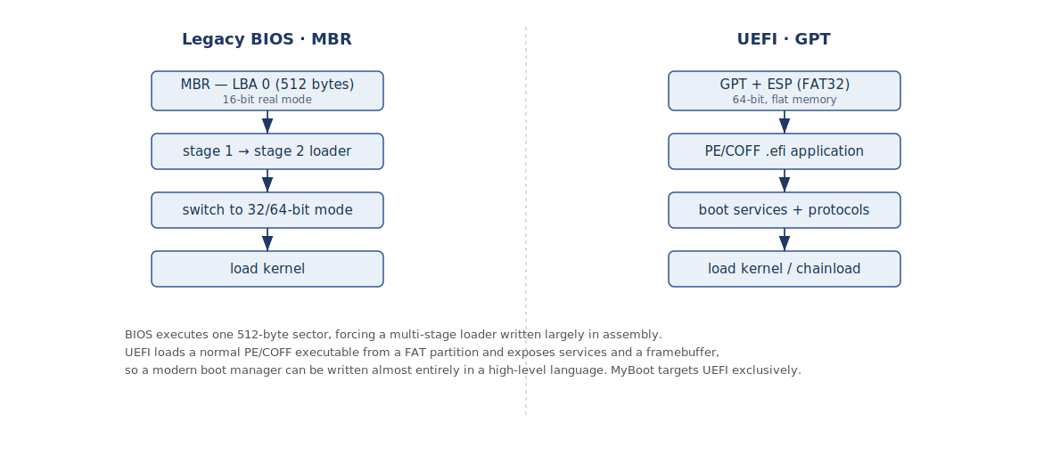
Figure 2.1: Legacy BIOS versus UEFI boot paths. BIOS executes a single 512-byte sector and needs a multi-stage assembly loader; UEFI loads a PE/COFF executable from a FAT partition and exposes services and a framebuffer.

2.3 The Boot Manager versus Boot Loader Distinction
A recurring source of confusion is the conflation of two related but distinct roles. A boot loader is a program that loads an operating-system kernel into memory and transfers control to it. A boot manager is a program that presents a menu of boot options and launches the selected one, which may itself be a boot loader. The rEFInd project draws this distinction explicitly, describing itself as a boot manager rather than a boot loader, and observing that popular tools such as GRUB perform both functions and thereby blur the two. Because every EFI-capable operating system ships its own boot loader, a boot manager need not itself load kernels in the general case; it can delegate to each system's native loader.
This project extends the distinction a step further. Beyond selecting and launching, it argues for a third role — boot management — in which the software maintains a semantic model of every bootable environment, reasons about their health, treats booting as a confirmable transaction, and federates the fragmented boot configuration. MyBoot is therefore primarily a boot manager in this stronger sense: it discovers, models, presents, launches by delegation, and manages the outcome, retaining direct kernel loading only as an advanced, optional capability.

2.4 Review of Existing Boot Managers and Bootloaders
The following survey examines seven representative projects, selected to span the boot-manager versus boot-loader role and the choice of a memory-unsafe language against a memory-safe one. Each is examined both for what it does well and for the point at which it stops short of boot management.

2.4.1 rEFInd
rEFInd is a graphical boot manager for EFI and UEFI systems and is the closest existing analogue to the interface this project envisions. It automatically detects installed EFI boot loaders, Linux kernels, firmware entries and recovery tools at run time and presents them in a graphical menu, and it is most useful precisely on machines that boot two or more of Linux, macOS and Windows. Its feature set is instructive for the interface goals of this project: user-configurable graphics and icons, user-defined fonts, pointer and some touch input, and proper handling of more operating systems than fit on a single screen, a case in which its own predecessor merely displayed an empty list. rEFInd is, however, a boot selector: its model is to scan, present and launch. It does not build a semantic model of health, treat a boot as a transaction, or federate configuration. It therefore serves as the interface benchmark the project must match, and as the clearest illustration of the management layer that remains unbuilt above excellent discovery.

2.4.2 systemd-boot
systemd-boot, formerly gummiboot, is a deliberately minimal UEFI boot manager whose design philosophy is the instructive counterpoint to rEFInd: simple, reliable and fast, at the explicit cost of graphical richness and broad discovery. It assembles its menu from description files placed on the ESP in accordance with the Boot Loader Specification, and it automatically generates entries for a small set of well-known targets — notably the Windows Boot Manager at a fixed ESP path — while deliberately not scanning for arbitrary EFI applications. Of particular importance to this project, systemd-boot implements a boot-counting mechanism with automatic fallback to an older, working entry when a new one fails repeatedly, encoding the attempt counters in the entry filename and decrementing them on each attempt until user space marks the boot good. This is the closest existing precedent for the transactional boot model proposed here, and the project builds upon it rather than claiming to originate the idea; the extensions sought are a cross-operating-system rather than Linux-only scope, an explicit success-confirmation protocol, and integration with a richer health and recovery model.

2.4.3 GNU GRUB
GNU GRUB is the most widely deployed boot loader and manager in the Linux world and represents the maximalist end of the spectrum. It carries its own filesystem drivers and a module system, and it boots operating systems it does not directly understand — including Windows — by chainloading. Its breadth is its strength and its complexity is its weakness: its configuration is intricate and its interface is text-oriented. GRUB is also the source of an important cautionary lesson. The BootHole vulnerability, catalogued as CVE-2020-10713, was a buffer overflow in GRUB's parsing of its configuration file that allowed arbitrary code execution and the bypass of UEFI Secure Boot on a very large number of Linux and Windows machines, because the configuration file was not itself signed. For this project GRUB is valuable as the reference implementation of chainloading, as a demonstration of how much machinery a manager needs if it attempts to understand every filesystem itself, and as direct evidence for the memory-safety argument that motivates a Rust implementation.

2.4.4 Limine
Limine is a modern, portable, multiprotocol bootloader and boot manager that serves as the reference implementation of its own boot protocol while also supporting the Linux boot protocol including the EFI stub, the Multiboot protocols, and chainloading. It supports both BIOS and UEFI, GPT and MBR partitioning, and the FAT and ISO9660 filesystems, and it follows a clean multi-stage architecture in which each stage grants more capability than the last. Its approach to Secure Boot is notable: it boots under Secure Boot when its executable is signed with a firmware-trusted key, and it protects its configuration by baking a cryptographic hash of the configuration file into the signed image — a direct, pragmatic answer to the very class of unsigned-configuration weakness that BootHole exploited. From Limine the project takes a model of disciplined multi-stage structure and a sound pattern for configuration integrity.

2.4.5 The rust-osdev Bootloader and uefi-rs
Two projects from the Rust operating-system-development community are foundational to a Rust implementation. The rust-osdev bootloader is an experimental x86-64 bootloader that works on both BIOS and UEFI systems, written in Rust with some inline assembly, and it loads a given kernel from a FAT partition. It is a boot loader rather than a boot manager — it loads one kernel rather than presenting and managing a set of foreign operating systems — and it is therefore the reference to study for the advanced capability of direct Linux kernel loading and for idiomatic bare-metal Rust structure. The uefi-rs project is not a bootloader but the library on which a Rust UEFI application is built: it provides safe, ergonomic wrappers over the UEFI system table, boot services, graphics and file protocols. The maintainers of Lanzaboote credit uefi-rs with removing much of the difficulty of dealing with UEFI, and note that because the UEFI Rust target is now well supported the development environment is comfortable. Together these projects establish both the feasibility and the practical foundation of a Rust implementation, while also showing that the existing Rust work stops at loading rather than managing.

2.4.6 Lanzaboote
Lanzaboote is the single most relevant project to this work, because it already combines several of the project's hardest requirements: it is written in Rust, it targets NixOS with its many generations, and it implements Secure Boot. It is a custom UEFI stub that brings Secure Boot to NixOS, and it exists precisely because bundling a kernel and initial RAM disk into a single signed image per generation would quickly exhaust the limited space on the EFI System Partition. Lanzaboote instead keeps the kernel and initial RAM disk separate on the ESP and defers signature verification to the firmware's own image-loading service, preserving the chain of trust while conserving space. Its command-line tool consumes a NixOS bootspec document, signs the relevant files, assembles the image and installs it, and is explicitly aware of multiple generations, signing every configuration that should remain bootable. Lanzaboote demonstrates that the Rust-plus-NixOS-plus-Secure-Boot combination is achievable, validates the strategy of discovering generations through the bootspec mechanism rather than by guessing from filenames, and offers a clean separation between an installation tool and a small on-disk UEFI component that the proposed architecture imitates. It is, however, specialised to NixOS Secure Boot rather than a general cross-operating-system management platform.

2.4.7 OpenCore
OpenCore is an open-source environment for booting macOS, widely used to run macOS on legacy Apple hardware and on non-Apple machines. It is examined here to establish, on the evidence, why directly booting macOS is out of scope. OpenCore works by replicating the behaviours macOS expects from Apple's own firmware and boot loader, and by preparing the system through the injection of platform identification, configuration tables and kernel extensions to satisfy the operating system's security expectations. The volume of Apple-specific machinery this entails is the justification for treating macOS, at most, as a system the user may chainload through such a pre-installed environment. On Apple-Silicon hardware the boot architecture is different again and is not UEFI-based, placing it entirely outside the project's platform. OpenCore does, however, illustrate one management-oriented capability — run-time ACPI table patching — that this project notes as a future-work opportunity rather than a core deliverable.
The following table summarises the survey.
Project | Language | Category | Principal lesson for MyBoot
rEFInd | C | Graphical boot manager | Auto-detection and a themeable graphical menu; strong selection, but a selector rather than a boot-management model.
systemd-boot | C | Minimal boot manager | Boot Loader Specification parsing and boot counting with automatic fallback — the closest existing precedent for transactional boot.
GNU GRUB | C / asm | Boot loader and manager | Chainloading and broad support; also the BootHole lesson on memory-unsafe pre-boot parsing.
Limine | C / asm | Multiprotocol bootloader | Clean multi-stage design; BIOS and UEFI; config-hash integrity under Secure Boot.
rust-osdev/bootloader | Rust / asm | Kernel bootloader | Idiomatic no_std structure and direct loading of a kernel from a FAT partition.
uefi-rs | Rust | UEFI library | Safe wrappers over the UEFI tables, framebuffer and file protocols; the foundation crate.
Lanzaboote | Rust | UEFI stub / NixOS | Rust plus NixOS generations plus Secure Boot; discovery via bootspec; tool-plus-stub separation.
OpenCore | C | macOS boot environment | The scale of Apple-specific machinery required, justifying macOS's exclusion as a direct target.

2.5 Operating-System Boot Protocols
A management-focused boot manager must accommodate the native boot mechanism of each operating system it launches. This section examines the four that matter for the project.

2.5.1 The Windows Boot Manager and Chainloading
Windows on UEFI systems is launched through its own Windows Boot Manager, an EFI application installed on the ESP. The correct strategy for a third-party manager is not to understand the Windows kernel boot process but to load and start this application and let Microsoft's boot chain proceed — the same chainloading technique GRUB uses for systems it does not directly boot. A correction relevant to this project's own reference material is that the UEFI Windows Boot Manager is the boot-manager firmware application on the ESP, and not the boot-manager component within the Windows system partition; conflating the two yields the wrong file path. Windows is also central to the configuration-federation problem: it maintains its own Boot Configuration Data store, and its installation and update processes routinely re-register the Windows Boot Manager and re-order the firmware boot entries, which is the mechanism by which a third-party manager can appear to vanish after a Windows update. This is a principal motivation for the declarative, reconciling configuration model developed later.

2.5.2 The Linux EFI Boot Stub
Linux is unusually accommodating to custom boot arrangements. Since version 3.3 the kernel can be built to masquerade as a Portable Executable, so that the firmware or a boot manager can load and execute the kernel image directly as though it were an ordinary EFI application, without a separate boot loader. This gives the project two levels of Linux support: a simpler chainloading level that loads and starts an existing EFI image, and a more advanced direct-loading level that reads the kernel and initial RAM disk, constructs the kernel's boot parameters, exits the firmware boot services and jumps to the kernel entry point. Linux is also the natural home for the transactional model's success marker, since a small system service can record, after a successful start-up, that the selected environment reached user space.

2.5.3 NixOS Generations and the Boot Loader Specification
NixOS builds a complete, immutable system profile on each reconfiguration and retains previous profiles as bootable generations, so that a defective change can be undone by booting an earlier generation. The NixOS bootloader builder iterates over the generations and writes a Boot Loader Specification description file per generation into the loader-entries directory on the boot partition, adding a further entry for each specialisation of a generation. The authoritative source of the facts used to write these entries is the bootspec mechanism, a machine-parsable set of facts about a generation's closure, defined by a NixOS design proposal to let bootloader tools support NixOS uniformly. By default a specialisation inherits its parent generation's sort key, so that in the menu each generation is followed immediately by its specialisations, and the number of generations exposed can be limited by a configuration option.
The practical consequence is that NixOS discovery need not be reinvented: parsing the Boot Loader Specification entries yields every generation and specialisation, already ordered, and reading the bootspec facts yields the same information from its authoritative source. This corrects the fragile alternative of recognising generations by pattern-matching filenames. NixOS is therefore the project's ideal demonstration case: its generations are exactly the versioned, rollback-oriented boot environments that the Boot Graph and the transactional lifecycle are designed to model, and the innovation sought is not inventing generations but building a richer health-aware, transactional management layer around them.

2.5.4 The macOS Boot Architecture
macOS is the operating system the project deliberately does not attempt to boot directly, for architectural rather than effort-related reasons. As the review of OpenCore established, booting macOS on anything other than a supported, unmodified Apple machine requires replicating a substantial body of Apple-specific firmware and boot-loader behaviour and injecting platform identification, configuration tables and kernel extensions. Moreover, current Apple hardware uses a processor architecture and boot chain that are not UEFI-based at all. The defensible position, adopted here, is to support macOS only to the extent of chainloading a purpose-built environment the user has already installed.

2.6 Gaps in Existing Systems
The survey reveals a consistent pattern: the ecosystem is mature at selecting and loading operating systems and immature as an intelligent, transactional, recoverable management platform. The gaps below are stated as opportunities for integration and coherence. Several are partially addressed in isolated, operating-system-specific or tool-specific forms; the opportunity is to unify them into one cross-operating-system architecture above the firmware's existing primitives.

2.6.1 The User-Experience Divide, and Memory Safety
Existing tools split into two extremes with an unoccupied middle. The bloated legacy model, exemplified by GRUB, carries a virtual filesystem and scripting engine but renders through a legacy graphics pipeline whose theming is configured through intricate files. The minimalist console model, exemplified by systemd-boot, is fast and secure but offers only a simple text menu without graphical menus, theming or pointer input. rEFInd and Clover already show that a themeable graphical interface is achievable, so the interface itself is not the primary gap; rather, the graphical, self-discovering tool that best matches the desired experience is written in a memory-unsafe language. The pre-boot environment is a privileged and poorly observed attack surface, and the BootHole class of configuration-parsing vulnerabilities showed that a string-handling defect in such a component can compromise the entire chain of trust. A memory-safe implementation is therefore both an interface and a security opportunity.

2.6.2 Boot Selectors Rather Than Boot Intelligence
The deepest gap is conceptual. Current systems predominantly answer “what can I boot?” through a pipeline that scans, finds loaders, presents entries and boots the user's choice. They go much less far toward answering “what is the healthiest thing to boot, why, and what should happen if it fails?”. A management-focused manager would instead run a longer pipeline — discover, identify, understand, validate, health-check, rank, present, boot, monitor the result, and recover or roll back — turning the boot menu into a managed lifecycle. This is the central opportunity the project pursues and the organising idea of its design.
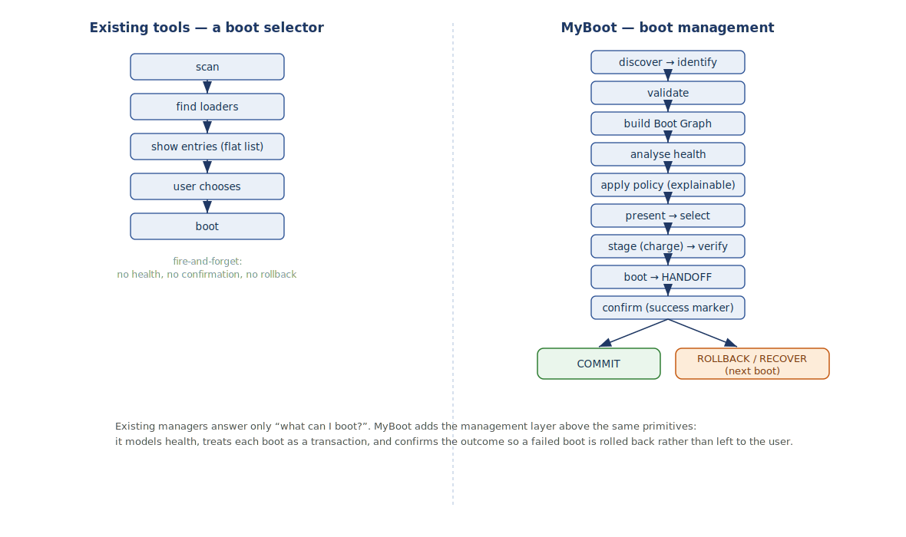
Figure 2.2: Boot selection versus boot management. Existing tools answer only “what can I boot?”; MyBoot adds a management pipeline above the same primitives, treating each boot as a transaction that is confirmed and, on failure, rolled back.

2.6.3 Flat Menus Rather Than a Semantic Boot Graph
When many operating systems, kernels, generations and recovery environments are present, existing managers display them as a flat, sequential list that quickly becomes cluttered and, in some tools, prone to truncation. Even where structured metadata exists — the Boot Loader Specification entries and NixOS bootspec facts carry distribution, generation and specialisation information — it is generally flattened at presentation time. The opportunity is to build a semantic Boot Graph that groups entries hierarchically by operating system, then generation, then kernel, specialisation and recovery environment, so that a machine with many bootable environments remains navigable. Such a structure scales naturally to an arbitrary number of operating systems multiplied by their kernels, generations and recovery options.
Boot Graph (root)
├─ NVMe0 (internal disk)
│ ├─ Windows
│ │ ├─ Windows 11
│ │ ├─ Windows Recovery (WinRE)
│ │ └─ Windows Boot Manager
│ ├─ NixOS
│ │ ├─ Generation 128 (current · healthy)
│ │ │ └─ Specialisation: VFIO Gaming
│ │ ├─ Generation 127 (rollback target)
│ │ └─ Generation 126
│ └─ Ubuntu
│ ├─ Kernel 6.x (current)
│ └─ Kernel 6.x (previous / fallback initramfs)
└─ USB0 (removable)
└─ Linux installer

2.6.4 Absence of a Transactional Boot Model with Confirmation and Rollback
Existing managers largely treat a boot attempt as fire-and-forget: the selected entry is launched, and if it fails the user is left to guess what happened and to remedy it manually. The closest existing precedent for a better model is systemd-boot's boot counting, which decrements an attempt counter encoded in each entry and falls back to an older, working entry until user space marks the boot good; a comparable idea appears in the snapshot ecosystem, where the grub-btrfs tool lists Btrfs snapshots created by tools such as Snapper in the GRUB menu and allows a user to boot a read-only snapshot before committing to a full rollback. These precedents are valuable but partial: they are specific to one operating system or one filesystem and are not unified into a cross-operating-system transactional model. The opportunity is to treat every boot as a transaction — validated, staged, launched, then either confirmed and committed on success or rolled back on failure — across all supported systems, with the boot health of each candidate environment made explicit in the interface.
Transactional boot lifecycle
DISCOVER → IDENTIFY → VALIDATE → BUILD BOOT GRAPH
→ ANALYSE HEALTH → APPLY BOOT POLICY → PRESENT
→ SELECT → STAGE → VERIFY → BOOT → CONFIRM
├─ success → COMMIT
└─ failure → ROLLBACK / RECOVER

2.6.5 No Universal Boot-Result Protocol
The transactional model runs into a genuine and interesting technical obstacle. Once the manager transfers control to an operating system it no longer runs, so it cannot directly observe whether the system reached a usable state. Confirming success therefore requires a cooperative boot-result protocol: the booted system must record, through an agreed mechanism such as a firmware variable or a marker on the ESP, that it started successfully, so that the next invocation of the manager can distinguish a completed boot from one that failed after handoff. systemd's boot-count-and-mark-good scheme is a partial, Linux-specific instance of exactly this idea. No such protocol is shared across Windows, Linux, the BSDs and custom systems, and designing a small, well-defined lifecycle of boot states that cooperating systems can report is one of the stronger opportunities this project identifies, tempered by the honest recognition that broad adoption of any such protocol is itself difficult.

2.6.6 Fragmented Configuration and Boot-Order Drift
Boot configuration is scattered across the UEFI firmware's boot-order and boot-selection variables, the Windows Boot Configuration Data store, and the several configuration formats of the Linux managers, with no federating view. Because installers and updates re-assert their own entries — Windows in particular re-registers its boot manager and re-orders the firmware entries on update — the effective configuration drifts silently, and users routinely discover that one operating system's installer has displaced another's boot manager. The opportunity is not to invent yet another configuration syntax but to provide a single declarative model that describes the desired boot state, generates the appropriate native entries, and periodically reconciles the desired state against the actual firmware state, detecting drift and offering repair, while leaving each operating system's own configuration untouched.

2.6.7 Poor Observability, Fragmented Recovery and Unsafe Self-Update
When a boot fails, existing managers typically offer a black screen or an opaque error code and little structured diagnosis, and the tools required to investigate — hardware health, firmware state, signature status — often become available only after a separate live environment is booted. Recovery is similarly fragmented across the Windows Recovery Environment, the various Linux approaches and the NixOS generations, so that a user facing a machine that will not start must understand several distinct mechanisms. Finally, a manager that updates its own binary can brick a machine if the new version is defective, yet existing tools rarely provide an atomic, self-rolling-back update path. The opportunities here are structured pre-boot diagnostics with exportable logs, a single cross-operating-system recovery interface that presents every viable fallback in one place with an explainable recommendation, and — as future work — an atomic update mechanism for the manager itself with automatic rollback on a failed candidate.

2.6.8 Absence of Formal Verification in Boot Managers
A final gap concerns assurance. The mainstream multi-boot managers — GRUB, systemd-boot and rEFInd — are not formally verified; their correctness rests on testing and long field exposure. This is not for want of precedent in adjacent fields. The seL4 microkernel carries a machine-checked proof of functional correctness in the Isabelle/HOL proof assistant; the CompCert C compiler is specified and proven correct in the Rocq prover, formerly named Coq, so that its generated code is guaranteed to behave as the source prescribes; and the HACL* and EverCrypt libraries provide cryptographic code verified in F*, compiled to C, and deployed in production in Mozilla Firefox, the Linux kernel and the WireGuard VPN. The tools therefore exist and are mature; they have simply not been brought to bear on the boot-manager layer, where the BootHole vulnerability showed the concrete cost of an unverified configuration parser running before any security control is active.
For a memory-safe Rust implementation the opportunity is unusually tractable, because verification tooling now targets Rust directly. The Kani model checker, developed at Amazon Web Services, compiles proof harnesses from Rust and checks for panics, arithmetic overflow and out-of-bounds access without requiring annotations; it has been used to prove that the untrusted-input parser in the Firecracker virtual-machine monitor cannot be driven to panic by malformed guest input — precisely the property that MyBoot's GPT, FAT, PE/COFF, Boot Loader Specification and bootspec parsers must satisfy against untrusted on-disk data. The opportunity this project identifies is therefore twofold: to specify the boot transaction's safety and liveness at the design level in a model checker, and to verify the boot-critical parsers at the level of the implementation code, so that the central promise — that a defective boot can never leave the machine unbootable — is supported by machine-checked argument rather than by testing alone. The limit must be stated honestly: a design-level proof establishes that the model is correct, not that the Rust matches the model, and a full functional proof of an entire boot manager, in the manner of seL4 or CompCert, is a person-years undertaking beyond this project's scope.
Eight candidate verification tools were evaluated for their fit to this project. The table below summarises the assessment and the approach adopted: model checking of the design in TLA+, code-level verification of the parsers in Kani, and, optionally, verified cryptography in F* for the Secure Boot signature path.
Tool | Kind | Notable track record | Fit for this project
TLA+ | Specification and model checking (temporal logic) | Used at AWS since 2011 to design S3, DynamoDB and other services; created by Leslie Lamport | Adopted at the design level: model the boot transaction, the boot-result protocol and NVRAM reconciliation, and check safety and liveness.
Kani | Bounded model checker for Rust (from AWS) | Proved panic-freedom of the untrusted-input parser in the Firecracker virtual-machine monitor | Adopted at the code level: verify the GPT, FAT, PE/COFF, BLS and bootspec parsers on the actual Rust.
F* / Low* | Proof-oriented language extracting to C | HACL*/EverCrypt verified cryptography deployed in Firefox, the Linux kernel and WireGuard | Optional, for the Secure Boot signature subsystem specifically.
Coq / Rocq | Interactive proof assistant (dependent types) | CompCert verified C compiler; the Four Colour Theorem | Powerful but heavy; algorithm-level proofs only as a stretch goal.
Lean 4 | Proof assistant and functional language | Mathlib; large pure-mathematics formalisations | Mathematics-leaning; not aimed at no_std systems code.
Alloy | Bounded structural model finder | Found protocol bugs in Chord; judged by AWS less expressive than TLA+ | Useful for Boot Graph and configuration constraints; secondary to TLA+.
Idris 2 / Agda | Dependently typed functional languages | Academic programming-language research | Research-oriented; not suited to producing the shipping binary.
ACL2 | Automated reasoning (Common Lisp) | Floating-point hardware verification at AMD | Built for arithmetic and hardware; a weak fit — not adopted.

2.7 From Boot Selection to Boot Management: The Conceptual Framework
From the gaps above, the project adopts a conceptual framework that reframes the boot manager as a boot-management platform. The framework is organised around a strict separation of concerns and a single uniform data model, and it is built above the firmware's existing boot-selection primitives rather than replacing the operating systems' native configuration.
A platform layer wraps the firmware services — graphics, storage, filesystem access and firmware variables — behind safe Rust abstractions. A discovery layer enumerates disks, partitions, the EFI System Partition, firmware boot variables and Boot Loader Specification entries, and reduces everything it finds to a uniform, operating-system-agnostic model of bootable targets. Above discovery sits the distinctive contribution: a Boot Graph engine that organises those targets into the semantic hierarchy described earlier; a set of operating-system adapters, each contributing discovery, identification, validation, health reporting and launch behaviour for one system behind a common interface, so that support for a new system is a matter of adding an adapter rather than modifying the core; a health-and-validation component that checks the presence and integrity of each target's loader, kernel and supporting files and records the outcome of previous boots; a deterministic and explainable policy engine that recommends a default from that health information according to stated rules rather than an opaque model; and a transaction manager that validates, stages, launches, confirms and, on failure, rolls back or invokes recovery. A presentation layer renders the Boot Graph and its health annotations as a graphical menu and gathers the user's selection, remaining ignorant of filesystems and operating-system internals and seeing only the uniform model. A configuration layer maintains the declarative desired state and reconciles it against the firmware. Beneath everything, an execution layer performs the actual launch — chainloading the Windows boot manager, loading a Linux EFI stub, resolving a NixOS generation — and, at the defining moment of the whole system, exits the firmware boot services and transfers control to the operating system, after which the manager's responsibility ends until the cooperative success marker is read on the next boot.
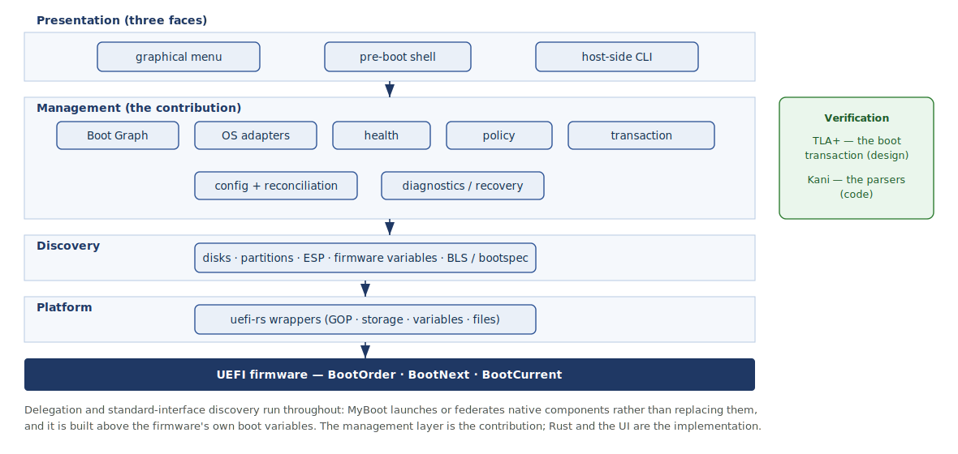
Figure 2.3: The boot-management conceptual framework: a layered engine (platform, discovery, management, presentation) built above the firmware's own boot variables, with the transaction and parsers verified. The management layer is the contribution; Rust and the interface are implementation.
Two principles run through this framework. The first is delegation: wherever an operating system provides its own boot component or configuration store, the manager launches or federates it rather than replacing it, following the existing managers in their use of chainloading and following Lanzaboote in deferring verification to the firmware. The second is discovery and decision through standard interfaces and explainable rules rather than guesswork: the manager reads the Boot Loader Specification and the NixOS bootspec facts, and its policy engine recommends defaults through deterministic, auditable logic, deliberately keeping any unpredictable model out of the critical boot path. The central research question of the project follows directly from this framework: whether a UEFI boot manager can provide a transactional, declarative, operating-system-agnostic boot-environment model — with automatic discovery, health verification, failure detection, rollback, recovery and a graphical interface — built above the firmware's existing primitives rather than replacing native configuration. Chapter Three develops the requirements and detailed design of these subsystems, in which the memory-safe Rust implementation and the graphical interface serve as the technology through which the model is realised, not as the contribution itself.
Two further principles complete the framework. The first is verification of what matters most: the boot transaction's safety and liveness are specified and model-checked at the design level in TLA+, and the boot-critical parsers are verified at the level of the Rust code with Kani, so that the strongest correctness claims rest on machine-checked argument rather than on testing alone, while the gap between a verified model and the running binary is acknowledged rather than concealed. The second is a single engine behind three coordinated faces. All user interaction is a thin presentation over the same Boot Graph and transaction manager: a graphical boot menu rendered on the firmware framebuffer for everyday selection; a pre-boot recovery and inspection shell for diagnosis and manual booting, in the tradition of the GRUB and UEFI shells; and a host-side management command-line tool that runs under an installed operating system, where installation, image signing, application of the declarative configuration and reconciliation of the firmware state are most safely performed. This mirrors the established pairing of a menu with a host-side tool seen in systemd-boot with its bootctl utility, GRUB with grub-install, and rEFInd with its installer, and it reinforces the separation of concerns by keeping every interface ignorant of everything below the uniform model.

2.8 Chapter Summary
This chapter has established why the project targets UEFI rather than legacy BIOS, has distinguished the boot loader, the boot manager and the stronger notion of boot management that organises the project, and has critically surveyed seven representative open-source projects, finding each strong at selection or loading but stopping short of management. It has examined the native boot protocols of Windows, Linux, NixOS and macOS, taking corrective positions on the Windows boot-manager path and on NixOS generation discovery and a defensible position on excluding direct macOS booting. It has set out, in detail and with honest crediting of partial precedents such as systemd-boot's boot counting and grub-btrfs snapshot booting, the gaps in the current ecosystem: the unoccupied middle ground and the memory-safety opportunity; the prevalence of boot selectors over boot intelligence; flat menus rather than a semantic Boot Graph; the absence of a transactional model with confirmation and rollback; the lack of a universal boot-result protocol; fragmented configuration and boot-order drift; poor observability, fragmented recovery and unsafe self-update; and the absence of formal verification in existing boot managers despite mature tools in adjacent fields. From these it has derived a boot-management conceptual framework, centred on a Boot Graph, an adapter architecture, a health-aware and explainable policy engine, a transactional lifecycle and a reconciling declarative configuration, together with a verification strategy that pairs design-level model checking in TLA+ with code-level verification of the parsers in Kani, and a single engine presented through three coordinated interfaces, which guides the design developed in the next chapter.

References
Arch Linux. rEFInd; systemd-boot; Limine; grub-btrfs. ArchWiki and Arch manual pages. https://wiki.archlinux.org/
Antynea and contributors. grub-btrfs — include Btrfs snapshots at boot options. https://github.com/Antynea/grub-btrfs
Dortania. OpenCore Install Guide and Legacy Patcher documentation. https://dortania.github.io/
Eclypsium. There's a Hole in the Boot (BootHole, CVE-2020-10713). https://eclypsium.com/2020/07/29/theres-a-hole-in-the-boot/
freedesktop.org. systemd-boot and loader.conf manual pages; Automatic Boot Assessment. https://www.freedesktop.org/software/systemd/man/
Limine Bootloader. Limine — a modern, advanced, portable, multiprotocol bootloader. https://github.com/limine-bootloader/limine
NIST. CVE-2020-10713 (BootHole). National Vulnerability Database. https://nvd.nist.gov/vuln/detail/cve-2020-10713
NixOS. Bootloader and Lanzaboote articles; RFC 0125 (Bootspec); systemd-boot builder in nixpkgs. https://wiki.nixos.org/ and https://github.com/NixOS/
Rod Smith. The rEFInd Boot Manager. https://www.rodsbooks.com/refind/
rust-osdev. bootloader and uefi-rs. https://github.com/rust-osdev/
Lanzaboote contributors. Lanzaboote: Secure Boot for NixOS. https://github.com/nix-community/lanzaboote
x86.lol. Lanzaboote: Towards Secure Boot for NixOS. https://x86.lol/generic/2022/11/26/lanzaboote.html
Newcombe, C. et al. How Amazon Web Services Uses Formal Methods. Communications of the ACM, 2015; and Systems Correctness Practices at AWS. https://cacm.acm.org/
Kani Rust Verifier (model-checking/kani), Amazon Web Services. https://model-checking.github.io/kani/
Lattuada, A. et al. Verus: Verifying Rust Programs Using Linear Ghost Types. OOPSLA, 2023.
Leroy, X. et al. CompCert — a formally verified optimizing C compiler (Rocq/Coq). https://compcert.org/
Klein, G. et al. seL4: Formal Verification of an OS Kernel (Isabelle/HOL). https://sel4.systems/
Project Everest. HACL*, ValeCrypt and EverCrypt — verified cryptography in F*. https://project-everest.github.io/
de Moura, L. and Ullrich, S. The Lean 4 Theorem Prover; Mathlib community. https://lean-lang.org/
Jackson, D. Alloy: a language and tool for relational models. https://alloytools.org/
The Rocq Prover (formerly Coq). https://rocq-prover.org/

