MYBOOT
An Intelligent, Transactional UEFI Boot-Environment Manager Written in Rust
System Project Report
Chapter Three
System Analysis and Design
Prepared by Shaka
Independent Systems Engineering Project
Version 1.0 · August 2026

Chapter Three: System Analysis and Design

3.1 Introduction
Chapter Two established the conceptual framework: a boot-management platform organised as a layered engine — platform, discovery, Boot Graph, operating-system adapters, health and validation, an explainable policy engine, a transaction manager and a reconciling configuration layer — presented through three coordinated interfaces, with the boot-critical properties to be verified rather than only tested. This chapter turns that framework into a concrete design. It states the requirements, analyses the boot pipeline as an ordered process, fixes the architecture and its module decomposition, and then specifies each distinctive subsystem: the Boot Graph data model, the BootProvider adapter interface, the transaction manager and its cooperative boot-result protocol, the declarative configuration and its reconciliation against firmware, the persistence model and the reasoned exclusion of a relational database, the three user interfaces, and finally the two verification artefacts — a TLA+ specification of the boot transaction and a Kani harness plan for the parsers. Design decisions that rest on external facts are grounded in the UEFI specification and the systemd Boot Loader Interface, which are cited in the References.

3.2 Requirements

3.2.1 Actors
- The user. Selects an operating system at boot, and occasionally repairs or reconfigures the machine. Wants a fast, legible menu and a machine that always starts.
- The installed operating systems. Provide their own EFI boot components, which MyBoot launches, and — for the transactional model — cooperate by recording a success marker once they reach a usable state.
- The administrator / developer. Installs and signs MyBoot, edits the declarative configuration, and runs the host-side tool to reconcile firmware state and garbage-collect old generations.
- The platform firmware. Launches MyBoot as a UEFI application, exposes boot services, the framebuffer, storage, and the boot-order variables, and revokes its services at handoff.

3.2.2 Functional Requirements
ID | Requirement
FR1 | Discover every bootable environment across all disks, the ESP, the firmware boot variables and Boot Loader Specification entries.
FR2 | Assemble a semantic Boot Graph grouping targets by operating system, then generation, kernel, specialisation and recovery.
FR3 | Validate each target and compute a health status (healthy, degraded, unbootable, unknown).
FR4 | Present the Boot Graph through three interfaces: a graphical menu, a pre-boot shell and a host-side command-line tool.
FR5 | Launch a target through the correct provider: Windows chainload, Linux EFI stub, Linux direct load, NixOS generation, or generic EFI chainload.
FR6 | Treat each boot as a transaction: stage, launch, then confirm and commit on success or roll back on failure.
FR7 | Obtain a cooperative success marker from the booted operating system to distinguish a completed boot from one that failed after handoff.
FR8 | Maintain a declarative configuration and reconcile it against the firmware state, detecting and repairing boot-order drift.
FR9 | Record structured pre-boot diagnostics and an exportable boot-history log.
FR10 | Provide a single cross-operating-system recovery interface with an explainable recommended action.
FR11 | Operate under Secure Boot: ship a signed image and verify (or defer to firmware) the images it launches.
FR12 | Be extensible to new operating systems by adding a provider, without modifying the core.

3.2.3 Non-Functional Requirements
ID | Requirement | Approach
NFR1 | Safety: never leave the machine unbootable. | Transactional rollback; a fallback or recovery is always reachable — proven in TLA+ (3.11).
NFR2 | Memory safety: no undefined behaviour in parsers. | Rust, plus Kani proofs of panic- and out-of-bounds-freedom (3.12).
NFR3 | Reliability: predictable default selection. | A deterministic, explainable policy engine; no opaque model in the boot path.
NFR4 | Performance: fast discovery and handoff. | In-memory Boot Graph; lazy validation; optional double-buffered UI.
NFR5 | Footprint: fit the ESP and firmware limits. | A small no_std binary; state kept out of scarce NVRAM (3.9).
NFR6 | Portability: tolerate imperfect firmware. | Degrade gracefully when a protocol is missing; never assume conformance.
NFR7 | Security: protect the boot chain. | Signed image; configuration-integrity hash; least privilege.
NFR8 | Usability at large N. | Collapsible Boot Graph; keyboard and pointer; health badges.
NFR9 | Verifiability of critical properties. | Design-level model checking (TLA+) and code-level verification (Kani).

3.3 System Analysis: The Boot Pipeline
The system is analysed as an ordered pipeline that transforms the raw firmware environment into a committed boot. Each stage has a single responsibility and communicates with the next only through the uniform model, so that the interfaces and the operating-system adapters remain ignorant of one another's internals.
- Initialise: receive the UEFI image handle and system table; acquire the framebuffer, storage and file protocols; open the manager's own ESP volume.
- Discover: enumerate disks and partitions (GPT), identify filesystems, read the ESP, the firmware boot variables and the Boot Loader Specification entries.
- Model: hand each provider the discovered volumes; merge their targets into the semantic Boot Graph; compute a stable identifier for every entry.
- Validate: check the presence and integrity of each target's loader, kernel and supporting files; annotate each entry with a health status and its last recorded result.
- Decide: apply the deterministic policy engine to recommend a default from health, last-good history and configuration.
- Present: render the Boot Graph through the active interface and obtain the user's selection (or time out to the recommended default).
- Transact: begin a boot transaction — validate the choice, stage it (charging the attempt), and prepare the handoff.
- Execute: acquire the memory map, call ExitBootServices, and transfer control through the target's provider; the manager no longer runs.
- Confirm: on the next invocation, read the cooperative success marker; commit the previous attempt or, if it failed, roll back to a fallback or enter recovery.

3.4 Architecture and Module Decomposition
The architecture is a single engine behind three faces. The engine is a set of Rust crates with strictly one-directional dependencies, from the uniform model outward to the firmware; no crate above the model layer depends on a specific filesystem, partition scheme or operating system. The three interfaces are thin front-ends over the engine and share its Boot Graph and transaction manager.
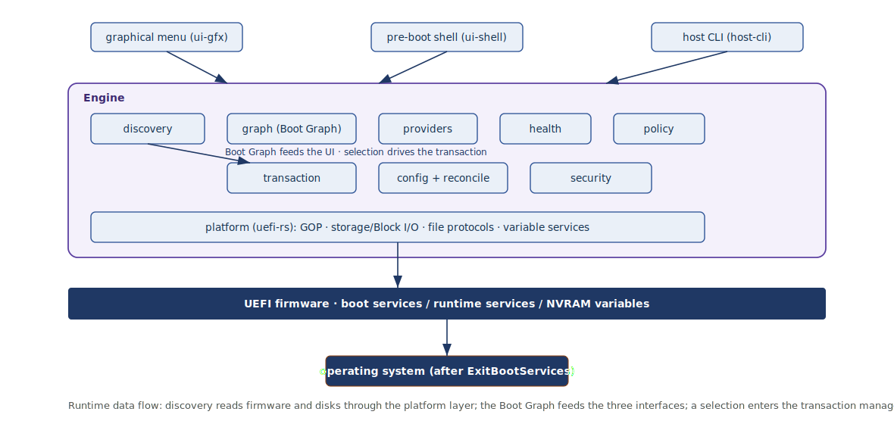
Figure 3.1: Runtime architecture and data flow: discovery reads the firmware and disks through the platform layer; the Boot Graph feeds the three interfaces; a selection enters the transaction manager, which launches and exits boot services to the operating system.
Module (crate) | Responsibility
platform | Safe wrappers over UEFI: system table, boot services, GOP framebuffer, Simple File System, Block I/O, and the variable services (GetVariable / SetVariable).
storage | GPT and MBR parsing, FAT reading, ESP location; presents a VolumeSet to the rest of the engine.
discovery | Enumerates volumes, firmware variables and Boot Loader Specification entries; produces raw targets.
graph | The Boot Graph data model and its construction, ordering and stable identity.
providers | One BootProvider per OS family: Windows, Linux (stub and direct), NixOS, generic EFI, recovery.
health | Validation and health scoring; reads the last recorded boot result.
policy | The deterministic, explainable default-selection engine.
transaction | The boot transaction: staging, the success-marker protocol, commit, rollback and recovery.
config | The declarative configuration and its reconciliation against firmware.
persistence | NVRAM variables and ESP files (see 3.9); no database engine.
ui-gfx / ui-shell / host-cli | The graphical menu, the pre-boot shell, and the host-side management tool.
security | Secure Boot integration, signature checks and configuration integrity.

3.5 The Boot Graph Data Model
The Boot Graph is the single uniform model over which every interface and decision operates. It is a shallow tree — disks, then operating systems, then entries — and it is derived state: it is rebuilt in memory on each boot from discovery and is never itself persisted. Each entry carries a stable identifier, its role in the hierarchy, the method by which it is launched, the paths it needs, a health status and its last recorded result.
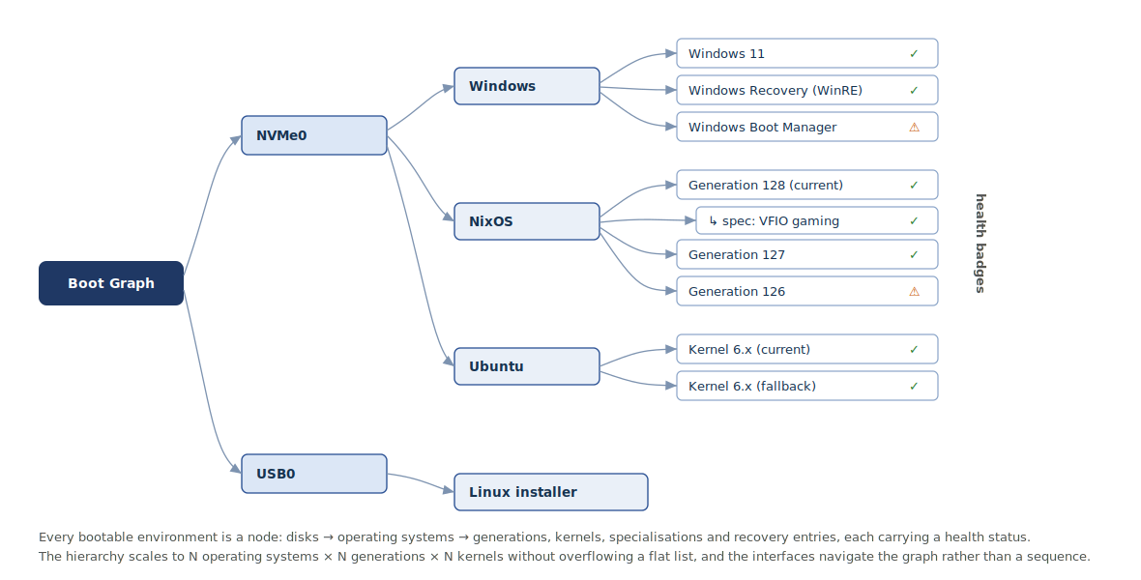
Figure 3.2: The Boot Graph: every bootable environment is a node — disks, then operating systems, then generations, kernels, specialisations and recovery entries — each annotated with a health status, so the hierarchy scales without overflowing a flat list.
pub struct BootGraph { pub disks: Vec<DiskNode> }
pub struct DiskNode { pub id: DiskId, pub label: String, pub systems: Vec<OsNode> }
pub struct OsNode {
pub kind: OsKind,
pub name: String,
pub entries: Vec<BootEntry>, // generations / kernels / recovery
}
pub struct BootEntry {
pub id: EntryId, // STABLE across reboots (see 3.5)
pub title: String,
pub role: EntryRole,
pub method: BootMethod,
pub loader: Option<EfiPath>,
pub kernel: Option<EfiPath>,
pub initrd: Option<EfiPath>,
pub cmdline: Option<String>,
pub health: Health,
pub last_result: Option<BootResult>,
}
pub enum OsKind { Windows, Linux, NixOs, Bsd, GenericEfi, Recovery }
pub enum EntryRole {
Default,
Generation(u32),
Specialisation { parent: u32, name: String },
Kernel(String),
Recovery,
Fallback,
}
pub enum BootMethod {
WindowsBootManager, // chainload \EFI\Microsoft\Boot\bootmgfw.efi
LinuxEfiStub, // chainload a PE-masquerading kernel
LinuxDirect, // load kernel + initrd, build boot params
NixGeneration, // resolve a generation via bootspec
EfiChainload, // any other native .efi loader
}
pub enum Health { Healthy, Degraded(Reason), Unbootable(Reason), Unknown }
Two design points deserve emphasis. First, the identifier must be stable across reboots so that the transaction manager, the configuration and the logs can refer to the same entry over time even as generations are added and removed; it is therefore derived deterministically from stable attributes of the entry (its operating system, role and loader path) rather than from a discovery-order index. Second, health is a first-class annotation rather than a computed afterthought, because the policy engine, the interfaces and the recovery facility all consume it; an entry is degraded or unbootable with a machine-readable reason, not merely present or absent.

3.6 The BootProvider Adapter Interface
Support for each operating system is encapsulated behind a single trait. A provider discovers its own targets, re-validates and scores them, describes them for the interface, and launches them; it knows nothing of any other provider, and the engine merges the providers' output into the Boot Graph. Adding a new operating system is therefore a matter of implementing this trait and registering the provider, satisfying the extensibility requirement without touching the core.
/// One provider per OS family. A provider never knows about any other;
/// the engine owns the set and merges their output into the Boot Graph.
pub trait BootProvider {
/// Which OS family this provider handles.
fn kind(&self) -> OsKind;
/// Enumerate bootable targets found on the given volumes.
fn discover(&self, vols: &VolumeSet) -> Result<Vec<BootTarget>, DiscoverError>;
/// Re-check that a target is still launchable and score its health.
fn validate(&self, t: &BootTarget, vols: &VolumeSet) -> Health;
/// UI-facing description (title, subtitle, icon hint, role).
fn describe(&self, t: &BootTarget) -> Descriptor;
/// Prepare and launch. On SUCCESS control never returns (handoff);
/// this returns only if the launch itself failed.
fn boot(&self, t: &BootTarget, bs: &BootServices)
-> Result<core::convert::Infallible, BootError>;
}
The concrete providers mirror the boot protocols analysed in Chapter Two. The Windows provider chainloads the Windows Boot Manager. The Linux providers offer two levels — chainloading the EFI-stub kernel, and, as an advanced capability, loading the kernel and initial RAM disk directly and constructing the boot parameters. The NixOS provider resolves generations and specialisations from the bootspec facts. A generic EFI provider chainloads any other native loader, and a recovery provider surfaces recovery environments. The signature of boot encodes an important invariant: on success control passes to the operating system and never returns, so the method's success type is uninhabited and it yields a value only on failure.

3.7 The Transaction Manager and Boot-Result Protocol
The transaction manager treats a boot as a staged transaction that is committed only once the booted system is known to have started. Its phases correspond exactly to the states of the formal specification in Section 3.11: an entry is selected, validated, staged, launched and then either confirmed or failed, after which the manager rolls back to a fallback or enters recovery. The attempt is charged at the staging step — a counter for the entry is decremented before handoff — so that a boot which crashes after control has left the manager is correctly counted against that entry rather than being lost.
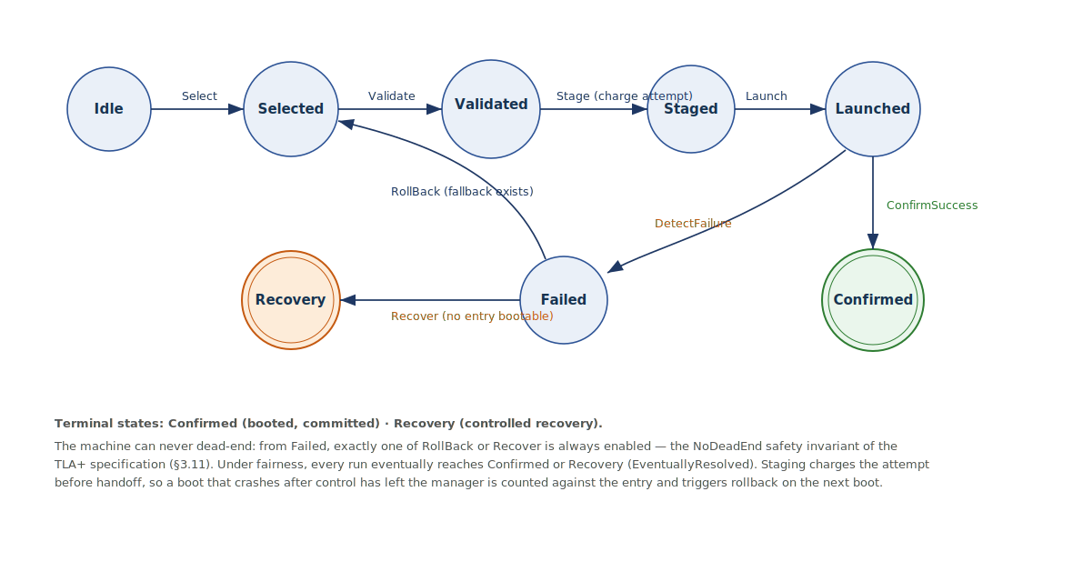
Figure 3.3: The boot transaction as a state machine, corresponding to the TLA+ specification of Section 3.11. From Failed exactly one of RollBack or Recover is always enabled (the NoDeadEnd invariant); Confirmed and Recovery are terminal.
The crux is confirmation across the irrevocable handoff. Because the manager stops running at ExitBootServices, it cannot observe success directly; it relies on a cooperative marker, and the design follows the established systemd Boot Loader Interface rather than inventing a new scheme. Under that interface the boot loader records which entry was booted in the EFI variable LoaderEntrySelected, the operating system sets the persistent or one-shot default through LoaderEntryDefault and LoaderEntryOneShot, and, when boot counting is enabled, the loader exposes LoaderBootCountPath, whose filename encodes the remaining and used attempt counters; a small operating-system service then marks the boot good once a completion target is reached, and the loader falls back to an older, working entry when the counter is exhausted. MyBoot adopts the same pattern: it decrements the counter at staging, and on the next boot the absence of a success mark means the previous attempt failed and must be rolled back; a success mark restores the entry's credit and commits it as the new last-good. The native firmware variables complement this — BootNext is used for a one-shot trial of a candidate and is deleted by the firmware before control transfers, and BootCurrent identifies the option chosen on the current boot.
The honest limit, already noted in Chapter Two, is that this requires the booted system to cooperate. Linux and NixOS can run the marking service directly; for Windows a small host-side helper performs the equivalent mark, and for a system that cannot cooperate at all the manager degrades to a conservative heuristic — a bounded one-shot trial via BootNext with user confirmation — rather than making an unsafe automatic commitment. In all cases the safety property holds: an unconfirmed boot is treated as a failure, and failure always has a defined path forward.

3.8 Declarative Configuration and Reconciliation
The configuration is declarative: it states the desired boot state rather than a sequence of edits, and the manager's job is to make the firmware match it. The format is a small, human-editable TOML file kept on the ESP; it names the default, the timeout and policy, the transaction parameters, the entries and their launch methods, and the recovery options.
[boot]
default = "nixos.current" # entry id or a symbolic default
timeout = 5 # seconds; "menu-force" = always show
policy = "last-good-then-default"
[transaction]
confirm = true # require a success marker from the OS
max_tries = 2 # attempts before an entry is deemed bad
rollback = "last-good" # last-good | previous-generation | recovery
[[entry]]
id = "windows"
method = "efi-chainload"
loader = "\EFI\Microsoft\Boot\bootmgfw.efi"
[[entry]]
id = "nixos"
method = "nixos-generation"
source = "bootspec" # discover generations from bootspec
[recovery]
shell = true # expose the pre-boot recovery shell
uefi_shell = true # offer the firmware UEFI Shell if present
Reconciliation compares this desired state with the actual firmware state and applies the minimal set of changes to close the gap, exactly as an installer would but continuously and reversibly. The desired entries are planned as EFI_LOAD_OPTION structures for the Boot#### variables together with an ordered BootOrder array of UINT16 identifiers; the actual state is read back with GetVariable; and the difference is applied and then verified, with a snapshot retained so that a failed application can be rolled back. This is the mechanism that repairs the boot-order drift analysed in Chapter Two, in which a Windows update re-asserts its own boot manager at the head of the order: reconciliation detects that the actual order no longer matches the desired one and restores it, without altering any operating system's own configuration.
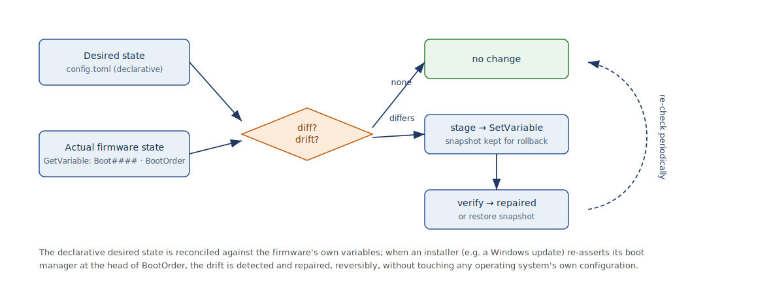
Figure 3.4: Declarative reconciliation: the desired state (config) is compared with the firmware's own variables and drift is repaired reversibly — for instance when a Windows update re-asserts its boot manager at the head of BootOrder.
reconcile(config, firmware):
desired = plan_entries(config) # Boot#### images + BootOrder
actual = read_firmware() # GetVariable: Boot####, BootOrder
diff = compare(actual, desired)
if diff.is_empty(): return NoChange
# atomic, reversible application
snapshot = actual.clone() # kept for rollback
for e in diff.added: SetVariable(Boot#### = encode(e)) # EFI_LOAD_OPTION
SetVariable(BootOrder = desired.order) # UINT16[]
for e in diff.removed: DeleteVariable(Boot####)
if read_firmware() != desired: # verify
restore(snapshot); return Failed
return Repaired(diff)
Changes to the configuration are themselves atomic and staged: a new configuration is written as a candidate, validated, and only then made current, with the previous configuration retained, so that a malformed edit can never strand the machine. A candidate entry may additionally be trialled for a single boot through BootNext before being made the persistent default.

3.9 Configuration and State Design: Why No Relational Database
A question that arises naturally, given that the earlier reports in this series describe database-backed web systems, is whether MyBoot needs a relational database. The answer is a reasoned no, on two independent grounds: such a database is both impossible in this environment and unnecessary for this data.
It is impossible because a relational database management system presupposes exactly the services a boot manager does not have. Before an operating system exists there is no process model, no thread scheduler, no virtual-memory manager and no system-call interface; after ExitBootServices even the firmware's own allocator and services are gone. A database engine needs a filesystem stack, a memory manager and concurrency primitives, none of which are available, and embedding one would inflate a binary that must remain small enough to live comfortably on the ESP. Moreover, the ACID transactionality a database offers concerns writes to stored data, whereas the transaction that matters here is a boot; the two are unrelated, and the boot transaction is provided by the manager's own state machine, not by a storage engine.
It is unnecessary because the data is small, hierarchical and largely re-derivable. The total persistent state is a few kilobytes: a default, a timeout, per-entry attempt counters, a last-good marker, and a history log. There are no relational joins to compute, no ad-hoc queries to answer, and no concurrent writers to coordinate — the manager is the single writer, and the Boot Graph itself is rebuilt from discovery on every boot rather than stored. What is required is therefore not a database but a small, well-chosen set of key–value and file stores, organised in three tiers.
Data category | Store | Format | Rationale
Firmware boot order and entries | UEFI NVRAM, global-variable GUID: BootOrder, Boot####, BootNext | EFI_LOAD_OPTION / UINT16 | The firmware's own boot policy and the authoritative launch surface.
Default, selected, one-shot, attempt counters | UEFI NVRAM, MyBoot vendor GUID (Boot-Loader-Interface style) | short strings / small integers | Must survive reboots and be read by the OS; kept tiny to respect scarce NVRAM.
Declarative configuration | ESP file /EFI/MyBoot/config.toml | TOML (text) | Human-editable and larger than NVRAM should hold.
Boot history and diagnostics | ESP file /EFI/MyBoot/log/*.ndjson | append-only NDJSON or CBOR | Grows over time and is exportable; unsuited to NVRAM.
Discovery cache (optional) | ESP file /EFI/MyBoot/cache.cbor | CBOR | Re-derivable; a speed-up, never authoritative.
The Boot Graph | in memory only | Rust structures | Derived each boot from discovery; deliberately not persisted.
This directly answers the corresponding research question from Chapter One: the persistence mechanisms appropriate to a pre-operating-system program are the firmware's own non-volatile variables for the few tiny values that must be read by the firmware or the operating system, and plain files on the EFI System Partition for the configuration and the growing log; a relational database is neither available nor warranted. A practical caution shapes the split between the two file-and-variable tiers: firmware NVRAM is small and has finite write endurance, so only minimal, must-persist state is kept there, and anything that grows — above all the history log — is written to the ESP instead.

3.10 User Interface Design: Three Faces over One Engine
All three interfaces are thin presentations over the same Boot Graph and transaction manager, and none contains boot logic of its own. This both satisfies the requirement for command-line and graphical access and reinforces the separation of concerns, since each face consumes only the uniform model.

3.10.1 The Graphical Boot Menu
The graphical menu is rendered directly on the UEFI Graphics Output Protocol framebuffer using an off-screen buffer that is composited and then copied to the display, with dirty-region tracking to limit the pixels moved per frame. An input router unifies events from the keyboard and from the UEFI Simple Pointer Protocol and USB human-interface devices, so the same navigation works by key or by pointer. The menu presents the Boot Graph collapsed by operating system, with generations and specialisations expandable beneath their parent and a health badge on each entry, and it scales to large numbers of entries by scrolling and grouping rather than by overflowing a flat list.
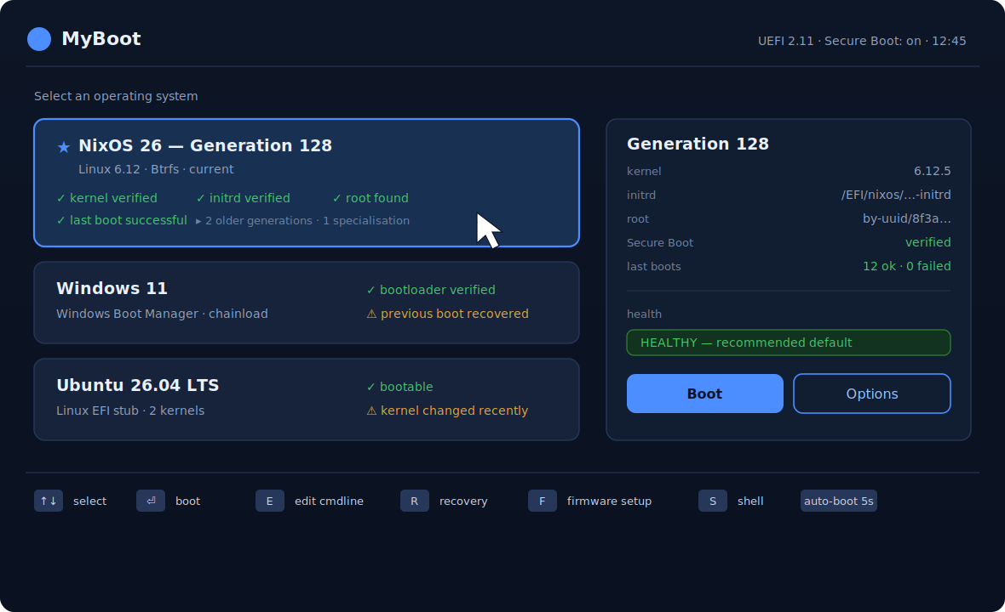
Figure 3.5: The graphical boot menu (design mockup). Entries are shown with health badges and a details panel; NixOS generations collapse under their parent, and the policy engine marks a recommended default.
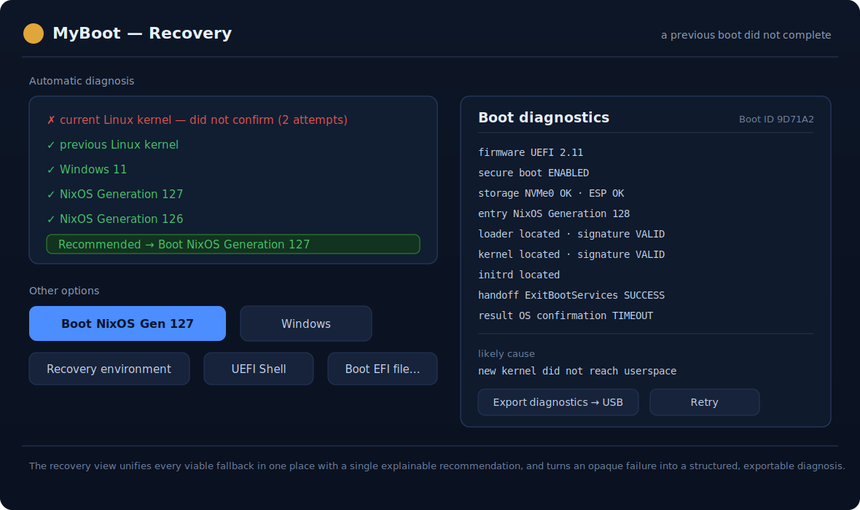
Figure 3.6: The recovery and diagnostics view (design mockup). Every viable fallback is presented in one place with a single explainable recommendation, and an opaque failure becomes a structured, exportable diagnosis.

3.10.2 The Pre-Boot Recovery Shell
The pre-boot shell is a text interface for diagnosis, recovery and development, in the tradition of the GRUB and UEFI shells but operating over the Boot Graph. It is the interface of last resort when the graphical menu cannot serve, and the natural place to inspect state during development.
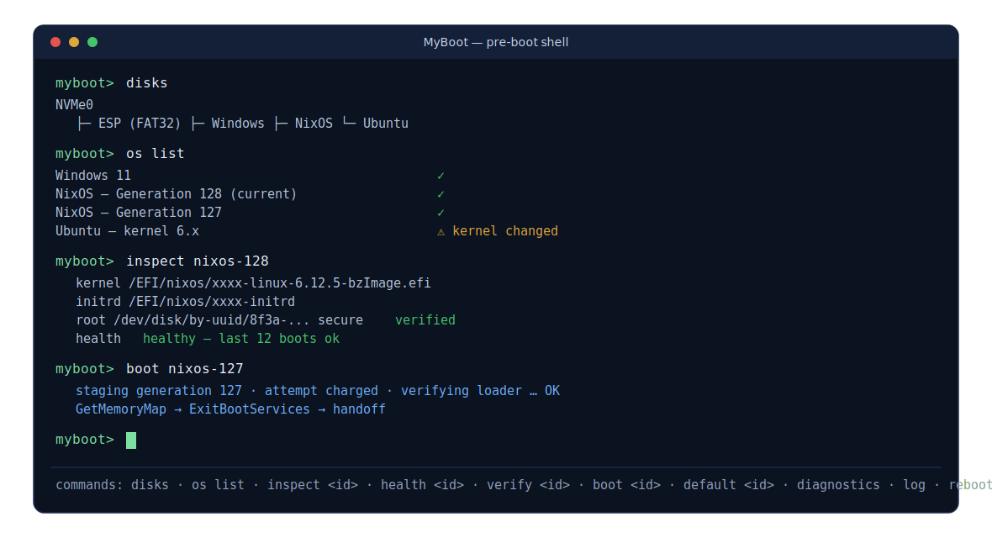
Figure 3.7: The pre-boot recovery shell (design mockup), operating over the same Boot Graph: disks, os list, inspect, health, verify and boot commands, used for diagnosis, recovery and development.
Command | Effect
disks / volumes | List discovered disks, partitions and filesystems.
os list | List the Boot Graph as operating systems and entries.
inspect <id> | Show an entry's method, paths, health and last result.
health <id> | Re-run validation for an entry and explain its status.
boot <id> | Start a boot transaction for the given entry.
default <id> | Set the persistent or one-shot default.
verify <id> | Check signatures and file integrity for an entry.
diagnostics / log | Show firmware and hardware diagnostics; view or export the boot log.
reboot / firmware | Reboot, or reboot into the firmware setup.

3.10.3 The Host-Side Management Tool
The host-side command-line tool runs under an installed operating system, where the operations that are unsafe or impossible before boot are best performed: installing and signing the manager, applying the declarative configuration, reconciling the firmware variables, and garbage-collecting old generations. It reaches the firmware variables through the operating system's facilities — the EFI variable filesystem and the efibootmgr utility on Linux, and the firmware-environment interfaces on Windows — and it is the tool that performs image signing for Secure Boot. This mirrors the established division of labour in which a boot menu is paired with a host-side utility, as with systemd-boot and bootctl, GRUB and grub-install, and rEFInd and its installer.
Command | Effect
myboot install / sign | Install the signed manager to the ESP and register it with the firmware.
myboot config apply / show | Validate and apply the declarative configuration.
myboot reconcile [--repair] | Compare desired and actual firmware state; report or repair drift.
myboot status | Show the Boot Graph, defaults, health and recent boot results.
myboot gc --keep N | Prune old generations and their entries.
myboot enroll-keys | Enrol Secure Boot keys for a self-signed trust chain.
myboot log export | Export the boot-history log for support or debugging.

3.11 Formal Specification of the Boot Transaction (TLA+)
The central safety promise — that a defective boot can never leave the machine unbootable — is specified and machine-checked at the design level in TLA+, the specification language whose use for exactly this kind of state-machine reasoning is well established. The model abstracts a boot as a small state machine over a set of entries, each with a bounded number of attempts; an entry is bootable while it has attempts left. Selecting, validating, staging, launching, confirming, failing, rolling back and recovering are the actions, and the staging action charges the attempt before handoff, mirroring the implementation.
------------------------- MODULE BootTransaction -------------------------
EXTENDS Naturals, FiniteSets
CONSTANTS Entries, \* finite set of boot entries (generations, OSes, recovery)
MaxTries \* attempts allowed per entry before it is deemed bad
NoEntry == CHOOSE x : x \notin Entries
VARIABLES phase, \* phase of the current boot attempt
selected, \* entry chosen to boot, or NoEntry
triesLeft, \* [Entries -> 0..MaxTries] remaining attempts
lastGood, \* last entry confirmed good, or NoEntry
committed \* entry whose boot was committed, or NoEntry
vars == <<phase, selected, triesLeft, lastGood, committed>>
Phases == {"Idle","Selected","Validated","Staged","Launched",
"Confirmed","Failed","Recovery"}
Bootable(e) == e \in Entries /\ triesLeft[e] > 0
StartAttempt == \E e \in Entries : Select(e)
TypeOK ==
/\ phase \in Phases
/\ selected \in Entries \cup {NoEntry}
/\ triesLeft \in [Entries -> 0..MaxTries]
/\ lastGood \in Entries \cup {NoEntry}
/\ committed \in Entries \cup {NoEntry}
Init ==
/\ phase = "Idle" /\ selected = NoEntry
/\ triesLeft = [e \in Entries |-> MaxTries]
/\ lastGood = NoEntry /\ committed = NoEntry
Select(e) ==
/\ phase = "Idle" /\ Bootable(e)
/\ selected' = e /\ phase' = "Selected"
/\ UNCHANGED <<triesLeft, lastGood, committed>>
Validate ==
/\ phase = "Selected" /\ Bootable(selected)
/\ phase' = "Validated"
/\ UNCHANGED <<selected, triesLeft, lastGood, committed>>
Stage == \* charge the attempt BEFORE handoff
/\ phase = "Validated"
/\ triesLeft' = [triesLeft EXCEPT ![selected] = @ - 1]
/\ phase' = "Staged"
/\ UNCHANGED <<selected, lastGood, committed>>
Launch ==
/\ phase = "Staged" /\ phase' = "Launched"
/\ UNCHANGED <<selected, triesLeft, lastGood, committed>>
ConfirmSuccess == \* OS wrote the success marker: commit + restore credit
/\ phase = "Launched"
/\ committed' = selected /\ lastGood' = selected
/\ triesLeft' = [triesLeft EXCEPT ![selected] = MaxTries]
/\ phase' = "Confirmed" /\ UNCHANGED <<selected>>
DetectFailure == \* no success marker: the attempt failed
/\ phase = "Launched" /\ phase' = "Failed"
/\ UNCHANGED <<selected, triesLeft, lastGood, committed>>
RollBack == \* a fallback exists: prefer the last good entry
/\ phase = "Failed" /\ \E e \in Entries : Bootable(e)
/\ selected' = IF Bootable(lastGood) THEN lastGood
ELSE CHOOSE e \in Entries : Bootable(e)
/\ phase' = "Selected"
/\ UNCHANGED <<triesLeft, lastGood, committed>>
Recover == \* nothing bootable: recovery, never a dead end
/\ phase = "Failed" /\ \A e \in Entries : ~Bootable(e)
/\ phase' = "Recovery"
/\ UNCHANGED <<selected, triesLeft, lastGood, committed>>
Next == StartAttempt \/ Validate \/ Stage \/ Launch
\/ ConfirmSuccess \/ DetectFailure \/ RollBack \/ Recover
Fairness == /\ WF_vars(StartAttempt) /\ WF_vars(Validate) /\ WF_vars(Stage)
/\ WF_vars(Launch) /\ WF_vars(DetectFailure)
/\ WF_vars(RollBack) /\ WF_vars(Recover)
Spec == Init /\ [][Next]_vars /\ Fairness
\* Safety: from any FAILED boot a way forward is always enabled.
NoDeadEnd == (phase = "Failed") => (ENABLED RollBack \/ ENABLED Recover)
\* Liveness: every run ends by booting something or reaching recovery.
Resolved == phase \in {"Confirmed","Recovery"}
EventuallyResolved == <>Resolved
THEOREM Spec => []TypeOK
THEOREM Spec => []NoDeadEnd
THEOREM Spec => EventuallyResolved
==========================================================================
Two properties capture the requirement. NoDeadEnd is a safety invariant: whenever a boot has failed, either a rollback or a recovery action is enabled, so the machine is never stuck without a way forward — by construction exactly one of the two is available, depending on whether any entry remains bootable. EventuallyResolved is a liveness property under weak fairness: every run eventually reaches either a confirmed boot or the recovery environment, so the system cannot spin forever or dead-end. Because the attempt counters decrease and are bounded, the model is finite and can be exhaustively checked by the TLC model checker on a small instance — for example three entries with two attempts each — giving confidence that the design satisfies the promise. The limit must be stated plainly, as in Chapter Two: this verifies the design, not that the Rust implementation refines it; closing that gap is the purpose of the code-level verification that follows.

3.12 Code-Level Verification of the Parsers (Kani)
The parsers are the components most exposed to untrusted input — arbitrary bytes read from disk — and therefore the components whose failure would most directly undermine the safety promise. They are verified at the level of the Rust code with Kani, the bounded model checker for Rust, which checks that no input causes a panic, an arithmetic overflow or an out-of-bounds access. The approach is the same one that was used to prove that the untrusted-input parser in the Firecracker virtual-machine monitor cannot be driven to panic by malformed guest input, applied here to the GPT, FAT, PE/COFF and Boot Loader Specification parsers.
// Boot-critical parsers take an untrusted &[u8] from disk. The safety
// property: no input can cause a panic, overflow, or out-of-bounds read.
#[cfg(kani)]
mod proofs {
use super::*;
// 1. GPT header: 512 fully-symbolic bytes must never panic the parser.
#[kani::proof]
#[kani::unwind(2)]
fn gpt_header_parse_never_panics() {
let buf: [u8; 512] = kani::any();
let _ = GptHeader::parse(&buf); // Ok or Err, never a panic
}
// 2. Any offset a GPT entry reports must stay inside the medium.
#[kani::proof]
fn gpt_entry_offsets_ordered() {
let buf: [u8; 128] = kani::any();
if let Ok(p) = GptEntry::parse(&buf) {
assert!(p.first_lba <= p.last_lba);
}
}
// 3. A BLS Type #1 entry of bounded length must parse without panic,
// and every field it returns must be a sub-slice of the input.
#[kani::proof]
#[kani::unwind(257)]
fn bls_entry_fields_within_input() {
let len: usize = kani::any();
kani::assume(len <= 256);
let mut buf = vec![0u8; len];
for b in buf.iter_mut() { *b = kani::any(); }
if let Ok(e) = BlsEntry::parse(&buf) {
assert!(e.title.len() <= len);
if let Some(k) = e.linux.as_ref() { assert!(k.len() <= len); }
if let Some(i) = e.initrd.as_ref() { assert!(i.len() <= len); }
}
}
// 4. A truncated/malformed EFI image must be rejected with Err,
// never a slice-index panic.
#[kani::proof]
fn pe_header_parse_is_total() {
let buf: [u8; 64] = kani::any();
let _ = PeHeader::parse(&buf);
}
}
Each harness feeds a fully symbolic, bounded input and asserts the properties downstream code relies on: that parsing is total (every input yields Ok or Err, never a panic), that reported offsets and lengths stay within the input, and that structural invariants hold. Loops are given explicit unwinding bounds, and the parsers are written against bounds-checked slices so that Kani can discharge the out-of-bounds obligations. A successful proof establishes panic- and out-of-bounds-freedom for all inputs up to the stated bound; the bound is the honest limit of the technique, and it is chosen to cover the structures the on-disk formats actually permit.

3.13 Security Design
Under Secure Boot the firmware will launch only trusted images, so the manager itself is signed, and the integrity of its configuration is protected in the manner Limine demonstrates — by binding a cryptographic hash of the configuration into the signed image — so that the configuration cannot be tampered with independently of the signed binary, which is precisely the weakness the GRUB BootHole vulnerability exploited. For the images the manager in turn launches, verification is, wherever possible, deferred to the firmware's own image-loading service, following the Lanzaboote design, so that the established chain of trust is preserved without re-implementing it; where the manager loads a kernel directly it verifies the signature explicitly, and this is the one subsystem where the verified cryptography of an F*-derived library would be adopted rather than trusted by assertion. The trust chain rests on the platform's own key hierarchy, and development proceeds with self-enrolled keys or with Secure Boot disabled, enabling it only once the signing pipeline is in place.

3.14 Chapter Summary
This chapter has converted the conceptual framework into a concrete design. It stated the actors, functional and non-functional requirements, and analysed the system as an ordered boot pipeline. It fixed a layered architecture with one-directional dependencies and a module decomposition, and specified the Boot Graph data model with stable identity and first-class health, the BootProvider adapter interface with its non-returning launch, and the transaction manager with a cooperative boot-result protocol grounded in the systemd Boot Loader Interface and the UEFI boot variables. It set out the declarative configuration and a reversible reconciliation that repairs boot-order drift, and gave the reasoned persistence model that replaces a relational database with firmware variables for tiny must-persist state, ESP files for the configuration and the growing log, and an in-memory, derived Boot Graph. It described the three interfaces as thin faces over one engine, and finally presented the two verification artefacts: a TLA+ specification whose NoDeadEnd and EventuallyResolved properties formalise the safety promise, and a Kani harness plan that verifies the parsers against untrusted input, with the honest boundary between a verified design and verified code stated in both. Chapter Four will describe the implementation of this design, and Chapter Five its testing and the results of the verification.

References
UEFI Forum. Unified Extensible Firmware Interface Specification, version 2.11, Section 3 (Boot Manager): Boot####, BootOrder, BootNext, BootCurrent and EFI_LOAD_OPTION. https://uefi.org/specs/UEFI/2.11/03_Boot_Manager.html
systemd project. The Boot Loader Interface: LoaderEntrySelected, LoaderEntryDefault, LoaderEntryOneShot, LoaderBootCountPath (vendor GUID 4a67b082-0a4c-41cf-b6c7-440b29bb8c4f). https://systemd.io/BOOT_LOADER_INTERFACE/
systemd project. systemd-boot(7) and systemd-bless-boot(8): Automatic Boot Assessment (boot counting and fallback). https://man7.org/linux/man-pages/man7/systemd-boot.7.html
Boot Loader Specification (BLS). https://uapi-group.org/specifications/specs/boot_loader_specification/
NixOS. RFC 0125: Bootspec. https://github.com/NixOS/rfcs/blob/master/rfcs/0125-bootspec.md
Kani Rust Verifier (model-checking/kani), Amazon Web Services. https://model-checking.github.io/kani/
Lamport, L. Specifying Systems: The TLA+ Language and Tools. Addison-Wesley, 2002; and Newcombe, C. et al., How Amazon Web Services Uses Formal Methods, CACM, 2015.
Lanzaboote contributors. Lanzaboote: Secure Boot for NixOS. https://github.com/nix-community/lanzaboote
Limine Bootloader. Configuration integrity under Secure Boot. https://github.com/limine-bootloader/limine

