MYBOOT
An Intelligent, Transactional UEFI Boot-Environment Manager Written in Rust
System Project Report
Chapter Four
Implementation
Prepared by Shaka
Independent Systems Engineering Project
Version 1.0 · August 2026

Chapter Four: Implementation

4.1 Introduction
This chapter describes how the design of Chapter Three is realised in code. It fixes the development toolchain and the workspace layout, presents the UEFI application entry point and the graphics subsystem against the current uefi-rs interface, gives the parser implementations that the Kani harnesses of Section 3.12 verify, and sets out the build-and-run procedure under emulated firmware. The code shown is representative rather than exhaustive: it establishes the shape of each subsystem and the exact library calls it depends on, so that the remaining code follows the same patterns. Every external interface used here — the uefi-rs entry macro and graphics protocol, the Rust UEFI target, and the QEMU and OVMF invocation — is drawn from the current upstream documentation cited in the References. Five figures document the structures a reader most needs to see: the crate graph, the runtime control flow, the rendering pipeline, the parser pipeline, and the test harness.

4.2 Development Environment and Toolchain
MyBoot is built with the stable Rust toolchain for the dedicated UEFI target and needs no nightly-only standard-library rebuild, because that target is a Tier-2 target shipped with prebuilt core and alloc. The application is a freestanding, no_std program: the standard library is unavailable before an operating system exists, but the core and alloc crates remain usable, the latter because uefi-rs installs a boot-services-backed allocator during initialisation.
- Language and target. Rust (stable), compiling to x86_64-unknown-uefi; the output is a PE/COFF .efi image.
- Core library. uefi-rs, which provides safe wrappers over the UEFI system table, boot services, the Graphics Output Protocol, the file protocols and the variable services.
- Verification. Kani for code-level model checking of the parsers, and the TLA+ tools for the design-level specification of Section 3.11.
- Emulation. QEMU with OVMF, the open-source UEFI firmware, for every build-test cycle before any hardware.

4.3 Workspace and Crate Layout
The system is a Cargo workspace whose members are the crates of the module decomposition from Section 3.4. The dependency direction is enforced by the workspace structure: the interface and engine crates depend inward on the model and the platform wrapper, and never the reverse. Figure 4.1 shows the crate graph, and the listing beneath it shows the directory layout.
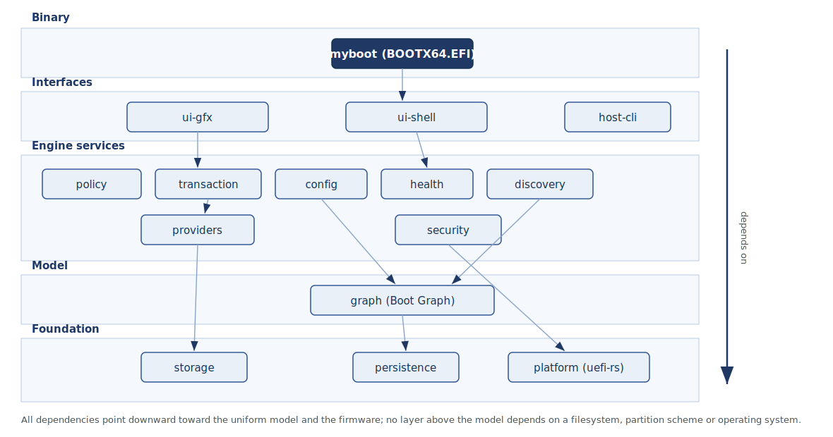
Figure 4.1: Workspace crate dependency graph. Interface and engine crates depend inward on the Boot Graph model and the uefi-rs platform wrapper; the arrow marks the single permitted direction of dependency.
myboot/ # cargo workspace
├── Cargo.toml # [workspace] members
├── crates/
│ ├── platform/ # uefi-rs wrappers: boot, system, GOP, FS, vars
│ ├── storage/ # GPT, MBR, FAT parsers; VolumeSet (Kani-verified)
│ ├── discovery/ # volumes + variables + BLS -> raw targets
│ ├── graph/ # Boot Graph model + construction
│ ├── providers/ # BootProvider impls: windows, linux, nixos, efi
│ ├── health/ # validation + health scoring
│ ├── policy/ # deterministic default selection
│ ├── transaction/ # staging, success marker, rollback, recovery
│ ├── config/ # declarative config + reconciliation
│ ├── persistence/ # NVRAM variables + ESP files (no database)
│ ├── ui-gfx/ # GOP double-buffered menu
│ ├── ui-shell/ # pre-boot text shell
│ └── security/ # Secure Boot, signatures, config integrity
├── bin/
│ └── myboot/ # the UEFI application (compiles to BOOTX64.EFI)
├── host-cli/ # std binary run under an installed OS
└── xtask/ # build + qemu-run + kani helpers
The application binary and the host-side tool are separated deliberately: the binary is the no_std UEFI image, while host-cli is an ordinary std program compiled for the host operating system, since it runs after boot to install, sign, reconcile and garbage-collect. An xtask crate holds the build, emulator and verification helpers so that the whole cycle is driven by cargo commands.
# bin/myboot/Cargo.toml
[package]
name = "myboot"
edition = "2021"
[dependencies]
uefi = { version = "0.33", features = ["alloc", "logger", "panic_handler"] }
storage = { path = "../../crates/storage" }
graph = { path = "../../crates/graph" }
providers = { path = "../../crates/providers" }
# ... remaining engine crates ...
# .cargo/config.toml
[build]
target = "x86_64-unknown-uefi" # Tier-2 target; no build-std required

4.4 The UEFI Application Entry Point
The entry point follows the current uefi-rs model, in which the firmware's system table and image handle are stored globally by the entry macro and reached through freestanding functions rather than passed as arguments. The application is marked no_main and no_std; the marked function is registered as the real entry by the macro, initialises the helper facilities, acquires the resources the engine needs, and delegates to the engine. Figure 4.2 traces the control flow from power-on through the handoff and the subsequent confirmation.
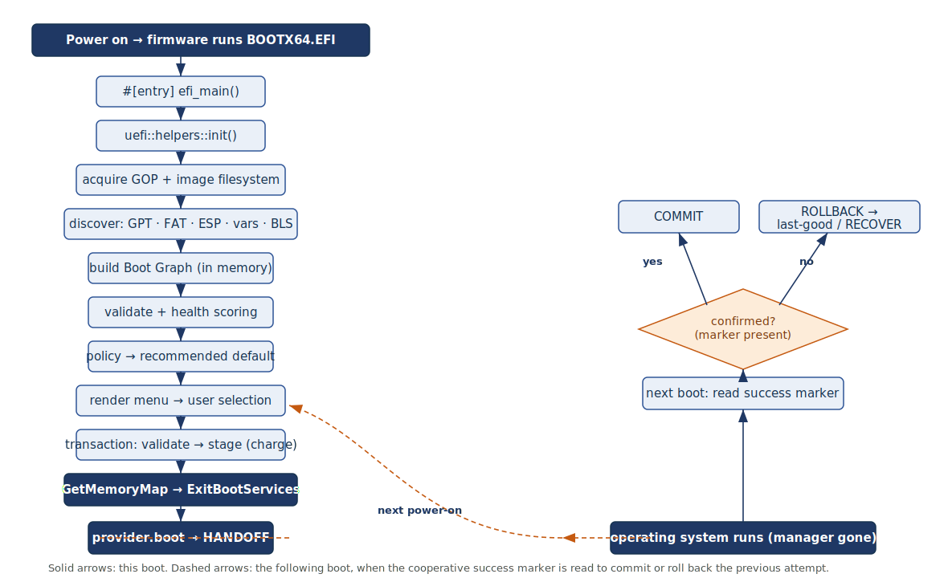
Figure 4.2: Runtime control flow of the UEFI application. Solid arrows are the current boot up to the ExitBootServices handoff; dashed arrows are the following boot, when the cooperative success marker is read to commit or roll back the previous attempt.
// bin/myboot/src/main.rs
#![no_main]
#![no_std]
extern crate alloc;
use uefi::prelude::*;
use uefi::boot;
#[entry]
fn efi_main() -> Status {
// Install logger, allocator and panic handler over boot services.
uefi::helpers::init().expect("uefi init failed");
// The image's own EFI System Partition, for reading MyBoot's files.
let esp = boot::get_image_file_system(boot::image_handle())
.expect("no image filesystem");
// Hand control to the engine. It discovers, builds the Boot Graph,
// renders the menu, runs the boot transaction, and only returns if
// it must fall back to the shell.
match engine::run(esp) {
Ok(never) => match never {}, // Infallible: normally unreachable
Err(e) => { log::error!("engine: {e:?}"); Status::LOAD_ERROR }
}
}
Two details of this entry point matter. The call to the helper initialiser is what makes the logger, the allocator and the panic handler available, and it is performed as early as possible. The engine's success type is uninhabited, mirroring the provider interface of Section 3.6: on a successful boot control passes to the operating system at ExitBootServices and never returns, so the only ordinary return path is an error that sends the user to the recovery shell.

4.5 Graphics: GOP Setup and the Rendering Pipeline
The graphical menu draws into an off-screen buffer held in system memory and copies completed regions to the firmware framebuffer, so that the display never shows a partially drawn frame. The Graphics Output Protocol is obtained through the current uefi-rs functions: a handle for the protocol is located, the protocol is opened exclusively, and the current mode gives the resolution used to size the back buffer. Drawing writes into the back buffer with bounds-checked indexing, and presentation copies either the whole buffer or, more usually, only the changed rectangle, using the protocol's block-transfer operation. Figure 4.3 shows this pipeline.
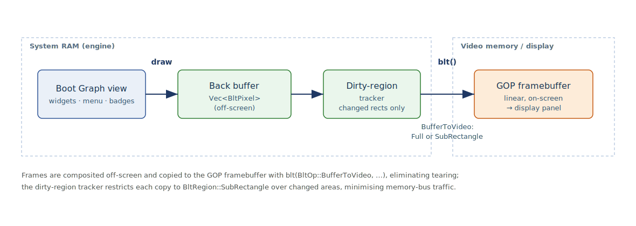
Figure 4.3: The double-buffered GOP rendering pipeline. Widgets are composited into an off-screen buffer in system RAM; a dirty-region tracker restricts each block transfer to the changed rectangle when copying to the on-screen framebuffer.
// crates/ui-gfx/src/framebuffer.rs
use alloc::vec;
use alloc::vec::Vec;
use uefi::boot;
use uefi::proto::console::gop::{BltOp, BltPixel, BltRegion, GraphicsOutput};
pub struct Screen {
gop: uefi::boot::ScopedProtocol<GraphicsOutput>,
w: usize,
h: usize,
back: Vec<BltPixel>, // off-screen buffer in system RAM
dirty: Option<Rect>, // smallest region changed this frame
}
impl Screen {
pub fn open() -> uefi::Result<Self> {
let handle = boot::get_handle_for_protocol::<GraphicsOutput>()?;
let mut gop = boot::open_protocol_exclusive::<GraphicsOutput>(handle)?;
let (w, h) = gop.current_mode_info().resolution();
Ok(Self { gop, w, h, back: vec![BltPixel::new(0,0,0); w*h], dirty: None })
}
#[inline]
pub fn put(&mut self, x: usize, y: usize, px: BltPixel) {
if x < self.w && y < self.h { // bounds-checked write
self.back[y*self.w + x] = px;
self.mark_dirty(x, y);
}
}
/// Copy only the changed rectangle to the GOP framebuffer (no tearing).
pub fn present(&mut self) -> uefi::Result {
match self.dirty.take() {
None => Ok(()),
Some(r) => self.gop.blt(BltOp::BufferToVideo {
buffer: &self.back,
src: BltRegion::SubRectangle { coords: (r.x, r.y), px_stride: self.w },
dest: (r.x, r.y),
dims: (r.w, r.h),
}),
}
}
}
The dirty-region optimisation is not premature: the framebuffer lives across the memory bus, so copying only changed rectangles rather than the whole screen materially reduces the cost of interactive updates such as moving the selection highlight. The same buffer abstraction backs both a bitmap-font text renderer and the widget layer that draws the collapsible Boot Graph.

4.6 Storage and the Parser Implementations
The storage crate turns raw sectors, read through the firmware's block-I/O protocol, into typed structures. Its parsers are the components most exposed to untrusted input and are therefore written to a strict discipline: they operate on borrowed byte slices, they never index a slice directly but obtain sub-slices through the checked accessor that yields an option, and they return a result for every input. This is exactly what allows the Kani harnesses of Section 3.12 to prove that no input can cause a panic or an out-of-bounds read. Figure 4.4 shows the on-disk GPT layout alongside the parser pipeline and marks the verified boundary.
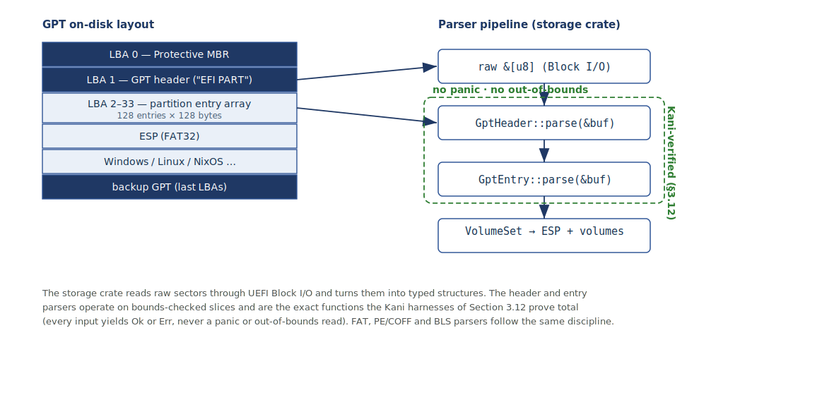
Figure 4.4: GPT on-disk layout and the storage-crate parser pipeline. The header and entry parsers, operating on bounds-checked slices, are the functions proven total by the Kani harnesses of Section 3.12; the FAT, PE/COFF and BLS parsers follow the same discipline.
// crates/storage/src/gpt.rs -- no_std, panic-free, the target of §3.12
pub struct GptHeader { pub entry_lba: u64, pub num_entries: u32, pub entry_size: u32 }
impl GptHeader {
/// Parse an LBA-1 GPT header from a bounds-checked slice.
/// Total function: every input yields Ok(..) or Err(..), never a panic.
pub fn parse(buf: &[u8]) -> Result<GptHeader, GptError> {
// get(..) returns Option, so a short buffer is Err, not a panic.
let sig = buf.get(0..8).ok_or(GptError::Short)?;
if sig != b"EFI PART" { return Err(GptError::BadSignature); }
let entry_lba = read_u64_le(buf, 72)?; // helpers use get(..), too
let num_entries = read_u32_le(buf, 80)?;
let entry_size = read_u32_le(buf, 84)?;
if entry_size < 128 { return Err(GptError::BadEntrySize); }
Ok(GptHeader { entry_lba, num_entries, entry_size })
}
}
#[inline]
fn read_u32_le(buf: &[u8], at: usize) -> Result<u32, GptError> {
let b = buf.get(at..at+4).ok_or(GptError::Short)?; // no indexing panic
Ok(u32::from_le_bytes([b[0], b[1], b[2], b[3]]))
}
The pattern generalises to the other formats the manager reads. The FAT reader locates and reads files on the EFI System Partition; the PE/COFF reader recognises and validates EFI images for chainloading; and the Boot Loader Specification reader parses the generation and specialisation entries, including those NixOS writes. Each is a total function over a byte slice, and each has a corresponding harness, so that the entire untrusted-input surface of the manager is covered by the same proof discipline rather than by testing alone.

4.7 Discovery, Providers and the Transaction
Above the parsers, the discovery crate assembles a VolumeSet and reads the firmware boot variables and the Boot Loader Specification entries, and hands the result to each registered provider; the providers return their targets, which the graph crate merges into the Boot Graph with stable identifiers. The transaction crate then drives the boot: it charges an attempt by decrementing the entry's counter before handoff, records which entry is being tried, and on the following boot reads the cooperative success marker to commit or roll back. The marker and the counters are stored exactly as Section 3.7 specifies — through the firmware variable services, using the native boot variables and the Boot-Loader-Interface-style variables under the manager's own vendor namespace — and the growing boot-history log is written to the EFI System Partition rather than to the scarce non-volatile variable store, in keeping with the persistence model of Section 3.9. The declarative configuration is applied and reconciled against the firmware by the same variable services, with a retained snapshot for reversible repair.

4.8 Building, Packaging and Running under QEMU and OVMF
The application is compiled for the UEFI target, copied to a FAT folder at the firmware fallback path, and run in QEMU with OVMF supplying the firmware and the host folder exposed as the EFI System Partition. Serial output is redirected to the terminal for logging, and the emulator can freeze the processor at start and expose a debugger stub, so that the boot manager can be single-stepped and deliberately broken without any risk to real hardware. Figure 4.5 shows the harness, and the listing beneath it gives the commands.
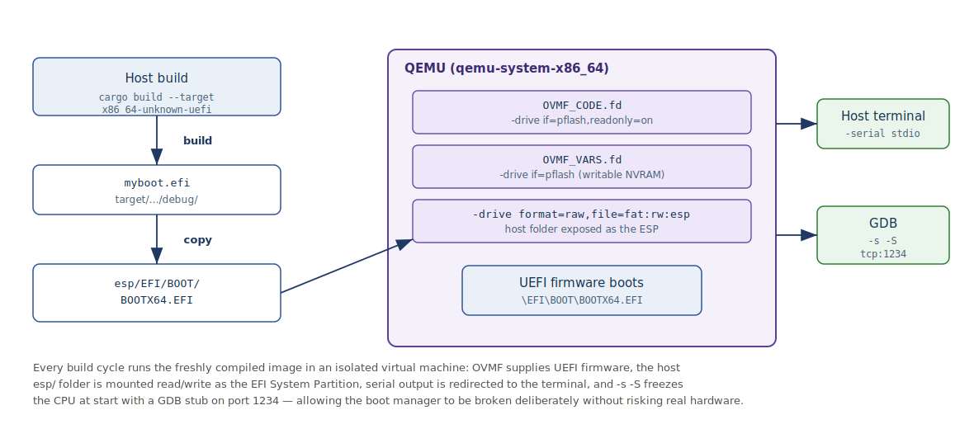
Figure 4.5: The QEMU and OVMF test harness. Each build cycle stages the freshly compiled image on a host ESP folder and boots it under emulated UEFI firmware, with serial output on the terminal and a GDB stub on port 1234 for source-level debugging.
# one-time
rustup target add x86_64-unknown-uefi
# build the UEFI application (Tier-2 target: no -Z build-std needed)
cargo build --release --target x86_64-unknown-uefi -p myboot
# stage it on a FAT "ESP" folder at the firmware fallback path
mkdir -p esp/EFI/BOOT
cp target/x86_64-unknown-uefi/release/myboot.efi esp/EFI/BOOT/BOOTX64.EFI
# run in QEMU with OVMF firmware; host folder mounted as the ESP
qemu-system-x86_64 \
-drive if=pflash,format=raw,readonly=on,file=/usr/share/OVMF/OVMF_CODE.fd \
-drive if=pflash,format=raw,file=OVMF_VARS.fd \
-drive format=raw,file=fat:rw:esp \
-serial stdio \
-s -S # freeze CPU, open a GDB stub on tcp:1234
Because the exposed folder is the live build output, a recompiled image is tested simply by restarting the emulator, with no disk image to rebuild. Source-level debugging is possible despite the image being relocated at load time by printing the image's runtime base address and giving it to the debugger so that symbols line up with the loaded code. This harness is the foundation of the testing strategy developed in Chapter Five, which adds deliberate fault injection and the recording of recovery behaviour.

4.9 Continuous Verification
The verification described in Chapter Three is wired into the ordinary build rather than performed once. The parser proofs run as a Kani invocation over the storage crate, and are intended to run in continuous integration so that a change which reintroduces a possible panic or out-of-bounds read fails the build. The design-level TLA+ specification is checked with its model checker on a bounded instance as described in Section 3.11. Together these make the two correctness claims of the project reproducible on every change, within the honest limits already stated: the model checker covers the design, and Kani covers the parser code up to its input bounds.
# verify the boot-critical parsers at the code level
cargo kani -p storage # runs every #[kani::proof] harness
# example expected summary
# VERIFICATION:- SUCCESSFUL gpt_header_parse_never_panics
# VERIFICATION:- SUCCESSFUL gpt_entry_offsets_ordered
# VERIFICATION:- SUCCESSFUL bls_entry_fields_within_input

4.10 Chapter Summary
This chapter has turned the design into an implementation. It fixed the stable Rust toolchain and the Tier-2 UEFI target, laid out the Cargo workspace so that dependencies point inward to the model and the platform wrapper, and presented the entry point against the current uefi-rs freestanding-function model. It showed the double-buffered Graphics Output Protocol pipeline with dirty-region updates, and the slice-based, panic-free parser implementations that the Kani harnesses verify. It set out the build, packaging and emulator procedure under QEMU and OVMF, and wired both the parser proofs and the design specification into the build as continuous verification. Five labelled figures document the crate graph, the control flow, the rendering pipeline, the parser pipeline and the test harness. Chapter Five will use this harness to present the testing strategy, the deliberate injection of corrupt inputs and failed boots, and the results of the formal verification.

References
rust-osdev. The Rust UEFI Book — Creating a UEFI Application; Drawing to the Screen. https://rust-osdev.github.io/uefi-rs/
rust-osdev. uefi crate documentation (entry macro, uefi::boot, uefi::helpers::init, uefi::proto::console::gop). https://docs.rs/uefi/
rust-osdev. uefi-rs API migration to freestanding functions (funcs_migration). https://github.com/rust-osdev/uefi-rs/blob/main/docs/funcs_migration.md
The Rust Team. Platform Support: x86_64-unknown-uefi (Tier 2). https://doc.rust-lang.org/rustc/platform-support/unknown-uefi.html
TianoCore. OVMF (Open Virtual Machine Firmware) for QEMU. https://github.com/tianocore/tianocore.github.io/wiki/OVMF
Kani Rust Verifier, Amazon Web Services. https://model-checking.github.io/kani/
UEFI Forum. UEFI Specification 2.11, Section 3 (Boot Manager). https://uefi.org/specs/UEFI/2.11/03_Boot_Manager.html
systemd project. The Boot Loader Interface. https://systemd.io/BOOT_LOADER_INTERFACE/

