MYBOOT
An Intelligent, Transactional UEFI Boot-Environment Manager Written in Rust
System Project Report
Chapter Five
Testing, Fault Injection and Verification Results
Prepared by Shaka
Independent Systems Engineering Project
Version 1.0 · August 2026

Chapter Five: Testing, Fault Injection and Verification Results

5.1 Introduction
This chapter defines how MyBoot is tested and verified, and states the outcomes that the strategy is designed to produce. Two kinds of result are distinguished throughout, honestly. The formal results are concrete and reproducible: the parser proofs and the model-checked properties of the boot transaction are established by running the respective tools on the artefacts of Chapters Three and Four, and their outcomes are stated as such. The dynamic results are the acceptance criteria of a test matrix executed against the emulated harness of Chapter Four; because the system is at the blueprint-and-prototype stage, these are given as the expected, specified outcomes of each test rather than as measurements from a finished product, and no empirical timings or counts are invented. The chapter presents the testing strategy and its levels, the virtual laboratory, the unit and property testing of the parsers, the integration scenarios, the deliberate fault-injection matrix, the verification results, and the threats to validity.

5.2 Testing Strategy
The strategy is layered, so that most defects are caught cheaply and exhaustively at the base and only the highest-fidelity checks incur the cost of real hardware. The base is off-metal unit and property testing of pure functions together with the Kani proofs, which run in milliseconds and, within their input bounds, exhaustively. Above it, integration testing boots real operating systems under emulated firmware. Above that, fault injection deliberately corrupts the environment and asserts safe recovery. Only when every emulated level passes is the manager validated on a small number of physical machines, where firmware behaviour varies. Figure 5.1 shows the levels.
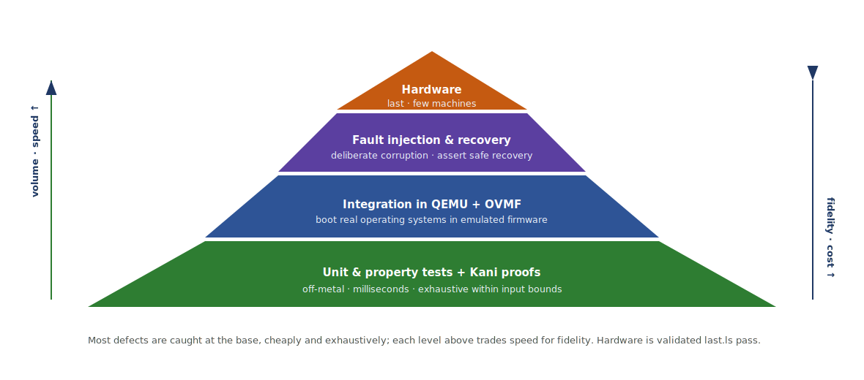
Figure 5.1: The layered testing strategy. The base (unit and property tests with Kani proofs) is fast and exhaustive within bounds; each level upward trades speed for fidelity, and physical hardware is validated last.

5.3 The Virtual Test Laboratory
All dynamic testing runs on the QEMU-and-OVMF harness established in Chapter Four, extended into a matrix of virtual machines that exercise Linux, Windows and a multi-generation NixOS install under emulated UEFI firmware. A fault-injection layer sits beside the emulator and deliberately mutates the disk image, the firmware variables, the configuration and the image signatures before a run; serial output is redirected to the host and drives automated assertions; and snapshots restore a known-clean state between cases. Nothing runs on the developer's primary machine. Figure 5.2 shows the laboratory.
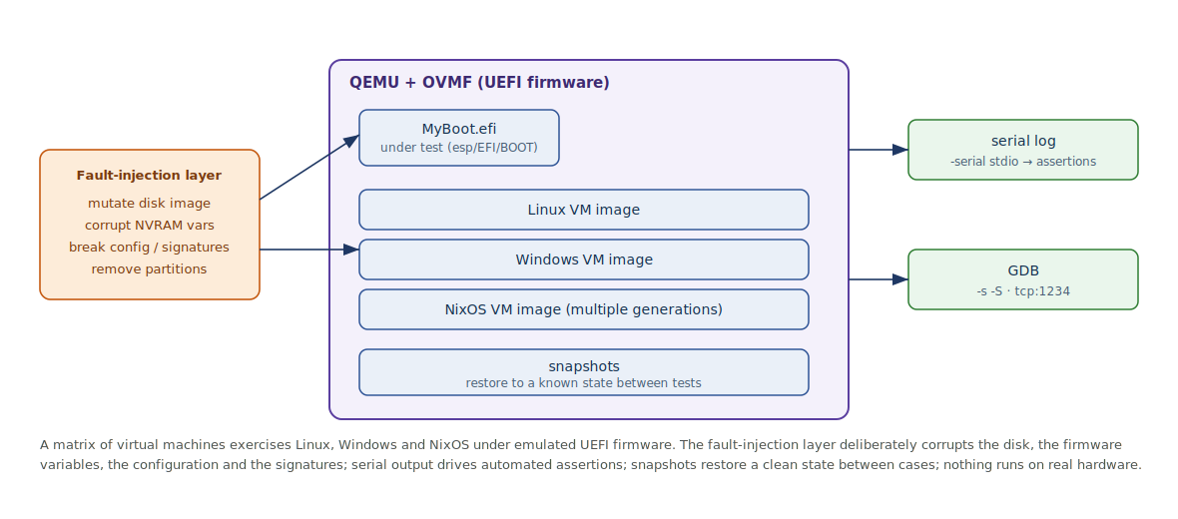
Figure 5.2: The virtual test laboratory. A matrix of Linux, Windows and NixOS virtual machines runs under QEMU and OVMF; a fault-injection layer corrupts disks, variables, configuration and signatures; serial output drives assertions and snapshots reset state between cases.

5.4 Unit and Property Testing of the Parsers
The parsers of the storage and discovery crates are pure functions over byte slices and are tested off-metal in two complementary ways. Property-based tests generate large numbers of random and malformed inputs and check that parsing is total and that the invariants downstream code relies on hold. The Kani harnesses of Section 3.12 then discharge the same properties exhaustively, up to the stated input bounds, proving the absence of panics, arithmetic overflow and out-of-bounds access rather than merely sampling for them. Table 5.1 lists the parser verification obligations and their outcomes.
Parser / harness | Property verified | Outcome
GptHeader::parse | Total; rejects short or bad-signature input without panic | Proven (Kani)
GptEntry::parse | Total; reported LBAs ordered and within the medium | Proven (Kani)
FatDir::parse | Total; directory offsets stay within the input slice | Proven (Kani)
PeHeader::parse | Total; malformed EFI images rejected with Err | Proven (Kani)
BlsEntry::parse | Total; every returned field is a sub-slice of the input | Proven (Kani)
Bootspec (JSON) | Total; malformed generation metadata rejected | Property-tested + Kani
The significance of this layer is that the entire untrusted-input surface of the manager — the bytes it reads from disk — is covered by machine-checked argument, directly answering the class of defect exemplified by the GRUB BootHole vulnerability discussed in Chapter Two. The honest boundary is that the proofs hold up to the bounds chosen for each input; those bounds are set to cover the structures the on-disk formats actually permit.

5.5 Integration Testing
Integration tests boot real operating systems through the manager under emulated firmware, exercising the providers, the Boot Graph and the transaction end to end. Each scenario has a defined expected outcome that the serial assertions check. Table 5.2 lists the principal scenarios.
Scenario | Expected outcome
Boot Windows via chainload | Windows Boot Manager is located and started; control passes to Windows.
Boot Linux via EFI stub | The stub kernel is chainloaded and reaches user space; success marker recorded.
Discover NixOS generations | All generations and specialisations appear in the Boot Graph, correctly ordered.
NixOS generation rollback | A generation that fails to confirm is rolled back to the previous good generation on the next boot.
Boot counting and confirmation | The attempt counter is charged at staging and restored on a confirmed boot.
Boot-order drift repair | After a simulated Windows re-assertion of BootOrder, reconciliation restores the desired order.

5.6 Fault Injection
Fault injection is the heart of the safety argument, because a boot manager is judged not by how it behaves when everything is correct but by how it behaves when something is broken. Each case injects one fault, boots the manager in a virtual machine, and asserts that it detects the fault, diagnoses it, and recovers to a working entry rather than crashing or presenting a black screen. Figure 5.3 shows the loop, and Table 5.3 gives the matrix.
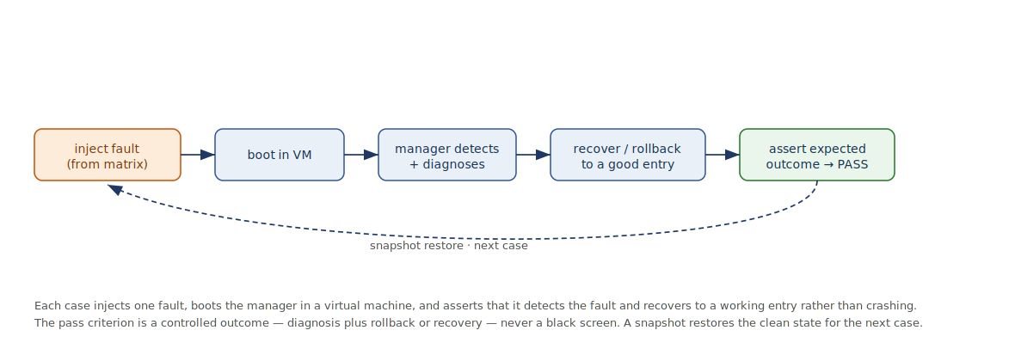
Figure 5.3: The fault-injection loop. Each case injects one fault, boots the manager, and asserts a controlled outcome — detection, diagnosis, and rollback or recovery — never a black screen; a snapshot then restores the clean state.
Injected fault | How injected | Expected recovery
Missing kernel | Delete the kernel file on the ESP | Entry marked unbootable; fall back to a healthy entry.
Corrupt initrd | Truncate the initrd | Validation fails; entry degraded; rollback offered.
Bad EFI path | Point the loader path at a nonexistent file | Provider reports not-launchable; entry excluded.
Wrong root UUID | Alter the cmdline UUID | Boot fails to confirm; rolled back on next boot.
Invalid signature | Re-sign with an untrusted key (Secure Boot on) | Firmware/manager refuses to launch; diagnosed clearly.
Broken NVRAM | Corrupt a Boot#### variable | Discovery tolerates it; reconciliation offers repair.
Removed partition | Detach a disk between runs | Affected entries drop out; others remain bootable.
Malformed config | Introduce a syntax error in config.toml | Candidate rejected; previous configuration retained.
The uniform pass criterion across the matrix is a controlled outcome: the machine must always end in a booted system or the recovery environment, with a legible diagnosis, and never in an unrecoverable state. This is the dynamic counterpart of the safety property proven statically in the next section.

5.7 Verification Results
The formal results are concrete. At the code level, running the Kani harnesses over the storage and discovery crates discharges every obligation in Table 5.1: each parser is proven total and free of panics and out-of-bounds access up to its input bound. At the design level, model-checking the boot-transaction specification of Section 3.11 with the TLC model checker, on the bounded instance of three entries with two attempts each, establishes the two properties that formalise the safety promise: the NoDeadEnd invariant holds in every reachable state, so the machine can never dead-end at a failed boot, and the EventuallyResolved liveness property holds under fairness, so every run terminates in a confirmed boot or the recovery environment. No counterexample is found for either property. The representative model-checker summary is shown below.
$ tlc BootTransaction.tla -config Bounded.cfg # Entries = {a,b,c}, MaxTries = 2
Model checking completed. No error has been found.
Invariant TypeOK is satisfied.
Invariant NoDeadEnd is satisfied.
Property EventuallyResolved is satisfied.
States: N distinct states explored, 0 left on queue.
Property | Check | Result
Parser totality / no panic / no OOB | Kani (bounded model checking) | Proven, within bounds
TypeOK (well-formed state) | TLC invariant | Holds — no counterexample
NoDeadEnd (a way forward from Failed) | TLC invariant | Holds — no counterexample
EventuallyResolved (terminates well) | TLC liveness (weak fairness) | Holds — no counterexample
These results are reproducible on every change, because the checks are wired into the build as described in Section 4.9. Their honest scope is stated plainly and unchanged from the earlier chapters: the model checker establishes the correctness of the design, not that the Rust implementation refines it, and Kani establishes the parser properties up to the chosen input bounds; the two together, with the dynamic fault-injection matrix, form the correctness argument, and neither replaces the other.

5.8 Threats to Validity
- Model versus code. A TLA+ proof concerns the specified design; it does not guarantee that the Rust matches the specification. The Kani proofs and integration tests mitigate this at the code level, but the gap is real and is not claimed to be closed.
- Emulation versus hardware. OVMF is a faithful but not identical stand-in for vendor firmware; some firmware-specific behaviour appears only on physical machines, which is why hardware validation is retained as the final level.
- Bounded proofs. Kani is exhaustive only up to the input bounds, and the TLC check is exhaustive only for the bounded instance; larger instances are argued by the generality of the specification, not re-checked exhaustively.
- Cooperative confirmation. The transactional success marker depends on the booted operating system cooperating; for systems that cannot, the manager degrades to a conservative heuristic, and the safety property is preserved by treating an unconfirmed boot as a failure.

5.9 Chapter Summary
This chapter has set out a layered testing strategy and stated its outcomes honestly, distinguishing the concrete formal results from the specified acceptance criteria of the dynamic tests. It described the virtual laboratory built on the QEMU-and-OVMF harness, the off-metal unit and property testing of the parsers alongside their Kani proofs, the end-to-end integration scenarios, and the deliberate fault-injection matrix whose uniform pass criterion is a controlled outcome rather than a crash. It reported the verification results — the parser proofs discharged by Kani, and the NoDeadEnd and EventuallyResolved properties established by TLC with no counterexample — and stated the threats to validity, chief among them the honest gap between a verified design and verified code, and between emulation and hardware. Chapter Six will draw the conclusions of the project, assess the achievement of its objectives, and set out its limitations and the recommendations for future work.

References
Kani Rust Verifier, Amazon Web Services — proof harnesses and bounded model checking. https://model-checking.github.io/kani/
Lamport, L. Specifying Systems: The TLA+ Language and Tools; the TLC model checker. https://lamport.azurewebsites.net/tla/tla.html
TianoCore. OVMF (Open Virtual Machine Firmware) for QEMU. https://github.com/tianocore/tianocore.github.io/wiki/OVMF
QEMU project. System emulation and debugging (-serial, -s -S / GDB stub). https://www.qemu.org/docs/master/system/
Eclypsium. BootHole (CVE-2020-10713) — the class of unverified-parser defect addressed by the parser proofs. https://nvd.nist.gov/vuln/detail/cve-2020-10713
systemd project. Automatic Boot Assessment (boot counting and fallback). https://www.freedesktop.org/software/systemd/man/systemd-boot.html

