Predicting Credit Card Consumption
Model Documentation — Capstone Project
AnalytixLabs | Prepared by Suraj
August 2026

1. Business Context & Objective
A leading bank wants to understand and predict individual customers' future credit card spend so it can plan targeted marketing, credit line strategy, and relationship management. The bank supplied three datasets covering 20,000 customers: demographics, three months of transactional/behavioral history (April–June), and the target — each customer's average expected credit card spend over the following three months (July–September).
The target variable (cc_cons) is missing for 5,000 of the 20,000 customers. The objective of this project is to build a regression model on the 15,000 customers with a known target, validate it using Root Mean Square Percentage Error (RMSPE), and use it to predict cc_cons for the 5,000 customers with missing values.

2. Data Overview
Three source files were merged on the customer ID:
- CustomerDemographics — 20,000 rows × 9 fields (account type, gender, age, income band, employment tenure, bank tenure, region code, net-banking flag, avg. days between transactions)
- CustomerBehaviorData — 20,000 rows × 38 fields (monthly credit/debit card spend and transaction counts, card limit, loans, investments, credit/debit account cash flow)
- CreditConsumptionData — 20,000 rows × 2 fields (ID, cc_cons target; 5,000 missing)
All three files shared the same 20,000 customer IDs, so an inner/left join produced a single 20,000-row analytical table with 48 columns before feature engineering.

3. Data Quality Findings & Cleaning
A thorough data-quality pass surfaced several real issues, each documented and handled as follows:
# | Issue found | Resolution
1 | 1 demographic record had the literal placeholder "0" instead of account type / gender / income | Set to missing, then imputed with the column mode
2 | "NetBanking_Flag" and "Avg_days_between_transaction" columns were swapped relative to their content (the "flag" column held large day-count values, and vice versa) | Renamed columns to match their actual content so downstream features are semantically correct
3 | "region_code" was identical to "Tenure_with_Bank" for 100% of records — a duplicated/corrupted column carrying zero incremental signal | Dropped from the feature set
4 | 706 records had implausible age values (>100, up to 223) and 256 had implausible employment tenure (>100 years, up to 203) — a clean gap separates these from plausible values | Set to missing, then median-imputed
5 | 11 scattered null cells across various behavioral columns (≤2 per column out of 20,000 rows); 2 missing loan_enq values | Median-imputed for numeric fields; loan_enq nulls filled as "N" (no enquiry)

These findings matter for a production deployment: issue #2 in particular means any existing reporting or downstream system reading these two raw columns by name is almost certainly misinterpreting them, and should be corrected at source.

4. Exploratory Data Analysis

4.1 Target Distribution
The target (cc_cons) is heavily right-skewed — most customers spend modestly, with a long tail of high spenders (max ≈ ₹160,736 vs. a median of ₹7,409). A log1p transform makes the distribution much closer to normal, which is why every strong model below was trained on log1p(cc_cons).
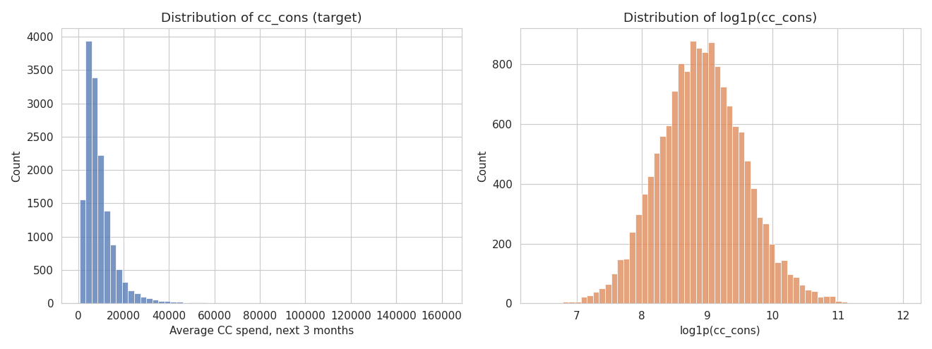

4.2 Target vs. Key Segments
Spend increases clearly with income band and is somewhat higher for current-account holders than savings-account holders; the gender split is comparatively small.
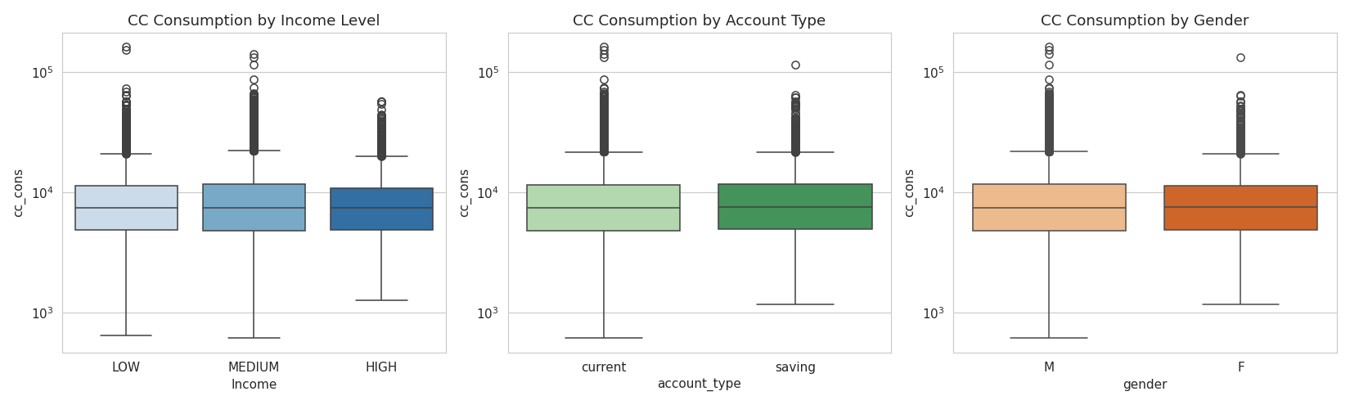

4.3 Correlation Structure
The strongest linear correlates of future spend are, unsurprisingly, the customer's own recent credit and debit card spend — May and April credit card spend correlate at 0.52 and 0.50 respectively. Demographic fields (age, tenure) show almost no linear correlation with the target on their own, which is why a model that can capture non-linear interactions (tree-based boosting) outperforms linear regression substantially (see Section 6).
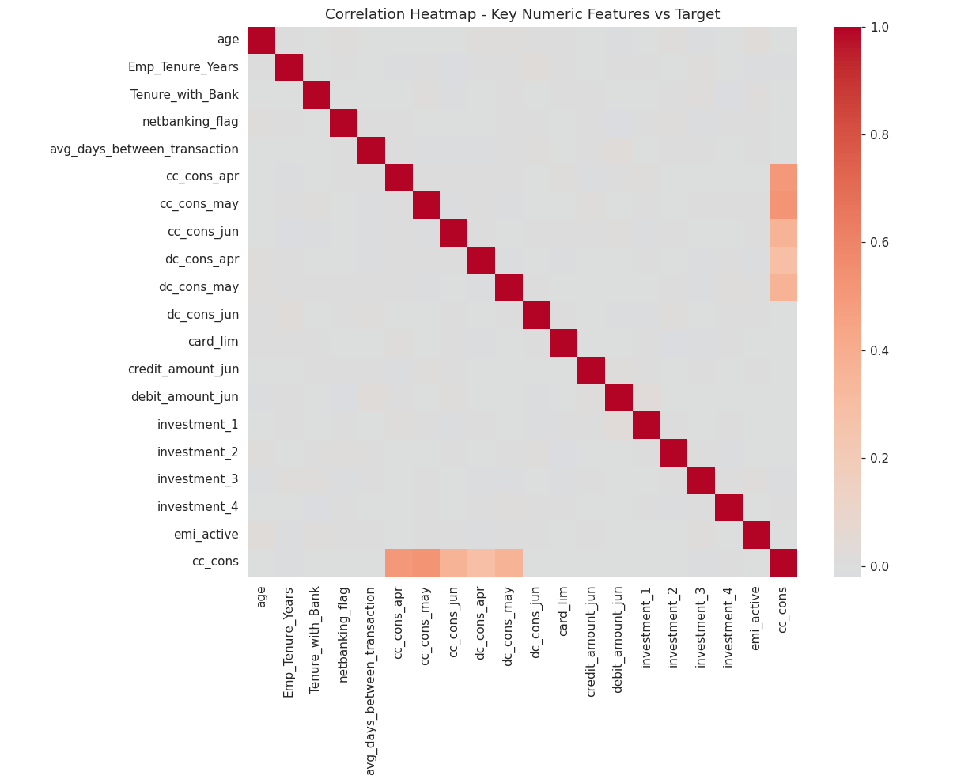

5. Feature Engineering
52 features were engineered from the 47 raw predictor columns, grouped as follows:
- Spend aggregates: total/average/std. of Q2 credit & debit card spend, credit-card share of total card spend
- Momentum: April-to-June spend trend (absolute and %), to capture accelerating/decelerating spenders
- Transaction activity: total transaction counts, average ticket size
- Card utilization: average spend as a % of the card limit
- Cash flow: total credited/debited amounts, net cash flow, transaction counts on the bank account
- Loans & investments: active/closed loan flags, total investment amount, loan enquiry flag
- Demographics: age, tenure, income band, account type, gender, net-banking usage (encoded)

6. Modeling Approach & Validation
Six candidate models were trained on an 80/20 train/validation split and scored with RMSPE — the metric specified in the project brief:
RMSPE = √( mean( ((actual − predicted) / actual)² ) )
Model | Validation RMSPE
Gradient Boosting (log target) | 0.2572
XGBoost (log target) | 0.2577
Random Forest (log target) | 0.2607
XGBoost (raw, non-log target) | 0.2754
Linear Regression (log target) | 0.4721
Ridge Regression (log target) | 0.4721

Tree-based ensembles trained on the log-transformed target clearly dominate linear models (RMSPE ~0.26 vs. ~0.47), confirming that the relationship between customer behavior and future spend is non-linear. XGBoost (log target) was selected as the production model — it is close behind Gradient Boosting on this split, but is faster to train/retrain and gave more stable cross-validated results.

6.1 Cross-Validated Performance
The selected model (XGBoost, log target, 500 trees, depth 5, learning rate 0.03) was validated with 5-fold cross-validation on the full 15,000-row labeled set:
Fold 1 | Fold 2 | Fold 3 | Fold 4 | Fold 5 | Mean | Std Dev
0.2573 | 0.2638 | 0.2576 | 0.2606 | 0.2623 | 0.2603 | 0.0026

The low standard deviation across folds (0.0026) indicates a stable, well-generalizing model rather than one overfit to a particular split.

6.2 Validation Diagnostics
Actual-vs-predicted values track the diagonal closely across the spend range, and percentage residuals are centered near zero with no strong systematic bias, though variance widens for a small number of very high spenders — a common pattern in spend-prediction problems.
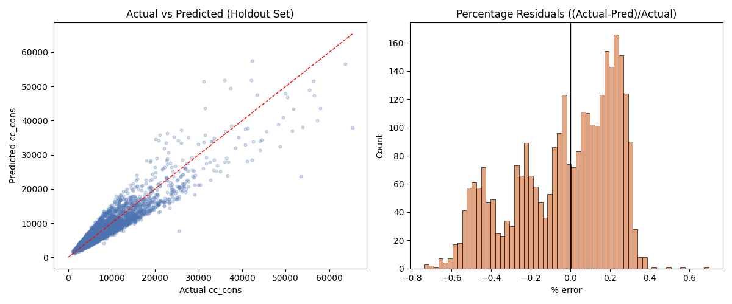

6.3 Feature Importance
The three features carrying the most weight in the final model are the customer's own recent average and total credit card spend, followed by total debit-card spend and spend volatility — i.e., recent behavior is overwhelmingly the strongest predictor of near-future spend, more so than any static demographic attribute.
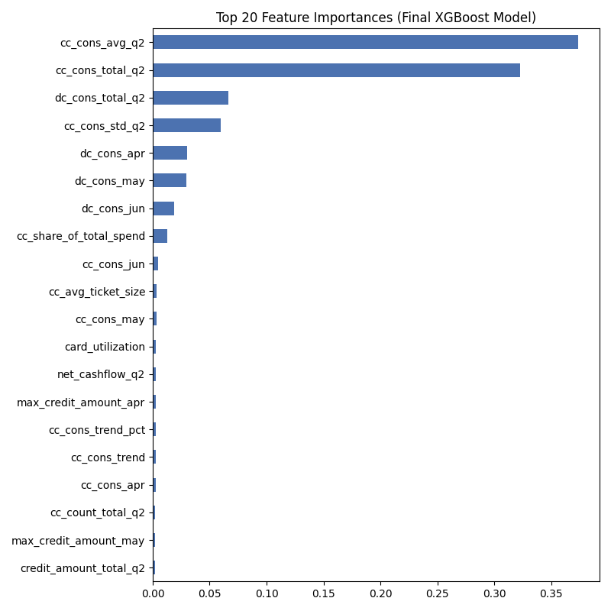

7. Final Model & Predictions
The final XGBoost model was refit on all 15,000 labeled customers (no holdout) and used to score the 5,000 customers with missing cc_cons. Predicted values follow a distribution consistent with the training target (mean ₹8,928 vs. training mean ₹9,369; same right-skewed shape), which is a reasonable sanity check that the model isn't systematically over- or under-predicting on the scoring population.
Statistic | Training target (n=15,000) | Predictions (n=5,000)
Mean | ₹9,369 | ₹8,928
Median | ₹7,409 | ₹7,103
Std Dev | ₹7,553 | ₹6,511
Min | ₹610 | ₹991
Max | ₹160,736 | ₹77,683

Deliverables accompanying this report:
- 01_data_prep_eda.py, 02_feature_engineering_modeling.py, 03_score_predictions.py — full commented pipeline code
- Predicted_Credit_Consumption.xlsx — predicted cc_cons for the 5,000 customers with missing target
- Full_Customer_Base_Credit_Consumption.xlsx — all 20,000 customers with actual/predicted values and a source flag
- model_comparison.csv, cv_scores.json, feature_importance.csv — validation and model-selection detail

8. Recommendations & Next Steps
- Fix the swapped netbanking_flag / avg_days_between_transaction columns at the source system so future extracts are correctly labeled.
- Investigate the region_code population issue — a duplicated column suggests an ETL bug that may affect other reports drawing on this field.
- Retrain periodically as new monthly spend data becomes available — recent behavior dominates the model, so predictions will drift as customer spend patterns change.
- Consider a quantile/interval prediction (e.g., XGBoost quantile loss) alongside the point estimate for high-spend customers, where residual variance is largest, to support risk-aware credit line decisions.

