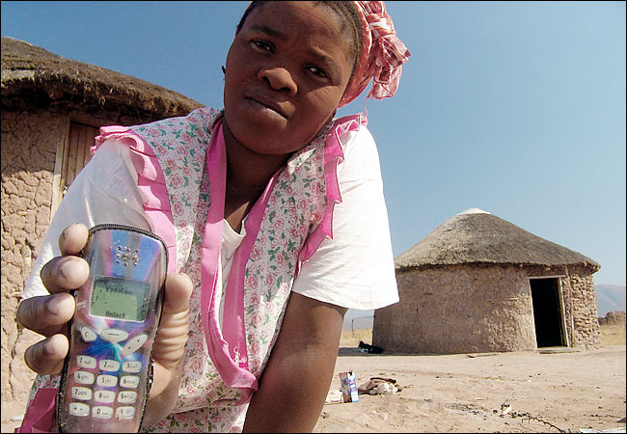

photo credit: http://tinyurl.com/jadffr8



Mobile Financial Services in Kenya, Uganda and Tanzania:

Downstream Prediction for Lasting Economic Retention

Project DoPLER, Phase I Report

Cameron Turner, [cameron@thedataguild.com](mailto:Cameron@thedataguild.com), Aman Ahuja, [aman@thedataguild.com](mailto:aman@thedataguild.com), David Gutelius, [david@thedataguild.com](mailto:david@thedataguild.com)

Palo Alto, CA 94301

Summer/Autumn 2016

Made possible by a grant from:



Project Administered by:



**Contents:**

I. Abstract 3

II. Introduction 3

III. Background 3

IV. Related Work 3

V. Data Sources 3

VI. Methodology and Models 4

VII. Working Definitions, Engineered Response Variables 4

VIII. Findings 5

Waterfall Effect by Key Factors 5

Multivariate Analyses 6

Decision Trees 6

Random Forest 7

Logistic Regression 7

Boosted Stumps 7

Comparison: World Bank FINDEX 2014 8

IX. Discussion 8

X. Proposed Next Steps 9

XI. Acknowledgements 9

XII. References 9

Data: 9

Papers: 9

XIII. Appendix 11

Full table comparison of mobile money attributes by country, FII: 11

Full table comparison of mobile money retention, by attribute FII: 29

Full table comparison of mobile money usage by country, 2014 FINDEX: 46

Full table comparison of mobile money usage by attribute, 2014 FINDEX: 57

# Abstract

In this pilot study, we seek to use existing data sets to better understand long-term retention of mobile financial services in Uganda, Tanzania and Kenya.

Using statistical modeling techniques we identify those parameters which might serve as predictors to labeled response variables to identify longitudinal retention and usage of services such as payments and loans on mobile devices.

The goal of the study is a directional framework to enable mobile network operators (MNOs) and non-government organizations (NGOs) to better deliver financial inclusion in these markets.

# Introduction

To date, much work has been done to understand the pathway between awareness and sign-up of digital financial services (DFS) in East Africa. This is referred to herein as “upstream” adoption.

Despite the research on the upstream process, from initial adoption to active usage, there is a dearth of understanding on longer term retention—herein referred to as “downstream”; activity beyond the initial 90 day of active usage.

In this work we seek to understand the relative effects of subscriber characteristics as they affect long term retention. For example:

* Gender
* Age
* Location
* Education Level
* Wealth
* Mobile- and Non-mobile Financial service usage

With the broader goal of financial inclusion of the currently unbanked populations, the study seeks to offer suggestions (though not quantified recommendations) on how to drive uptake of financial service offerings and products in these geographies.

# Background

The project lies in the broader context of the Financial Services for the Poor (FSP) group at the Gates Foundation, and more narrowly, within the broader multi-year effort of the FSP group to deliver the FSP portal—a clearing house of tools and research to better enable practitioners and researchers involved in financial services and financial inclusion projects in East Africa, including the MNOs themselves.

# Related Work

In the course of developing this pilot project, conversations were held with a broad consortium of stakeholders in the for- and non-profit space.

Specifically, the Financial Inclusion Insights study (FII), funded by the Gates Foundation and administered by Intermedia plays a key role in shaping the scope and background of this work.

Additionally, work by CGAP and the World Bank provide the foundational elements of our analyses. Specifically, the Financial Inclusion Index (FINDEX) study, administered by Gallup as a part of a broader, global survey on financial inclusion serves to contextualize many of the findings herein.

The DataLab at University of Washington[1] has worked deeply to understand the impact of mobile technologies in emerging markets and this study draws from prior work including Dr. Joshua Blumenstock’s work on mobile money.[2]

An advisor to this project, Dr. Matthew Jackson’s work at Stanford’s Department of Economics provides a basis for the understanding of networks in the community, and the effect on adoption and retention.[3] Additional sources and prior research are cited in the references section.

# Data Sources

The Financial Inclusions Insights (FII)[4] study by Intermedia (supported by The Gates Foundation) provides the most useful prior data available to assess financial inclusions within our geographies of interest.

For this study, we made contact with Intermedia and gained access to Phases one through three (2012-2014) of the annual longitudinal study.

Additionally the World Bank FINDEX study provides global, by-country measurement of key inclusion factors.

As observed in Table 1, differences were prevalent by geography in all basic demographic attributes, except for respondent age. As such, modeling was achieved on a per-country basis.

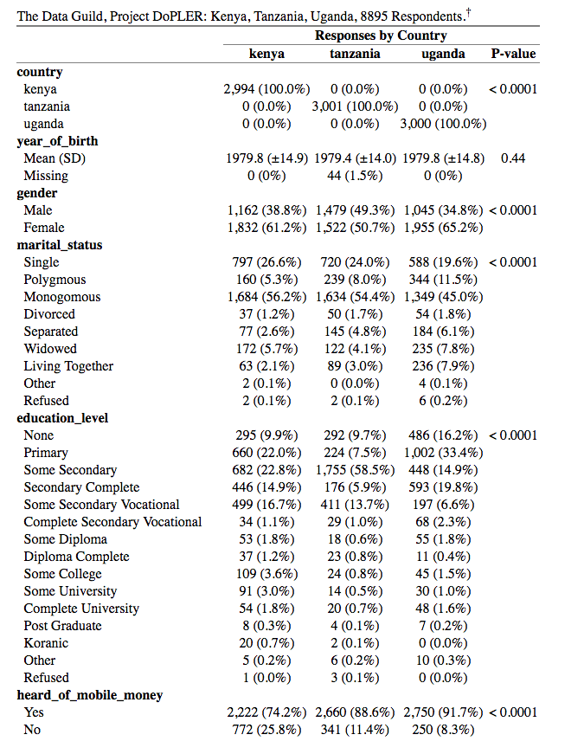

Table 1: FII Demographic Differences by Geography[5]

# Methodology and Models

To achieve a traditional retention analysis, the ideal data set might include longitudinal usage data by account. With such a data set, one could perform a time-series based survival analysis, the standard for clinical studies studying the effect of treatment.

To achieve parity with this approach in our context proved challenging: not only are we seeking to identify the “treatments” (subscriber attributes/behaviors) which lead to longer retention, but also no such longitudinal/paired data set existed from which we could derive effects over time.

Further, the data at hand is based on household surveys, notoriously susceptible to self-reporting bias.

To ameliorate these deficiencies, we sought to engineer a “pseudo-retention” variable. This was done using the FII questions that included a time variable. By using the questions including the phrases: “last time used…” and “how often in the last…” we constructed a backward-looking value for response; that is: were this question asked 90 days ago, which users would be retained? Here we followed Blumenstock, et al’s definition of retention as active use within 90 days.

Beyond retention we wished to model and understand penetration and retention from the standpoint of steps along a funnel.

The funnel begins with exposure/awareness, and ends in long-term, usage:

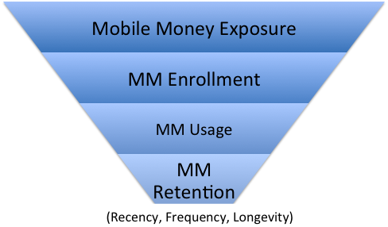

Figure 1: Conceptual Funnel Approach

In defining retention, we wish to not only account for “a single transaction of any type” within the time period of interest (90 days) but also look at the frequency and sophistication of these transactions.

# Working Definitions, Engineered Response Variables

To achieve the above, the following definitions are hereby employed:

**Exposure:** Does person have awareness of mobile money? (True/False)

**Enrollment:** Does person have a MM account **and** have they used it at least once? (True/False)

**Basic Usage:** Have they used MM account for basic services: deposit, withdraw, pay bills, send/receive money? (True/False)

**Sophisticated Usage:** Have they used MM account for sophisticated services: Insurance, long term savings, emergency funds, large transactions, periodic transactions: collect money, pay large bills (i.e. rent, insurance), save money, transfer money between accounts, loans, mortgage? (True/False)

**Frequency:** Have they used financial services at least one per month? (True/False)

**Longevity:** Have they used mobile money services for at least one year? (True/False)

**Recency:** Have they used mobile money services in the last 90 days? (True/False)

**Retention:** Are the three prior conditions true? (Recency + Longevity + Frequency) (True/False)

Of importance in the above is that here we engineer a very conservative definition of what “being retained” means in the context of mobile money; the subscriber must demonstrate not only active use, but have done so in the last 90 days (with frequency) and an enrollment of at least one year prior.

# Findings

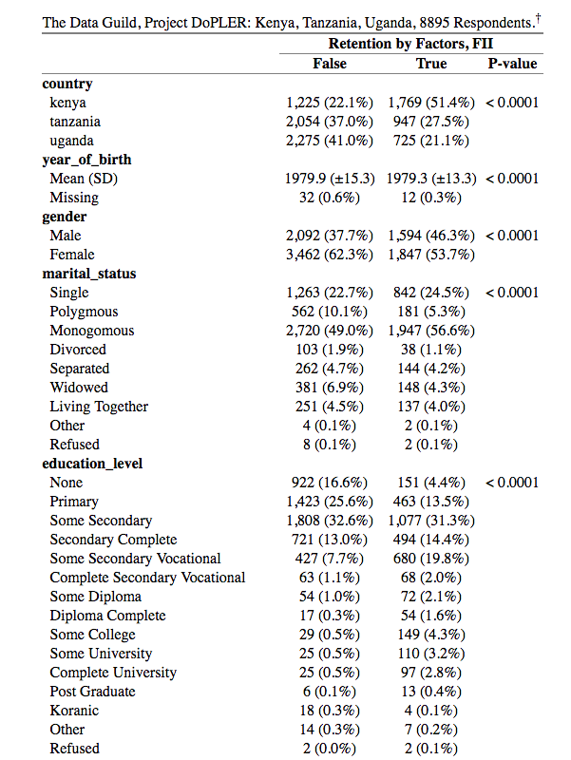

Table 2: Demographic Factors by Derived Retention Value

In Table 2, we see the relative effect of each of the available demographic characteristics of the subscriber, to achieve the final funnel step of being a retained subscriber.[6] We can see initially that **age** and **education** play a significant role in the probability of retention. We also observe further evidence of differences by geography, supporting the approach described above of per-country analysis.

From here, we seek to understand the relative effect of each factor, by country. From the funnel metaphor above, we switch now to a “waterfall”metaphor, by country.

## Waterfall Effect by Key Factors

If we look at the effect of education in Uganda, for example we see how each new level of education achieved significantly improves the subject’s likelihood to survive into a retained state.

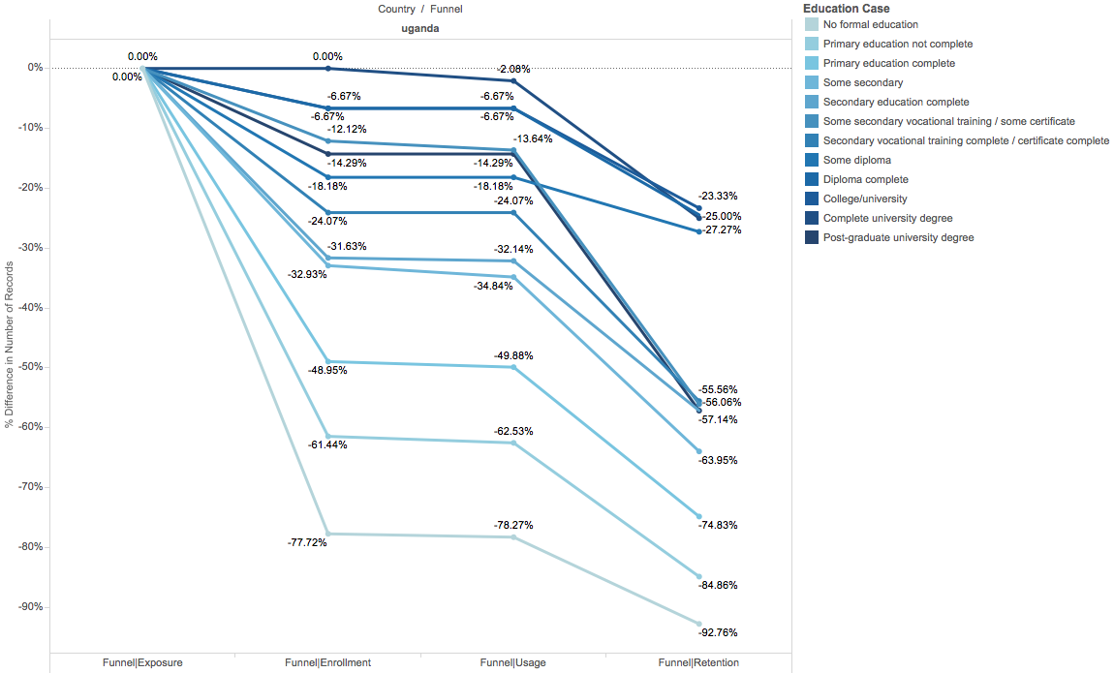

Figure 2: Retention by Education Level, Uganda 2014

The bottom line in Figure 2 shows that with no formal education, we are nearly 100% likely to have lost the subject between exposure to mobile money and retention. However, those with more education are more likely to be retained than not.

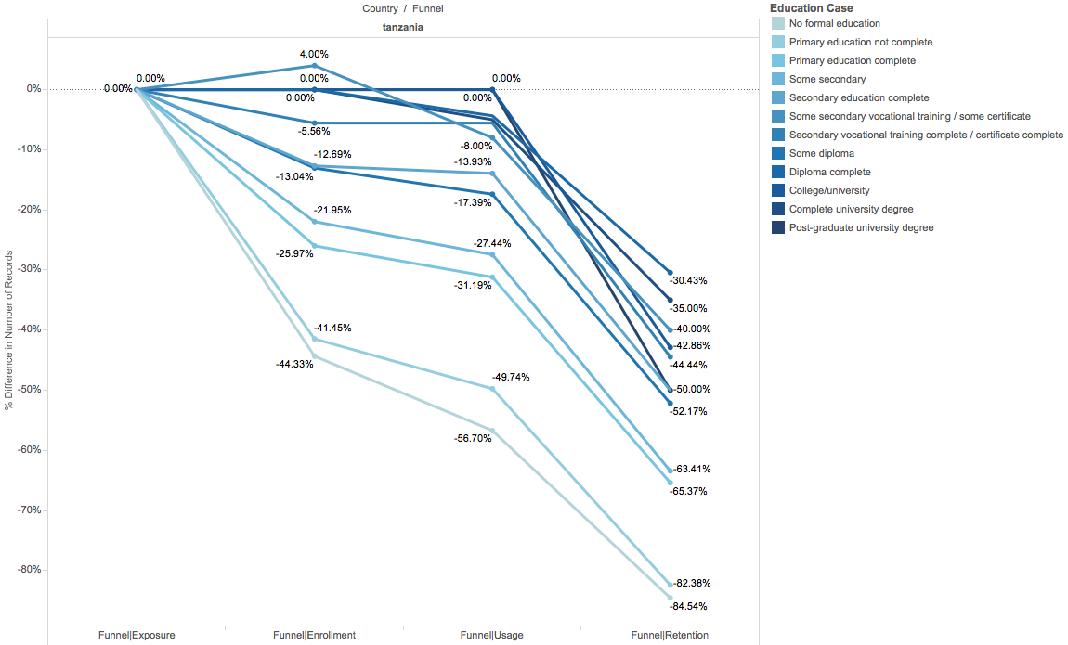

Figure 3: Retention by Education Level, Tanzania 2014

Results are similar for Tanzania (fig. 3), though not as pronounced as for Uganda.

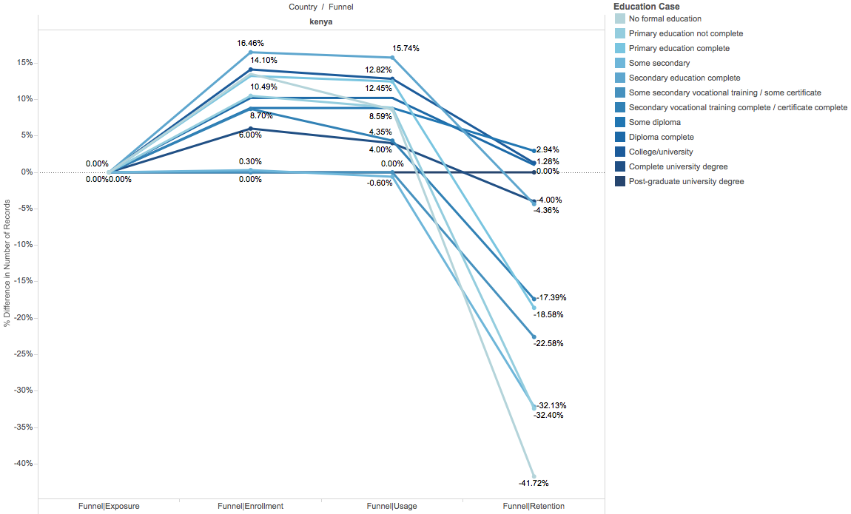

Figure 4: Retention by Education Level, Kenya 2014

For Kenya (fig. 4) an interesting result arises where more subjects claim to have enrolled in mobile money than be familiar. This was an abnormality in the FII data that is worth follow-up, though the team conjectures that perhaps given the high penetration of mobile money in Kenya[7] and position of this question, users believed the interviewer may have been referring to something besides those services familiar to nearly all, (i.e. Safaricom M-PESA).

Similar results are seen for age, where older age bins tend to fall away from mobile money with higher frequency than younger age bins.

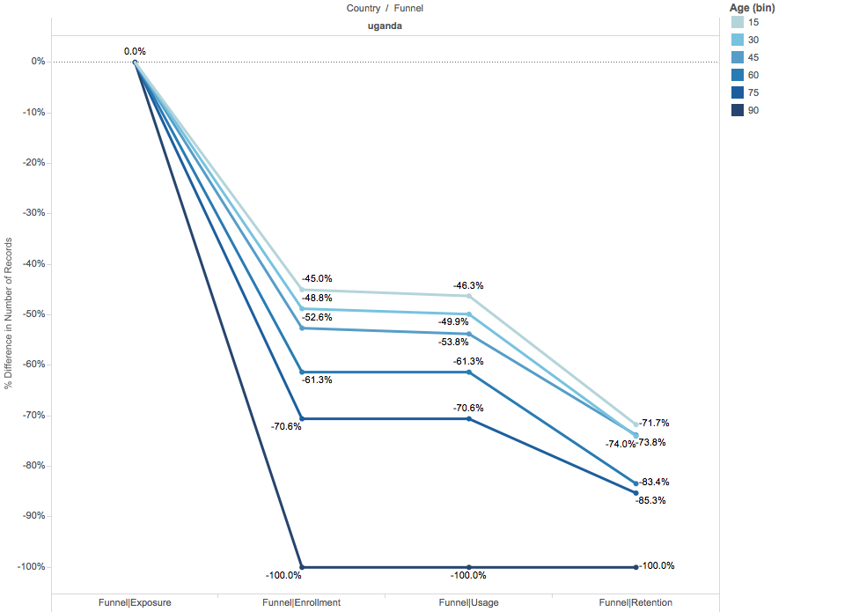

Figure 5: Retention by Age Bin Uganda 2014

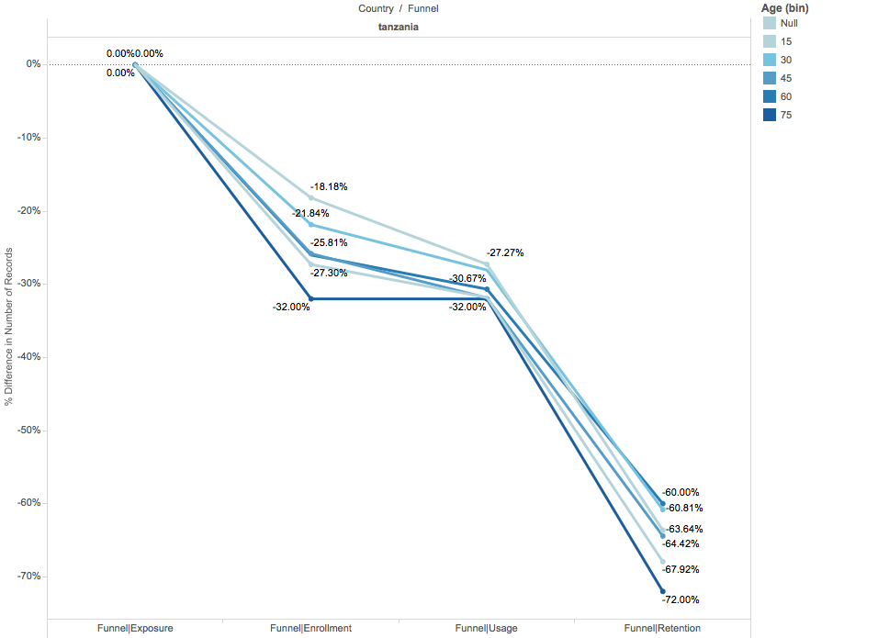

Figure 6: Retention by Age Bin, Tanzania 2014

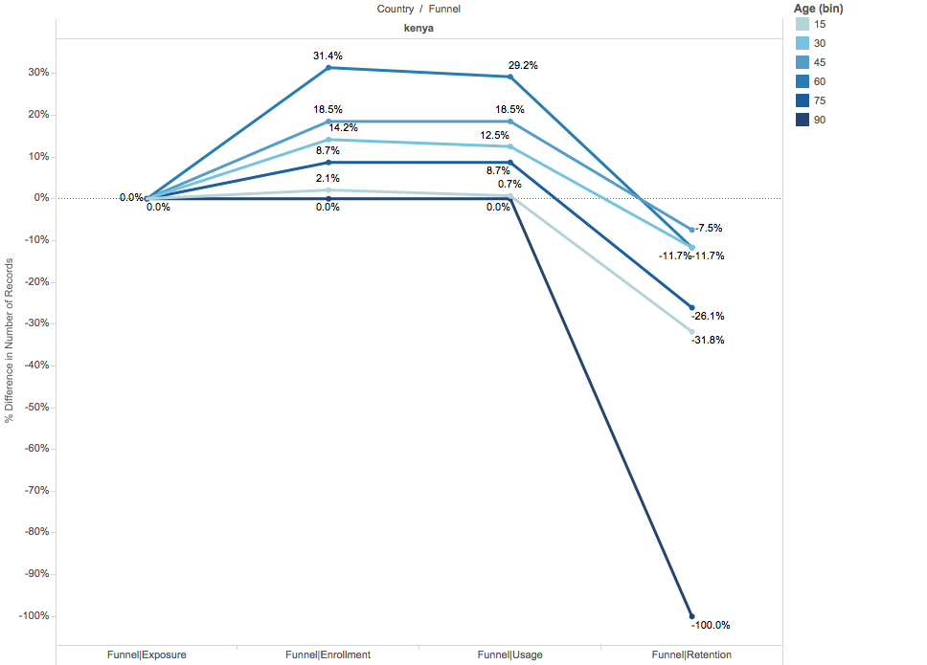

Figure 7: Retention by Age Bin, Kenya 2014

Worth noting is the loss in very old and very young, with middle-aged wage earners dominating the retained set.

## Multivariate Analyses

The results above demonstrate only two-way effects of individual predictors for each level of our funnel/waterfall.

We used several modeling techniques, recursive partitioning trees, random forest and gradient boosting (adaBoost) stumps and trees. These methods supported the findings above, highlighting the importance of age and education as dominant factors in predicting adoption of mobile money.

### Decision Trees

Recursive partitioning generates a single decision tree by splitting on the best predictor at each decision point.

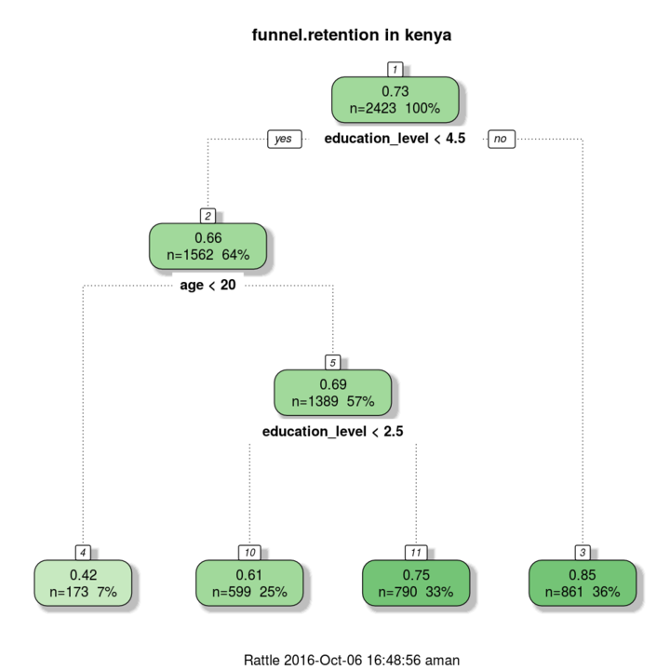

Figure 8: Recursive Partitioning Tree, Retention Kenya 2014

In this example, we can see that with more education and age, (answer:“yes” splits left at each decision point) we will achieve a higher predicted probability of retention (top number in each bubble). This is consistent with the above results, which assume independence.

Here is a more complex tree from Uganda. Following the path left, we can see that those under 20 with level four (“some secondary”) or less education are only 22% likely to be retained.

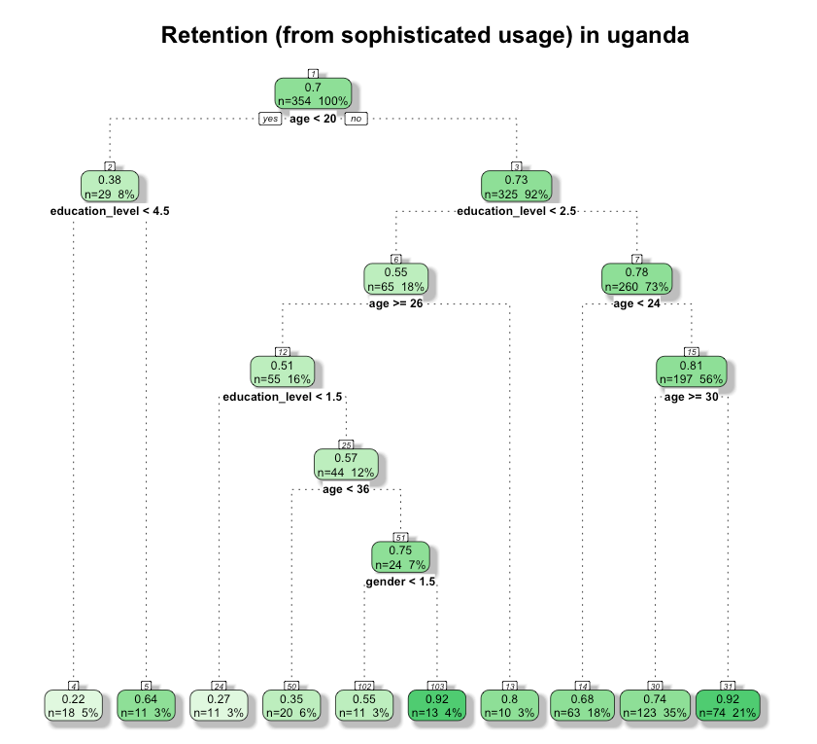

Figure 9: Recursive Partitioning Tree, Retention Uganda 2014

### Random Forest

We can use the random forest methodology to build several hundred trees and cross-validate the outcome for a decrease in variance with no increase in bias.

Our forest model was predicting long-term retention w/ >80% accuracy using just the demographic data available within the FII data: Age, Education, Marital Status and Gender.

While random forest models are not as easily interpreted as decision trees (R Part), the relative variable importance can tell you of each predictor’s value in reducing error in the resultant model.

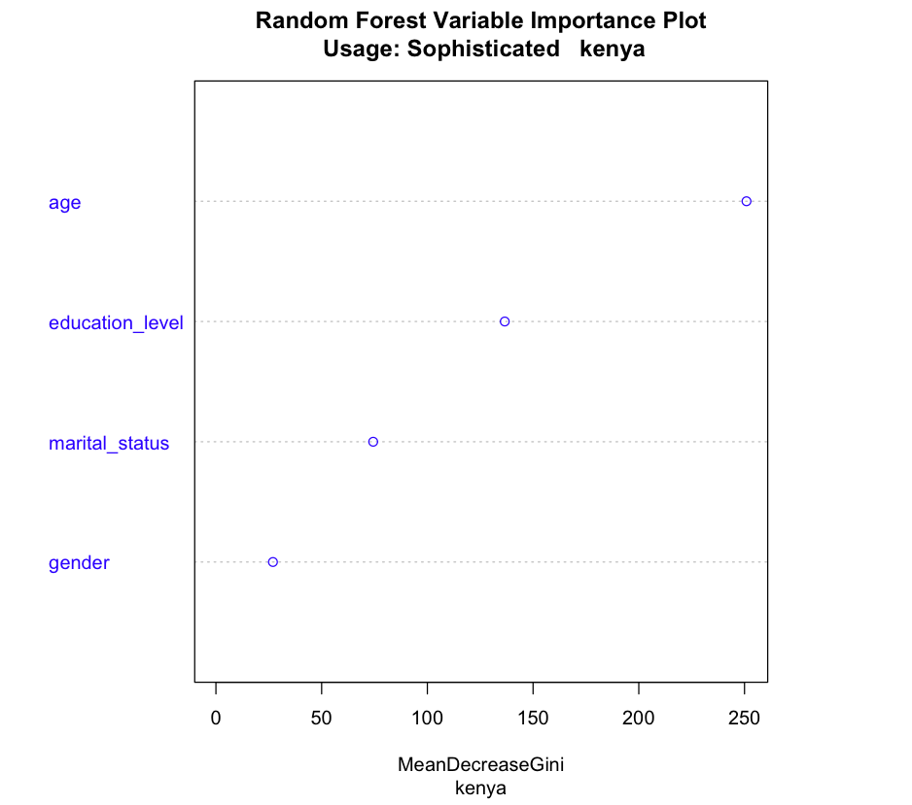

Figure 10: Random Forest, Relative Feature Importance, Kenya 2014

### Logistic Regression

Given the general linear relationship between our response variables (levels of waterfall) and predictors (demographics) we fit a simple logistic regression model to the data to predict retention. Here we first scale the data to generate comparable coefficients, and then use the absolute value of the coefficient to compare effect:

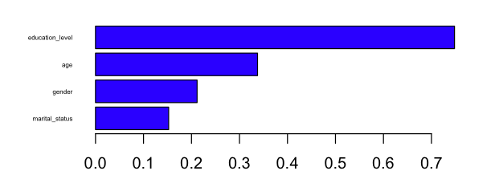

Figure 11: Logistic Regression, Absolute Value of Scaled Coefficients, Kenya Retention 2014

Here Education outweighs Age, though it should be noted that with the assumption of independence the interaction between age and education is ignored.

### Boosted Stumps

The boosted stumps method combines several weak models (decision based on single predictor) and combines them into a stronger model through boosting. It is similar to the random forest approach, though has the benefit of reducing error through iterative boosting.[8]

Here we see a highly consistent result with our other methods, placing age and education at the top of importance in relative influence on the final model, predicting retention across all countries.

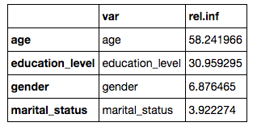

Table 3: Boosted Stumps, Relative Influence of Demographics, Kenya, Tanzania, Uganda, 2104

In consideration of all of the results above from the FII data, results were consistent with all countries, all levels in both rank and relative feature importance, a surprise to the team.

## Comparison: World Bank FINDEX 2014

The above analyses were completed using the 2014 Financial Inclusion Insights data set. To triangulate these findings, we additionally evaluated the 2014 FINDEX data. Although it did not include specific questions including “last time used”, it did enable a high-level analysis of factors that led to mobile money usage.

Recursive partitioning against the FINDEX data informs us that age and education do the best job reducing error in the model.

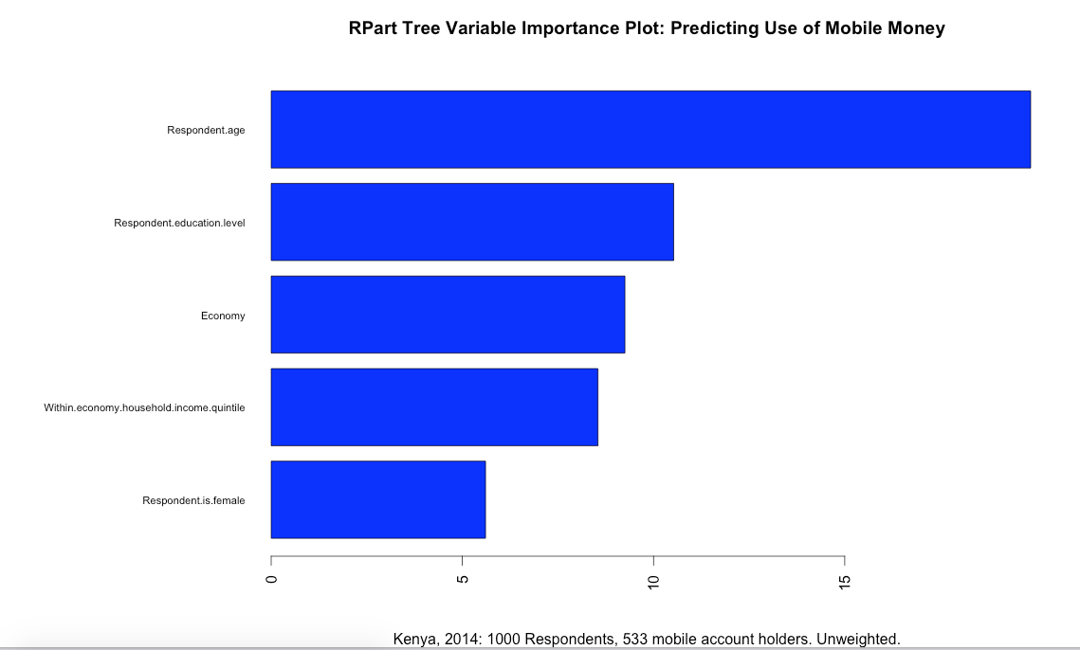

Figure 12: Variable Importance in MM Usage by Recursive Partitioning

We use all questions from FINDEX as prediction factors from which a random set is chosen at each stage.

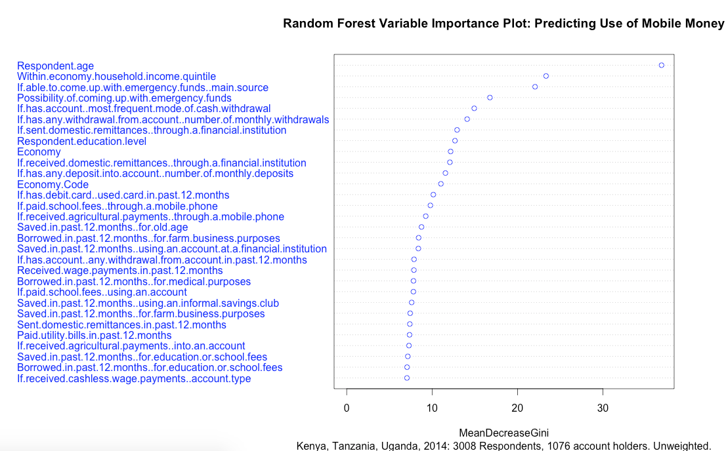

Figure 13: Variable Importance in MM Usage by Random Forest

This too aligns with our hypothesis of the importance of age and education in mobile money adoption, though the 2-way correlation between usage and other financial activities interrogated, does not provide deeper understanding of retention along a causal pathway.

# Discussion

The most noteworthy finding from these analyses is that (despite the radical differences between countries in demographics, adoption and services available) age and education consistently topped the list as enabling fairly accurate prediction at every level of our waterfall: enrollment, usage and retention.

Additionally through our investigation we developed a hypothesis that simpler, more basic services (deposit, withdraw, pay bills, send/receive money) act as “gateway services” for more sophisticated services (Insurance, long term savings, emergency funds, large transactions, periodic transactions: collect money, pay large bills (i.e. rent, insurance), save money, transfer money between accounts, loans, mortgage). Indeed, this hypothesis was true in the 2014 FII data for all but a single subscriber in the response set among nearly nine thousand.

Also worth noting is the low relative importance of gender in predicting retention. While prior literature points to gender inequality as a key issue to financial inclusion, gender took a lesser role in predicting adoption and retention in these data sets.

A limitation of this analysis was the shortcomings of the available data. Both the FII and FINDEX studies are meant to produce facts about the market, not develop input parameters for recommendation/prediction modeling. As such, beyond the very basic demographic data available, most of the other questions could not be adequately disambiguated against the response variables to draw meaningful conclusions.

Our hope is that this work, while not prescriptive in recommending activities in mobile financial product/feature development or marketing techniques, can provide a framework and methodology in follow-on research enabling such outcomes.

# Proposed Next Steps

As discussed above, the objective of identifying factors leading to long term retention was challenged by the limitations of our data.

For future projects we believe the correct approach is the development of a process and instrument for primary research within these and other geographies of interest. By developing the data set specifically designed for this purpose, we will enable a true time-series/survival analysis of users on mobile money platforms. The results of such a study could develop specific, actionable recommendations for mobile network operators (MNOs) as well as other service providers, government and non-government organizations (NGOs) in the sub-Saharan region and possibly beyond.

In the course of this project, we held several conversations with stakeholders such as Kiva.org, Branch.co, Orange, and Flutterwave who might directly benefit from further research in these areas. We also met with service providers such as Orange Door and Voto who have a data collection capability via IVR/SMS in the geographies of interest, using online surveys.

We therefore recommend a 3-month, phase II of this project, whereby we deploy a primary research instrument via IVR/SMS and develop new analyses based on true longitudinal responses, to identify factors and critical tipping points for long-term adoption.

Another underserved effect in this first exploratory phase is the influence of the social network in adoption and retention of mobile money usage. Prior research has shown that family-/neighbor-/village-influence is critical in gaining adoption, following Metcalfe’s law. [9]

Embedded in this methodology would be a system whereby respondents could refer others within their mobile money “network” to identify factors not just leading to long-term retention, but also organic adoption across a social graph.[10]

This study could be operated on a 3-6 month schedule, beginning immediately, including the following steps:

1. Development of the online survey/IVR/SMS instrument/package
2. Pilot deployment of instrument, by geography
3. Analysis of topline results
4. Follow-up/modification (if needed)
5. Full deployment (~3k responses by geography)
6. Survival analyses to isolate key factors, correlations between factors.
7. Recommendations, Communications to key stakeholders.

# Acknowledgements

The Data Guild wishes to acknowledge the many people who were helpful in reviewing and guiding our research. Specifically, Matthew Jackson (Stanford Department of Economics), Karen Fung (Curator, African Collection, Stanford Libraries), Joshua Blumenstock (UW/Berkeley), Kartik Raghavan, Jake Kendall, Steven Tiell (Accenture), Ted McCarthy (Google Access), Charlotte Stanton (Stanford), Iyinoluwa “E” Aboyeji (Andela/Fluterwave), Jody Rank (Ram Group), Melanie Walker, et al (World Bank).

We also wish to thank our sponsors and advisors on the project, Jennifer Kong and Theresa Boylan (Rockefeller Philanthropy Advisors) and Adam Sorensen (The Gates Foundation) without whom this work would not be possible.

# References

## Data:

Intermedia: *Financial Inclusion Insights Phases I-III (2012-2014) Used with permission.* Retrieved from <http://finclusion.org/>

World Bank, *Global Findex 2014: Kenya, Tanzania, Uganda.* Retrieved from:<http://www.worldbank.org/en/programs/globalfindex>

## Papers:

Khan,R., Manoj,J., Singh, A, Blumenstock, J.. *Behavioral Modeling for Churn Prediction: Early Indicators and Accurate Predictors of Custom Defection and Loyalty*

Information School, University of Washington, Seattle, WA, USA

Retrieved from: <https://arxiv.org/pdf/1512.06430v1.pdf>

Blumenstock, J., Cadamuro G., On, R.. (2015) Predicting *poverty and wealth from mobile phone metadata.* Science Magazine, 27 November 2015, Vol. 350 Issue 6264. Retrieved from <http://science.sciencemag.org/content/sci/350/6264/1073.full.pdf>

Khan R, Blumenstock J, *(2016) Predictors without Borders: Behavioral Modeling of Product Adoption in Three Developing Countries.* KDD ’16, August 13 - 17, 2016, San Francisco, CA, USA

*Retrieved from* [*http://www.kdd.org/kdd2016/papers/files/adf1160-khanA.pdf*](http://www.kdd.org/kdd2016/papers/files/adf1160-khanA.pdf)

World Bank (2015) *Global Financial Inclusion Database: The Little Data Book on Financial Inclusion.* Retrieved from: <http://www.worldbank.org/en/programs/globalfindex>

CGAP (2013: *The Power of Social Networks to Drive Mobile Money Adoption* Retrieved from: [*https://www.cgap.org/publications/power-social-networks-drive-mobile-money-adoption*](https://www.cgap.org/publications/power-social-networks-drive-mobile-money-adoption)

Morawcynski, O, Miscione, G (2008): *Examining Trust in Mobile Banking Transactions: The Case of M-Pesa in Kenya.* Retrieved from: <http://link.springer.com/chapter/10.1007%2F978-0-387-84822-8_19>

Jackson, M (2012): Economic Analysis of Social Networks. Retrieved from <http://web.stanford.edu/~jacksonm/EconAnalysesNetworks-Intro.pdf>

Kusimba, S, et al, IMTFI (2013): *Social Networks of Mobile Money in Kenya* Retrieved from: <http://www.imtfi.uci.edu/files/2013-1_kusimba_1.pdf>

Project Materials:

Python, R, Jupyter Notebooks and raw/derived data sets are available on github. Please contact [info@dataguild.com](mailto:info@dataguild.com) for access.

# Appendix

## Full table comparison of mobile money attributes by country, FII:

| The Data Guild, Project DoPLER: Kenya, Tanzania, Uganda, 8895 Respondents.† |
| --- |
|  | **Responses by Country** | | | |
|  | **kenya** | **tanzania** | **uganda** | **P-value** |
| **country** |
| kenya | 2,994 (100.0%) | 0 (0.0%) | 0 (0.0%) | < 0.0001 |
| tanzania | 0 (0.0%) | 3,001 (100.0%) | 0 (0.0%) |  |
| uganda | 0 (0.0%) | 0 (0.0%) | 3,000 (100.0%) |  |
| **year_of_birth** |
| Mean (SD) | 1979.8 (±14.9) | 1979.4 (±14.0) | 1979.8 (±14.8) | 0.44 |
| Missing | 0 (0%) | 44 (1.5%) | 0 (0%) |  |
| **gender** |
| Male | 1,162 (38.8%) | 1,479 (49.3%) | 1,045 (34.8%) | < 0.0001 |
| Female | 1,832 (61.2%) | 1,522 (50.7%) | 1,955 (65.2%) |  |
| **marital_status** |
| Single | 797 (26.6%) | 720 (24.0%) | 588 (19.6%) | < 0.0001 |
| Polygmous | 160 (5.3%) | 239 (8.0%) | 344 (11.5%) |  |
| Monogomous | 1,684 (56.2%) | 1,634 (54.4%) | 1,349 (45.0%) |  |
| Divorced | 37 (1.2%) | 50 (1.7%) | 54 (1.8%) |  |
| Separated | 77 (2.6%) | 145 (4.8%) | 184 (6.1%) |  |
| Widowed | 172 (5.7%) | 122 (4.1%) | 235 (7.8%) |  |
| Living Together | 63 (2.1%) | 89 (3.0%) | 236 (7.9%) |  |
| Other | 2 (0.1%) | 0 (0.0%) | 4 (0.1%) |  |
| Refused | 2 (0.1%) | 2 (0.1%) | 6 (0.2%) |  |
| **education_level** |
| None | 295 (9.9%) | 292 (9.7%) | 486 (16.2%) | < 0.0001 |
| Primary | 660 (22.0%) | 224 (7.5%) | 1,002 (33.4%) |  |
| Some Secondary | 682 (22.8%) | 1,755 (58.5%) | 448 (14.9%) |  |
| Secondary Complete | 446 (14.9%) | 176 (5.9%) | 593 (19.8%) |  |
| Some Secondary Vocational | 499 (16.7%) | 411 (13.7%) | 197 (6.6%) |  |
| Complete Secondary Vocational | 34 (1.1%) | 29 (1.0%) | 68 (2.3%) |  |
| Some Diploma | 53 (1.8%) | 18 (0.6%) | 55 (1.8%) |  |
| Diploma Complete | 37 (1.2%) | 23 (0.8%) | 11 (0.4%) |  |
| Some College | 109 (3.6%) | 24 (0.8%) | 45 (1.5%) |  |
| Some University | 91 (3.0%) | 14 (0.5%) | 30 (1.0%) |  |
| Complete University | 54 (1.8%) | 20 (0.7%) | 48 (1.6%) |  |
| Post Graduate | 8 (0.3%) | 4 (0.1%) | 7 (0.2%) |  |
| Koranic | 20 (0.7%) | 2 (0.1%) | 0 (0.0%) |  |
| Other | 5 (0.2%) | 6 (0.2%) | 10 (0.3%) |  |
| Refused | 1 (0.0%) | 3 (0.1%) | 0 (0.0%) |  |
| **heard_of_mobile_money** |
| Yes | 2,222 (74.2%) | 2,660 (88.6%) | 2,750 (91.7%) | < 0.0001 |
| No | 772 (25.8%) | 341 (11.4%) | 250 (8.3%) |  |
| **biggest_challenge_with_mobile_money** |
| Service down time | 624 (20.8%) | 848 (28.3%) | 666 (22.2%) | < 0.0001 |
| Agent down time | 352 (11.8%) | 346 (11.5%) | 145 (4.8%) |  |
| Operating phone | 79 (2.6%) | 35 (1.2%) | 36 (1.2%) |  |
| Unclear Tx fees | 78 (2.6%) | 351 (11.7%) | 176 (5.9%) |  |
| Agent float cash avail | 431 (14.4%) | 60 (2.0%) | 69 (2.3%) |  |
| Contacting customer care | 163 (5.4%) | 35 (1.2%) | 8 (0.3%) |  |
| Sending to wrong number | 310 (10.4%) | 53 (1.8%) | 55 (1.8%) |  |
| Family friends stealing money | 18 (0.6%) | 13 (0.4%) | 8 (0.3%) |  |
| Other fraud | 23 (0.8%) | 12 (0.4%) | 23 (0.8%) |  |
| Other | 263 (8.8%) | 50 (1.7%) | 127 (4.2%) |  |
| DK/Refused | 84 (2.8%) | 75 (2.5%) | 80 (2.7%) |  |
| Missing | 569 (19.0%) | 1,123 (37.4%) | 1,607 (53.6%) |  |
| **reason_never_used_mobile_money** |
| Don't know what it is | 11 (0.4%) | 45 (1.5%) | 149 (5.0%) | < 0.0001 |
| Don't know how to open | 41 (1.4%) | 109 (3.6%) | 102 (3.4%) |  |
| Don't have ID | 69 (2.3%) | 5 (0.2%) | 9 (0.3%) |  |
| No POS | 17 (0.6%) | 125 (4.2%) | 59 (2.0%) |  |
| Don't need | 62 (2.1%) | 130 (4.3%) | 163 (5.4%) |  |
| Registration too complicated | 4 (0.1%) | 8 (0.3%) | 26 (0.9%) |  |
| Registration fee too high | 0 (0.0%) | 17 (0.6%) | 20 (0.7%) |  |
| Too difficult | 5 (0.2%) | 43 (1.4%) | 21 (0.7%) |  |
| Tx fee too high | 4 (0.1%) | 25 (0.8%) | 18 (0.6%) |  |
| No money | 90 (3.0%) | 237 (7.9%) | 428 (14.3%) |  |
| No friends or family using | 1 (0.0%) | 18 (0.6%) | 36 (1.2%) |  |
| Don't understand | 11 (0.4%) | 32 (1.1%) | 63 (2.1%) |  |
| No phone | 136 (4.5%) | 15 (0.5%) | 33 (1.1%) |  |
| Don't trust | 9 (0.3%) | 15 (0.5%) | 28 (0.9%) |  |
| Family don't approve | 4 (0.1%) | 3 (0.1%) | 9 (0.3%) |  |
| All agents men | 0 (0.0%) | 1 (0.0%) | 0 (0.0%) |  |
| No advantage over existing | 5 (0.2%) | 3 (0.1%) | 40 (1.3%) |  |
| Other | 59 (2.0%) | 177 (5.9%) | 403 (13.4%) |  |
| Missing | 2,466 (82.4%) | 1,993 (66.4%) | 1,393 (46.4%) |  |
| **ever_used_mobile_money_for.deposit** |
| No | 402 (13.4%) | 470 (15.7%) | 592 (19.7%) | < 0.0001 |
| Yes | 2,023 (67.6%) | 1,408 (46.9%) | 801 (26.7%) |  |
| Missing | 569 (19.0%) | 1,123 (37.4%) | 1,607 (53.6%) |  |
| **ever_used_mobile_money_for.paygovt** |
| No | 2,385 (79.7%) | 1,832 (61.0%) | 1,372 (45.7%) | 0.090 |
| Yes | 40 (1.3%) | 46 (1.5%) | 21 (0.7%) |  |
| Missing | 569 (19.0%) | 1,123 (37.4%) | 1,607 (53.6%) |  |
| **ever_used_mobile_money_for.sendmoneyindiv** |
| No | 479 (16.0%) | 786 (26.2%) | 531 (17.7%) | < 0.0001 |
| Yes | 1,946 (65.0%) | 1,092 (36.4%) | 862 (28.7%) |  |
| Missing | 569 (19.0%) | 1,123 (37.4%) | 1,607 (53.6%) |  |
| **ever_used_mobile_money_for.getmoneyindiv** |
| No | 128 (4.3%) | 490 (16.3%) | 331 (11.0%) | < 0.0001 |
| Yes | 2,297 (76.7%) | 1,388 (46.3%) | 1,062 (35.4%) |  |
| Missing | 569 (19.0%) | 1,123 (37.4%) | 1,607 (53.6%) |  |
| **ever_used_mobile_money_for.getmoneygovt** |
| No | 2,401 (80.2%) | 1,850 (61.6%) | 1,366 (45.5%) | 0.047 |
| Yes | 24 (0.8%) | 28 (0.9%) | 27 (0.9%) |  |
| Missing | 569 (19.0%) | 1,123 (37.4%) | 1,607 (53.6%) |  |
| **ever_used_mobile_money_for.getwages** |
| No | 2,178 (72.7%) | 1,826 (60.8%) | 1,352 (45.1%) | < 0.0001 |
| Yes | 247 (8.2%) | 52 (1.7%) | 41 (1.4%) |  |
| Missing | 569 (19.0%) | 1,123 (37.4%) | 1,607 (53.6%) |  |
| **ever_used_mobile_money_for.paylarge** |
| No | 2,404 (80.3%) | 1,866 (62.2%) | 1,387 (46.2%) | 0.31 |
| Yes | 21 (0.7%) | 12 (0.4%) | 6 (0.2%) |  |
| Missing | 569 (19.0%) | 1,123 (37.4%) | 1,607 (53.6%) |  |
| **ever_used_mobile_money_for.payinsurance** |
| No | 2,390 (79.8%) | 1,868 (62.2%) | 1,387 (46.2%) | 0.001 |
| Yes | 35 (1.2%) | 10 (0.3%) | 6 (0.2%) |  |
| Missing | 569 (19.0%) | 1,123 (37.4%) | 1,607 (53.6%) |  |
| **ever_used_mobile_money_for.payloan** |
| No | 2,182 (72.9%) | 1,861 (62.0%) | 1,383 (46.1%) | < 0.0001 |
| Yes | 243 (8.1%) | 17 (0.6%) | 10 (0.3%) |  |
| Missing | 569 (19.0%) | 1,123 (37.4%) | 1,607 (53.6%) |  |
| **ever_used_mobile_money_for.savemoney** |
| No | 1,739 (58.1%) | 1,699 (56.6%) | 1,230 (41.0%) | < 0.0001 |
| Yes | 686 (22.9%) | 179 (6.0%) | 163 (5.4%) |  |
| Missing | 569 (19.0%) | 1,123 (37.4%) | 1,607 (53.6%) |  |
| **ever_used_mobile_money_for.setasidepension** |
| No | 2,384 (79.6%) | 1,853 (61.7%) | 1,371 (45.7%) | 0.64 |
| Yes | 41 (1.4%) | 25 (0.8%) | 22 (0.7%) |  |
| Missing | 569 (19.0%) | 1,123 (37.4%) | 1,607 (53.6%) |  |
| **ever_used_mobile_money_for.withdraw** |
| No | 38 (1.3%) | 64 (2.1%) | 119 (4.0%) | < 0.0001 |
| Yes | 2,387 (79.7%) | 1,814 (60.4%) | 1,274 (42.5%) |  |
| Missing | 569 (19.0%) | 1,123 (37.4%) | 1,607 (53.6%) |  |
| **ever_used_mobile_money_for.setasideother** |
| No | 1,957 (65.4%) | 1,721 (57.3%) | 1,282 (42.7%) | < 0.0001 |
| Yes | 468 (15.6%) | 157 (5.2%) | 111 (3.7%) |  |
| Missing | 569 (19.0%) | 1,123 (37.4%) | 1,607 (53.6%) |  |
| **ever_used_mobile_money_for.makeinvestment** |
| No | 2,412 (80.6%) | 1,866 (62.2%) | 1,381 (46.0%) | 0.47 |
| Yes | 13 (0.4%) | 12 (0.4%) | 12 (0.4%) |  |
| Missing | 569 (19.0%) | 1,123 (37.4%) | 1,607 (53.6%) |  |
| **ever_used_mobile_money_for.payatstore** |
| No | 2,249 (75.1%) | 1,859 (61.9%) | 1,373 (45.8%) | < 0.0001 |
| Yes | 176 (5.9%) | 19 (0.6%) | 20 (0.7%) |  |
| Missing | 569 (19.0%) | 1,123 (37.4%) | 1,607 (53.6%) |  |
| **ever_used_mobile_money_for.transfermobile** |
| No | 2,111 (70.5%) | 1,786 (59.5%) | 1,371 (45.7%) | < 0.0001 |
| Yes | 314 (10.5%) | 92 (3.1%) | 22 (0.7%) |  |
| Missing | 569 (19.0%) | 1,123 (37.4%) | 1,607 (53.6%) |  |
| **ever_used_mobile_money_for.transferbank** |
| No | 2,253 (75.3%) | 1,841 (61.3%) | 1,380 (46.0%) | < 0.0001 |
| Yes | 172 (5.7%) | 37 (1.2%) | 13 (0.4%) |  |
| Missing | 569 (19.0%) | 1,123 (37.4%) | 1,607 (53.6%) |  |
| **ever_used_mobile_money_for.transfermobiletoother** |
| No | 2,386 (79.7%) | 1,853 (61.7%) | 1,384 (46.1%) | 0.030 |
| Yes | 39 (1.3%) | 25 (0.8%) | 9 (0.3%) |  |
| Missing | 569 (19.0%) | 1,123 (37.4%) | 1,607 (53.6%) |  |
| **ever_used_mobile_money_for.lendinggroup** |
| No | 2,384 (79.6%) | 1,866 (62.2%) | 1,377 (45.9%) | 0.006 |
| Yes | 41 (1.4%) | 12 (0.4%) | 16 (0.5%) |  |
| Missing | 569 (19.0%) | 1,123 (37.4%) | 1,607 (53.6%) |  |
| **ever_used_mobile_money_for.payrent** |
| No | 2,359 (78.8%) | 1,856 (61.8%) | 1,381 (46.0%) | < 0.0001 |
| Yes | 66 (2.2%) | 22 (0.7%) | 12 (0.4%) |  |
| Missing | 569 (19.0%) | 1,123 (37.4%) | 1,607 (53.6%) |  |
| **ever_used_mobile_money_for.accountmaint** |
| No | 1,593 (53.2%) | 1,559 (51.9%) | 1,229 (41.0%) | < 0.0001 |
| Yes | 832 (27.8%) | 319 (10.6%) | 164 (5.5%) |  |
| Missing | 569 (19.0%) | 1,123 (37.4%) | 1,607 (53.6%) |  |
| **ever_used_mobile_money_for.other** |
| No | 2,416 (80.7%) | 1,872 (62.4%) | 1,391 (46.4%) | 0.50 |
| Yes | 9 (0.3%) | 6 (0.2%) | 2 (0.1%) |  |
| Missing | 569 (19.0%) | 1,123 (37.4%) | 1,607 (53.6%) |  |
| **ever_used_mobile_money_for.paymobilebill** |
| No | 644 (21.5%) | 684 (22.8%) | 794 (26.5%) | < 0.0001 |
| Yes | 1,781 (59.5%) | 1,194 (39.8%) | 599 (20.0%) |  |
| Missing | 569 (19.0%) | 1,123 (37.4%) | 1,607 (53.6%) |  |
| **ever_used_mobile_money_for.payschoolfee** |
| No | 2,188 (73.1%) | 1,814 (60.4%) | 1,306 (43.5%) | < 0.0001 |
| Yes | 237 (7.9%) | 64 (2.1%) | 87 (2.9%) |  |
| Missing | 569 (19.0%) | 1,123 (37.4%) | 1,607 (53.6%) |  |
| **ever_used_mobile_money_for.paymedical** |
| No | 2,339 (78.1%) | 1,853 (61.7%) | 1,361 (45.4%) | < 0.0001 |
| Yes | 86 (2.9%) | 25 (0.8%) | 32 (1.1%) |  |
| Missing | 569 (19.0%) | 1,123 (37.4%) | 1,607 (53.6%) |  |
| **ever_used_mobile_money_for.payelectrical** |
| No | 2,180 (72.8%) | 1,701 (56.7%) | 1,327 (44.2%) | < 0.0001 |
| Yes | 245 (8.2%) | 177 (5.9%) | 66 (2.2%) |  |
| Missing | 569 (19.0%) | 1,123 (37.4%) | 1,607 (53.6%) |  |
| **ever_used_mobile_money_for.paywater** |
| No | 2,360 (78.8%) | 1,846 (61.5%) | 1,361 (45.4%) | 0.097 |
| Yes | 65 (2.2%) | 32 (1.1%) | 32 (1.1%) |  |
| Missing | 569 (19.0%) | 1,123 (37.4%) | 1,607 (53.6%) |  |
| **ever_used_mobile_money_for.paysolar** |
| No | 2,400 (80.2%) | 1,860 (62.0%) | 1,385 (46.2%) | 0.33 |
| Yes | 25 (0.8%) | 18 (0.6%) | 8 (0.3%) |  |
| Missing | 569 (19.0%) | 1,123 (37.4%) | 1,607 (53.6%) |  |
| **ever_used_mobile_money_for.paytv** |
| No | 2,238 (74.7%) | 1,802 (60.0%) | 1,352 (45.1%) | < 0.0001 |
| Yes | 187 (6.2%) | 76 (2.5%) | 41 (1.4%) |  |
| Missing | 569 (19.0%) | 1,123 (37.4%) | 1,607 (53.6%) |  |
| **how_often_use_mobile_money_for.deposit** |
| Daily | 76 (2.5%) | 53 (1.8%) | 29 (1.0%) | < 0.0001 |
| Weekly | 495 (16.5%) | 240 (8.0%) | 123 (4.1%) |  |
| 15 days | 309 (10.3%) | 333 (11.1%) | 174 (5.8%) |  |
| Monthly | 658 (22.0%) | 397 (13.2%) | 223 (7.4%) |  |
| 3 Months | 291 (9.7%) | 269 (9.0%) | 140 (4.7%) |  |
| 6 Months | 111 (3.7%) | 76 (2.5%) | 60 (2.0%) |  |
| Annually | 33 (1.1%) | 29 (1.0%) | 31 (1.0%) |  |
| Almost Never | 50 (1.7%) | 11 (0.4%) | 21 (0.7%) |  |
| Missing | 971 (32.4%) | 1,593 (53.1%) | 2,199 (73.3%) |  |
| **how_often_use_mobile_money_for.paygovt** |
| Daily | 0 (0.0%) | 0 (0.0%) | 1 (0.0%) | 0.56 |
| Weekly | 2 (0.1%) | 4 (0.1%) | 2 (0.1%) |  |
| 15 days | 4 (0.1%) | 10 (0.3%) | 3 (0.1%) |  |
| Monthly | 17 (0.6%) | 10 (0.3%) | 10 (0.3%) |  |
| 3 Months | 5 (0.2%) | 9 (0.3%) | 2 (0.1%) |  |
| 6 Months | 3 (0.1%) | 4 (0.1%) | 1 (0.0%) |  |
| Annually | 3 (0.1%) | 3 (0.1%) | 0 (0.0%) |  |
| Almost Never | 6 (0.2%) | 6 (0.2%) | 2 (0.1%) |  |
| Missing | 2,954 (98.7%) | 2,955 (98.5%) | 2,979 (99.3%) |  |
| **how_often_use_mobile_money_for.sendmoneyindiv** |
| Daily | 18 (0.6%) | 17 (0.6%) | 10 (0.3%) | < 0.0001 |
| Weekly | 150 (5.0%) | 86 (2.9%) | 63 (2.1%) |  |
| 15 days | 251 (8.4%) | 180 (6.0%) | 124 (4.1%) |  |
| Monthly | 800 (26.7%) | 368 (12.3%) | 258 (8.6%) |  |
| 3 Months | 408 (13.6%) | 302 (10.1%) | 219 (7.3%) |  |
| 6 Months | 197 (6.6%) | 63 (2.1%) | 94 (3.1%) |  |
| Annually | 71 (2.4%) | 51 (1.7%) | 65 (2.2%) |  |
| Almost Never | 51 (1.7%) | 25 (0.8%) | 29 (1.0%) |  |
| Missing | 1,048 (35.0%) | 1,909 (63.6%) | 2,138 (71.3%) |  |
| **how_often_use_mobile_money_for.getmoneyindiv** |
| Daily | 22 (0.7%) | 28 (0.9%) | 12 (0.4%) | < 0.0001 |
| Weekly | 233 (7.8%) | 120 (4.0%) | 108 (3.6%) |  |
| 15 days | 293 (9.8%) | 219 (7.3%) | 163 (5.4%) |  |
| Monthly | 938 (31.3%) | 466 (15.5%) | 326 (10.9%) |  |
| 3 Months | 472 (15.8%) | 350 (11.7%) | 263 (8.8%) |  |
| 6 Months | 185 (6.2%) | 120 (4.0%) | 113 (3.8%) |  |
| Annually | 88 (2.9%) | 49 (1.6%) | 48 (1.6%) |  |
| Almost Never | 66 (2.2%) | 36 (1.2%) | 29 (1.0%) |  |
| Missing | 697 (23.3%) | 1,613 (53.7%) | 1,938 (64.6%) |  |
| **how_often_use_mobile_money_for.getwages** |
| Daily | 5 (0.2%) | 3 (0.1%) | 0 (0.0%) | 0.42 |
| Weekly | 26 (0.9%) | 6 (0.2%) | 3 (0.1%) |  |
| 15 days | 23 (0.8%) | 5 (0.2%) | 3 (0.1%) |  |
| Monthly | 118 (3.9%) | 16 (0.5%) | 25 (0.8%) |  |
| 3 Months | 40 (1.3%) | 9 (0.3%) | 4 (0.1%) |  |
| 6 Months | 18 (0.6%) | 8 (0.3%) | 4 (0.1%) |  |
| Annually | 7 (0.2%) | 2 (0.1%) | 1 (0.0%) |  |
| Almost Never | 10 (0.3%) | 3 (0.1%) | 1 (0.0%) |  |
| Missing | 2,747 (91.8%) | 2,949 (98.3%) | 2,959 (98.6%) |  |
| **how_often_use_mobile_money_for.payloan** |
| Daily | 13 (0.4%) | 2 (0.1%) | 1 (0.0%) | 0.074 |
| Weekly | 12 (0.4%) | 2 (0.1%) | 0 (0.0%) |  |
| 15 days | 113 (3.8%) | 5 (0.2%) | 6 (0.2%) |  |
| Monthly | 48 (1.6%) | 2 (0.1%) | 2 (0.1%) |  |
| 3 Months | 29 (1.0%) | 0 (0.0%) | 1 (0.0%) |  |
| 6 Months | 18 (0.6%) | 2 (0.1%) | 0 (0.0%) |  |
| Annually | 10 (0.3%) | 4 (0.1%) | 0 (0.0%) |  |
| Almost Never | 0 (0.0%) | 0 (0.0%) | 0 (0.0%) |  |
| Missing | 2,751 (91.9%) | 2,984 (99.4%) | 2,990 (99.7%) |  |
| **how_often_use_mobile_money_for.savemoney** |
| Daily | 10 (0.3%) | 6 (0.2%) | 5 (0.2%) | 0.0005 |
| Weekly | 91 (3.0%) | 22 (0.7%) | 14 (0.5%) |  |
| 15 days | 72 (2.4%) | 27 (0.9%) | 34 (1.1%) |  |
| Monthly | 346 (11.6%) | 76 (2.5%) | 59 (2.0%) |  |
| 3 Months | 109 (3.6%) | 26 (0.9%) | 23 (0.8%) |  |
| 6 Months | 27 (0.9%) | 13 (0.4%) | 11 (0.4%) |  |
| Annually | 15 (0.5%) | 5 (0.2%) | 9 (0.3%) |  |
| Almost Never | 16 (0.5%) | 4 (0.1%) | 8 (0.3%) |  |
| Missing | 2,308 (77.1%) | 2,822 (94.0%) | 2,837 (94.6%) |  |
| **how_often_use_mobile_money_for.withdraw** |
| Daily | 53 (1.8%) | 67 (2.2%) | 26 (0.9%) | < 0.0001 |
| Weekly | 564 (18.8%) | 329 (11.0%) | 211 (7.0%) |  |
| 15 days | 410 (13.7%) | 382 (12.7%) | 253 (8.4%) |  |
| Monthly | 812 (27.1%) | 472 (15.7%) | 350 (11.7%) |  |
| 3 Months | 347 (11.6%) | 384 (12.8%) | 244 (8.1%) |  |
| 6 Months | 105 (3.5%) | 113 (3.8%) | 104 (3.5%) |  |
| Annually | 50 (1.7%) | 49 (1.6%) | 53 (1.8%) |  |
| Almost Never | 46 (1.5%) | 18 (0.6%) | 33 (1.1%) |  |
| Missing | 607 (20.3%) | 1,187 (39.6%) | 1,726 (57.5%) |  |
| **how_often_use_mobile_money_for.setasideother** |
| Daily | 5 (0.2%) | 9 (0.3%) | 6 (0.2%) | < 0.0001 |
| Weekly | 49 (1.6%) | 14 (0.5%) | 15 (0.5%) |  |
| 15 days | 43 (1.4%) | 27 (0.9%) | 11 (0.4%) |  |
| Monthly | 251 (8.4%) | 64 (2.1%) | 38 (1.3%) |  |
| 3 Months | 75 (2.5%) | 20 (0.7%) | 21 (0.7%) |  |
| 6 Months | 30 (1.0%) | 11 (0.4%) | 13 (0.4%) |  |
| Annually | 6 (0.2%) | 4 (0.1%) | 6 (0.2%) |  |
| Almost Never | 9 (0.3%) | 8 (0.3%) | 1 (0.0%) |  |
| Missing | 2,526 (84.4%) | 2,844 (94.8%) | 2,889 (96.3%) |  |
| **how_often_use_mobile_money_for.payatstore** |
| Daily | 2 (0.1%) | 0 (0.0%) | 2 (0.1%) | 0.23 |
| Weekly | 30 (1.0%) | 3 (0.1%) | 4 (0.1%) |  |
| 15 days | 27 (0.9%) | 1 (0.0%) | 1 (0.0%) |  |
| Monthly | 49 (1.6%) | 10 (0.3%) | 6 (0.2%) |  |
| 3 Months | 37 (1.2%) | 2 (0.1%) | 3 (0.1%) |  |
| 6 Months | 14 (0.5%) | 2 (0.1%) | 3 (0.1%) |  |
| Annually | 3 (0.1%) | 1 (0.0%) | 0 (0.0%) |  |
| Almost Never | 14 (0.5%) | 0 (0.0%) | 1 (0.0%) |  |
| Missing | 2,818 (94.1%) | 2,982 (99.4%) | 2,980 (99.3%) |  |
| **how_often_use_mobile_money_for.transfermobile** |
| Daily | 3 (0.1%) | 3 (0.1%) | 0 (0.0%) | 0.083 |
| Weekly | 28 (0.9%) | 12 (0.4%) | 6 (0.2%) |  |
| 15 days | 39 (1.3%) | 16 (0.5%) | 1 (0.0%) |  |
| Monthly | 132 (4.4%) | 28 (0.9%) | 6 (0.2%) |  |
| 3 Months | 65 (2.2%) | 18 (0.6%) | 4 (0.1%) |  |
| 6 Months | 27 (0.9%) | 6 (0.2%) | 2 (0.1%) |  |
| Annually | 8 (0.3%) | 4 (0.1%) | 0 (0.0%) |  |
| Almost Never | 12 (0.4%) | 5 (0.2%) | 3 (0.1%) |  |
| Missing | 2,680 (89.5%) | 2,909 (96.9%) | 2,978 (99.3%) |  |
| **how_often_use_mobile_money_for.transferbank** |
| Daily | 0 (0.0%) | 1 (0.0%) | 0 (0.0%) | 0.025 |
| Weekly | 16 (0.5%) | 4 (0.1%) | 5 (0.2%) |  |
| 15 days | 22 (0.7%) | 4 (0.1%) | 0 (0.0%) |  |
| Monthly | 85 (2.8%) | 18 (0.6%) | 3 (0.1%) |  |
| 3 Months | 22 (0.7%) | 2 (0.1%) | 3 (0.1%) |  |
| 6 Months | 8 (0.3%) | 5 (0.2%) | 1 (0.0%) |  |
| Annually | 9 (0.3%) | 0 (0.0%) | 0 (0.0%) |  |
| Almost Never | 10 (0.3%) | 3 (0.1%) | 1 (0.0%) |  |
| Missing | 2,822 (94.3%) | 2,964 (98.8%) | 2,987 (99.6%) |  |
| **how_often_use_mobile_money_for.payrent** |
| Daily | 1 (0.0%) | 1 (0.0%) | 0 (0.0%) | 0.20 |
| Weekly | 4 (0.1%) | 3 (0.1%) | 1 (0.0%) |  |
| 15 days | 3 (0.1%) | 1 (0.0%) | 0 (0.0%) |  |
| Monthly | 45 (1.5%) | 8 (0.3%) | 7 (0.2%) |  |
| 3 Months | 8 (0.3%) | 3 (0.1%) | 2 (0.1%) |  |
| 6 Months | 2 (0.1%) | 1 (0.0%) | 1 (0.0%) |  |
| Annually | 2 (0.1%) | 3 (0.1%) | 0 (0.0%) |  |
| Almost Never | 1 (0.0%) | 2 (0.1%) | 1 (0.0%) |  |
| Missing | 2,928 (97.8%) | 2,979 (99.3%) | 2,988 (99.6%) |  |
| **how_often_use_mobile_money_for.accountmaint** |
| Daily | 54 (1.8%) | 43 (1.4%) | 20 (0.7%) | 0.0006 |
| Weekly | 202 (6.7%) | 77 (2.6%) | 49 (1.6%) |  |
| 15 days | 112 (3.7%) | 57 (1.9%) | 24 (0.8%) |  |
| Monthly | 271 (9.1%) | 69 (2.3%) | 31 (1.0%) |  |
| 3 Months | 93 (3.1%) | 38 (1.3%) | 19 (0.6%) |  |
| 6 Months | 38 (1.3%) | 15 (0.5%) | 7 (0.2%) |  |
| Annually | 24 (0.8%) | 7 (0.2%) | 6 (0.2%) |  |
| Almost Never | 38 (1.3%) | 13 (0.4%) | 8 (0.3%) |  |
| Missing | 2,162 (72.2%) | 2,682 (89.4%) | 2,836 (94.5%) |  |
| **how_often_use_mobile_money_for.paymobilebill** |
| Daily | 229 (7.6%) | 258 (8.6%) | 93 (3.1%) | < 0.0001 |
| Weekly | 678 (22.6%) | 387 (12.9%) | 187 (6.2%) |  |
| 15 days | 298 (10.0%) | 225 (7.5%) | 102 (3.4%) |  |
| Monthly | 311 (10.4%) | 137 (4.6%) | 100 (3.3%) |  |
| 3 Months | 146 (4.9%) | 121 (4.0%) | 59 (2.0%) |  |
| 6 Months | 52 (1.7%) | 38 (1.3%) | 28 (0.9%) |  |
| Annually | 24 (0.8%) | 13 (0.4%) | 16 (0.5%) |  |
| Almost Never | 43 (1.4%) | 15 (0.5%) | 14 (0.5%) |  |
| Missing | 1,213 (40.5%) | 1,807 (60.2%) | 2,401 (80.0%) |  |
| **how_often_use_mobile_money_for.payschoolfee** |
| Daily | 3 (0.1%) | 1 (0.0%) | 0 (0.0%) | < 0.0001 |
| Weekly | 13 (0.4%) | 2 (0.1%) | 4 (0.1%) |  |
| 15 days | 7 (0.2%) | 1 (0.0%) | 7 (0.2%) |  |
| Monthly | 60 (2.0%) | 10 (0.3%) | 18 (0.6%) |  |
| 3 Months | 102 (3.4%) | 15 (0.5%) | 42 (1.4%) |  |
| 6 Months | 24 (0.8%) | 16 (0.5%) | 7 (0.2%) |  |
| Annually | 14 (0.5%) | 13 (0.4%) | 9 (0.3%) |  |
| Almost Never | 14 (0.5%) | 6 (0.2%) | 0 (0.0%) |  |
| Missing | 2,757 (92.1%) | 2,937 (97.9%) | 2,913 (97.1%) |  |
| **how_often_use_mobile_money_for.paymedical** |
| Daily | 2 (0.1%) | 0 (0.0%) | 0 (0.0%) | 0.18 |
| Weekly | 4 (0.1%) | 0 (0.0%) | 1 (0.0%) |  |
| 15 days | 2 (0.1%) | 0 (0.0%) | 4 (0.1%) |  |
| Monthly | 23 (0.8%) | 9 (0.3%) | 5 (0.2%) |  |
| 3 Months | 13 (0.4%) | 9 (0.3%) | 8 (0.3%) |  |
| 6 Months | 16 (0.5%) | 2 (0.1%) | 4 (0.1%) |  |
| Annually | 17 (0.6%) | 5 (0.2%) | 7 (0.2%) |  |
| Almost Never | 9 (0.3%) | 0 (0.0%) | 3 (0.1%) |  |
| Missing | 2,908 (97.1%) | 2,976 (99.2%) | 2,968 (98.9%) |  |
| **how_often_use_mobile_money_for.payelectrical** |
| Daily | 0 (0.0%) | 3 (0.1%) | 0 (0.0%) | < 0.0001 |
| Weekly | 8 (0.3%) | 18 (0.6%) | 5 (0.2%) |  |
| 15 days | 5 (0.2%) | 25 (0.8%) | 5 (0.2%) |  |
| Monthly | 196 (6.5%) | 100 (3.3%) | 44 (1.5%) |  |
| 3 Months | 18 (0.6%) | 14 (0.5%) | 9 (0.3%) |  |
| 6 Months | 6 (0.2%) | 7 (0.2%) | 2 (0.1%) |  |
| Annually | 4 (0.1%) | 3 (0.1%) | 0 (0.0%) |  |
| Almost Never | 8 (0.3%) | 7 (0.2%) | 1 (0.0%) |  |
| Missing | 2,749 (91.8%) | 2,824 (94.1%) | 2,934 (97.8%) |  |
| **how_often_use_mobile_money_for.paywater** |
| Daily | 1 (0.0%) | 1 (0.0%) | 0 (0.0%) | 0.003 |
| Weekly | 3 (0.1%) | 1 (0.0%) | 3 (0.1%) |  |
| 15 days | 2 (0.1%) | 3 (0.1%) | 1 (0.0%) |  |
| Monthly | 54 (1.8%) | 18 (0.6%) | 18 (0.6%) |  |
| 3 Months | 1 (0.0%) | 6 (0.2%) | 8 (0.3%) |  |
| 6 Months | 1 (0.0%) | 0 (0.0%) | 0 (0.0%) |  |
| Annually | 2 (0.1%) | 2 (0.1%) | 0 (0.0%) |  |
| Almost Never | 1 (0.0%) | 1 (0.0%) | 2 (0.1%) |  |
| Missing | 2,929 (97.8%) | 2,969 (98.9%) | 2,968 (98.9%) |  |
| **how_often_use_mobile_money_for.paytv** |
| Daily | 1 (0.0%) | 1 (0.0%) | 0 (0.0%) | 0.006 |
| Weekly | 4 (0.1%) | 6 (0.2%) | 0 (0.0%) |  |
| 15 days | 3 (0.1%) | 7 (0.2%) | 3 (0.1%) |  |
| Monthly | 154 (5.1%) | 46 (1.5%) | 31 (1.0%) |  |
| 3 Months | 12 (0.4%) | 8 (0.3%) | 4 (0.1%) |  |
| 6 Months | 5 (0.2%) | 1 (0.0%) | 1 (0.0%) |  |
| Annually | 3 (0.1%) | 0 (0.0%) | 0 (0.0%) |  |
| Almost Never | 5 (0.2%) | 7 (0.2%) | 2 (0.1%) |  |
| Missing | 2,807 (93.8%) | 2,925 (97.5%) | 2,959 (98.6%) |  |
| **ever_used_any_mobile_money_service.MPesa** |
| No | 567 (18.9%) | 1,584 (52.8%) | 1,466 (48.9%) | < 0.0001 |
| Yes | 2,381 (79.5%) | 1,183 (39.4%) | 1,180 (39.3%) |  |
| Missing | 46 (1.5%) | 234 (7.8%) | 354 (11.8%) |  |
| **ever_used_any_mobile_money_service.AirtelMoney** |
| No | 1,929 (64.4%) | 1,873 (62.4%) | 1,709 (57.0%) | < 0.0001 |
| Yes | 153 (5.1%) | 677 (22.6%) | 520 (17.3%) |  |
| Missing | 912 (30.5%) | 451 (15.0%) | 771 (25.7%) |  |
| **ever_used_any_mobile_money_service.YUCash** |
| No | 1,241 (41.4%) | 1,998 (66.6%) | 896 (29.9%) | < 0.0001 |
| Yes | 23 (0.8%) | 573 (19.1%) | 15 (0.5%) |  |
| Missing | 1,730 (57.8%) | 430 (14.3%) | 2,089 (69.6%) |  |
| **ever_used_any_mobile_money_service.OrangeMoney** |
| No | 1,280 (42.8%) | 776 (25.9%) | 455 (15.2%) | < 0.0001 |
| Yes | 12 (0.4%) | 30 (1.0%) | 1 (0.0%) |  |
| Missing | 1,702 (56.8%) | 2,195 (73.1%) | 2,544 (84.8%) |  |
| **ever_used_any_mobile_money_service.Tangaza** |
| No | 534 (17.8%) | 197 (6.6%) | 252 (8.4%) | 1.00 |
| Yes | 2 (0.1%) | 1 (0.0%) | 1 (0.0%) |  |
| Missing | 2,458 (82.1%) | 2,803 (93.4%) | 2,747 (91.6%) |  |
| **ever_used_any_mobile_money_service.MobiCash** |
| No | 756 (25.3%) | 13 (0.4%) | 458 (15.3%) | 0.055 |
| Yes | 8 (0.3%) | 1 (0.0%) | 10 (0.3%) |  |
| Missing | 2,230 (74.5%) | 2,987 (99.5%) | 2,532 (84.4%) |  |
| **ever_used_any_mobile_money_service.Equitel** |
| No | 1,097 (36.6%) | 0 (0.0%) | 239 (8.0%) | 0.39 |
| Yes | 75 (2.5%) | 0 (0.0%) | 12 (0.4%) |  |
| Missing | 1,822 (60.9%) | 3,001 (100.0%) | 2,749 (91.6%) |  |
| **last_time_fin_activity_w_mobile_money.MPesa** |
| Yesterday | 213 (7.1%) | 146 (4.9%) | 174 (5.8%) | < 0.0001 |
| 7 days | 683 (22.8%) | 434 (14.5%) | 402 (13.4%) |  |
| 30 days | 857 (28.6%) | 352 (11.7%) | 294 (9.8%) |  |
| 90 days | 189 (6.3%) | 126 (4.2%) | 173 (5.8%) |  |
| >90 days | 439 (14.7%) | 125 (4.2%) | 137 (4.6%) |  |
| Never | 0 (0.0%) | 0 (0.0%) | 0 (0.0%) |  |
| Missing | 613 (20.5%) | 1,818 (60.6%) | 1,820 (60.7%) |  |
| **last_time_fin_activity_w_mobile_money.AirtelMoney** |
| Yesterday | 49 (1.6%) | 86 (2.9%) | 102 (3.4%) | < 0.0001 |
| 7 days | 47 (1.6%) | 265 (8.8%) | 159 (5.3%) |  |
| 30 days | 33 (1.1%) | 179 (6.0%) | 114 (3.8%) |  |
| 90 days | 17 (0.6%) | 72 (2.4%) | 86 (2.9%) |  |
| >90 days | 7 (0.2%) | 75 (2.5%) | 59 (2.0%) |  |
| Never | 0 (0.0%) | 0 (0.0%) | 0 (0.0%) |  |
| Missing | 2,841 (94.9%) | 2,324 (77.4%) | 2,480 (82.7%) |  |
| **last_time_fin_activity_w_mobile_money.YUCash** |
| Yesterday | 10 (0.3%) | 81 (2.7%) | 7 (0.2%) | 0.001 |
| 7 days | 7 (0.2%) | 211 (7.0%) | 3 (0.1%) |  |
| 30 days | 2 (0.1%) | 128 (4.3%) | 1 (0.0%) |  |
| 90 days | 2 (0.1%) | 114 (3.8%) | 4 (0.1%) |  |
| >90 days | 2 (0.1%) | 39 (1.3%) | 0 (0.0%) |  |
| Never | 0 (0.0%) | 0 (0.0%) | 0 (0.0%) |  |
| Missing | 2,971 (99.2%) | 2,428 (80.9%) | 2,985 (99.5%) |  |
| **have_account_with_any_mobile_money_service.MPesa** |
| No | 856 (28.6%) | 1,583 (52.7%) | 1,796 (59.9%) | < 0.0001 |
| Yes | 2,092 (69.9%) | 1,184 (39.5%) | 850 (28.3%) |  |
| Missing | 46 (1.5%) | 234 (7.8%) | 354 (11.8%) |  |
| **have_account_with_any_mobile_money_service.AirtelMoney** |
| No | 1,932 (64.5%) | 1,942 (64.7%) | 1,864 (62.1%) | < 0.0001 |
| Yes | 150 (5.0%) | 608 (20.3%) | 365 (12.2%) |  |
| Missing | 912 (30.5%) | 451 (15.0%) | 771 (25.7%) |  |
| **have_account_with_any_mobile_money_service.YUCash** |
| No | 1,240 (41.4%) | 2,063 (68.7%) | 899 (30.0%) | < 0.0001 |
| Yes | 24 (0.8%) | 508 (16.9%) | 12 (0.4%) |  |
| Missing | 1,730 (57.8%) | 430 (14.3%) | 2,089 (69.6%) |  |
| **have_account_with_any_mobile_money_service.OrangeMoney** |
| No | 1,280 (42.8%) | 773 (25.8%) | 455 (15.2%) | < 0.0001 |
| Yes | 12 (0.4%) | 33 (1.1%) | 1 (0.0%) |  |
| Missing | 1,702 (56.8%) | 2,195 (73.1%) | 2,544 (84.8%) |  |
| **have_account_with_any_mobile_money_service.Tangaza** |
| No | 531 (17.7%) | 197 (6.6%) | 252 (8.4%) | 0.88 |
| Yes | 5 (0.2%) | 1 (0.0%) | 1 (0.0%) |  |
| Missing | 2,458 (82.1%) | 2,803 (93.4%) | 2,747 (91.6%) |  |
| **have_account_with_any_mobile_money_service.MobiCash** |
| No | 754 (25.2%) | 13 (0.4%) | 464 (15.5%) | 0.15 |
| Yes | 10 (0.3%) | 1 (0.0%) | 4 (0.1%) |  |
| Missing | 2,230 (74.5%) | 2,987 (99.5%) | 2,532 (84.4%) |  |
| **have_account_with_any_mobile_money_service.Equitel** |
| No | 1,091 (36.4%) | 0 (0.0%) | 242 (8.1%) | 0.062 |
| Yes | 81 (2.7%) | 0 (0.0%) | 9 (0.3%) |  |
| Missing | 1,822 (60.9%) | 3,001 (100.0%) | 2,749 (91.6%) |  |
| **last_time_financial_activity_using_account.MPesa** |
| Yesterday | 150 (5.0%) | 119 (4.0%) | 85 (2.8%) | < 0.0001 |
| 7 days | 578 (19.3%) | 408 (13.6%) | 271 (9.0%) |  |
| 30 days | 720 (24.0%) | 360 (12.0%) | 261 (8.7%) |  |
| 90 days | 153 (5.1%) | 117 (3.9%) | 99 (3.3%) |  |
| >90 days | 41 (1.4%) | 51 (1.7%) | 18 (0.6%) |  |
| Never | 450 (15.0%) | 129 (4.3%) | 116 (3.9%) |  |
| Missing | 902 (30.1%) | 1,817 (60.5%) | 2,150 (71.7%) |  |
| **last_time_financial_activity_using_account.AirtelMoney** |
| Yesterday | 32 (1.1%) | 60 (2.0%) | 45 (1.5%) | < 0.0001 |
| 7 days | 38 (1.3%) | 218 (7.3%) | 109 (3.6%) |  |
| 30 days | 23 (0.8%) | 156 (5.2%) | 94 (3.1%) |  |
| 90 days | 11 (0.4%) | 72 (2.4%) | 61 (2.0%) |  |
| >90 days | 39 (1.3%) | 22 (0.7%) | 13 (0.4%) |  |
| Never | 7 (0.2%) | 80 (2.7%) | 43 (1.4%) |  |
| Missing | 2,844 (95.0%) | 2,393 (79.7%) | 2,635 (87.8%) |  |
| **last_time_financial_activity_using_account.YUCash** |
| Yesterday | 7 (0.2%) | 60 (2.0%) | 3 (0.1%) | < 0.0001 |
| 7 days | 2 (0.1%) | 162 (5.4%) | 1 (0.0%) |  |
| 30 days | 3 (0.1%) | 111 (3.7%) | 1 (0.0%) |  |
| 90 days | 1 (0.0%) | 77 (2.6%) | 4 (0.1%) |  |
| >90 days | 8 (0.3%) | 52 (1.7%) | 3 (0.1%) |  |
| Never | 3 (0.1%) | 46 (1.5%) | 0 (0.0%) |  |
| Missing | 2,970 (99.2%) | 2,493 (83.1%) | 2,988 (99.6%) |  |
| **last_time_financial_activity_using_account.Equitel** |
| Yesterday | 7 (0.2%) | 0 (0.0%) | 2 (0.1%) | 0.087 |
| 7 days | 26 (0.9%) | 0 (0.0%) | 2 (0.1%) |  |
| 30 days | 20 (0.7%) | 0 (0.0%) | 0 (0.0%) |  |
| 90 days | 7 (0.2%) | 0 (0.0%) | 2 (0.1%) |  |
| >90 days | 9 (0.3%) | 0 (0.0%) | 0 (0.0%) |  |
| Never | 12 (0.4%) | 0 (0.0%) | 3 (0.1%) |  |
| Missing | 2,913 (97.3%) | 3,001 (100.0%) | 2,991 (99.7%) |  |
| **how_long_using_mobile_money** |
| Mean (SD) | 4.8 (±0.7) | 4.3 (±1.1) | 4.5 (±1.0) | < 0.0001 |
| Missing | 569 (19.0%) | 1,123 (37.4%) | 1,607 (53.6%) |  |
| **source_filename** |
| fsp_final_kenya_w3_(public).csv | 2,994 (100.0%) | 0 (0.0%) | 0 (0.0%) | < 0.0001 |
| fsp_final_nigeria_w3_(public).csv | 0 (0.0%) | 0 (0.0%) | 0 (0.0%) |  |
| fsp_final_tanzania_w3_(public).csv | 0 (0.0%) | 3,001 (100.0%) | 0 (0.0%) |  |
| fsp_final_uganda_w3_(public).csv | 0 (0.0%) | 0 (0.0%) | 3,000 (100.0%) |  |
| **minFS** |
| 1 day | 452 (15.1%) | 219 (7.3%) | 188 (6.3%) | < 0.0001 |
| 7 days | 870 (29.1%) | 571 (19.0%) | 364 (12.1%) |  |
| 30 days | 700 (23.4%) | 700 (23.3%) | 462 (15.4%) |  |
| 90 days | 188 (6.3%) | 200 (6.7%) | 195 (6.5%) |  |
| >90 days | 215 (7.2%) | 188 (6.3%) | 184 (6.1%) |  |
| Never | 569 (19.0%) | 1,123 (37.4%) | 1,607 (53.6%) |  |
| † n=8955 observations, FII |

## Full table comparison of mobile money retention[11], by attribute FII:

| The Data Guild, Project DoPLER: Kenya, Tanzania, Uganda, 8895 Respondents.† |
| --- |
|  | **Retention by Factors, FII** | | |
|  | **False** | **True** | **P-value** |
| **country** |
| kenya | 1,225 (22.1%) | 1,769 (51.4%) | < 0.0001 |
| tanzania | 2,054 (37.0%) | 947 (27.5%) |  |
| uganda | 2,275 (41.0%) | 725 (21.1%) |  |
| **year_of_birth** |
| Mean (SD) | 1979.9 (±15.3) | 1979.3 (±13.3) | < 0.0001 |
| Missing | 32 (0.6%) | 12 (0.3%) |  |
| **gender** |
| Male | 2,092 (37.7%) | 1,594 (46.3%) | < 0.0001 |
| Female | 3,462 (62.3%) | 1,847 (53.7%) |  |
| **marital_status** |
| Single | 1,263 (22.7%) | 842 (24.5%) | < 0.0001 |
| Polygmous | 562 (10.1%) | 181 (5.3%) |  |
| Monogomous | 2,720 (49.0%) | 1,947 (56.6%) |  |
| Divorced | 103 (1.9%) | 38 (1.1%) |  |
| Separated | 262 (4.7%) | 144 (4.2%) |  |
| Widowed | 381 (6.9%) | 148 (4.3%) |  |
| Living Together | 251 (4.5%) | 137 (4.0%) |  |
| Other | 4 (0.1%) | 2 (0.1%) |  |
| Refused | 8 (0.1%) | 2 (0.1%) |  |
| **education_level** |
| None | 922 (16.6%) | 151 (4.4%) | < 0.0001 |
| Primary | 1,423 (25.6%) | 463 (13.5%) |  |
| Some Secondary | 1,808 (32.6%) | 1,077 (31.3%) |  |
| Secondary Complete | 721 (13.0%) | 494 (14.4%) |  |
| Some Secondary Vocational | 427 (7.7%) | 680 (19.8%) |  |
| Complete Secondary Vocational | 63 (1.1%) | 68 (2.0%) |  |
| Some Diploma | 54 (1.0%) | 72 (2.1%) |  |
| Diploma Complete | 17 (0.3%) | 54 (1.6%) |  |
| Some College | 29 (0.5%) | 149 (4.3%) |  |
| Some University | 25 (0.5%) | 110 (3.2%) |  |
| Complete University | 25 (0.5%) | 97 (2.8%) |  |
| Post Graduate | 6 (0.1%) | 13 (0.4%) |  |
| Koranic | 18 (0.3%) | 4 (0.1%) |  |
| Other | 14 (0.3%) | 7 (0.2%) |  |
| Refused | 2 (0.0%) | 2 (0.1%) |  |
| **heard_of_mobile_money** |
| Yes | 4,543 (81.8%) | 3,089 (89.8%) | < 0.0001 |
| No | 1,011 (18.2%) | 352 (10.2%) |  |
| **biggest_challenge_with_mobile_money** |
| Service down time | 842 (15.2%) | 1,296 (37.7%) | < 0.0001 |
| Agent down time | 336 (6.0%) | 507 (14.7%) |  |
| Operating phone | 102 (1.8%) | 48 (1.4%) |  |
| Unclear Tx fees | 282 (5.1%) | 323 (9.4%) |  |
| Agent float cash avail | 151 (2.7%) | 409 (11.9%) |  |
| Contacting customer care | 51 (0.9%) | 155 (4.5%) |  |
| Sending to wrong number | 98 (1.8%) | 320 (9.3%) |  |
| Family friends stealing money | 18 (0.3%) | 21 (0.6%) |  |
| Other fraud | 26 (0.5%) | 32 (0.9%) |  |
| Other | 205 (3.7%) | 235 (6.8%) |  |
| DK/Refused | 144 (2.6%) | 95 (2.8%) |  |
| Missing | 3,299 (59.4%) | 0 (0.0%) |  |
| **reason_never_used_mobile_money** |
| Don't know what it is | 205 (3.7%) | 0 (0.0%) | 1.0 |
| Don't know how to open | 252 (4.5%) | 0 (0.0%) |  |
| Don't have ID | 83 (1.5%) | 0 (0.0%) |  |
| No POS | 201 (3.6%) | 0 (0.0%) |  |
| Don't need | 355 (6.4%) | 0 (0.0%) |  |
| Registration too complicated | 38 (0.7%) | 0 (0.0%) |  |
| Registration fee too high | 37 (0.7%) | 0 (0.0%) |  |
| Too difficult | 69 (1.2%) | 0 (0.0%) |  |
| Tx fee too high | 47 (0.8%) | 0 (0.0%) |  |
| No money | 755 (13.6%) | 0 (0.0%) |  |
| No friends or family using | 55 (1.0%) | 0 (0.0%) |  |
| Don't understand | 106 (1.9%) | 0 (0.0%) |  |
| No phone | 184 (3.3%) | 0 (0.0%) |  |
| Don't trust | 52 (0.9%) | 0 (0.0%) |  |
| Family don't approve | 16 (0.3%) | 0 (0.0%) |  |
| All agents men | 1 (0.0%) | 0 (0.0%) |  |
| No advantage over existing | 48 (0.9%) | 0 (0.0%) |  |
| Other | 639 (11.5%) | 0 (0.0%) |  |
| Missing | 2,411 (43.4%) | 3,441 (100.0%) |  |
| **ever_used_mobile_money_for.deposit** |
| No | 945 (17.0%) | 519 (15.1%) | < 0.0001 |
| Yes | 1,310 (23.6%) | 2,922 (84.9%) |  |
| Missing | 3,299 (59.4%) | 0 (0.0%) |  |
| **ever_used_mobile_money_for.paygovt** |
| No | 2,232 (40.2%) | 3,357 (97.6%) | < 0.0001 |
| Yes | 23 (0.4%) | 84 (2.4%) |  |
| Missing | 3,299 (59.4%) | 0 (0.0%) |  |
| **ever_used_mobile_money_for.sendmoneyindiv** |
| No | 1,058 (19.0%) | 738 (21.4%) | < 0.0001 |
| Yes | 1,197 (21.6%) | 2,703 (78.6%) |  |
| Missing | 3,299 (59.4%) | 0 (0.0%) |  |
| **ever_used_mobile_money_for.getmoneyindiv** |
| No | 560 (10.1%) | 389 (11.3%) | < 0.0001 |
| Yes | 1,695 (30.5%) | 3,052 (88.7%) |  |
| Missing | 3,299 (59.4%) | 0 (0.0%) |  |
| **ever_used_mobile_money_for.getmoneygovt** |
| No | 2,233 (40.2%) | 3,384 (98.3%) | 0.037 |
| Yes | 22 (0.4%) | 57 (1.7%) |  |
| Missing | 3,299 (59.4%) | 0 (0.0%) |  |
| **ever_used_mobile_money_for.getwages** |
| No | 2,200 (39.6%) | 3,156 (91.7%) | < 0.0001 |
| Yes | 55 (1.0%) | 285 (8.3%) |  |
| Missing | 3,299 (59.4%) | 0 (0.0%) |  |
| **ever_used_mobile_money_for.paylarge** |
| No | 2,250 (40.5%) | 3,407 (99.0%) | 0.0004 |
| Yes | 5 (0.1%) | 34 (1.0%) |  |
| Missing | 3,299 (59.4%) | 0 (0.0%) |  |
| **ever_used_mobile_money_for.payinsurance** |
| No | 2,248 (40.5%) | 3,397 (98.7%) | < 0.0001 |
| Yes | 7 (0.1%) | 44 (1.3%) |  |
| Missing | 3,299 (59.4%) | 0 (0.0%) |  |
| **ever_used_mobile_money_for.payloan** |
| No | 2,230 (40.2%) | 3,196 (92.9%) | < 0.0001 |
| Yes | 25 (0.5%) | 245 (7.1%) |  |
| Missing | 3,299 (59.4%) | 0 (0.0%) |  |
| **ever_used_mobile_money_for.savemoney** |
| No | 2,067 (37.2%) | 2,601 (75.6%) | < 0.0001 |
| Yes | 188 (3.4%) | 840 (24.4%) |  |
| Missing | 3,299 (59.4%) | 0 (0.0%) |  |
| **ever_used_mobile_money_for.setasidepension** |
| No | 2,238 (40.3%) | 3,370 (97.9%) | < 0.0001 |
| Yes | 17 (0.3%) | 71 (2.1%) |  |
| Missing | 3,299 (59.4%) | 0 (0.0%) |  |
| **ever_used_mobile_money_for.withdraw** |
| No | 175 (3.2%) | 46 (1.3%) | < 0.0001 |
| Yes | 2,080 (37.5%) | 3,395 (98.7%) |  |
| Missing | 3,299 (59.4%) | 0 (0.0%) |  |
| **ever_used_mobile_money_for.setasideother** |
| No | 2,117 (38.1%) | 2,843 (82.6%) | < 0.0001 |
| Yes | 138 (2.5%) | 598 (17.4%) |  |
| Missing | 3,299 (59.4%) | 0 (0.0%) |  |
| **ever_used_mobile_money_for.makeinvestment** |
| No | 2,250 (40.5%) | 3,409 (99.1%) | 0.001 |
| Yes | 5 (0.1%) | 32 (0.9%) |  |
| Missing | 3,299 (59.4%) | 0 (0.0%) |  |
| **ever_used_mobile_money_for.payatstore** |
| No | 2,240 (40.3%) | 3,241 (94.2%) | < 0.0001 |
| Yes | 15 (0.3%) | 200 (5.8%) |  |
| Missing | 3,299 (59.4%) | 0 (0.0%) |  |
| **ever_used_mobile_money_for.transfermobile** |
| No | 2,186 (39.4%) | 3,082 (89.6%) | < 0.0001 |
| Yes | 69 (1.2%) | 359 (10.4%) |  |
| Missing | 3,299 (59.4%) | 0 (0.0%) |  |
| **ever_used_mobile_money_for.transferbank** |
| No | 2,237 (40.3%) | 3,237 (94.1%) | < 0.0001 |
| Yes | 18 (0.3%) | 204 (5.9%) |  |
| Missing | 3,299 (59.4%) | 0 (0.0%) |  |
| **ever_used_mobile_money_for.transfermobiletoother** |
| No | 2,241 (40.3%) | 3,382 (98.3%) | 0.0003 |
| Yes | 14 (0.3%) | 59 (1.7%) |  |
| Missing | 3,299 (59.4%) | 0 (0.0%) |  |
| **ever_used_mobile_money_for.lendinggroup** |
| No | 2,248 (40.5%) | 3,379 (98.2%) | < 0.0001 |
| Yes | 7 (0.1%) | 62 (1.8%) |  |
| Missing | 3,299 (59.4%) | 0 (0.0%) |  |
| **ever_used_mobile_money_for.payrent** |
| No | 2,238 (40.3%) | 3,358 (97.6%) | < 0.0001 |
| Yes | 17 (0.3%) | 83 (2.4%) |  |
| Missing | 3,299 (59.4%) | 0 (0.0%) |  |
| **ever_used_mobile_money_for.accountmaint** |
| No | 1,957 (35.2%) | 2,424 (70.4%) | < 0.0001 |
| Yes | 298 (5.4%) | 1,017 (29.6%) |  |
| Missing | 3,299 (59.4%) | 0 (0.0%) |  |
| **ever_used_mobile_money_for.other** |
| No | 2,250 (40.5%) | 3,429 (99.7%) | 0.46 |
| Yes | 5 (0.1%) | 12 (0.3%) |  |
| Missing | 3,299 (59.4%) | 0 (0.0%) |  |
| **ever_used_mobile_money_for.paymobilebill** |
| No | 1,266 (22.8%) | 856 (24.9%) | < 0.0001 |
| Yes | 989 (17.8%) | 2,585 (75.1%) |  |
| Missing | 3,299 (59.4%) | 0 (0.0%) |  |
| **ever_used_mobile_money_for.payschoolfee** |
| No | 2,183 (39.3%) | 3,125 (90.8%) | < 0.0001 |
| Yes | 72 (1.3%) | 316 (9.2%) |  |
| Missing | 3,299 (59.4%) | 0 (0.0%) |  |
| **ever_used_mobile_money_for.paymedical** |
| No | 2,230 (40.2%) | 3,323 (96.6%) | < 0.0001 |
| Yes | 25 (0.5%) | 118 (3.4%) |  |
| Missing | 3,299 (59.4%) | 0 (0.0%) |  |
| **ever_used_mobile_money_for.payelectrical** |
| No | 2,191 (39.4%) | 3,017 (87.7%) | < 0.0001 |
| Yes | 64 (1.2%) | 424 (12.3%) |  |
| Missing | 3,299 (59.4%) | 0 (0.0%) |  |
| **ever_used_mobile_money_for.paywater** |
| No | 2,233 (40.2%) | 3,334 (96.9%) | < 0.0001 |
| Yes | 22 (0.4%) | 107 (3.1%) |  |
| Missing | 3,299 (59.4%) | 0 (0.0%) |  |
| **ever_used_mobile_money_for.paysolar** |
| No | 2,247 (40.5%) | 3,398 (98.8%) | 0.0003 |
| Yes | 8 (0.1%) | 43 (1.2%) |  |
| Missing | 3,299 (59.4%) | 0 (0.0%) |  |
| **ever_used_mobile_money_for.paytv** |
| No | 2,226 (40.1%) | 3,166 (92.0%) | < 0.0001 |
| Yes | 29 (0.5%) | 275 (8.0%) |  |
| Missing | 3,299 (59.4%) | 0 (0.0%) |  |
| **how_often_use_mobile_money_for.deposit** |
| Daily | 23 (0.4%) | 135 (3.9%) | < 0.0001 |
| Weekly | 157 (2.8%) | 701 (20.4%) |  |
| 15 days | 220 (4.0%) | 596 (17.3%) |  |
| Monthly | 260 (4.7%) | 1,018 (29.6%) |  |
| 3 Months | 368 (6.6%) | 332 (9.6%) |  |
| 6 Months | 162 (2.9%) | 85 (2.5%) |  |
| Annually | 67 (1.2%) | 26 (0.8%) |  |
| Almost Never | 53 (1.0%) | 29 (0.8%) |  |
| Missing | 4,244 (76.4%) | 519 (15.1%) |  |
| **how_often_use_mobile_money_for.paygovt** |
| Daily | 0 (0.0%) | 1 (0.0%) | 0.30 |
| Weekly | 1 (0.0%) | 7 (0.2%) |  |
| 15 days | 2 (0.0%) | 15 (0.4%) |  |
| Monthly | 6 (0.1%) | 31 (0.9%) |  |
| 3 Months | 3 (0.1%) | 13 (0.4%) |  |
| 6 Months | 4 (0.1%) | 4 (0.1%) |  |
| Annually | 2 (0.0%) | 4 (0.1%) |  |
| Almost Never | 5 (0.1%) | 9 (0.3%) |  |
| Missing | 5,531 (99.6%) | 3,357 (97.6%) |  |
| **how_often_use_mobile_money_for.sendmoneyindiv** |
| Daily | 9 (0.2%) | 36 (1.0%) | < 0.0001 |
| Weekly | 49 (0.9%) | 250 (7.3%) |  |
| 15 days | 125 (2.3%) | 430 (12.5%) |  |
| Monthly | 269 (4.8%) | 1,157 (33.6%) |  |
| 3 Months | 375 (6.8%) | 554 (16.1%) |  |
| 6 Months | 185 (3.3%) | 169 (4.9%) |  |
| Annually | 123 (2.2%) | 64 (1.9%) |  |
| Almost Never | 62 (1.1%) | 43 (1.2%) |  |
| Missing | 4,357 (78.4%) | 738 (21.4%) |  |
| **how_often_use_mobile_money_for.getmoneyindiv** |
| Daily | 18 (0.3%) | 44 (1.3%) | < 0.0001 |
| Weekly | 90 (1.6%) | 371 (10.8%) |  |
| 15 days | 168 (3.0%) | 507 (14.7%) |  |
| Monthly | 367 (6.6%) | 1,363 (39.6%) |  |
| 3 Months | 591 (10.6%) | 494 (14.4%) |  |
| 6 Months | 258 (4.6%) | 160 (4.6%) |  |
| Annually | 127 (2.3%) | 58 (1.7%) |  |
| Almost Never | 76 (1.4%) | 55 (1.6%) |  |
| Missing | 3,859 (69.5%) | 389 (11.3%) |  |
| **how_often_use_mobile_money_for.getwages** |
| Daily | 0 (0.0%) | 8 (0.2%) | 0.14 |
| Weekly | 4 (0.1%) | 31 (0.9%) |  |
| 15 days | 6 (0.1%) | 25 (0.7%) |  |
| Monthly | 22 (0.4%) | 137 (4.0%) |  |
| 3 Months | 7 (0.1%) | 46 (1.3%) |  |
| 6 Months | 8 (0.1%) | 22 (0.6%) |  |
| Annually | 3 (0.1%) | 7 (0.2%) |  |
| Almost Never | 5 (0.1%) | 9 (0.3%) |  |
| Missing | 5,499 (99.0%) | 3,156 (91.7%) |  |
| **how_often_use_mobile_money_for.payloan** |
| Daily | 1 (0.0%) | 15 (0.4%) | 0.13 |
| Weekly | 1 (0.0%) | 13 (0.4%) |  |
| 15 days | 7 (0.1%) | 117 (3.4%) |  |
| Monthly | 6 (0.1%) | 46 (1.3%) |  |
| 3 Months | 3 (0.1%) | 27 (0.8%) |  |
| 6 Months | 3 (0.1%) | 17 (0.5%) |  |
| Annually | 4 (0.1%) | 10 (0.3%) |  |
| Almost Never | 0 (0.0%) | 0 (0.0%) |  |
| Missing | 5,529 (99.5%) | 3,196 (92.9%) |  |
| **how_often_use_mobile_money_for.savemoney** |
| Daily | 1 (0.0%) | 20 (0.6%) | < 0.0001 |
| Weekly | 19 (0.3%) | 108 (3.1%) |  |
| 15 days | 24 (0.4%) | 109 (3.2%) |  |
| Monthly | 62 (1.1%) | 419 (12.2%) |  |
| 3 Months | 50 (0.9%) | 108 (3.1%) |  |
| 6 Months | 18 (0.3%) | 33 (1.0%) |  |
| Annually | 9 (0.2%) | 20 (0.6%) |  |
| Almost Never | 5 (0.1%) | 23 (0.7%) |  |
| Missing | 5,366 (96.6%) | 2,601 (75.6%) |  |
| **how_often_use_mobile_money_for.withdraw** |
| Daily | 37 (0.7%) | 109 (3.2%) | < 0.0001 |
| Weekly | 221 (4.0%) | 883 (25.7%) |  |
| 15 days | 281 (5.1%) | 764 (22.2%) |  |
| Monthly | 396 (7.1%) | 1,238 (36.0%) |  |
| 3 Months | 660 (11.9%) | 315 (9.2%) |  |
| 6 Months | 266 (4.8%) | 56 (1.6%) |  |
| Annually | 139 (2.5%) | 13 (0.4%) |  |
| Almost Never | 80 (1.4%) | 17 (0.5%) |  |
| Missing | 3,474 (62.5%) | 46 (1.3%) |  |
| **how_often_use_mobile_money_for.setasideother** |
| Daily | 1 (0.0%) | 19 (0.6%) | < 0.0001 |
| Weekly | 14 (0.3%) | 64 (1.9%) |  |
| 15 days | 17 (0.3%) | 64 (1.9%) |  |
| Monthly | 39 (0.7%) | 314 (9.1%) |  |
| 3 Months | 37 (0.7%) | 79 (2.3%) |  |
| 6 Months | 17 (0.3%) | 37 (1.1%) |  |
| Annually | 8 (0.1%) | 8 (0.2%) |  |
| Almost Never | 5 (0.1%) | 13 (0.4%) |  |
| Missing | 5,416 (97.5%) | 2,843 (82.6%) |  |
| **how_often_use_mobile_money_for.payatstore** |
| Daily | 0 (0.0%) | 4 (0.1%) | 0.53 |
| Weekly | 1 (0.0%) | 36 (1.0%) |  |
| 15 days | 1 (0.0%) | 28 (0.8%) |  |
| Monthly | 4 (0.1%) | 61 (1.8%) |  |
| 3 Months | 4 (0.1%) | 38 (1.1%) |  |
| 6 Months | 3 (0.1%) | 16 (0.5%) |  |
| Annually | 0 (0.0%) | 4 (0.1%) |  |
| Almost Never | 2 (0.0%) | 13 (0.4%) |  |
| Missing | 5,539 (99.7%) | 3,241 (94.2%) |  |
| **how_often_use_mobile_money_for.transfermobile** |
| Daily | 0 (0.0%) | 6 (0.2%) | 0.11 |
| Weekly | 5 (0.1%) | 41 (1.2%) |  |
| 15 days | 9 (0.2%) | 47 (1.4%) |  |
| Monthly | 20 (0.4%) | 146 (4.2%) |  |
| 3 Months | 18 (0.3%) | 69 (2.0%) |  |
| 6 Months | 11 (0.2%) | 24 (0.7%) |  |
| Annually | 3 (0.1%) | 9 (0.3%) |  |
| Almost Never | 3 (0.1%) | 17 (0.5%) |  |
| Missing | 5,485 (98.8%) | 3,082 (89.6%) |  |
| **how_often_use_mobile_money_for.transferbank** |
| Daily | 0 (0.0%) | 1 (0.0%) | 0.17 |
| Weekly | 4 (0.1%) | 21 (0.6%) |  |
| 15 days | 0 (0.0%) | 26 (0.8%) |  |
| Monthly | 7 (0.1%) | 99 (2.9%) |  |
| 3 Months | 3 (0.1%) | 24 (0.7%) |  |
| 6 Months | 3 (0.1%) | 11 (0.3%) |  |
| Annually | 0 (0.0%) | 9 (0.3%) |  |
| Almost Never | 1 (0.0%) | 13 (0.4%) |  |
| Missing | 5,536 (99.7%) | 3,237 (94.1%) |  |
| **how_often_use_mobile_money_for.payrent** |
| Daily | 1 (0.0%) | 1 (0.0%) | 0.25 |
| Weekly | 0 (0.0%) | 8 (0.2%) |  |
| 15 days | 0 (0.0%) | 4 (0.1%) |  |
| Monthly | 10 (0.2%) | 50 (1.5%) |  |
| 3 Months | 4 (0.1%) | 9 (0.3%) |  |
| 6 Months | 0 (0.0%) | 4 (0.1%) |  |
| Annually | 2 (0.0%) | 3 (0.1%) |  |
| Almost Never | 0 (0.0%) | 4 (0.1%) |  |
| Missing | 5,537 (99.7%) | 3,358 (97.6%) |  |
| **how_often_use_mobile_money_for.accountmaint** |
| Daily | 24 (0.4%) | 93 (2.7%) | < 0.0001 |
| Weekly | 50 (0.9%) | 278 (8.1%) |  |
| 15 days | 38 (0.7%) | 155 (4.5%) |  |
| Monthly | 59 (1.1%) | 312 (9.1%) |  |
| 3 Months | 65 (1.2%) | 85 (2.5%) |  |
| 6 Months | 27 (0.5%) | 33 (1.0%) |  |
| Annually | 16 (0.3%) | 21 (0.6%) |  |
| Almost Never | 19 (0.3%) | 40 (1.2%) |  |
| Missing | 5,256 (94.6%) | 2,424 (70.4%) |  |
| **how_often_use_mobile_money_for.paymobilebill** |
| Daily | 156 (2.8%) | 424 (12.3%) | < 0.0001 |
| Weekly | 251 (4.5%) | 1,001 (29.1%) |  |
| 15 days | 138 (2.5%) | 487 (14.2%) |  |
| Monthly | 99 (1.8%) | 449 (13.0%) |  |
| 3 Months | 176 (3.2%) | 150 (4.4%) |  |
| 6 Months | 88 (1.6%) | 30 (0.9%) |  |
| Annually | 34 (0.6%) | 19 (0.6%) |  |
| Almost Never | 47 (0.8%) | 25 (0.7%) |  |
| Missing | 4,565 (82.2%) | 856 (24.9%) |  |
| **how_often_use_mobile_money_for.payschoolfee** |
| Daily | 1 (0.0%) | 3 (0.1%) | 0.001 |
| Weekly | 4 (0.1%) | 15 (0.4%) |  |
| 15 days | 2 (0.0%) | 13 (0.4%) |  |
| Monthly | 7 (0.1%) | 81 (2.4%) |  |
| 3 Months | 25 (0.5%) | 134 (3.9%) |  |
| 6 Months | 13 (0.2%) | 34 (1.0%) |  |
| Annually | 15 (0.3%) | 21 (0.6%) |  |
| Almost Never | 5 (0.1%) | 15 (0.4%) |  |
| Missing | 5,482 (98.7%) | 3,125 (90.8%) |  |
| **how_often_use_mobile_money_for.paymedical** |
| Daily | 0 (0.0%) | 2 (0.1%) | 0.009 |
| Weekly | 0 (0.0%) | 5 (0.1%) |  |
| 15 days | 0 (0.0%) | 6 (0.2%) |  |
| Monthly | 4 (0.1%) | 33 (1.0%) |  |
| 3 Months | 13 (0.2%) | 17 (0.5%) |  |
| 6 Months | 2 (0.0%) | 20 (0.6%) |  |
| Annually | 6 (0.1%) | 23 (0.7%) |  |
| Almost Never | 0 (0.0%) | 12 (0.3%) |  |
| Missing | 5,529 (99.5%) | 3,323 (96.6%) |  |
| **how_often_use_mobile_money_for.payelectrical** |
| Daily | 2 (0.0%) | 1 (0.0%) | 0.002 |
| Weekly | 7 (0.1%) | 24 (0.7%) |  |
| 15 days | 8 (0.1%) | 27 (0.8%) |  |
| Monthly | 31 (0.6%) | 309 (9.0%) |  |
| 3 Months | 9 (0.2%) | 32 (0.9%) |  |
| 6 Months | 3 (0.1%) | 12 (0.3%) |  |
| Annually | 1 (0.0%) | 6 (0.2%) |  |
| Almost Never | 3 (0.1%) | 13 (0.4%) |  |
| Missing | 5,490 (98.8%) | 3,017 (87.7%) |  |
| **how_often_use_mobile_money_for.paywater** |
| Daily | 1 (0.0%) | 1 (0.0%) | 0.55 |
| Weekly | 0 (0.0%) | 7 (0.2%) |  |
| 15 days | 1 (0.0%) | 5 (0.1%) |  |
| Monthly | 15 (0.3%) | 75 (2.2%) |  |
| 3 Months | 4 (0.1%) | 11 (0.3%) |  |
| 6 Months | 0 (0.0%) | 1 (0.0%) |  |
| Annually | 0 (0.0%) | 4 (0.1%) |  |
| Almost Never | 1 (0.0%) | 3 (0.1%) |  |
| Missing | 5,532 (99.6%) | 3,334 (96.9%) |  |
| **how_often_use_mobile_money_for.paytv** |
| Daily | 1 (0.0%) | 1 (0.0%) | 0.21 |
| Weekly | 1 (0.0%) | 9 (0.3%) |  |
| 15 days | 1 (0.0%) | 12 (0.3%) |  |
| Monthly | 19 (0.3%) | 212 (6.2%) |  |
| 3 Months | 3 (0.1%) | 21 (0.6%) |  |
| 6 Months | 1 (0.0%) | 6 (0.2%) |  |
| Annually | 1 (0.0%) | 2 (0.1%) |  |
| Almost Never | 2 (0.0%) | 12 (0.3%) |  |
| Missing | 5,525 (99.5%) | 3,166 (92.0%) |  |
| **ever_used_any_mobile_money_service.MPesa** |
| No | 3,206 (57.7%) | 411 (11.9%) | < 0.0001 |
| Yes | 1,734 (31.2%) | 3,010 (87.5%) |  |
| Missing | 614 (11.1%) | 20 (0.6%) |  |
| **ever_used_any_mobile_money_service.AirtelMoney** |
| No | 3,333 (60.0%) | 2,178 (63.3%) | < 0.0001 |
| Yes | 550 (9.9%) | 800 (23.2%) |  |
| Missing | 1,671 (30.1%) | 463 (13.5%) |  |
| **ever_used_any_mobile_money_service.YUCash** |
| No | 2,284 (41.1%) | 1,851 (53.8%) | < 0.0001 |
| Yes | 270 (4.9%) | 341 (9.9%) |  |
| Missing | 3,000 (54.0%) | 1,249 (36.3%) |  |
| **ever_used_any_mobile_money_service.OrangeMoney** |
| No | 1,033 (18.6%) | 1,478 (43.0%) | 0.061 |
| Yes | 24 (0.4%) | 19 (0.6%) |  |
| Missing | 4,497 (81.0%) | 1,944 (56.5%) |  |
| **ever_used_any_mobile_money_service.Tangaza** |
| No | 354 (6.4%) | 629 (18.3%) | 1.0 |
| Yes | 1 (0.0%) | 3 (0.1%) |  |
| Missing | 5,199 (93.6%) | 2,809 (81.6%) |  |
| **ever_used_any_mobile_money_service.MobiCash** |
| No | 431 (7.8%) | 796 (23.1%) | 0.23 |
| Yes | 4 (0.1%) | 15 (0.4%) |  |
| Missing | 5,119 (92.2%) | 2,630 (76.4%) |  |
| **ever_used_any_mobile_money_service.Equitel** |
| No | 449 (8.1%) | 887 (25.8%) | < 0.0001 |
| Yes | 9 (0.2%) | 78 (2.3%) |  |
| Missing | 5,096 (91.8%) | 2,476 (72.0%) |  |
| **last_time_fin_activity_w_mobile_money.MPesa** |
| Yesterday | 112 (2.0%) | 589 (17.1%) | < 0.0001 |
| 7 days | 319 (5.7%) | 1,184 (34.4%) |  |
| 30 days | 549 (9.9%) | 970 (28.2%) |  |
| 90 days | 274 (4.9%) | 214 (6.2%) |  |
| >90 days | 480 (8.6%) | 53 (1.5%) |  |
| Never | 0 (0.0%) | 0 (0.0%) |  |
| Missing | 3,820 (68.8%) | 431 (12.5%) |  |
| **last_time_fin_activity_w_mobile_money.AirtelMoney** |
| Yesterday | 45 (0.8%) | 96 (2.8%) | < 0.0001 |
| 7 days | 120 (2.2%) | 206 (6.0%) |  |
| 30 days | 167 (3.0%) | 304 (8.8%) |  |
| 90 days | 87 (1.6%) | 88 (2.6%) |  |
| >90 days | 131 (2.4%) | 106 (3.1%) |  |
| Never | 0 (0.0%) | 0 (0.0%) |  |
| Missing | 5,004 (90.1%) | 2,641 (76.8%) |  |
| **last_time_fin_activity_w_mobile_money.YUCash** |
| Yesterday | 16 (0.3%) | 25 (0.7%) | < 0.0001 |
| 7 days | 40 (0.7%) | 91 (2.6%) |  |
| 30 days | 91 (1.6%) | 130 (3.8%) |  |
| 90 days | 69 (1.2%) | 51 (1.5%) |  |
| >90 days | 54 (1.0%) | 44 (1.3%) |  |
| Never | 0 (0.0%) | 0 (0.0%) |  |
| Missing | 5,284 (95.1%) | 3,100 (90.1%) |  |
| **have_account_with_any_mobile_money_service.MPesa** |
| No | 3,569 (64.3%) | 666 (19.4%) | < 0.0001 |
| Yes | 1,371 (24.7%) | 2,755 (80.1%) |  |
| Missing | 614 (11.1%) | 20 (0.6%) |  |
| **have_account_with_any_mobile_money_service.AirtelMoney** |
| No | 3,446 (62.0%) | 2,292 (66.6%) | < 0.0001 |
| Yes | 437 (7.9%) | 686 (19.9%) |  |
| Missing | 1,671 (30.1%) | 463 (13.5%) |  |
| **have_account_with_any_mobile_money_service.YUCash** |
| No | 2,297 (41.4%) | 1,905 (55.4%) | 0.001 |
| Yes | 257 (4.6%) | 287 (8.3%) |  |
| Missing | 3,000 (54.0%) | 1,249 (36.3%) |  |
| **have_account_with_any_mobile_money_service.OrangeMoney** |
| No | 1,033 (18.6%) | 1,475 (42.9%) | 0.17 |
| Yes | 24 (0.4%) | 22 (0.6%) |  |
| Missing | 4,497 (81.0%) | 1,944 (56.5%) |  |
| **have_account_with_any_mobile_money_service.Tangaza** |
| No | 354 (6.4%) | 626 (18.2%) | 0.43 |
| Yes | 1 (0.0%) | 6 (0.2%) |  |
| Missing | 5,199 (93.6%) | 2,809 (81.6%) |  |
| **have_account_with_any_mobile_money_service.MobiCash** |
| No | 432 (7.8%) | 799 (23.2%) | 0.28 |
| Yes | 3 (0.1%) | 12 (0.3%) |  |
| Missing | 5,119 (92.2%) | 2,630 (76.4%) |  |
| **have_account_with_any_mobile_money_service.Equitel** |
| No | 449 (8.1%) | 884 (25.7%) | < 0.0001 |
| Yes | 9 (0.2%) | 81 (2.4%) |  |
| Missing | 5,096 (91.8%) | 2,476 (72.0%) |  |
| **last_time_financial_activity_using_account.MPesa** |
| Yesterday | 113 (2.0%) | 582 (16.9%) | < 0.0001 |
| 7 days | 261 (4.7%) | 1,080 (31.4%) |  |
| 30 days | 401 (7.2%) | 856 (24.9%) |  |
| 90 days | 202 (3.6%) | 167 (4.9%) |  |
| >90 days | 306 (5.5%) | 48 (1.4%) |  |
| Never | 88 (1.6%) | 22 (0.6%) |  |
| Missing | 4,183 (75.3%) | 686 (19.9%) |  |
| **last_time_financial_activity_using_account.AirtelMoney** |
| Yesterday | 42 (0.8%) | 88 (2.6%) | < 0.0001 |
| 7 days | 102 (1.8%) | 171 (5.0%) |  |
| 30 days | 117 (2.1%) | 248 (7.2%) |  |
| 90 days | 72 (1.3%) | 72 (2.1%) |  |
| >90 days | 63 (1.1%) | 74 (2.2%) |  |
| Never | 41 (0.7%) | 33 (1.0%) |  |
| Missing | 5,117 (92.1%) | 2,755 (80.1%) |  |
| **last_time_financial_activity_using_account.YUCash** |
| Yesterday | 28 (0.5%) | 21 (0.6%) | < 0.0001 |
| 7 days | 34 (0.6%) | 81 (2.4%) |  |
| 30 days | 65 (1.2%) | 100 (2.9%) |  |
| 90 days | 45 (0.8%) | 37 (1.1%) |  |
| >90 days | 36 (0.6%) | 34 (1.0%) |  |
| Never | 49 (0.9%) | 14 (0.4%) |  |
| Missing | 5,297 (95.4%) | 3,154 (91.7%) |  |
| **last_time_financial_activity_using_account.Equitel** |
| Yesterday | 1 (0.0%) | 14 (0.4%) | 0.14 |
| 7 days | 1 (0.0%) | 19 (0.6%) |  |
| 30 days | 1 (0.0%) | 27 (0.8%) |  |
| 90 days | 2 (0.0%) | 7 (0.2%) |  |
| >90 days | 2 (0.0%) | 7 (0.2%) |  |
| Never | 2 (0.0%) | 7 (0.2%) |  |
| Missing | 5,545 (99.8%) | 3,360 (97.6%) |  |
| **how_long_using_mobile_money** |
| Mean (SD) | 3.8 (±1.2) | 5.0 (±0.0) | < 0.0001 |
| Missing | 3,299 (59.4%) | 0 (0%) |  |
| **source_filename** |
| fsp_final_kenya_w3_(public).csv | 1,225 (22.1%) | 1,769 (51.4%) | < 0.0001 |
| fsp_final_nigeria_w3_(public).csv | 0 (0.0%) | 0 (0.0%) |  |
| fsp_final_tanzania_w3_(public).csv | 2,054 (37.0%) | 947 (27.5%) |  |
| fsp_final_uganda_w3_(public).csv | 2,275 (41.0%) | 725 (21.1%) |  |
| **minFS** |
| 1 day | 167 (3.0%) | 692 (20.1%) | < 0.0001 |
| 7 days | 442 (8.0%) | 1,363 (39.6%) |  |
| 30 days | 719 (12.9%) | 1,143 (33.2%) |  |
| 90 days | 354 (6.4%) | 229 (6.7%) |  |
| >90 days | 573 (10.3%) | 14 (0.4%) |  |
| Never | 3,299 (59.4%) | 0 (0.0%) |  |
| **fs90** |
| No | 3,872 (69.7%) | 14 (0.4%) | < 0.0001 |
| Yes | 1,682 (30.3%) | 3,427 (99.6%) |  |
| **age** |
| Mean (SD) | 35.1 (±15.3) | 35.7 (±13.3) | < 0.0001 |
| Missing | 32 (0.6%) | 12 (0.3%) |  |
| **funnel.exposure** |
| False | 1,011 (18.2%) | 352 (10.2%) | < 0.0001 |
| True | 4,543 (81.8%) | 3,089 (89.8%) |  |
| **mm4_any** |
| False | 3,299 (59.4%) | 0 (0.0%) | < 0.0001 |
| True | 2,255 (40.6%) | 3,441 (100.0%) |  |
| **mm6_any** |
| False | 3,707 (66.7%) | 299 (8.7%) | < 0.0001 |
| True | 1,847 (33.3%) | 3,142 (91.3%) |  |
| **funnel.enrollment** |
| False | 3,137 (56.5%) | 0 (0.0%) | < 0.0001 |
| True | 2,417 (43.5%) | 3,441 (100.0%) |  |
| **funnel.usage_basic** |
| False | 3,340 (60.1%) | 0 (0.0%) | < 0.0001 |
| True | 2,214 (39.9%) | 3,441 (100.0%) |  |
| **funnel.usage_sophisticated** |
| False | 5,038 (90.7%) | 1,700 (49.4%) | < 0.0001 |
| True | 516 (9.3%) | 1,741 (50.6%) |  |
| **funnel.usage** |
| False | 3,339 (60.1%) | 0 (0.0%) | < 0.0001 |
| True | 2,215 (39.9%) | 3,441 (100.0%) |  |
| **mm5_min** |
| Mean (SD) | 3.3 (±1.3) | 2.3 (±0.9) | < 0.0001 |
| Missing | 3,299 (59.4%) | 0 (0%) |  |
| **mm8_min** |
| Mean (SD) | 3.4 (±1.4) | 2.3 (±1.0) | < 0.0001 |
| Missing | 3,707 (66.7%) | 299 (8.7%) |  |
| **funnel.recent** |
| False | 3,788 (68.2%) | 0 (0.0%) | < 0.0001 |
| True | 1,766 (31.8%) | 3,441 (100.0%) |  |
| **funnel.longevity** |
| False | 4,718 (84.9%) | 0 (0.0%) | < 0.0001 |
| True | 836 (15.1%) | 3,441 (100.0%) |  |
| **mm17_basic_min** |
| Mean (SD) | 4.0 (±1.8) | 2.5 (±1.0) | < 0.0001 |
| Missing | 3,333 (60.0%) | 0 (0%) |  |
| **mm17_sophisticated_min** |
| Mean (SD) | 4.0 (±1.8) | 2.5 (±1.0) | < 0.0001 |
| Missing | 3,333 (60.0%) | 0 (0%) |  |
| **funnel.frequent** |
| False | 4,345 (78.2%) | 0 (0.0%) | < 0.0001 |
| True | 1,209 (21.8%) | 3,441 (100.0%) |  |
| **funnel.retention** |
| False | 5,554 (100.0%) | 0 (0.0%) | < 0.0001 |
| True | 0 (0.0%) | 3,441 (100.0%) |  |
| † n=8955 observations, FII |

## Full table comparison of mobile money usage by country, 2014 FINDEX:

| The Data Guild, Project DoPLER: Kenya, Tanzania, Uganda, 3008 Respondents, 1076 account holders. Unweighted. † 2014 |
| --- |
|  | **Responses by Country** | | | |
|  | **Kenya** | **Uganda** | **Tanzania** | **P-value** |
| **Economy** |
| Kenya | 533 (100.0%) | 0 (0.0%) | 0 (0.0%) | < 0.0001 |
| Uganda | 0 (0.0%) | 320 (100.0%) | 0 (0.0%) |  |
| Tanzania | 0 (0.0%) | 0 (0.0%) | 223 (100.0%) |  |
| **Economy.Code** |
| KEN | 533 (100.0%) | 0 (0.0%) | 0 (0.0%) | < 0.0001 |
| UGA | 0 (0.0%) | 320 (100.0%) | 0 (0.0%) |  |
| TZA | 0 (0.0%) | 0 (0.0%) | 223 (100.0%) |  |
| **Respondent.is.female** |
| 1 male | 280 (52.5%) | 194 (60.6%) | 128 (57.4%) | 0.063 |
| 2 female | 253 (47.5%) | 126 (39.4%) | 95 (42.6%) |  |
| **Respondent.age** |
| tempData[, i] | 32.4 (±11.0) | 35.4 (±13.8) | 35.7 (±13.7) | 0.0003 |
| **Respondent.education.level** |
| (dk) | 0 (0.0%) | 0 (0.0%) | 1 (0.4%) | < 0.0001 |
| completed primary or less | 135 (25.3%) | 93 (29.1%) | 89 (39.9%) |  |
| completed tertiary or more | 63 (11.8%) | 11 (3.4%) | 16 (7.2%) |  |
| secondary | 335 (62.9%) | 216 (67.5%) | 117 (52.5%) |  |
| **Within.economy.household.income.quintile** |
| 1 poorest 20% | 48 (9.0%) | 27 (8.4%) | 11 (4.9%) | < 0.0001 |
| 2 second 20% | 57 (10.7%) | 23 (7.2%) | 32 (14.3%) |  |
| 3 middle 20% | 94 (17.6%) | 50 (15.6%) | 23 (10.3%) |  |
| 4 fourth 20% | 139 (26.1%) | 70 (21.9%) | 32 (14.3%) |  |
| 5 richest 20% | 195 (36.6%) | 150 (46.9%) | 125 (56.1%) |  |
| **Has.a.debit.card** |
| no | 145 (27.2%) | 79 (24.7%) | 54 (24.2%) | 0.60 |
| yes | 388 (72.8%) | 241 (75.3%) | 169 (75.8%) |  |
| **If.has.debit.card..card.in.own.name** |
| no | 19 (3.6%) | 8 (2.5%) | 11 (4.9%) | 0.046 |
| yes | 514 (96.4%) | 312 (97.5%) | 209 (93.7%) |  |
| (dk) | 0 (0.0%) | 0 (0.0%) | 1 (0.4%) |  |
| (ref) | 0 (0.0%) | 0 (0.0%) | 2 (0.9%) |  |
| **If.has.debit.card..used.card.in.past.12.months** |
| (dk) | 1 (0.2%) | 1 (0.3%) | 0 (0.0%) | 0.18 |
| no | 393 (73.7%) | 215 (67.2%) | 160 (71.7%) |  |
| yes | 139 (26.1%) | 103 (32.2%) | 62 (27.8%) |  |
| (ref) | 0 (0.0%) | 1 (0.3%) | 1 (0.4%) |  |
| **Has.a.credit.card** |
| no | 481 (90.2%) | 297 (92.8%) | 217 (97.3%) | 0.0003 |
| yes | 52 (9.8%) | 22 (6.9%) | 5 (2.2%) |  |
| (dk) | 0 (0.0%) | 1 (0.3%) | 0 (0.0%) |  |
| (ref) | 0 (0.0%) | 0 (0.0%) | 1 (0.4%) |  |
| **If.has.credit.card..used.card.in.past.12.months** |
| no | 18 (3.4%) | 6 (1.9%) | 2 (0.9%) | 0.12 |
| yes | 515 (96.6%) | 314 (98.1%) | 221 (99.1%) |  |
| **If.has.account..any.deposit.into.account.in.past.12.months** |
| (dk) | 1 (0.2%) | 1 (0.3%) | 0 (0.0%) | < 0.0001 |
| (ref) | 3 (0.6%) | 0 (0.0%) | 1 (0.4%) |  |
| no | 122 (22.9%) | 56 (17.5%) | 78 (35.0%) |  |
| yes | 407 (76.4%) | 263 (82.2%) | 144 (64.6%) |  |
| **If.has.any.deposit.into.account..number.of.monthly.deposits** |
| 1 one or two times per month | 427 (80.1%) | 227 (70.9%) | 176 (78.9%) | 0.003 |
| 2 three������or more times per month | 70 (13.1%) | 74 (23.1%) | 29 (13.0%) |  |
| 3 money is not deposited in a typical month | 34 (6.4%) | 18 (5.6%) | 15 (6.7%) |  |
| 5 (refused) | 2 (0.4%) | 1 (0.3%) | 2 (0.9%) |  |
| 4 (dk) | 0 (0.0%) | 0 (0.0%) | 1 (0.4%) |  |
| **If.has.account..any.withdrawal.from.account.in.past.12.months** |
| (ref) | 4 (0.8%) | 0 (0.0%) | 1 (0.4%) | < 0.0001 |
| no | 133 (25.0%) | 58 (18.1%) | 89 (39.9%) |  |
| yes | 396 (74.3%) | 262 (81.9%) | 133 (59.6%) |  |
| **If.has.any.withdrawal.from.account..number.of.monthly.withdrawals** |
| 1 one or two times per month | 383 (71.9%) | 220 (68.8%) | 169 (75.8%) | 0.0005 |
| 2 three������or more times per month | 103 (19.3%) | 84 (26.2%) | 37 (16.6%) |  |
| 3 money is not taken out in a typical month | 45 (8.4%) | 11 (3.4%) | 14 (6.3%) |  |
| 4 (dk) | 2 (0.4%) | 4 (1.2%) | 0 (0.0%) |  |
| 5 (refused) | 0 (0.0%) | 1 (0.3%) | 3 (1.3%) |  |
| **If.has.account..most.frequent.mode.of.cash.withdrawal** |
| 1 you get it at an atm | 292 (54.8%) | 199 (62.2%) | 153 (68.6%) | < 0.0001 |
| 2 you get it over the counter in a branch of your financial institution | 161 (30.2%) | 100 (31.2%) | 20 (9.0%) |  |
| 3 you get it from a [insert local terminology for bank agent] who works at a store or comes to your home | 49 (9.2%) | 1 (0.3%) | 3 (1.3%) |  |
| 4 you get it some other way | 27 (5.1%) | 13 (4.1%) | 15 (6.7%) |  |
| 6 (dk) | 2 (0.4%) | 3 (0.9%) | 18 (8.1%) |  |
| 7 (refused) | 2 (0.4%) | 0 (0.0%) | 8 (3.6%) |  |
| 5 (do not need to get cash) | 0 (0.0%) | 4 (1.2%) | 6 (2.7%) |  |
| **If.has.account..made.a.transaction.using.a.mobile.phone** |
| no | 304 (57.0%) | 194 (60.6%) | 134 (60.1%) | 0.53 |
| yes | 229 (43.0%) | 126 (39.4%) | 89 (39.9%) |  |
| **Made.payments.online.using.the.Internet** |
| (dk) | 0 (0.0%) | 1 (0.3%) | 0 (0.0%) | 0.33 |
| no | 494 (92.7%) | 302 (94.4%) | 212 (95.1%) |  |
| yes | 39 (7.3%) | 17 (5.3%) | 11 (4.9%) |  |
| **Saved.in.past.12.months..for.farm.business.purposes** |
| (dk) | 1 (0.2%) | 0 (0.0%) | 0 (0.0%) | 0.044 |
| (ref) | 1 (0.2%) | 1 (0.3%) | 1 (0.4%) |  |
| no | 264 (49.5%) | 149 (46.6%) | 85 (38.1%) |  |
| yes | 267 (50.1%) | 170 (53.1%) | 137 (61.4%) |  |
| **Saved.in.past.12.months..for.old.age** |
| (dk) | 2 (0.4%) | 0 (0.0%) | 1 (0.4%) | 0.010 |
| (ref) | 1 (0.2%) | 1 (0.3%) | 2 (0.9%) |  |
| no | 352 (66.0%) | 243 (75.9%) | 162 (72.6%) |  |
| yes | 178 (33.4%) | 76 (23.8%) | 58 (26.0%) |  |
| **Saved.in.past.12.months..for.education.or.school.fees** |
| (dk) | 1 (0.2%) | 0 (0.0%) | 0 (0.0%) | 0.040 |
| (ref) | 1 (0.2%) | 1 (0.3%) | 1 (0.4%) |  |
| no | 245 (46.0%) | 132 (41.2%) | 120 (53.8%) |  |
| yes | 286 (53.7%) | 187 (58.4%) | 102 (45.7%) |  |
| **Saved.in.past.12.months..using.an.account.at.a.financial.institution** |
| (dk) | 1 (0.2%) | 0 (0.0%) | 1 (0.4%) | 0.003 |
| (ref) | 1 (0.2%) | 1 (0.3%) | 0 (0.0%) |  |
| no | 210 (39.4%) | 113 (35.3%) | 113 (50.7%) |  |
| yes | 321 (60.2%) | 206 (64.4%) | 109 (48.9%) |  |
| **Saved.in.past.12.months..using.an.informal.savings.club** |
| no | 260 (48.8%) | 185 (57.8%) | 179 (80.3%) | < 0.0001 |
| yes | 273 (51.2%) | 133 (41.6%) | 44 (19.7%) |  |
| (dk) | 0 (0.0%) | 1 (0.3%) | 0 (0.0%) |  |
| (ref) | 0 (0.0%) | 1 (0.3%) | 0 (0.0%) |  |
| **Has.loan.from.a.financial.institution.for.house..apartment..or.land** |
| (ref) | 1 (0.2%) | 0 (0.0%) | 0 (0.0%) | 0.31 |
| no | 425 (79.7%) | 239 (74.7%) | 175 (78.5%) |  |
| yes | 107 (20.1%) | 81 (25.3%) | 48 (21.5%) |  |
| **Borrowed.in.past.12.months..from.a.financial.institution** |
| (ref) | 1 (0.2%) | 0 (0.0%) | 0 (0.0%) | < 0.0001 |
| no | 405 (76.0%) | 200 (62.5%) | 172 (77.1%) |  |
| yes | 127 (23.8%) | 120 (37.5%) | 50 (22.4%) |  |
| (dk) | 0 (0.0%) | 0 (0.0%) | 1 (0.4%) |  |
| **Borrowed.in.past.12.months..from.a.store..store.credit.** |
| (dk) | 0 (0.0%) | 1 (0.3%) | 0 (0.0%) | < 0.0001 |
| (ref) | 1 (0.2%) | 0 (0.0%) | 0 (0.0%) |  |
| no | 433 (81.2%) | 267 (83.4%) | 220 (98.7%) |  |
| yes | 99 (18.6%) | 52 (16.2%) | 3 (1.3%) |  |
| **Borrowed.in.past.12.months..from.family.or.friends** |
| (ref) | 1 (0.2%) | 0 (0.0%) | 0 (0.0%) | < 0.0001 |
| no | 184 (34.5%) | 86 (26.9%) | 131 (58.7%) |  |
| yes | 348 (65.3%) | 234 (73.1%) | 91 (40.8%) |  |
| (dk) | 0 (0.0%) | 0 (0.0%) | 1 (0.4%) |  |
| **Borrowed.in.past.12.months..from.another.private.lender** |
| (dk) | 0 (0.0%) | 4 (1.2%) | 0 (0.0%) | 0.021 |
| (ref) | 1 (0.2%) | 0 (0.0%) | 0 (0.0%) |  |
| no | 483 (90.6%) | 293 (91.6%) | 212 (95.1%) |  |
| yes | 49 (9.2%) | 23 (7.2%) | 11 (4.9%) |  |
| **Borrowed.in.past.12.months..for.education.or.school.fees** |
| (ref) | 1 (0.2%) | 0 (0.0%) | 0 (0.0%) | < 0.0001 |
| no | 342 (64.2%) | 164 (51.2%) | 166 (74.4%) |  |
| yes | 190 (35.6%) | 156 (48.8%) | 57 (25.6%) |  |
| **Borrowed.in.past.12.months..for.medical.purposes** |
| (ref) | 1 (0.2%) | 0 (0.0%) | 0 (0.0%) | 0.0006 |
| no | 365 (68.5%) | 204 (63.7%) | 175 (78.5%) |  |
| yes | 167 (31.3%) | 116 (36.2%) | 47 (21.1%) |  |
| (dk) | 0 (0.0%) | 0 (0.0%) | 1 (0.4%) |  |
| **Borrowed.in.past.12.months..for.farm.business.purposes** |
| (ref) | 1 (0.2%) | 1 (0.3%) | 2 (0.9%) | 0.42 |
| no | 346 (64.9%) | 217 (67.8%) | 140 (62.8%) |  |
| yes | 186 (34.9%) | 102 (31.9%) | 81 (36.3%) |  |
| **Possibility.of.coming.up.with.emergency.funds** |
| 1 very possible | 206 (38.6%) | 133 (41.6%) | 137 (61.4%) | < 0.0001 |
| 2 somewhat possible | 179 (33.6%) | 126 (39.4%) | 58 (26.0%) |  |
| 3 not very possible | 88 (16.5%) | 46 (14.4%) | 9 (4.0%) |  |
| 4 not at all possible | 58 (10.9%) | 13 (4.1%) | 17 (7.6%) |  |
| 5 (dk) | 1 (0.2%) | 2 (0.6%) | 1 (0.4%) |  |
| 6 (refused) | 1 (0.2%) | 0 (0.0%) | 1 (0.4%) |  |
| **If.able.to.come.up.with.emergency.funds..main.source** |
| 1 savings | 247 (46.3%) | 176 (55.0%) | 101 (45.3%) | < 0.0001 |
| 2 family, relatives, or friends | 127 (23.8%) | 54 (16.9%) | 21 (9.4%) |  |
| 3 money from working or a loan from an employer | 123 (23.1%) | 72 (22.5%) | 38 (17.0%) |  |
| 4 a credit card or borrowing from a formal financial institution | 10 (1.9%) | 6 (1.9%) | 2 (0.9%) |  |
| 5 (a/an [insert local terminology for private lenders (i.e., loan shark or pawn shop)]) | 5 (0.9%) | 3 (0.9%) | 1 (0.4%) |  |
| 6 some other source | 18 (3.4%) | 8 (2.5%) | 58 (26.0%) |  |
| 7 (dk) | 3 (0.6%) | 1 (0.3%) | 0 (0.0%) |  |
| 8 (refused) | 0 (0.0%) | 0 (0.0%) | 2 (0.9%) |  |
| **Sent.domestic.remittances.in.past.12.months** |
| (ref) | 1 (0.2%) | 1 (0.3%) | 0 (0.0%) | 0.0009 |
| no | 153 (28.7%) | 60 (18.8%) | 70 (31.4%) |  |
| yes | 379 (71.1%) | 257 (80.3%) | 153 (68.6%) |  |
| (dk) | 0 (0.0%) | 2 (0.6%) | 0 (0.0%) |  |
| **If.sent.domestic.remittances..in.cash** |
| no | 127 (23.8%) | 32 (10.0%) | 70 (31.4%) | < 0.0001 |
| yes | 406 (76.2%) | 288 (90.0%) | 153 (68.6%) |  |
| **If.sent.domestic.remittances..through.a.financial.institution** |
| no | 454 (85.2%) | 241 (75.3%) | 175 (78.5%) | 0.001 |
| yes | 79 (14.8%) | 79 (24.7%) | 48 (21.5%) |  |
| **If.sent.domestic.remittances..through.a.mobile.phone** |
| no | 16 (3.0%) | 34 (10.6%) | 16 (7.2%) | < 0.0001 |
| yes | 517 (97.0%) | 286 (89.4%) | 207 (92.8%) |  |
| **If.sent.domestic.remittances..through.an.MTO** |
| no | 501 (94.0%) | 296 (92.5%) | 202 (90.6%) | 0.13 |
| yes | 32 (6.0%) | 22 (6.9%) | 21 (9.4%) |  |
| (dk) | 0 (0.0%) | 2 (0.6%) | 0 (0.0%) |  |
| **Received.domestic.remittances.in.past.12.months** |
| (ref) | 1 (0.2%) | 2 (0.6%) | 1 (0.4%) | < 0.0001 |
| no | 153 (28.7%) | 71 (22.2%) | 91 (40.8%) |  |
| yes | 379 (71.1%) | 247 (77.2%) | 131 (58.7%) |  |
| **If.received.domestic.remittances..in.cash** |
| no | 127 (23.8%) | 32 (10.0%) | 51 (22.9%) | < 0.0001 |
| yes | 406 (76.2%) | 288 (90.0%) | 172 (77.1%) |  |
| **If.received.domestic.remittances..through.a.financial.institution** |
| no | 446 (83.7%) | 220 (68.8%) | 163 (73.1%) | < 0.0001 |
| yes | 87 (16.3%) | 100 (31.2%) | 60 (26.9%) |  |
| **If.received.domestic.remittances..through.a.mobile.phone** |
| (dk) | 1 (0.2%) | 0 (0.0%) | 1 (0.4%) | 0.007 |
| no | 20 (3.8%) | 28 (8.8%) | 17 (7.6%) |  |
| yes | 512 (96.1%) | 292 (91.2%) | 205 (91.9%) |  |
| **If.received.domestic.remittances..through.an.MTO** |
| (dk) | 1 (0.2%) | 1 (0.3%) | 0 (0.0%) | 0.82 |
| no | 495 (92.9%) | 302 (94.4%) | 208 (93.3%) |  |
| yes | 37 (6.9%) | 17 (5.3%) | 15 (6.7%) |  |
| **Paid.utility.bills.in.past.12.months** |
| (dk) | 0 (0.0%) | 2 (0.6%) | 0 (0.0%) | < 0.0001 |
| (ref) | 1 (0.2%) | 0 (0.0%) | 0 (0.0%) |  |
| no | 228 (42.8%) | 194 (60.6%) | 118 (52.9%) |  |
| yes | 304 (57.0%) | 124 (38.8%) | 105 (47.1%) |  |
| **If.paid.utility.bills..in.cash** |
| no | 66 (12.4%) | 11 (3.4%) | 13 (5.8%) | < 0.0001 |
| yes | 467 (87.6%) | 309 (96.6%) | 210 (94.2%) |  |
| **If.paid.utility.bills..using.an.account** |
| (dk) | 1 (0.2%) | 0 (0.0%) | 1 (0.4%) | 0.0005 |
| no | 475 (89.1%) | 289 (90.3%) | 216 (96.9%) |  |
| yes | 57 (10.7%) | 30 (9.4%) | 6 (2.7%) |  |
| (ref) | 0 (0.0%) | 1 (0.3%) | 0 (0.0%) |  |
| **If.paid.utility.bills..through.a.mobile.phone** |
| no | 122 (22.9%) | 71 (22.2%) | 48 (21.5%) | 0.93 |
| yes | 411 (77.1%) | 249 (77.8%) | 175 (78.5%) |  |
| **Paid.school.fees.in.past.12.months** |
| (dk) | 2 (0.4%) | 0 (0.0%) | 0 (0.0%) | < 0.0001 |
| (ref) | 1 (0.2%) | 0 (0.0%) | 0 (0.0%) |  |
| no | 215 (40.3%) | 101 (31.6%) | 120 (53.8%) |  |
| yes | 315 (59.1%) | 219 (68.4%) | 103 (46.2%) |  |
| **If.paid.school.fees..in.cash** |
| no | 142 (26.6%) | 16 (5.0%) | 17 (7.6%) | < 0.0001 |
| yes | 391 (73.4%) | 304 (95.0%) | 206 (92.4%) |  |
| **If.paid.school.fees..using.an.account** |
| no | 360 (67.5%) | 234 (73.1%) | 178 (79.8%) | 0.002 |
| yes | 173 (32.5%) | 85 (26.6%) | 45 (20.2%) |  |
| (ref) | 0 (0.0%) | 1 (0.3%) | 0 (0.0%) |  |
| **If.paid.school.fees..through.a.mobile.phone** |
| no | 455 (85.4%) | 246 (76.9%) | 199 (89.2%) | 0.0003 |
| yes | 78 (14.6%) | 74 (23.1%) | 24 (10.8%) |  |
| **Received.wage.payments.in.past.12.months** |
| (ref) | 1 (0.2%) | 2 (0.6%) | 0 (0.0%) | 0.060 |
| no | 309 (58.0%) | 192 (60.0%) | 146 (65.5%) |  |
| yes | 223 (41.8%) | 125 (39.1%) | 75 (33.6%) |  |
| (dk) | 0 (0.0%) | 1 (0.3%) | 2 (0.9%) |  |
| **If.received.wage.payments..work.in.public.sector** |
| no | 481 (90.2%) | 253 (79.1%) | 171 (76.7%) | < 0.0001 |
| yes | 52 (9.8%) | 67 (20.9%) | 51 (22.9%) |  |
| (ref) | 0 (0.0%) | 0 (0.0%) | 1 (0.4%) |  |
| **If.received.wage.payments..in.cash** |
| no | 431 (80.9%) | 246 (76.9%) | 192 (86.1%) | 0.026 |
| yes | 102 (19.1%) | 74 (23.1%) | 31 (13.9%) |  |
| **If.received.wage.payments..into.an.account.or.to.a.card** |
| no | 75 (14.1%) | 42 (13.1%) | 12 (5.4%) | 0.001 |
| yes | 458 (85.9%) | 278 (86.9%) | 211 (94.6%) |  |
| **If.received.wage.payments..through.a.mobile.phone** |
| no | 472 (88.6%) | 292 (91.2%) | 212 (95.1%) | 0.014 |
| yes | 61 (11.4%) | 28 (8.8%) | 11 (4.9%) |  |
| **If.received.cashless.wage.payments..account.use** |
| 1 all of the money right away | 19 (3.6%) | 16 (5.0%) | 11 (4.9%) | 0.34 |
| 2 over time as needed | 513 (96.2%) | 304 (95.0%) | 210 (94.2%) |  |
| 3 (dk) | 0 (0.0%) | 0 (0.0%) | 1 (0.4%) |  |
| 4 (refused) | 1 (0.2%) | 0 (0.0%) | 1 (0.4%) |  |
| **If.received.cashless.wage.payments..account.type** |
| 1 you had this account before you began receiving payments from an employer. | 473 (88.7%) | 280 (87.5%) | 183 (82.1%) | 0.008 |
| 2 you had an account before, but this account was opened so you could receive payments from an employer. | 34 (6.4%) | 23 (7.2%) | 14 (6.3%) |  |
| 3 this was your first account, and it was opened so you could receive payments from an employer. | 24 (4.5%) | 17 (5.3%) | 23 (10.3%) |  |
| 4 (dk) | 2 (0.4%) | 0 (0.0%) | 0 (0.0%) |  |
| 5 (refused) | 0 (0.0%) | 0 (0.0%) | 3 (1.3%) |  |
| **Received.government.transfers.in.past.12.months** |
| (dk) | 0 (0.0%) | 4 (1.2%) | 3 (1.3%) | 0.028 |
| no | 475 (89.1%) | 288 (90.0%) | 202 (90.6%) |  |
| yes | 58 (10.9%) | 27 (8.4%) | 18 (8.1%) |  |
| (ref) | 0 (0.0%) | 1 (0.3%) | 0 (0.0%) |  |
| **If.received.government.transfers..in.cash** |
| no | 527 (98.9%) | 305 (95.3%) | 216 (96.9%) | 0.004 |
| yes | 6 (1.1%) | 15 (4.7%) | 7 (3.1%) |  |
| **If.received.government.transfers..into.an.account.or.to.a.card** |
| no | 17 (3.2%) | 11 (3.4%) | 6 (2.7%) | 0.90 |
| yes | 516 (96.8%) | 309 (96.6%) | 217 (97.3%) |  |
| **If.received.government.transfers..through.a.mobile.phone** |
| no | 525 (98.5%) | 312 (97.5%) | 218 (97.8%) | 0.54 |
| yes | 8 (1.5%) | 8 (2.5%) | 5 (2.2%) |  |
| **If.received.cashless.government.transfers..account.use** |
| 1 all of the money right away | 11 (2.1%) | 5 (1.6%) | 2 (0.9%) | 0.14 |
| 2 over time as needed | 522 (97.9%) | 315 (98.4%) | 219 (98.2%) |  |
| 4 (refused) | 0 (0.0%) | 0 (0.0%) | 2 (0.9%) |  |
| **If.received.cashless.government.transfers..account.type** |
| 1 you had this account before you began receiving payments from the government. | 514 (96.4%) | 314 (98.1%) | 214 (96.0%) | 0.26 |
| 2 you had an account before, but this account was opened so you could receive payments from the government. | 9 (1.7%) | 2 (0.6%) | 3 (1.3%) |  |
| 3 this was your first account, and it was opened so you could receive payments from the government. | 10 (1.9%) | 3 (0.9%) | 4 (1.8%) |  |
| 5 (refused) | 0 (0.0%) | 1 (0.3%) | 2 (0.9%) |  |
| **Received.agricultural.payments.in.past.12.months** |
| (ref) | 1 (0.2%) | 0 (0.0%) | 1 (0.4%) | < 0.0001 |
| no | 239 (44.8%) | 96 (30.0%) | 112 (50.2%) |  |
| yes | 293 (55.0%) | 224 (70.0%) | 109 (48.9%) |  |
| (dk) | 0 (0.0%) | 0 (0.0%) | 1 (0.4%) |  |
| **If.received.agricultural.payments..in.cash** |
| no | 25 (4.7%) | 1 (0.3%) | 5 (2.2%) | 0.0002 |
| yes | 508 (95.3%) | 319 (99.7%) | 218 (97.8%) |  |
| **If.received.agricultural.payments..into.an.account** |
| no | 461 (86.5%) | 283 (88.4%) | 193 (86.5%) | 0.69 |
| yes | 72 (13.5%) | 37 (11.6%) | 30 (13.5%) |  |
| **If.received.agricultural.payments..through.a.mobile.phone** |
| no | 424 (79.5%) | 242 (75.6%) | 165 (74.0%) | 0.17 |
| yes | 109 (20.5%) | 78 (24.4%) | 58 (26.0%) |  |
| **Saved.in.the.past.year** |
| no | 50 (9.4%) | 22 (6.9%) | 22 (9.9%) | 0.37 |
| yes | 483 (90.6%) | 298 (93.1%) | 201 (90.1%) |  |
| **Borrowed.in.the.past.year** |
| no | 75 (14.1%) | 46 (14.4%) | 70 (31.4%) | < 0.0001 |
| yes | 458 (85.9%) | 274 (85.6%) | 153 (68.6%) |  |
| † n=1076 observations, FINDEX 2014 |

## Full table comparison of mobile money usage by attribute, 2014 FINDEX:

| The Data Guild, Project DoPLER: Kenya, Tanzania, Uganda, 3008 Respondents, 1076 account holders. Unweighted. † 2014 |
| --- |
|  | **Made Mobile Transaction** | | |
|  | **no** | **yes** | **P-value** |
| **Economy** |
| Kenya | 304 (48.1%) | 229 (51.6%) | 0.53 |
| Uganda | 194 (30.7%) | 126 (28.4%) |  |
| Tanzania | 134 (21.2%) | 89 (20.0%) |  |
| **Economy.Code** |
| KEN | 304 (48.1%) | 229 (51.6%) | 0.53 |
| UGA | 194 (30.7%) | 126 (28.4%) |  |
| TZA | 134 (21.2%) | 89 (20.0%) |  |
| **Respondent.is.female** |
| 1 male | 348 (55.1%) | 254 (57.2%) | 0.49 |
| 2 female | 284 (44.9%) | 190 (42.8%) |  |
| **Respondent.age** |
| tempData[, i] | 34.0 (±12.8) | 33.9 (±12.2) | 0.92 |
| **Respondent.education.level** |
| (dk) | 1 (0.2%) | 0 (0.0%) | < 0.0001 |
| completed primary or less | 220 (34.8%) | 97 (21.8%) |  |
| completed tertiary or more | 44 (7.0%) | 46 (10.4%) |  |
| secondary | 367 (58.1%) | 301 (67.8%) |  |
| **Within.economy.household.income.quintile** |
| 1 poorest 20% | 47 (7.4%) | 39 (8.8%) | < 0.0001 |
| 2 second 20% | 87 (13.8%) | 25 (5.6%) |  |
| 3 middle 20% | 100 (15.8%) | 67 (15.1%) |  |
| 4 fourth 20% | 148 (23.4%) | 93 (20.9%) |  |
| 5 richest 20% | 250 (39.6%) | 220 (49.5%) |  |
| **Has.a.debit.card** |
| no | 196 (31.0%) | 82 (18.5%) | < 0.0001 |
| yes | 436 (69.0%) | 362 (81.5%) |  |
| **If.has.debit.card..card.in.own.name** |
| no | 19 (3.0%) | 19 (4.3%) | 0.60 |
| yes | 611 (96.7%) | 424 (95.5%) |  |
| (dk) | 1 (0.2%) | 0 (0.0%) |  |
| (ref) | 1 (0.2%) | 1 (0.2%) |  |
| **If.has.debit.card..used.card.in.past.12.months** |
| (dk) | 0 (0.0%) | 2 (0.5%) | < 0.0001 |
| no | 493 (78.0%) | 275 (61.9%) |  |
| yes | 137 (21.7%) | 167 (37.6%) |  |
| (ref) | 2 (0.3%) | 0 (0.0%) |  |
| **Has.a.credit.card** |
| no | 594 (94.0%) | 401 (90.3%) | 0.020 |
| yes | 36 (5.7%) | 43 (9.7%) |  |
| (dk) | 1 (0.2%) | 0 (0.0%) |  |
| (ref) | 1 (0.2%) | 0 (0.0%) |  |
| **If.has.credit.card..used.card.in.past.12.months** |
| no | 11 (1.7%) | 15 (3.4%) | 0.11 |
| yes | 621 (98.3%) | 429 (96.6%) |  |
| **If.has.account..any.deposit.into.account.in.past.12.months** |
| (dk) | 1 (0.2%) | 1 (0.2%) | < 0.0001 |
| (ref) | 1 (0.2%) | 3 (0.7%) |  |
| no | 180 (28.5%) | 76 (17.1%) |  |
| yes | 450 (71.2%) | 364 (82.0%) |  |
| **If.has.any.deposit.into.account..number.of.monthly.deposits** |
| 1 one or two times per month | 514 (81.3%) | 316 (71.2%) | < 0.0001 |
| 2 three������or more times per month | 68 (10.8%) | 105 (23.6%) |  |
| 3 money is not deposited in a typical month | 45 (7.1%) | 22 (5.0%) |  |
| 5 (refused) | 4 (0.6%) | 1 (0.2%) |  |
| 4 (dk) | 1 (0.2%) | 0 (0.0%) |  |
| **If.has.account..any.withdrawal.from.account.in.past.12.months** |
| (ref) | 4 (0.6%) | 1 (0.2%) | < 0.0001 |
| no | 209 (33.1%) | 71 (16.0%) |  |
| yes | 419 (66.3%) | 372 (83.8%) |  |
| **If.has.any.withdrawal.from.account..number.of.monthly.withdrawals** |
| 1 one or two times per month | 490 (77.5%) | 282 (63.5%) | < 0.0001 |
| 2 three������or more times per month | 90 (14.2%) | 134 (30.2%) |  |
| 3 money is not taken out in a typical month | 45 (7.1%) | 25 (5.6%) |  |
| 4 (dk) | 5 (0.8%) | 1 (0.2%) |  |
| 5 (refused) | 2 (0.3%) | 2 (0.5%) |  |
| **If.has.account..most.frequent.mode.of.cash.withdrawal** |
| 1 you get it at an atm | 348 (55.1%) | 296 (66.7%) | < 0.0001 |
| 2 you get it over the counter in a branch of your financial institution | 181 (28.6%) | 100 (22.5%) |  |
| 3 you get it from a [insert local terminology for bank agent] who works at a store or comes to your home | 35 (5.5%) | 18 (4.1%) |  |
| 4 you get it some other way | 30 (4.7%) | 25 (5.6%) |  |
| 6 (dk) | 20 (3.2%) | 3 (0.7%) |  |
| 7 (refused) | 10 (1.6%) | 0 (0.0%) |  |
| 5 (do not need to get cash) | 8 (1.3%) | 2 (0.5%) |  |
| **If.has.account..made.a.transaction.using.a.mobile.phone** |
| no | 632 (100.0%) | 0 (0.0%) | < 0.0001 |
| yes | 0 (0.0%) | 444 (100.0%) |  |
| **Made.payments.online.using.the.Internet** |
| (dk) | 0 (0.0%) | 1 (0.2%) | < 0.0001 |
| no | 608 (96.2%) | 400 (90.1%) |  |
| yes | 24 (3.8%) | 43 (9.7%) |  |
| **Saved.in.past.12.months..for.farm.business.purposes** |
| (dk) | 1 (0.2%) | 0 (0.0%) | < 0.0001 |
| (ref) | 1 (0.2%) | 2 (0.5%) |  |
| no | 326 (51.6%) | 172 (38.7%) |  |
| yes | 304 (48.1%) | 270 (60.8%) |  |
| **Saved.in.past.12.months..for.old.age** |
| (dk) | 1 (0.2%) | 2 (0.5%) | < 0.0001 |
| (ref) | 2 (0.3%) | 2 (0.5%) |  |
| no | 488 (77.2%) | 269 (60.6%) |  |
| yes | 141 (22.3%) | 171 (38.5%) |  |
| **Saved.in.past.12.months..for.education.or.school.fees** |
| (dk) | 0 (0.0%) | 1 (0.2%) | < 0.0001 |
| (ref) | 2 (0.3%) | 1 (0.2%) |  |
| no | 326 (51.6%) | 171 (38.5%) |  |
| yes | 304 (48.1%) | 271 (61.0%) |  |
| **Saved.in.past.12.months..using.an.account.at.a.financial.institution** |
| (dk) | 2 (0.3%) | 0 (0.0%) | < 0.0001 |
| (ref) | 2 (0.3%) | 0 (0.0%) |  |
| no | 303 (47.9%) | 133 (30.0%) |  |
| yes | 325 (51.4%) | 311 (70.0%) |  |
| **Saved.in.past.12.months..using.an.informal.savings.club** |
| no | 384 (60.8%) | 240 (54.1%) | 0.030 |
| yes | 247 (39.1%) | 203 (45.7%) |  |
| (dk) | 0 (0.0%) | 1 (0.2%) |  |
| (ref) | 1 (0.2%) | 0 (0.0%) |  |
| **Has.loan.from.a.financial.institution.for.house..apartment..or.land** |
| (ref) | 1 (0.2%) | 0 (0.0%) | 0.0003 |
| no | 517 (81.8%) | 322 (72.5%) |  |
| yes | 114 (18.0%) | 122 (27.5%) |  |
| **Borrowed.in.past.12.months..from.a.financial.institution** |
| (ref) | 1 (0.2%) | 0 (0.0%) | 0.0005 |
| no | 482 (76.3%) | 295 (66.4%) |  |
| yes | 148 (23.4%) | 149 (33.6%) |  |
| (dk) | 1 (0.2%) | 0 (0.0%) |  |
| **Borrowed.in.past.12.months..from.a.store..store.credit.** |
| (dk) | 1 (0.2%) | 0 (0.0%) | 0.074 |
| (ref) | 1 (0.2%) | 0 (0.0%) |  |
| no | 551 (87.2%) | 369 (83.1%) |  |
| yes | 79 (12.5%) | 75 (16.9%) |  |
| **Borrowed.in.past.12.months..from.family.or.friends** |
| (ref) | 1 (0.2%) | 0 (0.0%) | 0.016 |
| no | 255 (40.3%) | 146 (32.9%) |  |
| yes | 375 (59.3%) | 298 (67.1%) |  |
| (dk) | 1 (0.2%) | 0 (0.0%) |  |
| **Borrowed.in.past.12.months..from.another.private.lender** |
| (dk) | 3 (0.5%) | 1 (0.2%) | 0.86 |
| (ref) | 1 (0.2%) | 0 (0.0%) |  |
| no | 581 (91.9%) | 407 (91.7%) |  |
| yes | 47 (7.4%) | 36 (8.1%) |  |
| **Borrowed.in.past.12.months..for.education.or.school.fees** |
| (ref) | 1 (0.2%) | 0 (0.0%) | 0.002 |
| no | 419 (66.3%) | 253 (57.0%) |  |
| yes | 212 (33.5%) | 191 (43.0%) |  |
| **Borrowed.in.past.12.months..for.medical.purposes** |
| (ref) | 1 (0.2%) | 0 (0.0%) | 0.0001 |
| no | 466 (73.7%) | 278 (62.6%) |  |
| yes | 164 (25.9%) | 166 (37.4%) |  |
| (dk) | 1 (0.2%) | 0 (0.0%) |  |
| **Borrowed.in.past.12.months..for.farm.business.purposes** |
| (ref) | 3 (0.5%) | 1 (0.2%) | < 0.0001 |
| no | 448 (70.9%) | 255 (57.4%) |  |
| yes | 181 (28.6%) | 188 (42.3%) |  |
| **Possibility.of.coming.up.with.emergency.funds** |
| 1 very possible | 256 (40.5%) | 220 (49.5%) | 0.018 |
| 2 somewhat possible | 223 (35.3%) | 140 (31.5%) |  |
| 3 not very possible | 86 (13.6%) | 57 (12.8%) |  |
| 4 not at all possible | 62 (9.8%) | 26 (5.9%) |  |
| 5 (dk) | 3 (0.5%) | 1 (0.2%) |  |
| 6 (refused) | 2 (0.3%) | 0 (0.0%) |  |
| **If.able.to.come.up.with.emergency.funds..main.source** |
| 1 savings | 295 (46.7%) | 229 (51.6%) | 0.013 |
| 2 family, relatives, or friends | 135 (21.4%) | 67 (15.1%) |  |
| 3 money from working or a loan from an employer | 123 (19.5%) | 110 (24.8%) |  |
| 4 a credit card or borrowing from a formal financial institution | 11 (1.7%) | 7 (1.6%) |  |
| 5 (a/an [insert local terminology for private lenders (i.e., loan shark or pawn shop)]) | 5 (0.8%) | 4 (0.9%) |  |
| 6 some other source | 60 (9.5%) | 24 (5.4%) |  |
| 7 (dk) | 2 (0.3%) | 2 (0.5%) |  |
| 8 (refused) | 1 (0.2%) | 1 (0.2%) |  |
| **Sent.domestic.remittances.in.past.12.months** |
| (ref) | 2 (0.3%) | 0 (0.0%) | < 0.0001 |
| no | 205 (32.4%) | 78 (17.6%) |  |
| yes | 424 (67.1%) | 365 (82.2%) |  |
| (dk) | 1 (0.2%) | 1 (0.2%) |  |
| **If.sent.domestic.remittances..in.cash** |
| no | 133 (21.0%) | 96 (21.6%) | 0.82 |
| yes | 499 (79.0%) | 348 (78.4%) |  |
| **If.sent.domestic.remittances..through.a.financial.institution** |
| no | 563 (89.1%) | 307 (69.1%) | < 0.0001 |
| yes | 69 (10.9%) | 137 (30.9%) |  |
| **If.sent.domestic.remittances..through.a.mobile.phone** |
| no | 48 (7.6%) | 18 (4.1%) | 0.020 |
| yes | 584 (92.4%) | 426 (95.9%) |  |
| **If.sent.domestic.remittances..through.an.MTO** |
| no | 602 (95.3%) | 397 (89.4%) | 0.0001 |
| yes | 28 (4.4%) | 47 (10.6%) |  |
| (dk) | 2 (0.3%) | 0 (0.0%) |  |
| **Received.domestic.remittances.in.past.12.months** |
| (ref) | 3 (0.5%) | 1 (0.2%) | 0.0002 |
| no | 213 (33.7%) | 102 (23.0%) |  |
| yes | 416 (65.8%) | 341 (76.8%) |  |
| **If.received.domestic.remittances..in.cash** |
| no | 125 (19.8%) | 85 (19.1%) | 0.82 |
| yes | 507 (80.2%) | 359 (80.9%) |  |
| **If.received.domestic.remittances..through.a.financial.institution** |
| no | 541 (85.6%) | 288 (64.9%) | < 0.0001 |
| yes | 91 (14.4%) | 156 (35.1%) |  |
| **If.received.domestic.remittances..through.a.mobile.phone** |
| (dk) | 1 (0.2%) | 1 (0.2%) | 0.015 |
| no | 48 (7.6%) | 17 (3.8%) |  |
| yes | 583 (92.2%) | 426 (95.9%) |  |
| **If.received.domestic.remittances..through.an.MTO** |
| (dk) | 1 (0.2%) | 1 (0.2%) | 0.006 |
| no | 602 (95.3%) | 403 (90.8%) |  |
| yes | 29 (4.6%) | 40 (9.0%) |  |
| **Paid.utility.bills.in.past.12.months** |
| (dk) | 0 (0.0%) | 2 (0.5%) | 0.0006 |
| (ref) | 1 (0.2%) | 0 (0.0%) |  |
| no | 344 (54.4%) | 196 (44.1%) |  |
| yes | 287 (45.4%) | 246 (55.4%) |  |
| **If.paid.utility.bills..in.cash** |
| no | 43 (6.8%) | 47 (10.6%) | 0.033 |
| yes | 589 (93.2%) | 397 (89.4%) |  |
| **If.paid.utility.bills..using.an.account** |
| (dk) | 2 (0.3%) | 0 (0.0%) | < 0.0001 |
| no | 596 (94.3%) | 384 (86.5%) |  |
| yes | 33 (5.2%) | 60 (13.5%) |  |
| (ref) | 1 (0.2%) | 0 (0.0%) |  |
| **If.paid.utility.bills..through.a.mobile.phone** |
| no | 153 (24.2%) | 88 (19.8%) | 0.10 |
| yes | 479 (75.8%) | 356 (80.2%) |  |
| **Paid.school.fees.in.past.12.months** |
| (dk) | 2 (0.3%) | 0 (0.0%) | 0.004 |
| (ref) | 1 (0.2%) | 0 (0.0%) |  |
| no | 279 (44.1%) | 157 (35.4%) |  |
| yes | 350 (55.4%) | 287 (64.6%) |  |
| **If.paid.school.fees..in.cash** |
| no | 91 (14.4%) | 84 (18.9%) | 0.054 |
| yes | 541 (85.6%) | 360 (81.1%) |  |
| **If.paid.school.fees..using.an.account** |
| no | 496 (78.5%) | 276 (62.2%) | < 0.0001 |
| yes | 136 (21.5%) | 167 (37.6%) |  |
| (ref) | 0 (0.0%) | 1 (0.2%) |  |
| **If.paid.school.fees..through.a.mobile.phone** |
| no | 570 (90.2%) | 330 (74.3%) | < 0.0001 |
| yes | 62 (9.8%) | 114 (25.7%) |  |
| **Received.wage.payments.in.past.12.months** |
| (ref) | 2 (0.3%) | 1 (0.2%) | < 0.0001 |
| no | 425 (67.2%) | 222 (50.0%) |  |
| yes | 203 (32.1%) | 220 (49.5%) |  |
| (dk) | 2 (0.3%) | 1 (0.2%) |  |
| **If.received.wage.payments..work.in.public.sector** |
| no | 556 (88.0%) | 349 (78.6%) | < 0.0001 |
| yes | 76 (12.0%) | 94 (21.2%) |  |
| (ref) | 0 (0.0%) | 1 (0.2%) |  |
| **If.received.wage.payments..in.cash** |
| no | 541 (85.6%) | 328 (73.9%) | < 0.0001 |
| yes | 91 (14.4%) | 116 (26.1%) |  |
| **If.received.wage.payments..into.an.account.or.to.a.card** |
| no | 69 (10.9%) | 60 (13.5%) | 0.22 |
| yes | 563 (89.1%) | 384 (86.5%) |  |
| **If.received.wage.payments..through.a.mobile.phone** |
| no | 598 (94.6%) | 378 (85.1%) | < 0.0001 |
| yes | 34 (5.4%) | 66 (14.9%) |  |
| **If.received.cashless.wage.payments..account.use** |
| 1 all of the money right away | 26 (4.1%) | 20 (4.5%) | 0.93 |
| 2 over time as needed | 604 (95.6%) | 423 (95.3%) |  |
| 3 (dk) | 1 (0.2%) | 0 (0.0%) |  |
| 4 (refused) | 1 (0.2%) | 1 (0.2%) |  |
| **If.received.cashless.wage.payments..account.type** |
| 1 you had this account before you began receiving payments from an employer. | 564 (89.2%) | 372 (83.8%) | 0.011 |
| 2 you had an account before, but this account was opened so you could receive payments from an employer. | 33 (5.2%) | 38 (8.6%) |  |
| 3 this was your first account, and it was opened so you could receive payments from an employer. | 32 (5.1%) | 32 (7.2%) |  |
| 4 (dk) | 0 (0.0%) | 2 (0.5%) |  |
| 5 (refused) | 3 (0.5%) | 0 (0.0%) |  |
| **Received.government.transfers.in.past.12.months** |
| (dk) | 3 (0.5%) | 4 (0.9%) | 0.002 |
| no | 584 (92.4%) | 381 (85.8%) |  |
| yes | 45 (7.1%) | 58 (13.1%) |  |
| (ref) | 0 (0.0%) | 1 (0.2%) |  |
| **If.received.government.transfers..in.cash** |
| no | 624 (98.7%) | 424 (95.5%) | 0.001 |
| yes | 8 (1.3%) | 20 (4.5%) |  |
| **If.received.government.transfers..into.an.account.or.to.a.card** |
| no | 15 (2.4%) | 19 (4.3%) | 0.11 |
| yes | 617 (97.6%) | 425 (95.7%) |  |
| **If.received.government.transfers..through.a.mobile.phone** |
| no | 626 (99.1%) | 429 (96.6%) | 0.006 |
| yes | 6 (0.9%) | 15 (3.4%) |  |
| **If.received.cashless.government.transfers..account.use** |
| 1 all of the money right away | 10 (1.6%) | 8 (1.8%) | 0.91 |
| 2 over time as needed | 621 (98.3%) | 435 (98.0%) |  |
| 4 (refused) | 1 (0.2%) | 1 (0.2%) |  |
| **If.received.cashless.government.transfers..account.type** |
| 1 you had this account before you began receiving payments from the government. | 616 (97.5%) | 426 (95.9%) | 0.27 |
| 2 you had an account before, but this account was opened so you could receive payments from the government. | 5 (0.8%) | 9 (2.0%) |  |
| 3 this was your first account, and it was opened so you could receive payments from the government. | 10 (1.6%) | 7 (1.6%) |  |
| 5 (refused) | 1 (0.2%) | 2 (0.5%) |  |
| **Received.agricultural.payments.in.past.12.months** |
| (ref) | 2 (0.3%) | 0 (0.0%) | 0.14 |
| no | 275 (43.5%) | 172 (38.7%) |  |
| yes | 354 (56.0%) | 272 (61.3%) |  |
| (dk) | 1 (0.2%) | 0 (0.0%) |  |
| **If.received.agricultural.payments..in.cash** |
| no | 14 (2.2%) | 17 (3.8%) | 0.14 |
| yes | 618 (97.8%) | 427 (96.2%) |  |
| **If.received.agricultural.payments..into.an.account** |
| no | 578 (91.5%) | 359 (80.9%) | < 0.0001 |
| yes | 54 (8.5%) | 85 (19.1%) |  |
| **If.received.agricultural.payments..through.a.mobile.phone** |
| no | 533 (84.3%) | 298 (67.1%) | < 0.0001 |
| yes | 99 (15.7%) | 146 (32.9%) |  |
| **Saved.in.the.past.year** |
| no | 74 (11.7%) | 20 (4.5%) | < 0.0001 |
| yes | 558 (88.3%) | 424 (95.5%) |  |
| **Borrowed.in.the.past.year** |
| no | 137 (21.7%) | 54 (12.2%) | < 0.0001 |
| yes | 495 (78.3%) | 390 (87.8%) |  |
| † n=1076 observations, FINDEX 2014 |

1. http://datalab.ischool.uw.edu/
2. http://www.jblumenstock.com/
3. https://web.stanford.edu/~jacksonm/
4. http://finclusion.org/
5. See appendix for full table
6. See appendix for full frequency table of retention by FII response.
7. 51.2% in 2014 per FINDEX, see appendix
8. http://lyonesse.stanford.edu/~langley/papers/stump.ml92.pdf
9. https://en.wikipedia.org/wiki/Metcalfe%27s_law
10. See Dr. Jackson’s prior work, referenced above.
11. Retention, as defined in the manuscript: a function of Recency, Longevity and Transaction Quality