MBA Executivo em Business Analytics e Big Data

Grupo 1

Junho de 2019

## Modelagem Preditiva Avançada - Trabalho Final

**A multinacional de varejo Waldata está querendo expandir a sua presença na américa latina e por isso decide firmar uma parceria com a FGV para desenvolver um modelo preditivo do valor de vendas. Além disso a companhia decide apostar em um segundo modelo de ‘target ads’ tornando mais efetiva as campanhas de marketing. Assim a rede varejista pretende melhorar suas projeções de fluxo de caixa e otimizar a distribuição de seus produtos por departamentos.**

Exploração e limpeza dos dados:

#Carregando as bibliotecas  
library(caret)  
library(mlbench)  
library(ggplot2)  
library(datasets)  
library(pROC)  
library(ROCR)  
library(h2o)  
library(DataExplorer)  
library(grid)  
library(broom)  
library(tidyr)  
library(dplyr)  
library(scales)  
library(ggplot2)  
library(ggthemes)  
library(mlbench)  
library(foreach)  
library(doParallel)  
library(olsrr)  
library(lubridate)  
library(plotly)  
  
#No R podemos trabalhar com a computação em paralelo por meio de dois pacotes, a saber: foreach e doParallel.  
#Com isso aumentamos a velocidade de execução  
  
#Checa quantos núcleos existem  
ncl<-detectCores()  
  
#Registra os clusters a serem utilizados  
cl <- makeCluster(ncl-1)  
registerDoParallel(cl)

**Passo 1) Importando os datasets RETAIL e MARKETING**

#Importando os datasets  
  
dataRetail <- read.csv2("RETAIL_1.csv",dec = ".",header = TRUE);  
dataMkt <- read.csv2("Marketing.csv",dec = ".",header = TRUE);

**Passo 2) Exploração dos dados (análise de distribuições, valores faltantes, etc…).**

**a) Base de Dados RETAIL**

#Transformando o campo DATE  
dataRetail$DATE <- as.Date(dataRetail$DATE,"%d/%m/%Y")  
  
#Transformando o valor de Store em fator  
dataRetail$STORE <- as.factor(dataRetail$STORE)  
  
head(dataRetail)

## STORE DATE TEMPERATURE FUEL_PRICE MARKDOWN1 MARKDOWN2 MARKDOWN3  
## 1 1 2010-02-05 42.31 2.572 NA NA NA  
## 2 1 2010-02-12 38.51 2.548 NA NA NA  
## 3 1 2010-02-19 39.93 2.514 NA NA NA  
## 4 1 2010-02-26 46.63 2.561 NA NA NA  
## 5 1 2010-03-05 46.50 2.625 NA NA NA  
## 6 1 2010-03-12 57.79 2.667 NA NA NA  
## MARKDOWN4 MARKDOWN5 CPI UNEMPLOYMENT ISHOLIDAY WEEKLY_SALES  
## 1 NA NA 2.110.963.582 8.106 FALSE 24924.50  
## 2 NA NA 2.112.421.698 8.106 TRUE 46039.49  
## 3 NA NA 2.112.891.429 8.106 FALSE 41595.55  
## 4 NA NA 2.113.196.429 8.106 FALSE 19403.54  
## 5 NA NA 2.113.501.429 8.106 FALSE 21827.90  
## 6 NA NA 2.113.806.429 8.106 FALSE 21043.39

summary(dataRetail)

## STORE DATE TEMPERATURE FUEL_PRICE   
## 1 : 182 Min. :2010-02-05 Min. : -7.29 Min. :2.472   
## 2 : 182 1st Qu.:2010-12-17 1st Qu.: 45.90 1st Qu.:3.041   
## 3 : 182 Median :2011-10-31 Median : 60.71 Median :3.513   
## 4 : 182 Mean :2011-10-31 Mean : 59.36 Mean :3.406   
## 5 : 182 3rd Qu.:2012-09-14 3rd Qu.: 73.88 3rd Qu.:3.743   
## 6 : 182 Max. :2013-07-26 Max. :101.95 Max. :4.468   
## (Other):7098   
## MARKDOWN1 MARKDOWN2 MARKDOWN3   
## Min. : -2781 Min. : -265.76 Min. : -179.26   
## 1st Qu.: 1578 1st Qu.: 68.88 1st Qu.: 6.60   
## Median : 4744 Median : 364.57 Median : 36.26   
## Mean : 7032 Mean : 3384.18 Mean : 1760.10   
## 3rd Qu.: 8923 3rd Qu.: 2153.35 3rd Qu.: 163.15   
## Max. :103185 Max. :104519.54 Max. :149483.31   
## NA's :4158 NA's :5269 NA's :4577   
## MARKDOWN4 MARKDOWN5 CPI   
## Min. : 0.22 Min. : -185.2 1.327.160.968: 33   
## 1st Qu.: 304.69 1st Qu.: 1440.8 1.391.226.129: 24   
## Median : 1176.42 Median : 2727.1 2.010.705.712: 12   
## Mean : 3292.94 Mean : 4132.2 2.248.025.314: 12   
## 3rd Qu.: 3310.01 3rd Qu.: 4832.6 1.260.766.452: 11   
## Max. :67474.85 Max. :771448.1 (Other) :7513   
## NA's :4726 NA's :4140 NA's : 585   
## UNEMPLOYMENT ISHOLIDAY WEEKLY_SALES   
## Min. : 3.684 Mode :logical Min. : -863   
## 1st Qu.: 6.634 FALSE:7605 1st Qu.: 2726   
## Median : 7.806 TRUE :585 Median : 7948   
## Mean : 7.827 Mean : 14513   
## 3rd Qu.: 8.567 3rd Qu.: 19408   
## Max. :14.313 Max. :203670   
## NA's :585

Podemos visualizar algumas informações sobre a distribuição dos dados que podem indicar nexcessidade de ajustes nos mesmos:

## Visualização de dados básicos  
introduce(dataRetail)

## rows columns discrete_columns continuous_columns all_missing_columns  
## 1 8190 13 4 9 0  
## total_missing_values complete_rows total_observations memory_usage  
## 1 24040 2069 106470 941056

plot_intro(dataRetail)

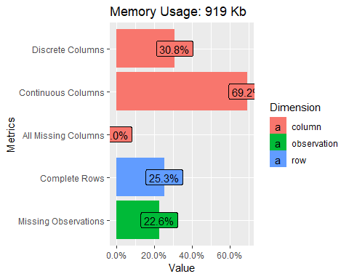

## Visualização da distribuição dos dados faltantes  
plot_missing(dataRetail)

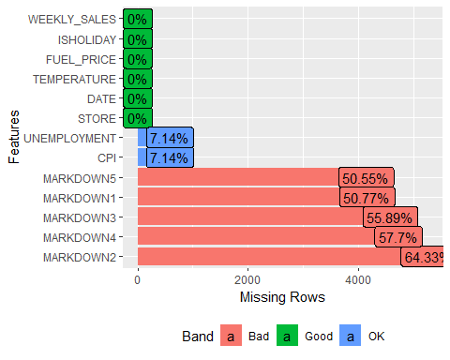

## Distribuição de frequênca de todas as variáveis discretas  
plot_bar(dataRetail[,which(colnames(dataRetail)!="DATE")])

## 1 columns ignored with more than 50 categories.  
## CPI: 2506 categories

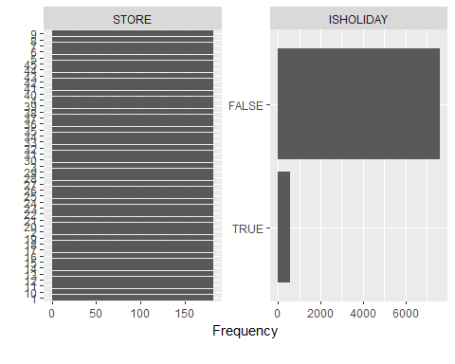

## Histogramas de todas variáveis continuas  
plot_histogram(dataRetail)

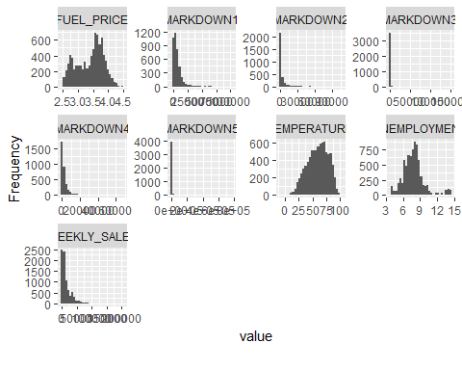

Verifica-se que os dados faltantes estão concentrados nos campos relacionados aos descontos fornecidos para os produtos e pode-se sem perda de interpretação assumir com o valor 0 nestes registros.

#Ajusta para o valor 0 todos os NS das colunas "MARKDOWN*"  
dataRetail[,which(startsWith(colnames(dataRetail),"MARKDOWN"))]<-apply(dataRetail[,which(startsWith(colnames(dataRetail),"MARKDOWN"))],1,function(x){replace(x, is.na(x), 0)});

A coluna “CPI” apresenta os dados com formatação errada e é necessário fazer uma normalização:

#Executando as correções  
dataRetail$CPI <- substr(gsub(pattern = "[.]",replacement = "",x = dataRetail$CPI),1,5)  
dataRetail$CPI <- as.double(dataRetail$CPI)/1E2

No caso das colunas “UNEMPLOYMENT” e “CPI”, e sendo uma série temporal, iremos considerar a última taxa válida anterior ao dado faltante para cada loja.

Para isso utilizaremos uma função para normalização dos valores :

na.lomf <- function(x) {  
  
 na.lomf.0 <- function(x) {  
 non.na.idx <- which(!is.na(x))  
 if (is.na(x[1L])) {  
 non.na.idx <- c(1L, non.na.idx)  
 }  
 rep.int(x[non.na.idx], diff(c(non.na.idx, length(x) + 1L)))  
 }  
  
 dim.len <- length(dim(x))  
  
 if (dim.len == 0L) {  
 na.lomf.0(x)  
 } else {  
 apply(x, dim.len, na.lomf.0)  
 }  
}  
  
dataRetail$UNEMPLOYMENT <- na.lomf(dataRetail$UNEMPLOYMENT)  
dataRetail$CPI <- na.lomf(dataRetail$CPI)  
  
summary(dataRetail)

## STORE DATE TEMPERATURE FUEL_PRICE   
## 1 : 182 Min. :2010-02-05 Min. : -7.29 Min. :2.472   
## 2 : 182 1st Qu.:2010-12-17 1st Qu.: 45.90 1st Qu.:3.041   
## 3 : 182 Median :2011-10-31 Median : 60.71 Median :3.513   
## 4 : 182 Mean :2011-10-31 Mean : 59.36 Mean :3.406   
## 5 : 182 3rd Qu.:2012-09-14 3rd Qu.: 73.88 3rd Qu.:3.743   
## 6 : 182 Max. :2013-07-26 Max. :101.95 Max. :4.468   
## (Other):7098   
## MARKDOWN1 MARKDOWN2 MARKDOWN3   
## Min. : -185.2 Min. : -23.97 Min. : -563.9   
## 1st Qu.: 0.0 1st Qu.: 0.00 1st Qu.: 0.0   
## Median : 0.0 Median : 0.00 Median : 0.0   
## Mean : 1703.7 Mean : 2164.52 Mean : 2342.6   
## 3rd Qu.: 989.1 3rd Qu.: 1457.41 3rd Qu.: 1863.1   
## Max. :112255.7 Max. :149483.31 Max. :139621.5   
##   
## MARKDOWN4 MARKDOWN5 CPI UNEMPLOYMENT   
## Min. : -2781.4 Min. : -20.0 Min. :126.1 Min. : 3.684   
## 1st Qu.: 0.0 1st Qu.: 0.0 1st Qu.:132.7 1st Qu.: 6.565   
## Median : 0.0 Median : 0.0 Median :182.8 Median : 7.742   
## Mean : 1522.1 Mean : 1148.8 Mean :172.9 Mean : 7.748   
## 3rd Qu.: 486.2 3rd Qu.: 229.9 3rd Qu.:214.4 3rd Qu.: 8.549   
## Max. :771448.1 Max. :109976.1 Max. :229.0 Max. :14.313   
##   
## ISHOLIDAY WEEKLY_SALES   
## Mode :logical Min. : -863   
## FALSE:7605 1st Qu.: 2726   
## TRUE :585 Median : 7948   
## Mean : 14513   
## 3rd Qu.: 19408   
## Max. :203670   
##

Após os ajustes feitos podemos verificar novamente as informações dos dados da base:

## Visualização de dados básicos  
introduce(dataRetail)

## rows columns discrete_columns continuous_columns all_missing_columns  
## 1 8190 13 3 10 0  
## total_missing_values complete_rows total_observations memory_usage  
## 1 0 8190 106470 793320

plot_intro(dataRetail)

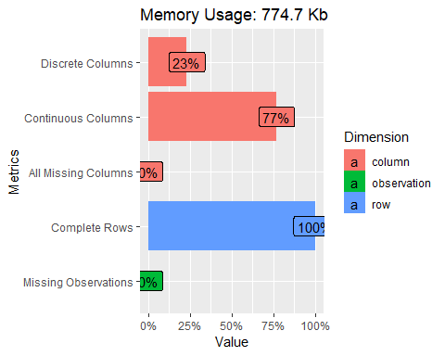

## Visualização da distribuição dos dados faltantes  
plot_missing(dataRetail)

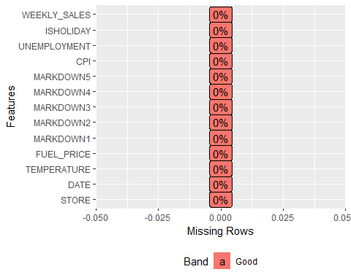

## Distribuição de frequênca de todas as variáveis discretas  
plot_bar(dataRetail)

## 1 columns ignored with more than 50 categories.  
## DATE: 182 categories



## Histogramas de todas variáveis continuas  
plot_histogram(dataRetail)

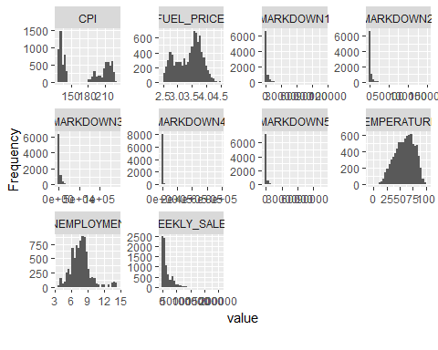

Temos agora uma base com todas as informações completas:

head(dataRetail)

## STORE DATE TEMPERATURE FUEL_PRICE MARKDOWN1 MARKDOWN2 MARKDOWN3  
## 1 1 2010-02-05 42.31 2.572 0 0 0  
## 2 1 2010-02-12 38.51 2.548 0 0 0  
## 3 1 2010-02-19 39.93 2.514 0 0 0  
## 4 1 2010-02-26 46.63 2.561 0 0 0  
## 5 1 2010-03-05 46.50 2.625 0 0 0  
## 6 1 2010-03-12 57.79 2.667 0 0 0  
## MARKDOWN4 MARKDOWN5 CPI UNEMPLOYMENT ISHOLIDAY WEEKLY_SALES  
## 1 0 0 211.09 8.106 FALSE 24924.50  
## 2 0 0 211.24 8.106 TRUE 46039.49  
## 3 0 0 211.28 8.106 FALSE 41595.55  
## 4 0 0 211.31 8.106 FALSE 19403.54  
## 5 0 0 211.35 8.106 FALSE 21827.90  
## 6 0 0 211.38 8.106 FALSE 21043.39

**b) Base de Dados MARKETING**

Verifica-se que alguns valores númericos possuem o caracter “_" no lugar da pontuação decimal:

summary(dataMkt)

## AGE JOB MARITAL_STATUS   
## Min. :17.00 admin :10422 divorced: 4612   
## 1st Qu.:32.00 blue-collar: 9254 married :24928   
## Median :38.00 technician : 6743 single :11568   
## Mean :40.02 services : 3969 unknown : 80   
## 3rd Qu.:47.00 management : 2924   
## Max. :98.00 retired : 1720   
## (Other) : 6156   
## EDUCATION DEFAULT HOUSING   
## university_degree :12168 no :32588 no :18622   
## high_school : 9515 unknown: 8597 unknown: 990   
## basic_9y : 6045 yes : 3 yes :21576   
## professional_course: 5243   
## basic_4y : 4176   
## basic_6y : 2292   
## (Other) : 1749   
## LOAN CONTACT MONTH DAY_OF_WEEK  
## no :33950 cellular :26144 may :13769 fri:7827   
## unknown: 990 telephone:15044 jul : 7174 mon:8514   
## yes : 6248 aug : 6178 thu:8623   
## jun : 5318 tue:8090   
## nov : 4101 wed:8134   
## apr : 2632   
## (Other): 2016   
## DURATION CAMPAIGN PDAYS PREVIOUS   
## Min. : 0.0 Min. : 1.000 Min. :-1.000 Min. :0.000   
## 1st Qu.: 102.0 1st Qu.: 1.000 1st Qu.:-1.000 1st Qu.:0.000   
## Median : 180.0 Median : 2.000 Median :-1.000 Median :0.000   
## Mean : 258.3 Mean : 2.568 Mean :-0.742 Mean :0.173   
## 3rd Qu.: 319.0 3rd Qu.: 3.000 3rd Qu.:-1.000 3rd Qu.:0.000   
## Max. :4918.0 Max. :56.000 Max. :27.000 Max. :7.000   
##   
## POUTCOME EMP_VAR_RATE CONS_PRICE_IDX CONS_CONF_IDX   
## failure : 4252 1_4 :16234 93.994 :7763 -36_4 :7763   
## nonexistent:35563 -1_8 : 9184 93.918 :6685 -42_7 :6685   
## success : 1373 1_1 : 7763 92.893 :5794 -46_2 :5794   
## -0_1 : 3683 93.444 :5175 -36_1 :5175   
## -2_9 : 1663 94.465 :4374 -41_8 :4374   
## -3_4 : 1071 93_2 :3616 -42 :3616   
## (Other): 1590 (Other):7781 (Other):7781   
## SUBSCRIBED   
## no :36548   
## yes: 4640   
##   
##   
##   
##   
##

#Executando as correções nestes campos  
dataMkt$CONS_CONF_IDX <- as.double(gsub(pattern = "_",replacement = ".",x = dataMkt$CONS_CONF_IDX))  
dataMkt$CONS_PRICE_IDX <- as.double(gsub(pattern = "_",replacement = ".",x = dataMkt$CONS_PRICE_IDX))  
dataMkt$EMP_VAR_RATE <- as.double(gsub(pattern = "_",replacement = ".",x = dataMkt$EMP_VAR_RATE))  
  
#Transformando o valor da campanha de Marketing em fator  
dataMkt$CAMPAIGN <- as.factor(dataMkt$CAMPAIGN)  
  
head(dataMkt)

## AGE JOB MARITAL_STATUS EDUCATION DEFAULT HOUSING LOAN CONTACT  
## 1 56 housemaid married basic_4y no no no telephone  
## 2 57 services married high_school unknown no no telephone  
## 3 37 services married high_school no yes no telephone  
## 4 40 admin married basic_6y no no no telephone  
## 5 56 services married high_school no no yes telephone  
## 6 45 services married basic_9y unknown no no telephone  
## MONTH DAY_OF_WEEK DURATION CAMPAIGN PDAYS PREVIOUS POUTCOME  
## 1 may mon 261 1 -1 0 nonexistent  
## 2 may mon 149 1 -1 0 nonexistent  
## 3 may mon 226 1 -1 0 nonexistent  
## 4 may mon 151 1 -1 0 nonexistent  
## 5 may mon 307 1 -1 0 nonexistent  
## 6 may mon 198 1 -1 0 nonexistent  
## EMP_VAR_RATE CONS_PRICE_IDX CONS_CONF_IDX SUBSCRIBED  
## 1 1.1 93.994 -36.4 no  
## 2 1.1 93.994 -36.4 no  
## 3 1.1 93.994 -36.4 no  
## 4 1.1 93.994 -36.4 no  
## 5 1.1 93.994 -36.4 no  
## 6 1.1 93.994 -36.4 no

summary(dataMkt)

## AGE JOB MARITAL_STATUS   
## Min. :17.00 admin :10422 divorced: 4612   
## 1st Qu.:32.00 blue-collar: 9254 married :24928   
## Median :38.00 technician : 6743 single :11568   
## Mean :40.02 services : 3969 unknown : 80   
## 3rd Qu.:47.00 management : 2924   
## Max. :98.00 retired : 1720   
## (Other) : 6156   
## EDUCATION DEFAULT HOUSING   
## university_degree :12168 no :32588 no :18622   
## high_school : 9515 unknown: 8597 unknown: 990   
## basic_9y : 6045 yes : 3 yes :21576   
## professional_course: 5243   
## basic_4y : 4176   
## basic_6y : 2292   
## (Other) : 1749   
## LOAN CONTACT MONTH DAY_OF_WEEK  
## no :33950 cellular :26144 may :13769 fri:7827   
## unknown: 990 telephone:15044 jul : 7174 mon:8514   
## yes : 6248 aug : 6178 thu:8623   
## jun : 5318 tue:8090   
## nov : 4101 wed:8134   
## apr : 2632   
## (Other): 2016   
## DURATION CAMPAIGN PDAYS PREVIOUS   
## Min. : 0.0 1 :17642 Min. :-1.000 Min. :0.000   
## 1st Qu.: 102.0 2 :10570 1st Qu.:-1.000 1st Qu.:0.000   
## Median : 180.0 3 : 5341 Median :-1.000 Median :0.000   
## Mean : 258.3 4 : 2651 Mean :-0.742 Mean :0.173   
## 3rd Qu.: 319.0 5 : 1599 3rd Qu.:-1.000 3rd Qu.:0.000   
## Max. :4918.0 6 : 979 Max. :27.000 Max. :7.000   
## (Other): 2406   
## POUTCOME EMP_VAR_RATE CONS_PRICE_IDX CONS_CONF_IDX   
## failure : 4252 Min. :-3.40000 Min. :92.20 Min. :-50.8   
## nonexistent:35563 1st Qu.:-1.80000 1st Qu.:93.08 1st Qu.:-42.7   
## success : 1373 Median : 1.10000 Median :93.75 Median :-41.8   
## Mean : 0.08189 Mean :93.58 Mean :-40.5   
## 3rd Qu.: 1.40000 3rd Qu.:93.99 3rd Qu.:-36.4   
## Max. : 1.40000 Max. :94.77 Max. :-26.9   
##   
## SUBSCRIBED   
## no :36548   
## yes: 4640   
##   
##   
##   
##   
##

Podemos visualizar algumas informações sobre a distribuição dos dados que podem indicar nexcessidade de ajustes nos mesmos:

## Visualização de dados básicos  
introduce(dataMkt)

## rows columns discrete_columns continuous_columns all_missing_columns  
## 1 41188 19 12 7 0  
## total_missing_values complete_rows total_observations memory_usage  
## 1 0 41188 782572 3640304

plot_intro(dataMkt)

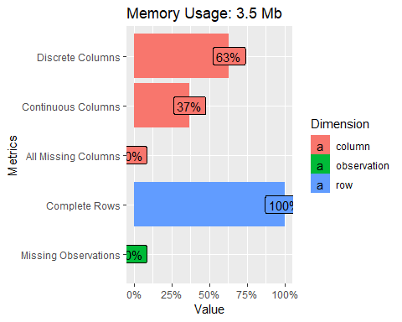

## Visualização da distrin=buição dos dados faltantes  
plot_missing(dataMkt)

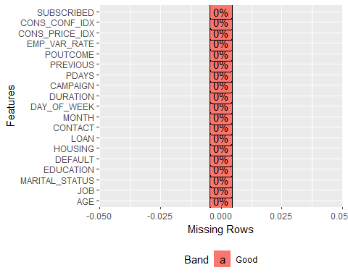

## Distribuição de frequênca de todas as variáveis discretas  
plot_bar(dataMkt)

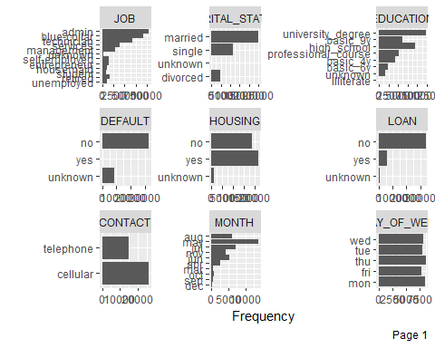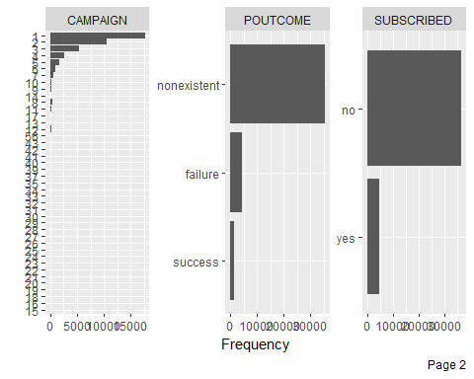

## Histogramas de todas variáveis continuas  
plot_histogram(dataMkt)

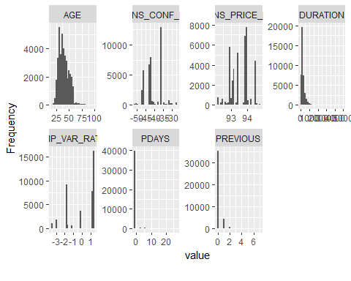

Podemos extrair algumas análises interessantes de forma a esclarecer o entedimento do problema.

Por exemplo, verificar qual a contribuição de cada loja para o total de vendas:

dataRetail %>% group_by(STORE) %>% summarize(Total_Vendas = sum(WEEKLY_SALES)) %>%   
 arrange(desc(Total_Vendas)) %>%   
 plot_ly(x = ~STORE, y = ~Total_Vendas) %>%  
 add_lines() %>%  
 add_trace(x = ~STORE, y = ~Total_Vendas, mode = 'markers',type = 'scatter') %>%  
 layout(title = "Vendas por Loja",  
 xaxis = list(title = "Loja"),   
 yaxis = list(title = "Total de Vendas"),showlegend = FALSE)

## Warning: package 'bindrcpp' was built under R version 3.5.2

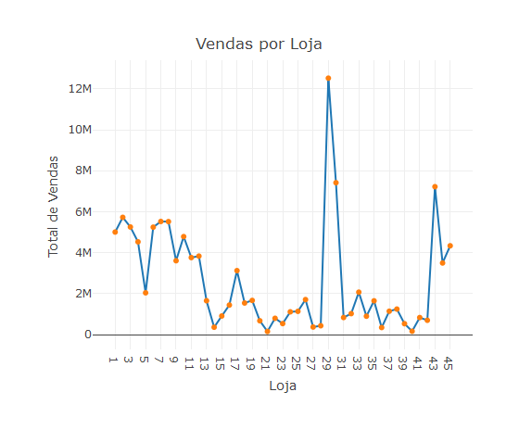

dataRetail %>% group_by(STORE) %>% summarize(Total_Vendas = sum(WEEKLY_SALES)) %>%   
 arrange(desc(Total_Vendas)) %>%   
 plot_ly(y = ~Total_Vendas,type = "box") %>%  
 layout(title = "Total de Vendas",   
 xaxis = list(title = "",showticklabels = FALSE),   
 yaxis = list(title = "Total de Vendas"),showlegend = FALSE)

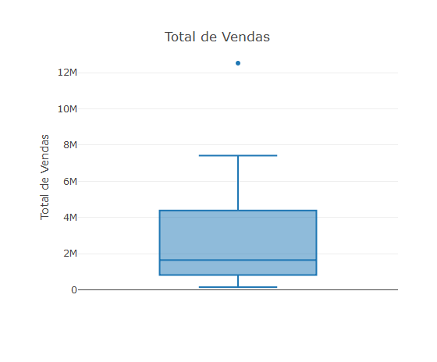

Observa-se que a loja 29 obteve um volume de venda total bem mais elevado que as demais lojas e poderia ser tratado como um outlier dentro da base de informações.

Outra análise interessante é o total de vendas por período:

dataRetail %>% group_by(DATE) %>% summarize(Total_Vendas = sum(WEEKLY_SALES)) %>%   
 arrange(desc(Total_Vendas)) %>%   
 plot_ly(x = ~DATE, y = ~Total_Vendas) %>%  
 add_lines() %>%  
 add_trace(x = ~DATE, y = ~Total_Vendas, mode = 'markers',type = 'scatter') %>%  
 layout(title = "Vendas por Período",  
 xaxis = list(title = ""),   
 yaxis = list(title = "Total de Vendas"),showlegend = FALSE)

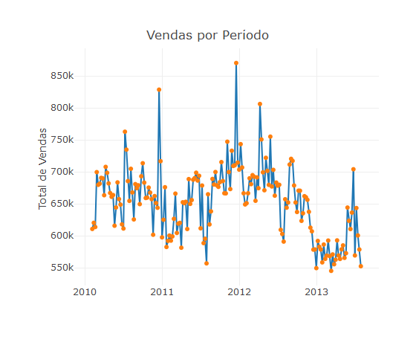

Após os procedimentos de entedimento e ajustes dos dados pode-se passar para a fase de modelagem.

**Passo 3) Dividir as bases em 70% para treino e 30% para teste do modelo. (Utilize sempre seed(314))**

Dividimos a base de Vendas criando os grupos de treino e teste Para isso definimos “p=0.7”, isto é 70% da base será escolhida aleatóriamente para treino e 30% para teste do modelo setando o seed para 314, para garantir que ao replicarmos essa partição em outro computador por exemplo, os mesmos dados irão respectivamente prar treino e teste.

set.seed(314)  
trainIndex_Retail <- createDataPartition(dataRetail$WEEKLY_SALES, p = .7, list = FALSE)  
  
dfTrain_Retail <- dataRetail[trainIndex_Retail,]  
dfTest_Retail <- dataRetail[-trainIndex_Retail,]  
  
#Dividimos a base de Marketing criando os grupos de treino e teste  
set.seed(314)  
trainIndex_Mkt <- createDataPartition(dataMkt$SUBSCRIBED, p = .7, list = FALSE)  
  
dfTrain_Mkt <- dataMkt[trainIndex_Mkt,]  
dfTest_Mkt <- dataMkt[-trainIndex_Mkt,]

**Passo 4) Testar modelos de classificação para as campanhas de Marketing:**

1. Regressão Logística

set.seed(314)  
  
if (file.exists("modelMkt_GLM.rdata")) {  
 load("modelMkt_GLM.rdata")  
} else {  
 cv <- trainControl(method = "repeatedcv", number = 10, savePredictions = TRUE,  
 summaryFunction=twoClassSummary, classProbs = TRUE)  
   
 modelMkt_GLM <- train(SUBSCRIBED ~ DURATION + EMP_VAR_RATE + CONTACT + PREVIOUS + CONS_PRICE_IDX + PDAYS + POUTCOME + DEFAULT + EDUCATION + MARITAL_STATUS + CONS_CONF_IDX + DAY_OF_WEEK + AGE + MONTH + HOUSING + JOB, data = dfTrain_Mkt, method = "glm",  
 metric="ROC",trControl = cv, control = list(maxit = 50))  
  
}  
  
modelMkt_GLM

## Generalized Linear Model   
##   
## 28832 samples  
## 16 predictor  
## 2 classes: 'no', 'yes'   
##   
## No pre-processing  
## Resampling: Cross-Validated (10 fold, repeated 1 times)   
## Summary of sample sizes: 25949, 25948, 25949, 25949, 25949, 25949, ...   
## Resampling results:  
##   
## ROC Sens Spec   
## 0.9321541 0.9720916 0.4104236

Quando as colunas de uma matriz forem combinações lineares umas das outras, dizemos que a matriz é rank deficient (ou posto incompleto, em português). O problema é que matrizes assim não são invertíveis. Portanto, não dá para estimar os parâmetros da regressão. Possíveis causas: 1) Uma das variáveis preditoras é combinação linear das demais. Ou seja, alguma variável no modelo é redundante. 2) Talvez a amostra não seja grande o suficiente para o modelo a ser ajustado. 3) O modelo pode ter parâmetros demais e tamanho amostral de menos.

A regra geral é ter pelo menos uma quantidade de pontos igual ao número de parâmetros a serem ajustado no modelo. Assim se garante que a matriz não será rank-deficient.

Usando a base de teste para verificação do modelo:

#Usando a base de teste para verificação do modelo  
dataMktPred <- predict(modelMkt_GLM, newdata=dfTest_Mkt)

Gerando Matriz de Confusão:

#Verificando o resultado através da Matriz de Confusão  
cmMkt_GLM <- confusionMatrix(data=dataMktPred, dfTest_Mkt$SUBSCRIBED)  
cmMkt_GLM

## Confusion Matrix and Statistics  
##   
## Reference  
## Prediction no yes  
## no 10678 793  
## yes 286 599  
##   
## Accuracy : 0.9127   
## 95% CI : (0.9076, 0.9176)  
## No Information Rate : 0.8873   
## P-Value [Acc > NIR] : < 2.2e-16   
##   
## Kappa : 0.4806   
##   
## Mcnemar's Test P-Value : < 2.2e-16   
##   
## Sensitivity : 0.9739   
## Specificity : 0.4303   
## Pos Pred Value : 0.9309   
## Neg Pred Value : 0.6768   
## Prevalence : 0.8873   
## Detection Rate : 0.8642   
## Detection Prevalence : 0.9284   
## Balanced Accuracy : 0.7021   
##   
## 'Positive' Class : no   
##

Importância das Variáveis Preditoras:

imp <- varImp(modelMkt_GLM, useModel=FALSE, scale=FALSE)  
imp

## ROC curve variable importance  
##   
## Importance  
## DURATION 0.8182  
## EMP_VAR_RATE 0.7101  
## CONTACT 0.6083  
## PREVIOUS 0.6071  
## CONS_PRICE_IDX 0.6057  
## PDAYS 0.5960  
## POUTCOME 0.5670  
## DEFAULT 0.5629  
## EDUCATION 0.5477  
## MARITAL_STATUS 0.5356  
## CONS_CONF_IDX 0.5354  
## DAY_OF_WEEK 0.5142  
## AGE 0.5130  
## MONTH 0.5114  
## HOUSING 0.5108  
## JOB 0.5085

plot(imp)

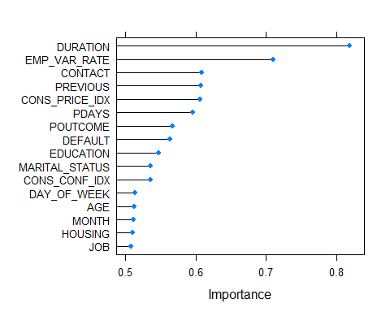

Gerando a curva ROC:

dfProbs <- predict(modelMkt_GLM, newdata=dfTest_Mkt, type="prob")  
head(dfProbs)

## no yes  
## 1 0.9872625 0.012737459  
## 2 0.9951136 0.004886442  
## 4 0.9908011 0.009198859  
## 7 0.9927951 0.007204881  
## 10 0.9952302 0.004769841  
## 12 0.9894477 0.010552340

gbm.ROC <- roc(predictor=dfProbs$yes,  
 response=dfTest_Mkt$SUBSCRIBED,  
 levels=rev(levels(dfTest_Mkt$SUBSCRIBED)))

## Setting direction: controls > cases

gbm.ROC$auc

## Area under the curve: 0.9375

plot(gbm.ROC,main="Curva ROC")

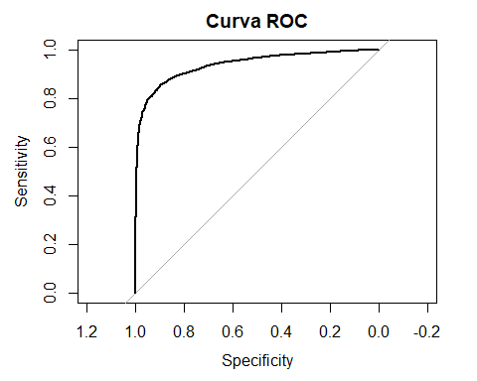

Salvando o modelo:

save(modelMkt_GLM,file="modelMkt_GLM.rdata")

1. Árvores de Decisão

Modelo Random Forest:

# Definindo Parâmetros do Cross Validation  
set.seed(314)  
  
if (file.exists("modelMkt_RF.rdata")) {  
 load("modelMkt_RF.rdata")  
} else {  
 cv <- trainControl(method = "repeatedcv", number = 10, savePredictions = TRUE, classProbs=TRUE)  
  
# Treinando o modelo  
 modelMkt_RF <- train(SUBSCRIBED~., data = dfTrain_Mkt, method = "rf",trControl = cv)  
}  
  
modelMkt_RF

## Random Forest   
##   
## 28832 samples  
## 18 predictor  
## 2 classes: 'no', 'yes'   
##   
## No pre-processing  
## Resampling: Cross-Validated (10 fold, repeated 1 times)   
## Summary of sample sizes: 25949, 25948, 25949, 25949, 25949, 25949, ...   
## Resampling results across tuning parameters:  
##   
## mtry Accuracy Kappa   
## 2 0.8889429 0.02751189  
## 46 0.9120422 0.52642179  
## 91 0.9115565 0.52567461  
##   
## Accuracy was used to select the optimal model using the largest value.  
## The final value used for the model was mtry = 46.

Usando a base de teste para verificação do modelo:

pred_Mkt_rf <- predict(modelMkt_RF ,newdata=dfTest_Mkt)

Gerando Matriz de Confusão:

cmMkt_RF <- confusionMatrix(data=pred_Mkt_rf, dfTest_Mkt$SUBSCRIBED)  
cmMkt_RF

## Confusion Matrix and Statistics  
##   
## Reference  
## Prediction no yes  
## no 10514 630  
## yes 450 762  
##   
## Accuracy : 0.9126   
## 95% CI : (0.9075, 0.9175)  
## No Information Rate : 0.8873   
## P-Value [Acc > NIR] : < 2.2e-16   
##   
## Kappa : 0.5367   
##   
## Mcnemar's Test P-Value : 5.129e-08   
##   
## Sensitivity : 0.9590   
## Specificity : 0.5474   
## Pos Pred Value : 0.9435   
## Neg Pred Value : 0.6287   
## Prevalence : 0.8873   
## Detection Rate : 0.8509   
## Detection Prevalence : 0.9019   
## Balanced Accuracy : 0.7532   
##   
## 'Positive' Class : no   
##

Importância das Variáveis Preditoras:

#   
imp <- varImp(modelMkt_RF, useModel=FALSE, scale=FALSE)  
imp

## ROC curve variable importance  
##   
## Importance  
## DURATION 0.8182  
## EMP_VAR_RATE 0.7101  
## CONTACT 0.6083  
## PREVIOUS 0.6071  
## CONS_PRICE_IDX 0.6057  
## PDAYS 0.5960  
## POUTCOME 0.5670  
## DEFAULT 0.5629  
## CAMPAIGN 0.5519  
## EDUCATION 0.5477  
## MARITAL_STATUS 0.5356  
## CONS_CONF_IDX 0.5354  
## DAY_OF_WEEK 0.5142  
## AGE 0.5130  
## MONTH 0.5114  
## HOUSING 0.5108  
## JOB 0.5085  
## LOAN 0.5058

plot(imp)

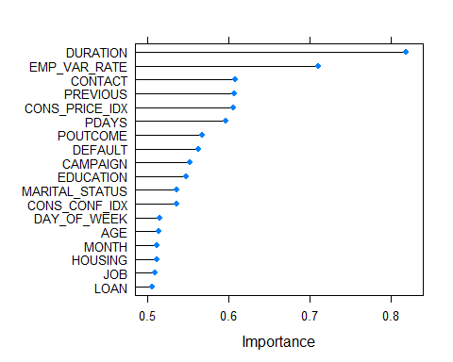

Salvando o modelo:

save(modelMkt_RF,file="modelMkt_RF.rdata")

1. SVM (Support Vector Machines)

options(warn=-1)  
set.seed(314)  
  
if (file.exists("modelMkt_SVM.rdata")) {  
 load("modelMkt_SVM.rdata")  
} else {  
 cv <- trainControl(method = "repeatedcv", number = 10)  
  
 modelMkt_SVM <- train(SUBSCRIBED~., data = dfTrain_Mkt, method = "svmLinear", trControl = cv, preProcess = c("center", "scale"))  
}  
  
modelMkt_SVM

## Support Vector Machines with Linear Kernel   
##   
## 28832 samples  
## 18 predictor  
## 2 classes: 'no', 'yes'   
##   
## Pre-processing: centered (91), scaled (91)   
## Resampling: Cross-Validated (10 fold, repeated 1 times)   
## Summary of sample sizes: 25949, 25948, 25949, 25949, 25949, 25949, ...   
## Resampling results:  
##   
## Accuracy Kappa   
## 0.9044117 0.3793564  
##   
## Tuning parameter 'C' was held constant at a value of 1

Usando a base de teste para verificação do modelo:

dataMktPred <- predict(modelMkt_SVM, newdata=dfTest_Mkt)

Gerando Matriz de Confusão:

cmMkt_SVM <- confusionMatrix(data=dataMktPred, dfTest_Mkt$SUBSCRIBED)  
cmMkt_SVM

## Confusion Matrix and Statistics  
##   
## Reference  
## Prediction no yes  
## no 10746 960  
## yes 218 432  
##   
## Accuracy : 0.9047   
## 95% CI : (0.8993, 0.9098)  
## No Information Rate : 0.8873   
## P-Value [Acc > NIR] : 2.542e-10   
##   
## Kappa : 0.3785   
##   
## Mcnemar's Test P-Value : < 2.2e-16   
##   
## Sensitivity : 0.9801   
## Specificity : 0.3103   
## Pos Pred Value : 0.9180   
## Neg Pred Value : 0.6646   
## Prevalence : 0.8873   
## Detection Rate : 0.8697   
## Detection Prevalence : 0.9474   
## Balanced Accuracy : 0.6452   
##   
## 'Positive' Class : no   
##

Importância das Variáveis Preditoras:

imp <- varImp(modelMkt_SVM, useModel=FALSE, scale=FALSE)  
imp

## ROC curve variable importance  
##   
## Importance  
## DURATION 0.8182  
## EMP_VAR_RATE 0.7101  
## CONTACT 0.6083  
## PREVIOUS 0.6071  
## CONS_PRICE_IDX 0.6057  
## PDAYS 0.5960  
## POUTCOME 0.5670  
## DEFAULT 0.5629  
## CAMPAIGN 0.5519  
## EDUCATION 0.5477  
## MARITAL_STATUS 0.5356  
## CONS_CONF_IDX 0.5354  
## DAY_OF_WEEK 0.5142  
## AGE 0.5130  
## MONTH 0.5114  
## HOUSING 0.5108  
## JOB 0.5085  
## LOAN 0.5058

plot(imp)



Salvando o modelo:

save(modelMkt_SVM,file="modelMkt_SVM.rdata")

1. Redes Neurais

options(warn=-1)  
  
set.seed(314)  
  
if (file.exists("modelMkt_RN.rdata")) {  
 load("modelMkt_RN.rdata")  
} else {  
 modelMkt_RN <- train(SUBSCRIBED~., data = dfTrain_Mkt, method='nnet', trace = FALSE, preProc = c("center", "scale"))  
}  
  
modelMkt_RN

## Neural Network   
##   
## 28832 samples  
## 18 predictor  
## 2 classes: 'no', 'yes'   
##   
## Pre-processing: centered (91), scaled (91)   
## Resampling: Bootstrapped (25 reps)   
## Summary of sample sizes: 28832, 28832, 28832, 28832, 28832, 28832, ...   
## Resampling results across tuning parameters:  
##   
## size decay Accuracy Kappa   
## 1 0e+00 0.8927249 0.2264516  
## 1 1e-04 0.8939668 0.2346662  
## 1 1e-01 0.8928008 0.2527808  
## 3 0e+00 0.8960573 0.4608805  
## 3 1e-04 0.8951037 0.4607795  
## 3 1e-01 0.9004783 0.5045524  
## 5 0e+00 0.9027900 0.4786326  
## 5 1e-04 0.9011746 0.4875981  
## 5 1e-01 0.9024922 0.4936859  
##   
## Accuracy was used to select the optimal model using the largest value.  
## The final values used for the model were size = 5 and decay = 0.

Scorando o modelo base de teste:

#scorando o modelo base de teste  
dataMktPred <- predict(modelMkt_RN, newdata=dfTest_Mkt)

Gerando Matriz de Confusão:

cmMkt_RN <- confusionMatrix(data=dataMktPred, dfTest_Mkt$SUBSCRIBED)  
cmMkt_RN

## Confusion Matrix and Statistics  
##   
## Reference  
## Prediction no yes  
## no 10423 563  
## yes 541 829  
##   
## Accuracy : 0.9107   
## 95% CI : (0.9055, 0.9156)  
## No Information Rate : 0.8873   
## P-Value [Acc > NIR] : <2e-16   
##   
## Kappa : 0.55   
##   
## Mcnemar's Test P-Value : 0.5274   
##   
## Sensitivity : 0.9507   
## Specificity : 0.5955   
## Pos Pred Value : 0.9488   
## Neg Pred Value : 0.6051   
## Prevalence : 0.8873   
## Detection Rate : 0.8436   
## Detection Prevalence : 0.8891   
## Balanced Accuracy : 0.7731   
##   
## 'Positive' Class : no   
##

Importância das Variáveis Preditoras:

imp <- varImp(modelMkt_RN, useModel=FALSE, scale=FALSE)  
plot(imp)



Salvando o modelo:

save(modelMkt_RN,file="modelMkt_RN.rdata")

**Passo 5) Testar modelos de regressão para o valor de vendas das lojas**

1. Regressão Linear

set.seed(314)  
  
if (file.exists("modelRetail_RL.rdata")) {  
 load("modelRetail_RL.rdata")  
} else {  
   
 #Desconsiderando a váriável DATE (não considerando como uma série temporal)  
 modelRetail_RL <- lm(WEEKLY_SALES ~ . - DATE, data = dfTrain_Retail)  
 k <- ols_step_backward_aic(modelRetail_RL)  
   
 #Retirando as variáveis indicadas   
 modelRetail_RL <- train(WEEKLY_SALES ~ STORE + FUEL_PRICE + MARKDOWN1 + MARKDOWN2 + CPI, data = dfTrain_Retail, method = "lm")  
  
}  
  
modelRetail_RL

## Linear Regression   
##   
## 5734 samples  
## 5 predictor  
##   
## No pre-processing  
## Resampling: Bootstrapped (25 reps)   
## Summary of sample sizes: 5734, 5734, 5734, 5734, 5734, 5734, ...   
## Resampling results:  
##   
## RMSE Rsquared MAE   
## 10235.91 0.6451901 6231.525  
##   
## Tuning parameter 'intercept' was held constant at a value of TRUE

Importância das Variáveis Preditoras:

imp <- varImp(modelRetail_RL ,useModel=FALSE, scale=FALSE)  
imp

## loess r-squared variable importance  
##   
## Overall  
## STORE 0.654476  
## FUEL_PRICE 0.133666  
## CPI 0.019835  
## MARKDOWN2 0.008059  
## MARKDOWN1 0.000000

plot(imp)

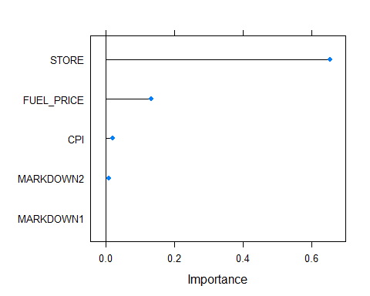

Avaliando o modelo com a base de teste:

predict_Model <- predict(modelRetail_RL, dfTest_Retail)  
  
#Retornando as métricas do modelo com a base de teste  
metric_modelRetail_RL <- postResample(pred = predict_Model, obs = dfTest_Retail$WEEKLY_SALES)  
metric_modelRetail_RL

## RMSE Rsquared MAE   
## 1.101246e+04 6.071794e-01 6.452532e+03

dfTest_Retail$Model <- predict_Model  
  
head(dfTest_Retail)

## STORE DATE TEMPERATURE FUEL_PRICE MARKDOWN1 MARKDOWN2 MARKDOWN3  
## 3 1 2010-02-19 39.93 2.514 0 0 0  
## 5 1 2010-03-05 46.50 2.625 0 0 0  
## 10 1 2010-04-09 65.86 2.770 0 0 0  
## 12 1 2010-04-23 64.84 2.795 0 0 0  
## 13 1 2010-04-30 67.41 2.780 0 0 0  
## 17 1 2010-05-28 80.44 2.759 0 0 0  
## MARKDOWN4 MARKDOWN5 CPI UNEMPLOYMENT ISHOLIDAY WEEKLY_SALES Model  
## 3 0 0 211.28 8.106 FALSE 41595.55 27814.66  
## 5 0 0 211.35 8.106 FALSE 21827.90 28011.13  
## 10 0 0 210.62 7.808 FALSE 42960.91 28530.05  
## 12 0 0 210.43 7.808 FALSE 16145.35 28639.99  
## 13 0 0 210.38 7.808 FALSE 16555.11 28626.38  
## 17 0 0 210.89 7.808 FALSE 15580.43 28422.16

df_diag <- data.frame(actual = dfTest_Retail$WEEKLY_SALES,   
 fitted = dfTest_Retail$Model)  
  
df_diag %>% plot_ly(x = ~actual, y = ~fitted) %>%  
 add_trace(x = ~actual, y = ~fitted, mode = 'markers',type = 'scatter') %>%  
 add_trace(x = ~actual, y= ~actual , type="scatter", mode="lines", name='abline') %>%  
 layout(title = "",  
 xaxis = list(title = "Valores Atuais"),   
 yaxis = list(title = "Predição"),showlegend = FALSE)

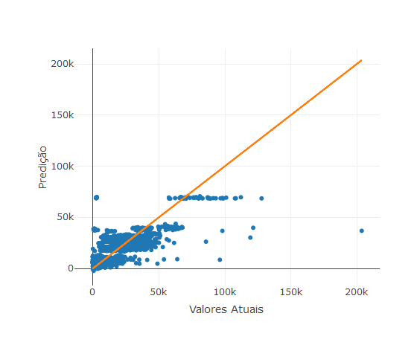

Salvando o modelo:

save(modelRetail_RL,file="modelRetail_RL.rdata")

1. Árvore de Decisão

Modelo com Boosting (XgBoost):

set.seed(314)  
  
# Treinando o modelo  
if (file.exists("modelRetail_Boosting.rdata")) {  
 load("modelRetail_Boosting.rdata")  
} else {  
 cv <- trainControl(method = "repeatedcv", number = 10, savePredictions = TRUE)  
 modelRetail_Boosting <- train(WEEKLY_SALES~. , data = dfTrain_Retail, method = "xgbTree",trControl = cv)  
}  
  
modelRetail_Boosting

## eXtreme Gradient Boosting   
##   
## 5734 samples  
## 12 predictor  
##   
## No pre-processing  
## Resampling: Cross-Validated (10 fold, repeated 1 times)   
## Summary of sample sizes: 5161, 5160, 5161, 5161, 5162, 5161, ...   
## Resampling results across tuning parameters:  
##   
## eta max_depth colsample_bytree subsample nrounds RMSE   
## 0.3 1 0.6 0.50 50 11662.411  
## 0.3 1 0.6 0.50 100 10742.303  
## 0.3 1 0.6 0.50 150 10466.877  
## 0.3 1 0.6 0.75 50 11749.834  
## 0.3 1 0.6 0.75 100 10806.615  
## 0.3 1 0.6 0.75 150 10465.747  
## 0.3 1 0.6 1.00 50 11820.420  
## 0.3 1 0.6 1.00 100 10871.345  
## 0.3 1 0.6 1.00 150 10498.132  
## 0.3 1 0.8 0.50 50 11665.381  
## 0.3 1 0.8 0.50 100 10753.376  
## 0.3 1 0.8 0.50 150 10509.213  
## 0.3 1 0.8 0.75 50 11721.006  
## 0.3 1 0.8 0.75 100 10817.135  
## 0.3 1 0.8 0.75 150 10482.607  
## 0.3 1 0.8 1.00 50 11799.393  
## 0.3 1 0.8 1.00 100 10872.083  
## 0.3 1 0.8 1.00 150 10500.019  
## 0.3 2 0.6 0.50 50 8631.294  
## 0.3 2 0.6 0.50 100 7562.384  
## 0.3 2 0.6 0.50 150 7057.032  
## 0.3 2 0.6 0.75 50 8511.241  
## 0.3 2 0.6 0.75 100 7347.159  
## 0.3 2 0.6 0.75 150 6838.627  
## 0.3 2 0.6 1.00 50 8634.126  
## 0.3 2 0.6 1.00 100 7542.668  
## 0.3 2 0.6 1.00 150 6986.769  
## 0.3 2 0.8 0.50 50 8493.321  
## 0.3 2 0.8 0.50 100 7373.237  
## 0.3 2 0.8 0.50 150 6965.094  
## 0.3 2 0.8 0.75 50 8414.890  
## 0.3 2 0.8 0.75 100 7250.529  
## 0.3 2 0.8 0.75 150 6783.783  
## 0.3 2 0.8 1.00 50 8699.336  
## 0.3 2 0.8 1.00 100 7578.065  
## 0.3 2 0.8 1.00 150 7045.071  
## 0.3 3 0.6 0.50 50 7425.706  
## 0.3 3 0.6 0.50 100 6594.415  
## 0.3 3 0.6 0.50 150 6365.257  
## 0.3 3 0.6 0.75 50 7250.625  
## 0.3 3 0.6 0.75 100 6428.788  
## 0.3 3 0.6 0.75 150 6104.467  
## 0.3 3 0.6 1.00 50 7415.266  
## 0.3 3 0.6 1.00 100 6445.550  
## 0.3 3 0.6 1.00 150 6023.405  
## 0.3 3 0.8 0.50 50 7202.892  
## 0.3 3 0.8 0.50 100 6447.738  
## 0.3 3 0.8 0.50 150 6221.864  
## 0.3 3 0.8 0.75 50 7141.640  
## 0.3 3 0.8 0.75 100 6329.738  
## 0.3 3 0.8 0.75 150 6026.314  
## 0.3 3 0.8 1.00 50 7370.844  
## 0.3 3 0.8 1.00 100 6423.861  
## 0.3 3 0.8 1.00 150 6044.624  
## 0.4 1 0.6 0.50 50 11209.018  
## 0.4 1 0.6 0.50 100 10560.247  
## 0.4 1 0.6 0.50 150 10277.357  
## 0.4 1 0.6 0.75 50 11256.787  
## 0.4 1 0.6 0.75 100 10513.905  
## 0.4 1 0.6 0.75 150 10246.552  
## 0.4 1 0.6 1.00 50 11297.486  
## 0.4 1 0.6 1.00 100 10557.033  
## 0.4 1 0.6 1.00 150 10266.645  
## 0.4 1 0.8 0.50 50 11214.004  
## 0.4 1 0.8 0.50 100 10539.513  
## 0.4 1 0.8 0.50 150 10274.658  
## 0.4 1 0.8 0.75 50 11225.926  
## 0.4 1 0.8 0.75 100 10508.114  
## 0.4 1 0.8 0.75 150 10248.796  
## 0.4 1 0.8 1.00 50 11310.561  
## 0.4 1 0.8 1.00 100 10554.564  
## 0.4 1 0.8 1.00 150 10271.405  
## 0.4 2 0.6 0.50 50 8005.001  
## 0.4 2 0.6 0.50 100 7176.823  
## 0.4 2 0.6 0.50 150 6792.689  
## 0.4 2 0.6 0.75 50 7901.577  
## 0.4 2 0.6 0.75 100 6951.020  
## 0.4 2 0.6 0.75 150 6554.077  
## 0.4 2 0.6 1.00 50 8120.865  
## 0.4 2 0.6 1.00 100 7067.054  
## 0.4 2 0.6 1.00 150 6564.404  
## 0.4 2 0.8 0.50 50 7858.207  
## 0.4 2 0.8 0.50 100 7086.247  
## 0.4 2 0.8 0.50 150 6793.976  
## 0.4 2 0.8 0.75 50 7831.713  
## 0.4 2 0.8 0.75 100 6961.156  
## 0.4 2 0.8 0.75 150 6547.003  
## 0.4 2 0.8 1.00 50 8130.830  
## 0.4 2 0.8 1.00 100 7068.452  
## 0.4 2 0.8 1.00 150 6517.398  
## 0.4 3 0.6 0.50 50 7168.457  
## 0.4 3 0.6 0.50 100 6677.008  
## 0.4 3 0.6 0.50 150 6466.998  
## 0.4 3 0.6 0.75 50 6871.088  
## 0.4 3 0.6 0.75 100 6127.276  
## 0.4 3 0.6 0.75 150 5987.825  
## 0.4 3 0.6 1.00 50 6933.161  
## 0.4 3 0.6 1.00 100 6281.309  
## 0.4 3 0.6 1.00 150 6039.220  
## 0.4 3 0.8 0.50 50 6925.145  
## 0.4 3 0.8 0.50 100 6531.179  
## 0.4 3 0.8 0.50 150 6377.005  
## 0.4 3 0.8 0.75 50 6819.745  
## 0.4 3 0.8 0.75 100 6276.431  
## 0.4 3 0.8 0.75 150 6103.741  
## 0.4 3 0.8 1.00 50 6803.539  
## 0.4 3 0.8 1.00 100 6032.869  
## 0.4 3 0.8 1.00 150 5795.786  
## Rsquared MAE   
## 0.5681204 8435.306  
## 0.6153877 7260.491  
## 0.6314056 6914.966  
## 0.5608036 8505.169  
## 0.6146110 7336.996  
## 0.6328467 6874.274  
## 0.5613950 8585.274  
## 0.6175036 7450.088  
## 0.6361115 6926.694  
## 0.5623398 8386.770  
## 0.6140122 7256.878  
## 0.6281935 6925.069  
## 0.5626942 8468.054  
## 0.6130347 7337.212  
## 0.6314739 6882.981  
## 0.5636205 8576.012  
## 0.6172027 7446.458  
## 0.6359002 6930.245  
## 0.7653384 5937.121  
## 0.8081193 4733.359  
## 0.8301383 4242.593  
## 0.7788495 5908.406  
## 0.8227099 4623.770  
## 0.8427745 4100.423  
## 0.7733879 6003.623  
## 0.8140119 4740.363  
## 0.8367401 4130.000  
## 0.7724133 5861.993  
## 0.8185336 4605.367  
## 0.8357045 4152.880  
## 0.7810008 5823.324  
## 0.8257596 4507.531  
## 0.8438374 3980.301  
## 0.7690911 6034.333  
## 0.8130356 4755.166  
## 0.8336454 4154.896  
## 0.8191266 4752.266  
## 0.8518897 3785.473  
## 0.8604485 3483.714  
## 0.8297669 4675.328  
## 0.8589442 3676.332  
## 0.8710552 3320.261  
## 0.8243452 4773.381  
## 0.8593697 3675.013  
## 0.8754989 3245.592  
## 0.8290409 4601.607  
## 0.8574406 3660.709  
## 0.8669324 3380.130  
## 0.8345850 4542.593  
## 0.8623223 3518.260  
## 0.8735058 3165.865  
## 0.8264832 4714.685  
## 0.8602889 3625.625  
## 0.8748392 3204.059  
## 0.5898864 7859.730  
## 0.6245830 6932.667  
## 0.6425375 6706.036  
## 0.5902577 7920.970  
## 0.6297804 6907.662  
## 0.6460039 6628.258  
## 0.5932652 7964.947  
## 0.6318381 6978.920  
## 0.6477330 6629.498  
## 0.5886459 7866.232  
## 0.6260264 6955.508  
## 0.6428860 6708.534  
## 0.5926392 7889.718  
## 0.6303833 6907.653  
## 0.6457718 6621.155  
## 0.5946902 7964.536  
## 0.6322856 6981.239  
## 0.6473482 6628.762  
## 0.7900322 5265.431  
## 0.8248232 4314.592  
## 0.8415474 4011.838  
## 0.7997974 5195.608  
## 0.8370289 4132.704  
## 0.8533124 3772.196  
## 0.7900994 5392.195  
## 0.8322929 4249.043  
## 0.8525280 3756.480  
## 0.7983744 5114.539  
## 0.8297508 4251.932  
## 0.8419766 3987.718  
## 0.8023179 5120.750  
## 0.8359813 4103.637  
## 0.8532750 3726.349  
## 0.7904514 5340.858  
## 0.8344101 4181.217  
## 0.8563388 3676.658  
## 0.8275724 4248.858  
## 0.8481292 3655.571  
## 0.8571144 3489.690  
## 0.8414377 4149.168  
## 0.8714550 3354.979  
## 0.8765669 3172.849  
## 0.8400611 4185.353  
## 0.8638803 3323.249  
## 0.8735289 3070.367  
## 0.8374398 4193.096  
## 0.8533337 3601.150  
## 0.8609798 3441.486  
## 0.8446791 4029.108  
## 0.8640801 3336.729  
## 0.8709708 3136.387  
## 0.8478564 4108.457  
## 0.8748736 3214.947  
## 0.8834655 2969.321  
##   
## Tuning parameter 'gamma' was held constant at a value of 0  
##   
## Tuning parameter 'min_child_weight' was held constant at a value of 1  
## RMSE was used to select the optimal model using the smallest value.  
## The final values used for the model were nrounds = 150, max_depth = 3,  
## eta = 0.4, gamma = 0, colsample_bytree = 0.8, min_child_weight = 1  
## and subsample = 1.

Avaliando o modelo com a base de teste:

pred_boosting <- predict(modelRetail_Boosting ,newdata=dfTest_Retail)  
  
#Retornando as métricas do modelo com a base de teste  
metric_modelRetail_Boosting <- postResample(pred = pred_boosting, obs = dfTest_Retail$WEEKLY_SALES)  
metric_modelRetail_Boosting

## RMSE Rsquared MAE   
## 6561.0698257 0.8615889 2963.6912254

dfTest_Retail$Model <- pred_boosting  
  
head(dfTest_Retail)

## STORE DATE TEMPERATURE FUEL_PRICE MARKDOWN1 MARKDOWN2 MARKDOWN3  
## 3 1 2010-02-19 39.93 2.514 0 0 0  
## 5 1 2010-03-05 46.50 2.625 0 0 0  
## 10 1 2010-04-09 65.86 2.770 0 0 0  
## 12 1 2010-04-23 64.84 2.795 0 0 0  
## 13 1 2010-04-30 67.41 2.780 0 0 0  
## 17 1 2010-05-28 80.44 2.759 0 0 0  
## MARKDOWN4 MARKDOWN5 CPI UNEMPLOYMENT ISHOLIDAY WEEKLY_SALES Model  
## 3 0 0 211.28 8.106 FALSE 41595.55 22965.67  
## 5 0 0 211.35 8.106 FALSE 21827.90 20877.67  
## 10 0 0 210.62 7.808 FALSE 42960.91 16258.98  
## 12 0 0 210.43 7.808 FALSE 16145.35 15983.64  
## 13 0 0 210.38 7.808 FALSE 16555.11 15874.88  
## 17 0 0 210.89 7.808 FALSE 15580.43 19329.27

df_diag <- data.frame(actual = dfTest_Retail$WEEKLY_SALES,   
 fitted = dfTest_Retail$Model)  
  
df_diag %>% plot_ly(x = ~actual, y = ~fitted) %>%  
 add_trace(x = ~actual, y = ~fitted, mode = 'markers',type = 'scatter') %>%  
 add_trace(x = ~actual, y= ~actual , type="scatter", mode="lines", name='abline') %>%  
 layout(title = "",  
 xaxis = list(title = "Valores Atuais"),   
 yaxis = list(title = "Predição"),showlegend = FALSE)

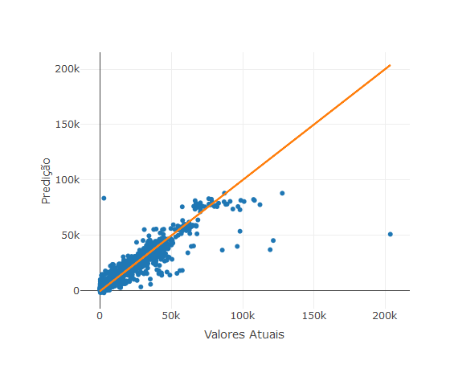

Importância das Variáveis Preditoras:

imp <- varImp(modelRetail_Boosting, useModel=FALSE, scale=FALSE)  
imp

## loess r-squared variable importance  
##   
## Overall  
## STORE 6.545e-01  
## UNEMPLOYMENT 5.842e-01  
## FUEL_PRICE 1.337e-01  
## CPI 1.984e-02  
## DATE 1.510e-02  
## MARKDOWN3 1.019e-02  
## MARKDOWN2 8.059e-03  
## TEMPERATURE 6.386e-03  
## ISHOLIDAY 9.245e-05  
## MARKDOWN4 0.000e+00  
## MARKDOWN1 0.000e+00  
## MARKDOWN5 0.000e+00

plot(imp)

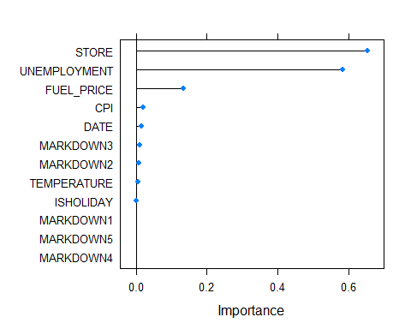

Salvando o modelo:

save(modelRetail_Boosting,file="modelRetail_Boosting.rdata")

Modelo Random Forest:

#Treinamento o modelo  
set.seed(314)  
  
if (file.exists("modelRetail_RF.rdata")) {  
 load("modelRetail_RF.rdata")  
} else {  
 modelRetail_RF <- train(WEEKLY_SALES~., data = dfTrain_Retail, method = "rf", trControl = cv)  
}  
  
modelRetail_RF

## Random Forest   
##   
## 5734 samples  
## 12 predictor  
##   
## No pre-processing  
## Resampling: Cross-Validated (10 fold, repeated 1 times)   
## Summary of sample sizes: 5161, 5160, 5161, 5161, 5162, 5161, ...   
## Resampling results across tuning parameters:  
##   
## mtry RMSE Rsquared MAE   
## 2 12621.092 0.6832040 9168.274  
## 28 5192.653 0.9052310 2393.189  
## 55 5276.347 0.9023141 2374.394  
##   
## RMSE was used to select the optimal model using the smallest value.  
## The final value used for the model was mtry = 28.

Avaliando o modelo com a base de teste:

pred_RF <- predict(modelRetail_RF ,newdata=dfTest_Retail)  
  
#Retornando as métricas do modelo com a base de teste  
metric_modelRetail_RF <- postResample(pred = pred_RF, obs = dfTest_Retail$WEEKLY_SALES)  
metric_modelRetail_RF

## RMSE Rsquared MAE   
## 5715.2742158 0.8950248 2328.7048207

dfTest_Retail$Model <- pred_RF  
  
head(dfTest_Retail)

## STORE DATE TEMPERATURE FUEL_PRICE MARKDOWN1 MARKDOWN2 MARKDOWN3  
## 3 1 2010-02-19 39.93 2.514 0 0 0  
## 5 1 2010-03-05 46.50 2.625 0 0 0  
## 10 1 2010-04-09 65.86 2.770 0 0 0  
## 12 1 2010-04-23 64.84 2.795 0 0 0  
## 13 1 2010-04-30 67.41 2.780 0 0 0  
## 17 1 2010-05-28 80.44 2.759 0 0 0  
## MARKDOWN4 MARKDOWN5 CPI UNEMPLOYMENT ISHOLIDAY WEEKLY_SALES Model  
## 3 0 0 211.28 8.106 FALSE 41595.55 28024.57  
## 5 0 0 211.35 8.106 FALSE 21827.90 21856.50  
## 10 0 0 210.62 7.808 FALSE 42960.91 25166.08  
## 12 0 0 210.43 7.808 FALSE 16145.35 17772.59  
## 13 0 0 210.38 7.808 FALSE 16555.11 16988.83  
## 17 0 0 210.89 7.808 FALSE 15580.43 19618.71

df_diag <- data.frame(actual = dfTest_Retail$WEEKLY_SALES,   
 fitted = dfTest_Retail$Model)  
  
df_diag %>% plot_ly(x = ~actual, y = ~fitted) %>%  
 add_trace(x = ~actual, y = ~fitted, mode = 'markers',type = 'scatter') %>%  
 add_trace(x = ~actual, y= ~actual , type="scatter", mode="lines", name='abline') %>%  
 layout(title = "",  
 xaxis = list(title = "Valores Atuais"),   
 yaxis = list(title = "Predição"),showlegend = FALSE)

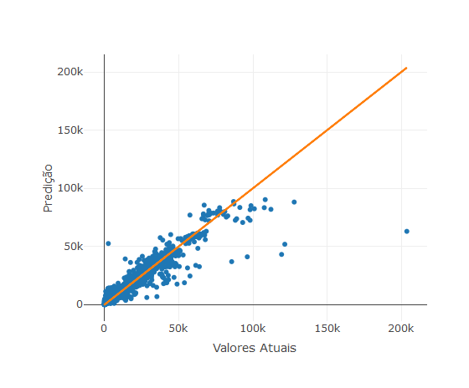

Importância das Variáveis Preditoras:

imp <- varImp(modelRetail_RF, useModel=FALSE, scale=FALSE)  
imp

## loess r-squared variable importance  
##   
## Overall  
## STORE 6.545e-01  
## UNEMPLOYMENT 5.842e-01  
## FUEL_PRICE 1.337e-01  
## CPI 1.984e-02  
## DATE 1.510e-02  
## MARKDOWN3 1.019e-02  
## MARKDOWN2 8.059e-03  
## TEMPERATURE 6.386e-03  
## ISHOLIDAY 9.245e-05  
## MARKDOWN4 0.000e+00  
## MARKDOWN1 0.000e+00  
## MARKDOWN5 0.000e+00

plot(imp)



Salvando o modelo:

save(modelRetail_RF,file="modelRetail_RF.rdata")

1. Redes Neurais

options(warn=-1)  
set.seed(314)  
  
if (file.exists("modelRetail_NNET.rdata")) {  
 load("modelRetail_NNET.rdata")  
} else {  
 # Definindo Parâmetros do Cross Validation  
 cv <- trainControl(method = "repeatedcv", number = 10, savePredictions = TRUE)  
 modelRetail_NNET <- train(WEEKLY_SALES~ ., data = dfTrain_Retail, method = "nnet",trControl = cv, maxit=1000, linout = 1)  
}  
  
modelRetail_NNET

## Neural Network   
##   
## 5734 samples  
## 12 predictor  
##   
## No pre-processing  
## Resampling: Cross-Validated (10 fold, repeated 1 times)   
## Summary of sample sizes: 5161, 5160, 5161, 5161, 5162, 5161, ...   
## Resampling results across tuning parameters:  
##   
## size decay RMSE Rsquared MAE   
## 1 0e+00 17184.32 0.0016126902 12761.47  
## 1 1e-04 17202.13 0.0002116679 12765.10  
## 1 1e-01 17180.41 0.0029806597 12759.33  
## 3 0e+00 17062.30 0.0217330495 12681.37  
## 3 1e-04 17164.74 0.0039172021 12755.99  
## 3 1e-01 16745.99 0.0575299420 12347.29  
## 5 0e+00 17145.61 0.0054903414 12723.18  
## 5 1e-04 17110.55 0.0146046906 12724.12  
## 5 1e-01 16885.18 0.0531855456 12425.33  
##   
## RMSE was used to select the optimal model using the smallest value.  
## The final values used for the model were size = 3 and decay = 0.1.

Importância das Variáveis Preditoras:

imp <- varImp(modelRetail_NNET, useModel=FALSE, scale=FALSE)  
imp

## loess r-squared variable importance  
##   
## Overall  
## STORE 6.545e-01  
## UNEMPLOYMENT 5.842e-01  
## FUEL_PRICE 1.337e-01  
## CPI 1.984e-02  
## DATE 1.510e-02  
## MARKDOWN3 1.019e-02  
## MARKDOWN2 8.059e-03  
## TEMPERATURE 6.386e-03  
## ISHOLIDAY 9.245e-05  
## MARKDOWN1 0.000e+00  
## MARKDOWN4 0.000e+00  
## MARKDOWN5 0.000e+00

plot(imp)

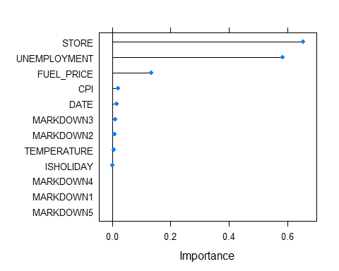

Avaliando o modelo com a base de teste:

pred_NNET <- predict(modelRetail_NNET ,newdata=dfTest_Retail)  
  
#Retornando as métricas do modelo com a base de teste  
metric_modelRetail_NNET <- postResample(pred = pred_NNET, obs = dfTest_Retail$WEEKLY_SALES)  
metric_modelRetail_NNET

## RMSE Rsquared MAE   
## 1.271506e+04 4.768282e-01 7.614559e+03

dfTest_Retail$Model <- pred_NNET  
  
head(dfTest_Retail)

## STORE DATE TEMPERATURE FUEL_PRICE MARKDOWN1 MARKDOWN2 MARKDOWN3  
## 3 1 2010-02-19 39.93 2.514 0 0 0  
## 5 1 2010-03-05 46.50 2.625 0 0 0  
## 10 1 2010-04-09 65.86 2.770 0 0 0  
## 12 1 2010-04-23 64.84 2.795 0 0 0  
## 13 1 2010-04-30 67.41 2.780 0 0 0  
## 17 1 2010-05-28 80.44 2.759 0 0 0  
## MARKDOWN4 MARKDOWN5 CPI UNEMPLOYMENT ISHOLIDAY WEEKLY_SALES Model  
## 3 0 0 211.28 8.106 FALSE 41595.55 33420.35  
## 5 0 0 211.35 8.106 FALSE 21827.90 33420.35  
## 10 0 0 210.62 7.808 FALSE 42960.91 33420.35  
## 12 0 0 210.43 7.808 FALSE 16145.35 33420.35  
## 13 0 0 210.38 7.808 FALSE 16555.11 33420.35  
## 17 0 0 210.89 7.808 FALSE 15580.43 33420.35

df_diag <- data.frame(actual = dfTest_Retail$WEEKLY_SALES,   
 fitted = dfTest_Retail$Model)  
  
df_diag %>% plot_ly(x = ~actual, y = ~fitted) %>%  
 add_trace(x = ~actual, y = ~fitted, mode = 'markers',type = 'scatter') %>%  
 add_trace(x = ~actual, y= ~actual , type="scatter", mode="lines", name='abline') %>%  
 layout(title = "",  
 xaxis = list(title = "Valores Atuais"),   
 yaxis = list(title = "Predição"),showlegend = FALSE)

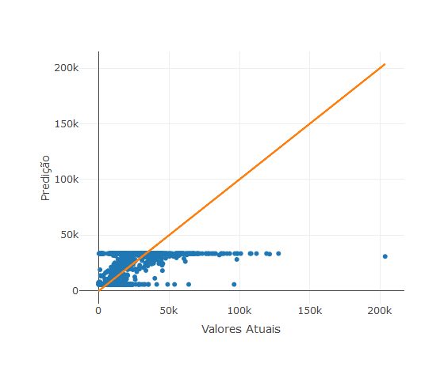

Salvando o modelo:

save(modelRetail_NNET,file="modelRetail_NNET.rdata")

Redes Neurais usando o pacote h2o:

library(h2o)  
h2o.init()

## Connection successful!  
##   
## R is connected to the H2O cluster:   
## H2O cluster uptime: 3 hours 51 minutes   
## H2O cluster timezone: America/Sao_Paulo   
## H2O data parsing timezone: UTC   
## H2O cluster version: 3.22.1.1   
## H2O cluster version age: 5 months and 29 days !!!   
## H2O cluster name: H2O_started_from_R_CTVIDAL_gjo731   
## H2O cluster total nodes: 1   
## H2O cluster total memory: 2.02 GB   
## H2O cluster total cores: 4   
## H2O cluster allowed cores: 4   
## H2O cluster healthy: TRUE   
## H2O Connection ip: localhost   
## H2O Connection port: 54321   
## H2O Connection proxy: NA   
## H2O Internal Security: FALSE   
## H2O API Extensions: Algos, AutoML, Core V3, Core V4   
## R Version: R version 3.5.0 (2018-04-23)

if (file.exists("modelRetail_H20.rdata")) {  
 load("modelRetail_H20.rdata")  
} else {  
   
 y <- "WEEKLY_SALES"  
 x <- setdiff(names(dfTrain_Retail), y)  
   
 #Criando uma grid de execução para varrer diversos modelos  
 hyper_params <- list(  
 activation=c("Rectifier","Tanh","Maxout","RectifierWithDropout","TanhWithDropout","MaxoutWithDropout"),  
 hidden=list(c(25,25,25,25),c(50,50,25,10),c(50,50,25,10,5),c(50,50,50,25,10)),  
 input_dropout_ratio=c(0,0.05,0.2),  
 l1=seq(0,1e-4,1e-6),  
 l2=seq(0,1e-4,1e-6)  
 )  
  
 #Definindo parâmetros e critérios de parada  
 search_criteria = list(strategy = "RandomDiscrete", max_models = 2000, seed=341,max_runtime_secs = 500, stopping_rounds=50, stopping_tolerance=1e-2)  
 dl_random_grid <- h2o.grid(  
 algorithm="deeplearning",  
 training_frame=as.h2o(dfTrain_Retail),  
 x=x,   
 y=y,  
 epochs=1000,  
 nfolds = 10,  
 stopping_metric="AUTO",  
 stopping_tolerance=1e-2,  
 hyper_params = hyper_params,  
 search_criteria = search_criteria  
 )   
 grid <- h2o.getGrid(dl_random_grid@grid_id,sort_by="r2",decreasing=TRUE)  
 grid  
   
 grid@summary_table[1,]  
 modelRetail_H20 <- h2o.getModel(grid@model_ids[[1]]) ## Modelo com o maior R2  
   
}  
  
modelRetail_H20

## Model Details:  
## ==============  
##   
## H2ORegressionModel: deeplearning  
## Model ID: Grid_DeepLearning_dfTrain_Retail_sid_b7e0_25_model_R_1561605970983_2_model_1   
## Status of Neuron Layers: predicting WEEKLY_SALES, regression, gaussian distribution, Quadratic loss, 14.181 weights/biases, 175,5 KB, 1.155.856 training samples, mini-batch size 1  
## layer units type dropout l1 l2 mean_rate rate_rms momentum  
## 1 1 59 Input 5.00 % NA NA NA NA NA  
## 2 2 50 Maxout 0.00 % 0.000048 0.000021 0.044778 0.190949 0.000000  
## 3 3 50 Maxout 0.00 % 0.000048 0.000021 0.012433 0.024537 0.000000  
## 4 4 25 Maxout 0.00 % 0.000048 0.000021 0.022190 0.050351 0.000000  
## 5 5 10 Maxout 0.00 % 0.000048 0.000021 0.098995 0.236253 0.000000  
## 6 6 1 Linear NA 0.000048 0.000021 0.024874 0.055597 0.000000  
## mean_weight weight_rms mean_bias bias_rms  
## 1 NA NA NA NA  
## 2 -0.004615 0.189334 0.103453 0.192756  
## 3 -0.032263 0.135813 0.668062 0.177408  
## 4 -0.025486 0.150788 0.702122 0.247921  
## 5 -0.022075 0.215274 0.646757 0.431579  
## 6 0.043850 0.306536 0.295645 0.000000  
##   
##   
## H2ORegressionMetrics: deeplearning  
## ** Reported on training data. **  
## ** Metrics reported on full training frame **  
##   
## MSE: 81624237  
## RMSE: 9034.613  
## MAE: 4240.384  
## RMSLE: NaN  
## Mean Residual Deviance : 81624237  
##   
##   
##   
## H2ORegressionMetrics: deeplearning  
## ** Reported on cross-validation data. **  
## ** 10-fold cross-validation on training data (Metrics computed for combined holdout predictions) **  
##   
## MSE: 86617054  
## RMSE: 9306.828  
## MAE: 5244.8  
## RMSLE: NaN  
## Mean Residual Deviance : 86617054  
##   
##   
## Cross-Validation Metrics Summary:   
## mean sd cv_1_valid cv_2_valid  
## mae 5171.5596 368.50864 4991.889 5722.7583  
## mean_residual_deviance 8.7106752E7 1.0491326E7 7.619316E7 8.510884E7  
## mse 8.7106752E7 1.0491326E7 7.619316E7 8.510884E7  
## r2 0.70553803 0.021313956 0.7159598 0.6737612  
## residual_deviance 8.7106752E7 1.0491326E7 7.619316E7 8.510884E7  
## rmse 9298.529 567.49603 8728.869 9225.445  
## rmsle 1.2980915 0.053460784 NaN 1.3544441  
## cv_3_valid cv_4_valid cv_5_valid cv_6_valid  
## mae 4769.766 5118.42 4701.216 6254.9653  
## mean_residual_deviance 9.1487736E7 6.9342528E7 9.8843152E7 1.0377208E8  
## mse 9.1487736E7 6.9342528E7 9.8843152E7 1.0377208E8  
## r2 0.7045732 0.7559948 0.69668424 0.6692413  
## residual_deviance 9.1487736E7 6.9342528E7 9.8843152E7 1.0377208E8  
## rmse 9564.922 8327.216 9941.989 10186.858  
## rmsle NaN NaN NaN NaN  
## cv_7_valid cv_8_valid cv_9_valid cv_10_valid  
## mae 4745.786 5459.525 4485.9214 5465.3477  
## mean_residual_deviance 1.07610496E8 1.01392928E8 6.527936E7 7.2037256E7  
## mse 1.07610496E8 1.01392928E8 6.527936E7 7.2037256E7  
## r2 0.6630486 0.72604626 0.7478217 0.7022492  
## residual_deviance 1.07610496E8 1.01392928E8 6.527936E7 7.2037256E7  
## rmse 10373.548 10069.405 8079.5645 8487.477  
## rmsle NaN 1.2417389 NaN NaN

Avaliando o modelo:

h2o.r2(modelRetail_H20)

## [1] 0.7245832

dfTest_Retail <- dfTest_Retail[,which(colnames(dfTest_Retail)!="Model")]  
  
perf <- h2o.performance(modelRetail_H20,as.h2o(dfTest_Retail))

##   
 |   
 | | 0%  
 |   
 |=================================================================| 100%

h2o.hit_ratio_table(perf)

## NULL

#Retornando as métricas do modelo com a base de teste  
metric_modelRetail_H20 <- h2o.r2(perf)  
metric_modelRetail_H20

## [1] 0.6426361

head(h2o.varimp(modelRetail_H20))

## Variable Importances:   
## variable relative_importance scaled_importance percentage  
## 1 CPI 1.000000 1.000000 0.023931  
## 2 STORE.14 0.957498 0.957498 0.022914  
## 3 STORE.45 0.946941 0.946941 0.022661  
## 4 STORE.30 0.946753 0.946753 0.022657  
## 5 STORE.33 0.936792 0.936792 0.022418  
## 6 STORE.3 0.924226 0.924226 0.022117

h2o.varimp_plot(modelRetail_H20)

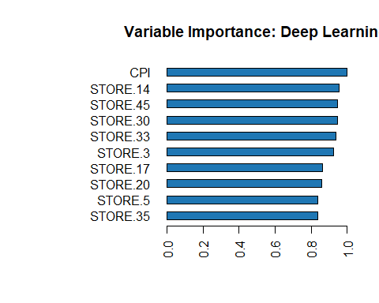

Salvando o modelo:

save(modelRetail_H20,file="modelRetail_H20.rdata")

**Passo 6) Avaliação final da performance dos modelos**

1. Modelos da base de Marketing

comparativo_Mkt <- data.frame(GLM=cmMkt_GLM$overall['Accuracy'],RANDOM_FOREST=cmMkt_RF$overall['Accuracy'],  
 SVM=cmMkt_SVM$overall['Accuracy'],REDES_NEURAIS=cmMkt_RN$overall['Accuracy'])  
  
comparativo_Mkt

## GLM RANDOM_FOREST SVM REDES_NEURAIS  
## Accuracy 0.912674 0.9125931 0.9046617 0.9106507

1. Modelos da base de vendas

comparativo_RT_Train <- data.frame(REGRESSAO_LOG=max(modelRetail_RL$results$Rsquared),TREE_BOOSTING=max(modelRetail_Boosting$results$Rsquared),RANDOM_FOREST=max(modelRetail_RF$results$Rsquared),REDES_NEURAIS_NNET=max(modelRetail_NNET$results$Rsquared),REDES_NEURAIS_H20=h2o.r2(modelRetail_H20))  
  
comparativo_RT_Test <- data.frame(REGRESSAO_LOG=metric_modelRetail_RL[2],TREE_BOOSTING=metric_modelRetail_Boosting[2],RANDOM_FOREST=metric_modelRetail_RF[2],REDES_NEURAIS_NNET=metric_modelRetail_NNET[2],REDES_NEURAIS_H20=metric_modelRetail_H20)  
  
comparativo_RT <- rbind("R2 TRAIN"=comparativo_RT_Train,"R2 TEST"=comparativo_RT_Test)  
  
comparativo_RT

## REGRESSAO_LOG TREE_BOOSTING RANDOM_FOREST REDES_NEURAIS_NNET  
## R2 TRAIN 0.6451901 0.8834655 0.9052310 0.05752994  
## R2 TEST 0.6071794 0.8615889 0.8950248 0.47682820  
## REDES_NEURAIS_H20  
## R2 TRAIN 0.7245832  
## R2 TEST 0.6426361

**Passo 7) Conclusão**

Para a base de Marketing verifica-se que o modelo que apresenta maior acurácia foi o GLM (Accuracy=0.912674), enquanto que para a base de vendas o modelo que apresentou a melhor perfomance na base de testes foi a Random Forest (R2=0.8950248).