**PENILAIAN SIKAP PERILAKU**

|  |  |
| --- | --- |
| **Kegiatan** | **: Pelatihan Dasar CPNS Golongan III** |
| **Hari/Tanggal** | **: Kamis, 03 Desember 2021** |
| **Penilai** | **: IAIN Kendari** |

|  |  |  |  |  |  |  |
| --- | --- | --- | --- | --- | --- | --- |
| No. | Nama Peserta | Indikator | | | | Jumlah (5%) |
| Kedisiplinan (1%) | Kepemimpinan (2%) | Kerjasama (1%) | Prakarsa (1%) |
| 1. | Novi Rahmii  NIP. 199206282020121011 | **97** | **95** | **95** | **94** | **19.05** |

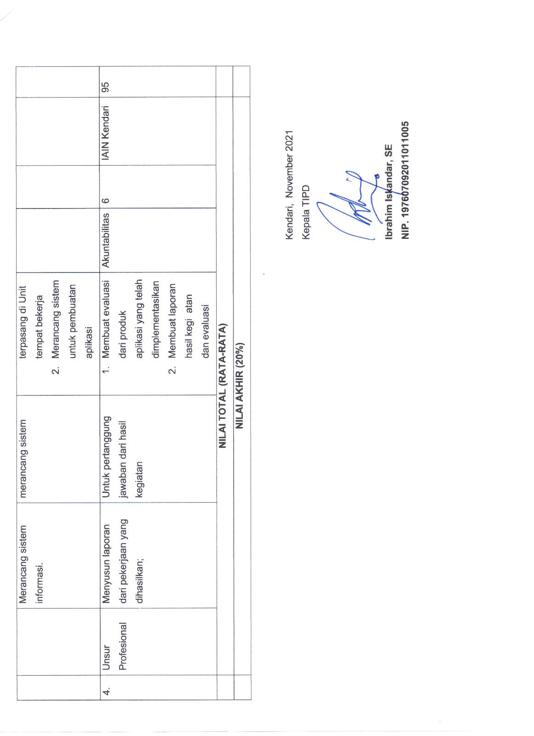Kendari, 03 Desember 2021

Kepala TIPD IAIN Kendari

**Ibrahim Iskandar, SE**

**197607092011011005**

**PENILAIAN SIKAP PERILAKU**

|  |  |
| --- | --- |
| **Kegiatan** | **: Pelatihan Dasar CPNS Golongan III** |
| **Hari/Tanggal** | **: Kamis, 03 Desember 2021** |
| **Penilai** | **: IAIN Kendari** |

|  |  |  |  |  |  |  |
| --- | --- | --- | --- | --- | --- | --- |
| No. | Nama Peserta | Indikator | | | | Jumlah (5%) |
| Kedisiplinan (1%) | Kepemimpinan (2%) | Kerjasama (1%) | Prakarsa (1%) |
| 1. | Novi Rahmilia, S.Sos.I  NIP. 199211252020122019 | **97** | **95** | **95** | **94** | **19.05** |

Kendari, 03 Desember 2021

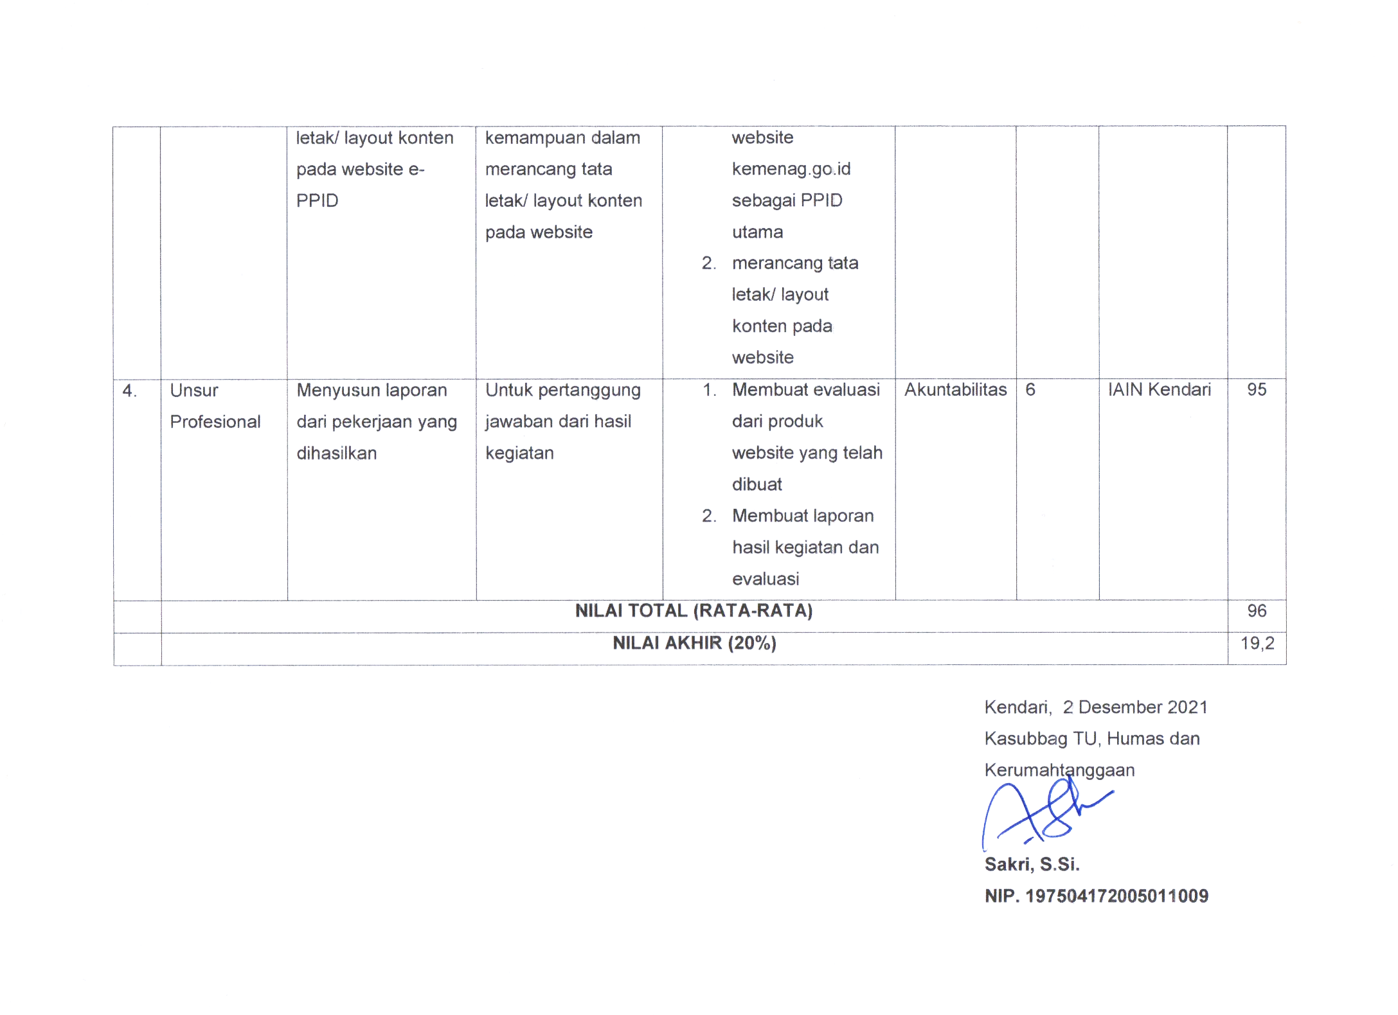Kasubbag TU, Humas dan Kerumahtanggaan

**Sakri, S.Si**

**NIP. 19750417200511009**

