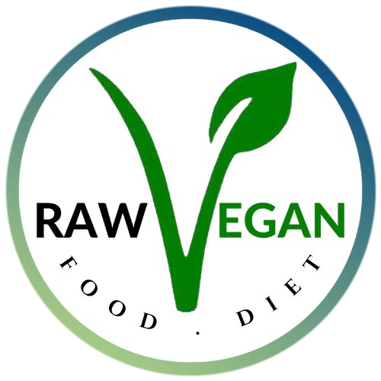
RAW VEGAN FOOD DIET
Coach & Client Agreement
1:1 Wellness Coaching · C.Sanchez

This agreement exists so that both of us enter this coaching relationship with clarity, mutual respect, and a shared understanding of what we are building together. It is not fine print — it is the foundation of how this work is done.

Section 1 — What You Can Expect From Me

My Commitment to You
- Personalized guidance tailored to your body, your history, and your specific health goals — never a generic plan.
- Honest, informed perspective built from nearly a decade of committed raw vegan, plant-based living, juice fasting, and dry fasting — and over 30 years of independent health study and self-healing exploration.
- Full presence and focused attention during every scheduled session and agreed communication.
- A safe, non-judgmental space where your questions, struggles, and progress are met with care and intention.
- Consistent encouragement of your growth — rooted in truth, not flattery.
- Referral to appropriate professional support (medical, therapeutic, or otherwise) if your needs fall outside the scope of wellness coaching.

The Experience You Will Receive
- A coaching relationship built on Natural Hygiene principles — the understanding that the body is innately intelligent and self-regulating when given the right conditions.
- Guidance that honors the whole person: physical, mental, and energetic.
- A framework that begins with your Why — your real reason — and builds outward from there into sustainable, identity-aligned transformation.
- Accountability that respects your autonomy and honors your pace — without pressure or force.

Section 2 — What I Expect From You

Your Commitment to This Process
- Show up to scheduled sessions on time and prepared. If you need to reschedule, provide a minimum of 48 hours' notice.
- Engage honestly — with your answers, your progress reports, and your challenges. This work is only as effective as the truth you bring to it.
- Implement the guidance between sessions. Transformation happens in the daily choices, not only in our conversations.
- Communicate openly when something is not working, when life circumstances shift, or when you need to adjust the approach.
- Come to this relationship as an active participant — not a passive recipient. You are the most important ingredient in your own transformation.

Your Responsibility for Your Outcomes
Results in this coaching relationship are co-created. I bring knowledge, structure, and unwavering belief in your capacity. You bring consistent effort, honest engagement, and a willingness to shift — not just your habits, but your identity.

I can show you the door. Walking through it is always your choice.

Section 3 — Scope of This Coaching Relationship

This is a wellness coaching relationship. It is not medical care, clinical treatment, or therapy. The following table clarifies what falls within and outside the scope of our work together.

Within Scope | Outside Scope
Lifestyle & nutrition coaching | Medical diagnosis or clinical treatment
Whole food, plant-based & raw food guidance | Prescription or management of medical conditions
Mindset & identity-based transformation | Mental health therapy or crisis intervention
Habit design & sustainable system building | Physical caregiving or hands-on assistance
Accountability & structured check-ins | Legal or financial advice
Energetic wellness & holistic self-care practices | On-demand emotional support outside agreed sessions
Referrals to appropriate professionals when needed | Guaranteed specific outcomes or timelines

Section 4 — Mutual Expectations

What We Both Agree To
Treat each other with respect, honesty, and integrity at all times.
Communicate clearly and in good faith when concerns arise — before they become problems.
Honor the time and energy invested by both parties in this relationship.
Acknowledge that transformation is not linear — and navigate the inevitable plateaus with patience and perspective.
Hold the shared understanding that this work is a partnership, not a transaction.

Section 5 — Confidentiality & Privacy

- Everything shared within our coaching sessions is held in strict confidence.
- No personal information, health details, or session content will be shared with any third party without your explicit written permission.
- Testimonials or success stories will only be used with your expressed consent.
- Your privacy is treated as a non-negotiable standard of this practice — not an afterthought.

Section 6 — A Note on Transformation

Lasting change does not happen to you — it happens through you. The guidance, tools, and frameworks offered in this coaching relationship are powerful. But they require your participation, your consistency, and your willingness to do the inner work alongside the outer.

This coaching relationship is not about dependency — it is about building a version of you that no longer needs to be coached back to your own foundation. The goal is your sovereignty over your own health, for life.

"The sky is the limit — when the foundation is right."
This is what we are building together.

By proceeding with 1:1 coaching, both parties acknowledge
having read, understood, and agreed to this framework.


Raw Vegan Food Diet · C.Sanchez · rawveganfooddiet.com

