Quarterly Report
Revenue grew 12% to 4.2M. The CEO is pictured below.
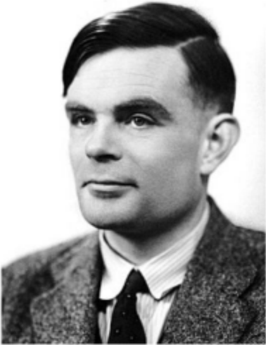
Figure 1: Alan Turing, founder.
Region | Sales
EU | 1.9M
US | 2.3M

