White Paper: BOM Analyzer

**Leveraging Multi-Supplier APIs and Predictive Insights for Optimized Electronic Component Sourcing & Risk Management**

**Prepared By:**  Tyler Allen   
**Date:** April 27, 2025  
**Version:** 1.0.0

1. Abstract

The New Product Introduction (NPI) process for electronic hardware is critically dependent on efficient and accurate component sourcing. Traditional Bill of Materials (BOM) analysis, however, often relies on manual, time-consuming methods prone to overlooking significant risks and cost-saving opportunities. Gathering real-time pricing, availability, and lead time data from multiple suppliers, assessing component lifecycle and geopolitical risks, and evaluating complex pricing tiers requires substantial effort. The BOM Analyzer is a purpose-built Python application designed to address these challenges. By integrating directly with official APIs from major distributors (Digi-Key, Mouser, Octopart/Nexar), the tool automates data aggregation and normalization. It calculates optimized purchasing costs considering price breaks, identifies multiple sourcing strategies (lowest cost, fastest, balanced), performs comprehensive risk assessments (sourcing diversity, stock, lead time, lifecycle, geography), estimates tariff impacts, and provides predictive forecasting using historical data (Prophet). Integration with OpenAI delivers AI-generated executive summaries and actionable recommendations. The BOM Analyzer empowers supply chain professionals, NPI teams, and small-to-medium enterprises to significantly reduce sourcing time, mitigate supply chain risks, optimize component costs, and make faster, data-driven decisions during critical NPI cycles.

2. Introduction: The Challenge of BOM Analysis

Bringing new electronic products to market under pressure demands efficient supply chain management, especially concerning the Bill of Materials (BOM). The NPI phase requires rapid, accurate sourcing decisions for numerous components, often from a diverse global supplier base. Traditional BOM analysis methods, however, face significant hurdles:

* **Time-Intensive Manual Data Collection:** Procurement specialists or engineers often spend hours, if not days, visiting multiple distributor websites, manually extracting stock levels, quantity-based pricing tiers, and fluctuating lead times for each BOM line item. This process is tedious, error-prone, and does not scale effectively for complex BOMs.
* **Data Volatility and Inaccuracy:** The electronic component market is dynamic. Pricing, stock availability, and lead times can change rapidly. Manually compiled data quickly becomes outdated, leading to inaccurate cost estimations, unexpected stockouts when placing orders, or critical delays in the NPI timeline.
* **Suboptimal Costing:** Identifying the true lowest cost requires analyzing complex variables like Minimum Order Quantities (MOQs) and multi-level price breaks across different suppliers for the specific quantity needed. Manual methods often oversimplify this, leading to missed cost-saving opportunities or inefficient "buy-up" decisions.
* **Overlooked Supply Chain Risks:** Critical risks often remain hidden until late in the process. Component lifecycle status (End-of-Life [EOL], Not Recommended for New Designs [NRND]), reliance on single-source components, manufacturing concentration in high-risk geopolitical regions, and tariff implications are difficult to track and quantify systematically using spreadsheets alone. Discovering these issues late can force expensive redesigns or jeopardize production schedules.
* **Lack of Predictive Insight:** Standard analysis provides a snapshot in time but offers little visibility into future trends. Teams lack the tools to anticipate potential price increases or lead time extensions based on historical patterns, hindering proactive negotiation, risk buffering, and long-term strategic planning.

These inefficiencies inherent in manual BOM analysis directly impact crucial NPI metrics like time-to-market, product cost, and overall project success. An automated, data-driven solution is needed to integrate real-time information, perform robust analysis, and provide actionable intelligence.

3. The Solution: BOM Analyzer

The BOM Analyzer is a desktop application developed in Python, specifically engineered to automate and enhance BOM analysis for NPI. It acts as a centralized platform to overcome the limitations of manual processes, enabling faster, data-driven, and risk-aware component sourcing.

Leveraging official Application Programming Interfaces (APIs) from major electronic component distributors (currently Digi-Key, Mouser, Octopart/Nexar), the BOM Analyzer accesses real-time data on pricing, stock availability, lead times, lifecycle status, country of origin, and other key component details.

The application workflow involves:

1. **BOM Import:** Ingesting a standard CSV BOM file containing Part Numbers and Quantities (Manufacturer is optional but helpful).
2. **Data Aggregation:** Querying enabled supplier APIs concurrently for each valid BOM line item.
3. **Data Normalization:** Processing diverse API responses into a standardized format, including converting various lead time expressions (weeks, days, 'stock') into numeric days and parsing multi-level pricing breaks.
4. **Cost Optimization:** Calculating the optimal total cost for the required quantity per part, considering supplier MOQs and evaluating potential cost savings from quantity price breaks using a configurable "Buy-Up Threshold".
5. **Strategy Generation:** Defining and calculating multiple distinct sourcing strategies for the entire BOM (e.g., Strict Lowest Cost, Fastest Available, User-Optimized based on cost/lead time weighting).
6. **Risk Assessment:** Calculating a multi-factor risk score (0-10) for each active part based on sourcing diversity, stock vs. need, lead time, lifecycle status (EOL/Discontinued), and geopolitical factors associated with the Country of Origin. Tariff impacts are also estimated.
7. **Predictive Analysis:** Storing historical data points from analyses and using the Prophet library to forecast future cost and lead time trends, with capabilities for tracking prediction accuracy against actual purchase data.
8. **AI Synthesis:** Utilizing the OpenAI API (if configured) to generate an executive summary, highlight critical risks and part issues (like EOL or Unknown status), and propose actionable recommendations based on the full analysis output.
9. **Reporting & Export:** Displaying results in clear, sortable tables and interactive visualizations within the GUI. Providing CSV exports for the main analysis view and each calculated sourcing strategy.

Built using Python and key libraries such as Tkinter, Pandas, Requests, Prophet, Matplotlib, Seaborn, and OpenAI, the BOM Analyzer provides a powerful yet accessible tool designed to significantly improve the NPI sourcing process. Its modular design allows for future integration with enterprise systems like PLM or ERP.

4. Key Features & Functionality

The BOM Analyzer offers a comprehensive suite of features:

* **BOM Import & Validation:**
  + Loads standard CSV BOM files.
  + Flexible column mapping for "Part Number", "Quantity", "Manufacturer".
  + Data cleaning (strips whitespace, handles non-numeric quantities) and validation (requires positive quantity).
  + Provides user feedback on loaded/removed parts.

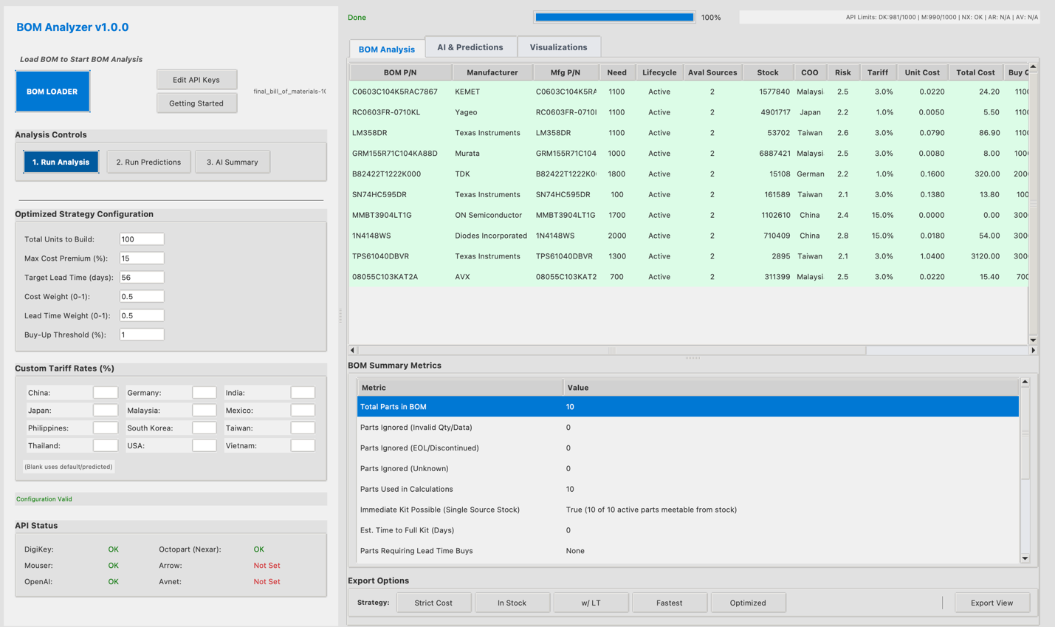

* **Multi-Supplier API Integration:**
  + Real-time data via official APIs: Digi-Key (OAuth2), Mouser (API Key), Octopart / Nexar (OAuth2).
  + Secure authentication handling (including local HTTPS server for DigiKey OAuth redirect) and token caching/refresh.
  + Parallel data fetching (ThreadPoolExecutor) for improved speed.
  + GUI display of API connection status and rate limit information.

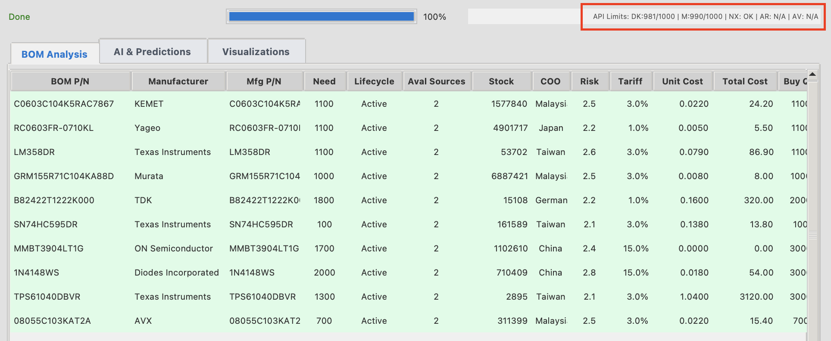

* **Automated Data Aggregation & Normalization:**
  + Retrieves stock, multi-level pricing tiers, lead times.
  + Normalizes various lead time formats (weeks, days, 'stock') into numeric days.
  + Extracts MPN, Manufacturer, Description, Packaging, Datasheet URL, COO, HTS Code (where available).
* **Cost & Lead Time Analysis:**
  + Calculates optimal total cost per part considering MOQs and price breaks (get_optimal_cost).
  + Configurable "Buy-Up Threshold" allows intelligent purchasing beyond exact need if cost-effective.
  + Identifies distinct "Lowest Cost" and "Fastest" options for each part.
* **Strategic Sourcing Options:**
  + Calculates and compares overall BOM cost and max lead time for multiple strategies:
    - Strict Lowest Cost: Buys exact need (or MOQ) at the best price for that quantity.
    - Lowest Cost In Stock: Cheapest options available immediately from stock (may be N/A).
    - Lowest Cost w/ LT: Absolute lowest total cost considering buy-ups, ignoring lead time.
    - Fastest: Options with the shortest effective lead time (0 if in stock).
    - Optimized Strategy: Balances cost vs. lead time based on user weights and constraints (Target LT, Max Premium %).
  + Provides detailed CSV exports for each strategy.

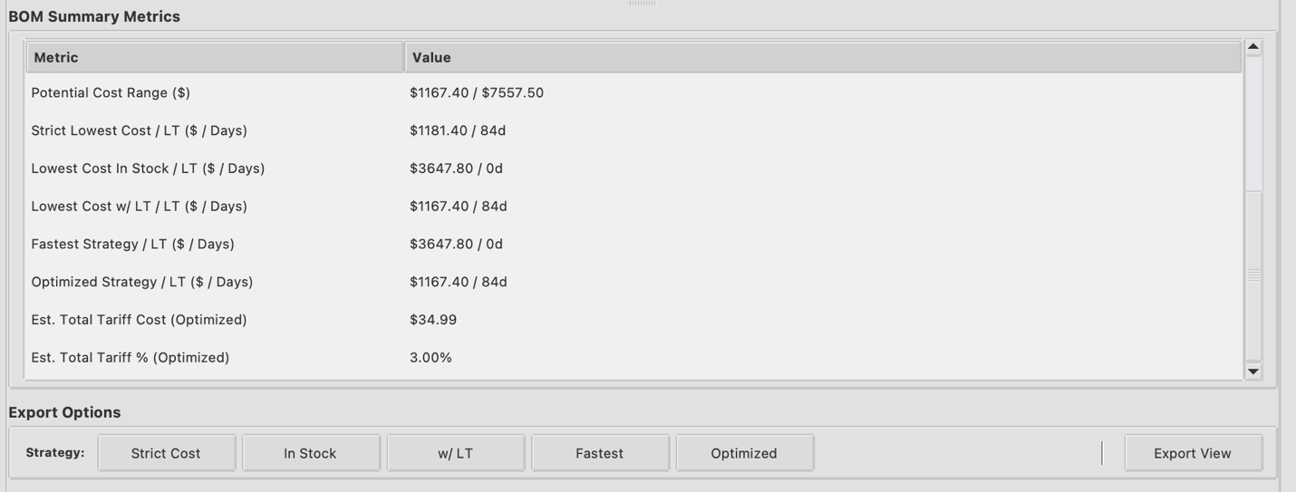

* **Multi-Factor Risk Assessment:**
  + Calculates weighted Risk Score (0-10) using: Sourcing Diversity, Stock vs. Need, Lead Time, Lifecycle Status, Geographic Origin.
  + Categorizes risk (Low/Moderate/High).
  + Visually flags risk levels in the main parts table.
  + Estimates tariff impact using custom rates, USITC HTS lookup (best-effort), or defaults.

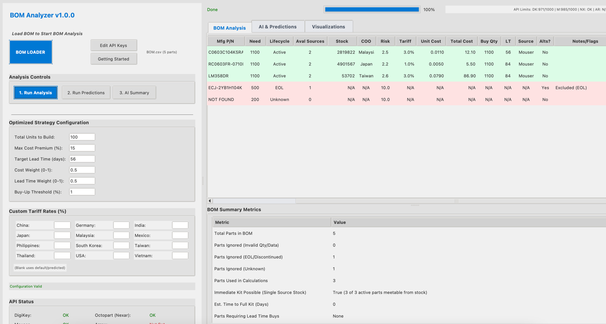

* **Predictive Analytics (Prophet):**
  + Saves historical cost/lead time/stock data locally (bom_historical_data.csv).
  + Forecasts future trends using Prophet.
  + Allows user input of actual procurement data (Real_Lead, Real_Cost, Real_Stock) to track prediction accuracy over time (supply_chain_predictions.csv).
  + Creation of historical dataset for future training of LLM

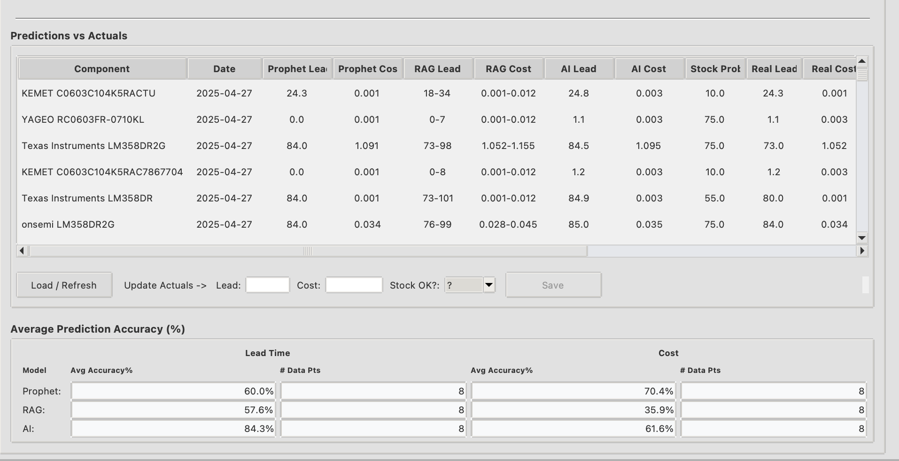

* **AI-Powered Summary (OpenAI):**
  + Generates executive summaries synthesizing analysis results using LLMs (e.g., GPT-4o).
  + Highlights critical issues (EOL, Unknown parts, stock gaps, high risks) with clear markers (CRITICAL:, WARNING:).
  + Provides actionable recommendations.
  + Identifies the single recommended strategy and enables direct export.

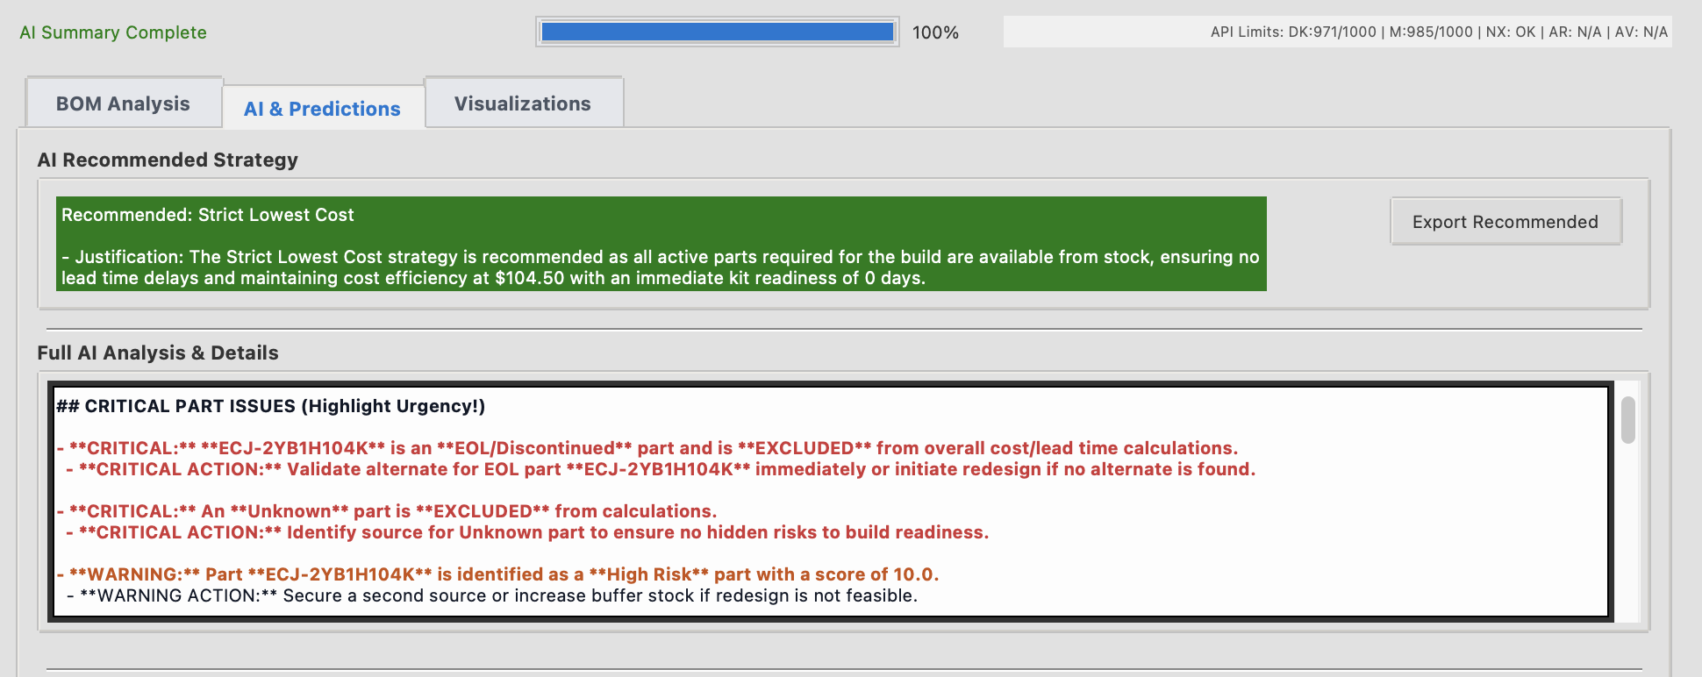

* **Data Persistence & Export:**
  + Local CSV storage for historical data and predictions.
  + CSV exports for main analysis view and calculated strategies.
  + Local JSON caching for API tokens and counters.
* **User Interface (Tkinter):**
  + Graphical interface using Tkinter/ttk.
  + Tabbed layout for results (Analysis, AI/Predictions, Visualizations).
  + Sortable, color-coded tables (ttk.Treeview).
  + Interactive plots (Matplotlib/Seaborn) with hover-over details (for Cost vs LT).
  + Universal status bar for messages and context-sensitive tooltips.

5. Benefits and Use Cases

Implementing the BOM Analyzer provides significant advantages:

**Key Benefits:**

* **Drastic Time Reduction:** Automates data collection from hours/days to minutes, freeing up valuable engineering and procurement resources.
* **Enhanced Cost Optimization:** Moves beyond simple unit price comparison to find true optimal costs considering quantity breaks and MOQs. The "Buy-Up Threshold" feature identifies opportunities for lower effective unit costs. Direct comparison of multiple strategies informs budget decisions.
* **Improved Lead Time Management:** Quickly surfaces fastest sourcing options and calculates a realistic "Time to Full Kit" based on actual lead times or stock availability, aiding schedule adherence.
* **Proactive Risk Mitigation:** Integrates risk assessment directly into the sourcing workflow. Quantifies and highlights risks related to sourcing depth, stock coverage, lead time, component lifecycle (EOL/NRND), and geopolitical factors (COO/Tariffs), enabling targeted mitigation efforts *before* they impact production.
* **Data-Driven Decision Making:** Provides a consolidated, real-time view across multiple suppliers, replacing assumptions with verifiable data. Enables clear trade-offs between cost, lead time, and risk based on calculated strategies.
* **Actionable AI Insights:** Translates complex data into concise, actionable executive summaries and recommendations via OpenAI, accelerating the decision cycle. Automatically flags critical part issues requiring immediate attention.
* **Improved Accuracy Tracking:** Allows comparison of predicted cost/lead times against actual procurement data, building a history to refine forecasting and assess supplier reliability over time.
* **Accessibility:** Offers powerful analysis capabilities in a desktop application suitable for teams or companies without access to expensive, large-scale enterprise software.

**Primary Use Cases:**

* **New Product Introduction (NPI) Sourcing:** Rapidly analyze BOMs for new designs to identify optimal suppliers, costs, lead times, and risks early in the development cycle.
* **Component Resourcing & Second Sourcing:** Quickly evaluate alternative parts or suppliers for existing products to improve cost, availability, or resilience.
* **Cost Reduction Initiatives:** Systematically analyze existing BOMs to identify cost-saving opportunities through alternative suppliers or optimized purchasing quantities.
* **Supply Chain Risk Assessment:** Evaluate existing or potential BOMs for vulnerabilities related to single sources, EOL parts, long lead times, or geopolitical concentration.
* **Design Feasibility:** Provide early feedback to design engineers on the cost and availability implications of component choices.

**Target Audience:**

* NPI Engineers & Program Managers
* Supply Chain & Procurement Professionals
* Hardware & Electrical Engineers
* Small to Medium-sized Electronics Design/Manufacturing Businesses (SMBs/SMEs)
* Operations Managers
* Consultants specializing in supply chain optimization.

6. Technical Architecture Overview

The BOM Analyzer is built using Python 3 and leverages several standard and third-party libraries:

* **Core Language:** Python 3.x
* **Graphical User Interface (GUI):** Tkinter and ttk (Python's standard GUI toolkit) for cross-platform desktop application framework.
* **Data Manipulation & Analysis:** Pandas for efficient data handling in DataFrames; NumPy for numerical operations.
* **API Communication:** requests library for making HTTP/HTTPS requests to supplier APIs.
* **Authentication & Security:**
  + python-dotenv to load sensitive API keys/secrets from a .env file (not committed to version control).
  + Standard http.server and ssl modules to implement the local HTTPS callback server required for Digi-Key's OAuth 2.0 Authorization Code Grant flow.
  + Manages OAuth token caching (JSON files) and automated refresh logic.
* **Concurrency:** concurrent.futures.ThreadPoolExecutor to perform parallel API calls to multiple suppliers simultaneously, significantly speeding up data fetching for large BOMs. Thread-safe GUI updates managed via root.after().
* **Data Storage:**
  + CSV files (bom_historical_data.csv, supply_chain_predictions.csv) for persistent storage of analysis history and prediction results.
  + JSON files (*.json in cache/ directory) for local caching of API tokens, counters, and application configuration.
* **Predictive Modeling:** prophet library (Facebook Prophet) for time-series forecasting of component cost and lead time based on historical data. Includes basic data cleaning and outlier detection.
* **AI Integration:** openai library to interact with OpenAI's API (e.g., GPT-4o) for generating natural language summaries and recommendations based on structured prompts derived from the analysis results. Includes error handling for rate limits and API issues. Uses @lru_cache to cache identical AI prompts/responses temporarily.
* **Visualization:** Matplotlib (core plotting) and Seaborn (enhanced statistical plots) integrated into the Tkinter GUI using matplotlib.backends.backend_tkagg. Provides interactive elements like tooltips on plots.
* **Utilities:** os, sys, pathlib (file system interaction), re (regex parsing), datetime, time, json, csv, webbrowser, subprocess (opening files/URLs).

7. Future Roadmap / Next Steps

The BOM Analyzer serves as a strong foundation. Future development aims to enhance integration, automation, and intelligence:

**Phase 1 / v1.x (Near-Term Enhancements):**

* **Activate Arrow/Avnet APIs:** Implement full data retrieval and processing for these distributors.
* **Expand Distributor Support:** Integrate APIs for additional major suppliers (e.g., TTI, Future Electronics).
* **Refine UI/UX:** Improve table filtering/searching, add more visualization options, enhance error feedback.
* **Parameter-Based Alternates:** Enhance alternate part suggestions based on key technical parameters beyond simple API substitution lists.
* **Improve RAG Model:** Replace mock RAG with connections to basic external data sources (e.g., market news RSS, commodity indices) for rudimentary context-aware prediction adjustments.

**Phase 2 / v2.x (Integration & Automation Focus):**

* **Basic ERP/PLM Integration:** Develop modules for BOM import/export via common database connections or standardized file formats (beyond CSV).
* **Draft Purchase Order Generation:** Automatically create draft POs (CSV/PDF) based on the selected strategy, ready for manual review and entry into procurement systems.
* **Historical Trend Dashboards:** Add simple visualizations within the app to show historical price/lead time trends for specific components.
* **Basic Automated Notifications:** Implement email/system alerts for critical events identified during analysis runs (e.g., new EOL parts, major stock drops).

**Phase 3 / v3.x (Advanced Features & Intelligence):**

* **Deeper ERP/PLM Integration:** Implement two-way communication (e.g., pushing draft POs to ERP via API), potentially including basic budget checks.
* **Advanced AI Integration:** Incorporate multiple LLMs (Claude, Gemini) for comparative analysis or ensemble recommendations. Explore fine-tuning models on anonymized historical data for domain specialization.
* **Order Management (Basic):** Allow manual status updates for generated POs within the tool. Explore supplier portal APIs for automated tracking where feasible.
* **Sophisticated Risk Modeling:** Integrate additional risk factors (e.g., supplier financial health indicators, detailed compliance data, multi-tier supply chain visibility if data available).

**Phase 4 / Beyond (Vision):**

* **Accuracy-Gated Autonomous Procurement:** Leverage calculated prediction accuracy against user-entered actuals. Implement configurable accuracy thresholds (e.g., >90%) to enable an AI Agent / Autonomous Mode. This mode could (with permissions): run analysis, select strategy, generate POs, route for approval (e.g., email to Finance for high value), and potentially auto-submit approved POs via API – creating a path to trusted end-to-end automation based on proven system performance.
* **Full "Purchase Now" Automation:** Securely implement direct purchasing via supplier APIs for approved POs.
* **Advanced Order Management & Exception Handling:** Integrate with shipping APIs; develop intelligent exception handling for delays/discrepancies.
* **Web-Based Version / SaaS:** Develop a cloud-based version for team collaboration, centralized data, and easier integration.
* **Continuous Background Monitoring:** Agent-based proactive monitoring of key BOMs for critical changes (price, stock, EOL).
* **Full Meta-LLM Analysis & Explainability:** Implement cross-LLM analysis and develop features to clearly explain AI recommendations and decisions.

8. Conclusion

Manual BOM analysis for NPI is inefficient and carries significant risks in today's volatile supply chain environment. The BOM Analyzer provides a robust, data-driven alternative. By automating real-time data collection, performing optimized cost calculations, generating comparative sourcing strategies, quantifying multi-factor risks, offering predictive insights, and leveraging AI for actionable summaries, this tool empowers users to make faster, more informed, and strategically sound component sourcing decisions. It demonstrably saves time, reduces costs, mitigates supply chain disruptions, and ultimately helps accelerate the New Product Introduction process. While highly valuable as a standalone desktop application, its architecture allows for future expansion and integration, positioning it as a key enabler for modernizing supply chain operations.

**Contact:**

Tyler Allen

www.linkedin.com/in/ctylerallen  
https://github.com/ctylerallen  
ctylerallen@proton.me