Machine Learning Tool

by

Corey Tyrrell

CSCI 198, Senior Project

Supervisor: David Ruby

Intro:

The purpose of this project was to design a Machine Learning tool that has the capabilities of running algorithms on a data-set. The algorithms that I have implemented on the tool are Simple Linear Regression, Multivariate Linear Regression, and K-Means Clustering algorithms. The different choices of which algorithm you would like to run are available by user input on the GUI.
The tool itself has three main functions. First, it takes in a user-specified data-set from a file and organizes that data to be used by a Machine Learning algorithm. The next function is prediction. The user enters a number set into the tool that corresponds with the algorithm you want to run, then when you click on the predict button, it will run the prediction code based on the specified algorithm and output a result. Lastly, there is plot function. If the user would like to see the data-set plotted, they simply have to press a button. For the Linear Regression algorithms, the data will be plotted with the regression line fitted amongst the data-points. The Clustering plot shows the centroids and the data-points around each centroid. Each data-point belonging to a specific cluster is represented by a color.
The main obstacles in each algorithm were similar for the regression problems, but much different for the clustering problem. In the regression algorithms, finding the regression line and the coefficients for prediction were the main obstacles. However, in the K-Means algorithm, the problem is inherently different and the obstacle was to generate the centroids and plot the data-points so they each belonged to a cluster. The prediction function for clustering just finds the nearest centroid based on what the user inputted.
The final product is able to produce predictions and plots for all of the algorithms. Given a specific data-set it can accurately make a prediction on the regression algorithms, and specify a cluster for the k-means cluster problem. These algorithms are important in Machine Learning and widely used. They are both forms of supervised learning and can tell you interesting things about your data. Clustering is good for large data-sets that are random and don't seem to have correlations, where as regression is good for data-sets where there seems to be a correlation between the data. These two algorithms were chosen because I found them interesting as well as important to the field of Machine Learning.

Tech:

The code was written and compiled in Python v2.7.5 using the IDLE environment in Windows 7.

Here are the packages that I used in the code that are not 3rd party packages:
Tkinter: Used to create the GUI, includes functions like Button() and Label() to tweak the interface.

TkFileDialog: Is used to browse for a file.

CSV: Used for file manipulation.

These are the 3rd party packages that were necessary for plotting as well as a lot of the mathematical calculations that were made:
Pylab: Used to plot and show the data-sets and other information.

Numpy: Used to help calculate the regression coefficients.

Scipy: Used to help cluster the data and find centroids.

Design:

My approach to the project was incremental. I decided to first to create a simple linear regression algorithm. Once I had developed a working algorithm, I wanted to make calls to that code from a GUI with import. I developed a GUI around the one Machine Learning Algorithm I had and was able to create text fields and buttons that would predict the information and print it to another text field inside of the tool. I also wanted to implement a button that showed a plot of the data. However, in order to do these two tasks separately I had to section off my regression code into 3 parts. A global part that did all the calculations necessary when you called it with import, a function that included the prediction formula, and a function that plotted and showed the data. At this point I had a GUI that worked with my regression code by calling functions from the code in the form of buttons in the GUI. I wanted the GUI to display the output in the GUI itself instead of in the shell, so I created a text field for that.
The next iteration required developing a multivariate regression algorithm. I used my simple regression code to start and made adjustments to the code. The main adjustment was to create a multidimensional array instead of just an array including x, and y like in the simple regression. After I implemented a multidimensional array I had to change the prediction formula. Before it was just 2 coefficients in the simple regression, one generated from the x and y. However in the multivariate there needs to be a coefficient for each field, so if you have x and y, and x has 4 variables, you would end up with 5 coefficients instead of 2 like in the simple regression. After I got the formula working I had to change the plotting function. I can't have a 4+ dimensional plot of the data so I chose a particular x to draw the data against y. The plotting was not much different from the simple regression approach.
After the code was complete and functioning on its own, I had to adjust the GUI. The GUI needed to be changed so when it called the prediction function, it would be able to tell which function to run. I added a simple text field that with the data the user inputs corresponds to a specific algorithm. With this I was able to write a simple if statement that decided which code to run. This worked the same for the plotting function.
The last algorithm I wrote was for the clustering problem. I used a set k of 3, although this can be adjusted with some minor code alterations to include as many k as you want. Based on this k and reading the data-set into an array, I was able to generate the centroids with a function from the SciPy library. Then to plot it I gave the data points that belonged to the same cluster a color that was representative of their group.
Once the clustering code was complete I added the clustering python code to the GUI and made adjustments to include option to run clustering “prediction” and plotting of the clusters. After this was all completed the code was essentially done. All that was left was adjustments to the look and the feel of the GUI.

How to Use the GUI and Example Cases:

Here is what the empty GUI looks like:
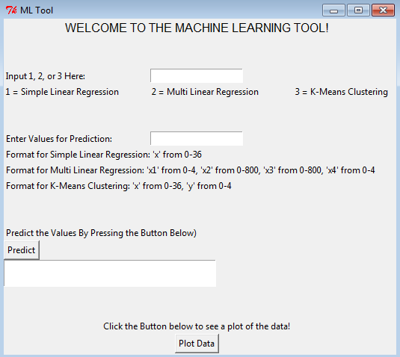

It works in 3 steps:

1 - Enter an input between 1-3. Below the text box are the 3 possible inputs for the algorithms you wish to run.

2 - Enter values for the prediction in the specific format stated below.

3 - Press the Predict Button to get a prediction based on your first input entered values.

4 – Plot the data. You can choose to do this instead of prediction after you enter an Input in the first text field. (Note: you must close the plot window in between plots)

Now here is an example:

Say you want to use Simple Linear Regression, and you want to predict what the value of y would be based on a score of 30.

First you need to enter 1 in the input field:

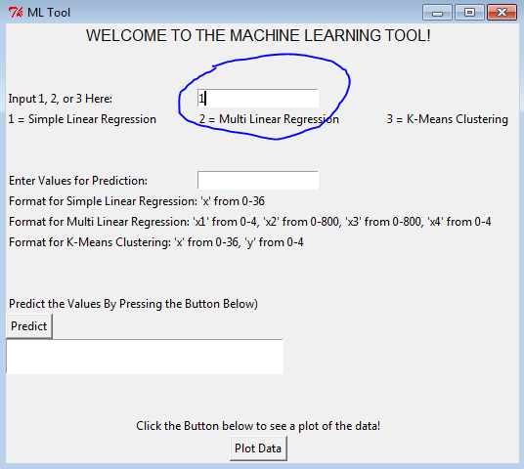

Next enter 30 in the values field:

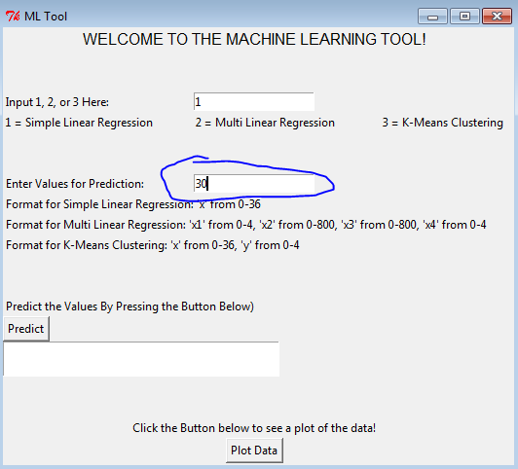

Next press “Predict.” You should get this output here:

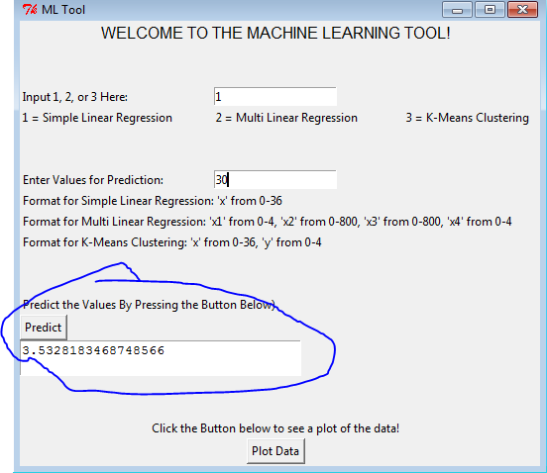

Lastly if you want to plot the data and see what it looks like, press “Plot Data”:

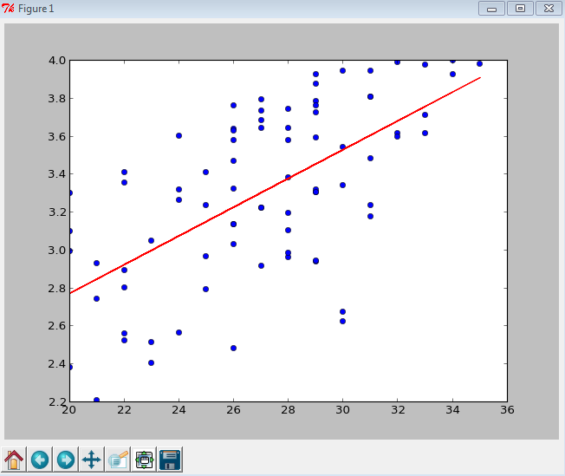
Also, as a side note, if you wish to use Multivariate Linear Regression, your input should look something like this:

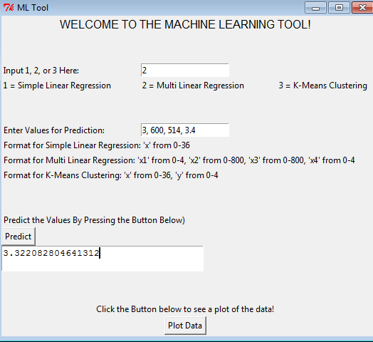

Future Work:

The code is functional and operating, however there are a few things that I believe might make the tool better.

1 - Implementation of a Browse function that allows the user to select what file they would like to run. I came close to this solution, however the way the clustering code is set up, when you call it more than once the data structures that store the data experience issues.

2 – Graphical tweaking to make the Tool look even cleaner. I wanted to implement a drop down box that you could select the algorithm you chose, but couldn't find a way to do that in Python.

3 – Along with the implementation of a Browsing function, I would like the code to be able to read in the data file and know automatically how big to size the arrays, specifically with the multivariate regression algorithm. The other two algorithms I have only take in 2 columns anyways, so this was not an issue for those algorithms, but it would be nice if the data could do it automatically for the multivariate to make the code more dynamic.

4- Add more algorithms. I only had a set amount of resources and time to create the project, and with more time I believe I could add more Machine Learning algorithms to the code to make a more practical and robust tool.

Other than that I believe it is a pretty solid tool only limited by its algorithm scope. It is useful for quick simple, multivariate regression and k-means clustering. With a little more work added it could be a really awesome tool!

