**CU Ionospheric Scintillation Simulator Technical Manual**

**Version 1.0**

Prepared by Dongyang Xu

([dongyang.xu@colorado.edu](mailto:dongyang.xu@colorado.edu))

University of Colorado Boulder

November 12, 2018



# Purpose of this document

This document provides:

1. The instructions to configure and execute this MATLAB-based ionospheric scintillation simulator.
2. The descriptions of the scintillation simulation methodology.
3. Simulation examples.

# Table of Contents

1. Purpose of this document 1

2. Table of Contents 2

3. Introduction 4

4. Scintillation Simulation Methodology 5

5. Simulator Program Configuration & Execution 8

6. Simulation Examples 9

7. References 15

8. List of Figures 16

9. Appendix 16

# Introduction

Ionospheric scintillation refers to the random fluctuation on the amplitude and/or phase of radio wave signals when traversing ionospheric plasma irregularity structure. It impacts a variety of space-based applications, including Global Navigation Satellite Systems (GNSS). Ionospheric scintillation most frequently occurs and has the strongest effects in the equatorial and low-latitude regions. Strong equatorial scintillation is characterized with simultaneous deep amplitude fading and rapid phase fluctuations. The combined effects greatly challenge signal tracking process in terms of increased tracking error, cycle slips, and even loss of lock, leading to degradation in the accuracy and integrity of GNSS navigation solutions. For aviation platforms with relatively high speeds, the signal condition becomes even more challenging as the temporal characteristics of received scintillation signals can drastically vary due to changes of flight direction [1][2]. It is therefore important to develop and evaluate robust tracking algorithms that can mitigate such adverse effects, especially for applications involving aircraft transportation such safety-of-life applications.

The scintillation simulator developed by University of Colorado Boulder (CU Boulder), Satellite Navigation and Sensing (SeNSe) Lab is aimed at providing the engineering and application community a research and algorithm development tool to address the aforementioned issues. This software scintillation simulator generates ionospheric scintillation effects for GPS signals across multiple frequency bands received on a platform with user-specified dynamics. The ionospheric scintillation effects are output as scintillation phase and amplitude time series and are effective in capturing the statistical features of real, strong equatorial scintillation as have been validated in [3]. The scintillation time series can be ingested into a generic GNSS signal simulator to yield GNSS scintillation signals for developing and testing receiver processing algorithms.

This document is hereafter organized as follows: section 4 briefly describes the scintillation simulator’s methodology; section 6 provides a guide on how to configure the input parameters and run the simulator program; section 7 presents simulation examples to help users gain more understanding regarding the simulation of scintillation effects on a dynamic platform; finally, a brief summary of the scintillation model which this simulator is based on is provided in the Appendix.

# Scintillation Simulation Methodology

This simulator is based on the physics of radio wave propagation through ionospheric plasma structure. The Two-component Power-law Phase Screen Model (TPPSM) presented in [3][4] is used to statistically imitate the ionospheric structure and drive the signal wave propagation. This model captures three important properties of realistic strong equatorial scintillation: 1) correlation between amplitude scintillation and phase scintillation; 2) coherency of scintillation levels and correlation of scintillation temporal variations across multiple frequency bands; 3) impact of platform dynamics on the characteristics of scintillation signals.

This section gives a brief description of the scintillation simulator architecture. A summary of the major mathematics for this model is given in the Appendix. Readers are also referred to [3][4] for more details.

Fig. 1 depicts the flow chart of the simulation routine. The parallelograms on the left side depict the user inputs and the rectangular components are the different steps of simulation.



Fig. 1. Flow chart of the CU ionospheric scintillation simulator. The parallelograms on the left side depict the parameters to be specified by users, while the rectangular components are the different steps within the scintillation simulation. The simulator outputs are the scintillation amplitude ($δ_{A}$) and phase ( $δ_{ϕ})$ time series at an update rate of 100Hz.

As can be seen in Fig. 1, the parameters to be specified by users include two categories: ground observed scintillation parameters and propagation geometric parameters. The ground observed scintillation parameters are the *S*4 index and intensity decorrelation time . The *S*4 index is the standard deviation of the normalized signal intensity, which has a value typically ranging from 0.6 to 1 for strong scintillation. The intensity decorrelation time $τ_{0}$ is defined as the time delay where the normalized autocorrelation function of the signal intensity decreases to $e^{-1}$. These two parameters describe the severity and temporal characteristics of the ground observed scintillation effects. The ionospheric structure responsible for such scintillation effects are then constructed based on the TPPSM.

In this implementation, the user-input *S*4 index and $τ_{0}$ are first converted to two major parameters of the TPPSM parameter set ( $U$ and ${ρ_{F}/v}_{eff_{static}}$) in the parameter mapping step. The *U* parameter dictates how strong the scattering of the ionospheric structure is and therefore how strong the observed scintillation is. The ${ρ_{F}/v}_{eff_{static}}$ is the time scaling factor of the ground observed scintillation and will be described shortly in the propagation geometry calculation step. The parameter mapping is established from TPPSM-based numerical computation. A large collection of equatorial scintillation data in different locations were used to validate the parameter mapping. Based on the mapped value of *U*, a realization of phase screen is then generated to represent the ionospheric plasma structure. It should be mentioned that in TPPSM there are three other parameters ($p_{1}$, $p_{2}$, and $μ_{0}$, see Appendix) required to completely specify the phase screen realization. In this simulator, they are spared from user specification and prefixed to their typical values. This is because the model parameter characterization based on the same collection of data showed rather focused distributions for all three parameters in the sense that their realistic variations only have a minor impact on the scintillation characteristics.

On the other hand, the propagation geometric parameters include the platform position and velocity (PV), simulation date and time, and satellite PRN number. Based on the user specified PRN, date and time, the satellite orbit is calculated using the corresponding ephemeris, which is automatically downloaded from Crustal Dynamics Data Information System (CDDIS) of NASA.

In the TPPSM-based scintillation signal propagation, all the geometric and dynamic dependencies are encapsulated in the calculation of the time scaling factor ${ρ_{F}/v}_{eff}$ [1]. The various quantities involved in this calculation include the propagation angles respecting the geomagnetic field, the satellite scan velocity and receiver scan velocity at the phase screen, and the drift velocity of the ionosphere irregularities ($V_{drift}$), etc. Among these intermediary quantities, the only unknown is $V_{drift}$, while all other ones can be calculated with the user-input propagation geometric parameters (satellite orbit and receiver PV). In this simulator, in order to obtain the ${ρ_{F}/v}_{eff}$ value for the dynamic platform of user’s choice (${ρ_{F}/v}_{eff_{dyn}}$), the value of $V_{drift}$ is first solved using the ${ρ_{F}/v}_{eff_{static}}$ value from ground observed scintillation which was obtained in the parameter mapping step.

Finally, a plane wave is propagated through the phase screen realization, following the user specified geometry and dynamics embedded in ${ρ_{F}/v}_{eff_{dyn}}$. This gives simulated scintillating wave fields at the receiver., i.e., the scintillation induced phase ($δ_{ϕ}$) and amplitude ($δ_{A}$). The simulated scintillation amplitude and phase can be further modulated onto nominal GNSS baseband samples to generate GNSS scintillation signals for receiver processing.

To summarize, the simulator can be easily configured to simulate realistic scintillation effects on platforms with user-specified trajectories that are consistent with real ground observed scintillation data. On the other hand, the simulator can also be configured to generate scintillation effects of extreme scenarios for algorithm testing. For example, the scintillation parameter $S_{4}$ can be set to 1 for extremely strong scintillation. In addition, the value of ${ρ_{F}/v}_{eff_{dyn}}$ is directly related to the decorrelation time of the simulated scintillation effects, which depicts how fast the scintillation signal evolves. In Section 6, examples will be given to demonstrate how users can manipulate platform dynamics to yield ${ρ_{F}/v}_{eff_{dyn}}$ values that result in scintillation effects with variations of extreme cases.

# Simulator Program Configuration & Execution

The program folder contains the .m file of function Main and the folder named ‘Libraries’ which contains the supporting functions for function Main.

The user-input parameters to be specified are all included in Main.m:

1. Simulation start date and time in UTC;
2. Simulation length in seconds;
3. Satellite PRN number;
4. *S*4 index and $τ_{0}$;
5. Platform position in latitude-longitude-height (LLH) coordinate and velocity vector in east-north-up (ENU) coordinate; (To generate stationary scintillation data, simply assign the velocity vector to all zeros.)
6. Number of frequencies to be simulated: 1 – GPS L1 only || 2 – L1 and L2 || 3 – L1, L2, and L5;
7. Figure plotting switch; (If on, figures to be plotted include satellite sky plot, ionosphere piercing point (IPP) LLH 3-D plot, simulated scintillation intensity and phase)

The variables for each input parameter are named in function Main in a self-explanatory manner and stored in the struct ‘userInput’. Comments are also provided above the value assignment of each variable to explain each variable and the correct input format. After specifying each parameter, run the Main function, and the scintillation amplitude and phase time series of specified length with an update rate of 100Hz will be recorded in the variables ‘Scin_amp’ and ‘Scin_phi’.

*For Windows or Mac users, if the program reports an error during the function ExtractRINEXeph.m which downloads the RINEX ephemeris file and extracts ephemeris parameters for satellite orbit computation, simply go to the simulator program folder and unzip the downloaded brdc****.**n ephemeris file by hand and then rerun the program.*

# Simulation Examples

This section presents simulation examples to display the simulator’s output figures (by setting the parameter #7 as 1). Three scenarios of different user platform trajectories are simulated to demonstrate how users can manipulate the platform dynamics to generate extreme scenarios of scintillation effects for algorithm testing. Their common configuration parameters are listed as follow.

1. Simulation start date and time in UTC: 2013/10/05 12:25:00;
2. Simulation length: 600s;
3. Satellite PRN number: 24;
4. *S*4 index and $τ_{0}$: 0.8 and 0.7s.
5. Platform position: Hong Kong (Lat 22.2 ° N, Lon 114.3° E, Height 60m);

The receiver trajectories are defined by different constant speeds as listed in Table 1. The first scenario is stationary, which is meant as a baseline. The latter two scenarios have the same speed of 150m/s (typical for an aircraft) at different directions. The two directions are selected to yield the maximum (scenario 2) and minimum (scenario 3) values of ${ρ_{F}/v}_{eff_{dyn}}$, which will be explained shortly.

Table 1 Velocity vectors for the three platform dynamic scenarios. The magnitude of the velocities for scenario 2 and 3 is 150 m/s

|  |  |  |  |
| --- | --- | --- | --- |
| **scenario #** | **Eastward velocity (m/s)** | **Northward velocity (m/s)** | **Upward velocity (m/s)** |
| **1** | 0 | 0 | 0 |
| **2** | 110 | -102 | 0 |
| **3** | -150 | 0 | 0 |

By specifying these parameters and running the program, three types of figure will be generated: 1) sky plot of the simulated satellite; 2) ionosphere piercing point (IPP) trajectory; 3) simulated scintillation intensity ($I=20*log10(δ_{A})$) and phase ($δ_{ϕ}$). Fig. 2 shows the sky plot of the simulated PRN under these three different scenarios.



Fig. 2. Sky plot of the simulated PRN under three different scenarios.

As can be seen in Fig. 2, the satellite is located at the southeast part of the sky w.r.t. the origin of the receiver trajectory. By comparing with the stationary scenario 1, we can see clearly that the receiver eastward and southward velocity components in scenario 2 contributed to the satellite trajectory on westward and northward direction, respectively, whereas for scenario 3 the satellite trajectory is moving further eastward as the receiver is going straight westward.

Fig. 3 shows the 2-D IPP trajectories (in black, origin depicted with a circle) and the corresponding IPP scan velocities ($V_{scan}$, depicted in red arrows) under the three scenarios to illustrate how much the user trajectories with a typical aircraft speed affect the scintillation signal propagation. The red arrows for each scenario are drawn proportionally according to the magnitude of the corresponding $V_{scan}$.

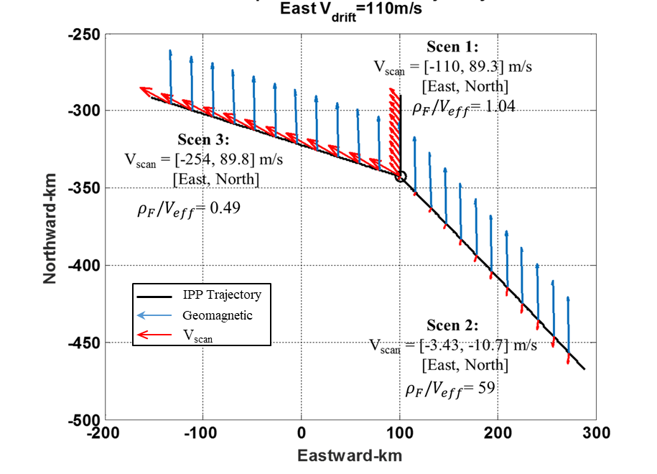

Fig. 3. 2-D IPP trajectories (in black, origin depicted with a circle) and the corresponding IPP scan velocities ($V_{scan}$, depicted in red arrows) under the three scenarios. The blue arrows illustrate the geomagnetic field line, which is almost North-South direction.

The trajectories are placed in a geodetic East and North coordinate frame w.r.t. the receiver origin. The blue arrows illustrate the geomagnetic field line, which is almost North-South aligned. The IPP scan velocity $V_{scan}$ signifies how fast the IPP scans through the irregularities, which is jointly determined by the IPP’s own moving velocity $V_{IPP}$ (contributed from satellite velocity and platform velocity projected at IPP) and $V_{drift}$. The ionospheric irregularities are known to be highly elongated along the geomagnetic field lines. Therefore, $V_{scan}$’s component on the cross geomagnetic field line direction (mainly the east-west component) is the dominant factor in the calculation of ${ρ_{F}/v}_{eff_{dyn}}$.

In reality, the irregularities in the equatorial region have a dominantly eastward drift velocity, which is typically between 50 and 150 m/s during the post sunset period when scintillation is most frequent and intense [5]. In this simulator, the $V_{drift}$ is derived from ${ ρ_{F}/v}_{eff_{static}}$ as mentioned earlier, which is 110m/s as listed in Fig. 3 for this example.

In scenario 1, $V_{IPP}$ is entirely introduced by the satellite motion, which is dominantly northward as suggested by the IPP trajectory. This northward $V_{IPP}$ in turn contributes to the northward component of $V_{scan}$ (89.3m/s), whereas $V_{drift}$ mainly contributes to the eastward component of $V_{scan}$ (-110m/s). scenario 2 is staged based on this finding with the receiver moving at a trajectory whose eastward velocity component is the same as $V_{drift}$. The resulting $V_{scan}$ is therefore very small on the East-West direction (-3.43m/s), which should in turn cause a very slow-varying scintillation on the receiver end. On the other hand, scenario 3 aims the receiver velocity fully at westward direction and therefore introduces a large increase on $V_{scan}$ in the east-west direction (-254m/s) as compared with scenario 1, which should result in a faster-varying scintillation. The values of ${ρ_{F}/v}_{eff_{dyn}}$ for the three scenarios listed in Fig. 3 clearly confirmed an inverse dependence on the east-west component of $V_{scan}$.

Fig. 4 shows 2.5-min segments of the simulated multi-frequency scintillation intensity (I-dB) and phase ($δ_{ϕ}$-rad) under the three scenarios. The *S*4 index and $τ_{0}$ values of these simulated signals are estimated and listed in their corresponding legends.

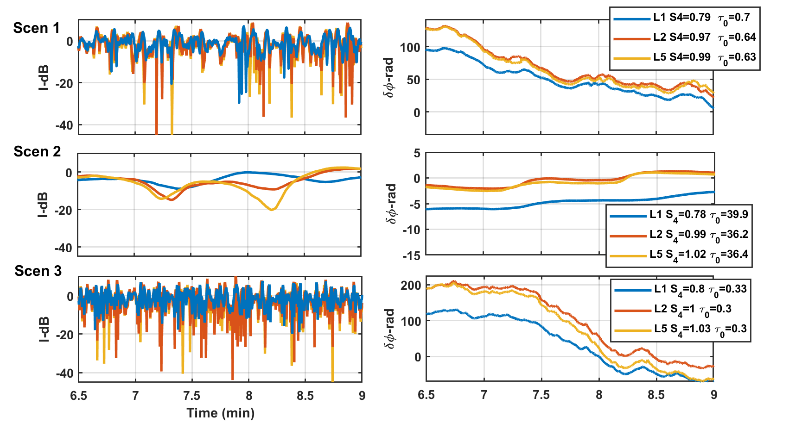

Fig. 4. Simulated scintillation effects under different scenarios.

As can be seen in Fig. 4, both the intensity and phase results exhibited significant differences in their temporal variations among three scenarios, whereas the *S*4 values do not vary much among scenarios.

For scenario 1, the L1 signal showed *S*4 index and $τ_{0}$ values consistent to the user specification, which validated the simulator’s effectiveness. The multi-frequency scintillation effects maintain coherency in scintillation levels (as suggested by the *S*4 indices of different frequencies), and the L2 and L5 clearly showed close correlation in fading and scintillation phase due to their closeness in carrier frequencies.

For scenario 2, the $τ_{0}$ values are over 50 times the values in scenario 1 for all frequencies, suggesting a much slower variation in scintillation effects. The fading is indeed much less frequent, shallower, yet longer compared to those in scenario 1. An extreme fading is the one that occurred around 8min on L5 and lasted over 20 seconds below -10dB. Similarly, $δ_{ϕ}$ in scenario 2 manifested a smoother variation within a much smaller range than those in scenario 1. Based on the above observations, scenario 2 obviously requires the tracking algorithm to prioritize more on its noise performance over dynamic performance.

As for scenario 3, the scintillation variations are the fastest as suggested by the frequent deep fading and violent phase fluctuations. The $τ_{0}$ values are a half of those in scenario 1. In this scenario, the tracking loop is greatly challenged by the simultaneous deep fading and rapid and large phase variations and demands an advanced loop design as investigated in our previous paper [2].

# References

1. Y. Jiao, C. L. Rino, and Y. T. Morton, “Ionospheric Scintillation Simulation on Equatorial GPS Signals for Dynamic Platforms,” *Navigation*, 65(2), 2018, pp. 263-274.
2. D. Xu, Y.T. Morton, Y. Jiao, and C. Rino, “Robust GPS Carrier Tracking Algorithms During Strong Equatorial Scintillation for Dynamic Platforms,” *Proc*. ION GNSS+, Portland, Oregon, September 2017, pp. 4112-4121.
3. C. L. Rino, B., Brian, Y. Jiao, D. Xu, Y. Morton, and C. Carrano, "A New GNSS Scintillation Model," *Proc. ION GNSS+*, Portland, Oregon, September 2017, pp. 3879-3887.
4. C. L. Rino, B. Breitsch, Y. Morton, Y. Jiao, D. Xu, and C. Carrano, “A Compact Multi-Frequency GNSS Scintillation Model”, accepted for publication on Navigation, 2018.
5. S. Basu, K. M. Groves, S. Basu, and P. Sultana, “Specification and Forcasting of Scintillations in Communication and Navigation Links: Current Status and Future Plans,” *Journal of Atmospheric Solar-Terrestrial Physics*, 64(16), 2002, pp. 1745–1754.
6. C. L. Rino, “The theory of scintillation with applications in remote sensing”, Hoboken, New Jersey: John Wiley & Sons, Inc., 2011.

# List of Figures

Fig. 1. Flow chart of the CU ionospheric scintillation simulator. The parallelograms on the left side depict the parameters to be specified by users, while the rectangular components are the different steps within the scintillation simulation. The simulator outputs are the scintillation amplitude ($δA$) and phase ( $δϕ)$ time series at an update rate of 100Hz.

Fig. 2. Sky plot of the simulated PRN under three different scenarios.

Fig. 3. 2-D IPP trajectories (in black, origin depicted with a circle) and the corresponding IPP scan velocities (Vscan, depicted in red arrows) under the three scenarios. The blue arrows illustrate the geomagnetic field line, which is almost north-south direction.

Fig. 4. Simulated scintillation effects under different scenarios.

# Appendix

The propagation theory behind the scintillation flow chart depicted in Fig. 1 was mainly developed in [6], and lately updated in [3][4]. This section summarizes the fundamental mathematics for the phase screen realization step and wave the propagation step in this simulator. Readers are referred to [4] and [6] for more details.

In the equatorial region, ionospheric irregularities are typically highly elongated along the geomagnetic field lines extending in the north-south direction. Consider the medium invariant along this direction, the phase screen structure can be simplified to be two-dimensional, namely, only variant in the east-west direction at a given height. Based on this approximation, the complex field $ψ$ at a distance $x$ from the phase screen is generated by the following forward and inverse discrete Fourier transforms (DFTs) [4]:

|  |  |
| --- | --- |
| $$\hat{ψ}\left(0;n∆q\right)=\sum_{m=0}^{N-1}{exp⁡\{iϕ\left(m∆y\right)\}}\exp{\{-2πinm/N\}}$$ | (1) |
| $$ψ\left(x;m∆y\right)=\frac{1}{N}\sum_{n=0}^{N-1}{\hat{ψ}\left(0;n∆q\right)exp⁡\{-ik{\left({n∆q}/k\right)}^{2}x/2\}exp⁡\{2πinm/N\}}$$ | (2) |

where $x$ is the propagation direction, *y* is the geomagnetic eastward direction, $ϕ(y)$ is the path-integrated phase structure, $k$ is the magnitude of the wavenumber, $q$ is the wavenumber on the $y$ direction with $∆q$ being its resolution, and $N$ is the size of the DFTs.

The path-integrated phase structure is characterized by a one-dimensional, two-component power-law SDF as follows:

|  |  |
| --- | --- |
| $$Φ_{ϕ}\left(q\right)=C_{p}\left\{\begin{aligned}q^{-p_{1}}, q≤q_{0} \\ q_{0}^{p_{2}-p_{1}}q^{-p_{2}}, q>q_{0}\end{aligned}\right.$$ | (3) |

where $C_{p}$ is the turbulence strength, $p_{1}$ and $p_{2}$ are the spectral indices, and $q_{0}$ is the break wavenumber.

Simplification is achieved by scaling the wavenumber $q$ with the Fresnel scale $ρ_{F}$ ($ρ_{F}=\sqrt{x/k }$) to a normalized unit such that $μ=qρ_{F}$. After such normalization, the SDF of the phase screen can be re-written as

|  |  |
| --- | --- |
| $$P\left(μ\right)=Φ_{ϕ}\left(q\right)/ρ_{F}=\left\{\begin{aligned}{U_{1}μ}^{{-p}_{1}}, {μ≤μ}_{0} \\ U_{2}μ^{-p_{2}}, μ>μ_{0}\end{aligned}\right.$$ | (4) |

where ${U_{1}=C}_{p}ρ_{F}^{p_{1}-1}$, $U_{2}=C_{p}q_{0}^{p_{2}-p_{1}}ρ_{F}^{p_{2}-1}$. Thus, the universal scattering strength $U$ can be defined as:

|  |  |
| --- | --- |
| $$U=\left\{\begin{aligned}U_{1}, μ_{0}≥1 \\ U_{2}, μ_{0}<1\end{aligned}\right.$$ | (5) |

$U$ is essentially the normalized phase spectral power at the Fresnel scale as $U≡P( μ=1)$.

A statistically equivalent phase screen realization can then be generated by imposing the above desired SDF on white noise:

|  |  |
| --- | --- |
| $${\overline{ϕ}}_{m}=\sum_{n=0}^{N-1}{\sqrt{P(n∆μ)∆μ/(2π)}}{}_{n}exp⁡\{-2πinm/N\}$$ | (6) |

where ${}_{n}$ is a zero-mean random process with the Hermitian property and the white-noise property.

Applying the phase screen realization and substituting $x$ with the Fresnel scale, the propagation equations (1) and (2) from the phase screen to the observation plane can be implemented in the simulation as:

|  |  |
| --- | --- |
| $$\hat{ψ}\left(0;n∆μ\right)=\sum_{m=0}^{N-1}{exp⁡\{i{\overline{ϕ}}_{m}\}}\exp{\{-2πinm/N\}}$$ | (7) |
| $$ψ\left(ρ_{F};m∆y/ρ_{F}\right)=\frac{1}{N}\sum_{n=0}^{N-1}{\hat{ψ}\left(0;n∆μ\right)exp⁡\{-i{\left(n∆μ\right)}^{2}/2\}exp⁡\{2πinm/N\}}$$ | (8) |

In addition, to convert the complex field in the space domain to the time domain, an effective scan velocity $v_{eff}$ is used, such that $y=v_{eff}t$. The calculation of $v_{eff}$ involves knowledge of the ionosphere anisotropy, propagation geometry including different angles formed between the line of sight signal and the geomagnetic field, and velocities including the effective scan velocities of satellite and receiver at the phase screen and the drift velocity of the ionosphere irregularities. For detailed $v_{eff}$ calculation procedure, readers are referred to [6].

The conversion from Doppler frequency to normalized wavenumber is

|  |  |
| --- | --- |
| $$μ=2πf_{D}(ρ_{F}/v_{eff})$$ | (9) |

where $f_{D}$ is the Doppler frequency. A sampled phase screen constructed with $P\left(μ_{n}\right)2π∆f_{D}/∆μ= P\left(μ_{n}\right)ρ_{F}/v_{eff}$ where $∆f_{D}=1/(N∆t)$ will generate a statistically equivalent realization in the time domain of the scintillation defined by the phase screen structure.

The model parameters (the structure parameters $U$, $p_{1},p_{2}, μ_{0}$ and the time scale factor $ρ_{F}/v_{eff}$) responsible for scintillation observed on one frequency can be scaled to those for another frequency using the following equations:

|  |  |
| --- | --- |
| $$μ_{0}(f;f_{r})=μ_{0}(f_{r})\sqrt{f_{r}/f}$$ | (10) |
| $$ρ_{F}/v_{eff}(f;f_{r})=ρ_{F}/v_{eff}(f_{r})\sqrt{f_{r}/f}$$ | (11) |
| $$U(f;f_{r})=\left\{\begin{aligned}U\left(f_{r}\right){\left(\frac{f_{r}}{f}\right)}^{\frac{1}{2}p_{1}+\frac{3}{2} }, if μ_{0}(f_{r})≥1,μ_{0}(f)≥1 \\ U\left(f_{r}\right)\frac{1}{μ_{0}{\left(f_{r}\right)}^{p_{2}-p_{1}}}{\left(\frac{f_{r}}{f}\right)}^{\frac{1}{2}p_{1}+\frac{3}{2} }, { if μ}_{0}(f_{r})<1,μ_{0}(f)≥1 \\ U\left(f_{r}\right)μ_{0}{\left(f\right)}^{p_{2}-p_{1}}{\left(\frac{f_{r}}{f}\right)}^{\frac{1}{2}p_{1}+\frac{3}{2} } , { if μ}_{0}(f_{r})≥1,μ_{0}(f)≥1 \\ U\left(f_{r}\right)\frac{μ_{0}{\left(f\right)}^{p_{2}-p_{1}}}{μ_{0}{\left(f_{r}\right)}^{p_{2}-p_{1}}}{\left(\frac{f_{r}}{f}\right)}^{\frac{1}{2}p_{1}+\frac{3}{2} }, {if μ}_{0}(f_{r})<1,μ_{0}(f)<1\end{aligned}\right.$$ | (12) |

where $f_{r}$ is the reference frequency. $p_{1}$ and $p_{2}$ remain the same for different frequencies.

Using model parameters of different frequencies that satisfy equation (10) through (12) and the same white noise realization ${}_{n}$ in (6), multi-frequency scintillation that are caused by the same ionospheric structure can be generated by the simulator to evaluate multi-frequency receiver algorithms and study multi-frequency scintillation characteristics.