ASSIGNMENT – 02
Question 1. Explain the concept of Machine Learning as a computational approach to learning from data. Discuss the relationship among data, features, learning algorithms, hypotheses/models, and predictions.
Answer 1. Machine Learning (ML) is a computational approach in which a computer system learns patterns from available data and uses those patterns to make predictions or decisions. Instead of programming every rule manually, we provide examples to the system and allow an algorithm to learn from them.
For example, if we want to predict whether a student will pass an examination, we can provide previous students' attendance, internal marks, study hours, and final results. The ML algorithm can learn patterns from this information and use them to predict the result of a new student.
Important components of Machine Learning
1. Data:
Data is the basic material required for Machine Learning. It can contain numbers, text, images, audio, transactions, sensor readings, etc.
2. Features:
Features are the individual characteristics or input variables used by the model.
For example, for predicting house prices:
- Area
- Number of rooms
- Location
- Age of the house
are possible features.
3. Learning Algorithm:
The learning algorithm is the method used to find patterns or relationships in the data. Examples include Decision Tree, Linear Regression, K-Means, and Neural Networks.
4. Hypothesis/Model:
During learning, the algorithm searches for a suitable relationship between the input features and the desired output. The resulting learned representation is called a model. In learning theory, a candidate relationship can also be described as a hypothesis.
5. Prediction:
Once the model has been trained, it can take new input data and generate a prediction.
The overall relationship can be represented as:
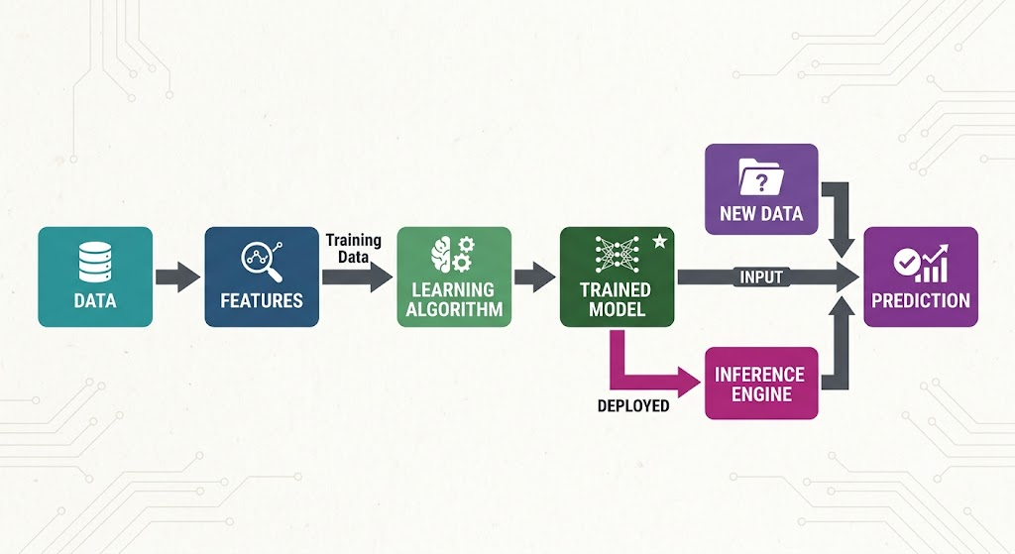
For example:
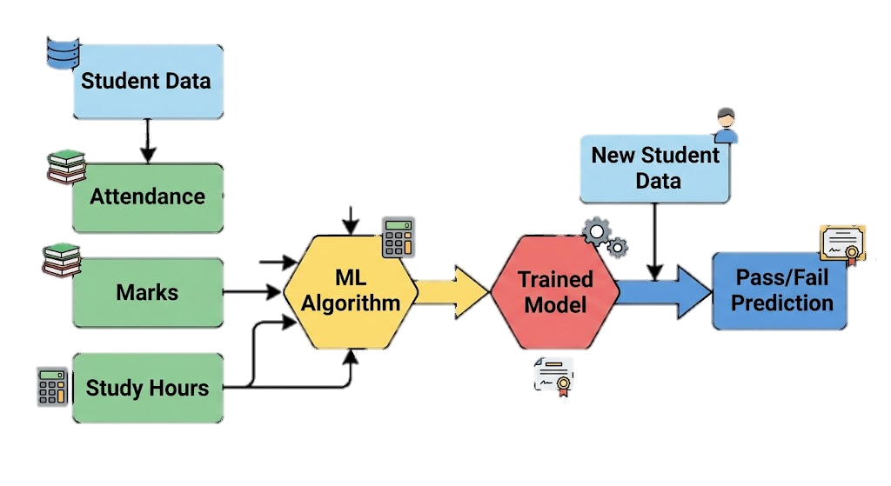
Thus, data provides the information, features represent useful parts of the data, the learning algorithm learns patterns, the model stores the learned relationship, and the model finally produces predictions for new inputs.

Question 2. Compare supervised, unsupervised, and reinforcement learning using a structured discussion of training data, feedback mechanism, objective function, typical tasks, and representative algorithms.
Answer 2. Machine Learning can be broadly divided into Supervised Learning, Unsupervised Learning, and Reinforcement Learning.
1. Supervised Learning
In supervised learning, the model is trained using labelled data, where the input and expected output are already known.
Example: Predicting whether an email is spam or not spam.
- Training data: Labelled data
- Feedback: Correct output/label
- Objective: Learn a relationship between input and output
- Typical tasks: Classification and regression
- Algorithms: Decision Tree, Linear Regression, Logistic Regression, Random Forest, SVM
2. Unsupervised Learning
In unsupervised learning, the data does not have predefined output labels. The algorithm tries to discover useful patterns or groups in the data.
Example: Grouping customers according to their purchasing behaviour.
- Training data: Unlabelled data
- Feedback: No predefined correct answer
- Objective: Discover hidden patterns or structure
- Typical tasks: Clustering and dimensionality reduction
- Algorithms: K-Means, DBSCAN, Hierarchical Clustering, PCA
3. Reinforcement Learning
In reinforcement learning, an agent interacts with an environment and learns through rewards and penalties.
Example: A robot learning how to reach a destination without hitting obstacles.
- Training data: Experience generated through interaction
- Feedback: Rewards and penalties
- Objective: Maximize long-term reward
- Typical tasks: Sequential decision-making and control
- Algorithms: Q-Learning, SARSA, Deep Q-Networks (DQN)
Comparison
Feature | Supervised | Unsupervised | Reinforcement
Training data | Labelled | Unlabelled | Interaction/experience
Feedback | Correct labels | No direct labels | Reward/penalty
Objective | Predict output | Find patterns | Maximize reward
Typical tasks | Classification, Regression | Clustering, Dimensionality reduction | Decision-making, Control
Example | Spam detection | Customer grouping | Robot navigation
Algorithms | Decision Tree, SVM | K-Means, DBSCAN | Q-Learning, DQN

Question 3. Select any three application domains of Machine Learning and analyze how ML can improve decision-making in each domain. Also discuss at least one limitation or risk associated with each application.
Answer 3.Machine Learning is used in many areas to support decision-making. Three important application domains are healthcare, finance, and transportation.
A. Healthcare
Machine Learning can analyse patient records, medical images, test results, and other healthcare data.
For example, an ML model can help identify patients who may have a higher risk of a particular disease. It can also assist in medical image analysis and patient monitoring.
How it improves decision-making
- Helps analyse large amounts of patient data.
- Can identify patterns that may be difficult to detect manually.
- Can support early risk identification.
- Can help healthcare professionals make more informed decisions.
Limitation/Risk
Healthcare data is sensitive, so privacy and security are major concerns. Also, an incorrect prediction can have serious consequences. ML predictions should therefore be used carefully and with appropriate professional oversight.
B. Finance
Financial institutions use Machine Learning for fraud detection, credit risk assessment, transaction analysis, and identifying unusual financial behaviour.
For example, an ML system can analyse a transaction and identify whether it has characteristics associated with potentially fraudulent activity.
How it improves decision-making
- Processes a large number of transactions quickly.
- Detects unusual patterns.
- Helps identify potentially risky transactions.
- Can support financial risk assessment.
Limitation/Risk
If historical financial data contains bias, the model may learn and reproduce that bias. Incorrect predictions can also result in legitimate transactions being flagged or genuine fraud being missed.
C. Transportation
Machine Learning can be used for traffic prediction, route planning, demand forecasting, vehicle maintenance, and driver-assistance systems.
For example, a navigation system can use historical and current traffic information to estimate travel times.
How it improves decision-making
- Helps estimate traffic conditions.
- Supports route selection.
- Can predict vehicle maintenance requirements.
- Helps transportation companies forecast demand.
Limitation/Risk
Transportation systems depend on real-world conditions that can change suddenly. Incorrect predictions or system failures can affect safety. Models therefore need continuous testing and monitoring.

Question 4. Design a conceptual Machine Learning system for detecting fraudulent online transactions. Describe the problem definition, data requirements, feature selection, model training, validation strategy, evaluation metrics, deployment, and monitoring stages.
Answer 4. Fraud detection is a suitable Machine Learning application because online platforms generate a large number of transactions and fraudulent behaviour can have different patterns.
1. Problem Definition
The objective is to determine whether an online transaction is:
Legitimate or Fraudulent
Therefore, this can be formulated as a binary classification problem.
2. Data Requirements
The system may use historical transaction information such as:
- Transaction amount
- Date and time
- Transaction location
- Payment method
- Device information
- Number of transactions in a particular period
- Previous transaction behaviour
- Whether the transaction was previously identified as fraudulent
Sensitive information should only be collected and used when there is a valid purpose and appropriate authorization.
3. Feature Selection
Relevant features should be selected based on their usefulness for identifying unusual transactions.
For example:
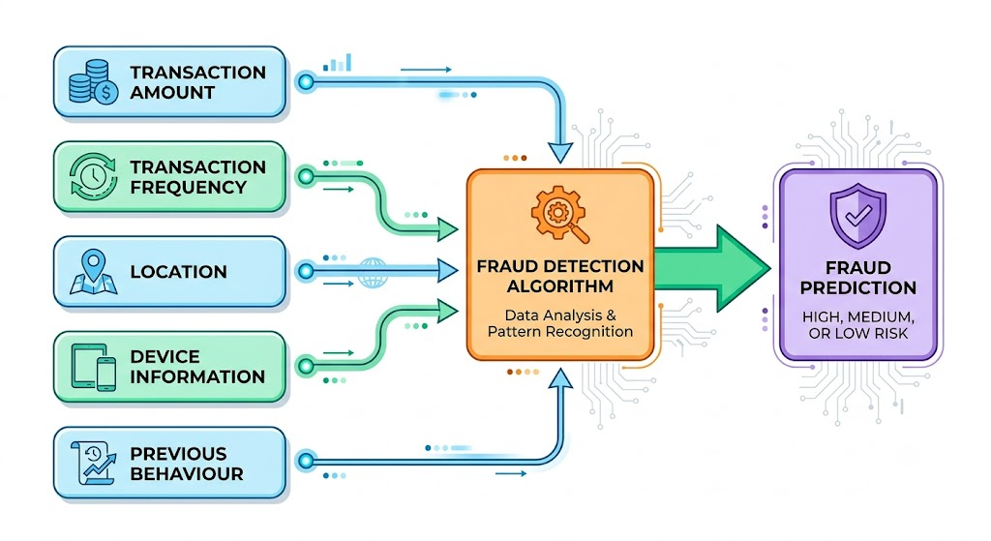
Irrelevant or highly problematic features should be removed.
4. Model Training
The historical labelled dataset can be divided into training and testing/validation portions.
Possible algorithms include:
- Logistic Regression
- Decision Tree
- Random Forest
- Gradient Boosting
- Neural Networks
The model learns patterns associated with legitimate and fraudulent transactions.
5. Validation Strategy
The dataset should be divided carefully so that information from the future does not accidentally enter the training data.
A possible approach is:
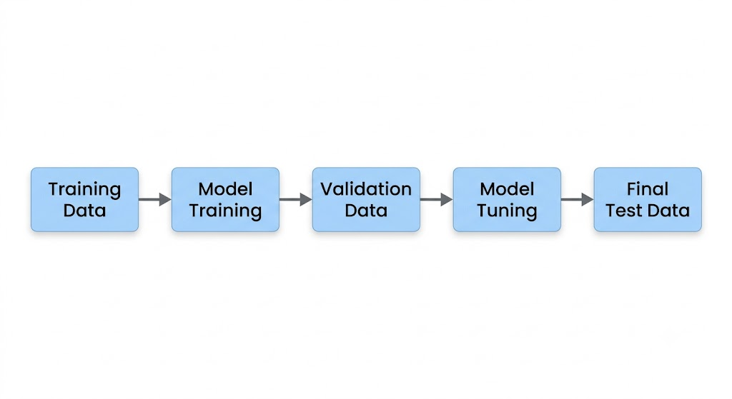
For transaction data, a time-based split can be useful because it more closely represents how the model will encounter future transactions.
6. Evaluation Metrics
Accuracy alone may not be sufficient because fraudulent transactions are usually much fewer than legitimate transactions.
Important metrics include:
- Precision
- Recall
- F1-score
- ROC-AUC
- PR-AUC
- Confusion Matrix
Recall is useful for understanding how many fraudulent transactions were detected, while precision indicates how many transactions flagged as fraud were actually fraudulent.
7. Deployment
After satisfactory evaluation, the model can be integrated into the online payment system.
A simplified process is:
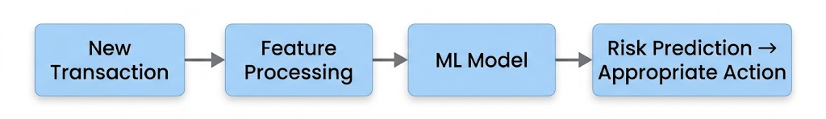
Depending on the system design, a high-risk transaction could be sent for additional verification rather than automatically rejecting it.
8. Monitoring
After deployment, the model should be continuously monitored for:
- Changes in fraud patterns
- Changes in transaction behaviour
- Decrease in model performance
- False positives and false negatives
- Data drift
- System latency
The model can be retrained when sufficient new and reliable data becomes available.

Question 5. Discuss the evolution of Machine Learning and identify the major factors responsible for the recent growth of AI and ML, such as large datasets, improved algorithms, specialized hardware, cloud computing, and increased computational capacity.
Answer 5. Machine Learning has developed gradually over several decades.
Early Development
In the 1940s and 1950s, researchers began exploring mathematical models of artificial neurons and the possibility of machines learning from experience.
In 1959, Arthur Samuel used the term Machine Learning while working on a checkers-playing program that could improve through experience.
Development of Learning Algorithms
During the following decades, researchers developed methods such as perceptrons, decision trees, statistical learning techniques, and neural networks.
However, limited computing power and limited data restricted the practical use of many complex models.
Growth During the 1990s and 2000s
During the 1990s, statistical Machine Learning became increasingly important. Algorithms such as Support Vector Machines and improved decision-tree methods became widely studied.
The growth of the internet then resulted in a rapid increase in the amount of digital data available.
Deep Learning Growth
During the 2010s, deep learning became highly successful in areas such as image recognition, speech processing, and natural language processing.
The success of systems such as AlexNet in 2012 demonstrated the effectiveness of deep neural networks when combined with large datasets and powerful hardware.
Major Factors Behind Recent Growth
1. Large Datasets:
Websites, smartphones, sensors, social platforms, and business applications generate huge amounts of data.
2. Improved Algorithms:
Better neural network architectures, optimization methods, regularization techniques, and training methods have improved model performance.
3. Specialized Hardware:
GPUs and other specialized processors can perform the large number of calculations required by modern ML models efficiently.
4. Cloud Computing:
Cloud platforms provide access to storage and computing resources without requiring every organization to purchase its own high-end hardware.
5. Increased Computational Capacity:
Modern processors, distributed computing, and improved storage allow researchers to train models using much larger datasets and more complex architectures.
Therefore, the recent growth of AI and ML is the result of several factors working together rather than a single technological development.

Question 6. Explain the common causes of failure in Machine Learning projects. Discuss how data quality, feature representation, inappropriate model selection, overfitting, bias, changing data distributions, and inadequate evaluation can affect system performance.
Answer 6. Machine Learning projects can fail even when the selected algorithm is technically correct. Several factors can reduce the performance and usefulness of an ML system.
1. Poor Data Quality
Incorrect, incomplete, duplicated, or outdated data can result in a model learning incorrect patterns.
Example: If customer ages are incorrectly recorded, the model may learn relationships that do not actually exist.
2. Poor Feature Representation
Features should represent useful information about the problem. If important information is missing or features are poorly designed, even a powerful algorithm may perform poorly.
3. Inappropriate Model Selection
Different problems require different types of models.
For example, using a clustering algorithm for a problem where labelled classification is required may not produce the desired result.
4. Overfitting
An overfitted model learns the training data too closely and performs poorly on unseen data.
Training performance: Very high
Real-world performance: Poor
5. Bias
Bias can enter through the data collection process, feature selection, labels, or assumptions used during model development.
A model trained on biased historical data may reproduce those patterns.
6. Changing Data Distributions
Real-world data changes over time.
For example, customer purchasing behaviour may change because of new trends, economic conditions, or changes in technology.
A model trained on old data may therefore become less accurate.
7. Inadequate Evaluation
Using only one metric or testing the model on unsuitable data can give a misleading impression of performance.
For example, accuracy may look very high on an imbalanced dataset even when the model performs poorly for the minority class.
Conclusion
A successful ML project requires proper attention to data, features, algorithms, validation, fairness, and monitoring. Model training is only one part of the complete process.

Question 7. Data Science and Machine Learning are closely related but not identical disciplines. Compare them using a practical business problem and show which activities belong primarily to Data Science and which specifically involve Machine Learning.
Answer 7. Consider an e-commerce company that wants to reduce customer churn.
The company wants to identify customers who may stop using its platform.
Data Science Activities
A Data Science team may:
- Understand the business problem.
- Collect customer information.
- Combine data from different sources.
- Clean missing and incorrect data.
- Perform exploratory data analysis.
- Create charts and visualizations.
- Identify important factors related to customer behaviour.
- Communicate findings to business teams.
These activities are part of the broader Data Science process.
Machine Learning Activities
Machine Learning activities may include:
- Selecting relevant features.
- Dividing data into training and testing datasets.
- Selecting a suitable ML algorithm.
- Training the model.
- Tuning model parameters.
- Evaluating predictions.
- Deploying the trained model for prediction.
- Monitoring model performance.
Practical Difference
Activity | Primarily Data Science | Specifically Machine Learning
Business problem understanding | ✓
Data collection | ✓
Data cleaning | ✓
Data visualization | ✓
Statistical analysis | ✓
Feature engineering | ✓ | ✓
Model training |  | ✓
Algorithm selection |  | ✓
Model evaluation |  | ✓
Prediction |  | ✓
Business reporting | ✓
Therefore, Data Science has a broader scope, while Machine Learning focuses particularly on learning patterns from data and using trained models for predictions or decisions.

Question 8. Suppose an e-commerce company wants to recommend products to users. Determine whether supervised, unsupervised, or reinforcement learning or a combination would be appropriate. Justify your choice and describe the possible data and feedback involved.
Answer 8. An e-commerce recommendation system can use a combination of Machine Learning approaches rather than relying on only one type.
1. Supervised Learning
Supervised learning can be used when historical user interactions are available as labelled examples.
Possible data includes:
- Products viewed
- Products purchased
- Product ratings
- Search history
- Previous clicks
- User preferences
The model can learn patterns between user characteristics and products they are likely to interact with.
2. Unsupervised Learning
Unsupervised learning can be used to identify groups of similar users or products.
For example:
Customers → Clustering → Customer Groups
Similarly, products can be grouped based on their characteristics or user interaction patterns.
This can help the recommendation system find similar products or users.
3. Reinforcement Learning
Reinforcement learning can be useful when the system needs to learn how recommendations affect future user behaviour.
For example:
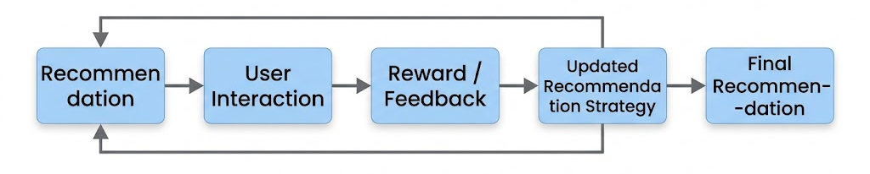
Possible feedback includes:
- User clicks the product
- User adds it to the cart
- User purchases it
- User ignores the recommendation
- User removes or skips the recommendation
Suitable Approach
A practical recommendation system may combine these approaches:
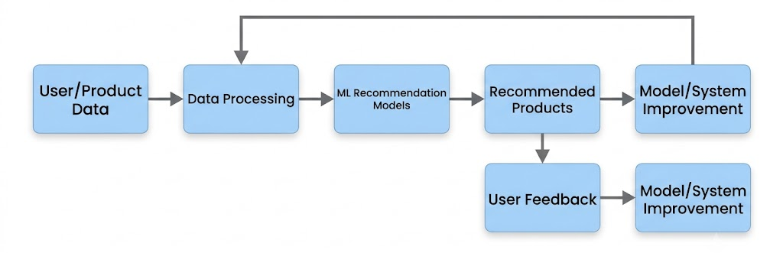
Using multiple approaches can allow the system to consider both historical behaviour and patterns in user/product data, while feedback can help improve recommendations over time.

Question 9. Explain the importance of selecting appropriate evaluation measures for Machine Learning systems. Why can accuracy be misleading for some problems? Illustrate your answer using an imbalanced classification scenario.
Answer 9. Evaluation measures are used to determine how well a Machine Learning model performs. Choosing an appropriate metric is important because different problems have different requirements.
Why Accuracy Can Be Misleading
Accuracy is calculated as:
Accuracy = Correct Predictions / Total Predictions
It works well when the classes are reasonably balanced and the cost of different errors is similar.
However, it can be misleading when the dataset is imbalanced.
Example: Fraud Detection
Suppose there are 10,000 transactions:
- 9,900 are legitimate.
- 100 are fraudulent.
Now suppose a model predicts every transaction as legitimate.
The model correctly predicts all 9,900 legitimate transactions but misses all 100 fraudulent transactions.
Its accuracy would be:
9,900 / 10,000 = 99%
At first, 99% looks excellent. However, the model has detected zero fraudulent transactions, making it practically useless for fraud detection.
Therefore, other metrics should also be considered.
Important Metrics
Precision:
Of all transactions predicted as fraud, how many were actually fraud?
Recall:
Of all actual fraudulent transactions, how many did the model detect?
F1-score:
Provides a combined measure based on precision and recall.
A confusion matrix is also useful because it shows:
- True Positives
- True Negatives
- False Positives
- False Negatives
For fraud detection, the appropriate balance between these errors depends on the practical consequences of incorrectly flagging legitimate transactions versus missing fraudulent ones.
Thus, there is no single evaluation metric that is best for every ML problem. The metric should be selected according to the objective and consequences of the application.

Question 10. Discuss the ethical, social, and technical issues that may arise when deploying Machine Learning systems. Include algorithmic bias, privacy, explainability, security, fairness, accountability, and model drift in your discussion.
Answer 10. Machine Learning systems can provide useful services, but their deployment also creates ethical, social, and technical challenges. These issues should be considered throughout the development and deployment process.
1. Algorithmic Bias
ML models learn from data. If the training data contains unwanted bias, the model may reproduce or even amplify it.
For example, a model trained on historical decisions may learn patterns that disadvantage certain groups.
Therefore, datasets and model outputs should be checked for potential bias.
2. Privacy
ML systems often require large amounts of personal data.
Examples include:
- Names
- Locations
- Financial information
- Health information
- Online behaviour
Such information should be collected, stored, and processed responsibly, with appropriate security and legal safeguards.
3. Explainability
Some complex ML models can be difficult to understand.
In sensitive applications, users may need an understandable explanation of why a particular prediction or decision was produced.
4. Security
ML systems can face security threats. Attackers may attempt to manipulate input data, exploit system weaknesses, or interfere with model behaviour.
Therefore, both the model and the surrounding application need appropriate security measures.
5. Fairness
A model should be evaluated to determine whether it produces systematically different outcomes for different groups without a justified reason.
Fairness should be considered during data collection, model development, testing, and deployment.
6. Accountability
It should be clear who is responsible for the design, deployment, and monitoring of an ML system.
If an automated system causes an incorrect outcome, there should be appropriate procedures for reviewing and correcting the decision.
7. Model Drift
The real-world environment can change after a model has been deployed.
For example, customer behaviour, fraud patterns, or market conditions may change over time. This can reduce the model's performance.
This is known as model drift or can involve data/concept drift, depending on what has changed.
Regular monitoring and, when necessary, retraining can help maintain performance.

