Assignment – 03
Question 1. Define Supervised Learning. Explain the key difference between supervised learning and unsupervised learning with one example of each.
Definition of Supervised Learning
Supervised Learning is a type of machine learning in which a model is trained using a labelled dataset. A labelled dataset contains input data along with the correct output. The model learns the relationship between inputs and outputs and uses this knowledge to predict results for new, unseen data.
Key differences between supervised and unsupervised learning:
Basis | Supervised Learning | Unsupervised Learning
Data | Uses labelled data. | Uses unlabelled data.
Goal | Predicts the output. | Finds hidden patterns or groups.
Learning | Learns from known answers. | Learns without predefined answers.
Common tasks | Classification and regression. | Clustering and association.
Algorithms | Linear Regression, Decision Tree. | K-Means, Hierarchical Clustering.

Examples:
- Supervised Learning: An email spam detection system learns from emails labelled as spam or not spam and classifies new emails.
- Unsupervised Learning: A shopping website groups customers according to their purchasing behaviour without predefined customer categories.
Conclusion: Supervised learning predicts outputs using labelled data, whereas unsupervised learning discovers patterns in unlabelled data.

Question 2. What are the two main types of supervised learning problems? Clearly distinguish between them and give one real-world example for each type.
The two main types of supervised learning problems are Classification and Regression.
1. Classification
Classification is a supervised learning task in which the model predicts a category or class label for the given input.
- Output: A discrete category or class.
- Purpose: To assign data to predefined classes.
- Algorithms: Logistic Regression, Decision Tree, SVM and Naive Bayes.
- Example: An email system classifies an email as spam or not spam.
2. Regression
Regression is a supervised learning task in which the model predicts a continuous numerical value based on the input data.
- Output: A numerical value.
- Purpose: To estimate quantities or measurements.
- Algorithms: Linear Regression, Decision Tree Regressor and Random Forest Regressor.
- Example: A real estate company predicts the price of a house based on its area, location and number of rooms.
Difference between Classification and Regression:
Basis | Classification | Regression
Output | Categorical | Continuous numerical value
Example | Spam or not spam | House price prediction
Objective | Predict a class | Predict a quantity
Evaluation metrics | Accuracy, Precision, Recall | MSE, RMSE, MAE
Conclusion: Classification predicts categories, while regression predicts numerical values.

Question 3. Explain the concept of Linear Regression. Write the equation of a simple linear regression model and define the terms. What is the role of the residual/error term?
Definition
Linear Regression is a supervised learning algorithm used to predict a continuous numerical value by establishing a linear relationship between an independent variable and a dependent variable.
For example, it can predict a student's marks based on the number of hours studied.
Equation of Simple Linear Regression
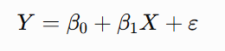
Where:
- Y (Dependent Variable): The value that we want to predict, such as student marks.
- X (Independent Variable): The input variable used for prediction, such as study hours.
- beta_0: The predicted value of Y when X is zero.
- beta_1: The change in the predicted value of Y for a one-unit increase in X.
- Error Term: Represents the part of the actual outcome that the model does not explain.
Example
Suppose the estimated relationship between study hours and marks is:
Y = 20 + 5X
If a student studies for 4 hours:
Y = 20 + 5(4) = 40
The predicted marks are 40.
Role of the Residual/Error Term
The error term represents random factors and other influences not captured by the model. After making a prediction, the residual is calculated as:
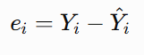
Where Y_i is the actual value and {Y}_i is the predicted value.
Residuals help us measure prediction errors and evaluate how well the regression model fits the data.
Conclusion: Linear Regression is useful for identifying linear relationships and predicting continuous numerical values.

Question 4. How does Logistic Regression differ from Linear Regression? Write the logistic (sigmoid) function and explain why it is suitable for binary classification. What is the decision boundary in logistic regression?
Definition of Logistic Regression
Logistic Regression is a supervised learning algorithm mainly used for classification problems. It estimates the probability that an input belongs to a particular class.
Despite its name, it is commonly used for classification rather than predicting continuous values.
Difference between Linear and Logistic Regression

Basis | Linear Regression | Logistic Regression
Purpose | Regression | Classification
Output | Continuous numerical value | Probability between 0 and 1
Function | Linear equation | Sigmoid function
Example | Predicting house prices | Predicting pass or fail
Evaluation | MSE, RMSE, MAE | Accuracy, Precision, Recall
Logistic (Sigmoid) Function
The sigmoid function converts a real-valued input into a probability between 0 and 1.
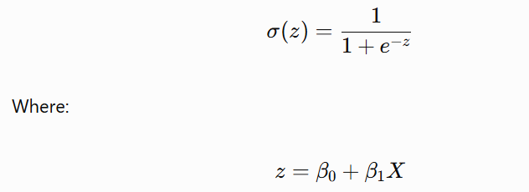
Here, e is the mathematical constant, and z is the linear combination of the input variables and model coefficients.
Why Is It Suitable for Binary Classification?
The sigmoid function produces a probability between 0 and 1. This probability can be used to classify an observation into one of two classes.
For example:
- If the predicted probability is 0.8, the model may classify the student as Pass.
- If the predicted probability is 0.2, the model may classify the student as Fail.
Using a threshold of 0.5, a probability of 0.5 or above is assigned to the positive class, and a probability below 0.5 is assigned to the negative class.
Decision Boundary
The decision boundary is the point or line that separates the predicted classes. With a threshold of 0.5, the boundary occurs where the model predicts a probability of 0.5.
For multiple input features, the decision boundary may be a line, a plane or a higher-dimensional boundary, depending on the model.
Conclusion: Logistic Regression is suitable for binary classification because it converts model outputs into probabilities and uses a decision threshold to assign classes.

Question 5. Describe how a Decision Tree works for classification. Explain Information Gain and Gini Impurity. Why can decision trees overfit the training data, and how can this problem be reduced?
Definition
A Decision Tree is a supervised learning algorithm that makes predictions by splitting data into smaller groups based on different conditions. Its structure resembles a tree.
Working of a Decision Tree
A Decision Tree consists of the following components:
- Root Node: Represents the first decision or condition.
- Internal Nodes: Represent additional tests on input features.
- Branches: Represent the possible outcomes of each test.
- Leaf Nodes: Represent the final predicted classes.
Example: Student Result Prediction
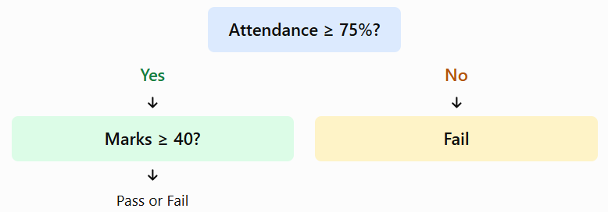The tree checks attendance first and then uses marks to make a prediction.
1. Information Gain
Information Gain measures how much a split reduces the uncertainty or impurity of a dataset.
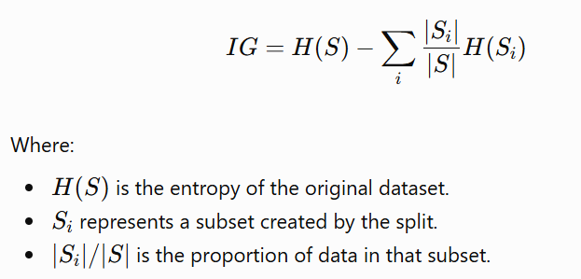
A split with higher Information Gain is generally preferred.
2. Gini Impurity
Gini Impurity measures the probability of incorrectly classifying a randomly selected observation if it is labelled according to the class distribution of its group.
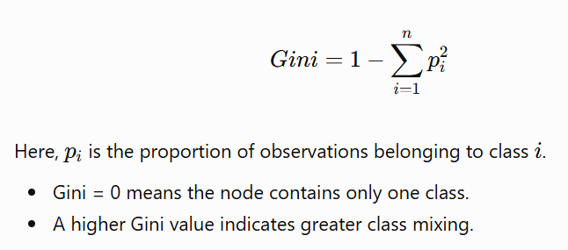
Why Can Decision Trees Overfit?
A Decision Tree can grow too deep and create many branches, learning noise and small details in the training data instead of general patterns. As a result, it may perform well on training data but poorly on unseen data.
Methods to Reduce Overfitting
- Pruning: Remove unnecessary branches.
- Maximum depth: Limit the depth of the tree.
- Minimum samples per leaf: Require a minimum number of observations in each leaf.
- Cross-validation: Evaluate model performance on different data splits.
- Ensemble methods: Use approaches such as Random Forest to improve generalisation.
Conclusion: Decision Trees are easy to understand and interpret, but controlling their depth and complexity is important for reliable predictions.
Question 6. What are Ensemble Methods? Differentiate between Bagging and Boosting with suitable examples of algorithms that use each technique. Why do ensemble methods generally perform better than a single model?
Definition of Ensemble Methods
Ensemble Methods are machine learning techniques that combine the predictions of multiple models to produce a final prediction. The aim is to improve accuracy, stability and generalisation compared with using a single model.
1. Bagging (Bootstrap Aggregating)
Bagging trains multiple models independently on different bootstrap samples of the training dataset. Their predictions are combined using voting for classification or averaging for regression.
Example: Random Forest trains multiple Decision Trees on sampled data and combines their predictions.
2. Boosting
Boosting trains models sequentially, where each new model attempts to correct errors or improve upon the predictions of earlier models. The final prediction combines the contributions of the trained models.
Examples: AdaBoost, Gradient Boosting and XGBoost.
Difference between Bagging and Boosting
Basis | Bagging | Boosting
Training | Models are trained independently and can be parallelised. | Models are trained sequentially in stages.
Main objective | Primarily reduces variance. | Often reduces bias and improves predictive accuracy.
Data handling | Uses bootstrap samples. | Later models focus on previous errors or residuals.
Combination | Voting or averaging. | Weighted or additive combination.
Examples | Random Forest, Bagged Trees | AdaBoost, Gradient Boosting, XGBoost
Why Do Ensemble Methods Perform Better?
- They combine the strengths of multiple models.
- They can reduce prediction errors.
- Bagging can reduce the effect of fluctuations in training data.
- Boosting can improve performance by correcting earlier mistakes.
- They often generalise better to unseen data when properly tuned.
Conclusion: Ensemble methods can provide more reliable predictions than a single model, although their performance depends on the data, algorithm and parameter settings.
Question 7. Explain the working principle of Support Vector Machines (SVM) for binary classification. What are support vectors and the margin? Briefly describe the role of the kernel trick in SVM.
Definition
Support Vector Machine (SVM) is a supervised learning algorithm used for classification and regression. For binary classification, it finds a decision boundary, called a hyperplane, that separates observations belonging to two classes.
Working Principle of SVM
- SVM takes labelled training data belonging to two classes.
- It identifies possible hyperplanes that separate the classes.
- It selects the hyperplane with the maximum margin between the two classes.
- The resulting boundary is used to classify new observations.
Support Vectors
Support vectors are the training observations closest to the decision boundary. These observations are especially important because they determine the position and orientation of the maximum-margin hyperplane.
Margin
The margin is the distance between the decision boundary and the closest observations from the two classes.
SVM generally aims to maximise this margin because a well-separated boundary can improve generalisation.
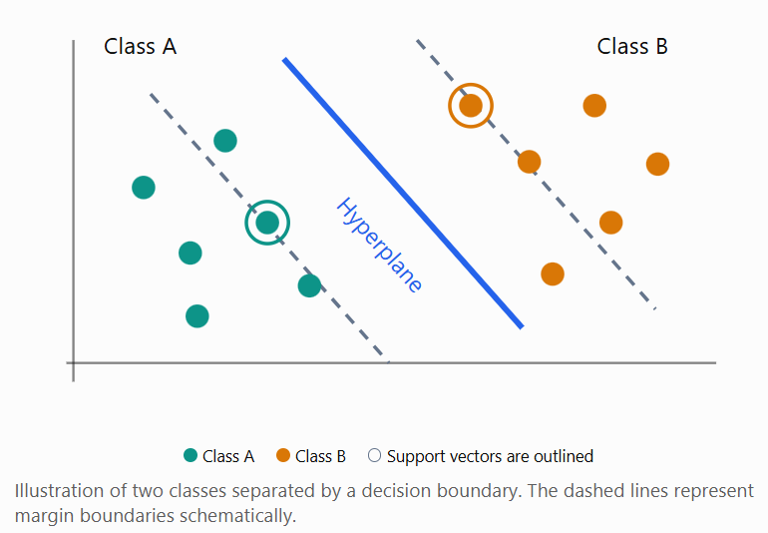
Kernel Trick
When data cannot be separated using a straight line or hyperplane in the original feature space, SVM can use the kernel trick.
A kernel calculates relationships between observations as if they were mapped into a higher-dimensional feature space, without explicitly calculating the full transformation.
Common kernels include:
- Linear Kernel
- Polynomial Kernel
- Radial Basis Function (RBF) Kernel
Example: The RBF kernel can help SVM create a nonlinear decision boundary for data that cannot be separated by a straight line.
Conclusion: SVM aims to find a maximum-margin decision boundary, with support vectors defining that boundary and kernels helping handle nonlinear data.
Question 8. List and briefly explain any four evaluation metrics used for classification problems. When is Accuracy not a good metric, and which metric would you prefer instead?
Classification metrics measure how well a classification model predicts the correct classes.
The four main metrics are:
1. Accuracy
Accuracy measures the proportion of all predictions that are correct.
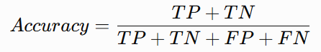
2. Precision
Precision measures the proportion of positive predictions that are actually positive.
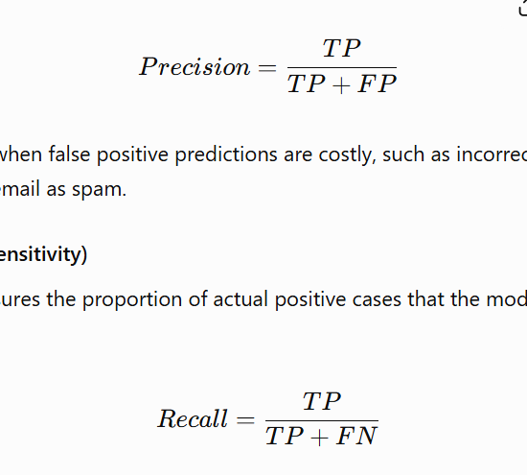
It is useful when false positive predictions are costly, such as incorrectly flagging a genuine email as spam.
3. Recall (Sensitivity)
Recall measures the proportion of actual positive cases that the model correctly identifies.
It is useful in medical screening, where missing a disease case may have serious consequences.
4. F1-Score
F1-Score is the harmonic mean of Precision and Recall. It balances these two metrics.
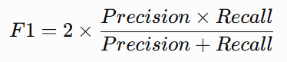
It is useful when both false positives and false negatives matter, especially with imbalanced datasets.
Where:
- TP (True Positive): Actual positive correctly predicted as positive.
- TN (True Negative): Actual negative correctly predicted as negative.
- FP (False Positive): Actual negative incorrectly predicted as positive.
- FN (False Negative): Actual positive incorrectly predicted as negative.
When Is Accuracy Not a Good Metric?
Accuracy may be misleading when the dataset is highly imbalanced.
For example, suppose a dataset contains 1,000 transactions, of which 990 are genuine and only 10 are fraudulent. A model that predicts every transaction as genuine achieves 99% accuracy but detects no fraudulent transactions.
In this situation, Recall is preferable when detecting as many fraudulent cases as possible is the priority. Precision should also be considered to control false alarms, and F1-Score can help balance Precision and Recall.
Conclusion: No single metric is best for every classification problem. The choice depends on class distribution and the cost of different prediction errors.
Question 9. For regression problems, explain MSE, RMSE, MAE and R-squared. Which metric is more sensitive to outliers and why?
Regression evaluation metrics measure the difference between actual and predicted numerical values.
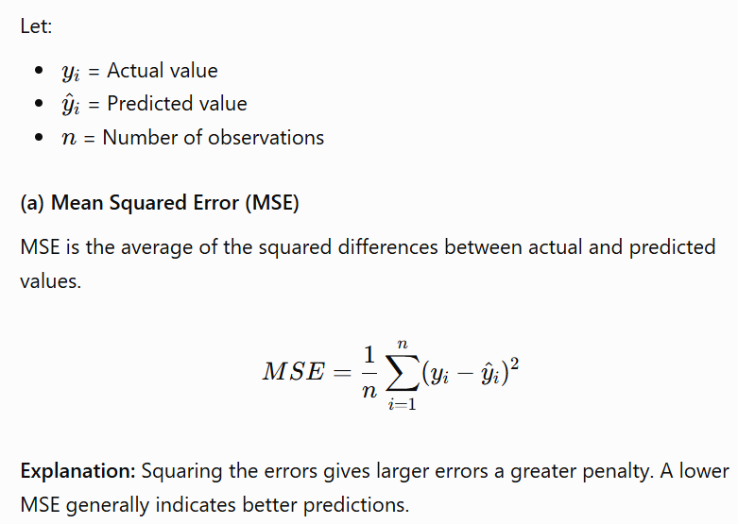
(b) Root Mean Squared Error (RMSE)
RMSE is the square root of MSE.
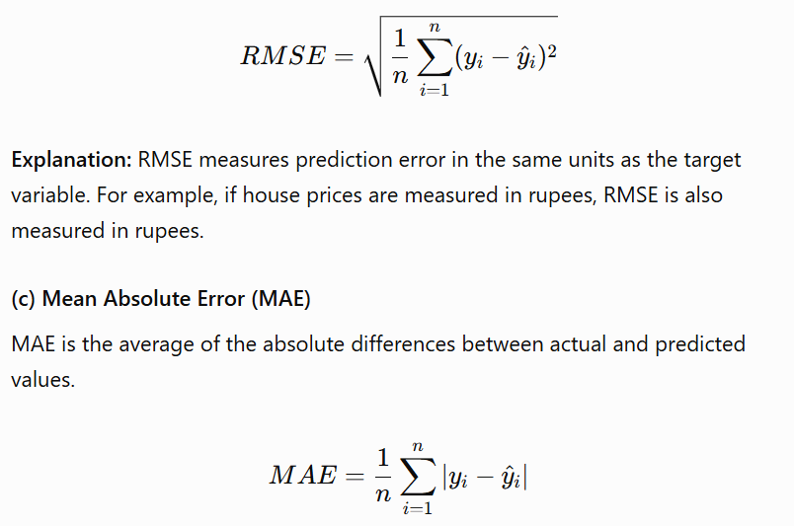Explanation: MAE gives the average magnitude of prediction errors without considering their direction. It is generally less sensitive to outliers than MSE and RMSE.
(d) R-squared (Coefficient of Determination)
R-squared measures how much of the variation in the dependent variable is explained by the regression model relative to a baseline that predicts the mean.
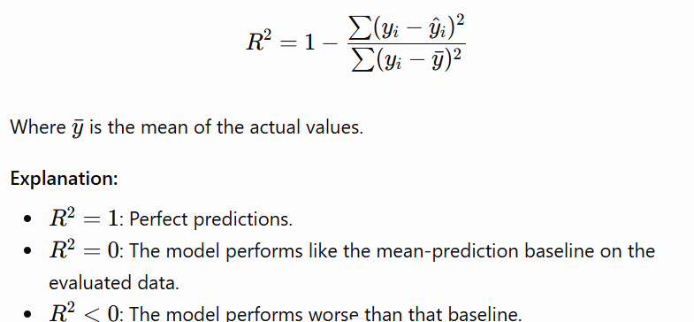
Comparison of Regression Metrics

Metric | Main Feature | Effect of Outliers
MSE | Average squared error | Highly sensitive
RMSE | Square root of MSE | Highly sensitive
MAE | Average absolute error | Less sensitive than MSE/RMSE
R-squared | Variation explained relative to baseline | Can be strongly affected by large errors
Which Metric Is More Sensitive to Outliers?
MSE is particularly sensitive to outliers because it squares each error. For example, an error of 10 contributes \(10^2=100\), while an error of 2 contributes \(2^2=4\). Therefore, a few large errors can significantly increase MSE.
RMSE is also sensitive to outliers because it is derived from MSE. MAE is often preferred when a more robust measure of typical error is needed.
Conclusion: MSE and RMSE penalise large errors strongly, MAE provides a more direct measure of average absolute error, and R-squared indicates how well a model explains variation in the target variable.
Question 10. Discuss any four real-world applications of Supervised Learning. For each application, mention the type of supervised learning problem and a suitable algorithm.
Supervised Learning is widely used in real-world applications because it can learn from labelled historical data and make predictions for new cases.
Application | Description | Problem Type | Suitable Algorithm
1. Email Spam Detection | Classifies emails as spam or not spam based on their features. | Classification | Naive Bayes
2. House Price Prediction | Predicts house prices using area, location, number of rooms and other features. | Regression | Linear Regression
3. Medical Diagnosis | Predicts whether a patient may have a particular disease using medical test results and patient data. | Classification | Logistic Regression
4. Sales Forecasting | Predicts future sales using historical sales data, prices and other relevant features. | Regression | Random Forest Regressor
1. Email Spam Detection
Email providers use supervised learning models trained on emails labelled as spam or legitimate. The model learns patterns such as suspicious words, links and sender information to classify new emails.
2. House Price Prediction
Real estate companies can use historical property data to estimate house prices. A Linear Regression model can learn how features such as area and location are related to selling prices.
3. Medical Diagnosis
Healthcare systems can use labelled patient records to predict the presence or absence of a disease. Logistic Regression can estimate the probability of a disease based on relevant patient features. Such predictions support, but do not replace, professional medical judgement.
4. Sales Forecasting
Businesses can train regression models on historical sales, prices, promotions and seasonal patterns to estimate future sales. A Random Forest Regressor can learn nonlinear relationships between these factors and sales figures.
Conclusion: Supervised learning supports decision-making in healthcare, business, finance and communication systems. Classification is used to predict categories, while regression is used to predict continuous numerical values.

