ASSIGNMENT – 01
1. What is Software Testing? Explain its objectives and importance.
Answer
Software Testing is the process of checking and evaluating a software application to find defects, errors, or unexpected behavior. It is performed to make sure that the software works according to the given requirements and provides the expected results.
Testing can be performed manually or with the help of automated testing tools.
Objectives of Software Testing
The main objectives are:
- Finding defects: To identify bugs and errors before the software reaches users.
- Checking requirements: To verify whether the software satisfies the specified requirements.
- Ensuring functionality: To check whether all features work correctly.
- Improving quality: To improve the reliability, performance, security, and usability of software.
- Reducing risk: To reduce the possibility of software failure after deployment.
- Customer satisfaction: To ensure that users receive a reliable and useful product.
Importance of Software Testing
Software testing is important because even a small error can cause serious problems, especially in applications related to banking, healthcare, education, and transportation. Testing helps organizations detect problems early, reduce development costs, and provide better software to customers.
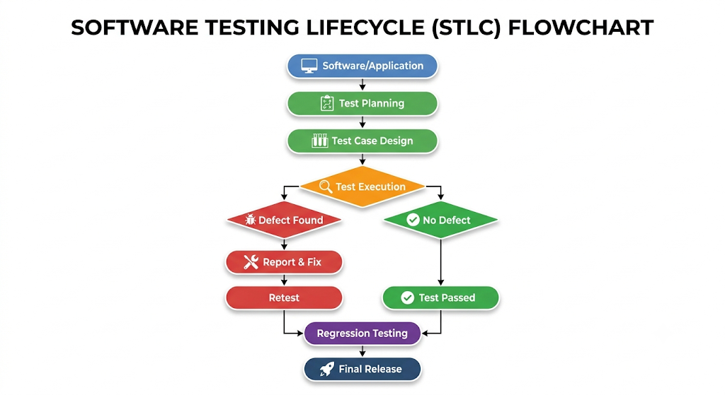
2. What is Software Quality Assurance (SQA)? Explain its role in software development.
Answer
Software Quality Assurance (SQA) is a systematic process used to ensure that software development follows defined quality standards, processes, and procedures.
The main purpose of SQA is not only to find defects but also to prevent defects from occurring by improving the development process.
Role of SQA in Software Development
SQA plays an important role throughout the Software Development Life Cycle (SDLC).
Its major roles include:
- Defining quality standards and procedures.
- Monitoring development activities.
- Reviewing requirements and design documents.
- Checking whether development follows the defined process.
- Supporting testing activities.
- Identifying process-related problems.
- Maintaining proper documentation.
- Conducting audits and reviews.
- Suggesting improvements to the development process.
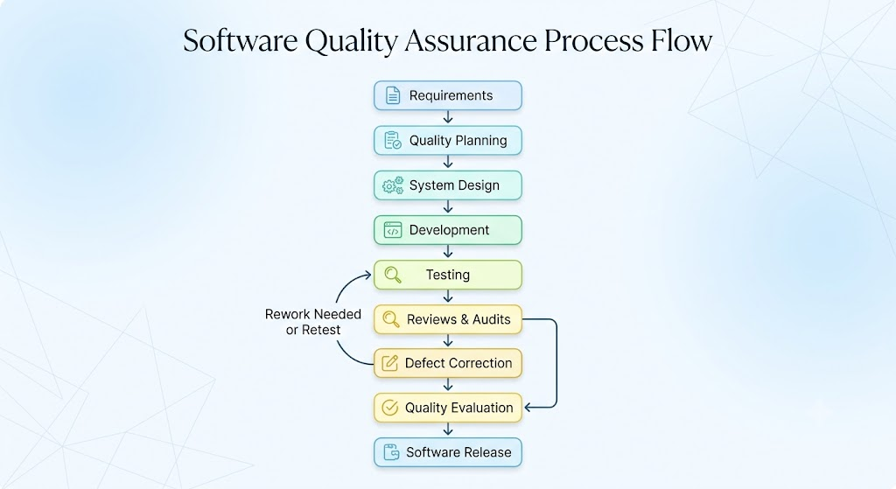

Example
Suppose a company is developing an online banking application. SQA ensures that proper development procedures, security standards, review processes, testing procedures, and documentation are followed throughout the project.

3. Differentiate between Software Testing and Quality Assurance.
Answer
Software Testing and Software Quality Assurance are closely related, but they have different purposes.
Basis | Software Testing | Software Quality Assurance
Meaning | Process of checking software for defects | Process of ensuring quality processes are followed
Main focus | Product | Process
Main objective | Find defects | Prevent defects
Nature | Mostly corrective/detective | Mostly preventive
Performed during | Mainly testing phases, but can occur throughout SDLC | Throughout SDLC
Activities | Test cases, test execution, bug reporting | Audits, reviews, process monitoring, standards
Example | Checking whether login works correctly | Checking whether the organization follows its defined testing process
Relationship
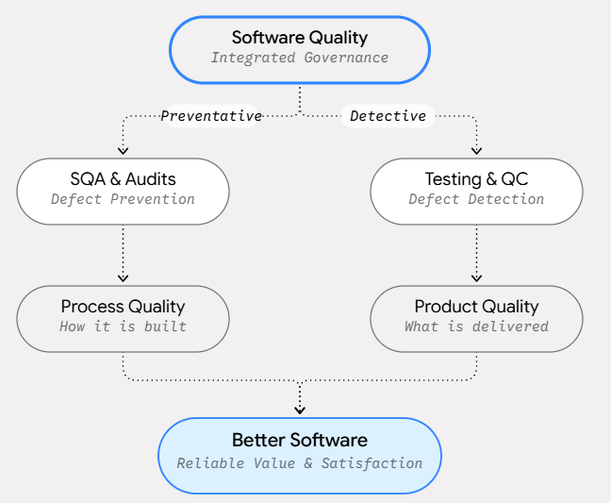
In simple words, testing mainly asks "Does the software work correctly?", while SQA asks "Are we following the right process to develop quality software?"

4. What is the difference between Quality Assurance (QA) and Quality Control (QC)?
Answer
Quality Assurance (QA) and Quality Control (QC) are both important parts of software quality management, but they focus on different areas.
Quality Assurance focuses on improving and monitoring the process used to develop software.
Quality Control focuses on checking the actual software product to identify defects.

Basis | Quality Assurance (QA) | Quality Control (QC)
Focus | Process | Product
Goal | Prevent defects | Detect defects
Nature | Preventive | Corrective/detective
Approach | Process-oriented | Product-oriented
Activities | Audits, standards, process improvement | Testing, defect identification
Timing | Throughout SDLC | Mainly during product evaluation
Example | Checking whether coding standards are followed | Testing whether a button works correctly
Easy Way to Remember
QA → Prevent Problems
QC → Find Problems

5. Explain the role and responsibilities of a Software Quality Assurance Engineer.
Answer
A Software Quality Assurance Engineer is responsible for helping an organization develop reliable and high-quality software by monitoring quality processes and supporting testing activities.
Major Responsibilities
- Requirement Review
Checks whether requirements are clear, complete, and testable.
- Test Planning
Helps prepare testing strategies, test plans, and test cases.
- Test Execution
Executes test cases to identify defects.
- Defect Reporting
Records defects with proper information such as steps to reproduce, expected result, and actual result.
- Process Monitoring
Checks whether the development team is following defined processes.
- Code and Document Reviews
Participates in reviews to identify problems at an early stage.
- Regression Testing
Checks whether new changes have affected existing functionality.
- Quality Reporting
Prepares reports related to testing progress, defects, and quality status.
- Process Improvement
Suggests ways to improve development and testing processes.

6. Explain the Verification and Validation and discuss their role in software quality.
Answer
Verification and Validation (V&V) are two important activities used to ensure software quality.
Verification
Verification checks whether the software is being developed according to specified requirements, standards, and design.
It mainly focuses on:
"Are we building the product right?"
Examples:
- Requirement reviews
- Design reviews
- Code reviews
- Inspections
- Document reviews
Validation
Validation checks whether the final software actually satisfies the user's needs and requirements.
It mainly focuses on:
"Are we building the right product?"
Examples:
- Functional testing
- System testing
- User acceptance testing
- Performance testing
Difference
Verification | Validation
Checks process and work products | Checks the actual software
Mostly static activities | Mostly dynamic activities
Does not necessarily execute the program | Usually involves executing the program
Reviews and inspections | Testing
"Building the product right" | "Building the right product"
Both are necessary because software can follow its technical specifications but still fail to meet the actual needs of users.

7. Explain how defects can affect the overall quality of software.
Answer
A defect is a flaw or mistake in software that can cause the system to produce an incorrect or unexpected result.
Defects can occur because of incorrect requirements, programming errors, design problems, integration issues, or insufficient testing.
Effects of Defects
- System Failure
Serious defects can cause the complete application to crash.
- Data Loss
Defects may result in incorrect modification or loss of important data.
- Security Problems
Security-related defects can expose confidential information.
- Poor Performance
Some defects can make software slow or unstable.
- Financial Loss
Errors in banking or payment systems can result in financial losses.
- Customer Dissatisfaction
Frequent errors can make users lose confidence in the software.
- Higher Maintenance Cost
Defects discovered after deployment are generally more expensive and difficult to fix.
Therefore, identifying and fixing defects as early as possible is an important part of software quality.

8. A banking application frequently crashes during online transactions. As a QA professional, explain what activities you would perform to improve the quality of the application.
Answer
A banking application is a critical system because it handles sensitive financial information and transactions. Frequent crashes during transactions indicate a serious quality problem.
As a QA professional, I would follow a systematic approach.
Step 1: Reproduce the Problem
First, I would try to reproduce the crash under different conditions, such as:
- Different devices
- Different browsers
- Different network speeds
- Different transaction amounts
- Multiple simultaneous users
Step 2: Analyze Logs
I would check application and server logs to identify errors, exceptions, or resource problems occurring when the application crashes.
Step 3: Report the Defect
The defect would be recorded with:
- Defect description
- Steps to reproduce
- Expected result
- Actual result
- Environment
- Severity
- Screenshots/logs
Step 4: Perform Functional Testing
Important transaction functions would be tested.
Step 5: Perform Performance Testing
I would check whether crashes occur because of:
- High number of users
- High transaction volume
- Server overload
- Memory problems
- Slow database operations
Step 6: Security Testing
Since banking applications handle sensitive information, security testing would also be performed to identify authentication, authorization, and data-protection problems.
Step 7: Retesting and Regression Testing

9. What is a Quality Management System (QMS)? Explain its importance in software development.
Answer
A Quality Management System (QMS) is a structured set of processes, procedures, standards, responsibilities, and documentation used by an organization to consistently achieve and improve quality.
In software development, QMS provides a systematic approach for managing software quality instead of depending only on individual developers or testers.
Importance of QMS
- Provides standardized development processes.
- Improves consistency in software development.
- Helps prevent defects.
- Improves documentation.
- Supports compliance with quality standards.
- Helps identify process weaknesses.
- Improves customer satisfaction.
- Supports continuous improvement.
Example
If a software company has a defined QMS, every project may follow established procedures for requirements, development, testing, defect management, documentation, and release.

10. Explain how QA activities are performed throughout the Software Development Life Cycle (SDLC).
Answer
Software Quality Assurance is not limited to the testing phase. QA activities should be performed throughout the Software Development Life Cycle (SDLC).
QA Activities in Different SDLC Phases

SDLC Phase | Major QA Activities
Requirement Analysis | Requirement review, ambiguity checking, completeness checking
Design | Design review, architecture review
Development | Coding standards, code review, static analysis
Testing | Test planning, test execution, defect tracking
Deployment | Release verification, deployment checks
Maintenance | Regression testing, defect analysis, process improvement

