ASSIGNMENT – 03
Q1. What is Test Planning? Explain the main steps involved in the test planning process.
Definition
Test Planning is the process of deciding what needs to be tested, how testing will be performed, who will perform it, and how much time and resources will be required.
It helps the testing team complete testing in a systematic and organized way.
Main Steps of Test Planning
1. Requirement Analysis: Understand the software requirements and identify the features that need testing.
2. Define Testing Objectives: Decide what testing should achieve, such as finding defects and checking functionality.
3. Determine Testing Scope: Identify which features are included and excluded from testing.
4. Select Testing Techniques: Decide which testing methods will be used, such as functional, performance, or security testing.
5. Resource Planning: Identify the required testers, tools, hardware, and software.
6. Prepare Test Schedule: Decide the start date, end date, and time required for each testing activity.
7. Identify Risks: Identify possible problems, such as a lack of resources or changing requirements.
8. Define Entry and Exit Criteria: Specify when testing can begin and when it can be considered complete.
9. Prepare the Test Plan: Document all testing activities, responsibilities, resources, and schedules.
10. Review and Approval: Get the plan reviewed and approved by the responsible team members.
Example
For an online shopping application, test planning includes deciding how to test login, product search, cart, payment, and order confirmation.
Flowchart
Requirement Analysis
|
v
Define Testing Objectives
|
v
Determine Testing Scope
|
v
Select Testing Techniques
|
v
Plan Resources and Schedule
|
v
Identify Risks
|
v
Prepare Test Plan
|
v
Review and Approval
Conclusion: Test planning helps ensure that testing activities are properly organized and completed within the available time and resources.

Q2. What is a Test Strategy? Explain its importance in software testing.
Definition
A Test Strategy is a high-level document that describes the overall approach, methods, and principles that will be followed to test software.
It explains how the organization or project will achieve its testing objectives.
Importance of Test Strategy
1. Defines the testing approach: Explains how testing will be performed.
2. Maintains consistency: Helps teams follow a common approach.
3. Supports resource planning: Helps identify the skills, tools, and infrastructure required.
4. Reduces risks: Identifies important areas that require more testing.
5. Improves efficiency: Avoids unnecessary testing activities.
6. Supports communication: Helps developers, testers, and managers understand the testing approach.
7. Improves quality: Encourages suitable testing methods for the software.
Main Elements of a Test Strategy
- Testing objectives and scope
- Testing levels and types
- Manual and automation approach
- Test environment and tools
- Risk assessment
- Test data management
- Defect management approach
- Entry and exit criteria
Example
For a banking application, the test strategy may prioritize security testing, transaction correctness, performance testing, and data protection because the application handles sensitive financial information.
Conclusion: A test strategy provides overall direction for testing and helps the team select suitable methods to achieve software quality goals.

Q3. What is a Test Plan? Explain the major contents of a Test Plan.
Definition
A Test Plan is a document that describes the testing activities, scope, objectives, resources, schedule, responsibilities, and procedures for a particular software project.
It acts as a guide for the testing team throughout the testing process.
Major Contents of a Test Plan
1. Test Plan Identifier: A unique name or number used to identify the plan.
2. Introduction: Describes the project and the purpose of testing.
3. Test Objectives: Defines what testing should achieve.
4. Test Scope: Specifies the features to be tested and those excluded.
5. Test Items: Lists the modules or components to be tested.
6. Testing Approach: Describes the testing levels, techniques, and methods.
7. Resources: Identifies the people, tools, hardware, and software required.
8. Test Schedule: Specifies the dates and duration of testing activities.
9. Roles and Responsibilities: Defines the duties of testers, developers, and managers.
10. Entry and Exit Criteria: Defines when testing can start and finish.
11. Risk and Contingency Plan: Identifies possible risks and the actions needed to handle them.
12. Deliverables: Lists the expected outputs, such as test cases, defect reports, and test summary reports.
Example
For a college management system, the test plan may include testing student registration, attendance, fee payment, examination results, and report generation.
Conclusion: A test plan provides detailed guidance for testing and helps ensure that testing is performed systematically.

Q4. Differentiate between a Test Strategy and a Test Plan.
A Test Strategy defines the overall testing approach, whereas a Test Plan explains how testing will be carried out for a specific project or testing activity.
Basis | Test Strategy | Test Plan
Meaning | Defines the overall testing approach | Describes detailed testing activities
Level | High-level | More detailed
Focus | Methods and principles | Execution, resources, and schedule
Scope | May apply across projects or at project level | Usually prepared for a specific project or testing level
Contents | Testing methods, risk approach, automation principles | Scope, test cases, resources, schedule, responsibilities
Changes | Often changes less frequently | May be updated as the project progresses
Responsibility | Usually defined by QA leadership or test management | Prepared by the responsible test manager or team
Example | Deciding to use risk-based testing | Scheduling payment testing for Monday
Conclusion: A test strategy explains the overall approach, while a test plan translates that approach into specific activities and responsibilities.

Q5. What are the main goals and objectives of software testing? Explain.
Software testing is performed to check software behaviour, identify defects, and determine whether the application meets its requirements.
Main Goals and Objectives
1. Defect Detection: Identify errors and defects before the software is released.
2. Requirement Verification: Check whether the software follows the specified requirements.
3. Functional Correctness: Ensure that features work as expected.
4. Reliability: Reduce the possibility of unexpected failures.
5. Performance: Check response time, stability, and behaviour under load.
6. Security: Identify weaknesses that may expose sensitive information.
7. Usability: Check whether users can operate the application easily.
8. Risk Reduction: Reduce the risk of failure after deployment.
9. Cost Reduction: Identify defects early to reduce correction costs.
10. Customer Satisfaction: Help deliver reliable software that meets user expectations.
Example
In an online payment application, testing checks whether the correct amount is transferred, the transaction status is accurate, and duplicate payments are prevented.
Conclusion: The main objective of software testing is to provide information about software quality and reduce the risks associated with its use.

Q6. What are Test Phases? Explain the different phases of software testing.
Definition
Test Phases are the different stages through which testing activities progress, from understanding requirements to completing testing and reporting results.
Different Phases of Software Testing
1. Requirement Analysis
The testing team studies the requirements and identifies the features that need testing.
2. Test Planning
The team decides the testing scope, approach, resources, responsibilities, and schedule.
3. Test Case Design
Test cases and test data are prepared based on the requirements.
4. Test Environment Setup
The required hardware, software, tools, database, and network are prepared.
5. Test Execution
Test cases are executed, and actual results are compared with expected results.
6. Defect Reporting and Tracking
Defects are recorded and assigned to developers for correction.
7. Retesting and Regression Testing
Retesting verifies the fixes, while regression testing checks whether changes have affected existing features.
8. Test Closure
The team prepares the final test report, summarizes results, and records lessons learned.
Copy-Paste Flowchart
Requirement Analysis
|
v
Test Planning
|
v
Test Case Design
|
v
Test Environment Setup
|
v
Test Execution
|
v
Defect Reporting
|
v
Retesting and Regression Testing
|
v
Test Closure and Final Report

Conclusion: These phases help the testing team perform testing in an organized manner and evaluate whether the software is ready for release.

Q7. What factors should be considered while developing a Test Strategy?
A Test Strategy should be developed after considering the project requirements, risks, resources, and expected quality level.
Important Factors
1. Project Requirements: Understand the functional and non-functional requirements.
2. Project Scope: Identify which features and components need testing.
3. Risk Level: Give more attention to critical features, such as payments and security.
4. Type of Application: Consider whether the software is a web, mobile, desktop, or embedded application.
5. Testing Levels: Decide whether unit, integration, system, and acceptance testing are required.
6. Testing Techniques: Select suitable techniques, such as black-box, white-box, and risk-based testing.
7. Resources: Consider the availability and skills of testers, developers, and other team members.
8. Tools and Technology: Select suitable testing and defect-tracking tools.
9. Time and Budget: Develop an approach that fits the project schedule and budget.
10. Security and Performance Needs: Consider data protection, response time, scalability, and reliability.
11. Automation Requirements: Identify which repetitive tests are suitable for automation.
12. Standards and Regulations: Consider any applicable industry, contractual, or legal requirements.
Conclusion: A good test strategy considers both technical and business needs and helps the testing team focus on the most important quality risks.

Q8. Explain the resource requirements needed for software testing.
Resource requirements are the people, tools, equipment, and other facilities needed to perform testing effectively.
Types of Resources
1. Human Resources
These are the people involved in testing activities.
Examples:
- Test manager
- QA engineer
- Manual tester
- Automation tester
- Performance tester
- Developers who help resolve defects
2. Hardware Resources
These include the physical devices required for testing.
Examples:
- Computers and laptops
- Mobile phones and tablets
- Servers
- Networking devices
3. Software Resources
These are the software applications and tools used during testing.
Examples:
- Test management tools
- Bug-tracking tools
- Automation tools
- Database software
- Browsers and operating systems
4. Test Environment
A suitable environment is required to execute tests under controlled conditions.
It may include servers, databases, network configurations, test accounts, and application builds.
5. Test Data
Test data includes the information required to perform test cases, such as sample user accounts, product details, and transaction records. Sensitive data should be protected, and synthetic or masked data should be used where appropriate.
6. Time and Budget
Testing requires sufficient time and money for planning, execution, defect correction, retesting, and reporting.
Resource Planning Table
Resource | Purpose
Testers | Execute tests and identify defects
Test tools | Support manual and automated testing
Hardware | Provide devices and computing capacity
Test environment | Provide a suitable place to execute tests
Test data | Supply information needed for test cases
Time and budget | Support the completion of testing activities
Conclusion: Proper resource planning helps the team perform testing efficiently and complete the required quality checks within the available budget and schedule.

Q9. What is a Test Schedule? Explain the importance of scheduling in software testing.
Definition
A Test Schedule is a timetable that specifies when testing activities will begin, how long they will take, and when they are expected to finish.
It helps the testing team organize work and coordinate testing with development activities.
Importance of Test Scheduling
1. Time Management: Ensures that testing activities are completed within the planned time.
2. Resource Allocation: Helps assign testers and tools to the required activities.
3. Task Coordination: Coordinates testing with development, integration, and release activities.
4. Progress Monitoring: Makes it easier to compare actual progress with planned progress.
5. Risk Management: Helps identify schedule delays early.
6. Deadline Management: Supports the achievement of project milestones.
7. Better Communication: Keeps team members informed about their responsibilities and deadlines.
Example of a Test Schedule
Activity | Duration
Requirement analysis | 2 days
Test planning | 2 days
Test case design | 3 days
Test execution | 5 days
Retesting and regression testing | 3 days
Test closure and reporting | 1 day
Note: This is an illustrative schedule. Actual durations depend on the project's size and complexity.
Schedule Flow
Requirement Analysis : Day 1-2
Test Planning : Day 3-4
Test Case Design : Day 5-7
Test Execution : Day 8-12
Retesting : Day 13-14
Regression Testing : Day 15
Test Closure : Day 16

Conclusion: A test schedule helps the team use time and resources effectively and complete testing activities in a planned manner.

Q10. What is a Test Case? Explain the main components of a test case.
Definition
A Test Case is a set of conditions, inputs, steps, and expected results used to verify whether a particular software function behaves correctly.
Test cases help testers check software systematically and maintain records of the testing performed.
Main Components of a Test Case
1. Test Case ID: A unique identifier for the test case.
2. Test Case Title: A short description of what is being tested.
3. Objective: Explains the purpose of the test.
4. Preconditions: Conditions that must be satisfied before testing.
5. Test Data: The input values required for the test.
6. Test Steps: The actions the tester must perform.
7. Expected Result: The result that should occur if the software works correctly.
8. Actual Result: The result observed during execution.
9. Status: Indicates whether the test passed, failed, or is blocked.
10. Remarks: Additional observations or defect references.
Example: Login Test Case
Component | Details
Test Case ID | TC_LOGIN_01
Title | Login with valid credentials
Objective | Check whether a registered user can log in
Preconditions | User account exists
Test Data | Valid username and password
Steps | Open login page, enter credentials, click Login
Expected Result | User should reach the dashboard
Actual Result | Recorded after execution
Status | Pass or Fail
Conclusion: A well-written test case makes testing repeatable, clear, and easier to review.

Q11. Explain the process of designing and writing effective test cases.
Test case design is the process of preparing test conditions, inputs, steps, and expected results to verify software behaviour.
Steps for Designing Effective Test Cases
1. Understand Requirements: Read the requirements carefully and identify expected software behaviour.
2. Identify Test Scenarios: Decide what functions and conditions need testing.
3. Select Test Design Techniques: Use methods such as equivalence partitioning, boundary value analysis, and decision tables.
4. Define Preconditions: Specify what must be true before the test begins.
5. Prepare Test Data: Select suitable valid, invalid, and boundary input values.
6. Write Test Steps: Describe each action clearly and in the correct order.
7. Define Expected Results: State the correct output or behaviour.
8. Review Test Cases: Check whether test cases are clear, complete, and non-ambiguous.
9. Execute Test Cases: Perform the steps and record actual results.
10. Update Test Cases: Modify them when requirements or application behaviour changes.
Characteristics of an Effective Test Case
- Clear and easy to understand
- Specific and repeatable
- Based on requirements
- Has defined expected results
- Includes appropriate positive and negative conditions
- Avoids unnecessary steps
- Can be traced to the relevant requirement
Example
For a password field, test cases should include a valid password, an incorrect password, an empty field, and values at the minimum and maximum permitted lengths.
Conclusion: Effective test cases improve test coverage, reduce confusion, and help identify defects systematically.

Q12. What is Bug Reporting? Explain the important information included in a bug report.
Definition
Bug Reporting is the process of recording and communicating a defect found during software testing so that the development team can understand, reproduce, and fix it.
A bug report should contain enough information to help developers identify the cause of the problem.
Important Information in a Bug Report
1. Bug ID: A unique identifier for the defect.
2. Bug Title: A short description of the problem.
3. Description: Detailed information about the defect.
4. Steps to Reproduce: The actions required to reproduce the issue.
5. Expected Result: The behaviour that should occur.
6. Actual Result: The behaviour observed.
7. Severity: The degree of impact on the software.
8. Priority: How urgently the defect should be fixed.
9. Environment: Device, operating system, browser, or software version.
10. Attachments: Screenshots, logs, or videos that help explain the issue.
11. Reported By: The person who identified the defect.
12. Status and Assignee: The current state of the defect and the person responsible for handling it.
Example of a Bug Report
Field | Example
Bug ID | BUG_101
Title | Login fails with valid credentials
Steps | Open login page, enter valid credentials, click Login
Expected Result | User reaches the dashboard
Actual Result | Error message appears
Severity | Major
Priority | High
Environment | Chrome on Windows
Status | New
Conclusion: A clear bug report helps developers reproduce defects quickly, fix them accurately, and improve software quality.

Q13. Explain the Bug Life Cycle in software testing.
Definition
The Bug Life Cycle is the sequence of stages a defect passes through from the time it is reported until it is closed or otherwise resolved.
It helps the testing team track defects and monitor their progress.
Stages of the Bug Life Cycle
1. New: The tester reports a defect for the first time.
2. Assigned: The defect is assigned to a developer or responsible team member.
3. Open: The developer begins investigating the issue.
4. Fixed: The developer makes a correction and submits the updated software.
5. Retest: The tester checks whether the defect has been corrected.
6. Verified: The tester confirms that the reported issue no longer occurs.
7. Closed: The defect is considered resolved and the record is closed.
Other possible statuses include:
- Reopened: The defect still exists after the fix or appears again.
- Rejected: The reported issue is not accepted as a valid defect.
- Duplicate: The same defect has already been reported.
- Deferred: The defect will be handled in a future release.
Copy-Paste Bug Life Cycle Diagram
New
|
v
Assigned
|
v
Open
|
v
Fixed
|
v
Retest
|
v
Verified
|
v
Closed

If the defect still exists:
Retest --> Reopened --> Assigned/Open

Conclusion: The bug life cycle helps ensure that defects are tracked, corrected, tested, and properly resolved.

Q14. What are Test Metrics? Explain their importance in measuring testing activities.
Definition
Test Metrics are measurable values used to evaluate the progress, effectiveness, coverage, and quality of software testing activities.
They help the testing team understand whether testing is progressing as planned and where improvement is needed.
Importance of Test Metrics
1. Measure Progress: Show how many test cases have been designed and executed.
2. Evaluate Test Coverage: Indicate how much of the requirements or software has been tested.
3. Track Defects: Help monitor the number, severity, and status of defects.
4. Support Decision-Making: Provide information for deciding whether more testing is required.
5. Identify Problems: Highlight delays, repeated failures, or areas with high defect rates.
6. Improve Productivity: Help evaluate the effectiveness of testing activities.
7. Estimate Future Work: Support better planning for later testing cycles.
Examples of Test Metrics
- Total number of test cases
- Number of test cases executed
- Test pass percentage
- Test coverage percentage
- Number of open defects
- Defect density
- Defect leakage
- Average time taken to resolve defects
Conclusion: Test metrics provide measurable information that helps teams monitor testing, evaluate risks, and make better quality-related decisions.

Q15. Explain different types of testing metrics used in software testing.
Testing metrics can be divided into different categories depending on what they measure.
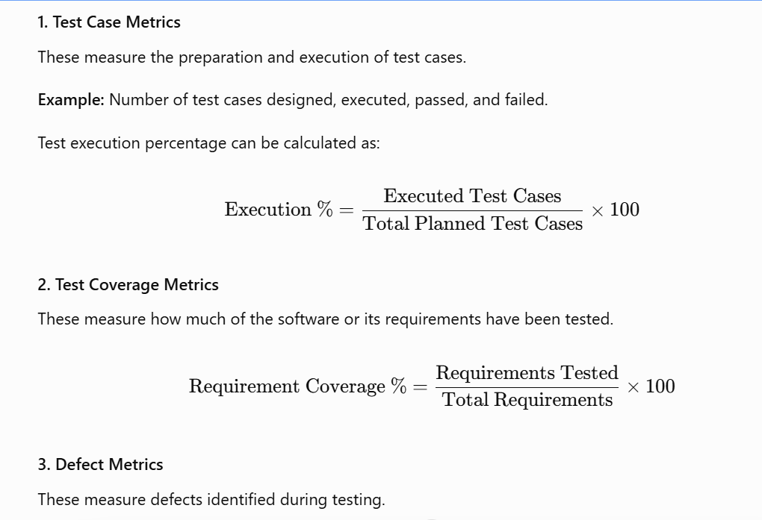
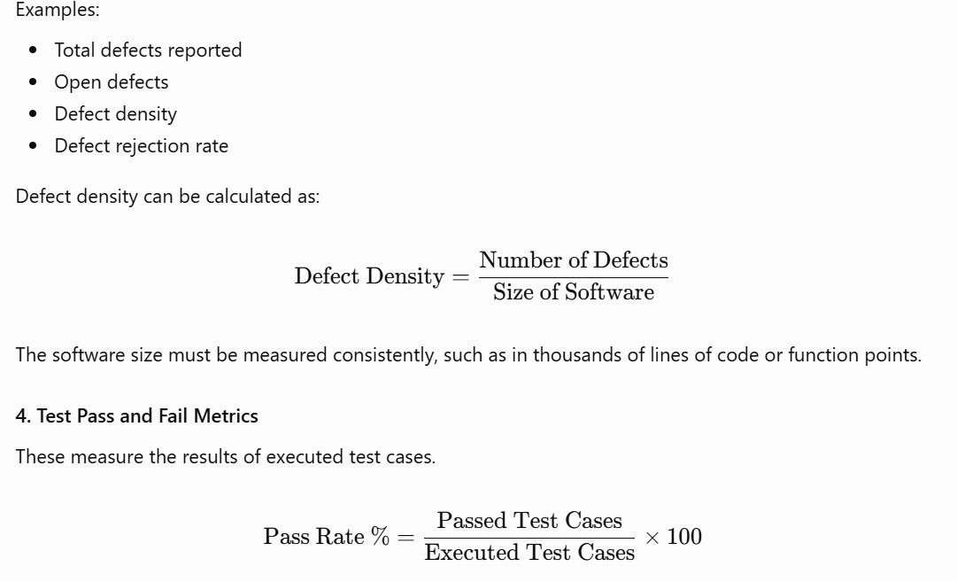
5. Defect Leakage
Defect leakage measures defects that were missed during testing and discovered later, such as after release. Organizations may use different formulas depending on their measurement policy.
6. Productivity Metrics
These measure the work completed by the testing team.
Example: Number of test cases designed or executed per tester per day.
7. Time-Based Metrics
These measure the time required to complete testing activities or resolve defects.
Example: Average defect resolution time.
Example
Suppose 100 test cases are executed, 90 pass, and 10 fail.
Conclusion: Different testing metrics help measure test progress, coverage, defect trends, and team performance. However, no single metric can fully describe software quality.

Q16. What are Test Case Design Techniques? Explain their importance in software testing.
Definition
Test Case Design Techniques are systematic methods used to select test inputs, conditions, and expected results for testing software.
They help testers design useful test cases without testing every possible input combination.
Major Test Case Design Techniques
1. Equivalence Partitioning
Divides input values into groups that are expected to behave similarly. A representative value from each group is selected for testing.
Example: If an age field accepts values from 18 to 60, valid values form one group, while values below 18 and above 60 form invalid groups.
2. Boundary Value Analysis
Focuses on the minimum and maximum limits of an input range because defects often occur at boundaries.
Example: For an allowed age range of 18–60, test 17, 18, 19, 59, 60, and 61.
3. Decision Table Testing
Uses a table to test different combinations of conditions and their resulting actions.
Example: Checking login behaviour for valid or invalid usernames and passwords.
4. State Transition Testing
Checks how software behaves when it moves from one state to another.
Example: An account becomes temporarily locked after a specified number of failed login attempts.
5. Use Case Testing
Designs test cases around user activities and real-world workflows.
Example: Testing the complete process of booking a ticket, from searching to payment and confirmation.
6. Error Guessing
Uses the tester's experience to predict where errors may occur.
Example: Entering blank values, special characters, or unusually long inputs.
Importance of Test Case Design Techniques
- Improve test coverage.
- Help detect defects efficiently.
- Reduce unnecessary test cases.
- Save time and effort.
- Improve the quality of test cases.
- Help test both normal and abnormal conditions.
Conclusion: Test case design techniques provide a structured way to select effective test cases and improve the chances of identifying defects.

Q17. What is Equivalence Partitioning? Explain with a suitable example.
Definition
Equivalence Partitioning is a black-box test design technique in which input data is divided into groups, called equivalence classes, that are expected to produce similar behaviour.
Instead of testing every possible input, the tester selects representative values from each group.
Example
Suppose a form accepts age values from 18 to 60 inclusive.
The input can be divided into three equivalence classes:
Equivalence Class | Input Range | Valid/Invalid
Class 1 | Below 18 | Invalid
Class 2 | 18 to 60 | Valid
Class 3 | Above 60 | Invalid
Representative test values can be selected as follows:
Test Case | Input | Expected Result
TC1 | 15 | Rejected
TC2 | 30 | Accepted
TC3 | 65 | Rejected
This reduces the number of test cases while covering the three main input classes.
Additional classes may be needed for non-numeric values, blank inputs, or other special conditions.
Copy-Paste Diagram
Age Input
|
+-- Below 18 --------> Invalid Class
|
+-- 18 to 60 --------> Valid Class
|
+-- Above 60 --------> Invalid Class

Conclusion: Equivalence Partitioning reduces testing effort by selecting representative inputs from groups that are expected to behave similarly.

Q18. What is Boundary Value Analysis? Explain with a suitable example.
Definition
Boundary Value Analysis (BVA) is a black-box test design technique that focuses on values at and around the boundaries of an input range.
It is based on the idea that defects often occur near minimum and maximum permitted values.
Example
Suppose an application accepts age values from 18 to 60 inclusive.
The important boundary values are 18 and 60.
For a standard boundary-value test set, we can select:
Test Case | Input | Expected Result
TC1 | 17 | Rejected
TC2 | 18 | Accepted
TC3 | 19 | Accepted
TC4 | 59 | Accepted
TC5 | 60 | Accepted
TC6 | 61 | Rejected
These values test just below, at, and just above both boundaries.
Conclusion: Boundary Value Analysis is useful for identifying errors in minimum and maximum limits, especially in forms, numeric fields, and range-based calculations.

Q19. Differentiate between Equivalence Partitioning and Boundary Value Analysis.
Equivalence Partitioning and Boundary Value Analysis are both black-box testing techniques. They help reduce the number of test cases while identifying potential defects.
Basis | Equivalence Partitioning | Boundary Value Analysis
Meaning | Divides inputs into equivalence classes | Focuses on values at and near boundaries
Main focus | Input groups | Minimum and maximum limits
Test selection | Representative value from each class | Boundary and neighbouring values
Best suited for | Inputs with distinct valid and invalid groups | Range-based inputs
Example | Testing age 15, 30, and 65 | Testing age 17, 18, 19, 60, and 61
Main benefit | Reduces tests by grouping similar inputs | Finds errors around limits
Relationship Between Both Techniques
Both techniques can be used together. Equivalence Partitioning checks representative values from different groups, while Boundary Value Analysis checks the edges of those groups.
Conclusion: Equivalence Partitioning focuses on groups of inputs, whereas Boundary Value Analysis focuses on values around the boundaries. Using both techniques improves test coverage.

Q20. What is Test Case Planning? Explain the steps involved in test case planning.
Definition
Test Case Planning is the process of deciding which test cases need to be prepared, what features they will cover, what data and resources they require, and how they will be organized and executed.
It helps ensure that the important software requirements are covered by suitable test cases.
Steps Involved in Test Case Planning
1. Requirement Analysis: Study the requirements and understand the expected behaviour.
2. Identify Test Scenarios: List the features and situations that need to be tested.
3. Define Test Conditions: Specify the conditions under which each feature will be tested.
4. Select Test Design Techniques: Choose suitable methods such as equivalence partitioning and boundary value analysis.
5. Prepare Test Data: Identify the inputs required for each test case.
6. Define Expected Results: Determine the correct output for each test.
7. Prioritize Test Cases: Give higher priority to critical and high-risk features.
8. Estimate Resources and Time: Determine the testers, tools, and time required.
9. Review Test Cases: Check that test cases are clear, complete, and traceable to requirements.
10. Organize and Maintain Test Cases: Store test cases properly and update them when requirements change.
Copy-Paste Flowchart
Requirement Analysis
|
v
Identify Test Scenarios
|
v
Define Test Conditions
|
v
Select Design Techniques
|
v
Prepare Test Data
|
v
Define Expected Results
|
v
Prioritize Test Cases
|
v
Review and Organize Test Cases
|
v
Execute and Maintain Test Cases

Example
For a college management system, test case planning may include student registration, login, attendance, fee payment, and result generation. Each feature is divided into scenarios, test data is prepared, and test cases are prioritized according to their importance.
Conclusion: Test case planning ensures systematic requirement coverage, proper prioritization, and efficient use of testing resources.
Quick Revision: Important Differences and Formulas
Topic | Key Point
Test Strategy | Overall testing approach
Test Plan | Detailed testing activities and responsibilities
Test Schedule | Timetable of testing tasks
Test Case | Steps, inputs, and expected result for checking a feature
Bug Report | Record describing a defect
Bug Life Cycle | Stages from defect reporting to resolution
Test Metrics | Measurements used to evaluate testing
Equivalence Partitioning | Select representative values from input groups
Boundary Value Analysis | Test values at and around limits
Important formulas
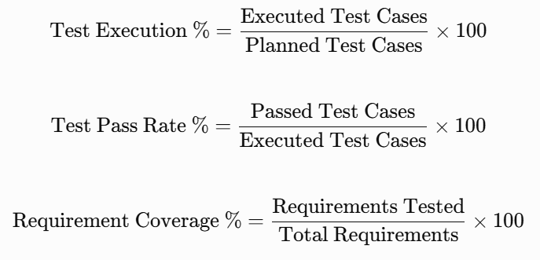
These answers are ready to copy into your assignment. The diagrams use plain text and arrows, so they can be pasted into Word; using a monospaced font such as Consolas or Courier New will help preserve their alignment.

