Figure-01: Post an ad to sell your car

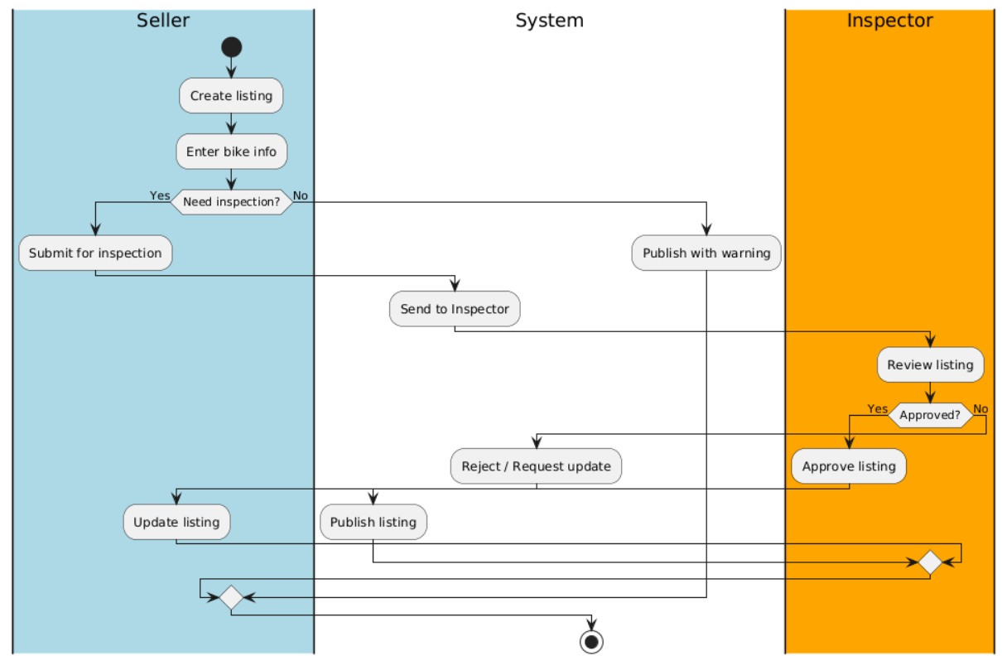Figure-01: Post an ad to sell your car

Figure-02: Buy a car + create an order
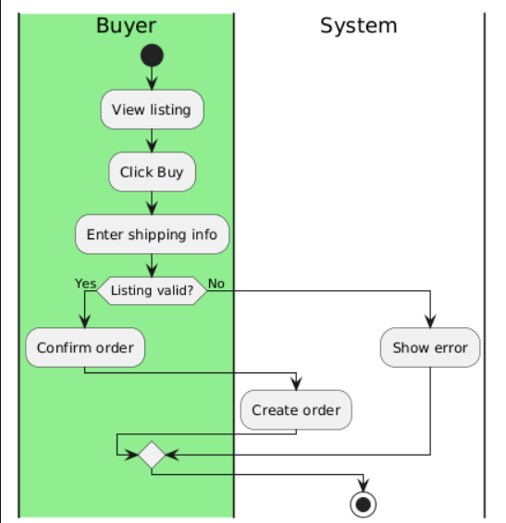
Figure-02: Buy a car + create an order

Figure-03: Payment
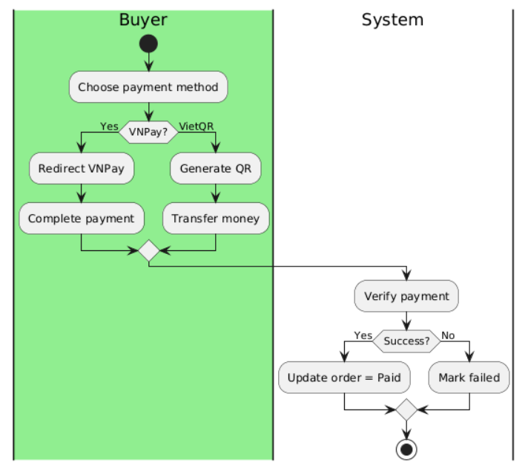
Figure-03: Payment

Figure-04: Shipment
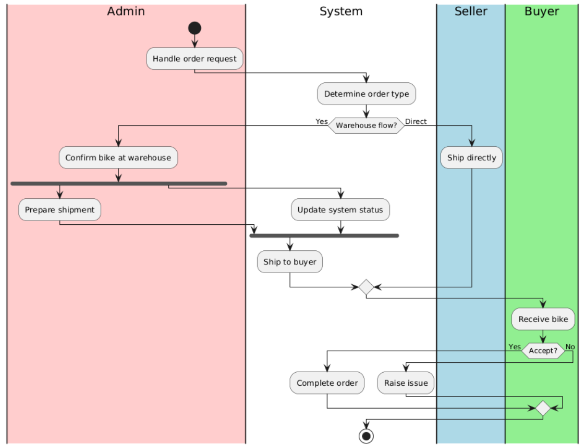
Figure-04: Shipment

Figure-05: Evaluate
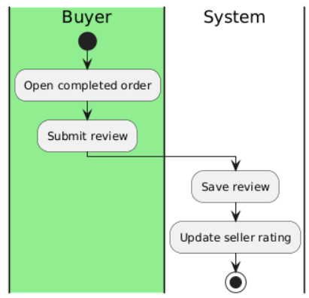
Figure-05: Evaluate

