TRAINING RESULTS REPORT
Facial Emotion Recognition – FER-2013
Training date (baseline) | 02/10/2026
Update date (improved configuration) | 05/10/2026
Environment | Kaggle Notebook – NVIDIA Tesla T4 GPU
Dataset | FER-2013 (msambare/fer2013)
Framework | PyTorch
Total run time (baseline) | ~68 minutes (4098 seconds)

Summary
This report presents the training and evaluation of two emotion recognition models on the FER-2013 dataset: M1 – Custom CNN (built from scratch) and M2 – a transfer learning model. In the first (baseline) run, M2 used MobileNetV2; after applying a series of improvements, M2 was upgraded to EfficientNet-B0 + CBAM.
Table 1. Main results on the test set
Model | Test Accuracy | Macro F1
Baseline – Custom CNN | ~52% | –
Baseline – MobileNetV2 | 67.7% | –
M1 – Custom CNN (final) | 64.85% | 0.6227
M2 – EfficientNet-B0 + CBAM (final) | 70.40% | 0.6893
Ensemble (M1 × 0.2 + M2 × 0.8) | 70.77% | 0.6938

The ensemble achieves the best result (70.77%), comfortably exceeding the minimum requirements (M1 ≥ 60%, M2 ≥ 65%). The Fear class remained the hardest class across all experiments.

1. Problem Overview

1.1. The FER-2013 Dataset
- 7 emotion classes: angry, disgust, fear, happy, neutral, sad, surprise.
- Training set: 28,709 images; test set: 7,178 images.
- Image size: 48×48 pixels, grayscale.
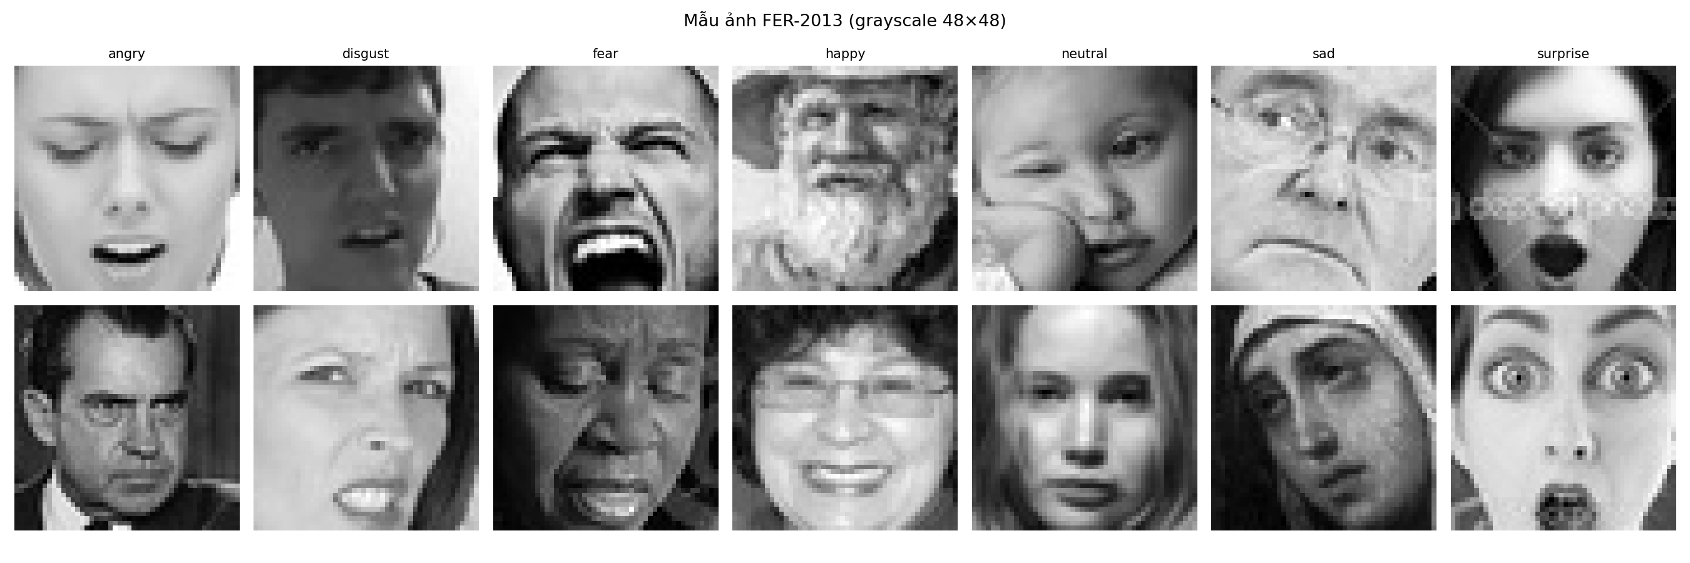
Figure 1. FER-2013 sample images (grayscale 48×48) for each emotion class

1.2. Key Characteristics of the Dataset
- Severe class imbalance: happy is the largest class (7,215 training images), while disgust is extremely small (436 images) – roughly a 16.5× difference.
- Noisy labels: even human annotators agree on only about 65–70% of labels.
- Small, low-quality images: 48×48 grayscale images make transfer learning from ImageNet difficult, since ImageNet models are trained on larger RGB images.
Table 2. Number of images per class
Class | angry | disgust | fear | happy | neutral | sad | surprise
Train | 3,995 | 436 | 4,097 | 7,215 | 4,965 | 4,830 | 3,171
Test | 958 | 111 | 1,024 | 1,774 | 1,233 | 1,247 | 831
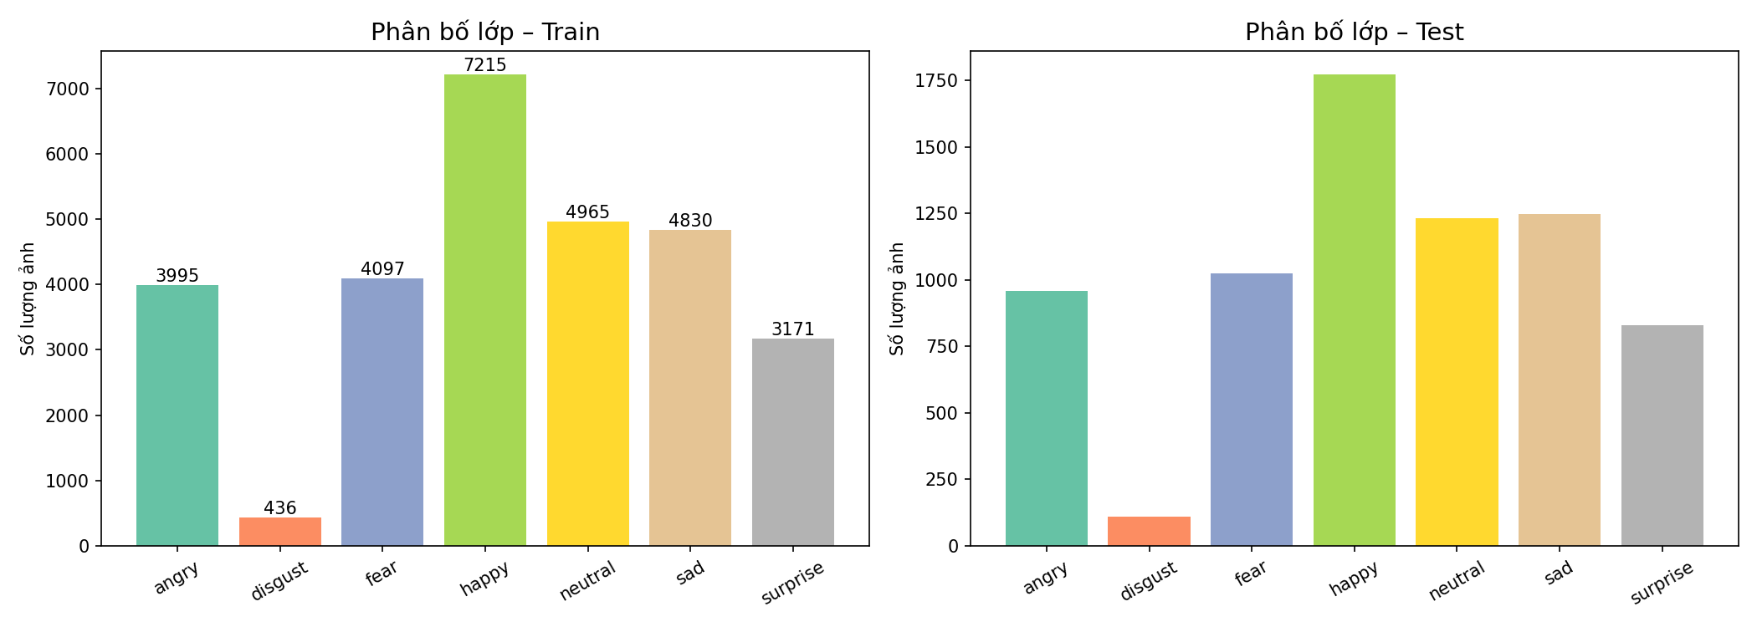
Figure 2. Class distribution on the training set (left) and test set (right)

2. Architecture and Methodology

2.1. Model 1 – Custom CNN (M1)
- CNN built from scratch: multiple Conv2D → BatchNorm → ReLU → MaxPool blocks.
- Classifier head with Dropout to limit overfitting.
- Optimizer: Adam (lr = 1e-3, weight_decay = 1e-4); scheduler: ReduceLROnPlateau (patience = 5, factor = 0.5).
- Parameters: 1,321,191.

2.2. Model 2 – Baseline: MobileNetV2 (Transfer Learning)
- Pretrained on ImageNet.
- Phase 1 (10 epochs): freeze the entire backbone, train only the classifier head – Adam (lr = 1e-3).
- Phase 2 (20 epochs): unfreeze the whole backbone and fine-tune – Adam (lr = 1e-4, weight_decay = 1e-4) + CosineAnnealingLR.

2.3. Model 2 – Final Configuration: EfficientNet-B0 + CBAM
After analyzing the problems of the baseline (see Section 5), the proposed improvements were implemented and validated over multiple training runs:
Table 3. Techniques applied in the final configuration
Technique | Implementation details
M2 backbone | Switched from MobileNetV2 to EfficientNet-B0 (4,542,693 parameters)
Attention | Added CBAM (Channel + Spatial Attention) after backbone.features, before the classifier
Gradual Unfreeze | 3 phases: (1) freeze backbone – 10 epochs; (2) unfreeze blocks 6–8 – 15 epochs; (3) unfreeze everything – 20 epochs
Learning rate | Phase 3 reduced to 5e-5 (instead of 1e-4) + CosineAnnealingLR
Weight decay | Tuned 5e-4 → 1.5e-3 → 1e-3; 1.5e-3 slightly lowered the score, so 1e-3 was kept
Label Smoothing | Applied in CrossEntropyLoss, combined with class_weights
Data Augmentation | RandomHorizontalFlip, RandomRotation (10°), ColorJitter; RandomErasing kept for M1 but removed from M2 because it reduced the score
Mixup | Applied in Phases 2 and 3 of M2 (alpha = 0.2); train accuracy is computed with the lam weighting so the curves reflect reality
Early Stopping | Separate patience per phase (4–7 depending on phase)
OHEM | Tried in Phase 3 (top 70% highest-loss samples per batch) – no improvement and increased overfitting (train–val gap up to 7.4%), so it was removed
Ensemble | Weighted combination of the softmax probabilities of M1 + M2, no retraining required

2.4. Handling Class Imbalance
Both models use CrossEntropyLoss with weight = class_weights, where the weights are computed from the class distribution of the training set.

3. Training Process

3.1. Baseline (trained on 02/10/2026)

a) Custom CNN – 30 epochs
Table 4. Training progress of Custom CNN (baseline)
Epoch | Train Loss | Val Loss | Train Acc | Val Acc
1 | 1.9654 | 1.9207 | 17.33% | 27.07%
5 | 1.8935 | 1.8382 | 26.16% | 32.11%
10 | 1.8432 | 1.7806 | 28.67% | 32.72%
15 | 1.8030 | 1.7547 | 28.95% | 34.37%
20 | 1.7508 | 1.6593 | 23.18% | 35.59%
25 | 1.5573 | 1.4047 | 38.45% | 45.29%
30 | 1.4071 | 1.2447 | 45.69% | 52.69%

Best Val Accuracy: 52.69%. Observations:
- The model learned very slowly during the first 20 epochs (val acc only around 32–38%), then rose sharply between epochs 20 and 30 (35% → 52%).
- Val acc > train acc in many epochs (e.g. epoch 21: train 26.34% vs val 41.60%) indicates severe underfitting – the CNN lacks capacity.
- Loss was still decreasing at epoch 30, so more epochs could help, but the architecture is too simple.

b) MobileNetV2 – Phase 1: classifier only (10 epochs)
Table 5. Training progress of MobileNetV2 – Phase 1 (baseline)
Epoch | Train Loss | Val Loss | Train Acc | Val Acc
1 | 1.7848 | 1.7951 | 29.49% | 26.76%
5 | 1.6697 | 1.7242 | 33.93% | 30.87%
10 | 1.6301 | 1.6424 | 35.78% | 34.98%

Best Val Accuracy Phase 1: 37.36%. The modest result is explained by the backbone being pretrained on 224×224 RGB images, while FER-2013 consists of small 48×48 grayscale images, so the backbone features do not fully match the new domain; val acc fluctuated and was unstable.

c) MobileNetV2 – Phase 2: full fine-tuning (20 epochs)
Table 6. Training progress of MobileNetV2 – Phase 2 (baseline)
Epoch | Train Loss | Val Loss | Train Acc | Val Acc
1 | 1.3932 | 1.2507 | 47.69% | 52.24%
2 | 1.1640 | 1.0891 | 56.44% | 58.41%
3 | 1.0475 | 0.9988 | 60.25% | 62.25%
5 | 0.8997 | 0.9658 | 65.01% | 64.11%
8 | 0.7681 | 0.9323 | 69.37% | 66.58%
10 (best) | 0.7004 | 0.9255 | 72.36% | 67.69%
12 | 0.6257 | 0.9739 | 75.08% | 66.66%
15 | 0.5290 | 1.0017 | 78.93% | 66.80%
18 | 0.4340 | 1.0826 | 82.87% | 67.04%
20 | 0.4078 | 1.1721 | 84.09% | 67.07%

Best Val Accuracy Phase 2: 67.69% (epoch 10). Observations:
- Unfreezing the whole backbone produced an immediate jump: from 37.36% to 52.24% after just one epoch.
- Clear overfitting from epoch 11: train acc kept rising (73.29% → 84.09%) while val acc stayed flat and fluctuated; val loss increased from 0.9255 to 1.1721 while train loss kept falling.
- The train–val gap at the end of Phase 2 is about 17%, a sign of severe overfitting.

3.2. Final Configuration (updated 05/10/2026)
This section shows the loss/accuracy curves per epoch for both models after applying the improvements from Section 2.3.

a) M1 – Custom CNN
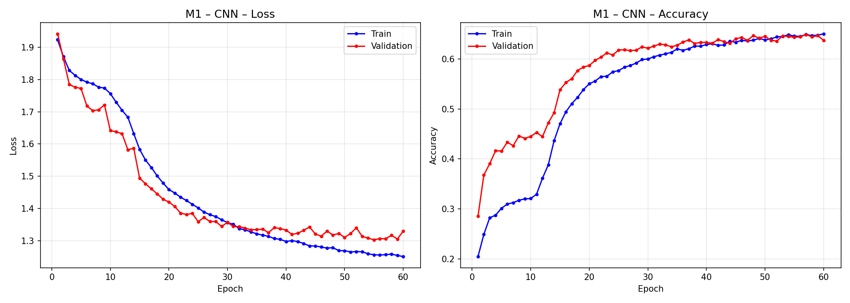
Figure 3. Loss and Accuracy curves of M1 – Custom CNN over 60 epochs
Observations from the curves:
- Val accuracy rises quickly over roughly the first 15 epochs, then slows and converges around 0.64–0.65; the test result is 64.85% (vs ~52% for the baseline).
- The train and validation curves track each other closely throughout (train acc ~0.65, val acc ~0.64 at epoch 60), with no sign of overfitting.
- Val loss plateaus around ~1.30–1.33 from about epoch 40 with slight fluctuation, while train loss keeps decreasing slowly (~1.25) – M1 is close to the ceiling of its architecture.

b) M2 – EfficientNet-B0 + CBAM
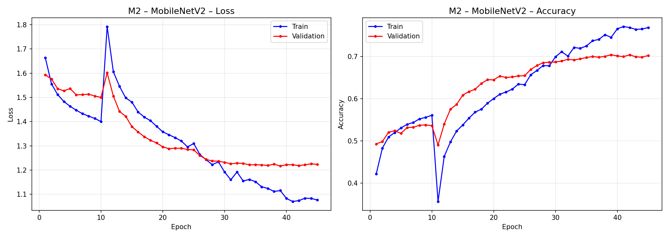
Figure 4. Loss and Accuracy curves of M2 over 45 epochs
Note: the original figure title reads "MobileNetV2"; the data shown corresponds to the final M2 configuration (EfficientNet-B0 + CBAM).
Observations from the curves:
- During epochs 1–10 (frozen backbone), val accuracy only reaches about 0.49–0.54.
- At epoch 11 (partial unfreezing begins), train loss jumps to ~1.79 and train accuracy drops to ~0.36. This is the "shock" of unlocking layers, but the model recovers within a few epochs and clearly surpasses its previous level.
- Afterwards, val accuracy rises steadily and saturates around 0.70 (from roughly epoch 35–40); val loss stabilizes at ~1.22.
- Train accuracy continues to ~0.77, giving a train–val gap of about 7% – mild overfitting, much lower than the MobileNetV2 baseline (~17%). This shows the effect of Gradual Unfreeze, a smaller learning rate, Label Smoothing, Mixup and augmentation.

4. Test Set Evaluation

4.1. Model Comparison
Table 7. Final results on the test set
Model | Test Acc | TTA | Macro F1 | Params | FPS (GPU)
M1 – Custom CNN | 64.85% | 65.51% | 0.6227 | 1,321,191 | 960.6
M2 – EfficientNet-B0 + CBAM | 70.40% | 70.20% | 0.6893 | 4,542,693 | 557.1
Ensemble (M1 × 0.2 + M2 × 0.8) | 70.77% | – | 0.6938 | – | –

Compared with the MobileNetV2 baseline (67.69%), the new M2 reaches 70.40% (+2.71 percentage points) and the ensemble reaches 70.77% – the best result across all experiments.

4.2. Classification Report – M2 (EfficientNet-B0 + CBAM)
Table 8. Per-class precision, recall and F1-score of M2
Class | Precision | Recall | F1-score | Support
Angry | 0.61 | 0.64 | 0.63 | 958
Disgust | 0.70 | 0.70 | 0.70 | 111
Fear | 0.61 | 0.51 | 0.55 | 1,024
Happy | 0.89 | 0.88 | 0.89 | 1,774
Neutral | 0.63 | 0.71 | 0.67 | 1,233
Sad | 0.60 | 0.56 | 0.58 | 1,247
Surprise | 0.79 | 0.83 | 0.81 | 831
Accuracy |  |  | 0.70 | 7,178
Macro avg | 0.69 | 0.69 | 0.69 | 7,178
Weighted avg | 0.70 | 0.70 | 0.70 | 7,178

Total misclassified images: 2,125 / 7,178 (29.6%). Happy (F1 = 0.89) and Surprise (F1 = 0.81) are recognized best; Fear is the weakest (F1 = 0.55), followed by Sad (F1 = 0.58).

4.3. Confusion Matrices
The confusion matrices are row-normalized (each row is the true class and sums to 1), so the diagonal values are the per-class recall.
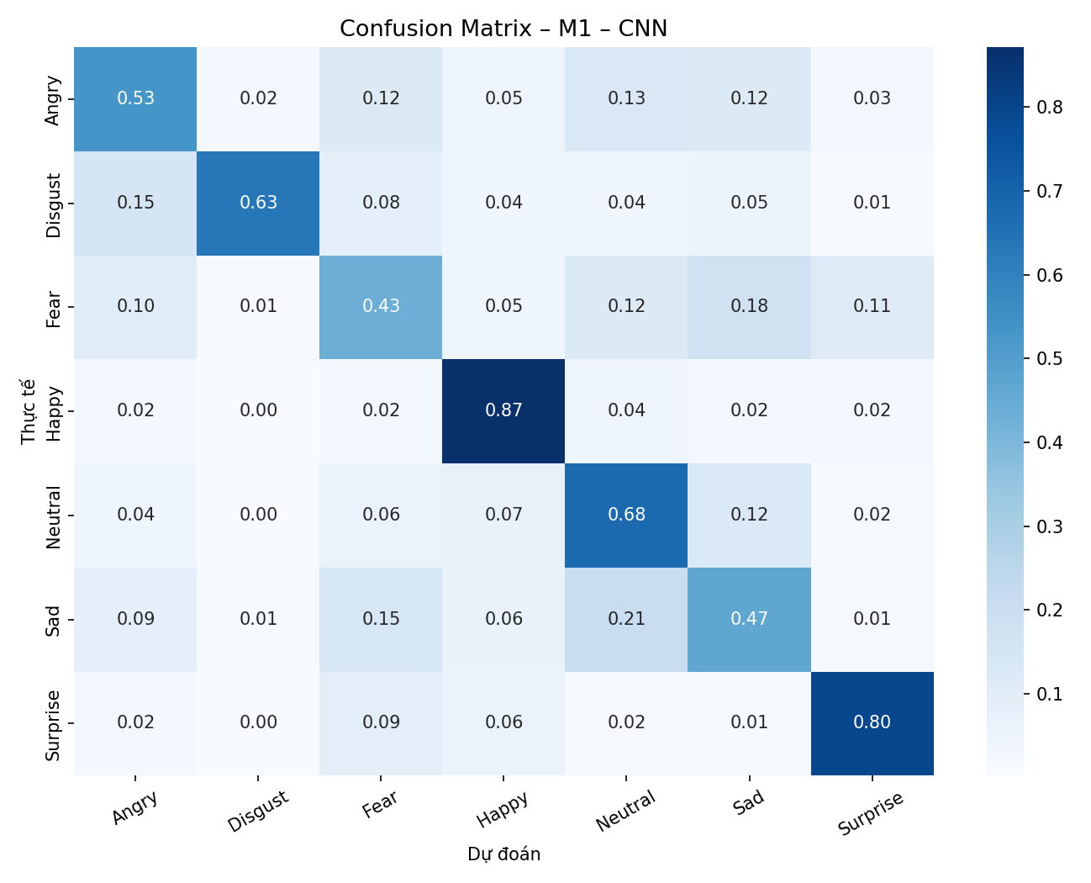
Figure 5. Confusion matrix of M1 – Custom CNN
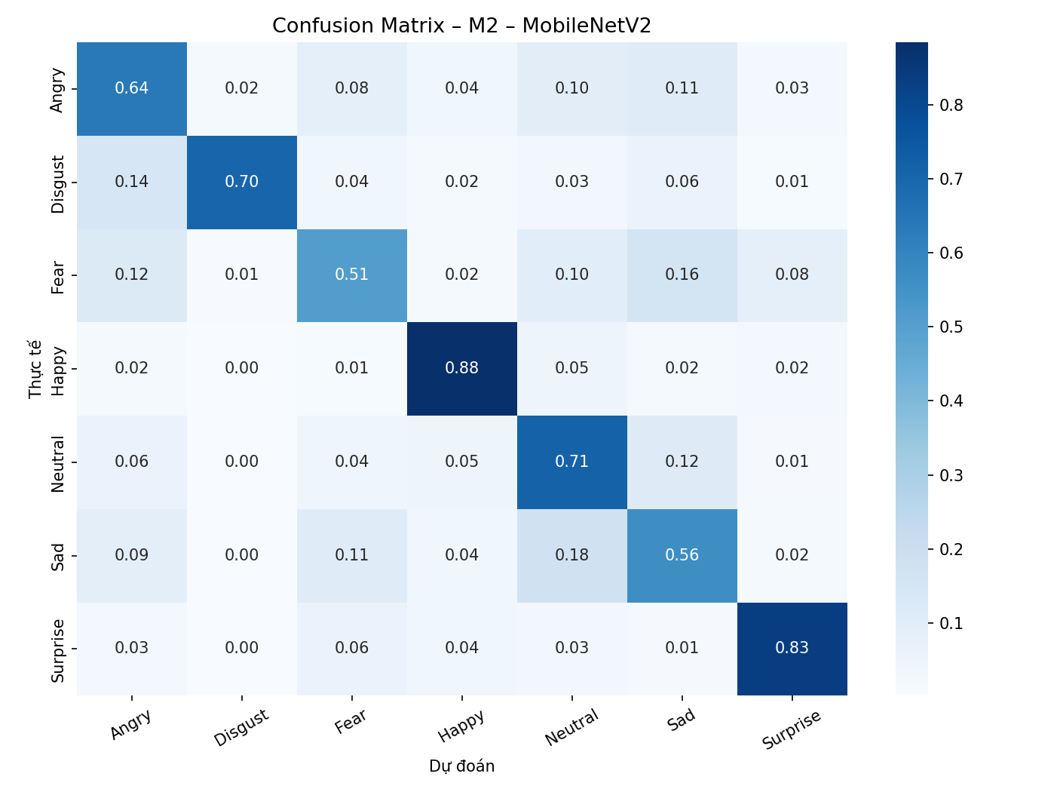
Figure 6. Confusion matrix of M2 – EfficientNet-B0 + CBAM
Note: the original figure title reads "MobileNetV2"; the data shown corresponds to the final M2 configuration (EfficientNet-B0 + CBAM).
Observations:
- M2 has higher diagonal recall than M1 on most classes: Angry 0.64 vs 0.53, Fear 0.51 vs 0.43, Sad 0.56 vs 0.47, Neutral 0.71 vs 0.68. Both models are strongest on Happy (~0.87–0.88) and Surprise (0.80–0.83).
- Fear is often confused with Sad (0.16), Angry (0.12) and Neutral (0.10); Sad is confused with Neutral (0.18) and Fear (0.11). These emotions have overlapping facial expressions.
- Disgust, despite only 111 test images, reaches 0.70 recall thanks to class_weights; its main error is confusion with Angry (0.14).

4.4. Analysis of Misclassified Images
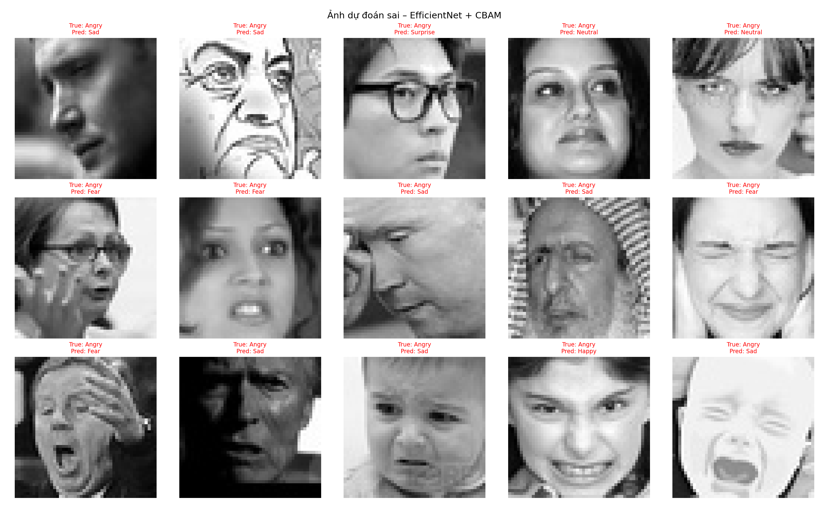
Figure 7. Fifteen images with true label Angry misclassified by M2 (EfficientNet + CBAM)
Among the 15 illustrated images (all of the Angry class), the model predicted Sad (7 images), Fear (4), Neutral (2), Surprise (1) and Happy (1). Many images are genuinely hard or have questionable labels: hand-drawn/caricature faces, profile or occluded faces, very dark images, a crying baby, a yawning face. This supports the view that the limit on performance comes from data quality (noisy labels) more than from the model architecture.

5. Problem Analysis

5.1. Overfitting of MobileNetV2 – Phase 2 (baseline)
Symptoms:
Epoch | Train Acc | Val Acc | Gap | Assessment
10 | 72.36% | 67.69% | 4.67% | Best point
20 | 84.09% | 67.07% | 17.02% | Overfitting

Causes:
- The Phase 2 learning rate (1e-4) is still fairly large when unfreezing the whole backbone, which "breaks" the pretrained features.
- Insufficient data augmentation, so the model memorizes training samples instead of learning general patterns.
- FER-2013 has noisy labels, so the model also learns wrong labels.
- Too many Phase 2 epochs: best val acc was reached at epoch 10, but training continued to epoch 20.

5.2. Underfitting of Custom CNN (baseline)
- At epoch 21: train 26.34% vs val 41.60%; at epoch 30: train 45.69% vs val 52.69% – the model had not learned enough from the training data.
- Causes: the architecture is too simple, 48×48 grayscale images carry little information, and class_weights may alter the gradient distribution during training.

5.3. Gap Versus Initial Expectations
The actual results (70.40% – 70.77%) fall short of the initial expected range (~74–76%). Main reasons:
- Focal Loss was not implemented – a proposal with potential to improve rare/hard classes (disgust, fear) that remains untested.
- Mild overfitting remains in Phase 3 – train acc ~77% vs val ~70%, leaving room for better regularization.
- Many configurations converged to the same ~70.0–70.6% ceiling despite changes in weight_decay, epochs or Mixup – suggesting the current architecture is near its limit given the available data and techniques.
- The 74–76% expectation was estimated before actual experiments and is only indicative. Note that state-of-the-art on FER-2013 (~75–76%) is achieved with very complex architectures and ensembles of many models.

6. Local Application Deployment and Testing
After training and saving the weights, the local system was synchronized and tested on 05/10/2026.

6.1. Modules
- src/model.py: synchronizes the EmotionCNN and EmotionEfficientNetCBAM architectures (with CBAM Attention), supporting flexible loading of both weight sets.
- src/detector.py: integrates the YuNet ONNX face detector (face_detection_yunet_2023mar.onnx), compatible with OpenCV 5.0.0, faster and more accurate than the traditional Haar Cascade.
- src/predict.py: converts BGR → RGB → Grayscale/ImageNet transform → PyTorch inference → Softmax confidence.
- src/app.py: the main application, supporting static images (run_image) and a realtime stream (run_stream).

6.2. Configuration
- config.yaml: automatically picks up the IP camera URL or the local webcam (--source 0).
- Confidence threshold: 0.4 (40%).
- Optimized frame settings: 640×480, target_fps = 20, buffer_size = 1 (prevents lag and camera buffer build-up).

6.3. Test Results
- Static image: YuNet correctly detected 4/4 faces in the test image. The EfficientNet + CBAM model classified well and was more sensitive on hard faces (confidence 60.2% and 47.0%, while the CNN fell below the 40% threshold).
- Realtime (webcam / IP camera): ran successfully with python src/app.py --model transfer; displays the bounding box, emotion label, confidence percentage and realtime FPS.

7. Conclusion and Future Work
After implementing all feasible proposals (except Focal Loss), M2 was upgraded from MobileNetV2 (67.7%) to EfficientNet-B0 + CBAM (70.40%), and the M1 + M2 ensemble reaches 70.77% – the best result. M1 also improved from ~52% to 64.85%. Gradual Unfreeze and the backbone change contributed the most; Hard Negative Mining (OHEM) was tried but was ineffective, most likely because noisy labels cause the "high-loss" sample selection to pick up mislabeled samples.
The results exceed the minimum requirements (M1 ≥ 60%, M2 ≥ 65%). Next steps:
- Implement Focal Loss to improve rare and hard classes (Disgust, Fear).
- Handle the easily confused group (Fear / Sad / Angry) separately.
- Try a larger architecture (e.g. EfficientNet-B2) or add real data rather than relying on augmentation alone.
- Clean the noisy labels of FER-2013 to raise the accuracy ceiling.

Appendix: Output Files
File | Description
model_cnn.pt | Custom CNN weights
model_mobilenet.pt | EfficientNet-B0 + CBAM weights (old name kept for compatibility with existing code)
model_efficientnet_cbam.pt | Copy of model_mobilenet.pt with a clearer name
class_distribution.png | Class distribution chart of the dataset
confusion_matrix.png | Confusion matrices of both models
training_curves_cnn.png | Loss/accuracy curves of the CNN
training_curves_mobilenet.png | Loss/accuracy curves of M2
wrong_predictions.png | 15 misclassified images of M2

