**Team Number:** 17-03

**Team Name:**

People Who Like to Eat

**Team Members:**

|  |  |  |
| --- | --- | --- |
| **Name** | **Github** | **E-mail** |
| Aditya Ahuja | cuadah9183 | [adah9183@colorado.edu](mailto:adah9183@colorado.edu) |
| Maxwell Meiser | maxwmeiser | maxwell.meiser@colorado.edu |
| Ash Young | ash-yo | amyo4457@colorado.edu |
| Saphire Young | ha-neul-yo | [saphire.young@colorado.edu](mailto:saphire.young@colorado.edu) |

**Application Name:**

Nutrilog

**Application Description:**

Our application’s primary feature will be a daily log/calendar for tracking meals and nutrition. The user will be able to register and login to our website, and the meals previously logged will be associated with the user’s account. On the homepage of our website the user will be able to access all other parts of our application, and our homepage will display additional information about nutrition. On the homepage, the user will be able to log meals for the current day.

The user will be able to see the history of their logged meals on a separate page. The user will be able to add preset meals specific to their account. When a preset meal is used in a log, all the information of the meal will automatically populate in the log form. A meal log will record the Calories, Protein, Fiber, and Sodium content of the meal, as well as the date and the general time that the meal was consumed.

**Vision Statement:**

For people who want to track their nutrition and practice more mindful eating habits. Our application will attempt to make users more aware of what they are eating and help them stay committed to a specific goal they are trying to achieve via nutrition.

**Version Control:**

https://github.com/cuadah9183/csci3308project.git

**Development Methodology:**

https://github.com/users/cuadah9183/projects/1/views/1

**Communication Plan:**

We will be using Discord to communicate.

**Meeting Plan:**

Team Meeting: Tuesdays at 12 PM MST (Discord)

Weekly Meeting With TA: Wednesday November 2, 9:40 AM MST

**Use Case Diagram:**

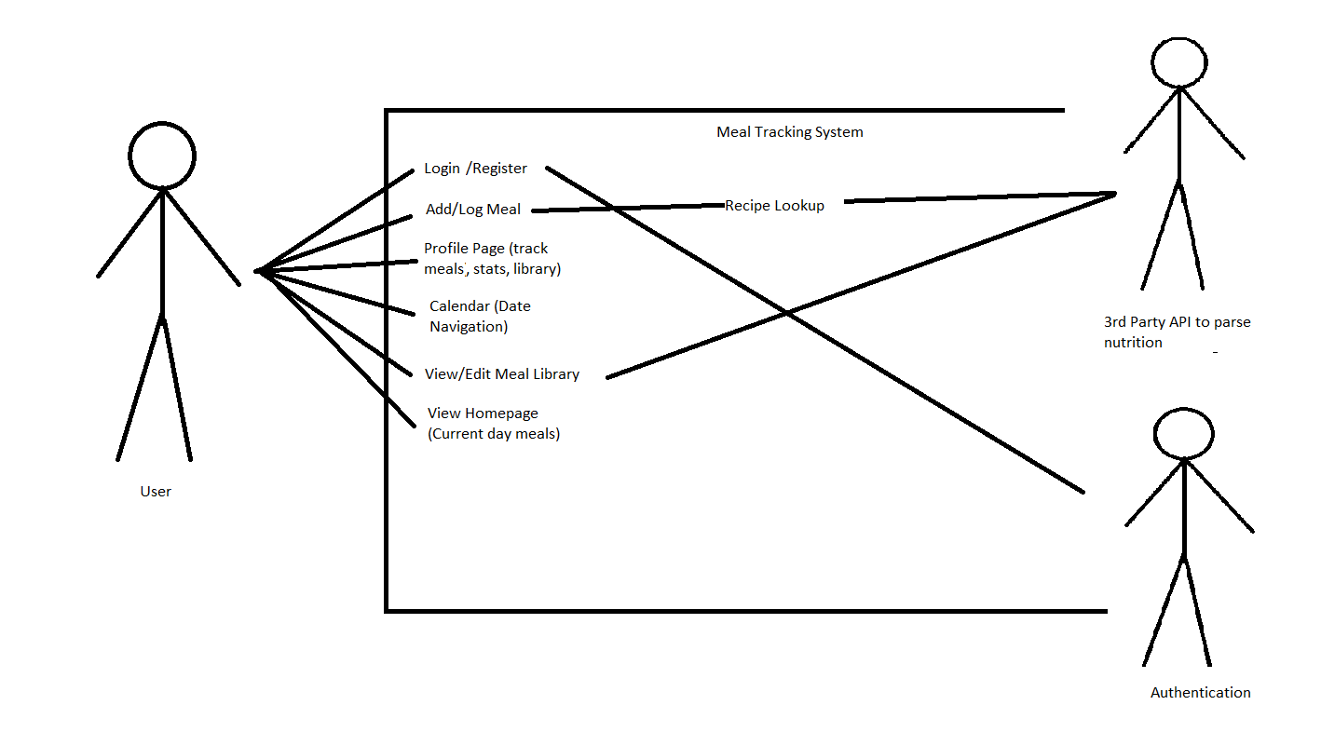

**Wireframes:**

[Figma Wireframe](https://www.figma.com/file/oUsLPn55Eehb8XzsjYhAaD/NutriLog-Wireframe?node-id=0%3A1)