QSound™ For The Atari Jaguar

QSound is a patented, innovative process for generating a sound field that is not bound to the playback speakers. It requires only traditional stereo playback equipment for reproduction, and provides enhanced audio imaging capabilities with startling contrasts.

Using the QSound process, sound sources can be placed in "virtual space": an arc approximately ±90 degrees in front of the listener, well outside the speakers. The QSound pan positions which map this space are numbered 0 (far left) to 32 (far right).

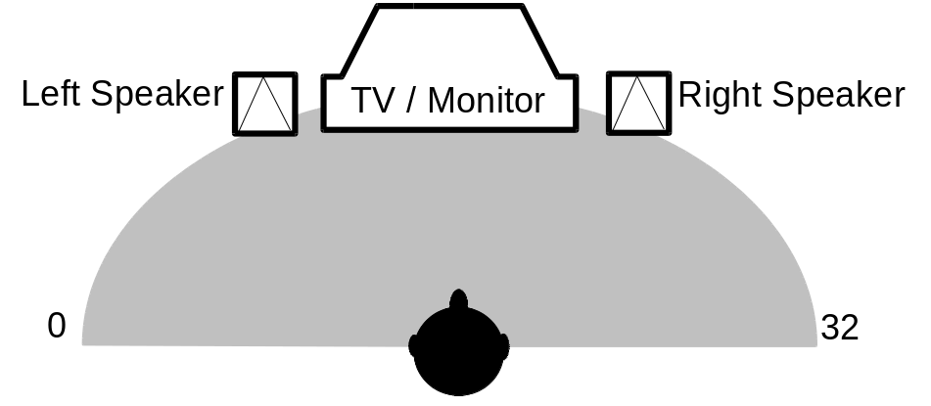

For game developers, QSound provides a rich environment for audio interfacing. For example, enemy fire can be heard in QSpace before the enemy appears on the screen; missiles launched off an F-16 jet fighter can be heard to drop off the wing tip before they race off into the distance; when you drive or fly past an explosion, it can appear to move beyond the player; background music can be given extra ambiance and depth.

Using QSound For Jaguar

There are two ways of using QSound for Atari Jaguar games:

1. For sounds which can be preprocessed and require no dynamic control of position, the QSystem II or Qcreator can be used. The QSystem is a post production mixing system which results in stereo output. QCreator is a software tool which runs under Microsoft Windows and allows developers to QSound process mono samples in AIFF, RIFF, and raw sample formats. Again, the result is a stereo sample. For more information, contact QSound directly at the address given at the end of this section.

2. For sounds which are to be panned dynamically at runtime, The Q1 module has been implemented on the Jaguar DSP. The rest of this document deals with the Q1 module.

The implementation of the dynamic Q1 module on the Atari Jaguar system can be viewed as a black box with a single entry point: the QSound function. The QSound module can process up to eight independently panned mono voices. Regardless of the number of inputs, the output is always a stereo stream, which may be mixed with other stereo data before it is played back through the I2S interface.

Note: There is no internal volume scaling of the input samples within the QSound module. It is the responsibility of the caller to do the required volume scaling of voices to ensure that overflow does not occur.

The QSound process is dependent on the sampling rate. The current implementation is for the default sampling rate of the DSP, which is a shade under 22050 Hz (SCLK set to #19). If you are running at any other sample rate, then please contact QSound Labs and we will provide an appropriately adjusted module for your desired sample rate.

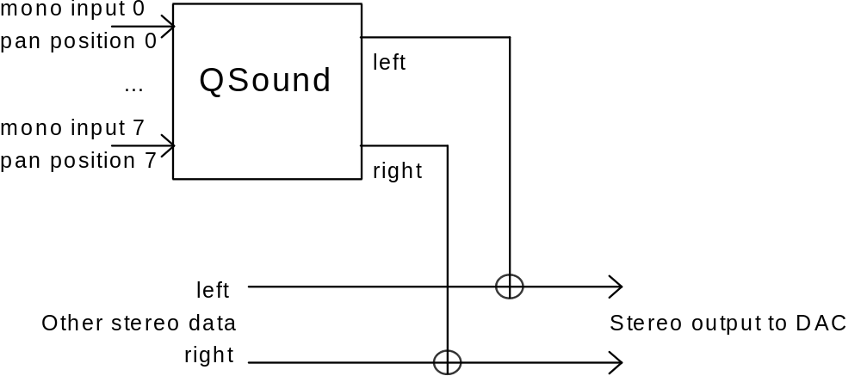

Descriptions of the routine follows. For further information or technical help, please contact Buzz Burrowes at QSound.

The QSOUND.OT Module

The file QSOUND.OT is a linkable object module containing the QSound routines. This file must be linked with your program, and at runtime, the routines must be loaded into Jaguar’s DSP. It has a single entry point which is documented below. See the documentation on the sample program for more information.

The QSound module is designed to be completely position-independent. You can load it anywhere in DSP memory where room is available. Usually, it follows with other DSP code supplied by you which feeds samples to the QSound module. See the demo program for an example.

QSound Function

Summary:

The QSound function is called every sample period in which at least one QSound voice is active. Typically this means once per sample (typically 22050 times per second).

Input:

r16 = return address

r17 = number of QSound voices to process (1 to 8)

r18 = Pointer to an array of structures which define the input sample and pan position for each voice. The structures look like this:

struct QSound_Voice /* Values use only low 16 bits of LONG */
{
long sample; /* Sample to be processed */
long pan_position; /* values from 0 (left) to 32 (right) */
}

Output:

r20 = left channel of stereo output (32 bits) ready to be fed to Jaguar’s I2S interface

r22 = right channel of stereo output (32 bits) ready to be fed to Jaguar’s I2S interface

Register Usage:

uses r12 through r27

Notes:

Requires/uses about (140 + (27 * num_voices)) instructions.

Example:

; copy 16 bit inputs to #samples

load QSound_ptr,r5 ; Get stored address where we put QSound module
movei #After,r16 ; return address for QSound
movei #1,r17 ; number of voices
jump T,(r5) ; call QSound module
move #toQSound,r18 ; r18 -> input samples/pan pairs
After:
shrq #16,r20 ; outputs in 16 bits for I2S Interface
shrq #16,r22
... ; store results for processing at next I2S interrupt

toQSound: ; up to 8 consecutive 2*32 bit locations
.ds.l 1 ; voice 0 sample
.ds.l 1 ; pan position for voice 0

.ds.l 1 ; voice 1 sample
.ds.l 1 ; pan position for voice 1

.ds.l 1 ; voice 2 sample
.ds.l 1 ; pan position for voice 2

.ds.l 1 ; voice 3 sample
.ds.l 1 ; pan position for voice 3

.ds.l 1 ; voice 4 sample
.ds.l 1 ; pan position for voice 4

.ds.l 1 ; voice 5 sample
.ds.l 1 ; pan position for voice 5

.ds.l 1 ; voice 6 sample
.ds.l 1 ; pan position for voice 6

.ds.l 1 ; voice 7 sample
.ds.l 1 ; pan position for voice 7

How To Contact QSound Labs

QSound Labs Inc. Tel: (403) 291-2492
2748 - 37 Ave N.E. Fax: (403) 250-1521
Calgary, AB, Canada
T1Y 5L3

Buzz Burrowes Tel: (310) 374-8017
QSound Labs, Inc. Fax: (310) 374-0998
2521 Ripley Avenue
Redondo Beach, CA 90278

Notice

QSound technology is protected by patent and copyright laws. Its use on the Atari Jaguar system is restricted to, and subject to, the licensing agreement signed with Atari.

All third parties interested in using QSound in Jaguar applications should check with Atari regarding this licensing agreement.

QDEMO - QSound Demo Program

The QDEMO program demonstrates how to use the QSound module to play back different samples and position them in 3D-space in real-time. You use the joypad to control the location of the sounds in 3D-space.

Below is a list of all the files which make up the QSound demo program. In order to reduce the size of the archive containing the demo, the executable program itself is not provided; the project must be built using the tools in your Jaguar developer’s kit.

Filename | Description
MAKEFILE | Used with MAKE utility to build executable program file from source code and data files.
QPANNER.DAS | MADMAC Source code file containing DSP interrupt routines and demo program’s interface to QSound function.
VIDSTUFF.INC | MADMAC include file containing miscellaneous equates used by the demo program’s object list setup
QSOUND.INC | MADMAC include file containing declarations of labels in QSOUND.OT module
QDEMO.LNK | ALN linker include file specifying names of files to be linked into demo program.
QSOUND.OT | This is a BSD-format object module containing QSound routines. Linked with demo program or with your own program to provide the QSound capabilities.
DEMO.S | This is the main code for the demo program. This displays the picture, reads the joystick and cooks the values for the QSPanner routine.
JLISTER.S | Part of the demo program shell. The routines in this file set up the program’s object list.
VIDINIT.S | Part of the demo program shell. The routines in this file set up the program’s video display.
QDEMO.S | Part of the demo program shell. This file does the basic startup and initialization routines, and then calls the routine in DEMO.S.
CLEARJAG.S | Part of the demo program shell. The routines in this file use the blitter to clear the bitmap memory that will be used by the picture that gets displayed.
JOYPAD.S | This file contains the joystick reading routines used by the program
INTSERV.S | This is part of the demo program shell. The routines in this file set up the program’s object list.
VALOGO16.PIC | Binary image of picture to be displayed by demo program. This is a raw image file containing no header. The image itself is 320 pixels wide by 200 pixels tall, 16-bit Jaguar RGB format. Included at link stage by using -ii option of ALN.
MIX3.SND | Sound file used by the program (the explosion). This is a raw 16-bit mono sound sample file (sample rate about 20khz). Included at link stage by using -ii option of ALN.
COPTER.SND | Sound file used by the program (the helicopter). This is a raw 16-bit mono sound sample file (sample rate about 20khz). Included at link stage by using -ii option of ALN.
PHASER.SND | Sound file used by the program (the gunshot). This is a raw 16-bit mono sound sample file (sample rate about 20khz). Included at link stage by using -ii option of ALN.

Below is a more in-depth description of some of the main files from this demo program. The files QDEMO.S, INTSERV.S, JLISTER.S, CLEARJAG.S, VIDINIT.S, and VIDSTUFF.INC are all part of a basic Jaguar program shell which is also used by some of the other sample programs included with the Jaguar development system. They take care of the basic program initialization, initializing system video, setting up an object list, clearing the picture’s bitmap memory, etc. Although they have been modified slightly to meet this demo’s specific requirements, they are basically the same files and routines which are used by JAGMAND, TESTRGB, TESTJPG, and other sample programs provided with the Jaguar’s development kit. They will be discussed here only superficially.

QDEMO.S

This file is where the program execution begins. The program is initialized, then our main program function is called. Below is the short version, minus some of the comments:

move.l #$00070007,G_END ; Set GOOD mode for GPU
move.l #$00070007,D_END ; Set GOOD mode for DSP
move.w #$FFFF,VI ; Disable all 68K interrupts, including VI
move.l #INITSTACK,a7 ; Put the stack at the top of DRAM
jsr set_stopobj ; Point OLP at stop object
jsr VideoIni ; Set up our video (borders, etc.)
jsr Lister ; Set up object list
jsr save_list ; Save a copy of fields which need refreshing
jsr IntInit ; Initialize and enable vblank interrupt
jsr Clear ; Clear our bitmap
move.l d5,OLP ; Aim Object processor at list setup by Lister
move.w #$6C7,VMODE ; Set 16 bit RGB; 320 overscanned
jsr qdemo ; Call our main program function

INTSERV.S

This file contains the routine that installs our vertical blank interrupt, as well as the vertical blank interrupt service routine (ISR). The ISR simply calls the restore_list function which copies over the portions of the object list which get changed every frame by the object processor.

CLEARJAG.S

This file contains a simple subroutine which uses the blitter to clear the memory used by the bitmap object we use to display our picture. It sets up a pattern containing all zeroes, and then blits this pattern into the bitmap.

JLISTER.S

This file contains the routine we use to create our object list, as well as the routines which save and restore the fields of the object list which are modified during each frame by the object processor.

The Lister routine creates the object list. The save_list routine is called after Lister to save the fields of the new object list which will be altered by the object processor. The restore_list function is called during each vertical blank routine. It simply copies back the information saved by the save_list function so that the object list is ready for the next frame. Finally, the set_stopobj function is called during initialization to point the object processor at a stop object (which blanks the screen).

VIDINIT.S

This file contains the routine that detects the current video standard (NTSC or PAL) and sets up the video registers which control aspects of the video such as the size and position of the borders at the edges of the screen.

VIDSTUFF.INC

This file contains a number of program-specific equates that describe the video and object list requirements of the program. (Such as the memory location to be used by the bitmap object we are using in our object list.)

JOYPAD.S

This file the readpad routine that we use to read the joypad controller. The joypad data is only read by this routine, not interpreted. The readpad routine outputs one variable which describes the current joypad reading and another that indicates what’s changed on the joypad since the last time we read it (buttons being pressed or released, etc.).

This file is essentially the same as the one used by the 3DDEMO sample program.

DEMO.S

This is the main program-specific part of the source code. The qdemo routine starts off by blitting our picture from ROM into RAM so that it can be displayed (displaying bitmaps directly from ROM is a big waste of bus bandwidth)./

Next it starts the main helicopter sound, and then jumps into a loop where it reads the joypad values (by calling the readpad function), and calls the interpad function.

The interpad function is responsible for interpreting the joypad values and taking the appropriate action: it sets the pan positions of the sounds, and starts a gunshot and explosion sound if the ‘B’ button is pressed.

QPANNER.DAS

This file contains source code for the Jaguar DSP. The QSWrapper function enables the Jaguar I2S interrupt, which is acting as the sample rate timer for our sound samples. Then it calls the QWave function.

The QWave function reads data from the sound samples being played, figures out the current pan positions, and then feeds this information to the QSound routine in the QSOUND.OT module, which then processes it. When an I2S interrupt occurs (about 22050 times per second), the processed samples are output to the I2S interface so we can hear the wonderful 3-D sound effects that QSound is capable of producing.

Also contained in this file is the source for the DSP interrupt routines. In many other DSP applications, the I2S interrupt would grab the current set of samples and feed them to the I2S interface (i.e. play the sound). But because QSound has to pre-process each set of samples, we do things a little differently. The I2S interrupt simply sets a semaphore that the main QWave function uses as a flag to indicate that we are ready to hand one set of samples off to the I2S interface (i.e. play the sound). As soon as this is done, it sends another set of samples off to the QSound function to be processed.

QSOUND.INC

This file contains declarations for the QSOUND.OT module (so you can figure out the length of the code before you copy it into the DSP). See DEMO.S for an example

VALOGO16.RGB

This is a raw binary file containing the picture which we display on screen during the demo program. It is an RGB picture with dimensions of 320 pixels wide, 200 pixels high, and 16 bits per pixel.

It is included and assigned a starting label and an ending label by using the -ii function of the ALN linker.

MIX3.SND, COPTER.SND, & PHASER.SND

These files contain the three raw mono 16-bit samples that will be played and passed through the QSound module. Note that the order these are specified in the link is important, as the PHASER and MIX3 sounds are sometimes played together as a single sound. If they aren’t consecutive, this won’t work correctly.

You may wish to substitute your own 16-bit mono sample files in order to see the results with QSound on the Jaguar.

These files are included and each assigned labels by using the -ii function of the ALN linker.

