

USER MANUAL

Contents
Introduction 1
Software Installation 2
Windows Software Installation 2
macOS Software Installation 3
Linux Software Installation 5
Hardware Setup 6
Using JCP 8
Basic Commands 8
Flashing ROMs 9
Loading to RAM 10
Using Serial EEPROMs 11
Advanced Options 12
Using the SkunkBoard 14
Acknowledgements 16


To the extent possible under law, James Jones has waived all copyright and related or neighboring rights to the SkunkBoard User Manual. This work is published from: United States.

Introduction
A SkunkBoard is a multipurpose add-on cartridge for the Jaguar 64-bit Interactive Multimedia Home Entertainment System. Revision 5 of the SkunkBoard has the following specifications:
- 8MiB of 16-bit flash storage, usable as 2x4MiB banks, or one 6MiB bank, mapped at 0x80000.
- Cypress C67300 USB controller and 16-bit RISC coprocessor.
- Xilinx 9572XL CPLD used to direct read and write requests to either the flash memory or the USB controller.
- 93C46 128B EEPROM organized as 64x16-bit words.
- 93C86 2KiB EEPROM organized as 1024x16-bit words.
- USB Mini-B device connector for communication with a host device, such as a PC.
- Two USB Type A host connectors for future use.
When the SkunkBoard is connected to a PC running Windows, macOS, or Linux, the command-line utility Jaguar Copy, or JCP, can be used to upload or download Jaguar ROM images to or from the flash storage, upload code or raw data to the Jaguar’s RAM, enable or disable each of the serial EEPROM chips, upload or download data to or from the serial EEPROM chips, and reset the Jaguar system. The source for the JCP command line utility and all firmware running on the board is provided, making the functionality of the SkunkBoard itself fully extensible. Taken together, these features enable the development and use of new and existing software on an unmodified Jaguar system.

Software Installation
For best results, install the appropriate software for your operating system prior to connecting the SkunkBoard to your computer for the first time. This will ensure the appropriate drivers are found automatically when the SkunkBoard is first connected, avoiding the need for manual driver configuration.

Windows Software Installation
An installer is provided for Windows. It will install JCP and, if requested, the appropriate USB driver files. The installer can be found in the “Windows” folder of the included USB drive:
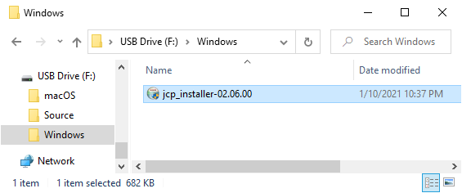
Open the installer, review & accept the license agreement, then select which components you would like to install and whether you would prefer the JCP installation directory to be added to the PATH environment variable:
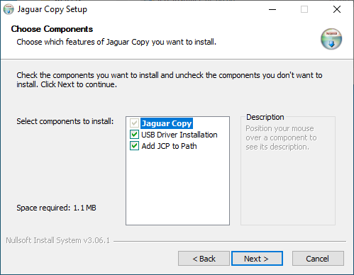
Unless you have previously installed libusb-win32 drivers for a SkunkBoard on your system or want to type out the full installation path on the command line every time JCP is run, be sure to select all of the installation components.

macOS Software Installation
An installer is provided for macOS. It will install JCP and, if requested, the appropriate USB driver files for both Intel and Apple Silicon-based Mac computers running macOS versions 10.9 (Mavericks) and above. The installer can be found in the “macOS” folder of the included USB drive:

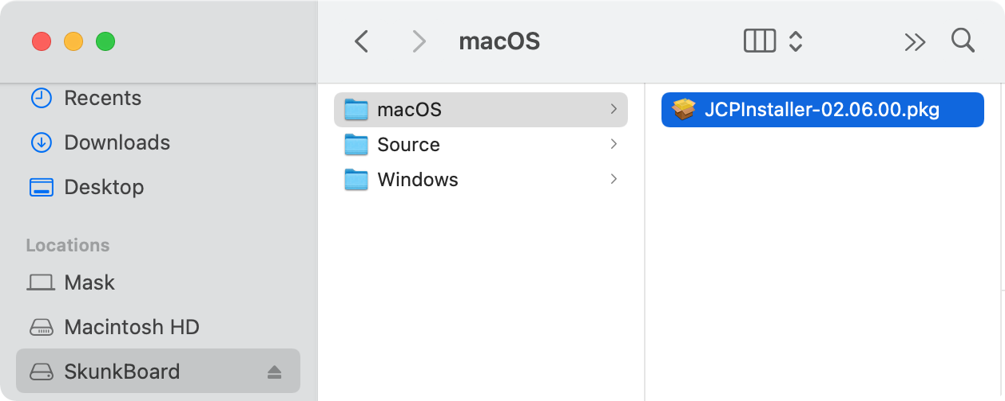
Open the installer, review & accept the license agreement, then select which components you would like to install:
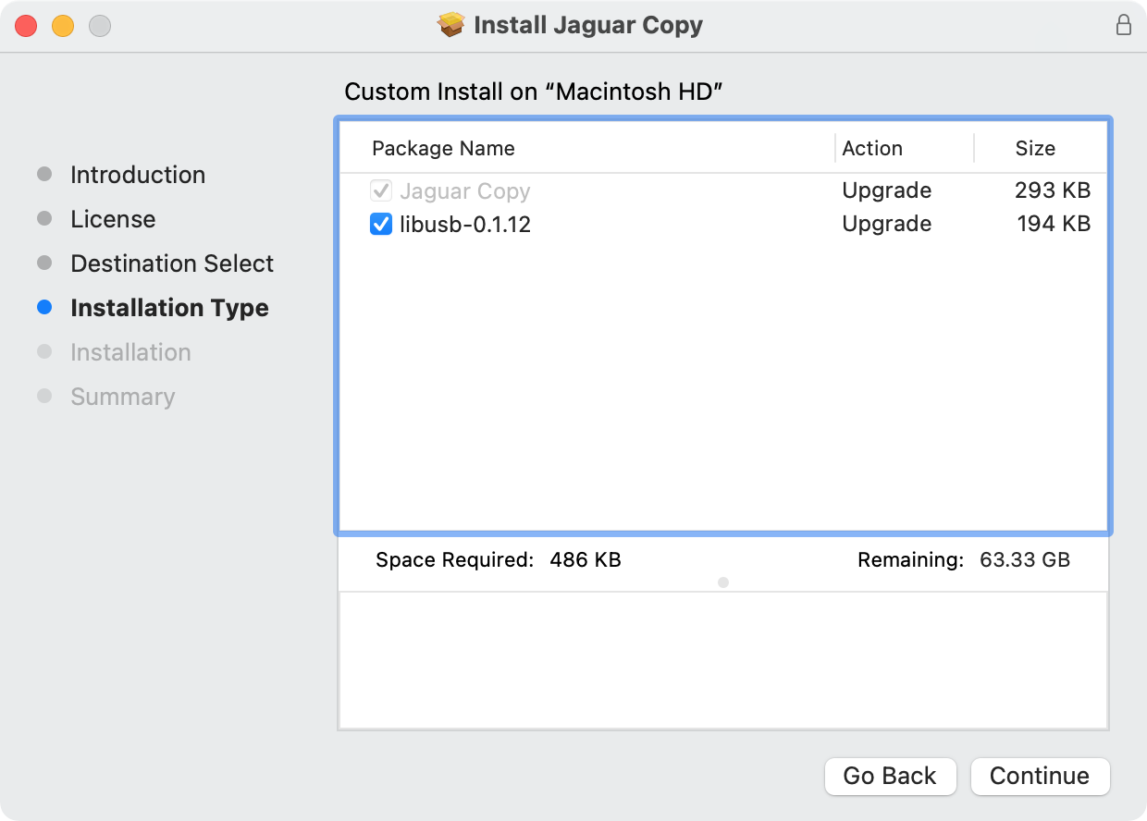
Unless you have previously installed libusb-0 libraries on your macOS system, be sure to select all of the installation components.

Linux Software Installation
To use JCP to communicate with a SkunkBoard on Linux, users must install libusb-0 using their distribution’s package management system or build it from source, then compile the JCP source code themselves. On Ubuntu systems and their derivatives, the following command will install the necessary prerequisites:
$ sudo apt-get install build-essential libusb-dev

After installing the prerequisites, copy the JCP source directory from the included USB drive, change to the copied directory, and run ‘make’ to compile JCP:
$ cp -r <USB Drive Mount Point>/Source/jcp/jcp /tmp/jcp
$ cd /tmp/jcp; make

JCP can then be installed system-wide (recommended):
$ sudo cp jcp /usr/local/bin

Or locally for the current user:
$ mkdir -p ~/.local/bin && cp jcp ~/.local/bin

JCP must be run as root, either using sudo (recommended):
$ sudo jcp

or by adding the set-user-ID bit to its file mode (NOT recommended):
$ sudo chown root `which jcp`
$ sudo chmod u+s `which jcp`

Hardware Setup

WARNING: SkunkBoards ship as bare circuit boards. Always use safe anti-static practices when handling them. Ground yourself by touching a metal object before touching the board, avoid moving around while holding the board, and handle it only by the edges. Always keep it in an anti-static bag when not in use.
A SkunkBoard connects to the Jaguar system in the same manner as an ordinary cartridge.
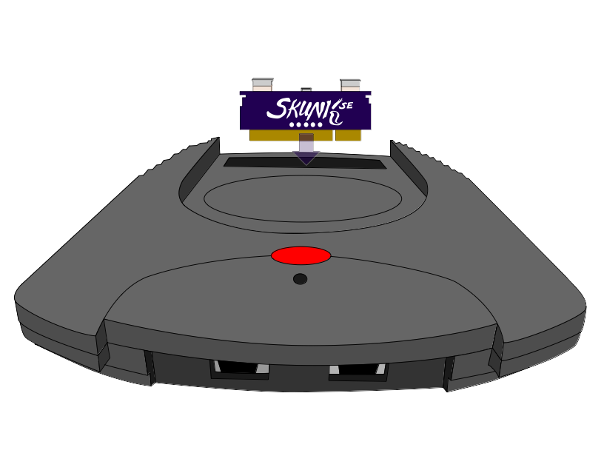
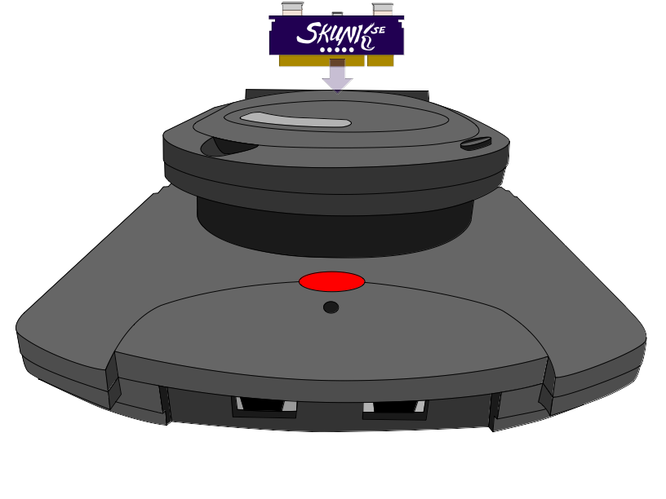
With the Jaguar system powered off, insert the board into the cartridge slot of the Jaguar or Jaguar CD add-on oriented such that the SkunkBoard logo is facing the front of the system and the components are facing the rear.
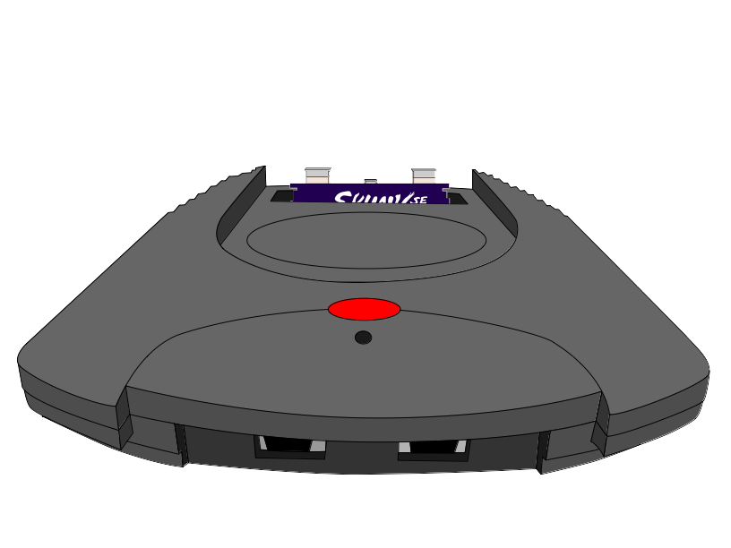
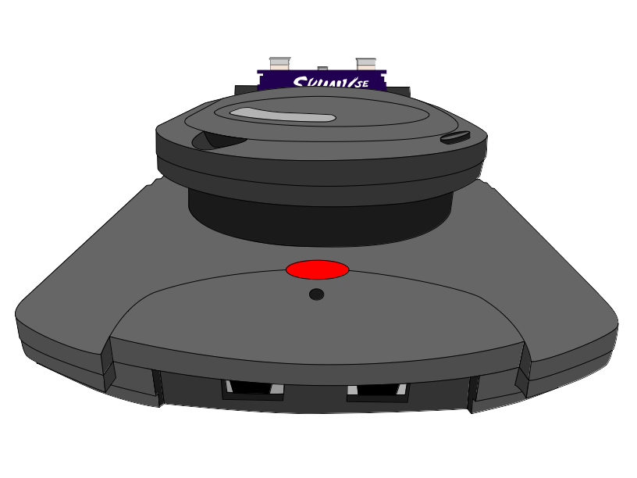

Power on the Jaguar system and verify a green screen is displayed. If a red screen with a Jaguar logo is displayed, power off the system, remove the SkunkBoard, clean both the edge connector of the SkunkBoard and the Jaguar cartridge slot, then reinsert the board and power on the system. Repeat as necessary.
For best results, follow the instructions in the previous chapter to install the appropriate software for your operating system prior to connecting the SkunkBoard to your computer for the first time. Then, connect a USB A↔USB Mini-B cable to your computer and the middle connector on top of the SkunkBoard.
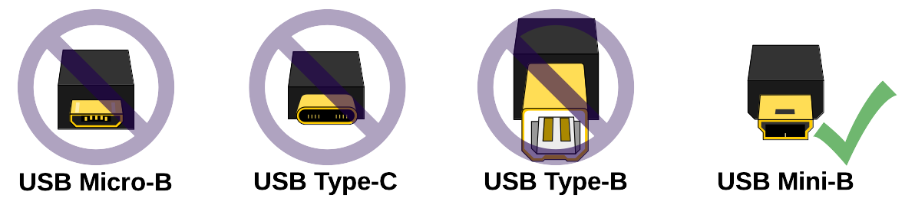
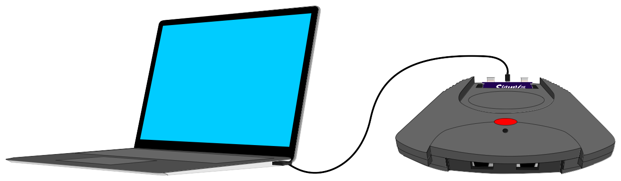
Your SkunkBoard is now ready for use!

Using JCP
JCP is a command-line program. It is assumed the user has a general familiarity with command-line usage on their operating system. If not, these tutorials will likely be helpful:
https://github.com/cubanismo/skunk_jcp/wiki/CommandLine
The examples here will use Unix-style command prompts, similar to those users will encounter on Linux and macOS, but the commands themselves are identical on all operating systems. The only difference will be in the appearance of the command prompt itself.
As noted above, Linux users will generally need to run JCP as root, either by logging in as or switching to the root user, prefixing all commands with ‘sudo’, or adding the set-user-ID bit to JCP when installing it. For brevity, the examples here assume JCP has the set-user-ID bit set.
Note almost all JCP commands work only while the Jaguar is displaying the initial green boot screen seen when the console is powered on with a SkunkBoard installed.

Basic Commands
Check SkunkBoard presence and display serial and version numbers:
$ jcp -s

If this command fails, double-check your software and drivers are installed correctly, JCP is running with the correct permissions, the SkunkBoard is connected to the computer with a USB cable, and the Jaguar is powered on and has booted to a blank green screen.
Reset the Jaguar:
$ jcp -r

This command is unique in that it works even after exiting the green SkunkBoard boot screen on the Jaguar.

Flashing ROMs
These commands load complete game ROM images to the persistent storage on the SkunkBoard. This is useful when testing the final build of your software, running homebrew games released in ROM format, or playing backups of commercial games you own. Because they are stored in persistent memory, these ROM images will remain available even after disconnecting the SkunkBoard from the computer and power cycling the Jaguar.
Load a ROM file to the first 4MiB flash bank on the SkunkBoard:
$ jcp -f <filename>

Load the ROM file to the second 4MiB flash bank instead:
$ jcp -2f <filename>

Load a 6MiB ROM, using both flash banks:
$ jcp -6f <filename>

This example flashes the ROM file test.rom to the second bank:
$ jcp -2f test.rom

Loading to RAM
Loading compiled code and raw data directly to the Jaguar’s RAM is a quick way to test while developing new software, or to run homebrew games that have not been built as ROMs. Because RAM is not persistent storage, the code and data uploaded will be lost as soon as the Jaguar is reset, and must be re-uploaded to use them again.
Load a file to RAM and execute it:
$ jcp <filename>

Most common program file formats are automatically detected and loaded at the correct address. Unrecognized files will be loaded at the hexadecimal address 0x4000. However, the load address may also be specified explicitly for unrecognized files.
Load a file to RAM at the specified address and execute it:
$ jcp <filename> 0x<hex_address>

A “console” mode is also available, which allows programs running on the Jaguar to read and write text and files to and from the host computer connected to the Jaguar. This is generally used when debugging a program during development. To enable the console, include the ‘-c’ option when loading a program to RAM:
$ jcp -c <filename>

The console may also be connected to an already-running program on the Jaguar by omitting the <filename> parameter:
$ jcp -c

How to make use of the console from within a Jaguar program is beyond the scope of this manual, but well-commented console library code is available in the JCP source found on the included USB drive in the file ‘skunk.s’.
Sometimes it is useful to pre-load information to RAM, such as images or map files, prior to loading the main code for your program.
Load a file to RAM at the specified address, but do not execute it:
$ jcp -n <filename> 0x<hex_address>

The following example loads a bpeg-encoded image to RAM at the address 0x100000, and then loads and executes a COF format bpeg viewer program file in RAM at the address specified in the COF file’s header:
$ jcp -n fish.bpg 0x100000
$ jcp picview.cof

Using Serial EEPROMs
There are two serial EEPROM chips on each SkunkBoard. EEPROM one contains 128 bytes of memory, as was generally included in original Jaguar cartridges. EEPROM two contains 2048 bytes of memory, as used in some more recent releases. The two are not compatible with each other, so you must select the appropriate chip for the software in use. EEPROM one is automatically selected each time the Jaguar is powered on.
To select one or neither of the serial EEPROM chips:
$ jcp -k [0|1|2]

Like the onboard flash memory, content can also be written to or read from these chips.
To write raw data to the currently enabled serial EEPROM:
$ jcp -p <filename>

To read raw data from the currently enabled serial EEPROM:
$ jcp -g <filename>

The following example enables serial EEPROM 1, reads back its contents to the file 128b.e2p, then switches to serial EEPROM 2 and writes the contents of the file 2048b.e2p to it:
$ jcp -k 1
$ jcp -g 128b.e2p
$ jcp -k 2
$ jcp -p 2048b.e2p

Advanced Options
Besides the above commands, there are various other options supported by JCP that are not generally required in normal usage.
To erase the entire bank when flashing, overriding ROM size detection:
$ jcp -ef <filename>

To boot a memory address without loading or flashing content:
$ jcp -b 0x<hex_address>

To override detected load addresses when flashing or loading RAM:
$ jcp -of <filename> 0x<hex_address>
$ jcp -o <filename> 0x<hex_address>

To override detected file header size when flashing or loading RAM:
$ jcp -hf <offset_bytes> <filename>
$ jcp -h <offset_bytes> <filename>

To upgrade the SkunkBoard to the latest BIOS known by JCP:
$ jcp -u

To force a BIOS upgrade even if the SkunkBoard has the latest BIOS:
$ jcp -fu

To use an external console program rather than the built-in one launched when using ‘-c’:
$ jcp -x <console_program>
$ jcp -x <console_program> <filename>

To enable quiet mode:
$ jcp -q <other_options>

Using the SkunkBoard
The SkunkBoard can be controlled directly using a Joypad during system startup and at the green boot screen.
While powering on the Jaguar console:
- Hold Button A to bypass ROM auto-boot. If an auto-boot ROM is not configured in the flash memory, this will have no effect.
- Hold Button C to bypass the SkunkBoard and boot the Jaguar CD add-on. If no Jaguar CD add-on is present, this will have no effect.
Once at the green boot screen:
- Press Left on the D-Pad to select the 128B serial EEPROM. The screen will flash yellow to confirm the selection.
- Press Right on the D-Pad to select the 2KiB serial EEPROM. The screen will flash blue to confirm the selection.
- Press Up on the D-Pad to launch the ROM in flash bank 1.
- Press Down on the D-Pad to launch the ROM in flash bank 2.
- Hold Button A and press Up on the D-Pad to launch a 6MiB ROM spanning both flash banks.

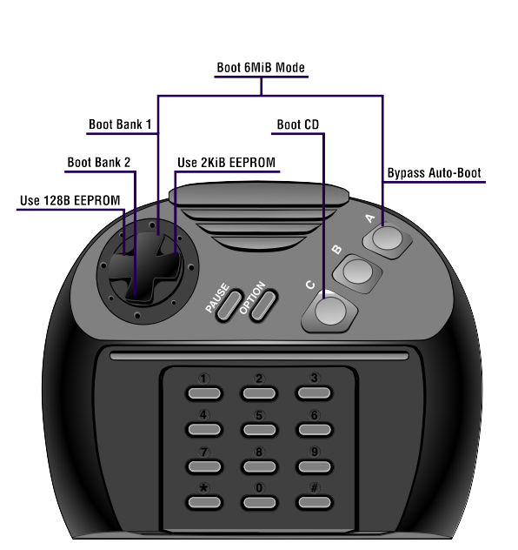

Acknowledgements

Thanks to the following people for making this project possible:
- KSkunk and Tursi for designing the original SkunkBoard PCB, firmware, and other assets. Without their work and their decision to place it and all related documentation in the public domain, none of this would have been possible.
- santosp for designing the revision 4 SkunkBoard PCBs which integrated a serial EEPROM, inspiring my own PCB tweaks that integrate two serial EEPROMs.
- Clint Thompson for sending me two unpopulated revision 4 SkunkBoard PCBs, leaving me no excuse not to attempt soldering components on to them, which in turn gave me the raw materials and confidence to attempt designing and building the revision 5 PCBs.
- Saturn for encouraging all my efforts and throwing some work my way.
- Mitch for unblocking some of my testing issues.
- Zerosquare, LinkoVitch, and all the others on the AtariAge forums who helped me whenever I got stuck and offered positive feedback in general. You all make this hobby fun.
- My family, who tolerated me locking myself away in the evenings to inhale solder fumes and obsess over CAD programs late into the night.

SkunkBoard Revision 5 Resources:
PCB: https://github.com/cubanismo/skunk_pcb
CPLD: https://github.com/tursilion/skunk_butcher
BIOS: https://github.com/cubanismo/skunk_bios
Bootstrapping: https://github.com/cubanismo/bjlSkunkFlash
JCP: https://github.com/cubanismo/skunk_jcp
Packaging: https://github.com/cubanismo/skunk_pkg


