4000 A.D.
An Interstellar Conflict Game

The time is 2000 years in the future . . .

Men now live on the planets of other stars many light-years from Earth. Rivalry between them has led to war, one that will be waged in space, with fleets of starships . . .

Each player, from his Home Star, directs his chips on journeys to other stars—to gain their resources, to do battle with enemy fleets, and ultimately to conquer the Home Stars of the enemy . . .

Movement in 4000 A.D. is based on the science-fiction idea of star travel. When ships journey the vast distances from one star to another, they travel faster than the speed of light. In so doing, they enter and travel through a kind of warped space, called “hyperspace”.

While, ships are in hyperspace, they cannot be detected. After a fleet has left a star, the enemy cannot know the direction in which it is traveling, or its destination, until it arrives out of hyperspace at another star.

Players in the game will be sending their ships on journeys whose objectives will be unknown to opponents. But the principles of movement allow players at all times to plot the possible positions and objectives of every traveling enemy fleet. With no chance element, these features make 4000 A.D. a unique game—one of the most challenging strategy games you have ever played.

4000 A.D. may be played in two different ways. In the Alliances game— for 2 or 4 players—players divide into two teams of allies and the conflict is between one alliance and the other. In the independents game—for 2, 3 or 4 players--each player is hostile to all others, and individual players are eliminated until one remains. In this Rules Book, all rules common to both versions are given first, followed by the different rules tar each version of play.

When learning either game the rules should be absorbed before referring to the discussions of strategy in the Strategy Book. An asterisk in the margin means that the background to this rule is outlined in the “Science Fact and Fiction” section of the Strategy Book.

THE PLAYING BOARD

Place the two halves of the playing board together. The board consists of two main areas: the center Star Field and the Hyperspace Paths surrounding it.

*The Star Field
Each star on the board represents the equivalent of our own Solar System—a star with one or more planets. (The planets are not shown). Certain planets contain human population and/or useful raw materials. When the rules refer to the occupation or resources of a star, this means of its planets.

Each star has its name in the center. Above the name is the letter showing the sector the star is in. Symbols below the name show the resources of the star.

DIVISION OF THE STAR FIELD INTO SECTORS

The stars on the board vary in depth. Thus the distance and the travel of ships between them is both horizontal and vertical.

A visual illusion of depth has been made in this way: the stars which are generally nearer to the observer, or “higher,” are larger and brighter (yellow) so that they stand out and seem closer. The stars, which are further from the observer, or “lower,” are smaller and darker (red) so that they recede from the eye and seem further away.

Consider the star field as a volume of space, divided Into 24 cubic sectors, 4 long, 3 wide, and 2 deep.

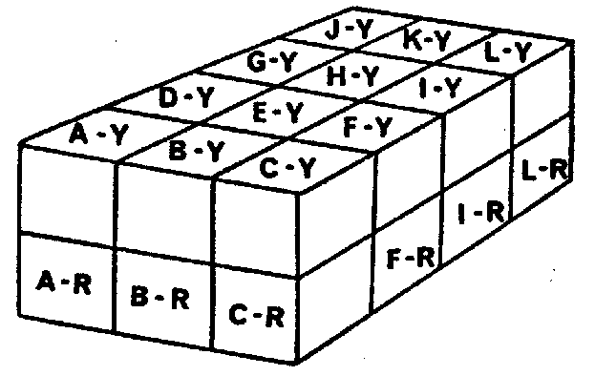

The lines across the board divide the star field into sectors horizontally. The division between the upper and tower sectors cannot be shown on the board, since it lies at a lower depth—between the yellow and red stars.

Thus there are 12 sectors along the upper level, and 12 along the lower level. When looking at each square area containing 4 stars it is necessary to see one cube on top containing the 2 yellow stars and another cube directly underneath containing the 2 red stars.

The 12 sectors in the upper level are called A-yellow to L-yellow, as they contain the yellow stars. The 12 sectors in the lower level are called A-red to L-red, as they contain the red stars. Thus, sector A-yellow is directly above sector A-red, B-yellow above B-red, and so on.

Each star bears the letter of its sector and its color places it in either the upper or lower level. For example, Algol is in sector A-yellow, Rigel in sector B-red, etc.

Resources of the Stars
The symbols under the star names show what resources its planets contain:

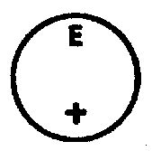
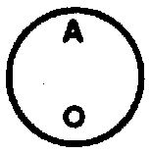

stars with a circle stars with a cross have raw
have human population materials (needed for the
building of starships)




stars with both stars with neither
symbols have both symbol have no resources,
population and materials only a strategic value

These resources are gained every second turn (called the ‘Production Turn”) and are used to produce new starship..

HOME STARS

The four stars at war are called “Home Stars.” They are:
Algol (sector A-yellow) Pavo (sector J-red)
Regulus (sector C-yellow) Antares (sector L-red)

Only the Home Stars have warfleets. All other stars—even those that are inhabited—are, at the beginning of the game, without defenses.

Each player has one Home Star (except in the 2-player game). See “Number of Players” in each version of play for distribution of the Home Stars.

*The Hyperspace Paths

There are four hyperspace paths. Each path comprises an “Entry Space” followed by spaces 1 to 7.

The paths are the basis of the game’s hidden movement of ships. When ships make a journey they are taken from the star field and moved along their path. But the path does not indicate a direction of travel nor a destination. The spaces on the path show only the number of turns the ships have been in hyperspace since starting their journey.

Each Home Star has its own Path—the one closest to it. (Algol, for example, always uses the path starting beside its sector). Whenever a player makes a journey, no matter what star he is departing from, he always moves his ships along his own hyperspace path.

THE PLAYING PIECES
Starships
There are four sets of starships: dark green, light green, dark red, light red. Each player uses a different color.

Each of the smaller pieces is 1 starship. Each of the larger pieces represents 5 ships. For the sake of convenience, a large piece may be used at the player’s discretion to substitute for 5 starships (and vice-versa). When moving a fleet greater than 10 ships, it is advisable to use at least one 5-ship piece.

At the start of the game, each player takes 15 ships (all 1-ship pieces) and positions them around his Home Star. (Never place ships on a star— do not cover its markings). Ships placed around a star represent the occupation of its planets.

*Hyperspace Warps (with Markers)
The hyperspace warp serves to carry the ships as they move along the hyperspace path. (The open part faces forwards). The warp also records the sector of the star the ships departed from when they began their journey.

Each player takes two warps, and for each warp he takes a yellow and a red marker.

When starting a journey, the proper colored marker must be inserted into the hole above the letter of the departure star’s sector. In the diagram, for example, if the marker is yellow, the warp will record that the ships in it departed from a star in sector “E-yellow.”

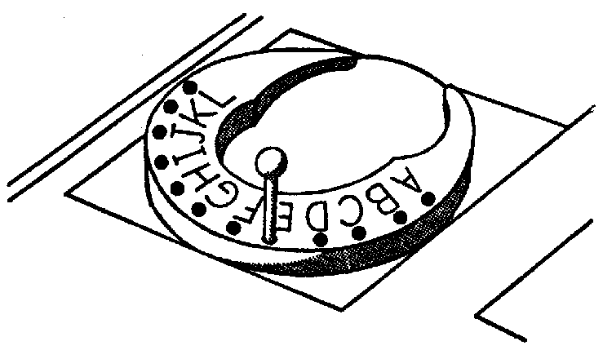

JOURNEYS BETWEEN THE STARS

A journey is always from one star to another star, and follows this sequence:
(1) Departure: entry into hyperspace from the departure star.
(2) Travel in hyperspace.
(3) Arrival: returning to normal space at the arrival star.

Calculating the Journey’s Length
The number of playing turns a journey will take is equal to the number of sectors from the departure star to the arrival star. The method of counting is as follows:

Start at (and include) the sector containing the departure star, and count until you reach (and include) the sector containing the arrival star. Always count in straight lines and turn, if necessary, at a right angle, horizontally or vertically. Never count diagonally, and never make more than one horizontal and one vertical turn. The number of sectors thus counted is the number of turns a journey between those two stars will require. For example:

(1). From Algol (sector A-yellow) to Hamal (sector D-yellow)

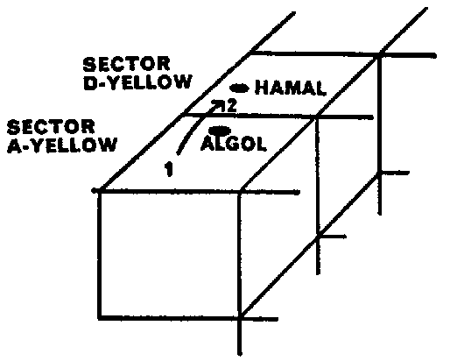

Count from sector A-yellow (containing the departure star) In a straight line to sector D-yellow (containing the arrival star). Two Sectors counted. This journey requires two turns.

(2) From Regulus (sector C-yellow) to Adhara (sector C-red):

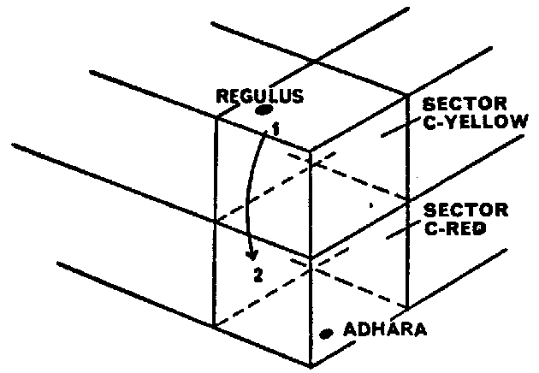

Count from sector C-yellow (containing the departure star) in a straight— vertical—line down to sector C-red (containing the arrival star). Two sectors counted. This journey requires two turns.

(3) From Vega (sector K-yellow) to Mira (sector D-red):

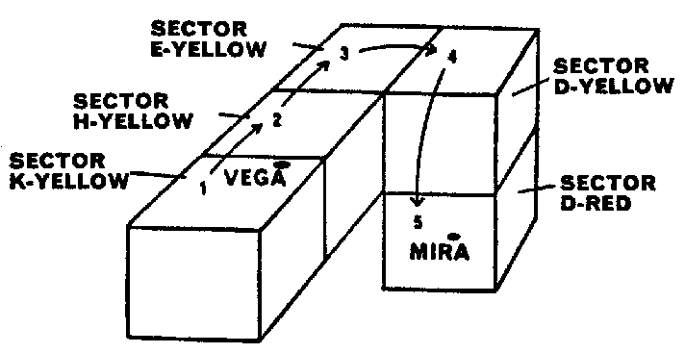

Count from sector K-yellow, to sector H-yellow, to sector E-yellow. Turn and continue to D-yellow. Then turn—vertically—and continue down to sector D-red. Five sectors counted. This journey requires five turns.

Sometimes a count can be made in more than one manner and still produce the same number. As a general rule, it is best when counting to stay in the same level of sectors as the starting one. Count in one direction, then turn if necessary to right or left; then, if the arrival star is at a different level, turn up or down as the case may be.

The method of counting, when it involves a right-angle turn, does not represent the actual path of the journey itself. But the calculation must be made in this way, counting the fewest possible sectors, which will then represent the length of the straight-line journey between the two stars.

When the two stars are in the same sector
If the departure star and arrival star are both in the same sector, only the one sector Is counted and the complete journey takes only one turn.

Making the Journey
A journey has been calculated as taking a certain number of playing turns. On each turn of the journey, the warp carrying the ships will travel forward one space along the path. The Departure is made at the beginning of the first turn, the Arrival at the end of the last turn.

For example: A journey from Vega to Mira (see example 3 above) has been calculated as five turns in length:

Turn 1— Departure Turn: Take the ships from the departure star, Vega, and place them on the warp in the Entry Space. Record the sector of the departure star by inserting the yellow marker above the letter “K.” Push the warp into space “1.”
Turn 2— Push the warp into space “2.”
Turn 3— Push the warp into space “3.”
Turn 4— Push the warp into space “4.”
Turn 5— Arrival Turn: Push the warp into space “5”. This is now the full number of turns required for the journey. The ships are immediately taken from the path and placed at the arrival star, Mira. Return the warp to the Entry Space or nearby.

Note: The warp may be used as a “shovel” to carry the ships to and from the path.

Between the Two Stars in the Same Sector
Departure, Travel, and Arrival all take place in the one turn. In this case, the transfer of the ships to and from the path is done only theoretically, and the ships may be moved directly from the one star to the other. However, this does mean a theoretical use of a warp, and if no warp is available on that turn, such a journey cannot be made.

All the ships in a warp must depart from a single star and arrive at a single star.

A journey always theoretically follows a straight line, and ships do not turn in hyperspace. If a warp should travel too many spaces, so that it has moved beyond the furthest sector on the board from its departure sector, the ships on it are lost (returned to box).

For an analysis of how the foregoing rules of movement are used in game play and strategy, see “Movement and Strategy” in the Strategy Book.

MOVES ON EACH TURN

For order of turn, see “Procedure of Play” In the rules for each version of play.

When each player takes his turn, he may make several moves that are parts of different journeys. They must be performed in the following order:

If he has one or both warps already on the path he moves the leading one first, pushing It forwards Into the next space. Then—
- If it is a continuing journey he simply leaves it thereon.
- If it is due to make an Arrival he transfers the ships in it to the star it has reached and removes the warp from the board.
If there is a second warp already on the path it is treated in the same way.

If, however, both warps are due to arrive on that turn at the same star, to combine against an enemy fleet, then—
- Both are pushed forward together and make a simultaneous Arrival (see—Multiple Attacking Fleets)

If there is now an empty warp available, then the player may also—
- Make one Departure from one star. This may be all the ships at that star or any number of them.

Making a Departure
Place the ships in the warp in the Entry Space, set the marker to record the sector of the departure star, and push the warp into space “1.” If this journey is longer than one turn, this player’s moves end here.

If, however, this journey requires only one turn (both stars in the same sector) then the ships will also immediately arrive. As explained above, such a journey can be made without using the path.

A player may make only one departure of any kind in one turn. If both warps are on the path on continuing journeys, then neither is available, and no departure of any kind can be made.

Battles: When an arrival is made, if it is at a star occupied by enemy ships, battle will take place immediately.

Arrival and Immediate Departure: it a player’s ships arrive at a star in the first part of his turn, his departure may then be some or all of the same ships from that star—unless upon arrival they engaged in battle. Then none of these ships can depart until his next turn.

OCCUPATION OF OTHER STARS

An undefended star may be occupied by any player who sends at least one ship there. He continues to occupy it as long as at least one ship remains. A star occupied by an enemy can only be gained by defeating the enemy force at the star.

RESOURCES AND PRODUCTION OF NEW SHIPS

The resources of men and materials at a player’s occupied stars are assumed to be continually transmitted back to his Home Star by means of a Matter Transmission System. These resources are used at the Home Star to produce new ships for the fleet.

New ships are taken on each production turn, which is every second turn. This can be kept track of by using a coin: At the start of the game, place the coin on the table heads up. After each round of the board, turn over the coin. When the coin is showing heads (except the first turn of the game) that is a production turn. When showing tails, it is not. (For the order in taking new ships, see “Procedure of Play” in the rules for each version of play).

Both materials and population are needed to produce a new ship (for construction and crew). Each player takes one new ship for each pair of circle and cross among the stars he occupies with his ships—Including his Home Star. The circle and cross do not have to be together on the same star, nor in the same sector. An extra of one symbol is of no value. New ships of a players’ color are taken from the box and placed at his Home Star only.

Loss of a Home Star
A player who loses his Home Star, but is not eliminated from the game, cannot continue to produce new ships. But he resumes production if he regains it.

The player who captures as enemy Home Star can draw from it only its own resources. He cannot bring his own or his enemy’s other resources to it, nor can he produce new ships for himself there.

A player may choose to withdraw all his ships from his own Home Star, but he remains in possession of it and can bring his resources and produce new ships there. He loses it if an enemy occupies it (without a battle).

*BATTLE
Battle takes place only at a star, in normal space. The larger fleet always totally destroys the smaller fleet, with no loss to itself. If the two are equal, they do not engage.

To defeat an enemy fleet at a star, a player must attack with at least one more ship than the defending force. Battle takes place on arrival, and the defending ships are destroyed (return to box). The victor now occupies the star and its resources go to his Home Star.

To defend a star from an expected attack, a player must have or send enough ships there to equal or outnumber the enemy force, so that he will not attack. If the defender is outnumbered and cannot bolster his force in time, he may depart from the star and avoid battle.

If both forces are equal, the attacker may not come out of hyperspace at that star, though he may come out at the other star in the same sector. No part of a fleet that wins a battle can depart on the same playing turn— no matter how much it outnumbered the enemy.

Multiple Attacking Fleets
A normal attacking force would be a single fleet, which outnumbers the enemy ships. But a player may also send to the enemy star two different fleets—each one smaller than the enemy force—from two different stars. He will time their journeys so that they both arrive on the same turn. They will make their arrivals together (as explained in “Moves on Each Turn”) combine and outnumber the enemy ships, winning the battle.

In planning such an action, the player must take into account that he can make only one departure per turn. The two journeys must start on different turns, and therefore they must be from two stars, which are different distances from the target. To plot the simultaneous arrivals of the two journeys, calculate the difference in turns between the length of each, start the longer one first, and the second one the required number of turns later.

See the Strategy Book for further discussion of the multiple fleet strategy.

ALLIANCES

NUMBER OF PLAYERS AND UISTRIBUTION OF HOME STARS

Alliances may be played by either 2 or 4 players. The Home Star alliances are Algol and Regulus against Pavo and Antares.

Each ally in an alliance may operate as independently as he likes, but co-operating actions between them can be undertaken. The game is won by the alliance that captures both Home Stars of the enemy alliance.

4 Players:
Divide into the two alliances. Each player has one Home Star. One alliance uses the red ships, the other the green ships. Each ally within the alliance uses a different shade of their color.

2 Players:
Each player plays one complete alliance. His two Home Stars will be two independent allies, with himself as overall commander.

Each player takes a fleet of 15 ships, two warps with markers, and a hyperspace path, for each of his Home Stars, (The two fleets will be different shades). All rules will apply as though his two Home Stars were separate players. On his turn, he makes a complete set of moves for each of his Home Stars.

PROCEDURE OF PLAY

One alliance takes its turn, then the other alliance. Within the turn of each alliance this is the procedure:
- If this Is a production turn, both allies take their new ships before either of them make their moves (see “Resources”)
- Each ally separately—always clockwise around the board—makes his moves.

CO-OPERATING ACTIONS BETWEEN ALLIES

Allied Moves Made Together
When a co-operating action between allies involves the arrival of their fleets on the same turn at the same star, in order to attack an enemy force together, then the two allies make those arrival moves together (see Multiple Attacking Fleets—Allies). Their remaining moves on that turn are made separately, as usual.
If, in order to make a simultaneous move and arrival, it is necessary for an ally to make one of his other moves out of normal sequence or turn (to get a ship out of the way) he may do so.

Two Allies at the Same Star
One ally may send ships to a star already occupied by another ally— without his permission. But if it is to an ally’s Home Star then his permission is required.

If the ships of two allies occupy the same star, the one who occupied it first is entitled to its resources. However, they may agree that the second will receive them, or that they both draw them on different production turns. If both arrive on the same turn, they must decide between themselves.

One ally cannot send another ally resources of a star, which he alone occupies. The other must send at least one ship there.

Allied ships at the same star are always under the separate control of each. But they form one force far defense, and if attacked and outnumbered, all are destroyed.

Combined Fleets
From a star they both occupy, one ally may depart with a fleet comprising his own and his ally’s ships (with the latter’s permission) using his own warp and path. It will form a single fleet for attacking. The other ally may reclaim his ships at any time (except while in hyper-space) through a normal departure move.

One ally cannot move a fleet composed entirely of the other ally’s ships. At least one of his own must be among them. At no time may one ally transfer permanent possession of his ships to the other ally.

Multiple Attacking Fleets—Allies
Both allies may each send a fleet against a single enemy star timed to arrive on the same turn. Planning and movement will be the same as the strategy of a single player (see page 9). But In this case, both Journeys may also be of the same length, since both departures can be made on the same turn, one by each ally. Furthermore, each ally may use more than one fleet, so that up to four fleets may be aimed at a single enemy target

All such arrival moves are made together (as explained In “procedure of Play”) so that all ships are combined for battle.

Note: In the two-player game, each player plans and moves for two “allies.” Co-operating actions between his Home Stars will be a natural part of his strategy. In multiple fleet planning he will have four fleets under his command. The two-player game thus contains the widest range of strategy potential for individual players.

Conferences
Co-operating actions between players cannot be set in motion, of course, without prior discussion. A player planning such a strategy may call for a conference. The opposing alliance must retire to a distance, to allow the player to discuss his plan at the board with his ally. A time limit for such conferences should be agreed upon before the game.

WINNING THE GAME

The alliance that captures both Home Stars of the enemy wins the game. The game is over as soon as the second enemy Home Star is captured.

The capture of a single Home Star is never permanent. Unless he has no more ships, the player is not eliminated from the game. He can try to recapture it, either by himself or with the help of his ally. His ally may also recapture it for him without his help.

The game may be conceded by either alliance at any time,

Alliances may be played with this optional rule: The alliance that captures both enemy Home Stars must not have lost either of its own Home Stars at the time. To win, they must regain their lost Home Star, while retaining those of the enemy. This rule will usually lengthen the playing time of the game.

INDEPENDENTS

NUMBER OF PLAYERS AND DISTRIBUTION OF HOME STARS
Independents may be played by either 3 or 4 players. When there are 2 players always play Alliances. Each player is enemy to all others, and players are eliminated by the loss of their Home Stars, until one remains, who wins the game.

4 Players:
Each player takes one Home Star and a different color of ships. Th. two shades of a color will be unrelated.

3 Players:
When playing three players, use a different set of Home Stars: Use Home Stars Regu!us and Antares, but make Mira (sector D-red) the third Home Star. Algol and Pavo will then become normal, undefended stars. In this way, all the Home Stars will be equidistant from each other (5 sectors). Only three colors of ships will be used.

PROCEDURE OF PLAY

The turn moves around the board clockwise. On the production turn, each player takes his new ships at the beginning of his own turn, before making his moves.

CAPTURE OF A HOME STAR

When a player’s Home Star is captured, if he cannot regain it on his very next turn, he is eliminated from the game.

If he does not regain it, he must on that next turn make any fleet(s) he has in hyperspace arrive at a star of his own choosing. These and each other fleet already at a star will then be individually “surrendered” to the first player who sends at least one ship to that star. If another player is already at the star, they are surrendered to him. That player then exchanges them at that star for ships of his own color, which become part of his fleet there.

Note that the eliminated player’s ships do not surrender before he taken his turn following the capture of his Home Star.

There is one other way a player may regain his lost Home Star and avoid elimination. On the very next turn, he may capture the Home Star of the player who captured his. He may then persuade the other player to agree to a mutual withdrawal— the other player must agree or face elimination himself, unless he is In a position to recapture his Home Star on his next turn. If they agree to withdraw, each must do so, when his next turn comes around.

WINNING THE GAME

The winner is the player who remains after all other players have been eliminated.

If the game is ended before the ultimate win is achieved, a peace alliance is established between all remaining players. The player who occupies the greatest number of stars (regardless of total ships) is the winner. If occupied stars are equal, the player with the greatest total of ships is the winner.

FORMATION OF ALLIANCES IN THE INDEPENDENTS VERSION

An additional dimension may be added to the Independents version of the game by introducing the option to form alliances. One player may propose an alliance to another player at any time or terminate it without prior warning. The terms and strategy for an alliance may be discussed away from the board if the two players wish. On returning, they are not bound to announce whether they have formed an alliance or not until a co-operating action takes place.

During the time they act as allies, all rules concerning allies apply to them as set out in the Alliances version: Joint occupation of a star and the drawing of its resources, the moving of a combined fleet by one ally, and strategies Involving the arrival of their fleets together at a single target (Including conferences).

No agreement made between allies is binding. One ally may attack the other at any time. However, once two fleets are together at the same star, or arrive together to do battle with a third force, neither of those fleets can attack the other while they are there together. Nor may one of the players send another fleet there to attack his ally’s force while still there himself.

Any act of treachery will, of course, terminate an alliance.

A player whose Home Star Is captured can regain it on the next turn with the help of an ally, but at least one ship of his own must be among the recapturing force. In a mutual withdrawal agreement, any allied forces Involved must also withdraw.

In the Independents version, the game cannot be won by an alliance.

© COPYRIGHT 1972 JOHN WADDINGTON LTD.
CASTLE GATE, OULTON. LEEDS LS2S SHG, ENGLAND
Printed In England

