**IBM SMS Data Application - General**

There is quite a lot going on with the SMS data gathering application, though in reality it isn’t all that complicated – but there is a LOT of detail. The end goal is to be able to synthesize HDL for use in programming a Field Programmable Gate Array (FPGA) to implement the machine’s logic.

The application was developed in C# under Visual Studio 2017, using MySQL. It ought not to be *too* difficult to change to a different database, though I did not generalize it in its current release. Why C#? The toolset was freely available, in wide use and I was interested in learning C#. Also, I did not expect there to be all that many people (if any) who might actually be interested in actually using the application. I considered a web application say under PHP. Given the relatively simple structure of the application, that ought to be do-able. If I am still around in another decade, who knows. ;)

The application is available on github at http://github.com/cube1us/IBM1410SMS

It will probably help to access a set of drawings, particularly from the IBM 1410, at least at first, as an aid in following this documentation. Recommended are:

* The SMS circuit card diagram volume at <http://bitsavers.org/pdf/ibm/1410/drawings/1410_SMS_VOL_1.pdf>
* Volume II containing the feature list, most of the card location charts and some ALD logic diagrams for the IBM 1410 at <http://bitsavers.org/pdf/ibm/1410/drawings/1410_SYSTEM_VOL_II.pdf>

For the database structure, the root directory for the project has some things worth looking at – especially the data model for the database. Also, one can use the MySQL workbench to look at the documentation for individual data elements. There is a very simple database isolation layer, found in sub-project MySQLFramework. The actual application is in sub-project IBM1410SMS. I wrote this because I found using an actual database entity framework created much more language/system/database dependency than I was comfortable with. Although the application was written to MySQL it should not be *too* hard to change it to use a different database.

C# Data entity object(s) for a given table or tables have to be re-created anytime a change is made to the table(s) involved. That is handled by the script SQLToEntity.pl found in the Tools folder of the IBM1410SMS project. This script writes the C# code for an entity into the Entities sub-folder.

The way I have used the application to date has been:

1. I used the information from the card location charts (most, but not all, of which are in Volume II, as referenced above) to build spreadsheets to use to pre-populate the card location information in the database.
2. I used the information from the SMS card volumes (there are two, one of which is referenced above) to analyze the circuits used for the cards that were identified during step 1.
3. Having completed the first two steps, I worked in parallel on the application code to edit information and to import information from the spreadsheets. This took place during the first few months of 2018.
4. Starting in May, 2018, I started processing the actual ALD logic diagrams and entering data into the database.
5. In March, 2020, I entered the Cable/Edge Connection Diagrams

**Database Structure**

The basic structure of the database, while relational, can be thought of as a few important hierarchies (naturally, this is nowhere near complete.) A standalone Python program, databasecheck.py, can be used to check certain things in the database.

* Machine (e.g., the 1411 CPU for the IBM 1410) [See the following page, too]
  + Feature
  + Frame
    - Machine Gate (The IBM 1410 really doesn’t have these)
      * Panel
        + IBMSMSPackaging Class (not currently in database)
        + Card Slot
* Volume Set
  + Volume
    - Page
      * Card Location Page
      * ALD Diagram Page (a Diagram Page with Diagram Blocks)
      * Cable/Edge Connector Page
* Card Location Page
  + Card Location Block
    - Card Type
* SMS Card Type
  + Logic Family (e.g., SDRTL)
  + Card Gate
    - Logic Functions (IBM+, IBM-, “Standard”)
    - Logic Voltage Levels
    - Gate Pin
* ALD Diagram Page
  + Diagram Block
    - Connection
  + DOT Function
  + Tie Down
  + ECO tags
* Cable/Edge Connector Page
  + Cable/Edge Connector Block
  + ECO tags
  + Cable Implied Destinations (There is no editor for this last one. It is a two text-column pages with cable source/destination rules of the form MMM,F,G,P,R,CC – Machine, Frame, Gate, Panel, Row and Column. The Row field of the source is typically “*”, meaning it matches any row)

**ALD Diagram Location Designations**

Unfortunately, IBM was not consistent in how they designated card locations in ALD diagrams. The IBM 1401 (SMS Module Type I), the 7090 (at first, called SMS Module Type II, then later called Sliding Gate Frames), the 1620 (for which I have not found a name) and the IBM 1410 (SMS Module IV aka ) are all different.

The program uses the nomenclature for the IBM 1410 – SMS Module IV internally. This can lead to some confusion while using the application (especially between rows and columns). Below is a table of a recommended way to use the application, to help translate. The labels used for these in the application dialogs can be set in the machine table using the EditMachine dialog.

Originally I had set this up where Frame and Gate are separate, based on a limited understanding of the SMS Module II Sliding Gate system, but I misunderstood. So, in the application, essentially the Gate is always the same as the Frame.

|  |  |  |  |  |
| --- | --- | --- | --- | --- |
| **Program Nomenclature** | **SMS Module IV / Rack and Panel Module (e.g. IBM 1410)** | **SMS Module I aka Swinging Gate Cube (e.g, IBM 1401)** | **SMS Module II / Sliding Gate Frame** | **IBM 1620** |
| **Machine** | **1411, 1414, 1415** | **1401** | **7100, 7606, 7607, 7151, …** | **1620, 1621, …** |
| **aldMachineType (database field in table machine)** | **Component. 11, 14, 15 (1411, 1414, 1415)** | **Frame: 01, 02, …** | **Frame: 01, 02, … (Note: May not correspond in order to Machine, above as I have listed them)** | **Machine Type: 01, 02, …** |
| **Frame == MachineGate** | **Frame** | **Module** | **Module** | **Gate** |
| **Panel** | **Gate** | **Gate** | **Panel (Chassis)** | **Panel** |
| **Row (alphabetic)** | **Row** | **Column !!!** | **Row** | **Row** |
| **Column (2 digits)** | **Column** | **Row !!!** | **Column** | **Column** |

Things to watch out for:

* You will probably want to set things up so that the application MachineGates (which are below Frame in the application hierarchy) just match the Frame.
* **Note in particular the row/column reversal for the IBM 1401. This is because the application currently insists that column be numeric.**
* Internally, the application uses the machine in most places, except that it uses the “aldMachineType” column in the machine table for the first two characters of card location when drawing logic blocks or buttons that display a card location. (There may well be other uses for this field down the line, for example in decoding Edge Connections that appear at the bottom of ALD Diagram Pages)

**Application Dialogs**

**Machines**

At the top of the heap, we have machines. A machine is not intended to be an entire computer. IBM subdivided computers (like the IBM 1410) into a series of machines (1411 – the CPU, 1415 – the console, 1414 – the I/O synchronizer, and so on). In addition, the application assumes a machine called SMS exists, to which it will attach SMS card ECOs.

The machine form, like many of the forms in this application, uses a .NET Data Grid View control. This control is not associated with the database directly. Instead, it is associated internally with a List or BindingList which absorbs any updates or deletes made in the rows displayed.

Like most of the forms in the application, any updates, including deletes, do not actually occur until you click the Apply button. (Attempts to delete rows, however, are checked for referential integrity. These checks are done in the application, not the database).

A new machine can be defined by entering the data in the new row that has “*” in the left hand column.

NOTE: In some of the data grid views, one has to click F2 to edit a field. I have not yet looked into exactly why one sometimes has to do that.

This page is accessed via Edit => Machines

This dialog is also where you set YOUR name to use for a given machine type for what the application internally calls Frames, Gates, Panels, Rows and Columns, and also the two character machine type prefix used in diagram boxes and buttons.

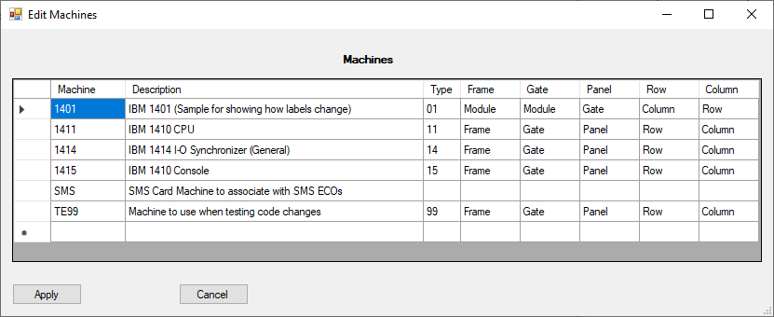

**Frames, (Machine) Gates and Panels**

In the SMS system, machines comprise one or more Frames, which comprise one or more Gates, which comprise one or more Panels, and panels are made of up card slots. Some machines (like the IBM 1410 machines) don’t actually use gates. In that case, in the application, one just creates a gate with the same name as the frame in the application.

Each panel entry defines the card slots available in that panel. In SMS, IBM used a coordinate system to define slots, where a letter was used for the row (skipping I and O), and a number for the card column.

There is also a class, IBMSMSPackaging.cs which contains machine-dependent information on panels, which identifies:

* Panels which are “special” when it comes to cross-checking Sheet edge connectors (the lists at the bottom of diagram pages)
* Which panels are adjacent to other panels
* Which rows and columns are valid for a panel, and which of those rows are interconnect rows used to make connections to other panels that do not show up on cable/edge connector pages.

The frame, gate and panel pages are accessed via:

* Edit => Frames, and selecting the appropriate machine
* Edit => Machine Gates, and selecting the appropriate machine and frame
* Edit => Panels, and selecting the appropriate machine, frame and gate

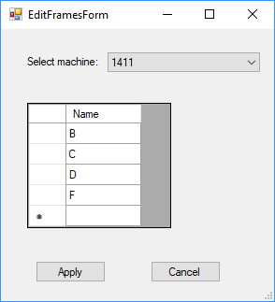 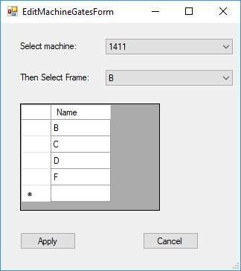

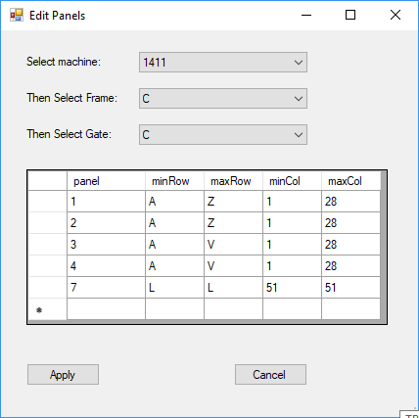

**Features**

An IBM Machine might have installed, whether at the factory or via an RPQ (Request for Price Quotation) a number of different features. For example, the IBM 1410 might or might not have the accelerator feature, or be configured with various amounts of core storage.

The Features dialog allows editing the features for a particular machine type. These are then used by card location chart pages to identify cases where a particular card location is present or used if a machine has a given feature, for use during troubleshooting or potentially while installing a particular feature.

This page is accessed via the menu entry Edit => Features and then selecting the desired machine type.

*Note: Currently the feature table for the IBM 1410 has some duplicate entries, of a sort, most of them starting with ‘$’ or ‘S’. One set was the result of features on a feature page, where some features, e.g. $40 used a ‘$’ instead of an’ S’. Other features were added automagically during import of card location chart entries, which use ‘S’. Thesemayl eventually need to be reconciled. In the* ***meantime do NOT use the ‘$’ entries*** *when editing the card location chart or gates.*

Use THESE entries, that start with ‘S’:

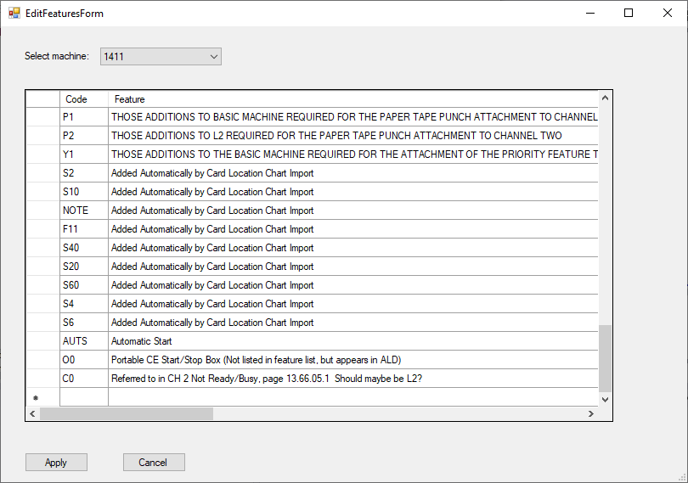

**Do NOT use these entries, that begin with ‘$’**

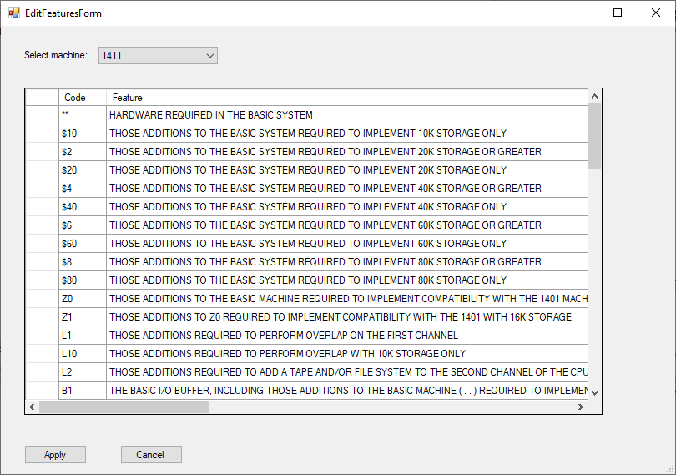

**ECOs**

Many artifacts can references Engineering Change Orders, or ECOs. These can either relate to a particular machine type (e.g. 1411, for the IBM 1410 CPU) or to the application-defined machine type “SMS”, used to capture ECO levels of SMS card drawing pages.

ECOs are accessed from the menu via Edit => ECOs, and then selecting the desired machine type or “SMS”.

When an ECO is entered while editing an Automated Logic Diagram (ALD) page, it is automatically entered into the ECO table. The description can be changed later, if desired.

Currently the application does not really use the ECO, though in theory one could have multiple ALD pages with the same page number, but different ECO levels if the application allowed for that. The database does make allowance for this eventual possibility by containing the ECO in the cardLocationPage and the diagramECOtag tables, but more work would be necessary, including identifying the “defining” (probably latest) ECO in the diagramPage table, which it does not currently contain. Then one could associate particular pages with particular ECOs into a given volume – and then use those throughout the application.

Alternatively, for now, one would need to “clone” the database and then alter it for a different machine. Definitely a shortcoming in the application.

Note: The database for machine 1411 currently contains an ECO with a blank ECO number that I should probably investigated (see below)

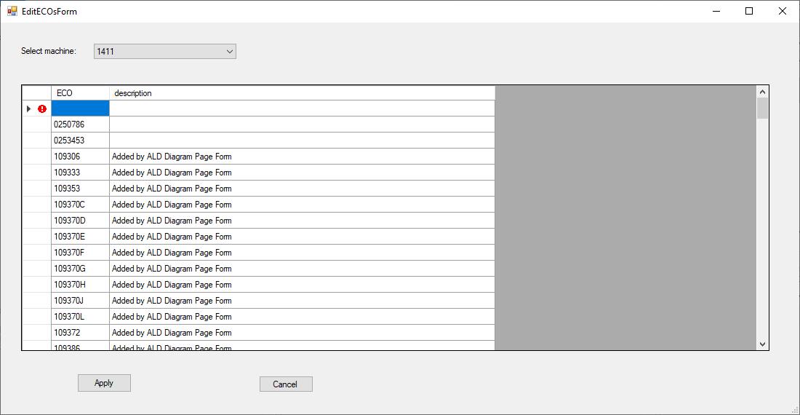

**Volume Sets**

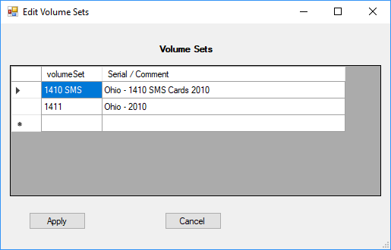

Volume Sets are also at the top of the heap of the paper trail. A volume set is an associated set of volumes (which in turn contain diagram pages) – typically associated with a given machine type and/or serial number, or, perhaps, a given source for the materials (which is the case in this example). The association in the application is completely arbitrary. Volume sets and volumes have no association with a “machine” as described above.

This screen is accessed via Edit => Volume Sets

**Volumes**

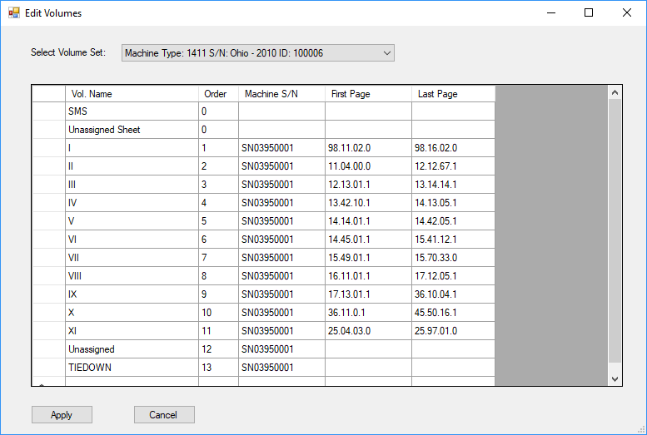

A volume is intended to represent a particular multi-ring volume binder within a given volume set. These would be associated with the classic dark blue IBM binders that could be found in a cart in the machine room or nearby, for CE’s to use when diagnosing problems with the computer. In the application, the volumes are associated with a given volume set. A volume can be associated with a given machine serial number – but this is just information – it is not used by the application. (The ID:###### displays the internal database key for the volume set, for informational purposes).

Volumes can also be identified for SMS card type entries, as these are derived from pages in their own separate IBM “blue binders”.

This screen is accessed via Edit => Volumes, and then selecting the appropriate Volume Set in the drop down list.

**Logic**

Logic levels and operations in the application are defined by the Logic section of the menu, which contains entries for editing logic families, logic voltage levels, IBM logic functions, and “standard” logic functions.

**Logic Families**

IBM defined several logic families for use in SMS. The IBM 1410, for which I built this application, uses only a subset of them. Logic families are used when defining SMS card types (described later) – a given card is presumed to use only one of the logic families. This screen shot of the Logic Family editor, accessed by Logic => IBM Logic Families, show some of them. (Not sure why the blank logic family is in there, possibly an artifact of importing a card type that did not have a family specified). The logic families are for documentation only, and not used for anything else (in particular, they are not used for HDL generation).

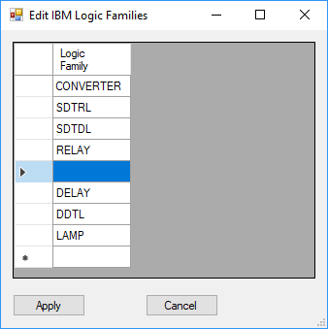

**Logic Voltage Levels**

The various IBM logic families used (usually different) specified voltage levels to represent 0 or1. These can be different for an IBM SMS Automated Logic Diagram logic block input and output, and are represented most often by a single letter, or left blank in the logic block. For example, the most typical level in the IBM 1410 is “S” (logic family SDTRL), where +S is ideally 0v and –S is ideally -5 v. The values in the logic level table, accessed via Logic => Logic Voltage Levels *are specified in tenths of a volt.* As with logic families, the voltage levels are not really used in the application. Most of the levels in the screen shot below were obtained from the manual IBM Customer Engineering, Instruction Reference, 1410 System Fundamentals, S223-2589, page 77. I used levels where +S, for example, is presumed to be logic ‘1’ and –S is presumed to be logic ‘0’.

This is a screenshot of the Logic Levels dialog,accessed by Logic => Logic Voltage Levels in the menu.

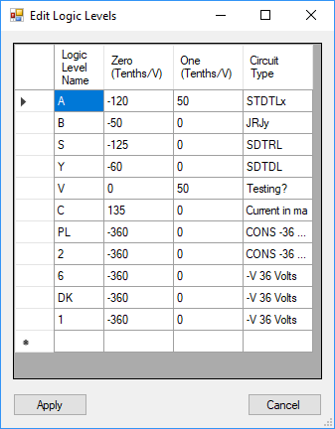

**IBM Logic Functions**

At the top of each ALD logic block, there is a logic function symbol, for example +A or –O or IP, and so on. These represent logic functions *as IBM defined them*, representing “positive logic” and “negative logic”. But, care is needed when interpreting the diagrams, because it seems that **built into many (but not all) of these names *is an assumption that the output of the gate is inverted***. For example, SDTRL gates are often NAND in terms of –S == 0 and +S == 1. But they show up in the ALD diagrams as +A (or, equivalently, -O). As with families and voltage levels the application does *not* use these IBM logic functions. They are for documentation only. One thing worthy of note: if the IBM logic function has an extra “A” or “O” at the end, one will usually find that the output of the gate goes to a “DOT Function”. Whether a DOT function performs an actual AND or an OR depends on how the circuits are constructed, and may differ from the logic implied by that trailing letter. For example, SDTRL “DOT Functions” operate as “OR” gates, using the logic values of +S == 0V and –S == -12V, because SDTRL uses PNP transistors, and when they are on, they pull the voltage to 0. So turning any one transistor on in the gates feeding the DOT function will pull the voltage to 0 – a logical OR. There are also lots of special IBM logic functions: D (driver), DLY (delay), R (resistor), CAP (capacitor), IP (power inverter), L (load – usually a diode clamp) and so on. NOTE: Currently this table is NOT used to validate the logic function entered on a logic diagram – it is actually a free-form text field. Access this dialog via Logic => IBM Logic Functions.

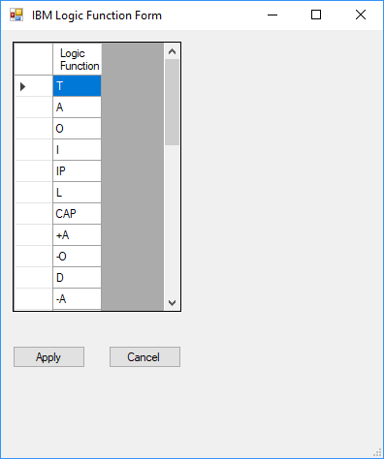

**“Standard” Logic Functions**

Because at some point the plan is to generate a representation of a machine from the ALD diagrams, I defined another logic function that I call the “Standard Logic Function”. These are the more familiar kinds of logic: NAND, NOR, NOT as well as a plethora of special ones (DELAY, EQUAL (for driver circuits that don’t invert), Resistor, Capacitor, Trigger (a flip flop), Sense (amplifier), OSC (oscillator), ONE (always logic ‘1’), ZERO (always logic ‘0’), Switch, “special” (which would require specific code in the application to generate HDL) and so on. These ARE used by the application. When an ALD logic block is defined to the application, the application requires the selection of a “Gate” (a circuit card gate, not to be confused with the machine gate, described earlier) which is associated with the card type and the particular pins used for that logic block by IBM. Each Gate, in turn, has associated with it one of the Standard Logic Functions (which is visible when the gate is selected in the application). The circuit card gate definition (described later) requires selection of one of these Standard Logic Functions when it is edited. The Standard Logic Function for a particular circuit card gate is determined by an analysis of the circuit in the card, for each gate on the card. This page is accessed via the menu Logic => Standard Logic Functions.

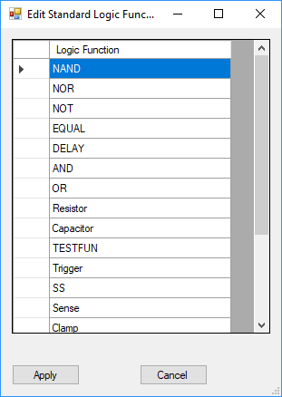

**SMS Card Types**

The information on SMS cards used by the IBM 1410 are handled specially in the application, rather than as pages, but are, in fact, derived from pages in the typical IBM blue volumes. There are three types of entities involving SMS cards: SMS Card Types, Therefore, an SMS card type is assigned a Volume First among these are the SMS card types, SMS card gates and card pins.

SMS card types are edited via the menu SMS Cards => Edit SMS Card Types, selecting the particular SMS volume containing the card type of interest and then selecting the card type itself.

This page also allows one to create a new SMS card type in a given volume by clicking on “New Card Type” or correcting/assigning a card type to a different volume using the “Changed Diagram Volume” pull down.

Each card type has a 3 or 4 character type (you can decide whether or not to include the trailing “-“ in a card type, though I did not do so for the IBM 1410.) and an IBM part number.

The SMS Card Type entity identifies the volume in which the page describing the particular SMS card type appears, along with the logic family for the card, and various meta-data that appear on the SMS card type page. The Card Type itself is central to the application. The part number is used in pull-down lists and the like. The rest of the meta-data are not used by the application.

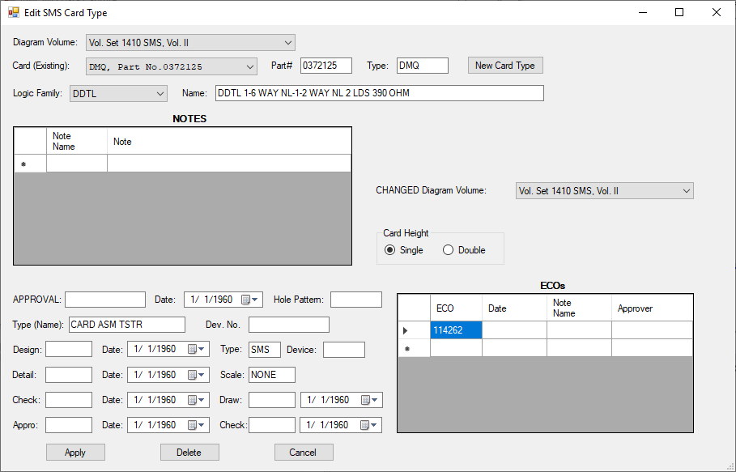

**SMS Card Gates**

SMS card type gates (not to be confused with machine gates) is where “the rubber meets the road” in this application.

A given SMS card type may have one or more logic gates / flip flops / etc. These are determined by essentially reverse engineering the information on the SMS card page.

These are accessed in the application from the Menu via SMS Cards => Edit SMS Card Gates, selecting the appropriate SMS volume and then the desired Card Type.

The first column is an arbitrary gate number, usually assigned left to right, top to bottom.

The next column is “Pin”. In the application, each SMS card gate is said to have a “defining pin”. While this is somewhat arbitrary, it must be unique among the defining pins used in a given SMS card gate, and appears in the “Pin” column in the Edit Card Gates dialog. (Also, it turns out this is never actually USED in the current application, and the associated database column is not really correct. See issue #49)

The third column is “T#”, which stand for Transistor Number. It is not required by the application, but can be entered to avoid confusion in gate identification. Just pick one of the transistor numbers listed on the SMS card circuit diagram.

The next column identifies the “positive” logic function, as used on IBM ALD diagram pages. See “IBM Logic Functions” above. This is not actually used by the application, at least at present.

The next column is the “negative” logic function, as might appear on IBM ALD diagram pages. If the positive logic function is +”A”, then this will be “-O”, and if the positive logic function is “+O” then this will be “+A”. In other cases, like “I” (for inverter) or “DE” (for delay) it will be the same as the “positive” logic function. It is not actually used in the application.

The next column, “Logic Function: *is of critical importance to the application*. This column is intended to be used during the process of HDL generation. It is the actual *physical* logic function performed by the gate, determined by reverse-engineering the SMS diagram page. See “Standard Logic Functions” above.

The Latch column is used to define cases where one gate is used in combination with another gate (via a cross connection) to form a latch. For gates that are not part of a Latch this will be a 0.

The next column defines whether or not the gate’s output(s) is open collector. Only at most ONE gate that is NOT open collector can participate in a “DOT function” on an ALD diagram page.

The next two columns define the gate’s *default* input and output logic levels (see Logic Voltage Levels, above). These can be overridden, however, on a given ALD logic diagram page.

Next is an optional “HDL Name”. It is used to identify a particular block of code in the HDL generation process for gates that cannot be readily defined by just the “Logic Fun.” column. For example, on gate type AEK this column contains “SMS_AEK” for the HDL Name. (AEK is a power inverter, but with some special logic which is not readily defined as a standard logic function.)

Finally there is the Comp. (component) value column. Some “gates” are really just single electronic components like load resistors or capacitors. This column identifies the value of the component (ohms, microfarads, etc.).

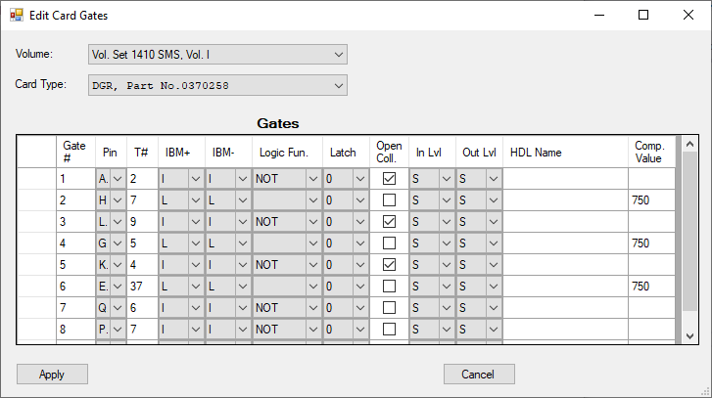

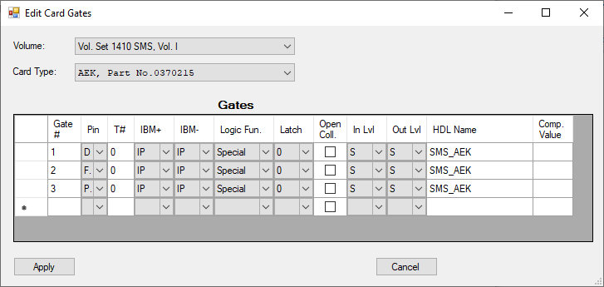

Each card gate connects to one or more pins. These pins are accessed from the menu via SMS Cards => Edit SMS Card Pins and then selecting the SMS Card Volume, Card Type and Gate (by number).

The first column is the Pin. This will usually be a letter, corresponding to an actual pinout on the card edge of the SMS card. However, there are also internal gate-to-gate connections that do not go to the card edge. The “Pin” column for these are generally left blank.

The next two columns identify gate to gate connections. If the “Pin” column is blank, then at least one of these should identify a gate from which the signal is derived (Input Gate) or to which the signal is sent (Output Gate). Note that it is also possible to have both a card edge pin identification and a gate-to-gate connection – but generally that should not be done, favoring instead using a common Pin in such cases.

The next two columns identify whether a given pin is used as an Input, an Output or both.

The next two columns identify whether a given pin is “DOT connected” (DOT-ed And/Or) with another gate. Dot Out indicates an output pin is connected to another gate’s output on the same card. Dot In indicates that an given input pin is connected to multiple gates’ outputs on the same card.

The “Map To” column is special. For pins that are part of a gate with logic function "Special" (and perhaps others down the road), this specifies the corresponding HDL entity port/parameter name for this pin to be used when generating HDL.

The Voltage (Tenths) column indicates voltage sources. (0 does NOT mean ground. Probably something worth making more clear)

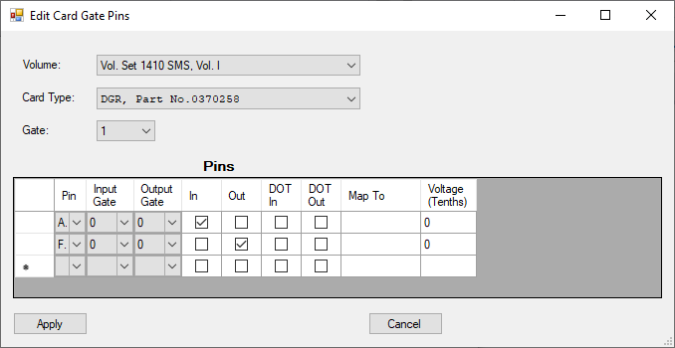

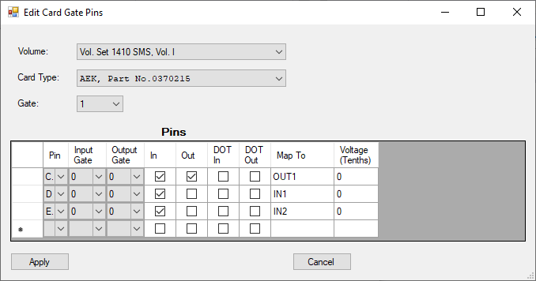

**Pages**

Volumes handled by this application are comprised of Tie Down Pages, Card Location Pages, Logic Diagram Pages and Cable/Edge Connection Pages. A card location page is a chart which identifies which modules are in which slots of a panel(in a gate, frame and machine). A logic diagram chart is where the machine’s logic was printed out – the Automated Logic Diagram. A Cable/Edge connection page describes inter-panel, inter-gate and inter-frame connections.

Note: Pages from the volumes describing SMS card circuit diagrams are not currently handled as pages. Instead they are handled via the SMS Cards menu, as described earlier.

**Card Location Pages**

A Card Location page is a chart / matrix of which cards are located in which machine card slots, and often also identifies the ALD Diagram sheet(s) which use the gate(s) on the card.

The top level dialog edits the page characteristics, and is accessed by Edit => Card Location Pages, and specifying the Machine, Volume Set, Volume and Page to be edited (or clicking “New Page” to create a new Card Location Page.

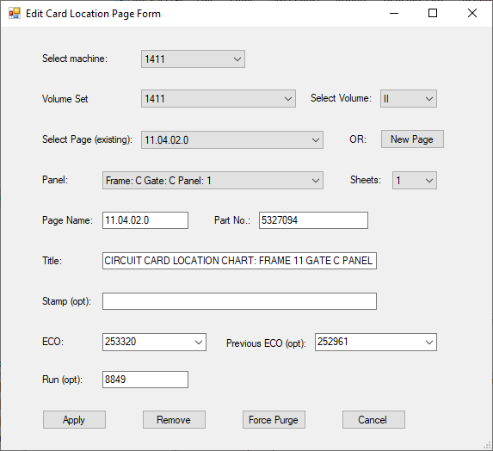

**Card Location Chart**

The detail for card locations is accessed via Edit => Edit Card Location on the menu, and specifying the Machine, Page, Panel, Card Row and Card Column. Currently, to do this effectively requires that you find the card location chart of interest in the card location chart of interest in the scanned diagrams or the spreadsheets derived from the card location charts, because of the correlation between Page and Panel. (For example, one would have to know that page 11.04.02.0 is the page containing the card location chart for IBM 1411 Frame C, (Gate C), Panel 1. (I have a TODO to allow one to select the page, and have it pre-populate the Panel, and vice versa.

The Card Type, Feature, Crossed out (with a great big “X” on the card location chart) and numbers that appear at the bottom of the block (Bottom Notes) are captured from card location chart.

In the data table, the Page column contains pages that have ALD Diagram logic blocks that refer to this card in this card slot. Sheet Column and Sheet Row identify the coordinates of the logic block that refers to this card. The ECO, if present, identifies the ECO level on the card location chart block. The On Sheet column means that during the spreadsheet capture, the card and card slot were verified to be consistent with the card location chart. Ignore means that this logic block was marked to be ignored for one reason or another. Missing means that while the card location chart indicates the given sheet location uses this card, it was found to be missing on the actual ALD diagram sheet.

Ignore is more complicated. This indicates that this entry should NOT be used when pre-populating information when capturing a logic block on an ALD diagram - for example, if it was found to not actually be present on the ALD diagram set. Ordinarily this is because a discrepancy between an ALD diagram page and the card location chart was noticed during data entry from the Card Location Chart.

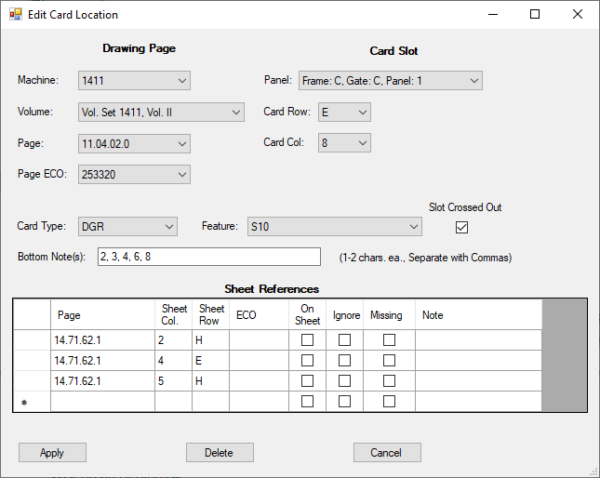

Edit Card Location Chart Dialog

**Tie Down Page**

Tie Downs are identified on (one or more) pages. These are typically used for cases where a signal should be tied to ground or a specific logic level to provide signals where the card(s) for a particular feature are not present because the feature is not installed in the machine.

The “W/O” column identifies the feature where, if it is NOT present, requires the use of a particular tie down. The “With” column identifies the feature where, if it IS present, requires the use of a particular tie down. The “Check”column simply captured the check marks that were or were not present for a given entry (likely identifying the cases where a particular tie down was used on a particular machine.)

Be default, a tie down is to ground, unless “Other Pin” is identified.

The actual page number of the tie down list was captured, but is not displayed and is not selectable as it should be. (And the pull down should be pre-populated with appropriate value(s) once a Volume Set is selected.)

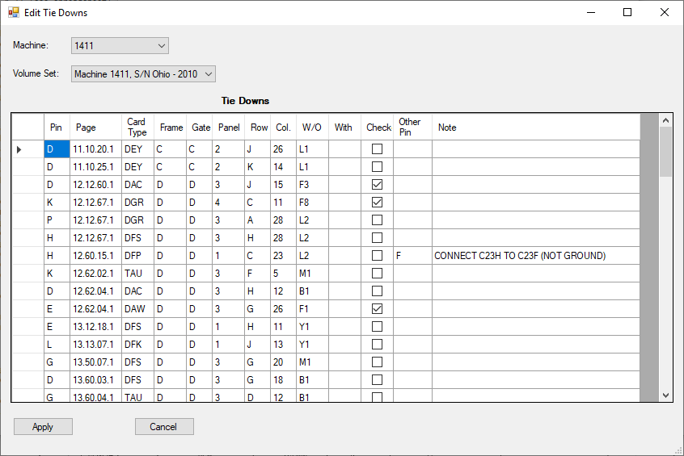

**ALD Diagrams**

The pages discussed heretofore are the support structure for the main event: ALD diagram pages. ALD diagram pages are the pages that are the “meat” of the application.

The top of the ALD diagram hierarchy is the ALD Diagram page, which is accessed via Edit => ALD Diagram Pages, and selecting the machine, volume set, volume and page. Selecting the machine, volume set and volume pre-populates the “Select Page” pull down. One can also add a new page to the volume using the “New Page” button.

This first screen contains meta-data for the page, such as its name (number), the IBM part number for the page itself and the title at the top of the page.

If the page has been stamped with a particular note (e.g. Field Use Only) that is also noted, along with any particular comments on the page (either generated on the ALD itself, or hand-written notes.).

If the page identifies one or more ECOs in its history, those are listed in the Diagram Page ECO’s table. The table can be edited.

Most sheets have **logical** connections from other sheets as inputs or to other sheets as outputs. The Sheet Edge Information table contains that information. The row is the **approximate** row on the ALD diagram sheet where the signal appears. They are NOT exact. Each signal name on a given sheet must be unique in the inputs and/or the outputs. The Count column is generated by this application, and identifies the number or other sheets related to a particular sheet edge signal. Inputs will ordinarily show a count of 1, of course. Except for the count column, this table can also be edited in place.

When a **physical** connection is made from a card in one gate or panel to another card in a different gate and/or panel, that is identified at the very bottom of the ALD diagram as a pair of connections from a given machine/gate/panel/card slot/pin to another machine/gate/panel/card slot/pin. Those are edited by clicking on the “Edit Edge Connections” button.

While this information was captured on the diagrams, it is not currently validated against the connection pages which show panel to panel connections – indeed, those connection pages are not currently in the database design at present. Doing so would allow one to validate these physical connections, nor are these connections cross-checked for inconsistencies. This is an identified “TODO”.

Finally, and probably most importantly/interestingly are the logic block / interconnections shown in the main part of the ALD page, accessed by clicking on the “Edit ALD Blocks” button.

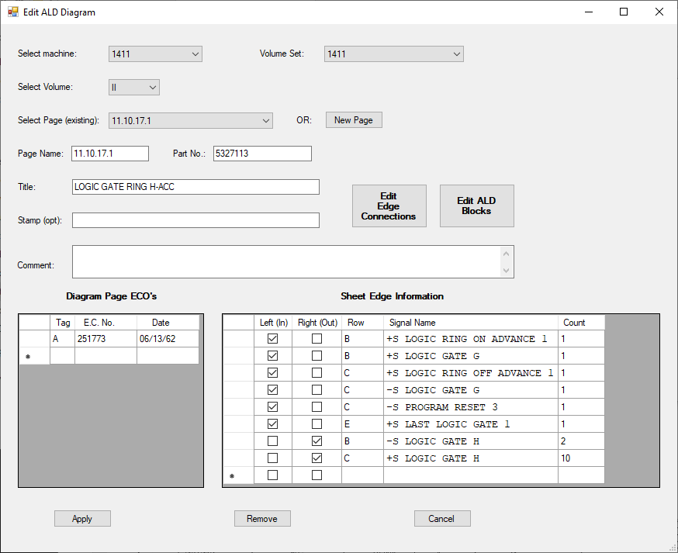

Top Level Edit ALD Diagram Page

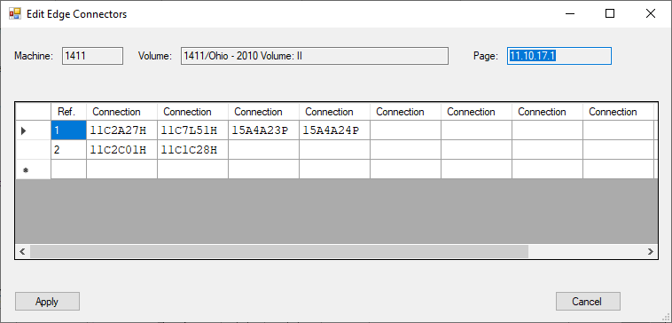

Edge Connections Table

**Editing the ALD Diagram**

Clicking on the “Edit ALD Blocks” button brings up a chart which looks a bit like the ALD diagram page itself. Columns are numbered from 5 down to 1 (as they are in the ALD diagram itself) and the rows are similarly labelled A through I.

In between each block are entries which indicate the existence of “DOT Functions”. A dash (“-“) is for no DOT function, an “A” for a **logical**“AND” and an “O” for a **logical**“OR”. DOT functions cannot be edited directly, but instead are accessed via the logic blocks which provide inputs to them or to which they provide their outputs.

The logic blocks themselves may be empty (do not appear on the ALD diagram sheet), or may have a machine/frame/gate/ECO designation/panel/row/column/card type designation, just as they appear on the ALD diagram pages. At the bottom of the block is also additional information added by the application: the identified **card** gate and the number of identified inputs / outputs to/from this logic block.

The ECO designation is a letter, which corresponds to the table of Diagram Page ECOs, just like it does on the original IBM ALD diagram page.

Clicking on an individual block brings up the Edit Diagram Logic Block dialog for editing the information associated with a given logic block.

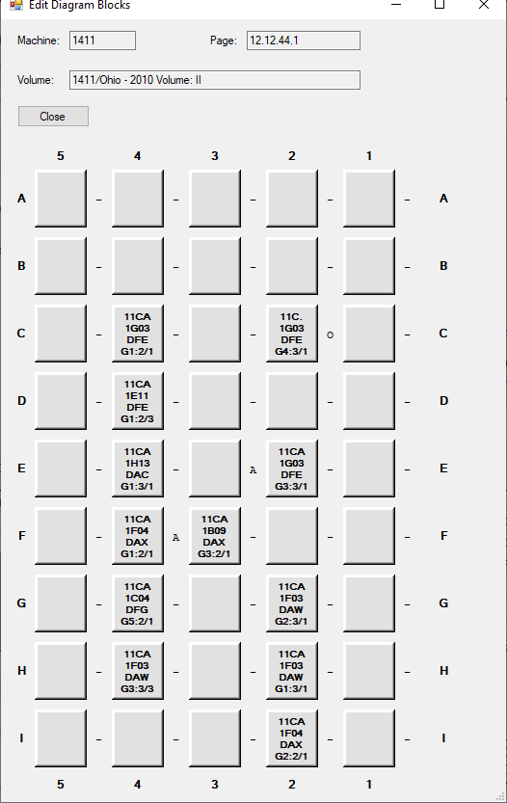

Edit Diagram Blocks Dialog

Editing a Diagram Logic Block or DOT Function

Accessed by clicking on an individual logic diagram block, the Edit Diagram Logic Block dialog contains all of the information associated with an ALD diagram logic block, except for its connections. This includes its logic function, in IBM terms (Block Symbol), its input and output modes / levels (see logic voltage levels, above), the location of the card (machine/frame/gate/eco tag/panel/card location) and the card type. On the right is a graphic representation that is intended to match up with the representation on the printed ALD diagram page itself, which makes cross-checking a little easier.

Some blocks have a title indicating the use of a particular logic block which appears above the printed box.

Some “gates” (typically things like load resistors, capacitors, etc.) have outputs on the left hand side, in which case that box is checked.

Some logic gates (typically flip flops) occupy two squares on an ALD diagram page. In that case, the Extended box is checked, and an indication is made whether this block is extended to the one above it, for the one below it (they come in pairs, of course.)

The “Gate” pull down identifies which of the logic gates on a particular SMS card correspond to this particular logic block. This is done by matching up the gate with (the most) corresponding pins to the pins identified on the original ALD diagram page. Sometimes (especially with flip flops) the pins are arbitrarily shared between the two extended logic blocks, but for simple gates, they should correspond exactly.

Connections to and from other logic blocks or to and from signals on the sheet edges are edited by clicking on the “(Apply and) Edit connections” button. The “Apply and” is to remind the user that clicking on this button first applies any changes that may have been made on this dialog before opening the connections dialog.

The “No HDL Generation” check box is used to inhibit generation of HDL from this logic box.

This form has some special keyboard shortcuts:

* ALT+E: Selects the ECO combo box
* ALT+F: Selects the Frame combo box (which may have a different name – see above)
* ALT+G: Selects the Gate combo box (which may have different name – see above)
* ALT+M: Selects the Machine combo box
* ALT+N: Selects the Notes text box
* ALT+T: Selects the card Type combo box

Unfortunately I was unable to find a way to make the little dashed box appear that makes it clear the control is selected – but it does appear once the user first presses tab on the form at any point.

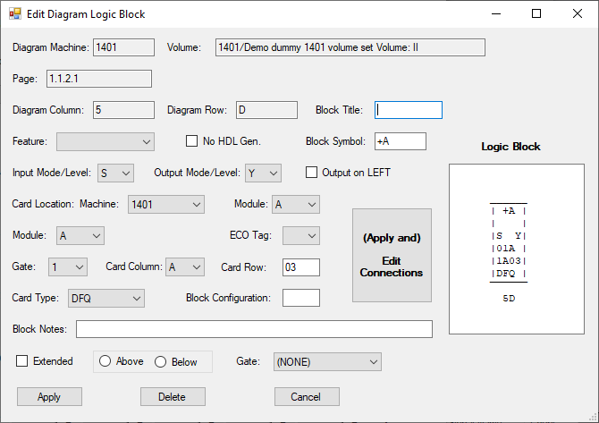

Edit Diagram Logic Block Dialog

Edit Connections Dialog

Finally, by clicking on the Edit Connections button, we reach the page where connections are displayed. At the top are read only fields identifying the ALD diagram page and logic block that these connections relate to.

Then there are two tables which list and allow editing of an individual connection, along with buttons to Add Input or Output connections.

In these tables, the Pin identifies the input or output pin on this gate.

There are three types of connections, identified by the Type column, and which are captured in different tables in the database (column references here start with the “Pin” column as column number 1.)

* P – gate connections from or to pins on other logic blocks on this same page, in which case the third column contains the coordinate of the connected logic block and the associated pin.
* E – edge connections from or to signals identified on the edges of this ALD diagram page, in which case the third column identifies the other sheet upon which this signal originates or to which this signal is sent, and the last column contains the row and signal name.
* D – dot function connections from or to “DOT functions” (wired and/or connections) on this page, or, rarely, with gates on other pages, in which case the third column contains the coordinate of the logic block to the LEFT of the DOT function, the fourth column contains an “A” or “O” for the logical function of the DOT function. The next column contains a “+” or “-“, indicating whether the DOT function is defined using negative logic or positive logic. These last two columns are guesses based on the logic function identified on the gates which connect to the DOT function, and are *not* expected to be used during HDL generation.

An individual connection may be edited by clicking the “Edit” button before the first actual data column. A new connection is added by clicking the Add Input button or the Add Output button.

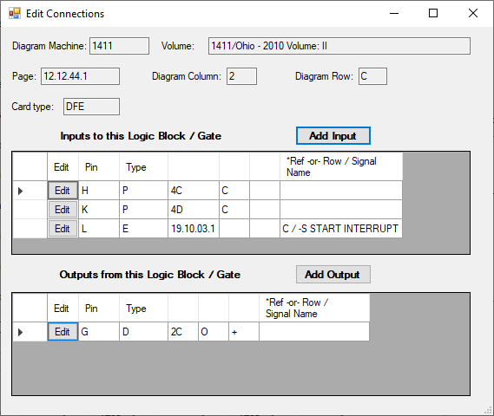

Edit Connections Dialog

Editing a DOT Function

To edit a DOT function, click on the “A”, “O” or dash (to add a DOT function) that exists between the larger logic block entries on the diagram.

This dialog is a combination DOT function editing dialog (where all one can specify is AND or OR) and a list of connections to and from the DOT function. The rest of the information in the top of the dialog is derived from the parent dialogs and is read-only.

Note that connections to the DOT function from a logic block on the same page or to a logic block on the same page cannot be edited here. Instead, such connections are edited from the logic block gate involved.

One can add/delete/edit connections to the DOT function from the edge of the sheet (originating from other sheets) or from the DOT function to the edge of the sheet (sending signals to other sheets) from the Edit DOT function dialog. The resulting dialog is described later.

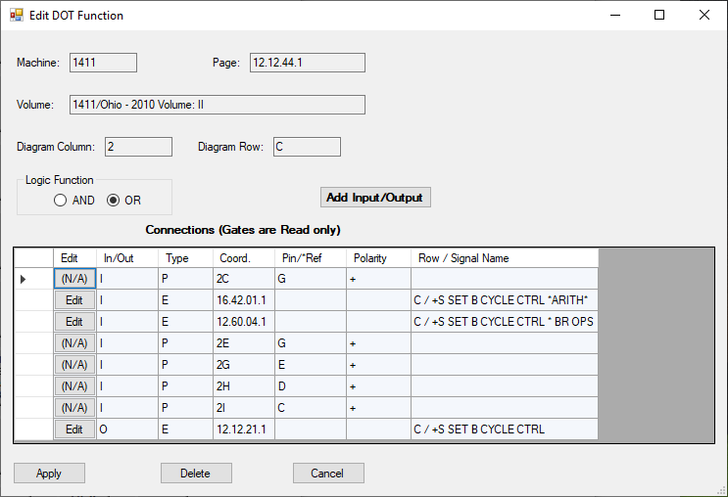

Edit DOT Function Dialog

Logic Block (Gate) Connections

The three types of connections to and from logic blocks are edited using the same dialog – the Edit Logic Block (Gate) Connection dialog. There are two major flavors of this dialog, depending upon whether one edits the connection from the input side or the output side. The machine, volume, page, diagram column/row and card type fields are read-only, filled in from the information from the parent Edit Diagram Logic Block and Edit Connections dialogs. To move a connection to a different gate, deleted it from one gate and add it back in the correct location.

For an input connection from another logic block on the same page, specify the input pin, select “Gate” from the Type radio button list, and specify the logic block coordinate and pin of the source of the connection. Some logic block connections (most often connections that are outputs to the sheet edge on the right hand side), there is a number reference that refers to the connection list near the bottom of the page. Those are specified using the *REF pull down list.

For an output connection to a gate, the dialog is similar, but specifies the gate which receives the signal as an Input. One can edit a gate-to-gate connection from either side of the connection. Also, for output signals, one specifies whether the connection is positive logic or negative logic using the Polarity radio buttons. Generally, connections that appear on top half of the output of a logic block in the original IBM ALD diagram are positive logic, and negative ones come out from the bottom half of the logic block.

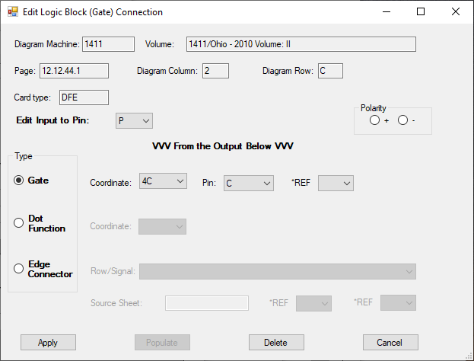

Input connection from another logic block on the same page

Inputs that come from the (left hand side) sheet edge are specified by selecting the input pin, as before, but then selecting the “Edge Connector” radio button. This enabled one to select the edge signal from the “Row/Signal” pull down, and then specify the sheet that is the source of the signal, along with up to two references, as described above.

For an output connection to an Edge, the dialog is similar, except specifying an output signal on the right hand side of the original IBM ALD diagram page.

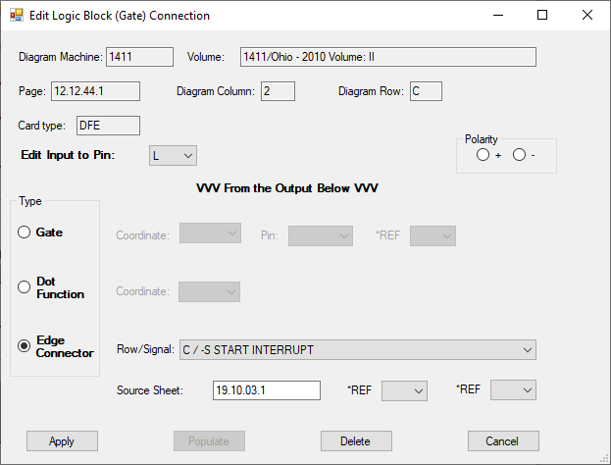

Input connection from a sheet edge

Inputs from DOT functions and outputs to DOT functions are specified by selecting the “Dot Function” radio button, and specifying the logic block coordinate which is to the immediate LEFT of the DOT function letter on the overall diagram.

Again, connections to and from DOT functions on the same page as the gates are edited like this, from the gates involved, rather than from the Edit DOT Function page.

Note that the type (And/Or) of the DOT function is not specified in the connection, but rather specified by editing the DOT function entry itself, as described earlier.

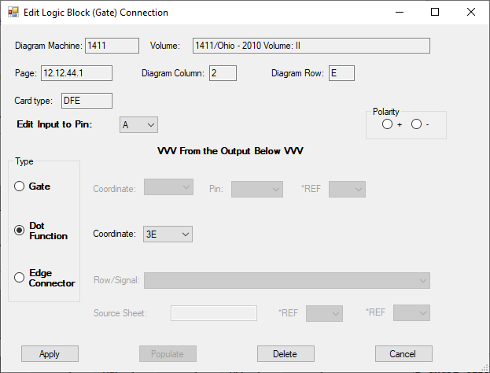

Input connection from a DOT function

Editing DOT Function Edge Connections

As mentioned earlier, DOT functions can, sometimes, receive connections from a sheet edge or provide outputs to a sheet edge. These are accessed from the Edit DOT Function dialog page by clicking on the “Edit” button for the connection. A new edge connection for a DOT function is created by clicking the Add Input/Output button. (Again, connections to or from DOT functions from or to logic blocks (gates) on the same page are edited from the logic block dialog.)

For a new connection, one specifies the In or Out radio button. A DOT function sheet edge connection cannot be changed between input and output once created. Instead, delete the incorrect one, and add the correct connection.

As with logic block gate connections, the information at the top of the dialog is read-only, inherited from the parent dialogs. Once one specifies In or Out (when adding), one then selects a Row/Signal from the drop down list, specifies a source or destination sheet and optionally an edge connection reference from the drop down list.

For convenience, selecting the Row/Signal will pre-populate the Source/Destination Sheet.

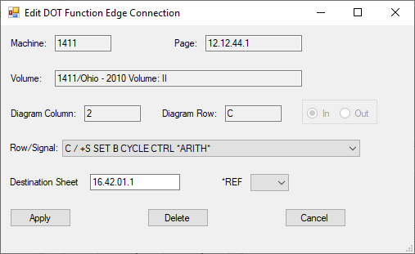

DOT function Edge Connection dialog for an input to the DOT function

Editing Cable/Edge Connections

The Cable/Edge Connection dialogs are similar in hierarchy to the ALD Diagram pages, but a bit simpler.

The top of the Cable/Edge connection diagram hierarchy is the Cabl/Edge Connection page, which is accessed via Edit => Cable/Edge Connection Pages, and selecting the machine, volume set, volume and page. Selecting the machine, volume set and volume pre-populates the “Select Page” pull down. One can also add a new page to the volume using the “New Page” button.

For a new page, fill in the Page Name (e.g. 11.04.02.3) which appears at the top of the page on the right, the Part Number, which appears at the top of the page on the left, and the title, which appears at the top of the page in the middle, and click “ADD”, and then select the page you just added to proceed (as of this writing, it is not automatically selected for you).

Once a page is selected, the Cable/Edge Connection Page ECO’s table is accessible. This is just like the one for the ALD diagrams. At the bottom of each Cable/Edge connection page in the drawing set is a list of one or more ECO’s with an accompanying ECO identification label (starting with “A”), and a date, which is entered into the Cable/Edge Connection Page ECO’s table.

Then click “Edit Cable/Edge Connection” button to edit the individual cable/edge connections. That produces a matrix of blocks similar to that of an ALD Diagram, but instead of containing logic blocks, this contains representations of cable/edge connection blocks for the following “card types”

* “CONN” – On an IBM 1410, these are flat ribbon cables that go between panels of a given frame/gate or between frames.
* “CABL” – These are cables other than the flat ribbon cables
* “RPQ” – These are card slot cable connections reserved for “request for price quotation” enhancements to a machine.
* “SAVE” – These serve a similar function to “RPQ” slots
* “STRL” – These are connection slots reserved for use with the Pound Sterling RPQ

As with an ALD diagram, clicking an individual block brings up a dialog to edit the characteristics of that block. The sheets that document cable/edge connection blocks are labeled using the same sheet coordinate system (rows A-I, top to bottom and columns 1-5, RIGHT TO LEFT) as the ALD diagram sheets.

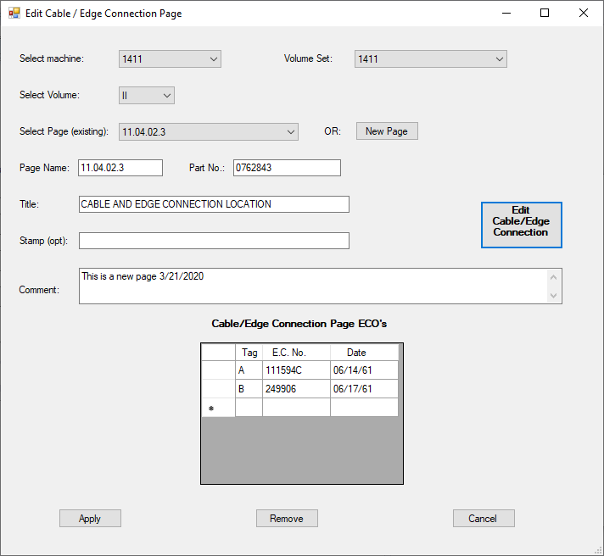

The Edit Cable/Edge Connection Page Dialog

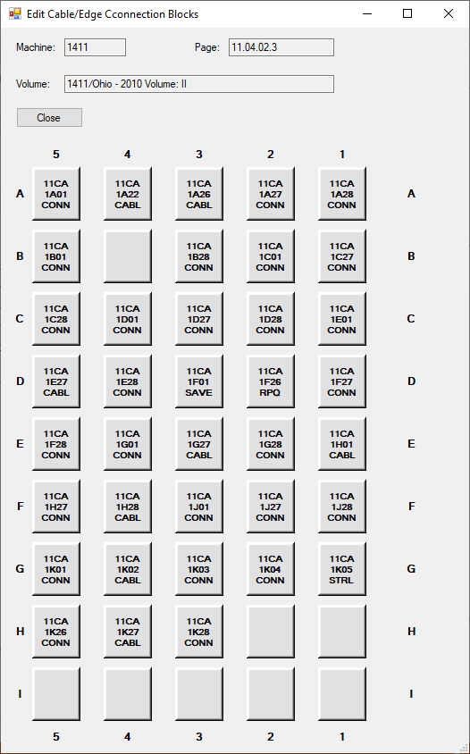

The Edit Cable/Edge Connection Blocks “matrix” Dialog

**Editing a Cable/Edge Connection Block**

The page for editing an individual cable/edge connection block, which corresponds to the connection block on the page in the original documentation, is accessed by clicking on that block. If the only information for a cable/edge connection block comes from the card location pages (i.e., has never been edited and saved), the characters in the block will be grey. Once edited and saved, the characters will appear black. (In the example below, all of the blocks had been edited). The Machine, Volume, Page, Diagram Column and Diagram Row are read-only as with the ALD diagrams.

For a cable/edge connection block there are two general areas. The top part relates to where the cable comes from, or its source. The bottom portion, below the horizontal bar in the dialog relates to where the cable goes to, or its destination. To the right is a display in a format similar to the one that appears in the original documentation.

Both the source and destination have a:

* Machine
* Frame and Gate (for the IBM 1410 they are the same)
* Panel
* Card Row
* Card Column

All of these are pull-downs except for the Card Column, which is a number corresponding to column in the card panel in the machine (not to a diagram column).

On the IBM 1410 and likely other machines, lots of connections follow a pattern. For example, a connector that is in column 01 of a panel would typically go to 28 of the panel next to it. 02 to 27 and 03 to 26 are the same – so the cables do not cross each other. In the parlance of this application, those are called “implied destination” because they don’t actually appear in the diagram. Indeed in the IBM installation manual for the IBM 1410 there is language which reads, for 1411D(D)1K01 “In this case socket K28 is assumed since it is the corresponding socket in 1411C2 and there is no note to indicate otherwise”

When first editing a block that is new but that appears in a card location diagram, if that block has a corresponding entry in the Cableimplieddestinations table, then the Destination will show that implied destination and the “Explicit Destination” checkbox near the bottom will be checked, rendering the destination fields read-only.

The destination can be changed between an implied destination and an explicit one by checking the Explicit Destination checkbox. If the Checkbox is cleared, but there is not matching rule for the source, a warning message appears, and the checkbox is left as checked.

The card types other than “CONN” and “CABL” cause special things to happen in the drawing on the right, clear the explicit destination check box (making the destination read only, because if the entry is not “CONN” or “CABL” there is no known destination).

Because the original pages I worked from did not show the card types other that “CONN” and “CABL” in a consistent way, the drawing on the right may not exactly match the original. In particular, many of the originals show the source Machine (2 digits), Frame and Panel for these card types, but did not always do so, so that top line is blank in the application.

At the very top of the drawing, above the rectangle is what I called at “Top Note”, and it can be entered to match the original drawing. If that is left blank by the user, and the an explicit destination is identified, then when the entry is saved and then opened again, that Top Note will be automatically filled in. Save it again, and it gets saved in the database. (Having the application fill that in during the first editing of the destination proved tricky enough that I didn’t bother doing that.)

There are two checkboxes on the form that relate to reporting, as well:

* The “No Conn. Check” checkbox is used to tell the reporting subsystem that it should skip checks involving this box relating to consistency with a partner check box being consistent with this one. This would typically be used where the other end of the connection is something like a CE panel or (on the IBM 1410) panel 7 which is used to connect to cables to external units.
* The “No Edge Check” checkbox is used to tell the reporting subsystem that it should skip checks involving this box relating to the Edge Connector Location Lists that appear on the bottom of ALD Diagram sheets.

As with the other dialogs, the Apply button applies updates, the Delete button deletes the entry (but leaves any underlying card location data from the card location chart entries alone), and Cancel cancels any changes.

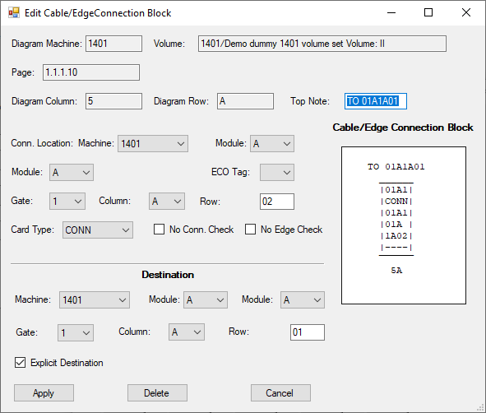

The Edit Cable / Edge Connection Block Dialog (Above)

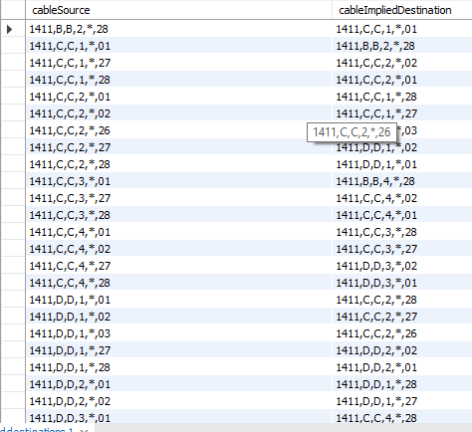

Some Cable/Edge Connection Implied Destination Rules

**Importing Data**

As described earlier, development started by creating some spreadsheets with data, as doing so was bound to be much more efficient than using the application to enter some things (like the card location charts.) Also, this allows the application to pre-populate quite a bit of information, which helps speed things along.

The spreadsheets used originally to import data (and, in some cases, kept up to date as errors were found while editing pages later) can be found in folder

**IBM1410-ImportedSpreadSheets**

The main spreadsheet is IBM1410-Drawing-Data.xlsx.

Individual .csv files were then created by exporting information from this spreadsheet to use by the import classes in the application.

Notice the use of past tense – these were one-time imports. Importing them again would be disastrous.

Data which can be imported includes:

* (Machine) Features
* SMS Card information (type, pins, internal connections, etc.)
* (Card) Location Pages to pre-create the pages containing card location charts
* Card Location Charts
* Tie Downs

Importing of cable interconnection pages has not yet been completed (or even properly designed in the database.)

**Logic Synthesis**

As stated earlier, the end-goal of this project is to be able to recreate the logic for an IBM SMS machine (and the IBM 1410 in particular) from the information gathered in the database.

The rudimentary beginnings of this process can be found in the “Generate HDL” portion of the menu.

The Generate HDL entry in the menu allows generation of HDL from individual pages.

The Generate Group entry is designed to support generation of HDL from a group of pages, so that their edge signals can be combined. The Page(s) to generate can use “%” style SQL syntax to specify the group of pages to use as input to the process.

Currently code only exists for VHDL generation (and it is incomplete and rudimentary), however the framework of the application is designed to support generation of more than one kind of HDL.

**Reports**

The Reports menu is for generating various types of reports that may turn out to be useful in order to locate and correct errors in the (manually) captured data.

* Card Type Usage Report, which creates a report of every ALD page on which a particular card type appears, its coordinates, its levels (In and Out) and its pins, as an aid to locating errors.
* Connector Check Report, which checks the connectors and cables on cable/edge connector sheets against each other.
* Edge Connection Check report, which checks sheet edge connections appearing at the bottom of ALD diagrams for inconsistencies among the connections which appear all of the sheets, and for inconsistencies or omissions with respect to the cable/edge connector sheets. The check can be run either including the pin (useful for signal-level checks) and without the pin (useful for checks against the cable/edge connectors.) It is recommended to first run the check with the pin, resolve those errors, and then run the check without the pins and resolve those errors, and then repeating the two step process until you are satisfied with the results. Perfection is not likely unless you have a completely consistent print set for a given actual serial number.
* databasecheck.py is a standalone Python program for doing some consistency checks of the database. Mostly these are related to referential integrity at a logical level.