First you would need to download and install mongodb on your machine if not already installed. Please follow this link to install it:

[How to Install MongoDB on Windows 10 - YouTube](https://www.youtube.com/watch?v=FwMwO8pXfq0&t=389s&ab_channel=ProgrammingKnowledge)

After which you then open the mongo shell and look for this link below:

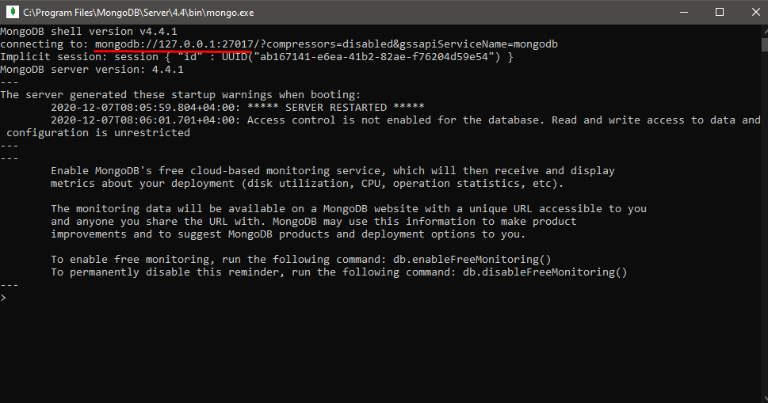

You then take that link and paste it in the app.js file which can be found under the file upload folder as seen below:

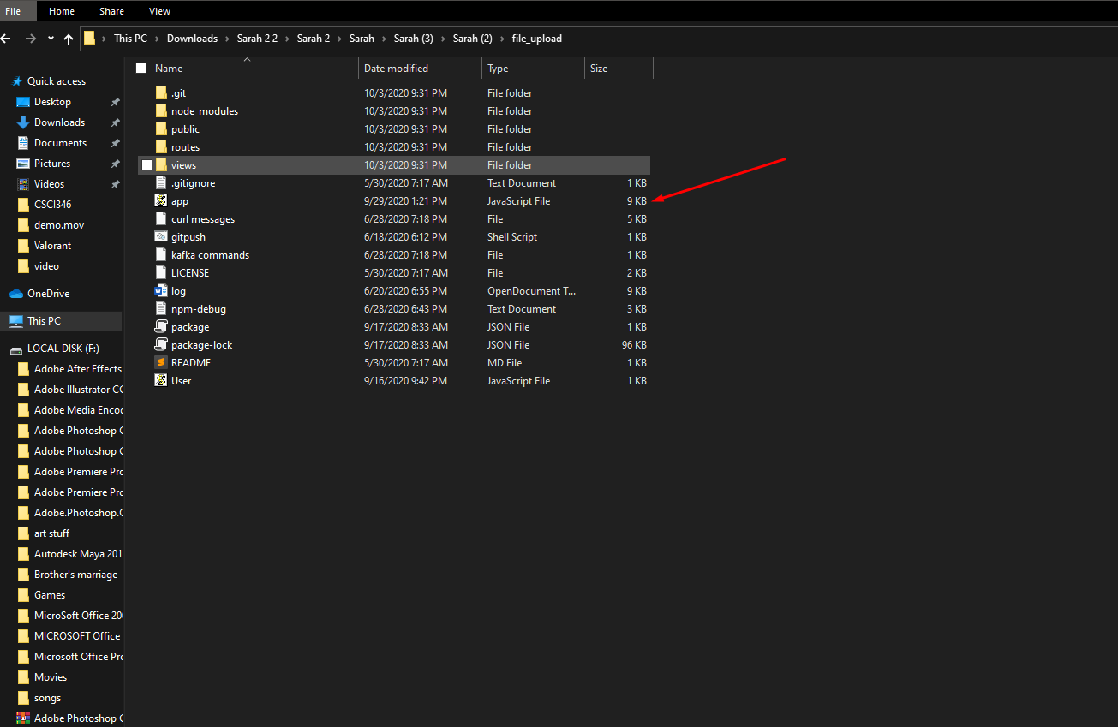

Once you are within the app.js file paste it as highlighted below on line number 19:

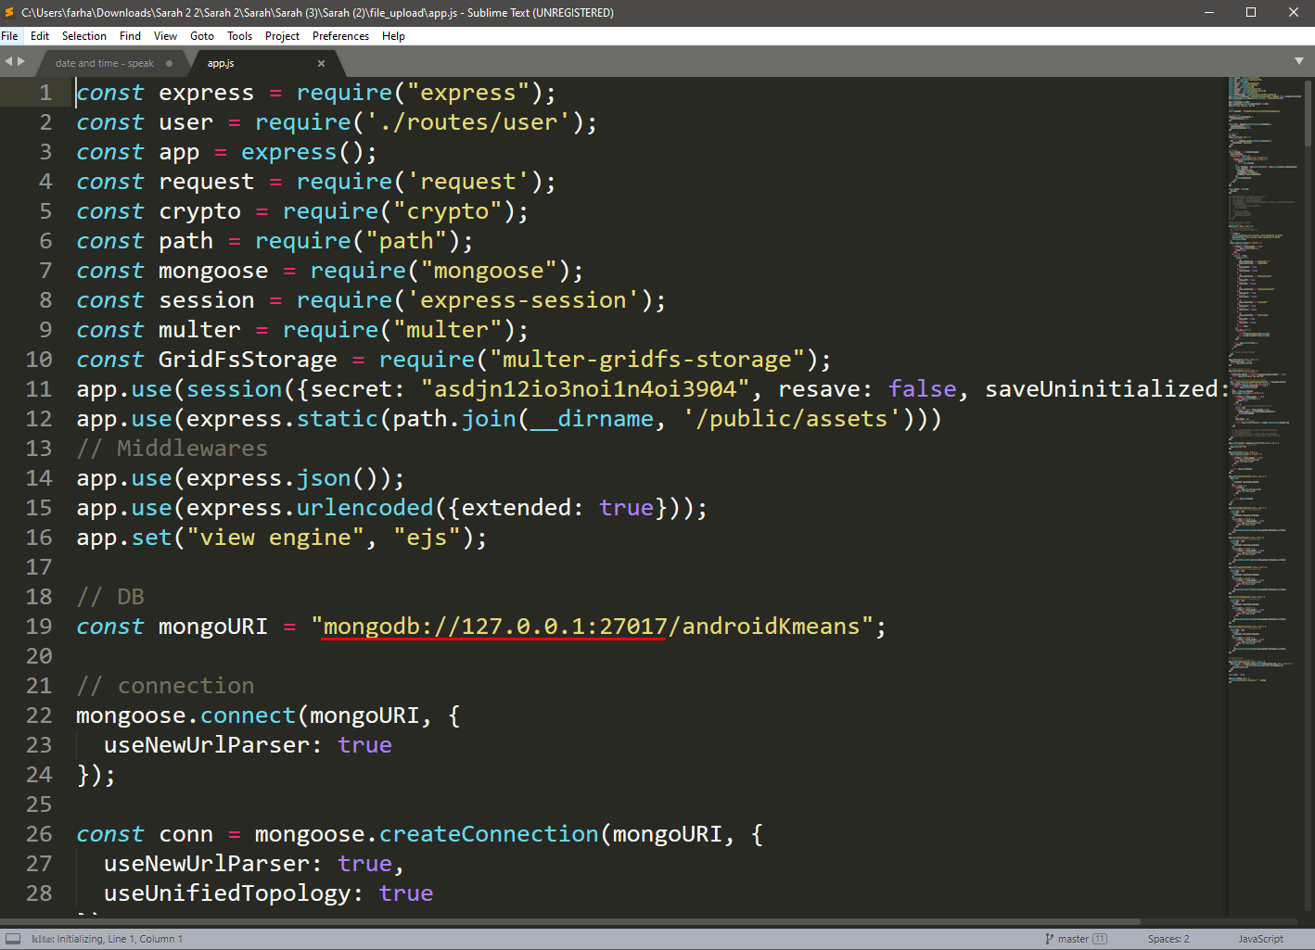

If the link is the same as the screenshots above then obviously no changes are required to be made to the app.js file. After which you then open the command line and install the dependencies required for the project like so:

npm install -y

after which you then start the node.js server by typing the following commands:

npm start

you can now open your browser and search:

<http://localhost:5001/>

you will then be greeted with the following the interface:

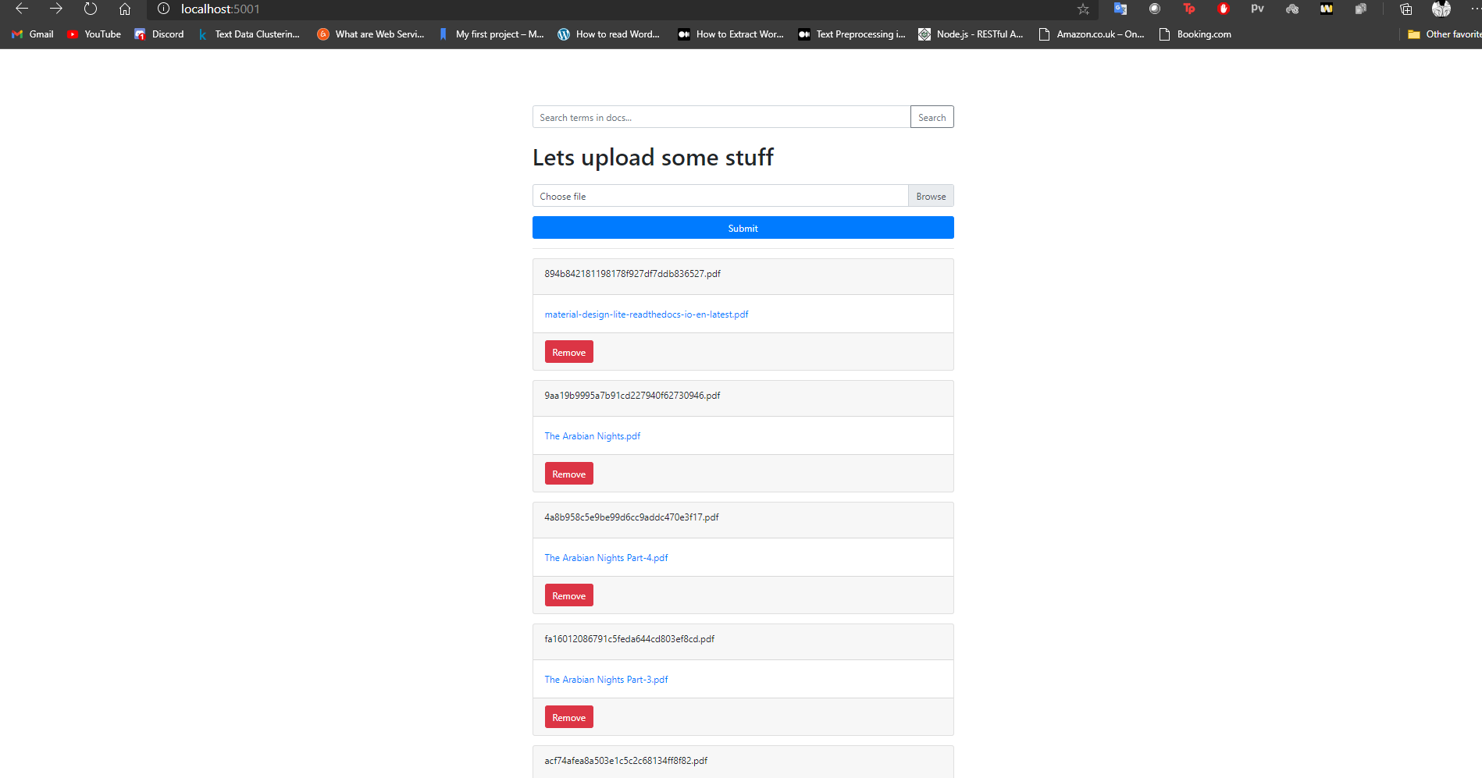

You can now upload the highlighted documents present in this folder:

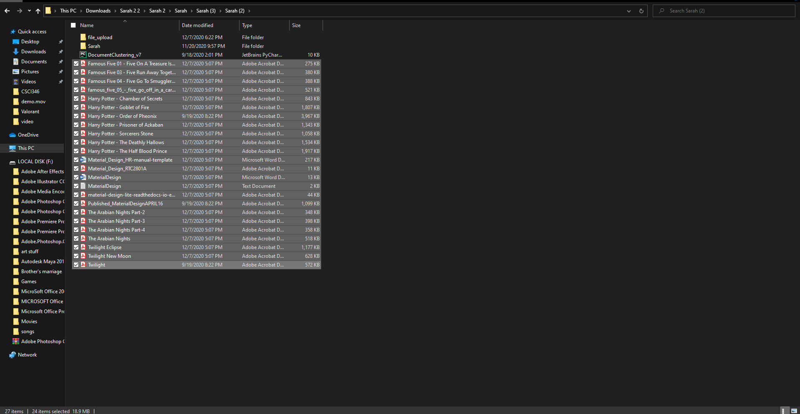

You should then install anaconda from here:

<https://www.anaconda.com/products/individual#Downloads>

and then open the anaconda navigator and install the following dependencies:

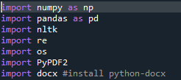

You can now run the document clustering code by opening the command line within the same directory and typing the following command and as a result after sometime your command line should look like this:

