Lab Specification

The primary mathematics tools support three operation: generate the equation in a quiz,solve the equation and check the answer of the equation.

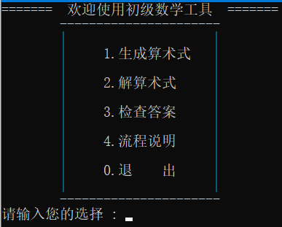

Generating Equation

For the first part,generating the equation,program will read the data in a specified file and use it to generate the needed problem into another file.

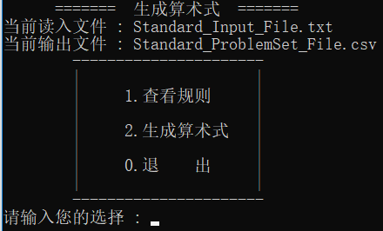

**Equation Type:**

Equation generator can generate three types of problem :

1 --- The addition , subtraction , multiplication , division on only integer.

2 --- The same four operation on fraction and integer.

3 --- The same four operation on float number,fraction and integer.

There will be 2 to 5 number in each equation.Parenthesis will be included in some of the equation.

**Data Reading from the Specified File:**

Program will read the data from the specified file (Standard_Input_File.txt) to generate equation.It read the data from the file two by two.For each reading,the first parameter is the number of equation of some type to generate,the second parameter is the type of equation.For example,if user input “5 1” into the specified file,five equation of type 1 will be output in another file.

**Generating Equation:**

After reading the number of equation and the type of equation,program will generate the needed equation and output them line by line into the target file (Standard_ProblemSet_File.csv).The csv file can be opened by the Notepad or Excel.

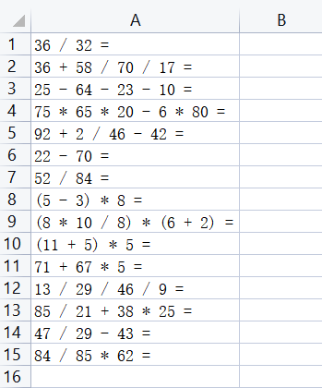

Some brief description are included in the program,input “2” in the program will see it.

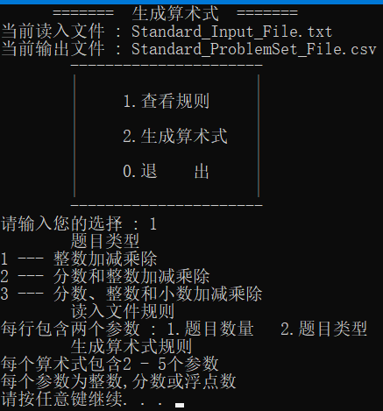

Solving Equation

For the second part,solving the equation,program will read the csv file,solve the equation and output the equation with the answer into another csv file.

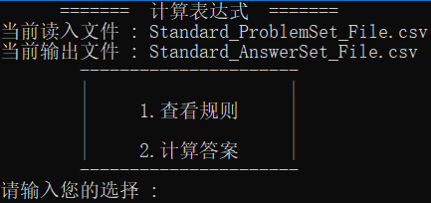

**Data Reading from the Problem Set File:**

Program will read the equation data from the specified file (Standard_ProblemSet_File.csv).

**Solving Equation:**

Program will use the equation reading from the problem set file.To solve the equation,program will use the Reverse Polish Notation Calculator to solve it.

The calculation among the integer, fraction and float number are implemented as well.

The result of the calculation contain the float number will be a float number which keeps two decimal.

If the calculation does not contain the float number and contains fraction,the result will be a fraction.

The result of calculation between integer will be an integer.

After the equations are solved,the equations with correct answer will be output into another file (Standard_AnswerSet_File.csv).

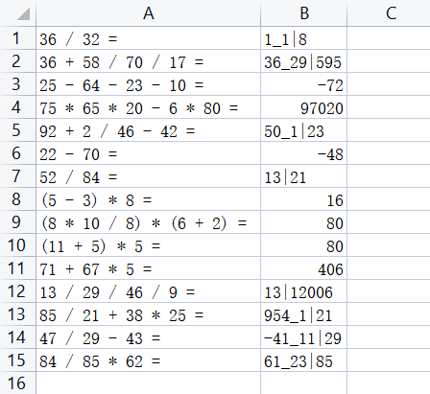

Some brief description of answer format are included in the program,input “1” in the program will see it.

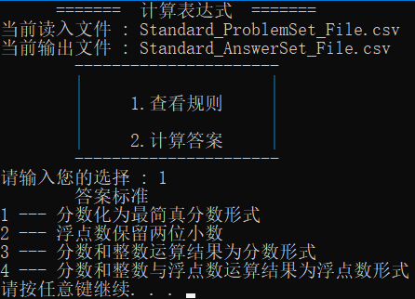

Checking Answer

Program will read the equations and answers from the answer file,use the equation to solve the correct answer and compare the answer from the file to the standard answer.

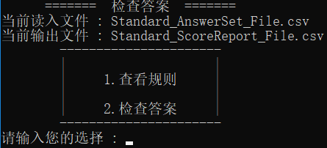

**Data Reading from the Problem Set File:**

Program will read the equation data from the specified file (Standard_AnswerSet_File.csv).

**Checking the answer of equations:**

Program will using the equation to generate the correct answer using the Equation Solver and compare the answer with the answer read from file.If the answer is correct,program will output the result,equations and original answers in another file (Standard_ScoreReport_File.csv).

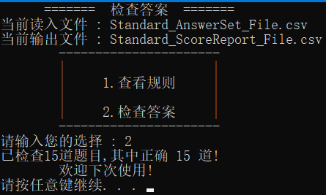

Some brief description of the standard answers are included in the program,input “1” in the program will see it.

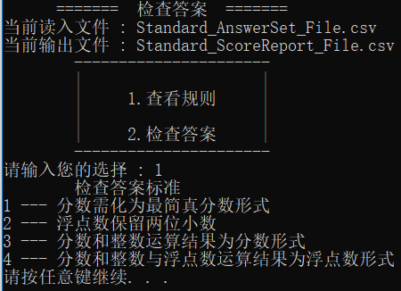

**Test 1:**

Input Equation File:

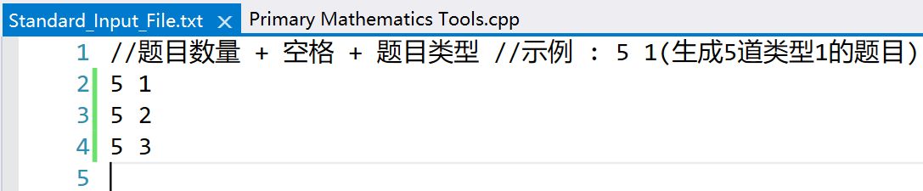

Problem Set File:

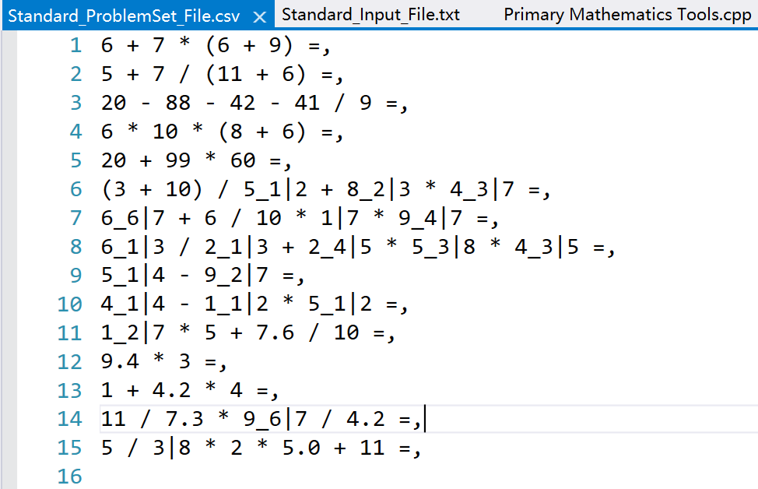

Answer Set File:

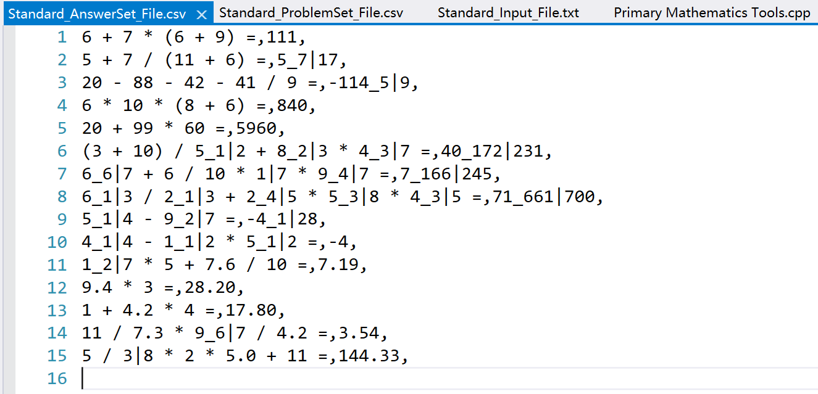

Score Result File:

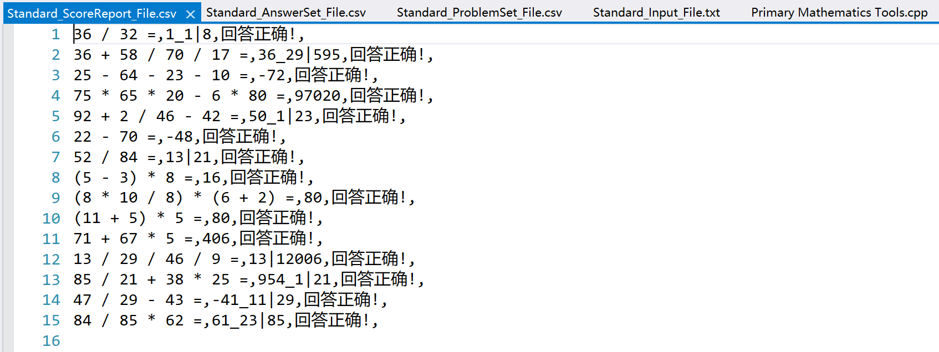

**Test 2:**

Input Equation File:



Problem Set File:

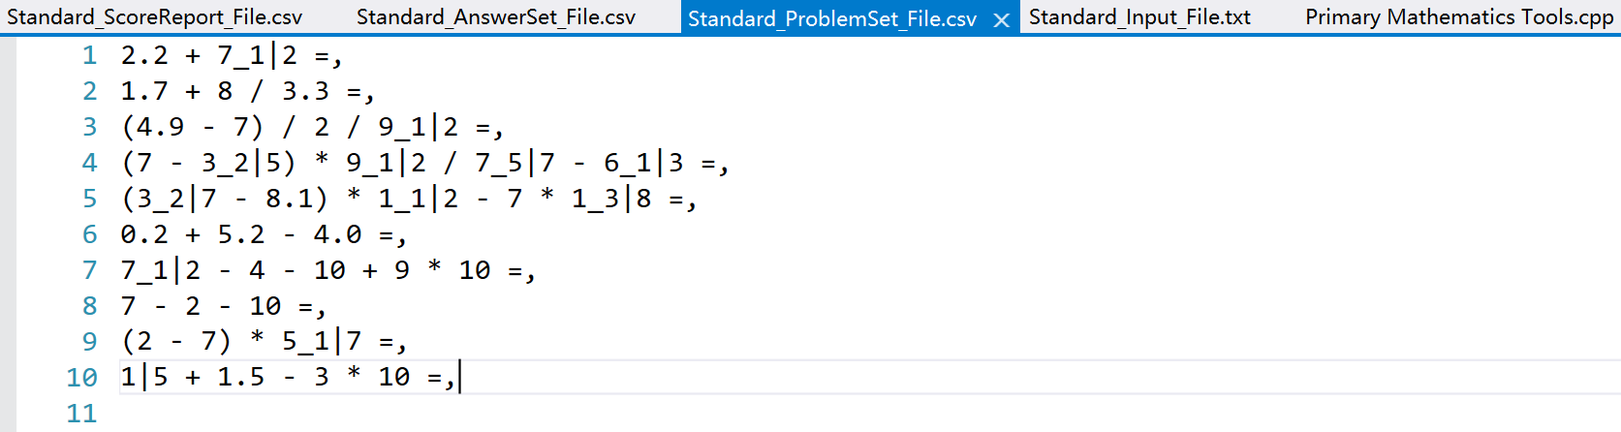

Answer Set File:(A wrong answer on the line 8)

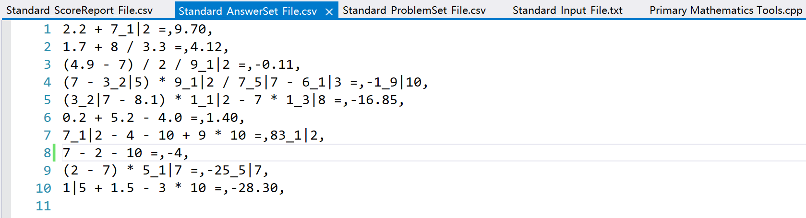

Score Result File and Output:

