**Introduction to Scientific Computing, Homework #3**

**Due by 12pm, Thursday, May 19, 2022**

**Problem 1 [10]:** The arrangement of seeds in a sunflower head (and flowers such as daisies) follows a fixed mathematical pattern. The nth seed is at position

,

with angular coordinate πdn/180 radians, where d is the constant angle of divergence(in degrees) between any two successive seeds (i.e., between the seeds n and (n + 1)). Write a function

function seedsPlot(d)

to plot the seed’s pattern, using a circle (o) for each seed. A remarkable feature of this model is that the angle d must be exact 137.51° to get proper sunflowers. Experiment with different values, such as 137.45°(spokes, from fairly far out), 137.65° (spokes all the way), and 137.92° (Catherine wheels).

# Problem 2 [10]:

There are two dates, find the number of days between them, if the two dates are consecutive, set the number of days between them as two day. The input format is two integers representing two dates in the form YYYYMMDD. Note that leap years and peace years need to be taken into account. Leap years happen in two ways. The first case is when the year is a multiple of 4 and not a multiple of 100. For example, 2004 and 2020 are leap years. The second case is when the year is a full hundred and must be a multiple of 400. For example, 1900 is not a leap year, and 2000 is a leap year.

Your job is to write a function called processScores with the following signature

function difference=The_date_difference(time1,time2)

Some examples are as follows

If time1 is ‘20210101’, time2 is ‘20210105’, the difference is ‘5’.

If time1 is ‘20210105’, time2 is ‘20210101’, the difference is ‘5’.

**Problem 3 [20]:**

You need to write a function to rank the grades of Zhejiang University students. The initial information includes each student's student number and grade. There are n examination rooms, each with 5 students. The initial information is placed in a text file and arranged in the order of the examination room.

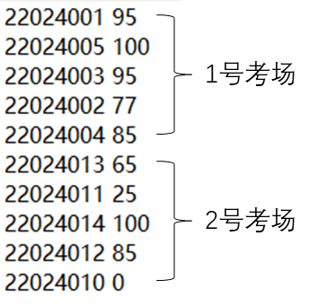

You are to write a function called Scores_ranking with the following signature

function rank=Scores_ranking(n)

Your output should be an array of 5 columns, representing student number, score, examination room number, local rank, and final rank. Where, local rank represents the ranking within the scope of the examination room, and final rank represents the ranking among all students. The output must be sorted in nondecreasing order of the final ranks. The students with the same score must have the same rank. If the scores are the same, the output must be sorted in nondecreasing order of their student numbers.

22024005 100 1 1 1

22024014 100 2 1 1

22024001 95 1 2 3

22024003 95 1 2 3

22024004 85 1 4 5

22024012 85 2 2 5

22024002 77 1 5 7

22024013 65 2 3 8

22024011 25 2 4 9

22024010 0 2 5 10

**Problem 4 [20]:** You are to create two functions that generate and plot a data set. The first function, saveSineWave(fileName), will generate a sine wave with the form y=5*sin(x)+2 over the domain -2π≤x≤2π with a step size of π/100. This function will then save the x and y data as a single MATLAB variable (.mat) in the working directory with the “fileName” you specify when calling the function. The function plotSineWave(fileName) will then open the .mat data file and produce a pleasing plot of the sine curve that includes axis labels. The fileName input should, as an example, have the form ‘myXYdata’ not ‘myXYdata.mat’. Note: your function saveSineWave should be able to save the generated data using any file name you specify when invoking the function. You will then need to input the same fileName string when opening and plotting the data with plotSineWave.

**Problem 5 [20]:**

The game of life, developed by British mathematician John Conway, is the classic example of a cellular automata. You can find a wonderful description of this game at the following Wikipedia site <http://en.wikipedia.org/wiki/Conway%27s_Game_of_Life>. Your job will be to implement this game in Matlab. The game state will be represented by a 2 dimensional logical arrays where 1s correspond to ‘live’ cells and 0s to ‘dead’ cells. In order to do this you will need to implement the following MATLAB functions.

* Function out = getCell (in, row, col)
  + Takes as input a 2 dimensional logical array and a row and col index and returns the value of the cell at those coordinates. If the coordinates are illegal, say the row or col indices are less than 1 or greater than the dimension of the array, this function should return 0.
* Function out = countNeighbors (in)
  + Takes as input a 2 dimensional logical array, in, and produces an output array the same size as the input which indicates how many live neighbors each cell in the input has. (Hint: use the getCell function)
* Function out = updateCells (in)

Takes as input a 2 dimensional logical array, find its living neighbors by using the countNeighbors(), and computes what the next generation would look like based on the rules of the game:

**For a space that is 'populated':**

Each cell with one or no neighbors dies, as if by loneliness.

Each cell with four or more neighbors dies, as if by overpopulation.

Each cell with two or three neighbors survives.

**For a space that is 'empty' or 'unpopulated':**

Each cell with three neighbors becomes populated.

You should test your life program using some of patterns listed in the wikipedia entry. You may find it convenient to store the patterns in small array (egs glider = [1 1 1; 1 0 0; 0 1 0] and then copy these subarrays into various locations in the input array). A 100 by 100 array should prove suitable for testing, a sample script LifeScript.m is provided for your testing.

**Problem 6 [20]:** You have obtained a summer research position with Apple. The company is currently investigating reliability issues of the electrical connectors on the lightning cables. In particular, a new, lower cost manufacturing process has led to high resistances between the lightning plugs and the electrical connections with which they mate.

You are scanning these metal surfaces using atomic force microscopy (AFM) (<http://en.wikipedia.org/wiki/Atomic_force_microscopy>) with the hope of identifying variations in the surface of the electrical connecter that may contribute to these reliability issues. The measurement consists of rastering the connector surface with a nanoscale probe tip while measuring the topography of the surface, the friction force between the probe tip and surface, and current through the probe tip-surface junction. The resulting data sets are output as two dimensional matrices of data representing the magnitude of a response at regularly-spaced locations across the sample surface.

You have been performing a lot of these AFM scans and would like to visually summarize your findings for each data file. You decide to use MATLAB to quickly produce standardized plots of each data set and save the plots to your working folder. To do this, you concoct a plotting function with the following function declaration.

function plotAFMdata(H,F,I,ss,saveName)

where H is a two dimensional matrix of height data, F is a two dimensional matrix of friction data, I is a two dimensional matrix of current response data, ss is a scalar describing the scan size of the data set (taken to be 200 nm for your data), and saveName is the data file to which you will save the figure you produced. You can assume that H, F, and I will always be square and have the same dimensions.

The data is provided to you from the AFM (after some additional processing) as a .mat file with fields corresponding to ‘height’, ‘friction’, and ‘current’ (current response) in units of nanometers, millivolts, and volts, respectively. You have been provided with the data set AFMdata0001.mat to test your function.

plotAFMdata should produce a figure closely resembling the following figure.

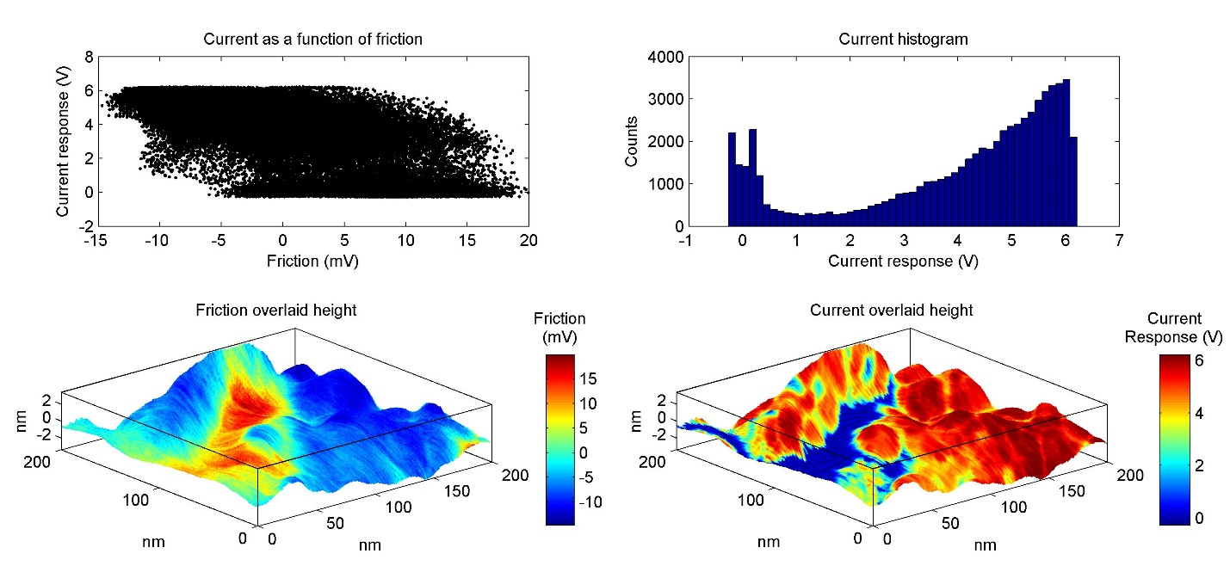

plotAFMdata should produce a single figure with the following axes and specifications.

Axes 1 and 2) Produce a three dimensional plot of height with color provided by the friction data and a three dimensional plot of height with color provided by the current response data. The plots should include the following modifications.

* Each axis should extend no further than the range of the data.
* The azimuth and elevation should be specified.
* Do not include a grid.
* Include a bounding box.
* Include a color bar. You may have to adjust the position of the color bar so that it does not overlap the plot.
* Include a title on the color bar.

Axes 3) Plot current response as a function of friction.

* You can let MATLAB automatically select the domain and range.

Axes 4) Produce a histogram of the current response for all current data points.

* Specify a domain of -1 to 7 but do not specify the range.

All plot modifications should be invoked using code in plotAFMdata. All plots should include the following elements, specifications, or modifications.

* Include labels on all axes.
* Include titles on all plots.
* Specify the font size and font name for all text elements.
* Specify a white figure background color.

You want to ensure that your code will display the plot correctly on any modern computer. Therefore, your figure should be positioned in the center of the computer screen and have dimensions of 1000 x 460 pixels (width x height).

plotAFMdata will save the figure to the working folder under the name specified by saveName as a 24-bit jpeg with a resolution of 300 pixels/inch. Note that the command used to save MATLAB figures often resizes the figure during the file writing process. You may have to specify the ‘PaperPositionMode’ as ‘auto’ when first establishing the figure. plotAFMdata will then close the figure window after saving the jpeg.

You will create an associated script to test your function that loads the test data and launches the plotAFMdata function.

Include a copy of your plot in your .docx submission.