**Introduction to Scientific Computing, Homework #4**

(Note: Long codes will NOT be placed in a box for better typography and copying)

**Problem 1 Solution (Only key functions, full testing script in attachments)**

%% My work

function [t, collisionState] = findCollision (ballState, wall, coefficient_of_restitution)

x = ballState(1);

y = ballState(2);

vx = ballState(3);

vy = ballState(4);

if wall(1)==wall(3) % Wall is vertical

if vx*(wall(1)-x)<=0 % No speed or wrong direction

t = inf;

collisionState = [];

return ;

end

if wall(2)>wall(4) % swap if start>end

tmp = wall(2);

wall(2)=wall(4);

wall(4)=tmp;

end

xt = wall(1); % target X

new_y = vy*(xt-x)/vx+y; % Y of collision position.

if new_y>=wall(2)&&new_y<=wall(4) % Fall inside the range of wall

t = (xt-x)/vx; % How many time left before collison

collisionState = [xt, new_y, ...

-vx*coefficient_of_restitution, vy*coefficient_of_restitution];

return ;

else

t = inf;

collisionState = [];

return ;

end

else % Wall is horizontal, the same

if vy*(wall(2)-y)<=0

t = inf;

collisionState = [];

return ;

end

if wall(1)>wall(3)

tmp = wall(1);

wall(1)=wall(3);

wall(3)=tmp;

end

yt = wall(2);

new_x = vx*(yt-y)/vy+x; % x of collision position.

if new_x>=wall(1)&&new_x<=wall(3)

t = (yt-y)/vy;

collisionState = [new_x, yt, ...

vx*coefficient_of_restitution, -vy*coefficient_of_restitution];

return ;

else

t = inf;

collisionState = [];

return ;

end

end

end

function newBallState = updateBallState (ballState, dt, walls, coefficient_of_restitution)

[wallcnt, ~] = size(walls);

minT_id = 1;

t = inf;

for i=1:wallcnt % Find the next wall to hit (minimum time before collision)

wall = walls(i,:);

[tmpt, ~] = findCollision(ballState, wall, coefficient_of_restitution);

if tmpt<t % Log the wall with the minimum time to hit

minT_id = i;

t = tmpt;

end

end

[t, collisionState] = findCollision(ballState, walls(minT_id,:), coefficient_of_restitution);

if t<=dt % Collision is coming

newBallState = updateBallState(collisionState, dt-t, walls, coefficient_of_restitution);

% Recursively update the state

else

newBallState = UpdateBallStateNoCollisions(ballState, dt);

end

function next_state = UpdateBallStateNoCollisions (current_state, dt)

% Nested function, for normal movement without collisions

next_state = current_state;

x = current_state(1);

y = current_state(2);

vx = current_state(3);

vy = current_state(4);

next_state(1) = (x + vx*dt);

next_state(2) = (y + vy*dt);

end

end

**Problem 1 Runtime Screenshot**

(Next Page)

**Problem 2 Solution**

clc;clear;

msd_posVel(0.2, 0.1, 2, 10, 5, 0, 100);

msd_water(0.2, 0.1, 0:0.1:20, 10, 5, 0, 300);

function dy = msd(t, y, c, k, m)

% y1'=y2

% y2'=(-c*y2-k*y1)/m

dy=[y(2);(-c.*y(2)-k.*y(1))./m]; % Equations(given)

end

function msd_posVel(c, k, m, yi, vi, t_beg, t_end)

figure;

tspan = [t_beg, t_end];

[t, x]=ode45(@msd, tspan, [yi vi], [], c, k, m);

% Extra arguments is acceptable

% [yi vi] specifics initial conditions

% [] stands for no extra options

[Ax, C1, C2] = plotyy(t, x(:,1), t, x(:,2));

% plotyy is deprecated, but stick to it since it is required to use :)

title('msd pos. and vel.');

%% Style Settings

set(gcf, 'Color', 'w');

set(Ax, 'FontName', 'Consolas', 'FontSize', 12);

xlabel('Time (sec)');

set(get(Ax(1), 'Ylabel'), 'string', 'Position (m)');

set(get(Ax(2), 'Ylabel'), 'string', 'Velocity (m/s)');

set(Ax(1), 'ylim', [-20, 30]);set(Ax(2), 'ylim', [-4, 6]);

set(Ax(1), 'ycolor', 'b');set(Ax(2), 'ycolor', 'r'); % Match the curves

set(Ax, 'Xlim', [0, 100]);

set(C1, 'Linestyle', '-', 'color', 'b', 'Linewidth', 2);

set(C2, 'Linestyle', '-', 'color', 'r', 'Linewidth', 2);

grid off; % No grid

hold off;

end

function msd_water(c, k, m, yi, vi, t_beg, t_end)

figure;set(gcf, 'Color', 'w');

N = length(m);

x = linspace(t_beg, t_end, N);

y = m;

Z = zeros(length(x), N, 2); % Pre-allocating for speeding

for i=1:N % Compute data points for different m

[~, Z(:,i,:)]=ode45(@msd, x, [yi vi], [], c, k, m(i));

end

[X, Y] = meshgrid(x, y);

plot3(X', Y', Z(:,:,1), 'k');

set(gca, 'FontName', 'Consolas', 'FontSize', 10);

xlabel('Time (s)');ylabel('Mass (kg)');zlabel('Position (m)');

view(-15, 55);

box off;grid off;hold off;axis tight;

end

**Problem 2 Plots**

(Next Page)

**Problem 3 Plot**

**Problem 3 Solution**

clc;clear;

ntimesteps = 20000;

xt = lotkaVolterra([1, 1], 1, 2.5, 1, 2.5, 0.001, ntimesteps);

figure;

plot(1:ntimesteps, xt(1,:), '-', 'LineWidth', 1, 'color', 'blue');

% prey, blue

hold on;

plot(1:ntimesteps, xt(2,:), '-', 'LineWidth', 1, 'color', [0.4 0.7 0.4]); %

% predator, deep green.

xlabel('Time');ylabel('Population');

legend('Prey', 'Predator');

set(gca, 'FontSize', 8, 'LineWidth', 1);

axis auto;

function state = lotkaVolterra (initial_state, alpha, beta, gamma, delta, dt, ntimesteps)

LotkaVolterra = @(t, x) [

alpha*x(1)-beta*x(1)*x(2);

-gamma*x(2)+delta*x(1)*x(2)]; % Derived from given equations

t = 0:dt:ntimesteps*dt-dt; % Total counts: ntimesteps

assert(ntimesteps==length(t)); % Required

[~, state] = ode45(LotkaVolterra, t, initial_state);

state = state'; % Just to meet requirements in problem

end

(Next Page)

**Problem 4 Solution**

% O(n^3) for special constructed map.

% BFS can reach O(n^2) in worst cases.

clc;clear;

%% Generate test data

map = randi(10, 11); % Random maps for test

map = map>2; % 1s:0s=8:2

map(5, 5) = 1;

disp(grassfire(map, 5, 5));

%% Grassfire function

function distance = grassfire (occupancy, dest_row, dest_col)

[rows, cols] = size(occupancy);

distance = inf(rows+2, cols+2); % border padding

distance(dest_row+1, dest_col+1) = 0;

updated = 1; %flag

while updated

updated = 0;

for i=2:rows+1

for j=2:cols+1

if ~occupancy(i-1, j-1) % Keep dis. of obstacles be inf.

continue;

end

new_dis = 1 + min([distance(i-1, j), distance(i+1, j), ...

distance(i, j-1), distance(i, j+1)]);

%NOTE: this kind of query(crossing row/column) is very common

%in scientific computation needs, like particle physics. But it

%breaks "space locality" and leads to high performance loss,

%since cache misses will occur high frequently, and

%pre-fetching no longer make a difference.

%The way to solve it is by dividing the full matrix into small

%blocks in special orders.

%

%See also: morton code

if new_dis<distance(i, j)

distance(i, j) = new_dis;

updated = 1;

end

end

end

if ~updated

break;

end

end

distance = distance(2:rows+1, 2:cols+1); % de-padding

end

(Next Page)

(Next Page)

**Problem 5 Solution**

clc;clear;

close all;

%% Constants

FIGS = 10;

A = 0.5;

k = 2*pi;

D = 0.05;

U = 1;

n = 21;

h = 2/(n-1);

x = 0:h:2;

dt=0.05;

%%

y2 = A*sin(k*x); % Initial phase

for i=0:FIGS-1

t=i*dt;

y1 = exp(1)^(-D*k^2*t)*A*sin(k*(x-U*t));

plot(1:n, y2, '-b', 'LineWidth', 2);

hold on;

plot(1:n, y1, '-r', 'LineWidth', 2);

hold off;

legend('Numerical', 'Exact');

xlabel('n');ylabel('f');

xlim([1 n]);ylim([-4*A 4*A]);

str = sprintf("nstep=%d time=%.2f", i+1, t);

text(11, -1, str, "Color", 'k', 'FontSize', 12); % Required

%% Compute next numerical sequence

newy=zeros(1, n);

calc = @(a,b,c)(b-(c-a)*U*dt/2/h+(c-2*b+a)*D*dt/h/h); % shortcut

for j=2:n-1

newy(j) = calc(y2(j-1), y2(j), y2(j+1));

end

newy(1) = calc(y2(n-1), y2(1), y2(2)); % Special judge for boundaries

% Regard node 1 and node n as the same node.

% Then turn the sequence into a ring:

% ...--(n-1)--(1|n)--2--3--...--(n-1)--(1|n)--2--3--...

newy(n) = newy(1);

y2=newy;

%%

pause(1);

end

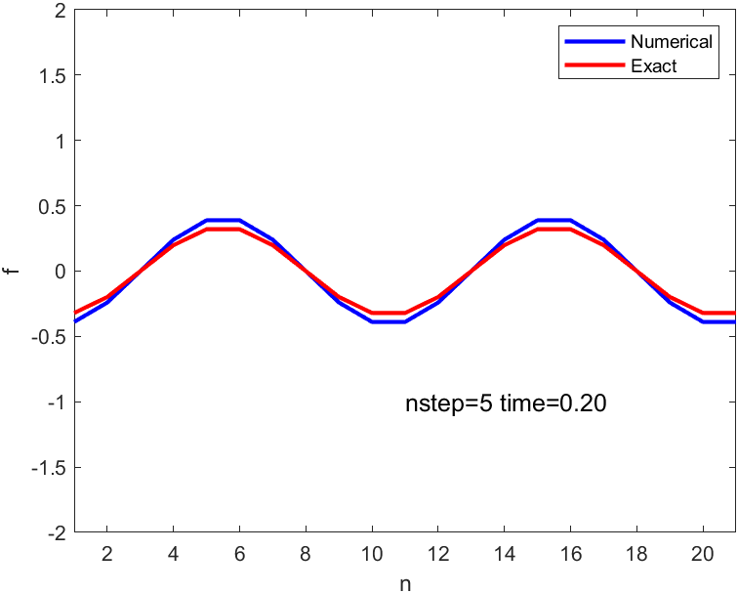**Problem 5 Plots(nstep=5, nstep=10)**

(The End)