**GITCONNECT**

**A PROJECT REPORT**

*Submitted by*

**Harsh Pandya [1721BECE30076]**

**Purvesh Patel [1721BECE30107]**

**Umang Patel [1721BECE30113]**

*In fulfilment for the award of the degree of*

BACHELOR OF ENGINEERING

*in*

COMPUTER ENGINEERING



LDRP Institute of Technology and Research, Gandhinagar

**Kadi Sarva Vishwavidyalaya**

March 3, 2021

**LDRP INSTITUTE OF TECHNOLOGY AND RESEARCH**

**GANDHINAGAR**

**CE-IT Department**



**CERTIFICATE**

This is to certify that the Project Work entitled “**GITCONNECT**” has been carried out by **Team CUBICSX** under my guidance in fulfilment of the degree of Bachelor of Engineering in Computer Engineering Semester-8 of Kadi Sarva Vishwavidyalaya University during the academic year 2020-2021.

Dr. Mehul Barot Dr. Shivangi Surti

**Internal Guide Head of Department**

**LDRP-ITR LDRP-ITR**

**ACKNOWLEDGMENT**

I would like to express my appreciation to all those who provided me the possibility to complete this report. A special gratitude is given to our project manager Dr. Mehul Barot, whose contribution in stimulating suggestions and encouragement, helped the team to coordinate the project especially in writing this report.

Furthermore a special thanks goes to my team-mate Mr. Harsh Pandya, Mr. Umang Patel and Mr. Purvesh Patel, who helped me to guide and gave suggestions about different tasks and helped to develop them. Last but not least, many thanks go to the head of the project, Prof. Vishal Barot and Prof. Pratik Modi, who has invested his full effort in guiding the team in achieving the goal. I have to appreciate the guidance given by other supervisors, professors as well as our friends and the panel especially in our project presentation that has improved our presentation skill thanks to their comments and advice.

**Harsh Pandya**

**Purvesh Patel**

**Umang Patel**

**ABSTRACT**

The report primarily focuses on the problem of requirement of developers for contributing in open source projects. The report reviews the problem in broad aspects. By doing analysis of the open source developers community, It was found that it is also hard to find good projects for contribution and collaboration. Focusing on this specific problem of finding partners or developers for your projects, we provide a online platform where developers can connect to other developers and start their work with them. On this platform, users can find projects and new ideas that are introduced by other users. The users can make requests for projects as per their interest and also can share new project ideas with others. Understanding this problem in depth, This platform is our contribution to not only the open source community but Atmanirbhar India to work together, develop together and grow together.

**LIST OF DIAGRAMS**

|  |  |
| --- | --- |
| Diagram 1 | Login and Validate user in gitConnect database |
| Diagram 2 | Search projects flow diagram |
| Diagram 3 | Add/Modify Projects flow diagram |
| Diagram 4 | System Diagram |

## **TABLE OF CONTENT**

**INTRODUCTION** **6**

**AIMS AND OBJECTIVES OF WORK:** **7**

**PROBLEM DEFINITION:** **8**

**PLAN OF WORK:** **8**

**TIMELINE CHART:** **9**

**TECHNOLOGY STACK:** **9**

Front-end development: 10

Back-end development: 10

**LITERATURE REVIEW:** **10**

**SYSTEM REQUIREMENTS:** **12**

User Characteristics: 12

Hardware Requirements: 12

Software Requirements: 12

Functional Requirements: 12

Non-Functional Requirements: 12

**ASSUMPTION AND DEPENDENCIES:** **13**

Assumptions: 13

Dependencies: 13

**FLOW DIAGRAM:** **13**

**SYSTEM DIAGRAM:** **17**

**RESULT, DISCUSSION AND CONCLUSION:** **18**

Result: 18

Discussion: 18

Conclusion: 18

**REFERENCES:** **19**

## 

## 

## **INTRODUCTION**

Considering the current scenario of the world, it is very difficult to find developers who have problem solving skills and an enthusiastic mind to work on any problem statements. On the other hand, it's difficult to find the projects and problem statements according to our interest on which one can contribute their skills. There is a lack of a platform for developers where they can share the ideas and find other developers to work on that idea as a team.

Solving this problem, we choose to create an online open source platform where all developers can come connect across, share their ideas with each other and start working together on ideas. In any field’s problem statement, It is always hard to choose a project to give our worth time and skills. By using this platform, any students who want to develop a project on his own idea or want to contribute to someone else's idea, they can do so by requesting one.

Our main aim to provide this web-app platform is to bring all developers together to develop,explore,learn and grow their network with other developers.

## 

## **AIMS AND OBJECTIVES OF WORK:**

* To develop a web-application where users can come together and work together according to their skills and interest.
* The User can share their own ideas and can also work on other users' ideas by making requests to collaborate.
* We provide a platform to the users who can find the projects according to their interest.
* Users can search and explore all the project details and can claim to contribute to the project.
* The developers can monitor other users' requests to contribute and can sort out according to their profiles.
* The primary achievement of this platform is to connect and have a team work experience with users or around the globe.

## 

## **PROBLEM DEFINITION:**

It is very difficult to find developers who can work with us to make an idea into reality. In the same way, it's equally difficult to find the projects on which we can contribute using our skills. There should be a platform for developers **connecting** them so they can share the ideas and find other developers to work on that idea as a team.

## **PLAN OF WORK:**

* From the above-defined problem statement, we are proposing a web-based solution where a different developer can share project definition and also can be a collaborator in a different project.
* We are proposing a Web App solution where the developers can share their project definition and find different developers who would like to collaborate in that project.
* The owner of the project can set the number of developers and skills needed and can choose from the list of interested developers, who have sent their invitation for collaboration and can start working as a team.
* The collaborator can gain a new skill set and a team experience besides this they can ask the owner to provide endorsement for their work.

## **TIMELINE CHART:**

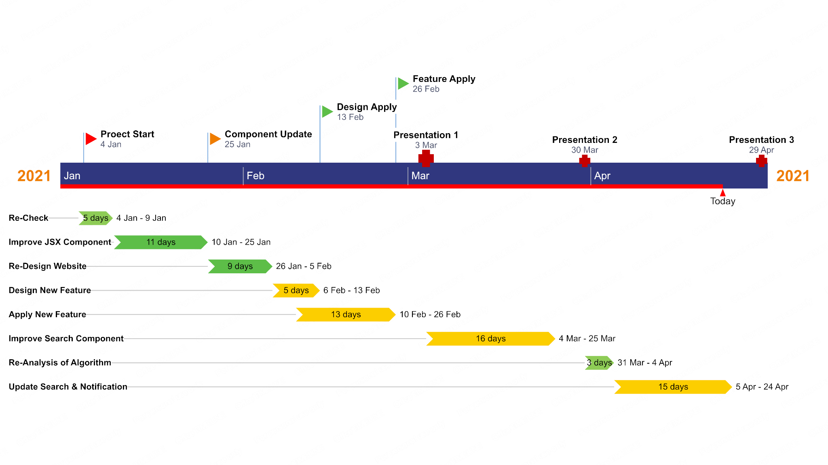

## **TECHNOLOGY STACK:**

Three main technologies are used to create a website. ReactJS for front-end development, NodeJS for back-end and MongoDB database for storing user data.

### **Front-end development:**

* We use ReactJS for developing interactive front-end websites.
* Users can register first with his github account to join this community.
* Users can search projects as per their interest and send requests to the project owner for joining him for development.
* Users can edit their personal details and introduce new ideas to the community and find developers.
* Also users can bookmarks projects for future development.
* Users can receive comments regarding his work that can make the user profile more valuable.

### **Back-end development:**

* A back-end server created in python Django for handling user requests and sending appropriate responses to users.
* Every field in the webpage is validated and directly sent to the server.
* Every route and API path of the server is secured so other than the website can't access server and data.
* Server is connected with MongoDB database with secure API key.
* User data directly stored in the database.

## **LITERATURE REVIEW:**

In today’s time there are so many ongoing projects and brillants ideas that can impact on industry and give a whole new direction to industry.But working on a project as a single developer is difficult and so we need co-developers to build a project. It is very difficult to find developers who can work with you to make an idea into reality. In the same way, it's equally difficult to find the projects on which we can contribute using our skills.

Finding the developer with the same skill set or experience of working with a team and on an industry based project is a difficult job. And convincing a good developer to make a contribution into the project is equally difficult. Besides that finding a good project and convincing a project author to work with them or contributing into the project is also a hard task. There is no such type of platform available that gives a chance to make a contribution in someone else's project except Github and Gitlab. But both the platforms are not able to find projects relevant to user coding interest.

To overcome the problem of finding the project and making a contribution, we provide a platform that brings developers and contributors on the same ground. So users can find the project of their relevant interest and start contributing after the author’s approval. Also the project author can see the user profile and user skills and make sure that users are capable to contribute to the project or not. Also every user can introduce the new project ideas and other users can rate that idea,to make the project interesting for other users. Also users can bookmark the project definition for review again in the future. We also provide features for making a team of developers. So users can find a new developer, make a team and contribute to the next level. Users can select problem definitions from different problem categories and make contributions. By making a contribution to a project, the user can gain the reputation point and this reputation point leads the user to another big project.

Developing this open-source platform, we provide solutions to find other developers to build software together and contribute to the project. Any developer can register and start developing as per interest.

## **SYSTEM REQUIREMENTS:**

### **User Characteristics:**

Analysing user characteristics is an important aspect of any project. It allows us to clearly define and focus on who the end users are for the project. Also, it allows checking the progress of the project to ensure that we are still developing the system for the end users.

* Users should understand the modules.
* Users can easily interact with the proposed system.

### **Hardware Requirements:**

* 2 GB RAM
* 1.6 GHz Processor

### **Software Requirements:**

* Any operating system
* A modern web browser

### **Functional Requirements:**

* The user will login/signup into the system with a github account.
* Users can create projects or join other projects.
* Email notifications will be provided.
* Users can search projects and also bookmark them.

### **Non-Functional Requirements:**

* User Interface: The user interface is designed such that the user feels it ease to work with and get acquainted to it easily.
* The interface is user friendly and self-descriptive so that the user need not take many pains in handling the daily activities.
* Response Time: The response time is not too large that the user needs to spend hours waiting for the output like waiting for the home screen to open.

## **ASSUMPTION AND DEPENDENCIES:**

### **Assumptions:**

* We will provide a user-friendly interface so that any user can easily navigate through the system, but he/she should be capable of providing input to the system for successful interaction.
* Internet connection is being established properly.
* User is the person having enough knowledge for the traversing operation.

### **Dependencies:**

* The system is dependent upon the user’s valid credentials i.e. login, establishing connection and sharing proper problem statements.
* This application is dependent on internet connection.

## **FLOW DIAGRAM:**

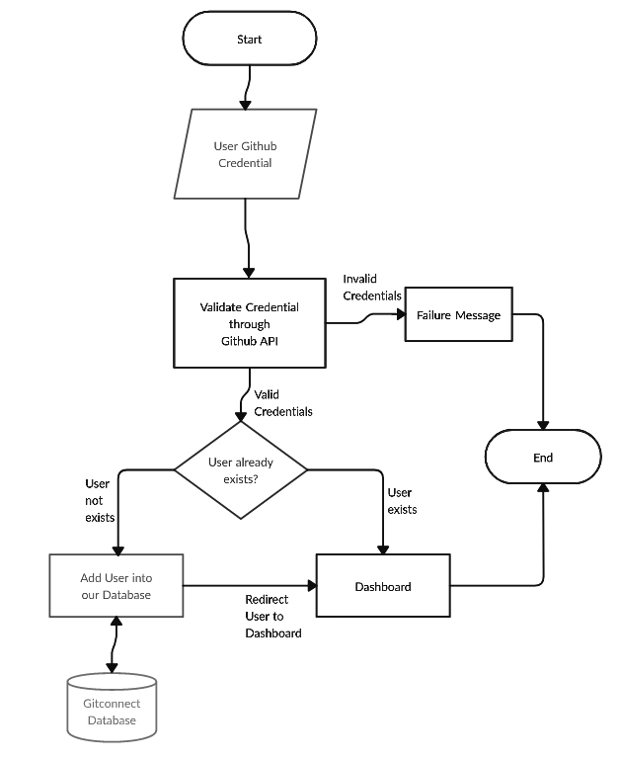

[ Diagram-1: Login and Validate user in gitConnect database ]

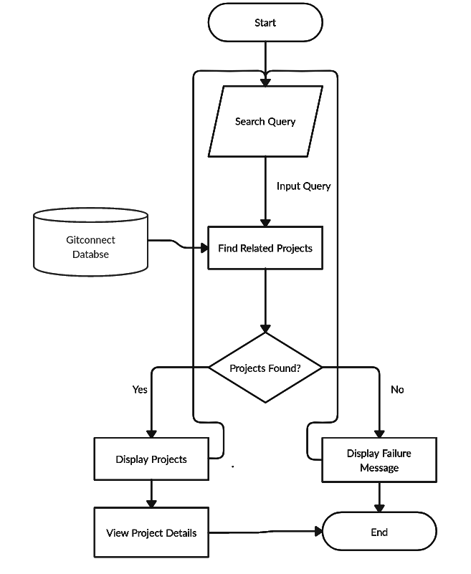

[ Diagram-2: Search projects flow diagram ]

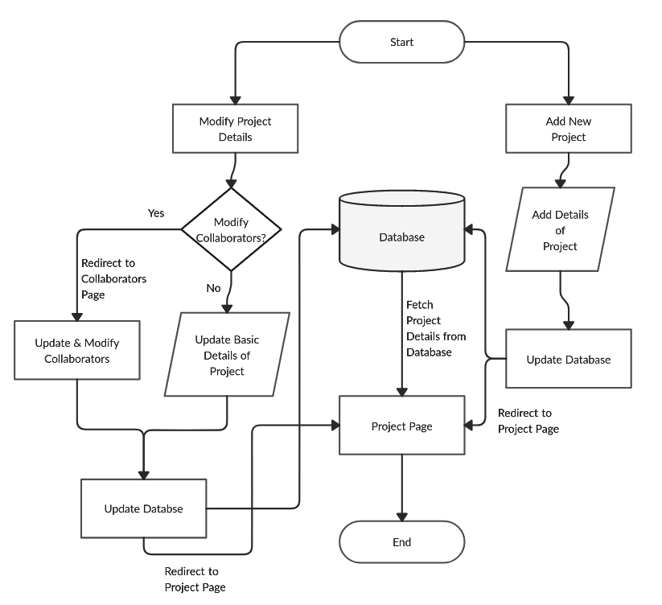

[ Diagram-3: Add/Modify Projects flow diagram ]

## **SYSTEM DIAGRAM:**

[ Diagram-4: System Diagram ]

## **RESULT, DISCUSSION AND CONCLUSION:**

### **Result:**

* The users can use this platform to share their ideas world wide.The chances of growing startups may also rise with time.
* The users can use this platform to find projects of their interest for their academic years also with professional experience.
* The users can collaborate or contribute in other projects by using this platform showcasing sharing which is one of our old traditions.

### **Discussion:**

As the use of technology is increasing and it actually does the work easy for humans and nowadays normally most of the things are being done online so we have developed this system so users can get benefit of technology provided he/she is having proper internet connection.

### **Conclusion:**

Today's time, It is hard to find developers to work with and it is also hard to become a collaborator rather than a contributor. We are providing a platform where a developer can bring their idea and find other developers to work with him as a collaborator or contributer. It also helps developers to find developers that are experts in other fields in which you are just a beginner. Using this platform, any developers find new projects and build their network with other developers for future works.

## **REFERENCES:**

1. <https://reactjs.org/docs/getting-started.html>
2. <https://reactjs.org/tutorial/tutorial.html>
3. <https://material-ui.com/>
4. <https://nodejs.org/api/documentation.html>
5. <https://docs.mongodb.com/>