**REPORT**

**gitConnect – Cubix**



by

**HARSH PANDYA**

**PARI NIMAVAT**

**PURVESH PATEL**

**UMANG PATEL**

**ABSTRACT**

The report primarily focuses on the problem of requirement of developers for contributing in open source projects. The report reviews the problem in broad aspects. By doing analysis of the open source developers community, It was found that it is also hard to find good projects for contribution and collaboration. Focusing on this specific problem of finding partners or developers for your projects, we provide a online platform where developers can connect to other developers and start their work with them. On this platform, users can find projects and new ideas that are introduced by other users. The users can make requests for projects as per their interest and also can share new project ideas with others. Understanding this problem in depth, This platform is our contribution to not only The open source community but Atmanirbhar India to work together, develop together and grow together.

**Table of Contents**

|  |  |
| --- | --- |
| **Contents** | **Page No.** |
| Abstract | i |
| Table of Contents | ii |

|  |  |  |
| --- | --- | --- |
| **Chapter 1:** | **Introduction** |  |
| **Chapter 2:** | **Objectives** |  |
| **Chapter 3:** | **System Design** |  |
| **Chapter 4:** | **System Implementation** |  |
| **Chapter 5:** | **Applications** |  |
| **Chapter 6:** | **Conclusion and Future Scope** |  |
|  | **References** |  |

**Chapter 1: Introduction**

* Considering the current scenario of the world, it is very difficult to find developers who have problem solving skills and an enthusiastic mind to work on any problem statements. On the other hand, it's difficult to find the projects and problem statements according to our interest on which one can contribute their skills. There is a lack of a platform for developers where they can share the ideas and find other developers to work on that idea as a team.
* Solving this problem, we choose to create an online open source platform where all developers can come connect across, share their ideas with each other and start working together on ideas. In any field’s problem statement, It is always hard to choose a project to give our worth time and skills. By using this platform, any students who want to develop a project on his own idea or want to contribute to someone else's idea, they can do so by requesting one.
* Our main aim to provide this web-app platform is to bring all developers together to develop,explore,learn and grow their network with other developers.

**Chapter 2: Objectives**

* To develop a web-application where users can come together and work together according to their skills and interest.
* The User can share their own ideas and can also work on other users' ideas by making requests to collaborate.
* We provide a platform to the users who can find the projects according to their interest.
* Users can search and explore all the project details and can claim to contribute to the project.
* The developers can monitor other users' requests to contribute and can sort out according to their profiles.
* The primary achievement of this platform is to connect and have a team work experience with users or around the globe.

**Chapter 3: System Design**

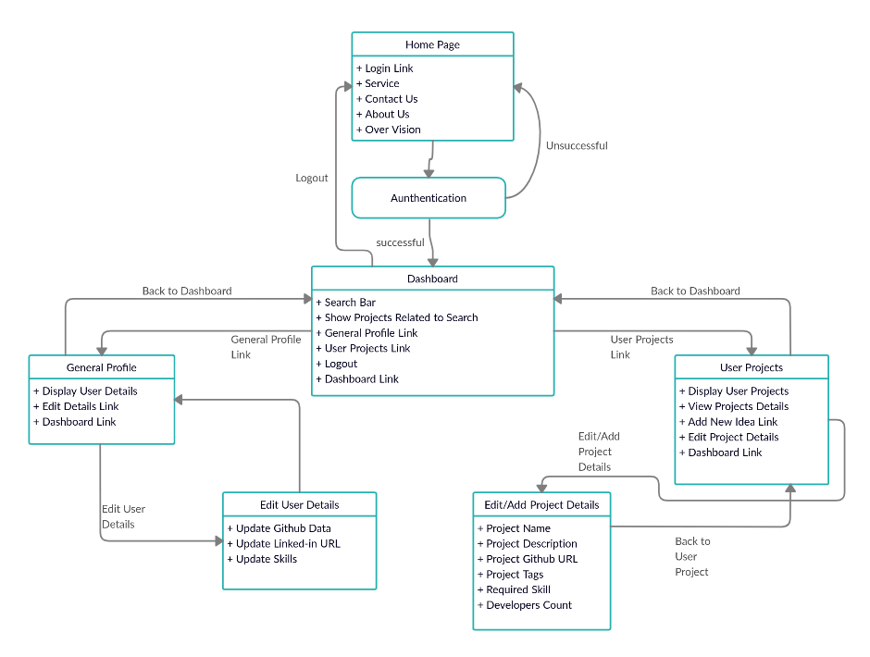

**Chapter 4: System Implementation**

Three main technologies are used to create a website. ReactJS for front-end development, NodeJS for back-end and MongoDB database for storing user data.

**Front-end development**

* We use ReactJS for developing interactive front-end websites.
* Users can register first with his github account to join this community.
* Users can search projects as per their interest and send requests to the project owner for joining him for development.
* Users can edit their personal details and introduce new ideas to the community and find developers.
* Also users can bookmarks projects for future development.
* Users can receive comments regarding his work that can make the user profile more valuable.

**Back-end development**

* A back-end server created in NodeJS for handling user requests and sending appropriate responses to users.
* every field in the webpage is validated and directly sent to the server.
* every route and API path of the server is secured so other than the website can't access server and data.
* server is connected with MongoDB database with secure API key.
* user data directly stored in the database.

**Chapter 5: Applications**

* The mission Atmanirbhar bharat and HAB59 gave us the chance to showcase our project and plan inspired by such a mission we developed a web app:GitConnect where people can explore their interests and learn teamwork with social distancing.
* The users can use this platform to share their ideas world wide.The chances of growing startups may also rise with time.
* The users can use this platform to find projects of their interest for their academic years also with professional experience.
* The users can collaborate or contribute in other projects by using this platform showcasing sharing which is one of our old traditions.

**Chapter 6: Conclusion and Future Scopes**

**Conclusion**

* Today's time, It is hard to find developers to work with and it is also hard to become a collaborator rather than a contributor. We are providing a platform where a developer can bring their idea and find other developers to work with him as a collaborator or contributer. It also helps developers to find developers that are experts in other fields in which you are just a beginner. Using this platform, any developers find new projects and build their network with other developers for future works.

**Future Scopes**

* A User can develop his own team on this platform to work with each other and someone else's projects.
* An organization from github can also join this platform and work with other projects.
* Also We can scale this Idea from developers community to field of Mechanical Engineering, Automobile Engineering, Mathematics field etc.
* We can scale this idea to the Education level, where students can share their difficulties and others will solve that.
* A user can rate a project without contributing to that project, so great ideas and implementation will pop out first.

**References**

* <https://reactjs.org/docs/getting-started.html>
* <https://reactjs.org/tutorial/tutorial.html>
* <https://material-ui.com/>
* <https://nodejs.org/api/documentation.html>
* <https://docs.mongodb.com/>