- TAPI organization
之前的TAPI架構
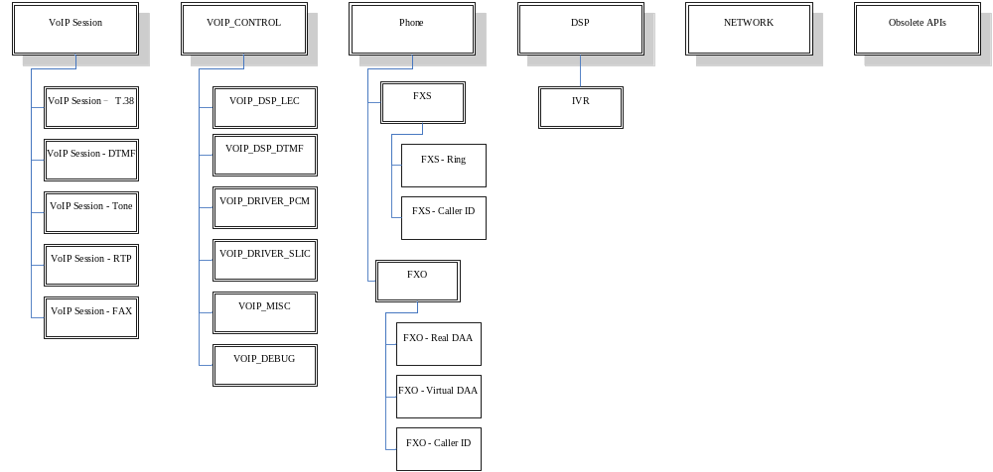
之後的架構
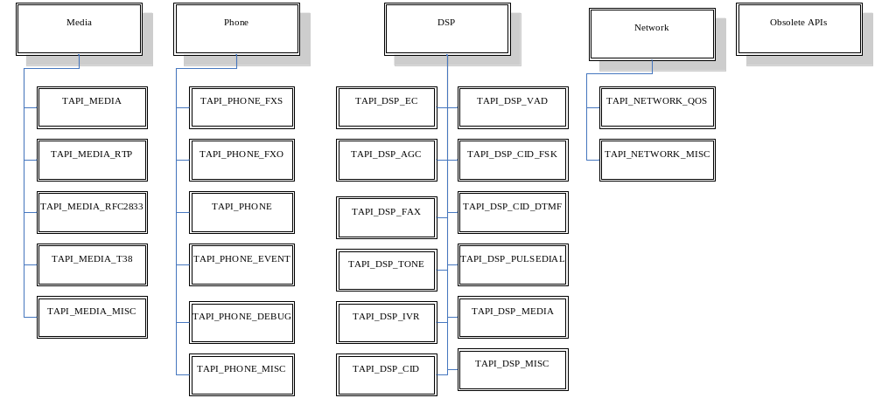
- doxygen 撰寫rule：
  - 於@ingroup後的@brief簡述該API的功能與目的
Example:
/**
* @ingroup VOIP_PHONE
* @brief Reinit DSP for FXS/FXO channel when on hook
* @param chid The channel number.
* @retval 0 Success
*/
int32 rtk_Onhook_Reinit(uint32 chid);
  - 若@brief需要描述較多的文字，請於@ingroup後的@brief簡單描述後，空一行再編輯欲描述的文字。
Example:
/**
* @ingroup VOIP_FXS
* @brief Setup the flash hook time
*
* Flash hook or hookflash simulates quickly hanging up then picking up again.
* @param chid The channel number.
* @param min_time The min time period for flash hook.
* @param time The max time period for flash hook.
* @retval 0 Success
*/
int32 rtk_Set_Flash_Hook_Time(uint32 chid, uint32 min_time, uint32 time);
如此在function list時會看到簡述文字
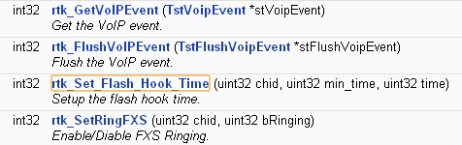
Link過去的詳細function描述，欲增加的字文就會在此呈現：
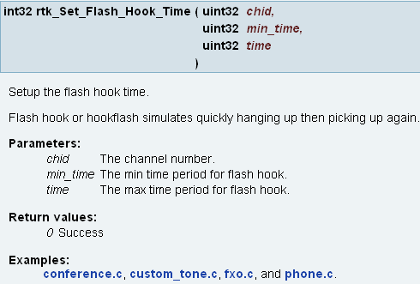
  - 若該API己停用，請於@ingroup後加VOIP_OBSOLETE，將此api歸類於obsolete
  - 若有輸入參數，請描述其可能的值及該參數的範圍值。並且將其換行，使其看起來較整齊。
換行請統一使用<br> (“/n”就不使用)
Example:
/**
* @ingroup VOIP_DSP
* @brief Set echo tail for LEC
* @param chid The channel number.
* @param echo_tail The echo tail length that is the length of time over which it can cancel echoes. <br>
* Value range: 1~32 <br> Unit: ms <br> Step: 1
* @param nlp Non-linear processor mode <br>
* 0: NLP off <br> 1: NLP_mute <br> 2: NLP_shift <br> 3: NLP_cng
* @note 0: NLP off. Turn off NLP processing. <br>
* 1: NLP_mute. Removes the nonlinear and residual part of the echo. <br>
* 2: NLP_shift. To improve the voice quality when users in a specific environment are some of the voices is discontinuous.<br>
* 3: NLP_cng. Not only to remove residual echo, but also generate the comfort noise.
* @retval 0 Success
*/
int32 rtk_Set_echoTail(uint32 chid, uint32 echo_tail, uint32 nlp);
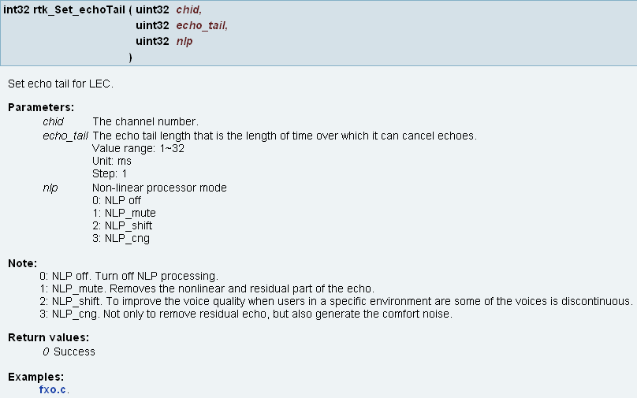
  - 若api輸入的參數，有其structure，請使用\ref 連結
Example:
/**
* @ingroup VOIP_PHONE
* @brief Get the SLIC state
* @param chid The channel number.
* @param pval The SLIC state. Please refer to \ref SLICEVENT for more detail states.
* @retval 0 Success
*/
int32 rtk_GetSlicEvent(uint32 chid, SLICEVENT *pval);
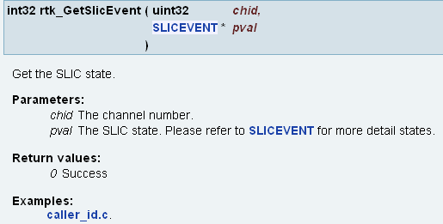
  - 若return 值有多個時，請使用多個@retval
Example:
/**
* @ingroup VOIP_FXS_CALLERID
* @brief FSK Caller ID Generation
* @param chid The FXS channel number.
* @param str_cid The Caller ID
* @param str_date The Caller Date
* @param str_cid_name The Caller ID Namertk_Stop_CID
* @param mode Mode <br>
* 0: type I<br> 1: type II
* @note When application calls this API to send FSK caller ID, DSP ring the phone automatically after sending caller ID. <br>
* So, there is no need to ring the phone by application. <br>If caller ID is configured to sendbetween 1st and 2nd ring, DSP also can handle it with
* ring cadence automatically.
* @retval 0 Success
* @retval -2 Busy state
*/
int32 rtk_Gen_FSK_CID(uint32 chid, char *str_cid, char *str_date, char *str_cid_name, char mode);
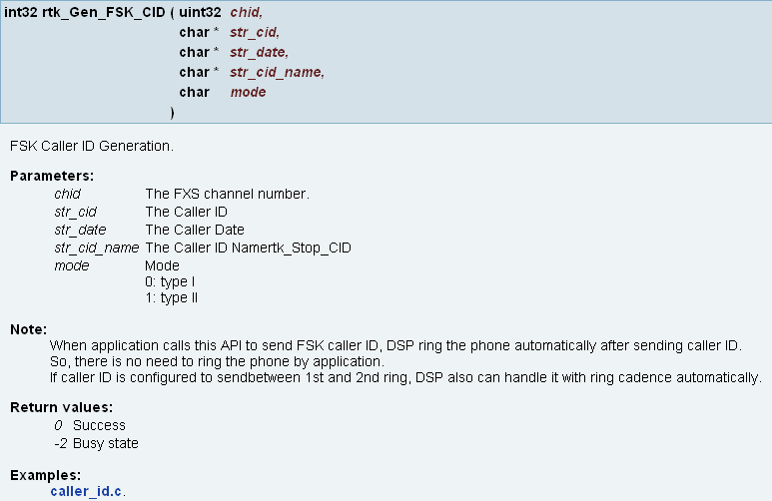
  - 請將typedef struct或typedef enum內的element後面，加 ///< 簡述該變數之功能，並於上面加@brief說明該structure的目的與功能
Example:
/**
* @brief Structure for payload type
* @see do_mgr_VOIP_MGR_SET_VAD_SID_THRESHOLD()
*/
typedef struct {
uint32 ch_id; ///< Channel ID
uint32 m_id; ///< Media ID
int32 nThresVAD; ///< Threshold for VAD average amplitude. default 63. range=1~200
int32 nThresCNG; ///< Maximum CNG amplitude. default 0 (off). range =0~200
int32 nSIDMode; ///< SID configuration mode (0:Disable configuration, 1:Fixed noise level 2: Adjust noise level)
int32 nSIDLevel; ///< SID noise level, range=0~127, Unit:dBov, default 70
int32 nSIDGain; ///< SID gain up/down based on SID noise level, range=-127~127, Unit:dB, default:0 (not change)
}
TstVoipThresVadCngConfig;
