DFT-NEGF based quantum transport simulations
Day 1: general introduction to DFT transport calculations

The aim of this first DFT-NEGF tutorial is to show applications for the concepts explained in the lecture on DFT based quantum transport for real atomistic systems. A set of calculations will be performed during the tutorial, some of which contain predefined input, and some for which the participants will have to modify the input file to create a new input.
At the beginning of the tutorial the general concepts that will be covered and the main quantities of interest will be outlined. Since calculations will be run remotely on a cluster, a brief introduction on how to login, run, and copy off files from such a cluster will be outlined.
In this tutorial we will run examples 1 and 2 of this documentation file. The other examples (3-5) are optional examples that the participants can run after conclusion of the tutorial if they want. The considered systems examples 1 and 2 are all based on 1-D monoatomic Au chains, first without spin polarization, and then with spin polarization. These allow very quick calculations, so that most time will be spent for setting up the systems and for the data analysis.

Logging in and copying files

Instructions for logging in and on where to run have already been provided in the previous tutorials. The Files for the Smeagol tutorial are in the
/home/lasesqtm/Smeagol/Smeagol_Tutorial_Files
directory. Within that directory there are 3 subdirectories:
bin: in this directory there are all the needed executables and scripts; the ~/bin/ directory already contains copies of all these scripts and executables, the files in this directory are mainly to see which files are used for the Smeagol tutorial.
DFT_NEGF_Transport: in this directory there are all the files for the tutorial example runs
DFT_NEGF_Transport_Outputs: in this directory there are all the outputfiles for the tutorial example runs, which you can use to verify your results

Copy the directory DFT_NEGF_Transport to the directory where you will run your calculations. Do not run in the original directory, since it is needed by other users as well.

Change to the directory where you will run the calculations, and then into the newly copied DFT_NEGF_Transport subdirectory.
Inside the DFT_NEGF_Transport directory there are four subdirectories, namely “Day_1”, “Day_2”, “Docs”, and “pseudopotentials”. This is a one day tutorial, so we will only run the examples in the “Day_1” directory, the “Day_2” exercises are just left for completeness. The “Day_2” examples woul also take longer to run, since they are for a rather large system, so that you should not run them during this tutorial.
In the “Day_1” directory you will run the calculations, in the “Docs” there are some pdf files as documentation (e.g. the Smeagol and Siesta user guides, which are the codes that we use for this tutorial, and a pdf containing some concepts that we will cover during this tutorial), and the “pseudopotentials” directory contains sample pseudopotential files that can be ued in this tutorial. Inside the “Day_1” directory there are 3 further subdirectories:
Inputs: this is the directory where you will run the calculations
Inputs_including_exercises: contains also example input files that you will set up yourself in the exercises; you might compare your files to the ones in this directory in case of doubt.
Instructions: contains the files Tutorial_Smeagol_Day1.odt (open office format) and Tutorial_Smeagol_Day1.pdf , which contain the instructions to run the tutorial.

To run a calculation you have to execute
mpirun -n num_nodes executable
where the executable is the command you want to run., and num_nodes is an integer number between 1 and 8 in our case, which specifies how many processors you want the code to run on in parallel. In our case the executable will be “smeagol-1.2”.

To copy files from the cluster to your desktop computer you have to use scp or sftp, you will be familiar with that from the previous tutorials.

Throughout the tutorial you will need to edit files (mainly input files) with a text editor. This is best done using within the terminal window on the cluster directly using e.g. vi, emacs, nano (nano is relatively simple to use).

Calculations

The DFT-NEGF quantum transport calculations are run using the Smeagol software. The following files are provided in the “~/bin” directory of the test accounts:
1)smeagol-1.2 : the Smeagol executable
2)Pot.exe : code to generate planar averages of potentials and charge densities
3)pot.sh : a small shell script that calls Pot.exe automatically for all potential and charge density files
4)Potential.dat example
5)get_PDOS.sh, fmPDOS: shell script and program to generate projected densities of states (PDOS)
6)fdf2xyz_xsf.sh, xcrysden_fdf.sh, expand_cell3.pl: scripts to convert the atomic structure from fdf format to xcrysden xsf format and xyz formats.

We use two sets of leads (electrodes) input files, one corresponding to a semi-infinite Au-wire, and the other one corresponding to semi-infinite Au-bulk, stacked along the (111) direction. We note that in order to make the calculations faster for this tutorial the Au is treated in an approximate way by putting the d-orbitals into the core and considering only the 6s orbital in the valence.
In the following sections the set of examples and the commands on how to run Smeagol are presented. Input files are found in directories example1 to example4 in the directory “DFT_NEGF_Transport/Day_1/Inputs”. Output files are found in the corresponding file in the DFT_NEGF_Transport_Outputs directory (also for some of the systems where we do not provide the input and where the students will create their own input files).

Example 1: infinite Au-wire

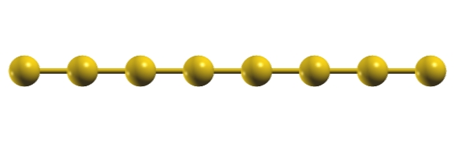Figure 1: Atomic structure
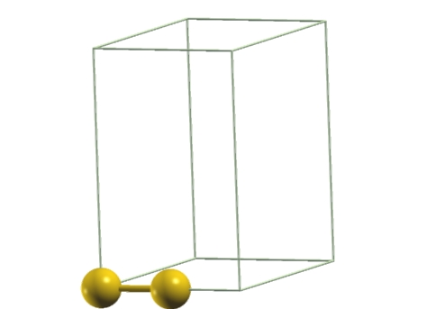Figure 2: Leads unit cell

In this first example the basic system is a perfectly periodic 1-dimensional Au chain. We will first illustrate the main output files obtained in a DFT-NEGF transport calculation on this system

Leads
The semi-infinite leads are a key component for a transport calculation, since they provide the set of scattering states and the electrons that can flow in and out of the scattering region. In this tutorial we will not discuss the leads calculation in detail. The leads cell needs to be stacked periodically along the transport direction z. On each side of the scattering region simulation cell we include one leads unit cell.
We start by considering 1-dimensional (1D) electrodes consisting of a periodic Au chain (Fig. 2). Note that the transport direction is along the z axis. The unit cell of this chain contains 2 Au atoms. Note that the use of a 2 atom unit cell in the leads is due to the requirement for leads cell to have only electronic coupling with the next cell (first-nearest neighbor). This requirement would not be met if we used just one atom per unit cell, since the shorter simulation cell would have second-nearest neighbor coupling.
First change into directory leads-1D and run Smeagol there to generate the leads files for an infinite chain:
cd /home/training/train02/DFT_NEGF_Transport/Day_1/Inputs
cd leads-1D
mpirun -n 1 ~/bin/smeagol-1.2 < input.fdf > out&
The file “input.fdf” is the Smeagol input file and is read from standard input, whereas standard output of the code is redirected to the file “out”. The input file is written in the so-called fdf format, and therefore the file name usually is chosen to end with .fdf. In this tutorial we always call the input file “input.fdf”. Note that we use only one processor for the leads calculation, since this system is too small to run in parallel (it has only 2 orbitals). Copy “bulklft.DAT”, “bulkrgt.DAT”, “Au_wire_leads.DM” and “Au_wire_leads.HST” to the “example1” directory.
cp bulklft.DAT bulkrgt.DAT Au_wire_leads.DM Au_wire_leads.HST ../example1

Scattering region

Change from the leads directory into directory “example1” by executing
cd ..
cd example1
Before running the code it is usually useful to visualize the atomic structure. The provided script fdf2xyz_xsf.sh will extract the atomic coordinates and atomic species from the input.fdf file, and convert them to a xyz file and to a xsf file (which can be opened e.g. with xcrysden). The xyz format is supported by most atomic structure plotting programs. You can download the xyz and/or the xsf file to your desktop and display the atomic structures with xcrysden.
Execute
mpirun ~/bin/smeagol-1.2 < input.fdf > out&
This will take a few minutes on 8 processors and generate a set of output files. You can follow the running of the code by typing on the terminal:
tail -f out
This will follow the output as the code runs. The command can be terminated by pressing Ctrl-c.
This particular run calculates the I-V curve for the wire in 8 bias voltages (bias steps). The “buffer.out” file contains information about the convergence. We will look at a few of the output files that are relevant for transport calculations. The first is the Au.CHR file, which contains the charge of the system, q, at each bias point for all selfconsistent steps. It is important to check that the charge is approximately neutral at selfconsistency. This can be done by making sure that it is approximately equal to the charge at the first selfconsistent step. In this case, the charge neutral system should contain 8 electrons (1 for each Au s-orbital).
Note that contrary to a standard DFT calculation the transport simulation cell corresponds to an open system, so that in principle the charge inside the simulation cell can differ from the one that gives charge neutrality for that cell alone. Clearly if the cell is large enough it must be approximately charge neutral due to charge screening. Check the charge by opening the Au.CHR file, and verify that at selfconsistency the charge is approximately conserved for the following bias points:
q(V=0.0 eV)= ________
q(V=0.5 eV)= ________
q(V=1.5 eV)= ________

When self-consistency is achieved, for each bias step a set of files are output, with the prefix equal to the index of the bias step. We will now consider 3 of these files with the following endings:
1) .TRC: contains the data for the transmission coefficient, T, in units of 2e²/h as function of energy in eV, with the Fermi energy set to 0. The first column is the energy in eV, the second and third column both correspond to T, the fourth column corresponds to the number of open channels in the electrodes, the fifth column represents the density of states, DOS, of the leads, and the sixth column corresponds to the total DOS of the simulation cell in units of states/eV. The number of open channels of the leads is equal to the number of bands with positive group velocity at a given energy, and therefore corresponds to the maximum transmission for each energy. For a system without scattering therefore the transmission will be equal to the number of open channels.
2) .VH : is the Hartree electrostatic potential on a real space mesh in binary form.
3) .RHO: is the charge density on a real space mesh in binary form.
To each of these files the bias step is prepended as integer number to the file name. For example 2.Au.TRC is the transmission coefficient for bias step 2, which corresponds to a bias voltage of 0.2 eV. The actual bias corresponding to a bias step can be obtained from the input file. These files contain the raw data, additionally a file with the extension “_TRC.agr” is output, which contains the transmission, the number of channels, the density of states of the scattering region, and the density of states of the leads. The file is output in “xmgrace” format, so that it can be opened with the plotting program “xmgrace” if this is available. For example to visualize the file for bias step 2 run “xmgrace 2.Au_TRC.agr”.
The current I (in units of Ampere) as function of voltage V (in units of Volt) is saved in the Au.CUR file.

In order to analyse the transport properties we will usually check these files. We now go through them for the 1D Au-chain one by one:
1) The .VH potential file is a function of all three dimensions, in order to obtain a simple one-dimensional function we take the average over the x and y plane for a given z-position (the z-axis is the transport direction). The program Pot.exe is used to this aim, and it needs a special input file Potential.dat. To avoid editing of the input file the shell script pot.sh can be used, this will calculate the planar average for each .VH and .RHO file in the directory. We therefore execute
pot.sh
This will create a set of new files, the planar average files will have the extension “_AV.dat”. These are ASCII files with columns of data. The first column is the z-coordinate, the second column is the planar average of the potential for the <bias-step>.Au-VH_AV.dat file, and of the charge density for the <bias-step>.Au-RHO_AV.dat file. The other columns are not needed in this tutorial.
We can now visualize the potential at 0 bias by plotting the first two columns of the 0.Au-VH_AV.dat (to plot the data execute “xmgrace filename”, in this case “xmgrace 0.Au-VH_AV.dat”). The potential oscillates, and has usually a minimum at the position of the atoms due to the electrostatic attraction of the electrons to the positively charged nucleus. We can also plot the 0.Au-RHO_AV.dat file, which usually has an enhanced value around the positions of the atoms, where the charge density has the largest value.
An important quantity to analyze is the difference in the planar average of the potential at different voltages. We can use a plotting program to substract the potential at 0-bias from the one at finite bias, the result is the planar average of the potential drop across the junction. For example, to plot the potential drop at 0.5 eV of bias, execute
xmgrace 0.Au-VH_AV.dat 5.Au-VH_AV.dat
and then click on “Data->Transformations->Evaluate Expression...”. In the opening window select on the left side the set “G0.S1”, and type in the Formula cell: “y=y-S0.y”, and then click “Accept”. This will give a new set of data (green curve) that is the difference of the two opened data sets.
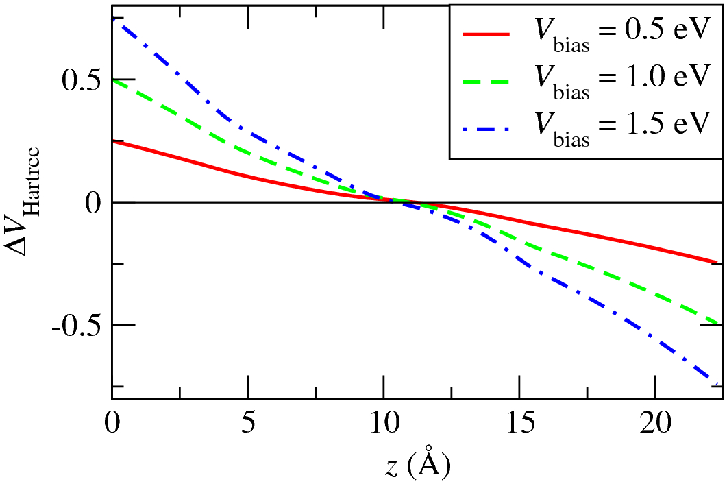

Figure 3: Potential drop for the 1-D monoatomic Au chain for 3 different bias voltages
Note that in this simple test case the potential drop is applied in an unphysical way, since in a real perfectly periodic 1-D metallic chain no potential drop can develop, since scattering is too weak to allow the formation of an accumulation of charges (which in turn would cause the potential drop). For a physical system the slope should be approximately zero at the left and right boundaries where the leads are joined. We will verify this later with 2-D electrodes.

2) One of the key results of the calculation is the energy dependent transmission coefficient, T(E), since it is directly proportional to the current through the system for a given bias voltage (at small bias we can approximately write I=T(E_{F})*V). We can look at the transmission coefficient as function of energy by plotting the first two columns of the file with the .TRC ending. We first plot the 0 bias transmission
xmgrace 0.Au.TRC
We see that at 0-bias the transmission is either 0 or 1 (in units of quantums of conductance). Indeed the T(E) is identical to the number of channels incoming from the leads, since there is no scattering inside the simulation cell for this perfectly periodic system.
Verify how T(E) changes when applying a bias voltage by plotting it at 0, 0.5, 1.0 and 1.5 eV:
xmgrace 0.Au.TRC 5.Au.TRC 10.Au.TRC 15.Au.TRC
As a bias is applied the perfect periodicity in the potential is broken and scattering induces a reduction of the transmission coefficient.
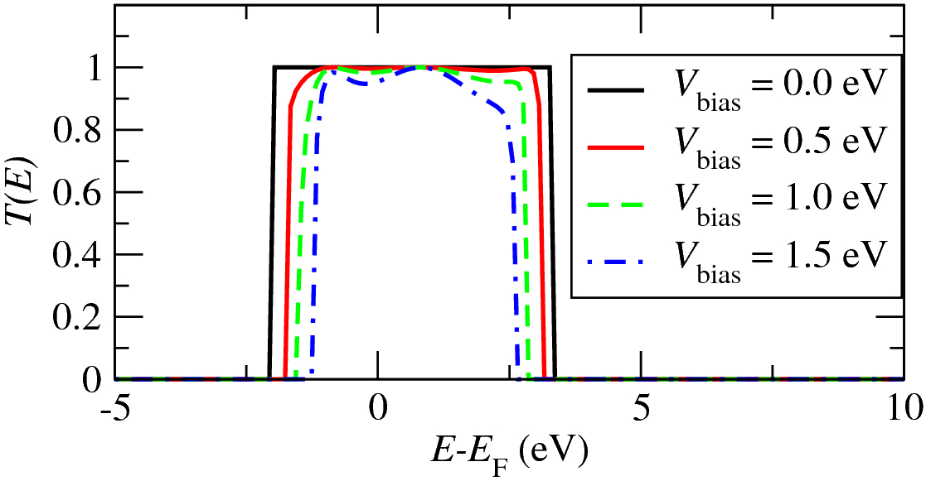

Figure 4: Transmission coefficients as a function of energy for the 1D Au-chain for different bias voltages

We now plot the total DOS of the system (6th column of the TRC file in this case), which shows the typical character of periodic 1-D systems that have Van Hove singularities at the band edges. Note that although the DOS diverges at the band edges, the number of channels (equal to the number of bands with positive group velocity in the electrodes) is always 1 for all energies within the bandwidth of the band.
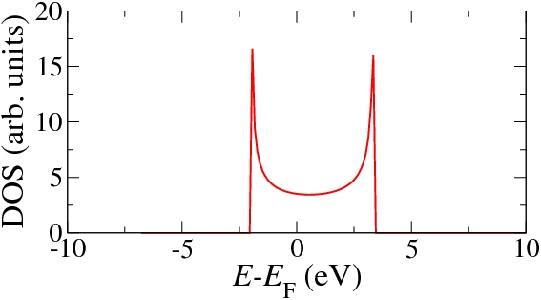Figure 5: Density of states of the infinite gold wire.

3)Finally we plot the current in the Au.CUR file. To plot the current vs. Voltage curve (I-V) execute: “xmgrace Au.CUR” (the file systemlabel.CUR has the I-V data, with Voltage in Volt, and current in Ampre). The current increases approximately linearly up to 1.5 Volt with a conductance approximately equal to one quantum of conductance (a current of about 74 µA at 1 V corresponds to one quantum of conductance).
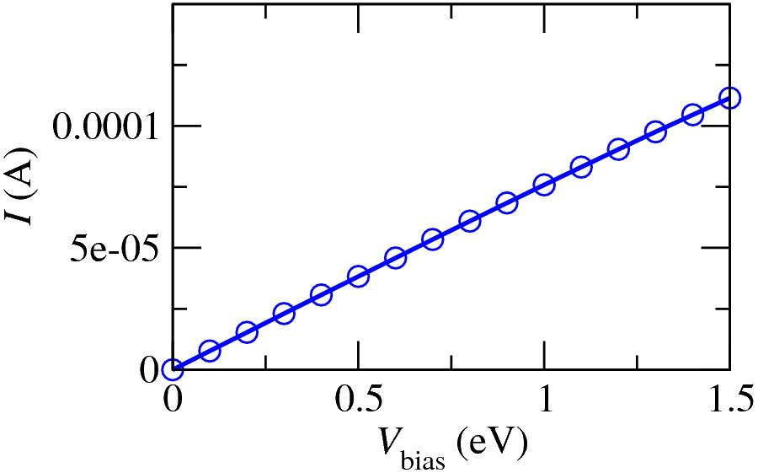

Figure 6: Current versus bias voltage for the 1D Au chain. The current corresponds to a conductance approximately equal to one quantum of conductance.

We have now analyzed the main Smeagol output for this 1D Au-chain example. In all the other examples we will analyze the transport properties by looking at the same files.

Exercises
For each exercise, in the example1 directory make a subdirectory with the name exercise_number (where number is the number of the exercise, i.e. 1, 2, ...). For example, for exercise_2 execute
mkdir exercise_2
Copy all the needed input files into that directory. See the “Leads” subsection for which files are needed for the electrodes. Moreover you need the “input.fdf” file for the scattering region, and the set of pseudopotential files (with .psf ending) for all elements in the calculation. Note: sample input files and outputs are provided in the Output directory. In case of doubt, you can compare your input files with the ones in the Outputs directory.
Figure 7: Atomic structure of exercise 1
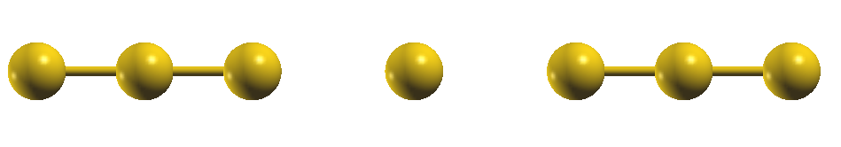

- In this calculation we introduce scattering by removing one atom from the perfectly periodic chain. The calculation will be run just for one bias step at 0 bias, therefore set NIVPoints to 0 and set the voltage to be 0.0 eV in the input.fdf file (Vinitial 0.0 eV; Vfinal 0.0 eV). Also change the SaveBiasSteps block, to save only the step 0. Remove atom 4 from the input file and shift atom 5 to a z coordinate equal to 9.8 Ang. The SaveBiasSteps block contains the indices of the bias points for which the Hartree potential files (.VH) and the real space charge density (.RHO) are output. Since these files are rather large, we do usually not output them for each bias point. Note: never change the position of the first 2 Au atoms, and of the last 2 Au atoms (the reason is that these have to be identical to one leads unit cell). There are now only 7 atoms in the scattering region, and therefore you also have to decrease the NumberOfAtoms option by 1 from 8 to 7. Since the coupling to the electrodes of the shifted atom is reduced when compared to the perfect chain, a localized resonant state will form.
Calculate the 0 bias transmission on 4 processors (having removed one atom we have only 7 orbitals left in the system, so we need to run on less than 8 processors) and plot it with xmgrace. At which energy is the resonant state formed?
E_{state}=______________
From the graph also measure the height of the peak (T_{max}) and approximately its full width at half maximum (FWHM):
T_{max}= __________
FWHM=________
Now perform the same calculations shifting the central Au atom to z=9 Ang and then to z=11 Ang. Make a separate subdirectory for each run (mkdir z_9; mkdir z_11), and copy all the required runtime files to those directories. Note down the results for the same quantities for z=9 Ang
E_{state}= __________
T_{max}=___________
FWHM=_________
and for z=11 Ang
E_{state}=___________
T_{max}=___________
FWHM=_________
Using the relations
T_max=4*gamma_L*gamma_R/(gamma_L+gamma_R)^2,
FWHM=gamma_L + gamma_R,
why is T_max reduced when the central Au atom is shifted away from the symmetry position?
____________________________________________________________________________________________________________________________________
From above relations you can infer gamma_L and gamma_R from T_max and FWHM, if you assume that the larger of the two gammas is always the one for the side where the molecule is closer to the electrodes. Can you then calculate gamma_L and gamma_R as function of position?

z=9.0 Ang z=9.8 Ang z=11.0 Ang
gamma_L ____________ ____________ _______________
gamma_R ____________ ____________ _______________
In this calculation we will also analyze the projected density of states (PDOS) on the Au atoms, which will help in understanding the shape of the energy dependent transmission. In order to get the PDOS printed you need to set the option “TRC.EMPDOS” to T. Calculate the PDOS for the shifted Au atom using the get_PDOS.sh script (see Appendix 2 for how to use the script). To run the script an input file is required, which tells the script for which atoms and orbitals to calculate the PDOS. A sample input file for this script, called “Input_fm”, can be found in the Inputs/example1/ directory, which prints the PDOS for the atoms with index 1, 2, 3, 4, 5. Copy this file to the directory where you are running the example, and execute
get_PDOS.sh 0.Au.TRC.EMPDOS Input_fm 0
This generates 5 new files, one for each entry in the Input_fm file, with the ending of the file corresponding to the string chosen in the Input_fm script for each entry. For example, in this case the file “0.Au.TRC.EMPDOS.Au_chain3” is the PDOS of the 3rd atom in the Au chain. In each of these files the first column is the energy in eV (the 0 is set to EF), and the second column is the PDOS for that atom in units of states/eV.
The PDOS of each atom is different, and all are markedly different from the one for the perfecly periodic system (Fig. 3). Compare the PDOS with the transmission, which atoms are mainly responsible for the transmission peak?
atom_index=_____________
This information can be gained by checking which PDOS peak matches best in shape the transmission peak.
- In this second exercise instead of removing an atom we will add an additional Au atom attached to the Au wire, again only for the 0 bias case. Take the input file of exercise 1 of example 1 and first add back the atom in the chain make sure all atoms are equidistant (so that we have again a perfectly periodic 8 atom Au chain). Then add an additional Au at z=11.2 Ang, x=2.8 Ang, and y = 0 Ang. You also have to increase the NumberOfAtoms option to 9. Note: in the atom list in the input file the atoms should be sorted along z, so add the atoms in the right place in the block AtomicCoordinatesAndAtomicSpecies (somewhere in the middle, never at the beginning of the block or at the end, since these atoms are assumed to be at the boundary of the scattering region). In this case put the added atom as sixth atom in the AtomicCoordinatesAndAtomicSpecies block, so that it has atomic index 6.
Calculate and plot the 0 bias transmission and PDOS for this system. Use the Input_fm from the previous exercise as basis, and add also an entry for the 6th Au atom, with name “Au_adatom”. Unlike in the previous exercise, the transmission is rather large in a wide range, but there is a dip at a specific energy where T is approximately 0:
E_{dip}=______________
To find the origin of this dip we compare the transmission with the PDOS, and look for a feature on the PDOS at the energy E_{dip}. On which atom is this feature found?
atom index=__________
This atom corresponds to the adsorbed Au atom,and the feature is an enhanced PDOS, corresponding to a resonant state on that atom at E_{dip}. Contrary to exercise 1 of example1. this resonant state now leds to a suppression of the transmission, can you explain why:
________________________________________________________________________________________________________________________________________________________________________________________________________________________________________________________________________
Figure 8: Atomic structure of exercise 2
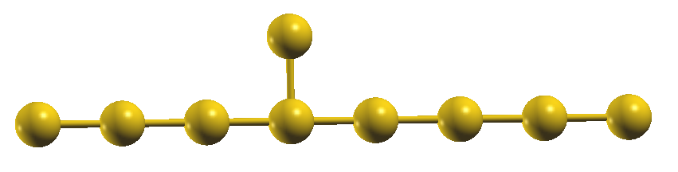
- Optional: Before running this exercise first run all calculations in the “Example 2” section. Should there be time left at the end of the tutorial, you might run this exercise as well.
Make a “quantum interference device”: leave 3 atoms on the left, and 3 on the right side of the wire, and remove the middle atoms. Then join gold atoms in such a way, to form connect left and right side through a circle or rectangular shape (or any shape). By choosing the right lengths on each side, one might be able to make a device with very small or even 0 transmission at the Fermi level. Calculate also the PDOS for all atoms in the circle. Note: you might have to increase the lattice vectors along x and y (in the LatticeVectors block) in order to keep the wire disconnected from its periodic images (the code always assumes periodic boundary conditions, therefore to simulate isolated wires enough vacuum needs to be included to separate the periodic images).
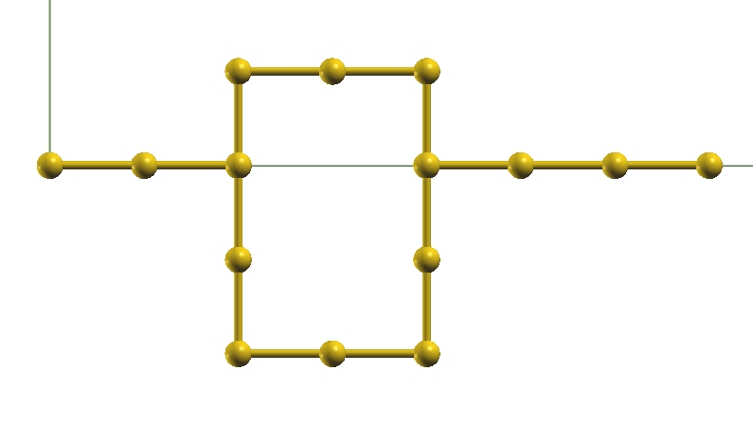

Figure 9: Example for a system setup of exercise 3

Magnetic systems

Example 2: 1D Au chain with magnetic adatoms

So far all calculations were for non-magnetic systems. In this second part we will investigate the spin-polarization of current and transmission, and the change of resistance when spins of two adatoms are parallel and anti-parallel..
In this first example the basic system is a perfectly periodic 1-dimensional Fe chain. We will use this system to illustrate the main changes compared to a non-spin-polarized system.

Leads

The Au leads have not net spin. However, since the overall system in spin-polarized if we add magnetic atoms, we need to calculate also the leads in a spin-polarized calculation. First change into directory leads-1D, make a subdirectory with name “spinpolarized”:
cd /home/training/train02/DFT_NEGF_Transport/Day_1/Inputs
cd leads-1D
mkdir spinpolarized
Copy the input.fdf and Au.psf file into that directory from the leads-1D directory, and change into that directory
cp input.fdf Au.psf spinpolarized
cd spinpolarized
Edit the new input.fdf file and set the option SystemLabel, found at the top of the file, to Au_wire_leads_sp. The additional “_sp” ending will tell us that these are spin-polarized leads files. Then change also the option SpinPolarized from F to T. This tells the code that it needs to perform a spin-polarized calculation. Run Smeagol there to generate the leads files
mpirun -n 1 ~/bin/smeagol-1.2 < input.fdf > out&
Then copy “bulklft.DAT”, “bulkrgt.DAT”, “Au_wire_leads_sp.DM” and “Au_wire_leads_sp.HST” to the “example2” directory.
cp bulklft.DAT bulkrgt.DAT Au_wire_leads_sp.DM Au_wire_leads_sp.HST ../../example2
This concludes the leads calculation for this system, and we can set up the scattering region.

Scattering region

We will set up the scattering region for the spin-polarized system starting from the Au chain with the adatom attached (example 1-exercise 2). The aim is to observe how the depletion in conductance changes when a spin-polarized atom is adsorbed. First therefore copy the input.fdf and Au.psf file from the example1/exercise_2 directory to the example2 directory.
cd /home/training/train02/DFT_NEGF_Transport/Day_1/Inputs
cd example1/exercise_2
cp input.fdf Au.psf ../../example2
cd ../../example2
Here now edit the input.fdf file to make the calculation spin-polarized. As done for the leads, add again the ending “_sp” to the SystemLabel input flag, and set SpinPolarized to T. Run smeagol-1.2 for this input file.
In general, when self-consistency is achieved, the same files are output as for a non-spinpolarized calculation, however these files now contain additional data for the spin-polarization. In particular, the file with the .TRC ending, which contains the data for the transmission coefficient, T, is now output in units of e²/h (compared to 2e^2/h for calculations without spin-polarization), since each spin-channel gives a maximum transmission of that value. The first column is the energy in eV, the second column the total transmission, the third column T for spin up, the fourth column T for spin down. The fifth (sixth) column contains the number of open channels in the electrodes for spin up (down). The seventh and eight column contain the DOS of the leads for spin up and down, respectively. And finally the ninth and tenth columns contain the up and down DOS for the scattering region. The file with the .RHO ending, which contains the charge density on a real space mesh, now contains data for both up and down spins, and so does the file with the .EMPDOS ending that contains the PDOS. Since the Hartree potential has no spin-dependence, the file with the .VH ending is unchanged compared to a non-spin-polarized calculation. If the get_PDOS.sh script is run for a spin-polarized calculation, in each of the output files (one for each entry in the Input_fm file) there are three columns, in the first there is the energy, and in the second one the PDOS for up-spins, and in the third one the PDOS for down-spins. The one for down-spins is multiplied with -1, so that it has a negative sign (this is the usual convention for plotting spin-polarized DOSs).
Plot the total transmission coefficient and make sure that the results are the same as for the non-spin-polarized calculation (keeping in mind the factor 2 due to the change of units).

Exercises
For each exercise, in the example2 directory make a subdirectory with the name exercise_number (where number is the number of the exercise, i.e. 1, 2, ...).

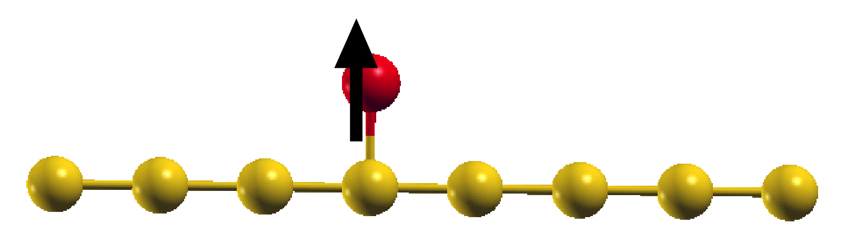

Figure 10: Au chain with a spin-polarized Fe atom adsorbed
Figure 11: Leads unit cell

- In this exercise we will calculate a Fe magnetic adatom adsorbed on the Au nanowire. To this aim replace the adsorbed Au atom by a magnetic atom. Make a directory exercise_1 as subdirectory of the example2 directory, copy all the required input files, including the input.fdf file, from the example2 directory in this new directory. Then change into the new directory and edit that input.fdf file. In the input file you have to change the NumberOfSpecies to 2, which tells the code that now there are 2 atomic species in the system (instead of 1). Then you have to add a line “2 26 Fe” in the block ChemicalSpeciesLabel. This tells the code that the second species has atomic number 26 and is iron. In general, all the atomic species used in the calculations are defined in this block. For the adsorbed atom, inside the block AtomicCoordinatesAndAtomicSpecies you have to replace the species index from Au (species index 1) to the Fe (species index 2). Each line of this block contains the x-coordinate in Angstrom of an atom (first entry), the y-coordinate (second entry) and the z-coordinate (third entry). The fourth number is an integer and is the atomic species index. Note that the text after the fourth column is not read by the code in this block, so arbitrary comments can be added. Finally, because this is a magnetic system, we need to set the initial spin of selected atoms. Assuming that the adatom is atom number 6 in the AtomicCoordinatesAndAtomicSpecies block, to this aim insert a block DM.InitSpin by adding the following lines at the end of the input.fdf file:
%block DM.InitSpin
6 +
%block DM.InitSpin
This tells the code that atom with index 6 (in this case the Fe atom) will be initialized with maximum spin along the up direction. To initialize the atom in the down direction one needs to replace the “+” with a “-”. Usually at self-consistency the magnitude of the spin will change from the initial value, but its direction will remain the same.
Finally we need to add the pseudopotential file for Fe into this directory. A set of pseudopotentials is located in the
/home/training/train02/DFT_NEGF_Transport/pseudopotentials
Change into that directory and copy the “Fe.psf” file to the example2/exercise_1 directory. If you later need pseudopotentials for other elements, they are all labelled by their atomic name with a .psf ending appended.
This concludes the setup, execute “fdf2xyz_xsf.sh input.fdf” to obtain the xyz and xsf files,and then visualize the atomic structure, to check its correctness.
Now run the calculation in this directory. In general spin-polarized systems take more iterations to converge than non-spinpolarized systems. To check whether the system has indeed a net magnetic moment you can check the output file for a line with “Total Spin”, which contains the total magnetic moment of the simulation cell. From the command line you can also execute
grep “Total Spin” out
to extract this line. The total magnetic moment, mu, of the system is
mu=_______________________________
Since the system is expected to be magnetic, plot the second column (T_total), but also the third (T_up), and the fourth (T_down) as function of energy (the first column). If you use xmgrace to plot this you can execute
xmgrace -block 0.Fe_pc_P.TRC -bxy 1:2 -bxy 1:3 -bxy 1:4&
The transmission is significantly different for up and down spins for all energies. In particular a quantity of interest is the spin-polarization around the Fermi energy, which determines the low bias spin polarization of the current. We define it as
P(E_{F})=(T_up-T_down)/(T_up+T_down)
Evaluate this number for this system:
P(E_{F})=_________________

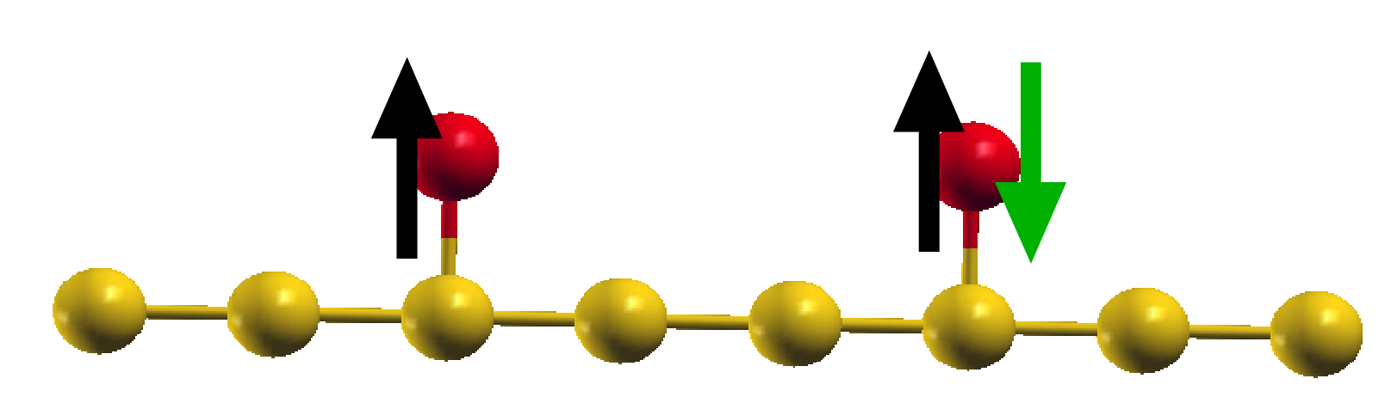Figure 12: Au chain with two spin-polarized Fe atoms adsorbed
Figure 13: Leads unit cell

- Now we add a second atom to the system. In this case the relative orientation of the spins on the two atoms will critically affect the transmission. For collinear spin alignments there are two options: either the spins of the two atoms are parallel to each other (P configuration), or anti-parallel (AP configuration). The normalized difference in the current for the two configurations
MR=(I_P-I_AP)/(I_P+I_AP),
is usually referred to as magnetoresistance (MR). Here I_P is the current for the P configuration, and I_AP is the current for the AP configuration. With this definition the MR is bound between -1 and 1. A commonly used alternative definition is where one divides the difference in currents only by the smaller of the two. With this alternative definition the MR can go from minus infinity to plus infinity. A large MR is a key factor in many devices such as magnetic hard disc drives read heads.
For small bias voltage the current is simply I=T(EF)*V, so that we get a low bias approximation for the MR by
MR(small bias)=[T(E_{F};P)-T(E_{F;}AP)]/[T(E_{F};P)+T(E_{F};AP)]
We will calculate this quantity for a system with 2 Fe adatoms.
Make a subdirectory exercise_2 of example2. Inside this directory you make a directory “P” and one “AP”. First copy all the required input files from the example2/exercise_1 directory into the P directory. Then edit the input.fdf file in the P directory: change the z position of the already present Fe atom to 5.6 Ang, and add an additional adsorbed Fe atom to the system, with a z coordinate of 14.0 Ang, and x and y coordinates equal to the ones of the first Fe atom. In this way we maximize the Fe-Fe distance for this system. Note that the 2 first and the 2 last atoms of the scattering region along z must be Au, since it is required that those atoms at the boundary correspond to one leads unit cell. Increase the NumberOfAtoms option by 1. Also update the DM.InitSpin block by inserting an additional line for the added Fe atom, and initialize both Fe atoms with a “+” spin. If the atomic index of the already present Fe atom has changed, then this new number needs to be included in this block. Note that the correct initialization of the spins is very important. Then copy all the files from this directory to the AP directory. Change into that directory, and the only change to the input file is that for the Fe atom at z=14.0 Ang you set the initial spin to “-”.
Now run the code in both directories. Plot the spin-resolved transmission for both cases and note the differences
______________________________________________________________________________________________________________________________________________________________________________________________________
Can you explain the results from the transmission of the single Fe atom?
______________________________________________________________________________________________________________________________________________________________________________________________________
Plot also the PDOS for the two Fe atoms. First set up an appropriate Input_fm file, and then execute get_PDOS.sh
Then evaluate the small bias MR with above equation
MR(small bias)=________________________________
This value will depend on the relative positions of the two Fe atoms, you can vary the positions to check the influence on the result.
If the MR would be evaluated at energies different from E_{F}, can you find energies from the transmission graph where the MR is very large, if so at what energies?
____________________________________________________________

OPTIONAL CALCULATIONS
The systems in the remaining part of this document are optional systems within this tutorial. In case a group finishes ahead of time they can consider running these exercises as well.

Example 3: Two Au-surfaces joined by a C ₃ molecule

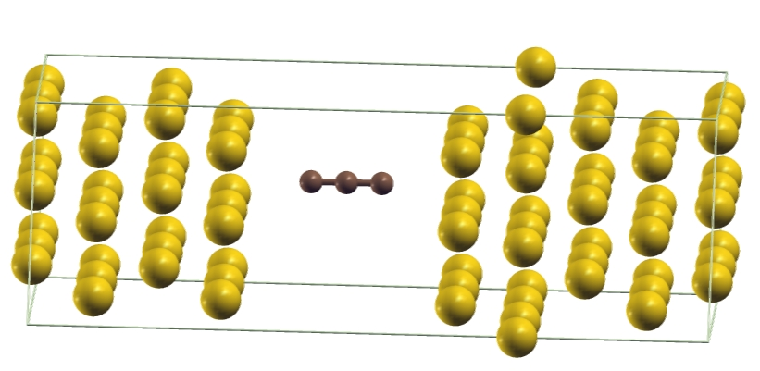Figure 14: Atomic structure

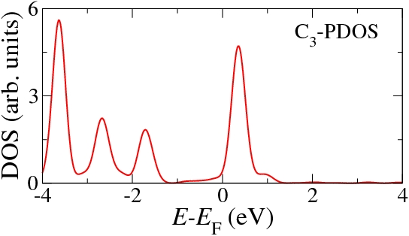Figure 15: Projected density of states of the C₃ molecule attached to Au.

In this example we evaluate the transport through a molecule coupled to the electrodes. The molecule of choice is a C₃ molecule suspended between the electrodes. In a real physical system the molecule will bond to the electrodes via some linkers, however here for simplicity we just place it there by hand to illustrate the general transport mechanisms. We will investigate different possible bondings to electrodes in the next tutorial.
First change into directory leads-2D and run Smeagol there to generate the leads files (if they are not there yet). Copy “bulklft.DAT”, “bulkrgt.DAT”, “Au_leads.DM” and “Au_leads.HST” to the “example2” directory. There is already an input.fdf file present in the example2 directory. There is also an additional pseudopotential for the carbon atoms (C.psf) in that directory.
Run the program with the given input.fdf file. Since the system is now significantly larger than for the 1D-chain, you should run the code in parallel over all the 8 available processors by executing
mpirun ~/bin/smeagol-1.2 < input.fdf > out&
If the “-n” flag is omitted when executing mpirun, it will use the maximum available number of processors for a job. In this way the total runtime will be about 8 times less then if the code runs on one processor only.
The run calculates the I-V from -1.0 Volt to 1.0 Volt, with in total 9 bias steps. Note that since we run the I-V from -1.0 eV to 1.0 eV in 9 steps, the 0 bias step is for -1.0 eV, 1st bias step for -0.75 eV, ..., 4th bias step for 0.0 eV, ..., and 8th bias step for 1.0 eV. Calculate and plot the transmission for a bias voltage of -1.0 (bias step index 0), -0.5 (bias step index 2), 0.0 (bias step index 4), 0.5 eV (,bias step index 6) and 1.0 eV (bias step index 8), and follow the position of the highest occupied molecular orbital (HOMO) and of the lowest unoccpied molecular orbital (LUMO) as function of bias
E_{HOMO}(V=-1.0 eV) =______________ E_{LUMO}(V=-1.0 eV) = ___________
E_{HOMO}(V=0.0 eV) =______________ E_{LUMO}(V=0.0 eV) = ___________
E_{HOMO}(V=1.0 eV) = ______________ E_{LUMO}(V=1.0 eV) = ___________
Note that for transport calculations we are mainly interested in the energy levels that are closest to the metal Fermi level, which are usually the HOMO and LUMO levels of the molecules. As the bias increases, do the levels shift to higher or lower energies?
_____________________________________________________________________
Verify that the transmission peaks are indeed due to molecular states by plotting the PDOS on the 3 C atoms, and comparing the peak positions to the ones of the transmission. Do this first for 0 bias
get_PDOS.sh 4.AuC3Au.TRC.EMPDOS Input_fm 0
and then for 1 Volt
get_PDOS.sh 8.AuC3Au.TRC.EMPDOS Input_fm 0
and verify that the peaks shift to higher energies as for the transmission.

The found shift of the energy level as function of bias is related to the charging of the molecule under bias, can you explain it?
________________________________________________________________________________________________________________________________________________________________________________________________________________________________________________________________________________________________

We can now analyze how the potential drops across the junction by calculating the potential averaged over the x-y plane. For this we run
pot.sh
in this directory. Then we open the potential average files for 2 bias voltages
xmgrace 4.AuC3Au-VH_AV.dat 8.AuC3Au-VH_AV.dat
As outlined in example1 we now take the difference between the potential at finite bias and the one at 0 bias to obtain the potential drop. At which z positions does the potential drop approximately start and end?
z_{drop starts}= _______________________
z_{drop ends}= _______________________
Perform the analogous calculation also for the charge density by plotting the *RHO_AV.dat files with xmgrace
xmgrace 4.AuC3Au-RHO_AV.dat 8.AuC3Au-RHO_AV.dat
and taking the differences. Due to the out-of-equilibrium charge flow the charge density at finite bias is significantly different from the one at 0 bias. At which z positions is there the largest accumulation or depletion of electrons?
z(accumulation, left electrode)= _________
z(charging, molecule) = _________
z(depletion, right electrode) = _________
Verify that these positions correspond approximately to the positions where the potential drop changes slope significantly, since the potential drop is caused by the local charging. Is the sign of the charging compatible with a flow of electrons from left to right at positive bias, and why?
________________________________________________________________________________________________________________________________________________________________________________________________________________________

Exercises
For each exercise, in the example3 directory make a subdirectory with the name exercise_number (where number is the number of the exercise, i.e. 1, 2, ...). Copy all the needed input files into that directory (see the “Leads” subsection for which files are needed). Note: sample input files and outputs are provided in the Output directory. In case of doubt, you can compare your input files with the ones in the Outputs directory.
- Here we investigate the effect of changing the coupling of the molecule to the electrodes on the transmission and current. We can change the electronic coupling to the electrodes by shifting the molecule closer to one of the electrodes. Make a separate subdirectory (exercise_1), where you copy all the required runtime files including the input.fdf file. In this new input.fdf file shift the molecule closer to the right surface by about 1 Angstrom by editing the atomic positions of the C atoms in the AtomicCoordinatesAndAtomicSpecies block. Calculate the I-V for this system by running the code with this input file. Compare the 0 bias (corresponds to bias step 4) transmission coefficient to the one obtained in example 3 where the molecule was placed symmetrically between the two leads, in particular evaluate the height of the 0 bias transmission peak for HOMO and LUMO
T_{max}(HOMO, symmetric junction)= _____ T_{max}(HOMO, asymmetric junction)=_____
T_{max}(LUMO, symmetric junction) = _____ T_{max}(LUMO, asymmetric junction)=_____ Why is the transmission peak height reduced for asymmetric coupling?
____________________________________________________________________________________________________________________________________
Evaluate the motion of the HOMO and LUMO energy levels with bias
E_{HOMO}(V=-1.0 eV) = ________ E_{LUMO}(V=-1.0 eV) = ________
E_{HOMO}(V=0.0 eV) = ________ E_{LUMO}(V=0.0 eV) = ________ E_{HOMO}(V=1.0 eV) = ________ E_{LUMO}(V=1.0 eV) = ________
Due to charging the LUMO was moving away from E_{F} to higher energies for the system with the molecule centered between the electrodes and therefore with approximately equal coupling. In this case however with the stronger coupling to the right electrode the LUMO moves to lower energies for positive bias. Keeping in mind that the chemical potential of the left (right) electrode moves to higher (lower) energies with increasing bias, can you explain the different behavior from the symmetric case?
______________________________________________________________________________________________________________________________________________________________________________________________________
Plot now the current vs. voltage for both systems and compare them, what are the main differences and what is the origin of these differences, based on the data analysis so far?
________________________________________________________________________________________________________________________________________________________________________________________________________________________
- One of the key features of molecular transport is the alignment of the molecular levels with the Fermi energy of the electrodes. Since DFT usually underestimates the HOMO-LUMO energy gap, this results in the energy levels often being too close to the Fermi energy, and therefore a too high transmission and current when compared to experiment. This overestimation of the conductance from DFT-LDA calculations is a common feature, however it is not the case for all systems. We will now look how these LDA deficiencies affect the transport through this Au-C₃-Au system. Such a level alignment can be improved with beyond local density approximation (LDA) methods (such as SIC, B3LYP, GW...), a practical and computationally inexpensive approach to shift the levels to the correct energies is the use of a scissor operator on top of the LDA results. With a scissor operator one sets in the input file a shift to be applied on top of the LDA calculated eigenvalues. The shift is usually set based on experimental data or on total energy difference calculations for charging energies. For example, if the experimental ionization potential of the molecule and the metal workfunction are known, then to a first approximation the relative energy of the HOMO with respect to the Fermi energy should be equal to the difference of metal workfunction and molecule ionization potential. For the LUMO the relative energy to E_{F} should approximately be equal to the the difference between the metal workfunction and the electron affinity of the molecule. By then comparing the energy levels in LDA to these target values one can determine the necessary shift to bring them to the correct energy. For the C₃ molecule the gas phase ionization potential is 13.0 eV, while the electron affinity is 2.0 eV. Considering that the Au workfunction is approximately 5.3 eV, it means that we expect the HOMO energy to be at around -7.7 eV below E_{F}, while the LUMO energy should be at around 3.3 eV above E_{F}. We therefore need to shift the LDA HOMO down in energy by about 5.7 eV, and the LUMO energy needs to be shifted to higher values by about 3.0 eV.
For this exercise, make a separate subdirectory exercise_2, and copy all the runtime files for the symmetrically placed molecule to this subdirectory. Edit the input.fdf file in this new subdirectory. Towards the bottom of the file the list of options for the scissor operator are found. Change the value of “Scissor.Operator” to T (this means that the scissor operator will be used, by default it is false), and set shift.occupied.levels to -5.7 eV and shift.virtual.levels to 3.0 eV. The remaining options regarding the scissor operators are already set, which are the indices of the range of the atoms of the molecule and the number of electrons in the isolated molecule. Moreover we will run the calculation at 0 bias only, therefore set Vinitial 0.0 eV, Vfinal 0.0 eV,and NIVPoints 0. Inside the %block SaveBiasSteps keep only the value 0 and delete the other entries.
We will now evaluate the change in the transmission when the levels are shifted by these amounts in order to get a feeling how much LDA transmission values can be quantitatively off compared to a system with a quantitatively more correct level alignment. Run the calculation and then plot the 0 bias transmission. First check the position of the LUMO level (the HOMO level is now shifted off scale), to make sure that it is indeed shifted to higher energies by the required amount:
E_{LUMO}(V=0.0 eV,LDA) =_____ E_{LUMO}(V=0.0 eV;LDA+scissor) = ________
To emphasize the differences in the transmission plot the transmission on a log scale. Compare the value of the transmission at the Fermi energy for LDA and for the calculation where the scissor operator is applied
T(E_{F},LDA) = _________ T(E_{F},LDA+scissor)= ________
The transmission with the scissor operator is significantly smaller than the one with pure LDA. While qualitatively the transport is LUMO dominated in both cases, for quantitative predictions it is therefore important to obtain HOMO and LUMO eigenvalues at the right energies.
Which of the two values is more appropriate depends on the details of the system. Note that so far we did not consider image charge effects, which will usually reduce the shift from LDA depending on the distance of the molecule to the surface. The formation of an image charge on the metal surface for charged molecules leads to a reduction of ionization potential and an increase in the electron affinity of the molecule. This implies that the HOMO-LUMO gap reduces when compared to the isolated molecule. This effect gets stronger the closer the molecule is to the surface. Indeed for molecules lying flat on metal surfaces often LDA eigenvalues are at approximately correct energies due to this image charge effect.
For a molecule between two flat electrodes one obtains the following approximate relation for the shift of the eigenvalues due to the image charge effect
W=-e^2*Ln(2)/8*pi*epsilon*a
where e is the electron charge, 4*pi*epsilon is the Coulomb's constant, and a is the distance of the center of the molecule to the image charge plane (assuming the molecule is in the middle of the junction). The image charge plane is usually between 1 and 2 Ang above the atomic positions of the surface atoms. Here we will assume that it is at 1 Ang above the surface, so that a is approximately equal to 3.3 Ang. Inserting this value in the above relation gives a shift W of HOMO and LUMO of about 3 eV. Make a separate subdirectory called exercise_2b where you repeat the calculation with the scissor operator, however using the shifts including this image charge effect, namely -2.7 for the HOMO, and 0.3 for the LUMO. Evaluate again the transmission at the Fermi energy and compare to the results for LDA and for the shift obtained without taking into account the image charge:
T(E_{F},LDA+scissor when including image charge effects)= ________
Is the LDA value for the transmission appropriate in this case?
__________________________________________________________________

Example 4 (Optional): Constructing your own molecule
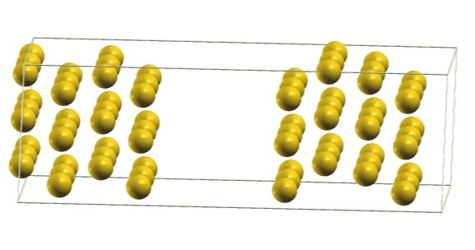

Here you can replace the C₃ molecule with a molecule of your choice. Copy the runtime files from exercise 3 into the example4 directory, and edit the input file “input.fdf” in such a way as to remove the 3 C₃ atoms between the left and right telectrode. Change the fdf-parameters NumberOfAtoms accordingly, remove the 3 Au atoms from the list in AtomicCoordinatesAndAtomicSpecies, change SaveBiasSteps, and NIVPoints. This corresponds to a parallel plate capacitor. You can optionally run the calculation for the capacitor alone.
You can add atoms or molecules in the space between the leads. A set of gold capacitors with different distance are provided going from 3 Ang to 13 Ang, use one with a suitable distance as template where to add the molecule. Molecules can be for example H₂, H₂O, CO, CO₂, CH₃, LiH, H₂S. You can check the molecular structure in the internet, but you can also “invent” a molecule. A set of pseudopotentials for different elements is provided in the “pseudopotentials” directory. You can perform an analogous analysis to the one performed in example3 for the C₃ molecule.

Example 4 (Optional): Two Au(111)-surfaces joined by a 3-atom gold wire

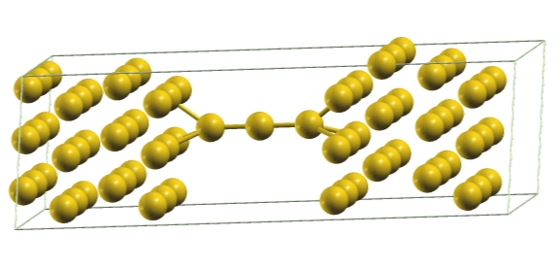Figure 16: 3-atom Au nanowire bridging two Au(111) electrodes.

This corresponds to a realistic system that can be realized experimentally. We will first only look at the 0-bias properties to compare the transmission coefficient to the one for the infinite wire calculated previously, and then calculate the I-V and potential drop. The surfaces are treated by imposing periodic boundary conditions along x and y and using Bloch theorem in the x-y plane. The Au(111) surface is often used in MCBJ and MCBJ-STM experiments..
First change into directory leads-2D and run Smeagol there to generate the leads files. Copy “bulklft.DAT”, “bulkrgt.DAT”, “Au_leads.DM” and “Au_leads.HST” to the “example2” directory by executing from within the leads-2D directory
cp bulklft.DAT bulkrgt.DAT Au_leads.DM Au_leads.HST ../example2
These leads files will be needed also for all the other calculations with gold surfaces. We note that for a well-converged calculation more Au-layers would be needed on each side. Moreover instead of using an ABC stacking for the Au(111) electrodes we use an AB stacking, which allows us to reduce the size of the system for this tutorial. However this does not affect significantly the transport properties.
Run smeagol-1.2 in this directory. The input file is set up to run only 1 bias step at 0.0 eV of bias voltage. Open the file 0.Au_Au_TRC.agr with xmgrace, and compare transmission, number of channels in the leads, DOS of the scattering region and DOS of the leads. Open also the 0.Au_TRC.agr file in the example1 directory with xmgrace (calculated in example1), which corresponds to the same data for the perfectly periodic infinite 1D Au chain. How do the transmissions compare qualitatively and quantitatively for the two systems, is the transmission for the simple 1D Au wire a good approximation for the one of the real finite length chain between the thick electrodes?
________________________________________________________________________________________________________________________________________________How do the number of channels in the electrodes compare?
________________________________________________________________________________________________________________________________________________How do the DOSs compare for the scattering regions of the two systems? _______________________________________________________________________________________________________________________________________________How do the DOSs of the leads compare?
________________________________________________________________________________________________________________________________________________
Plot also the PDOS for the 3 Au atoms of the wire and for 2 arbitrary surface Au atoms, and compare it to the transmission. By comparing PDOS and transmission, which atom determines the bandwidth in energy of the high-transmission region?
atom index=______________

Exercises
For each exercise, in the example2 directory make a subdirectory with the name exercise_<number> (where number is the number of the exercise, i.e. 1, 2, ...). Copy all the needed input files into that directory (see the “Leads” subsection for which files are needed).
- We now calculate the I-V of the system from 0.0 Volt to 2.0 Volt by using 10 bias steps. To this aim copy the 0 bias input.fdf file into the exercise_2 subdirectory, and edit it to change the input file options Vinitial 0.0 eV, Vfinal 2.0 eV,and NIVPoints 10. Inside the %block SaveBiasSteps include 2 more steps to save, namely 5 and 10. In this way we will get the real space potential and charge density printed at 0.0 Volt, at 1.0 Volt and at 2.0 Volt. Compare the I-V file (Au_Au.CUR) with the one obtained for the infinite chain
xmgrace Au_Au.CUR ../../example1/Au.CUR
Is the current for the 1D Au infinite periodic chain a good approximation for the finite length one attached to 2D electrodes?
__________________________________________________________________
We can now analyze how the potential drops across the junction by calculating the potential averaged over the x-y plane. For this we run
pot.sh
in this directory. Then we open the potential average files for 2 bias voltages
xmgrace 0.Au_Au-VH_AV.dat 5.Au_Au-VH_AV.dat
As outlined in example1 we now take the difference between the potential at finite bias and the one at 0 bias to obtain the potential drop.
At which z positions does the potential drop approximately start and end?
z_{drop starts}=__________________________
z_{drop ends}=_____________________________
Perform the analogous calculation also for the charge density by plotting the *RHO_AV.dat files with xmgrace
xmgrace 0.Au_Au-RHO_AV.dat 5.Au_Au-RHO_AV.dat
and taking the differences. Due to the out-of-equilibrium charge flow the charge density at finite bias is significantly different from the one at 0 bias. At which z positions is there the largest accumulation of charge, and at which the largest depletion?
z_{accumulation}=__________________________
z_{depletion}=_____________________________
Verify that these positions correspond approximately to the positions where the potential drop begins and ends, since the potential drop is caused by the local charging.

Appendix A: Using the Pot.exe program

The Pot.exe program expects to find a file called “Potential.dat”, which contains the necessary input parameters. All of these can be left identical to the ones in the provided template, except the entry in the first line, where “file-prefix” has to be replaced by the prefix of the file obtained by removing the .VH or .RHO ending. In the second line by setting “rho” as value the .RHO file is considered, if it is set to “vh” then the potential .VH is considered. For example, to obtain the planar average of the potential in the file 0.Au-Au.VH the first two lines in the Potential.dat file have to be
'0.Au_Au'
'vh'

After setting up the input file Potential.dat execute “Pot.exe”.

Appendix B: Using the get_PDOS.sh script
The shell script get_PDOS.sh prints out a usage guide if called without arguments. It needs two input files:
1)file.PDOS or file.TRC.EMPDOS (the name is arbitrary): this file contains the output from a siesta or smeagol calculation for the PDOS.
2)Input_fm: input file for get_PDOS.sh, that tells the script for which orbitals it should print the PDOS. There should not be any empty lines in the file, and for each atom where the PDOS should be printed add 3 lines:
a)the first starts with a “#” character, and then followed by some arbitrary text. The text is then used as part of the output file name, and also in the xmgrace figure, for that particular orbital.
b)the index of the atom in the siesta input file
c)The number “0”.
Note: in principle the input file can have more options, to print orbital dependent PDOSs, but this is not needed for the tutorial.

Here are the contents of an example input file Input_fm (this can be used for example 1, exercise 1):
#Au_chain1
1
0
#Au_chain2
2
0
#Au_chain3
3
0
#Au_chain4
4
0
#Au_chain5
5
0

Appendix C: Basic linux bash commands

When you open a terminal window (shell) in linux, you can enter commands. The shell that you will use is called “bash”. The commands that will be needed most in this tutorial are
ls: lists the contents of a directory
cd directoryname: changes into the directory with name directoryname
cd ..: changes into top directory of the current working directory
mkdir directoryname: makes a new directory with name directoryname
cp file1 file2 file3...fileN destdir: copies the files file1 to fileN to the directory with path destdir
rm file1 file2 file3... fileN: permanently deletes the files file1 to fileN
rm -r dir1 dir2 dir3... dirN: permanently deletes the directories dir1 to dirN and all their contents (you should be careful when running this command)

