

**FDIAMOND**

**Software Requirement Document**

| **Class JS1802 - Group 4** | |
| --- | --- |
| **Group members** | * Nguyen Thi Bich Duyen - SE183629 (Leader) * Nguyen Huu Quoc Hung - SE172905 * Ha Duy Tung - SE173573 * Tran Nguyen Thu An - SE182972 * Doan Dang Thien Bao -SE171827 |
| **Supervisor** | Ms. Nguyen Thi Cam Huong |

– HoChiMinh, July 2024 –

**I. Introduction 4**

1. Product Background 4

2. Existing Systems 4

2.1 Blue Nile 4

3. Business Opportunity 5

4. Software Product Vision 5

5. Major Features 6

Feature 1: Account Management 6

Feature 2: Product Management 6

Feature 3: Order Management 6

Feature 4: Discount Management 6

Feature 5: Admin Report Management 6

6. Limitations and Exclusions 7

**II. Overall Description 7**

1. Product Overview 7

2. Business Process 9

**III. User Requirements 10**

1. Actors 10

2. Use Cases 11

2.1 Diagram 11

2.2 Descriptions 11

3. Business Rules 17

**IV. Functional Requirements 18**

1. System Functional Overview 18

1.1 Screen Flow 18

1.2 Screen Descriptions 19

1.3 Screen Authorization 21

1.4 Non-Screen Functions 22

2. Data Requirements 22

2.1 Logical Data Model 22

2.2 Data Dictionary 23

2.3 Reports 27

2.4 State transition diagram 29

3. Account Management 29

3.1. Register 30

4. Product Management 30

4.1. Add Product 30

5. Discount Management 31

5.1. Create Discount Code 31

6. Order Management 31

6.1. Place Order 31

7. Admin Report Management 32

7.1. View Dashboard 32

**V) Sequence Diagram 33**

1. CRUD Product 33

2. Order 33

3. Cancel Order 33

**VI) Class Diagram 33**

1. CRUD Product 33

2. Order 33

3. Cancel Order 33

# 

# 

# 

# 

# 

# 

# 

# 

# 

# 

# I. Introduction

## 1. Product Background

The proposed Diamond Online Shop offering a comprehensive online marketplace for diamonds and fine jewellery, ensuring a seamless shopping experience that combines quality, transparency, and exceptional customer service.

## 2. Existing Systems

#### 2.1 Blue Nile

**Description:** Blue Nile is a prominent online retailer that specialises in diamonds and fine jewellery. The platform offers a vast selection of certified diamonds and customizable jewellery settings.

**Link:** [Blue Nile](https://www.bluenile.com/)

**System Actors:**

* **Customers:** Individuals looking to purchase diamonds and fine jewellery.
* **Blue Nile Staff:** Employees responsible for managing inventory, fulfilling orders, and providing customer support.

**Features:**

* **Extensive Diamond Search:** Customers can search for diamonds based on various criteria such as carat, cut, colour, and clarity.
* **Customizable Jewellery:** Allows users to create custom engagement rings and other jewellery by selecting the diamond and setting.
* **Educational Resources:** Provides detailed information and guides about diamonds and jewellery to educate customers.
* **Secure Payment:** Offers secure payment options and financing plans.
* **Customer Support:** Provides customer support through chat, email, and phone.

**Pros:**

* Extensive selection of diamonds and jewellery.
* User-friendly interface with robust search and customization options.
* Comprehensive educational resources.
* Secure payment and financing options.

**Cons:**

* High competition with other online and physical jewellery stores.
* Some customers may prefer to see and feel the jewellery before purchasing.
* High-value transactions require strong security and trust-building measures.

## 3. Business Opportunity

**Problem:** Despite the availability of various online jewellery stores, customers often face challenges in finding a platform that combines an extensive selection of high-quality diamonds, customizable options, and comprehensive educational resources. Additionally, many customers seek a personalised shopping experience and assurance of authenticity and quality, which is not always adequately addressed by existing platforms.

**Proposed Solution:** The Diamond Online Shop will provide a user-friendly platform offering a wide range of certified diamonds and customizable jewellery options. The platform will include educational resources to help customers make informed decisions, secure payment options, and excellent customer support. By focusing on quality, transparency, and customization, the Diamond Online Shop will differentiate itself from competitors and meet the evolving needs of customers.

**Competitive Advantage:**

* **Extensive Selection:** A wide range of certified diamonds and fine jewellery.
* **Customization:** Options to create personalised jewellery.
* **User Experience:** Intuitive interface and seamless shopping experience.
* **Security and Trust:** Robust security measures and customer support.

## 4. Software Product Vision

The vision of our software product is to create a premier online marketplace for diamonds and fine jewellery that offers an exceptional shopping experience. Our platform aims to provide customers with a wide selection of certified diamonds, customizable jewellery options, and valuable educational resources, all while ensuring secure transactions and outstanding customer support.

Key elements of our software product vision include:

* **Convenience and Efficiency:** A one-stop solution for purchasing diamonds and jewellery, with a seamless browsing and buying process.
* **Personalization:** Customizable options to create unique and personalised jewellery.
* **Transparency and Trust:** Detailed product descriptions, certifications, and customer reviews to build trust and confidence.
* **Educational Resources:** Informative guides and resources to help customers make informed decisions.
* **Customer Support:** Responsive and helpful customer service to assist with any inquiries or issues.

## 5. Major Features

#### Feature 1: Account Management

* **FE-01:** User Authentication and Registration
  + **FR1.1:** Login as Customer (via Gmail or other methods)
  + **FR1.2:** Login as Administrator
  + **FR2.1:** Register Customer
  + **FR2.2:** Register Administrator
  + **FR3:** Forgot Password
  + **FR4:** Update Account Information

#### Feature 2: Product Management

* **FE-02:** Product Catalogue Management
  + **FR5.1:** Search Products by ID/Name
  + **FR5.2:** Filter Products (Customer and Admin Views)
  + **FR5.3:** Sort Products
  + **FR5.4:** View Product Details
  + **FR5.5:** Add New Products (Admin)
  + **FR5.6:** Edit Product Details (Admin)
  + **FR5.7:** Delete Products (Admin)

#### Feature 3: Order Management

* **FE-03:** Order Processing and Fulfilment
  + **FR6.1:** Create Order
  + **FR6.2:** Add Products to Cart
  + **FR6.3:** View Cart and Cart Lines
  + **FR6.4:** Remove Cart Lines or Items
  + **FR6.5:** Apply Voucher to Payment
  + **FR6.6:** Execute Payment (Momo, PayPal, VnPay)
  + **FR6.7:** View Order History and Details
  + **FR6.8:** Cancel Order (Manually or Automatically)

#### Feature 4: Discount Management

* **FE-04:** Promotions and Discounts
  + **FR7.1:** Create and Manage Discount Codes
  + **FR7.2:** Apply Discounts to Orders
  + **FR7.3:** Search Discount by Name

#### Feature 5: Admin Report Management

* **FE-05:** Reporting and Analytics
  + **FR8.1:** Generate Sales Reports
  + **FR8.2:** View Customer Analytics
  + **FR8.3:** View Product Analytics
  + **FR8.4:** View Order Analytics

## 6. Limitations and Exclusions

**LI1: Online Interaction Limitation**

* Customers may not have the opportunity to physically inspect diamonds and jewellery before purchasing, relying solely on online descriptions and images.

**LI2: Manual Updates for Availability**

* Hosts must promptly update the system's availability status to avoid issues such as double bookings, with responsibility for any resulting complications resting on the host.

**LI3: Customer Confirmation of Successful Transactions**

* Hosts are responsible for ensuring customers confirm the successful completion of transactions, with reminders and follow-ups as necessary.

# II. Overall Description

## 1. Product Overview

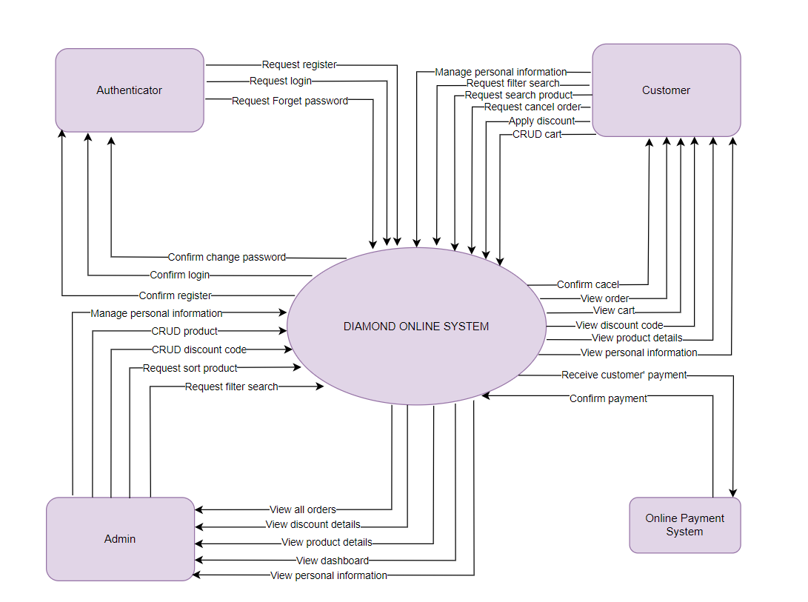

## 2. Business Process

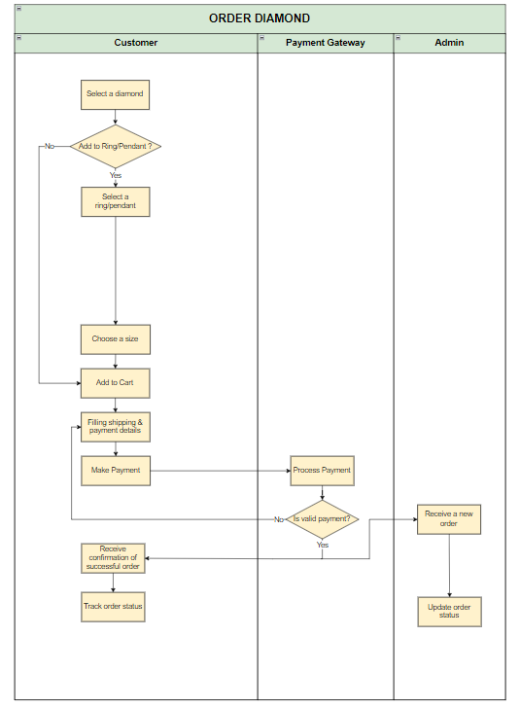

| **#** | **Process Step** | **Description** |
| --- | --- | --- |
| 1 | Select a Diamond | Choose from a wide range of diamonds, filtering by cut, color, clarity, and carat to find the perfect stone for your ring. |
| 2 | Select ring | Browse through various ring settings and styles, selecting the one that complements your chosen diamond. |
| 3 | Choose Ring Size | Determine the correct ring size by either measuring an existing ring or using a ring size guide provided by the jeweler. |
| 4 | Add to Cart | Review your selected diamond and ring setting, then add them to your shopping cart for purchase. |
| 5 | Filling Payment Details | Enter your billing information, including name, and payment method, to proceed with the purchase. |
| 6 | Make Payment | Confirm your payment details and authorize the transaction to complete your purchase. |
| 7 | Process Payment | The payment system verifies your payment information and processes the transaction. |
| 8 | Receive a new Order | The order is received by the jeweler’s system, and an order confirmation is generated. |
| 9 | Update Order Status | The status of your order is updated as it progresses through stages |
| 10 | Receive Confirmation of Order | You receive a notification confirming that your order has been successfully placed and is being processed. |
| 11 | Track Order Status | Use the tracking information provided to monitor the progress |

# 

# III. User Requirements

## 1. Actors

| **#** | **Actor** | **Description** |
| --- | --- | --- |
| 1 | Account | An account refers to a user who has not registered or logged in. These users can browse the website, view product pages, and search for items. However, they do not have the ability to add items to their cart or place an order until they create an account and log in. |
| 2 | Customer | A customer is an account that has registered and logged in, allowing full access to the platform's features. Customers can add items to their shopping cart, place orders, and make payments. They can also view their order history, track current orders. Customers receive notifications about their orders, and updates from the system. |
| 3 | Admin | An admin is an account with elevated privileges who manages the e-commerce platform. Admins have the authority to create, read, update, and delete (CRUD) product listings. They oversee inventory management, ensuring that product information is accurate and up-to-date. They also have access to detailed analytics and reports to make data-driven decisions for improving the platform. |

## 2. Use Cases

### 2.1 Diagram

[*https://drive.google.com/file/d/1NJMAd52x-peCx8tcZ7qzvxM98n_Xn7c3/view?usp=sharing*](https://drive.google.com/file/d/1NJMAd52x-peCx8tcZ7qzvxM98n_Xn7c3/view?usp=sharing)

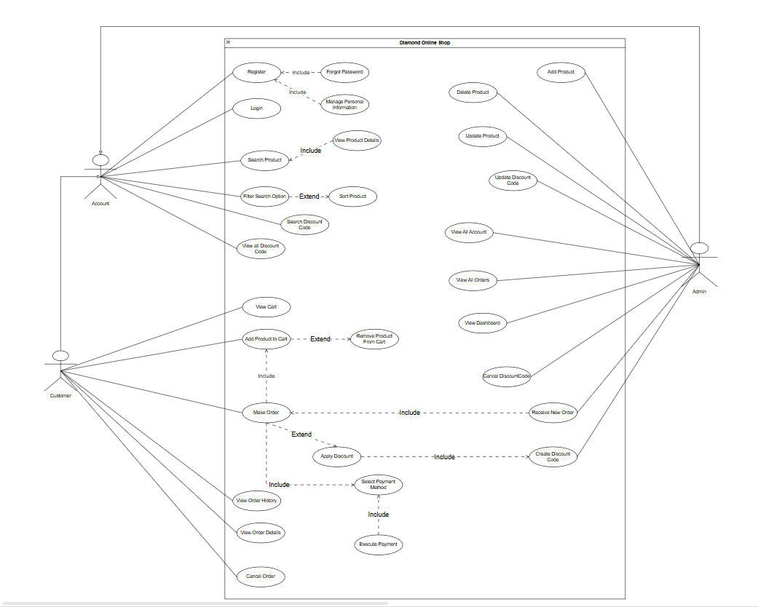

### 2.2 Descriptions

| **ID** | **Use Case** | **Actors** | **Use Case Description** |
| --- | --- | --- | --- |
| UC-01 | Register | Account | Allows users can create a new account or register within the system. It enables users to provide their necessary information and credentials to set up an account, gaining access to the system's features and functionalities. |
| UC-02 | Login | Account | Allows users to Log in to the system. Depending on the user's role, they can use the features of that role |
| UC-03 | Login with Google | Account(Customer) | Allows users to Log in to the system by their Gmail |
| UC-04 | Manage Personal Information | Account | Allows the user can update their information in the system. |
| UC-05 | Add Product | Admin | Admins can add new products to the catalog, including details like name, description, price, and images. |
| UC-06 | Delete Product | Admin | Allow admin/employee set the status Visible of product to false |
| UC-07 | Search Product | Account | Users can search for products using keywords. |
| UC-08 | Update Product | Admin | Admins can update product details such as price, description, and availability. |
| UC-09 | View Product Details | Account | Users can view detailed information about a product, including images, description, and price. |
| UC-10 | Create Discount Code | Admin | Admins can generate discount codes for promotions. |
| UC-11 | Search Discount Code by Name | Account | Users can search for discount codes using specific keywords or names. |
| UC-12 | View All Discount Code | Account | Admins can view a list of all discount codes./ Customer view available discount code |
| UC-13 | Cancel Discount Code | Admin | Admins can deactivate or cancel existing discount codes. |
| UC-14 | Update Discount Code | Admin | Admins can modify the details of existing discount codes. |
| UC-15 | Add Products to Cart | Customer | Allows the user can add items to their shopping cart within the system. It allows users to select products they wish to purchase and store them temporarily in the shopping cart before proceeding to the checkout process. |
| UC-16 | Remove Products From Cart | Customer | Allows users to remove unwanted products from shopping cart. |
| UC-17 | View Cart | Customer | Allows the user can view the contents of their shopping cart before proceeding to checkout. The system displays the products in the cart, their quantities, prices, and provides options for modification. |
| UC-18 | Order | Customer | Allows the user can place an order for diamond within the system. It enables users to select items, provide shipping and payment details, and complete the purchase transaction. |
| UC-19 | Apply Discount to Order | Customer | Users can apply discount codes to their orders to receive discounts. |
| UC-20 | Execute Payment | Customer | Users can complete the payment process using their selected payment method. |
| UC-21 | Cancel Order | Customer | Users can cancel an order they have placed, if allowed by the system's policies. |
| UC-22 | View Order Details | Customer | Users can view detailed information about their orders, including products, prices, and status. |
| UC-23 | View Order History | Customer | Users can view a history of all their past orders. |
| UC-24 | Receive New Orders | Admin | Admins can receive notifications and view new orders placed by customers. |
| UC-25 | View All Order | Admin | Admins can view a comprehensive list of all orders placed by customers. |
| UC-26 | View All Accounts | Admin | Admins can view and manage all user accounts registered in the system. |
| UC-27 | View Dashboard | Admin | Admins can view a dashboard with various metrics and reports about the system's performance and usage. |

| ID and Name: | **UC-18 Order Diamond** | | |
| --- | --- | --- | --- |
| Created By: |  | Date Created: | 1/7/24 |
| Primary Actor: | Customer | Secondary Actors: | Admin, Banking System |
| Description: | This use case allows the customer to place an order for a diamond, within the system. It enables users to select items, provide shipping and payment details, and complete the purchase transaction. | | |
| Trigger: | The customer selects the diamond/ring/earring/necklace for purchase. | | |
| Preconditions: | PRE-1. The user has a registered account on the platform.  PRE-2. The user is logged into their account.  PRE-3. Diamonds/Rings/Earrings/Necklaces are available for purchase. | | |
| Postconditions: | POST-1. The system records the transaction correctly.  POST-2. The user's purchase information is saved within their login session. | | |
| Normal Flow: | **18.0 Order**   1. The customer navigates to the product selection. 2. The system displays product variations. 3. The customer selects the desired product variation. 4. Choose the product 5. Choose to add to ring or pendant (if diamond) 6. The system guides the user through the process. 7. Apply Discount Code (optional) 8. The customer provides necessary details (payment) information. 9. The system presents a summary of the order, including selected options and estimated costs. 10. The customer reviews the order details and confirms the transaction. 11. The system processes payment and verifies it. 12. The customer receives an order confirmation via email or notification. 13. The system stores the order information. 14. The system records the order status. | | |
| Alternative Flows: | **UC-18.AF1 Adding More Products to the Order**   1. Once the customer has added a diamond to the cart and provided order details, they decide to add more products to their order. 2. The customer selects the option to add more items. 3. The system redirects the customer back to the diamond selection page. 4. Customer browses and selects an additional diamond (or diamonds), indicating the quantity for each. 5. The system adds the new selection(s) to the shopping cart, updating the order total based on the new items added. 6. After adding the desired items, the customer chooses to proceed to check out. 7. The system then returns to the main flow where the customer can finalise their updated order. | | |
| Exceptions: | **UC-18.E1 Selected Product Unavailability:**  1. The system informs the customer that the selected product is not available in stock.  2a. If the customer cancels the order process, then the system terminates the use case.  2b. If the customer decides to select a different diamond, then the system restarts the use case.  **UC-18.E2 Insufficient Balance**  1.The system informs the customer about their insufficient balance for the transaction.  2a. If the customer cancels the order process, then the system terminates the use case.  2b. If the customer decides to use a different payment method or reduce the quantity of the order, the system returns to the payment processing step of the normal flow.  **UC-18.E3 Payment Gateway Error:**  1.The system informs the customer about the error in processing the payment due to technical issues with the payment gateway.  2a. If the customer decides to cancel the order, the system terminates the use case.  2b. If the customer decides to try again later or use a different payment method, the system returns to the payment processing step of the normal flow. | | |
| Priority: | High | | |
| Frequency of Use: | Due to its significance, this function can be used many times a day across different time zones. | | |
| Business Rules: |  | | |
| Other Information: | The customer can cancel the order process anytime before confirming payment. | | |
| Assumptions: | The system is functional and operational at the time the customer intends to use it.  The payment gateway available.  The customer has a stable internet connection to complete the transaction process.  The customer provides valid information for order and payment.  All payment methods supported by the system are functional. | | |

## 3. Business Rules

| **ID** | **Rule Definition** |
| --- | --- |
| BR-01 | Users must be authenticated before accessing any customer or admin functionalities. |
| BR-02 | User registrations must be verified via email before the account is activated. |
| BR-03 | Users can only update their own personal information. |
| BR-04 | Search filters must match products based on the specified criteria exactly. |
| BR-05 | Orders cannot be placed without valid payment. |
| BR-06 | Only one discount code can be applied per order. |
| BR-07 | Order only can be cancelled in 24 hours after making payment. |
| BR-08 | Users give a OrderId in email to store staff to pick up |
| BR-09 | Admins are the only users allowed to create, edit, or delete products and discount codes. |
| BR-10 | GIA reports must be retrieved from an authenticated source to ensure accuracy. |
| BR-11 | All financial data displayed in the admin dashboard must be updated daily. |
| BR-12 | The system must enforce unique email addresses for each user account. |
| BR-13 | Discount codes must be unique and not reusable unless specified by the admin. |
| BR-14 | The system must validate payment methods against supported providers before processing. |

# IV. Functional Requirements

## 1. System Functional Overview

### 1.1 Screen Flow

***Admin https://drive.google.com/file/d/1a1z8OJ3t3FlyW_EuR6fSBVCg1VRopTSo/view?usp=sharing***

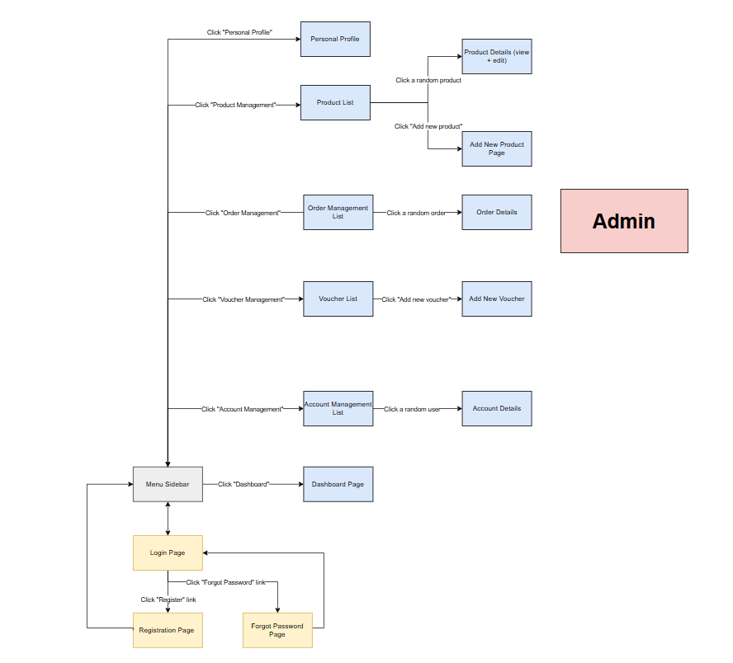

***Customer https://drive.google.com/file/d/1a1z8OJ3t3FlyW_EuR6fSBVCg1VRopTSo/view?usp=sharing***

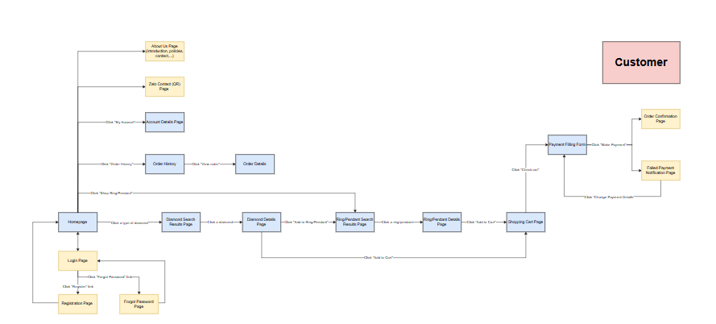

### 1.2 Screen Descriptions

| **#** | **Screen** | **Feature** | **Description** |
| --- | --- | --- | --- |
| FR-01 | User Profile |  | This page allows users to view and edit their profile information, including personal details, contact information, and preferences. Users may also upload a profile picture. |
| FR-02 | Login |  | This page allows users to log in to their accounts using their credentials (e.g., email address and password). |
| FR-03 | Register |  | This page enables new users to create an account by providing required information, such as name, email address, and password. |
| FR-04 | Forget Password |  | This button allows users to recover their account password in case they forget it. Typically involves sending a password reset link to the user's registered email address. |

*Customer*

| **#** | **Screen** | **Feature** | **Description** |
| --- | --- | --- | --- |
| FR-05 | Home |  | The homepage of the platform serves as the entry point for users, offering a glimpse into the diverse range of products and services available. |
| FR-06 | Search Result Page |  | Displays a list of diamonds or other jewelry items matching the user's search criteria. Users can refine their search using filters such as price, cut, color, clarity, and carat weight. |
| FR-07 | Diamond Details Page |  | Provides detailed information about a selected diamond, including specifications, certification details, and high-resolution images. Users can view the diamond from multiple angles. |
| FR-08 | Ring/Pedant Search Result Page |  | Shows a list of rings or pendants that match the user's search criteria. Filters and sorting options help users find the perfect piece of jewelry. |
| FR-09 | Ring/Pedant Search Details Page |  | Offers comprehensive details about a selected ring or pendant, including material, design specifications, available sizes, and customization options. High-quality images are provided. |
| FR-10 | Shopping Cart Page |  | Displays items that the user has added to their shopping cart. Users can review their selections, update quantities, remove items, and proceed to checkout. |
| FR-11 | Payment Fill Form |  | A secure form where users enter their payment details, such as credit card information or other payment methods, to complete their purchase. |
| FR-12 | Order Confirm Page |  | Confirms that the user's order has been successfully placed. Displays order details, including items purchased, total cost |
| FR-13 | Failed Payment Notification |  | Alerts the user when a payment attempt has failed. Provides information on the reason for the failure and instructions on how to retry or use a different payment method. |
| FR-14 | Order History |  | Allows users to view a history of all their past orders, including order dates, items purchased, total amounts, and current status of each order. |
| FR-15 | Order Detail |  | Provides detailed information about a specific order, including product details, order status, shipping information, and payment method used. |
| FR-16 | Contact |  | Provides users with various ways to contact customer support, including email, phone numbers, and a contact form. May also include FAQs and a live chat option. |
| FR-17 | About us Page |  | Offers information about the company, its history, mission, values |

*Admin*

| **#** | **Screen** | **Feature** | **Description** |
| --- | --- | --- | --- |
| FR-18 | Menu Sidebar |  | A collapsible sidebar providing easy navigation to different sections of the application, such as the dashboard, account management, product list, orders, and settings. |
| FR-19 | Dashboard Page |  | The main admin interface displaying an overview of key metrics and insights, such as sales figures, new orders, user activity, and inventory levels. Includes widgets and charts for quick analysis. |
| FR-20 | Account Management List |  | Displays a list of all user accounts, including customers and admins. Admins can search, filter, and manage accounts, such as viewing details or deactivating accounts. |
| FR-21 | Account Details |  | Provides detailed information about a specific user account, including personal information, order history, account status, and activity logs. |
| FR-22 | Voucher List |  | Shows a list of all available vouchers, including details such as voucher codes, discounts, expiration dates, and usage status. Admins can search, filter, and manage vouchers. |
| FR-23 | Add New Voucher |  | A form that allows admins to create a new voucher by specifying details like the voucher code, discount percentage or amount, expiration date, and any usage restrictions. |
| FR-24 | Order Management List |  | Displays a list of all orders placed on the platform. Admins can search, filter, and sort orders by various criteria, such as date, status, and customer name. |
| FR-25 | Order Details |  | Provides comprehensive details about a specific order, including products purchased, customer information, payment status, shipping details, and order history. |
| FR-26 | Product List |  | Shows a list of all products available on the platform, including details like product name, category, price, stock status, and options to edit or delete products. |
| FR-27 | Add New Product Page |  | A form that allows admins to add a new product to the platform by entering details such as product name, description, category, price, images, and stock quantity. |
| FR-28 | Product Details |  | Provides detailed information about a specific product, including its description, specifications, images, pricing, and availability. Admins can edit product details from this page. |

### 1.3 Screen Authorization

| **Screen** | **Role1** | **Role2** |
| --- | --- | --- |
| User Profile | X | X |
| Login | X | X |
| Register | X | X |
| Forget Password | X | X |
| Home | X |  |
| Search Result Page | X |  |
| Diamond Details Page | X |  |
| Ring/Pedant Search Result Page | X |  |
| Ring/Pedant Search Details Page | X |  |
| Shopping Cart Page | X |  |
| Payment Fill Form | X |  |
| Order Confirm Page | X |  |
| Failed Payment Notification | X |  |
| Order History | X |  |
| Order Detail | X |  |
| Contact | X |  |
| About us Page | X |  |
| Menu Sidebar |  | X |
| Dashboard Page |  | X |
| Account Management List |  | X |
| Account Details |  | X |
| Voucher List |  | X |
| Add New Voucher |  | X |
| Order Management List |  | X |
| Order Details |  | X |
| Product List |  | X |
| Add New Product Page |  | X |
| Product Details |  | X |

In which:

* Role1: Customer
* Role2: Admin

### 1.4 Non-Screen Functions

| **#** | **System Function** | **Feature** | **Description** |
| --- | --- | --- | --- |
| FR-11 | <<Function Name1>> | <<Feature Name>> | <<Function Name1 Description>> |
| FR-12 | … |  |  |

## 2. Data Requirements

### 2.1 Logical Data Model

<https://drive.google.com/file/d/1p8GJO6FrXx7xXIC5sYxDu3W2-M5W4R72/view?usp=sharing>

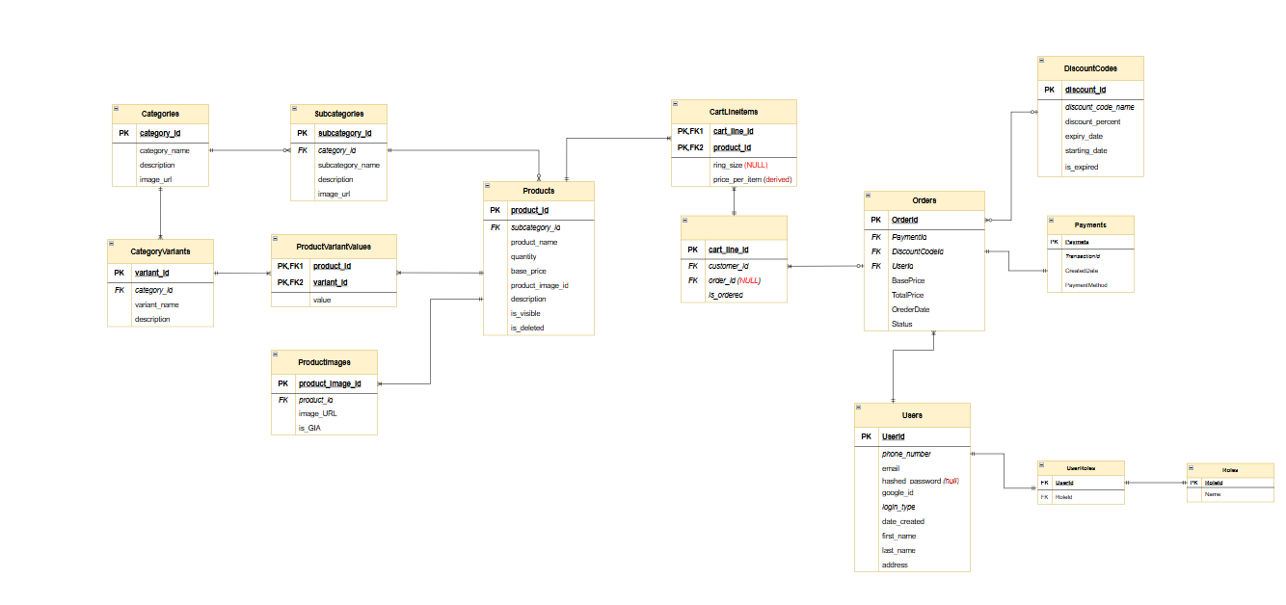

### 2.2 Data Dictionary

| **Data Element** | **Description** | **Composition or Data Type** | **Length** | **Values** |
| --- | --- | --- | --- | --- |
| Categories | This table stores information about the different categories of products available in the system. | category_id  category_name  description  image_url |  |  |
| category_id(PK) | A unique identifier assigned to each Category within a system. | Integer |  |  |
| category_name | Name of the category | String |  |  |
| description | Description of the category | String |  |  |
| image_url | URL of the image | String |  |  |
| SubCategories | This table stores information about the subcategories, which are specific segments under each main category. | sub_categoryid  category_id  subcategory_name  description  image_url |  |  |
| subcategory_id(PK) | A unique identifier assigned to each SubCategory within a system. | Integer |  |  |
| description | Description of the subcategory | String |  |  |
| CategoryVariants | This table stores information about different variants associated with categories, such as sizes, colors, etc. | variant_id  category_id  variant_name  description |  |  |
| variant_id (PK) | A unique identifier assigned to each Variant within a system. | Integer |  |  |
| variant_name | Name of variant | String |  |  |
| description | Description of the variant | String |  |  |
| Products | This table stores detailed information about each product available in the system. | product_id  subcategory_id  product_name  quantity  base_price  description  is_visibel  is_deleted |  |  |
| product_id(PK) | A unique identifier assigned to each Product within a system. | Integer |  |  |
| product_name | Name of Product | String |  |  |
| quantity | Quantity of the product available | Integer |  |  |
| base_price | Base price of the product | Decimal |  |  |
| description | Description of Product | String |  |  |
| is_visible | Indicates if the product is visible | boolean |  |  |
| is_deleted | Indicates if the product is visible | boolean |  |  |
| ProductVariantValues | This table stores the values associated with product variants. | variant_id  product_id  value |  |  |
| value | Value of the product variant | String |  |  |
| ProductImages | This table stores URLs of images for each product. | product_image_id  product_id image url  is_GIA |  |  |
| is_GIA | Indicates if the product image is GIA certified | boolean |  |  |
| CartLineItems | This table stores information about items in the user's shopping cart | CartLineId  ProductId  RingSize  Price |  |  |
| RingSize | Size of ring | Integer |  |  |
| Price | Price per item in the cart | Decimal |  |  |
| CartLines | This table stores information about the lines in a user's shopping cart | CartLineId  OrderId  UserId  IsOrdered |  |  |
| CartLineId | A unique identifier assigned to each CartLine within a system. | Integer |  |  |
| IsOrdered | Indicates if the cart line item has been ordered | boolean |  |  |
| Orders | This table stores information about user orders. | order_id  user_id  order_date  PaymentId  BasePrice  TotalPrice  DiscountCodeId |  |  |
| OrderId | A unique identifier assigned to each Order within a system. | Integer |  |  |
| order_date | Date when the order was placed | DateTime |  |  |
| BasePrice | Base price of the Order | decimal |  |  |
| TotalPrice | Total price of the order | decimal |  |  |
| Payments | This table stores information about payments made by users. | PaymentId  TransactionId  CreatedDate  PaymentMethod |  |  |
| PaymentId | A unique identifier assigned to each Payment within a system. | Integer |  |  |
| TransactionId | A unique identifier assigned to each Transaction within a system | String |  |  |
| CreatedDate | Date when the payment was created | DateTime |  |  |
| PaymentMethod | Method of payment used | String |  |  |
| DiscountCodes | This table stores information about discount codes. | discount_id  discount_code_name  discount_percent starting_date  end_date  is_expired |  |  |
| discount_id | A unique identifier assigned to each Discount Code within a system. | Integer |  |  |
| discount_code_name | Name of the discount code | String |  |  |
| discount_percent | Discount percentage provided by the code | Integer |  |  |
| starting_date | Date when the discount code becomes active | DateTime |  |  |
| end_date | Date when the discount code expires | DateTime |  |  |
| is_expried | Indicates if the discount code has expired | boolean |  |  |
| Users | This table stores information about users. | Id  FirstName  LastName  Address  UserName  Email  EmailConfirmed  PasswordHash  PhoneNumber |  |  |
| Id | A unique identifier assigned to each User within a system. | String |  |  |
| FirstName | First name of the user | String |  |  |
| LastName | Last name of the user | String |  |  |
| Address | User’s address | String |  |  |
| UserName | Username for the user account | String |  |  |
| Email | Email address of the user | String |  |  |
| EmailConfirmed | Indicates if the user's email is confirmed | boolean |  |  |
| PasswordHash | Hashed password for the user | String |  |  |
| PhoneNumber | User’s unique phone number | String |  |  |
| Roles | This table stores information about roles. | Id  Name |  |  |
| Id | A unique identifier assigned to each Role within a system. | String |  |  |
| Name | Name of roles | String |  |  |
| UserRoles | This table stores the relationship between users and roles | UserId  RoleId |  |  |

### 2.3 Reports

| **#** | **Report Name** | **Description** |
| --- | --- | --- |
| RPT-01 | Product Sales Summary | The Product Sales Summary report provides a detailed overview of all products sold within a specified time period. This report is essential for admin to analyze sales trends, identify top-selling products, It includes key metrics such as product IDs, names, quantities sold, base prices, total sales amounts, and associated category and subcategory names. This report helps in tracking the performance of products and making data-driven decisions to optimize sales strategies and inventory management. |
| RPT-02 | Customer Order History | The Customer Order History report allows customers to view their past orders over a specified time period. This report is crucial for customers to review their order history, track the status of their current orders, and reorder items they previously purchased. |

| Report ID: | RPT-01 |
| --- | --- |
| Report Title: | Product Sales Summary |
| Report Purpose: | This report provides a summary of all products sold within a specified time period. The sales manager uses this report to analyze sales trends, track top-selling products. |
| Priority: | High |
| Report Users: | Admin |
| Data Sources: | Database of product sales transactions |
| Frequency and Disposition; | The report is generated on demand by authorized users. Data in the report is static and reflects sales within the specified period. The report can be displayed on a user's computer screen. |
| Latency: | The complete report must be displayed within 5 seconds after it is requested. |
| Visual Layout: | Portrait mode |
| Header and Footer: | **Header:** Report title, the name of the report user, and the date range specified.  **Footer:** Page number (if printed).. |
| Report Body: | **Fields Shown and Column Headings:**   * Product ID * Product Name * Quantity Sold * Base Price * Total Sales (Quantity Sold * Base Price) * Category Name * Subcategory Name * Variant (if applicable)   **Selection Criteria:** Date range specified by the user, inclusive of end points.  **Sort Criteria:**   * Primary: Category Name (ascending) * Secondary: Subcategory Name (ascending) * Tertiary: Quantity Sold (descending) |
| End-of-Report Indicator: | None |
| Interactivity: | Users can click on Dashboard to view detailed sales transactions for that product, including transaction dates, customer names, and sales amounts. |
| Security Access Restrictions: | Only authorized admins can access the report. Each user can only view data relevant to their assigned categories and subcategories. |

| Report ID: | RPT-02 |
| --- | --- |
| Report Title: | Customer Order History |
| Report Purpose: | This report allows customers to view their order history over a specified time period. Customers can review past orders, track the status of current orders, and reorder items they previously purchased. |
| Priority: | Medium |
| Report Users: | Customer |
| Data Sources: | Database of customer orders |
| Frequency and Disposition; | The report is generated on demand by a customer. Data in the report is static and is displayed on the customer's web browser. It can be printed if the display device permits printing. |
| Latency: | The complete report must be displayed to the customer within 3 seconds after it is requested. |
| Visual Layout: | Portrait mode |
| Header and Footer: | **Header:** Report title, the name of the report user, and the date range specified.  **Footer:** Page number (if printed).. |
| Report Body: | **Fields Shown and Column Headings:**   * Order Number * Order Date * Product Name * Quantity Ordered * Base Price * Total Order Price (sum of all products in the order) * Status   **Selection Criteria:** Date range specified by the user, inclusive of end points.  **Sort Criteria:**   * Reverse chronological order (most recent orders first) |
| End-of-Report Indicator: | None |
| Interactivity: | Customers can click on an order number to view detailed information about the order |
| Security Access Restrictions: | A customer may retrieve only their own order history. Access is restricted to authenticated users. |

### 2.4 State transition diagram

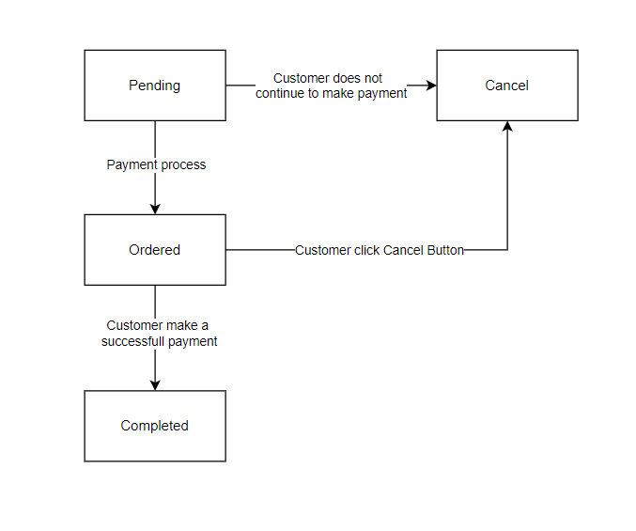

## 3. Account Management

### 3.1. Register

* **Function trigger:** The Register feature is triggered when a user accesses the registration page.
* **Function description:**
  + **Role:** Customer
  + **Purpose:** To create a new account on the platform.
  + **Interface:** Provides a registration form with fields for personal details, email, and password.
  + **Data Processing:** Validates and processes the registration details to create a new user account.
* **Function details:**
  + **Data:** Validates required fields (e.g., name, email, password) for completeness and correctness.
  + **Validation:** Displays error messages for missing or invalid data (e.g., weak password, duplicate email).
  + **Business Logic:** Creates a new user account with the provided details and stores it in the database.
* **Functionalities:**
  + **Normal Cases:** User successfully registers and receives a confirmation email.
  + **Abnormal Cases:** Registration fails due to invalid data; system displays errors and prompts corrections.

## 4. Product Management

### 4.1. Add Product

* **Function trigger:** The Add Product feature is triggered when an admin accesses the product management section and selects the option to add a new product.
* **Function description:**
  + **Role:** Admin
  + **Purpose:** To add new products to the platform’s catalog.
  + **Interface:** Provides a form for inputting product details, including name, price, description, and images.
  + **Data Processing:** Validates and processes the product details to add the new product to the catalog.
* **Function details:**
  + **Data:** Validates required fields (e.g., product name, price, description) for accuracy.
  + **Validation:** Displays error messages for missing or invalid data (e.g., non-numeric price).
  + **Business Logic:** Adds the new product to the database and makes it available in the product catalog.
* **Functionalities:**
  + **Normal Cases:** Admin successfully adds a product; product appears in the catalog.
  + **Abnormal Cases:** Product addition fails due to invalid data; system displays errors and prompts corrections.

## 5. Discount Management

### 5.1. Create Discount Code

* **Function trigger:** The Create Discount Code feature is triggered when an admin accesses the discount management section and selects the option to create a new discount code.
* **Function description:**
  + **Role:** Admin
  + **Purpose:** To create and manage discount codes for promotions.
  + **Interface:** Provides a form for inputting discount code details, including code, discount percentage, and validity dates.
  + **Data Processing:** Validates and processes the discount code details to create a new discount code.
* **Function details:**
  + **Data:** Validates required fields (e.g., code, discount percentage, start and end dates) for accuracy.
  + **Validation:** Displays error messages for missing or invalid data (e.g., past end date).
  + **Business Logic:** Adds the new discount code to the database and makes it available for use.
* **Functionalities:**
  + **Normal Cases:** Admin successfully creates a discount code; code is available for customers to use.
  + **Abnormal Cases:** Discount code creation fails due to invalid data; system displays errors and prompts corrections.

## 6. Order Management

### 6.1. Place Order

* **Function trigger:** The Place Order feature is triggered when a customer completes the checkout process.
* **Function description:**
  + **Role:** Customer
  + **Purpose:** To place an order for products in the shopping cart.
  + **Interface:** Provides a checkout form for inputting delivery address, payment information, and order details.
  + **Data Processing:** Validates and processes the order details to create a new order.
* **Function details:**
  + **Data:** Validates required fields (e.g., delivery address, payment method) for completeness and accuracy.
  + **Validation:** Displays error messages for missing or invalid data (e.g., incomplete address).
  + **Business Logic:** Creates a new order in the database and processes payment.
* **Functionalities:**
  + **Normal Cases:** Customer successfully places an order; order confirmation is displayed.
  + **Abnormal Cases:** Order placement fails due to invalid data or payment issues; system displays errors and prompts corrections.

## 7. Admin Report Management

### 7.1. View Dashboard

* **Function trigger:** The View Dashboard feature is triggered when an admin accesses the report management section.
* **Function description:**
  + **Role:** Admin
  + **Purpose:** To view key metrics and reports on a dashboard.
  + **Interface:** Provides a dashboard displaying various reports and metrics, such as sales, user activity, and inventory levels.
  + **Data Processing:** Retrieves and processes data from the database to generate the dashboard reports.
* **Function details:**
  + **Data:** Ensures data accuracy and relevance for the selected time period and criteria.
  + **Validation:** Displays error messages if data retrieval fails or if invalid criteria are selected.
  + **Business Logic:** Aggregates and displays data on the dashboard for admin review.
* **Functionalities:**
  + **Normal Cases:** Admin successfully views and interacts with the dashboard.
  + **Abnormal Cases:** Dashboard fails to load data; system displays errors and suggests retry.

# 

# V. Sequence Diagram

## CRUD Product

<https://drive.google.com/file/d/10PiAVJyvhNp8cxk6Q6urquT2xD1CgitG/view?usp=sharing>

## Order/Cancel Order

<https://drive.google.com/file/d/1vce5ZBUhFonwcQuSEZDpODzE6yjg8fhO/view?usp=drive_link>

# VI. Class Diagram

## CRUD Product

<https://drive.google.com/file/d/19XE7WJZN52I0RibWdeJX4LFhMnBPOUZc/view?usp=sharing>

## Order/Cancel Order

<https://drive.google.com/file/d/1MWzJbqYC3w9v265wuiHzbnxUa3RsYSLM/view?usp=drive_link>