**Banking Management System**

**A PROJECT REPORT**

***Submitted by***

**Mukul Dagar (22BCS15436)**

**Punit Yadav (22BCS15444)**

**Aradhya (22BCS15439)**

**Tanya (22BCS15446)**

***Submitted to***

**Er. Navjyot Kaur(E8508)**

***in partial fulfillment for the award of the degree of***

**BACHELOR OF ENGINEERING**

**IN**

**COMPUTER SCIENCE & ENGINEERING**



**TABLE OF CONTENTS**

**CHAPTER 1. ABSTRACT 1**

**CHAPTER 2. INTRODUCTION 2**

**CHAPTER 3. LITERATURE REVIEW 3**

**CHAPTER 4. HYPOTHESIS 4**

**CHAPTER 5. CONCLUSION AND FUTURE WORK 7**

**CHAPTER 6. REFRENCES AND CITATIONS 8**

**CHAPTER 1**

**ABSTRACT**

The Banking Management System is a user-friendly software application designed to facilitate various banking operations. This C++ based system offers a wide range of functionalities, including account creation, login, balance inquiry, deposits, withdrawals, account updates, and account deletion. The system is designed to provide customers with secure and convenient access to their accounts, while also offering efficient account management capabilities for bank administrators.

The project employs object-oriented programming principles to structure and manage account data, allowing for the dynamic addition and retrieval of customer information.

By implementing this Banking Management System, users can perform a variety of essential banking operations conveniently, with built-in security features to safeguard their financial information. Moreover, the project serves as a practical demonstration of object-oriented programming concepts, and menu-based user interfaces in the context of a real-world application.

The Banking Management System is designed with the user's convenience and data security in mind, making it a valuable resource for individuals seeking efficient and secure management of their financial accounts.

**CHATPTER 2**

**INTRODUCTION**

# Background

The Banking Management System project reflects the shift from traditional to automated banking methods. Leveraging object-oriented programming, it streamlines account management and secure transactions. The report delves into its design and implementation, illustrating its transformative role in the banking sector.

# Objective

The core objectives of the Banking Management System project are to modernize banking operations and enhance the customer experience. By showcasing the application of object-oriented programming, the project aims to serve as an educational resource and promote automation in banking.

# Scope

The Banking Management System project encompasses a comprehensive scope that includes user-centric account management and administrative tools for bank administrators. Moreover, the project serves as an educational platform for showcasing object-oriented programming and user-friendly interfaces.

**CHAPTER 3 LITERATURE REVIEW**

# Need of Banking Management System

A Banking Management System is imperative due to the evolving banking landscape and the growing need for efficient, secure, and user-friendly financial services. Traditional banking methods often involve lengthy processes, substantial paperwork, and are prone to human errors. Such systems struggle to keep pace with the increasing demand for convenient digital banking services, which require real-time access to account information, secure transactions, and efficient account management.

# Searching Algorithms

A review of similar systems and previous work in the field of Banking Management Systems is instrumental in understanding the current landscape of financial technology. This analysis allows for the identification of successful strategies, challenges faced, and areas requiring improvement. By examining existing banking solutions, open-source platforms, and fintech innovations, the project can draw inspiration from best practices and innovative features. Additionally, assessing security standards and user feedback provides critical insights for developing a system that prioritizes data security and user experience

**CHAPTER 4**

**CODE DESCRIPTION AND OUTPUT**

* **Code preview:**

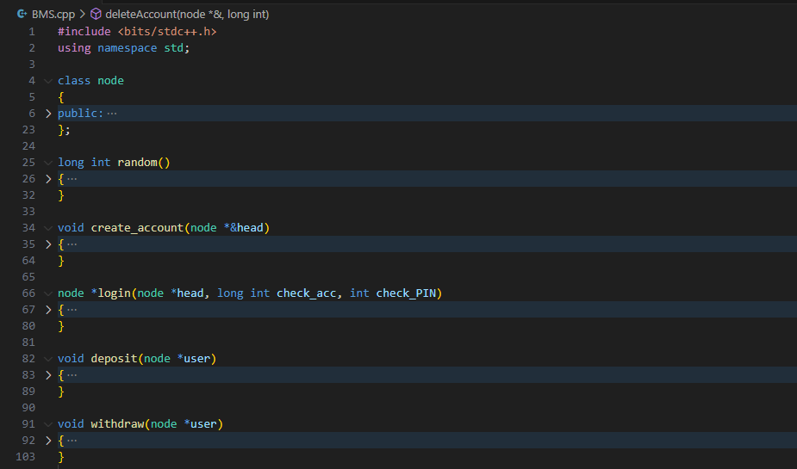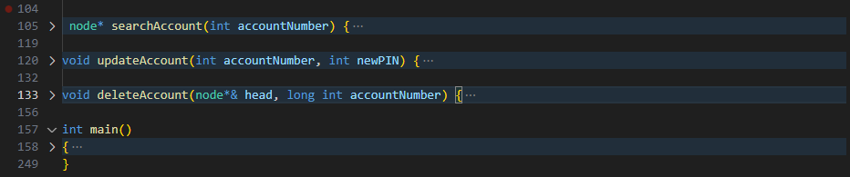

* **Output:**

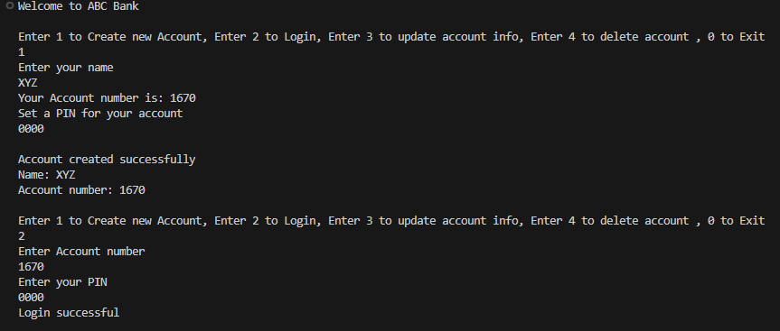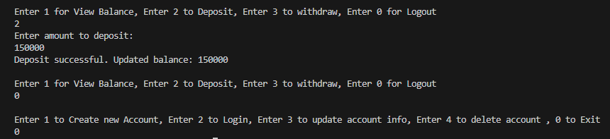

* **Programming Language used:**

C++

* **Header File used:**

#include<bits/stdc++.h> [includes all required header files]

* **Data Structure used:**

Linked List

* **Functions used:**

Random() : creates a random 4 digit account number whenever new account creation is done.

create_account() : creates a new account.

*login() : used to verify credentials during login.

deposit() : adds a entered amount to user’s account.

withdraw() : withdraws a entered amount below balance.

search_Account() : used to search account in bank.

update_Account() : used to update pin of any user.

delete_Account() : used to delete any account from bank.

**CHAPTER 5 CONCLUSION AND FUTURE WORK**

# Conclusion

In conclusion, the comprehensive exploration of searching and sorting techniques in phone-book applications has revealed the critical role these methods play in shaping user experience, data management, and overall application performance. The integration of efficient sorting and searching not only enhances user satisfaction but also strengthens user engagement, leading to increased user retention rates.

The application of machine learning and AI, the adoption of user- centric design principles, and the optimization of performance trade- offs further underscore the potential for innovation in this domain. By maintaining a balance between speed and resource usage, developers can ensure that phone-book applications not only meet but exceed user expectations.

# Future work

In the future, the landscape of phone-book applications holds great promise for research and development. One compelling avenue is the advancement of AI-driven personalization, where more sophisticated machine learning algorithms could power predictive contact organization and tailor user experiences to individual preferences, creating a highly personalized and adaptive interface.

Emerging technologies like voice-activated features offer an exciting prospect. Integrating voice commands could simplify contact management, making it more intuitive and accessible, especially for users on the go. Additionally, blockchain integration may provide a new dimension to secure and decentralized contact management, offering users greater ownership and control over their data.

**CHAPTER 5 REFERENCES AND CITATIONS**

1. Ajay Kumar, Bharat Kumar, Chirag Dawar and Dinesh Bajaj, Comparison Among Different Sorting Techniques, International Journal for Research In Applied Science And Engineering Technology (IJRASET), 2014.
2. Rekhadwivedi and Dr. Dinesh C. Jain, A Comparative Study on Different Types of Sorting Algorithms (On the Basis of C and Java), International Journal of Computer Science & Engineering Technology (IJCSET), 2014.
3. Ramesh Chand Pandey, Study and Comparison of various Sorting Algorithms, 2008.
4. V.P.Kulalvaimozhi, M.Muthulakshmi, R.Mariselvi, G.Santhana Devi, C.Rajalakshmi and C. Durai, Performance Analysis of Sorting Algorithm, International Journal of Computer Science and Mobile Computing, 2015.
5. Pankaj Sareen, Comparison of Sorting Algorithms (On the Basis of Average Case), International Journal of Advanced Research in Computer Science and Software Engineering, 2013.
6. Kamlesh Kumar Pandey and Narendra Pradhan, A Comparison and Selection on Basic Type of Searching Algorithm in Data Structure, International Journal of Computer Science and Mobile Computing, 2014.
7. Thomas Niemann, “Sorting and Searching Algorithms.
8. Brad Miller and David Ranum, Problem Solving with Algorithms and Data Structures, 2013.
9. Debadrita Roy and Arnab Kundu, A Comparative Analysis of Three Different Types of Searching Algorithms in Data Structure, International Journal of Advanced Research in Computer and Communication Engineering, 2014.
10. Amy CsizmarDalal, Searching and Sorting Algorithms, 2004.
11. Khalid Suleiman Al-Kharabsheh, Ibrahim Mahmoud AlTurani, Abdallah Mahmoud Ibrahim AlTurani&NabeelImhammedZanoon, Review on Sorting Algorithms A Comparative Study, International Journal of Computer Science and Security (IJCSS), 2013.
12. Vimal P.Parmar, Comparing Linear Search and Binary Search Algorithms to Search an Element from a Linear List Implemented through Static Array, Dynamic Array And Linked List, International Journal of Computer Applications, 2015.
13. Yuvraj Singh Chandrawat, Abhijeet Vajpayee and Aayush Pathak, Analysis and Comparative Study of Searching Techniques, International Journal of Engineering Sciences & Research Technology, 2015.
14. JehadHammad, A Comparative Study between Various Sorting Algorithms, International Journal of Computer Science and Network Security, 2015.
15. FahriyeGemciFurat, A Comparative Study of Selection Sort and Insertion Sort Algorithms, International Research Journal of Engineering and Technology, 2016.